Mathematics – learning sequence

Resource considerations
This lesson sequence allows for continuity of student learning and could be adapted to fit in with your existing teaching and learning program. Students will be supported to meet outcomes from a Key Learning Area. Each task has a duration of 30 minutes and could be used in conjunction with your framework, designed using the K-6 template. This lesson sequence uses a balance of synchronous and asynchronous learning strategies. The tasks provide options for students with and without technology. They can be used with any online platform. Suggestions about how your school will plan students’ learning from home and ways to communicate with students can be found through the Learning at home, school planning page. Assessment strategies are included to ensure evidence of learning is monitored and collected.

Early Stage 1 learning sequence
Outcomes
MAe-1WM – describes mathematical situations using everyday language, actions, materials and informal recordings
MAe-2WM – uses objects, actions, technology and/or trial and error to explore mathematical problems
MAe-3WM – uses concrete materials and/or pictorial representations to support conclusions
MAe-4NA – counts to 30, and orders, reads and represents numbers in the range 0 to 20
MAe-5NA – combines, separates and compares collections of objects, describes using everyday language, and records using informal methods
MAe-8NA – recognises, describes and continues repeating patterns
MAe-9MG – describes and compares lengths and distances using everyday language
MAe-17SP – represents data and interprets data displays made from objects
Learning sequence overview – This sequence of lessons provides opportunities to deepen critical aspects of early number sense in the context of games and investigations. Students will explore quantities, additive situations and various forms of patterning. Teachers will be able to leverage opportunities to connect these activities with other aspects of number and algebra whilst also extending into aspects of measurement and geometry, and statistics and probability.

Aim of lesson sequence
Teachers should look for evidence of:
- Reasoning
  - What evidence do students use when making decisions?
  - Are students thinking logically when exploring numbers, counting situations, games and when solving problems?
  - Do students re-think ideas based on new evidence/new understanding?
  - Do they make comparisons between objects and quantities?
- Communicating
  - Do students use appropriate mathematical and everyday language?
  - Do students use appropriate mathematical representations including pictures, gesturing, enactment and drawing when recording ideas?
  - Can students record and communicate ideas in ways that make sense to other people?
  - Do students listen to the ideas of others?
- Number sense
  - Do students reveal their knowledge of counting by using/referring to:
    - One-to-one correspondence?
    - Stable-order?
    - Conservation?
    - Order-irrelevance?
    - The number before and after a given number?
    - Able to count backward in a similar range to their ability to count forward count?
  - Do students reveal their knowledge of number by being able to represent them in various representations (words, symbols and by creating collections)?
  - Do students demonstrate part-part-whole knowledge?
    - Can they use this knowledge in the contexts of games and problems?
  - Additive thinking
    - Are students able to use counting to solve problems?
      - Can they count all?
      - Can they count on/back?
    - Do students use other strategies to solve problems?
      - Do they use number facts?
      - Do they use numbers flexibly?
- Measurement
  - Do students accurately measure items?
  - Are they able to keep track of measuring a given distance?
    - Do students need to lay a line of items along a length, or, can they use their finger or another marker, to determine length?
  - Can they reason about length through comparing?
  - Can they order objects?

Teacher notes
- These tasks are easily adaptable and can be used co-operatively, competitively, in a digital or non-digital environment.
- To access the videos in the PowerPoint, open the PowerPoint online, teachers and students may need to sign in with their school email address if prompted.

Activities
- Counting book
- Digital: Class to collaborate online. Use Activity 1 PowerPoint slide
- Non-digital: Help students make their own counting books. They need 5 zip-lock plastic bags, a stapler and a piece of cardboard.
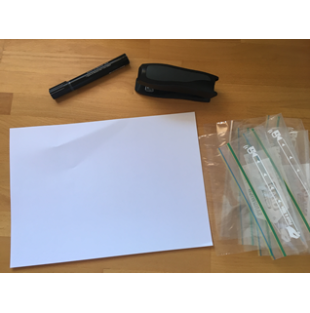
Open the zip-lock bags.
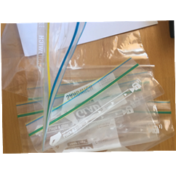
Lay the bags on the cardboard, like pages of a book.
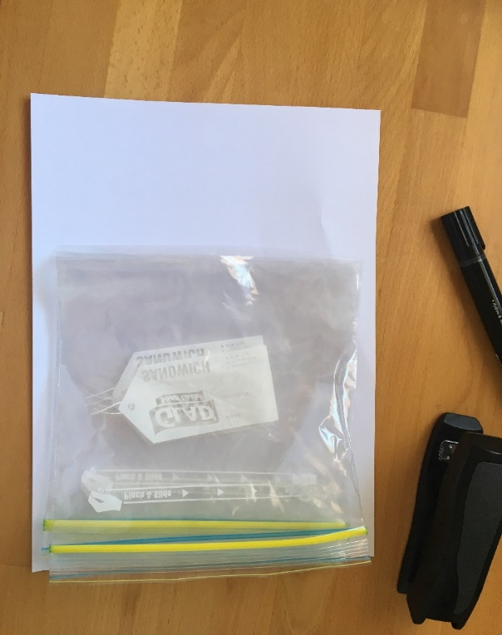
Take the remaining cardboard and fold it over the bags to form the spine of the book. Staple it into place.
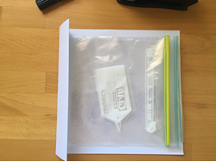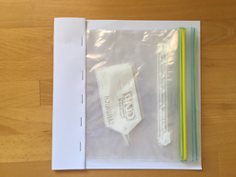
Finally, give the book a title!
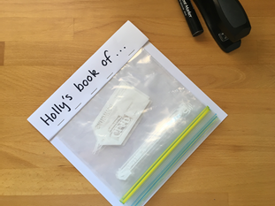
Once the book has been made, invite students to create their pages based on a particular mathematical idea. For example, you can make a book about 5. Send the student on a ‘5 hunt’ where they have to find different ways of showing 5. Then, ask students to read you their book.
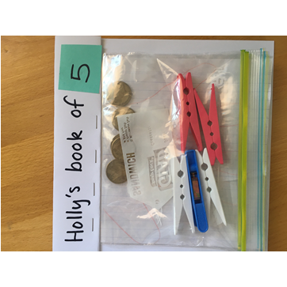
Here is part of a conversation to help illustrate what it can sound like when talking to students about their book:
Adult: You went on a hunt around the house to find different wants of representing 5. Can you read your book to me?
Holly: Yes. I have 5 pegs
Adult: How do you know that is 5?
Holly: See... it’s 2 pink and the 3. That makes 5.
Adult: I see...that’s 2 and then 3, 4, 5 (touching one object for each number word that is said)
Adult: What else have you got in your book?
Holly: This one is 5 dollars...see there’s 3 here and 2 more. That’s five.
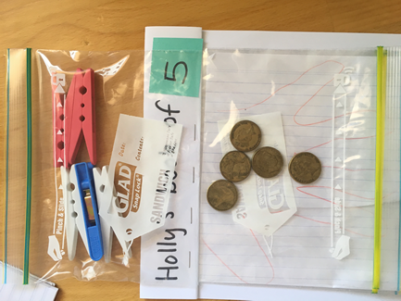
Holly: This one is my mum’s hand.
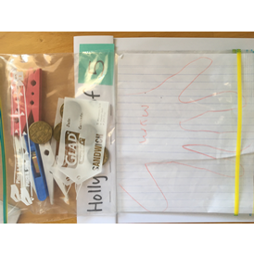
Adult: How do you know that’s five?
Holly: because she has 5 fingers on your hand
Adult: Look at all the different ways you found 5! Let’s find someone else to read it to!
Reflection:
Students draw their favourite page from their book.

- Number busting
- Digital: Class to collaborate online. Use Activity 2 PowerPoint slides
- Non-digital: Students select a number, such as 7.Ask them to get 7 items (for example, pasta pieces, counters or pencils).
Ask students to reorganise and describe their collection as many times as they can. They may like to use a mathematical structure such as a ten-frame to help them. They also may like to work collaboratively so they can share ideas. Parents at home might like to help their children record their thinking.
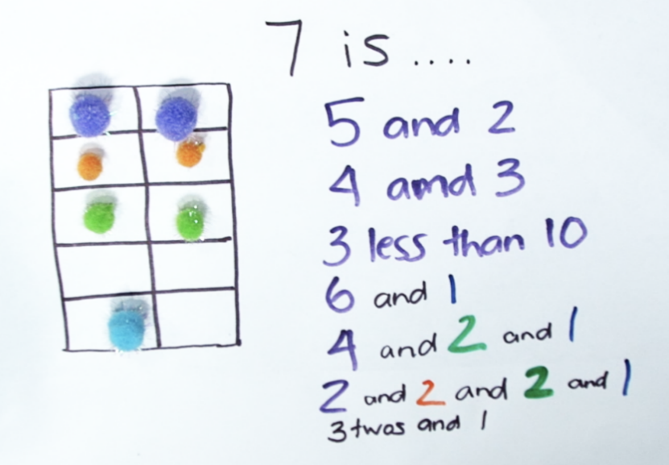
Ask: Can you try the same activity using different equipment (like LEGO, for example)?
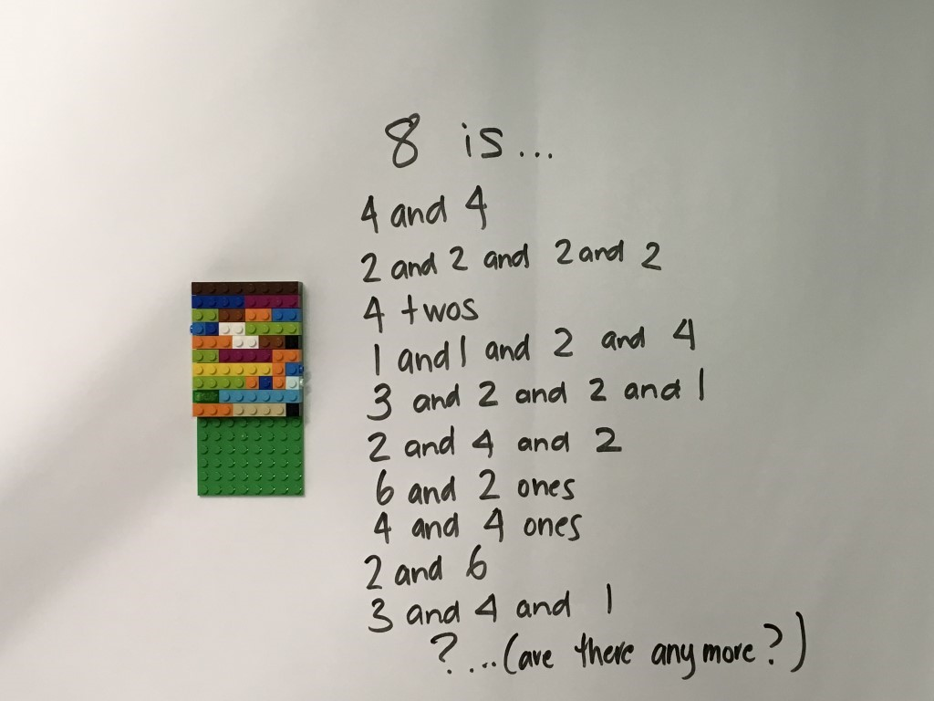
Ask students to draw and record 3 different ways they thought about their collection.
Reflection
- Were you surprised by all the different ways to make your number?
- What did your structure help you notice? (for example ten frame, dice pattern)
- What did you find interesting in this activity?

- ‘Guess my number’ and ‘race to write’
For today, we have two shorter activities. You might use one or you may use both in the same day. These games are beneficial in supporting reasoning, comparing quantities and numbers, and number formation.
Guess my number
Guess my number is a great game to introduce and support logical thought and strategy. It is easily adaptable for a broad range of capabilities and promotes number sense.
- Digital: Class to collaborate online. Use Activity 3 PowerPoint slides
- Non-digital: Ask students to write the numbers from 1 to 10 (for example) on a piece of paper or use cards to set the number range they will be using. In this example, the student chose to use between 1 and 8.
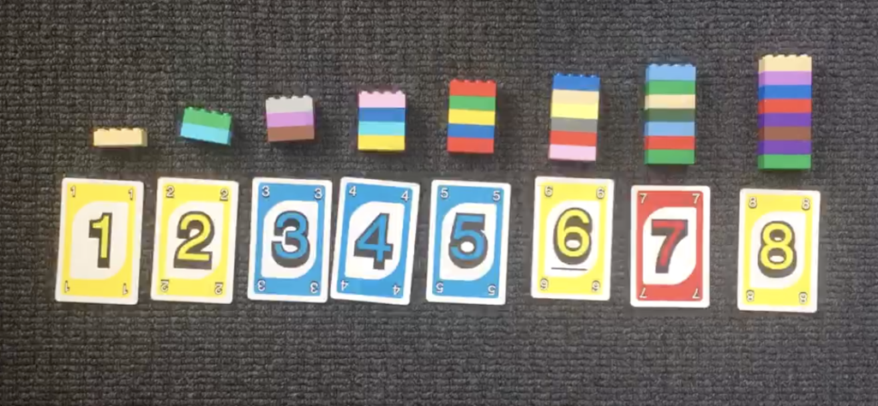
The student asks someone at home (the ‘secret holder’) to choose a secret number within the given range.
Students can play two variations of the game: The student can try to guess the secret number in the fewest number of guesses possible, or, they must try to guess the number with only 3 guesses.
After every guess, the 'secret holder’ tells the student whether their number is greater or less than their guess.
Here is part of a conversation to help illustrate what the game can sound like. This was a game between a teacher and a student, using the number range 1-12:
Secret holder: Ok, make your first guess!
Student: 3.
Secret holder: My number is not 3.
But my number is greater than 3.
Are there any numbers you can cross off your list?
Student: It’s not 3 so I can cross that off.
Student: It’s not 2 or 1 either as they are less than 3.
Secret holder: That’s great reasoning- because my number is greater than 3, but those numbers are less than 3, they can be crossed off.
What is your next guess?
Student: 7.
Secret holder: My number is not 7, but my number is less than 7. Can you cross any more numbers off the list?
Student: Yes! 7...8, 9, 10, 11 and 12!
Secret holder: What are the options you have left?
Student: 4, 5 or 6!
Secret holder: Take some time to think about what a good number would be to guess now.
Student: Maybe 5?
Secret holder: Why do you think that?
Student: If I choose 5...it’s in the middle. So, I will know the answer whatever happens with bigger and smaller. And it could just be 5!
Reflection:
- What is an effective strategy to guess the number quickly?
- If you played the game again tomorrow, what would you do differently? Why?

Race to write
This activity provides a context for students to practice writing numerals.
- Digital: Class to collaborate online. Use Activity 4 PowerPoint slides
- Non-digital: Provide students with a game board showing the numeral outlines, a marker and a 1-10 dot spinner.
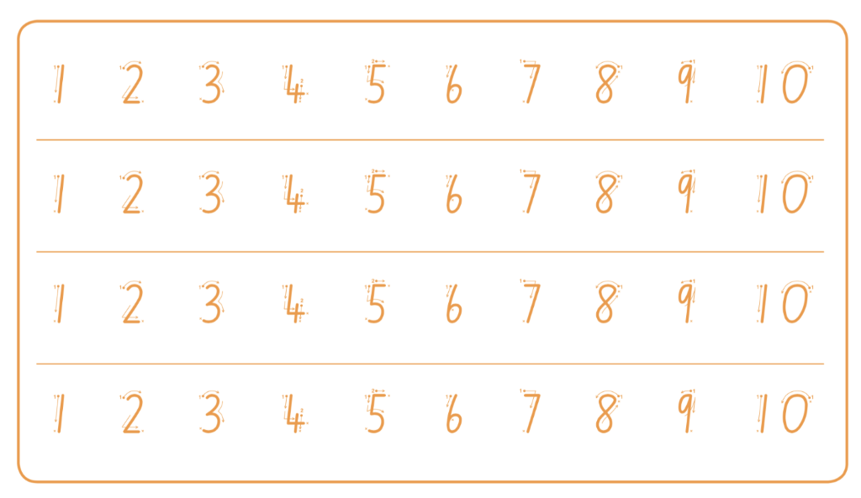
Students take turn to spin the spinner and trace over the corresponding numeral on their game board. The first student to complete any row wins the race.
Variations
- Provide students with a pile of number words they flip over to determine which numeral to write (e.g. cards that say ‘one’, ‘two’ etc.)
- Have a pile of ten frames showing 1-10. Students flip over to determine which numeral to write
- Work within the range of 1-5 before progressing to 1-10
- Work with numerals 1-20 using a second game board.
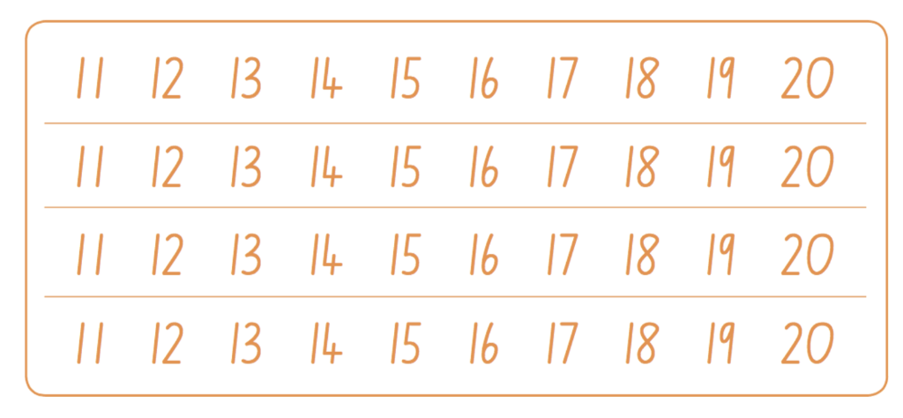Reflection
  - What is an effective strategy to guess the number quickly?
- Counting with understanding
- Digital: Class to collaborate online. Use Activity 4 PowerPoint slides
- Non-digital: You will need:
- Some pegs or paper clips
- Some numeral cards. You can make these using sticky-notes and a marker.
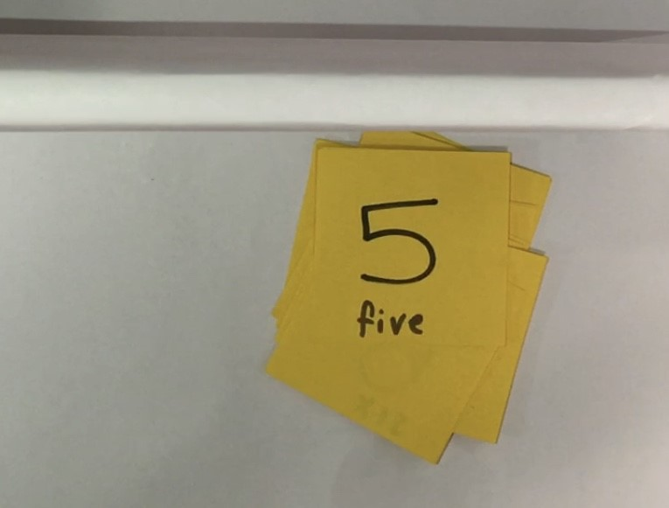
Provide students with a set of number cards within an appropriate number range. For this example, we are using 0-6. If you don’t have numeral cards, these can be made at home using paper and a marker.
Shuffle the cards. Turn one over at a time and ask the student to read the numeral. Then, ask them to attach the corresponding number of pegs (or some other item) onto the card.
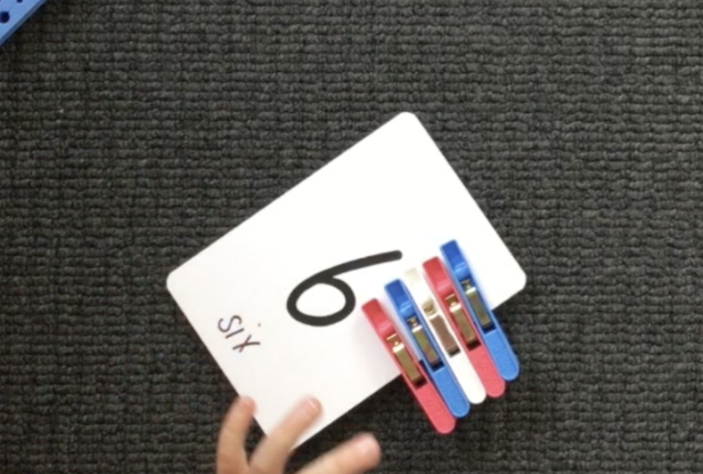
Then, ask students to order the cards from smallest to biggest, or, biggest to smallest.
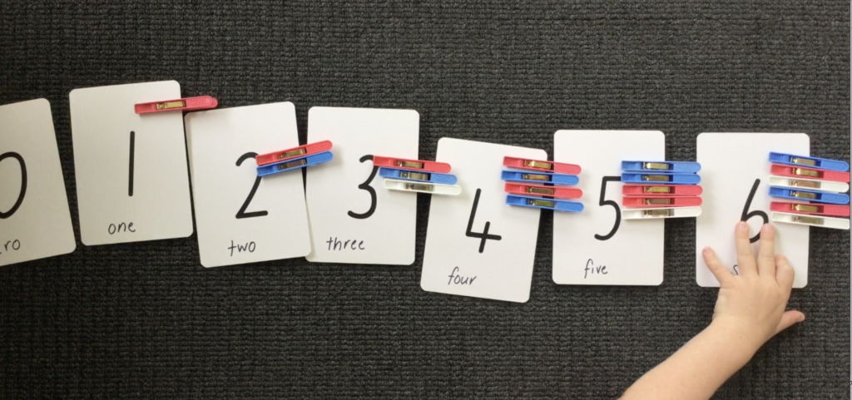
You can also ask students to close their eyes as you remove one of the cards. Then ask them to identify which card is missing and how they worked that out.
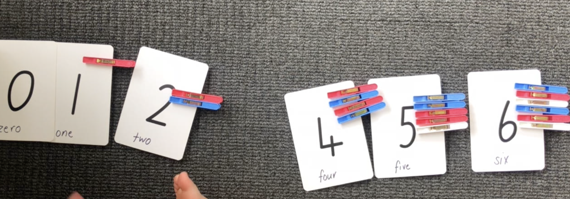
Then choose one card, for example 5. Ask the student how many pegs are on the card to establish/confirm that there are 5. Support the student’s understanding of conservation by spreading the pegs out, bringing them in close together and swapping 1 peg for a clip. Encourage them to use reasoning to determine there are still 5 things in the collection even if they are close together or far apart, or, when one thing is swapped for another.
Variations:
Provide students with cards that have a numeral and matching dot pattern so they can attach one peg for each dot.
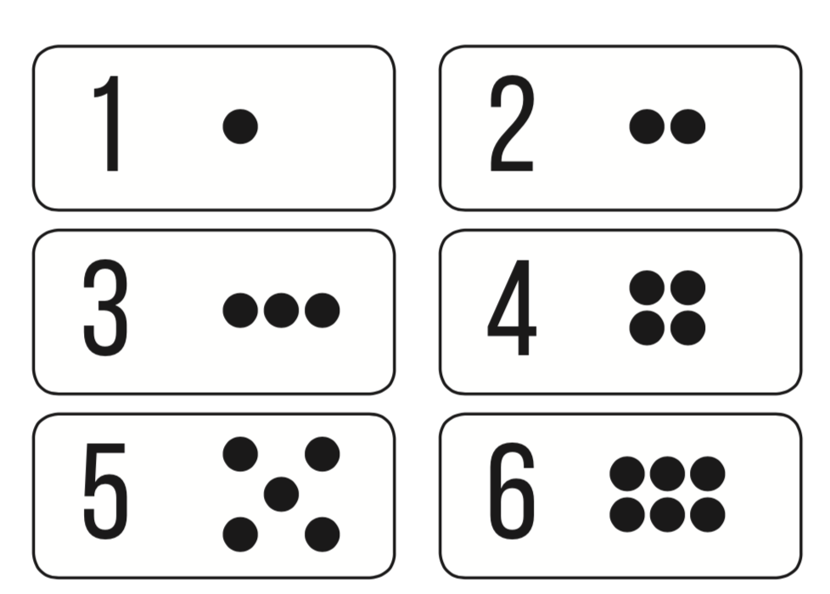
Place a row of paper cups on the floor. Encourage the students to count the empty cups. Ask the students to drop one counter into each cup and to count the counters as they are dropped into the cups. Direct the students to remove one cup at a time, counting backwards from 5.
Reflection
- What do you need to remember when counting?

- ‘10 or bust’ or ‘The counting game’
These activities support students in enhancing their reasoning skills whilst also developing their number sense.
10 or bust
- Digital: Class to collaborate online. Use Activity 5 PowerPoint slides.
- Non-digital: Students need:
- a game board (they can use a number track, a ten-frame, a drawing of 10 fingers, a drawing of a known number combination to 10 (for example, 6 and 4), etc.
- counters (or dried beans/pasta)
- a dice, spinner or numeral cards from 1-6.
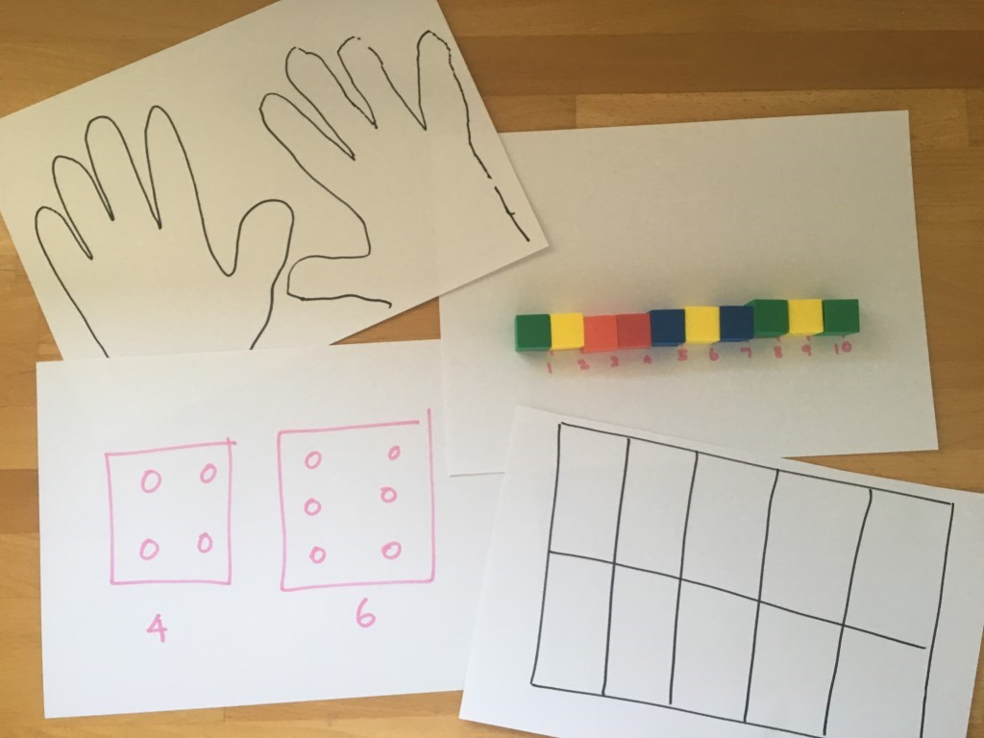
Students have 3 turns each to roll the dice and place the corresponding number of counters on their game board. Students can choose to miss 1 turn, but it cannot be their last roll.
If a student goes over 10, they have ‘busted’ and are out of the game.
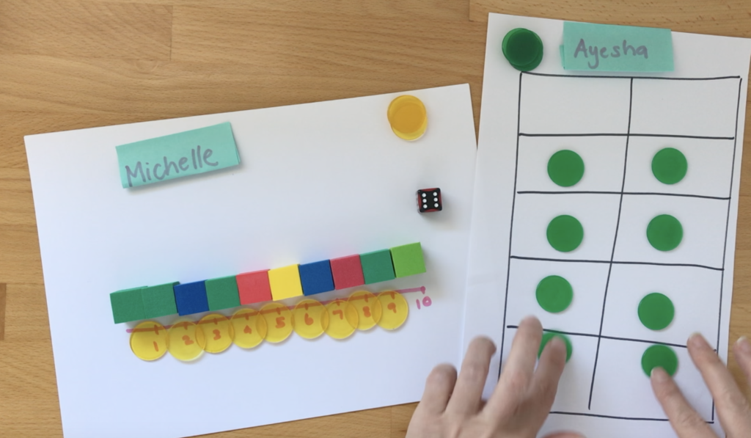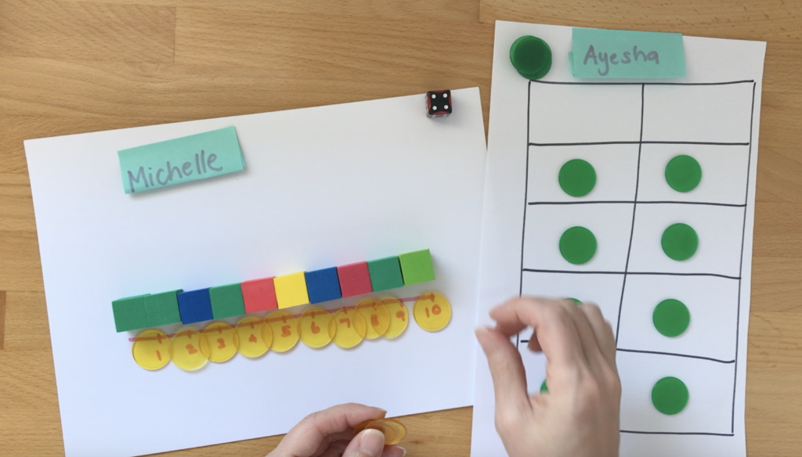
The student closest to 10 after 3 rolls each is the winner. Students can play best out of 3, playing by making up to 10 as well as backwards to 0.
Reflection
- How could we change the game to make it more/less challenging?
- Did you work out a way to play this game so that you didn’t lose? What was your strategy? Did it work?
The counting game
It is easily adaptable to suit a broad range of learners. For this example, we have used the target of 24. Teachers should choose an appropriate target number based on the needs and capabilities of students.
- Digital: Class to collaborate online. Use Activity 5 PowerPoint slides
- Non-digital: Collect 24 items. Using 24 as a target number, students take it in turns to count on by saying the next 1, 2 or 3 number words in the sequence, placing items into a central pile as they are counted. Players collect a point if they say the target number. A new target number is chosen and players play again. Try playing forward and backward. For example:
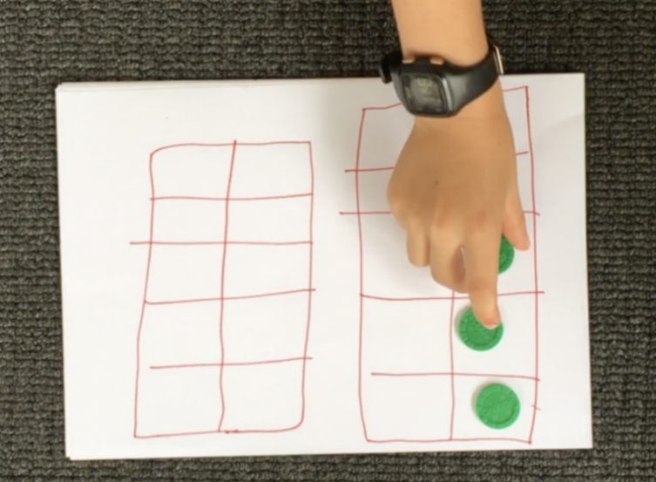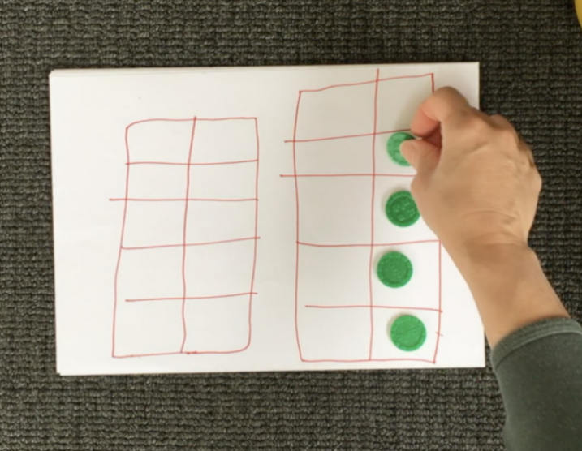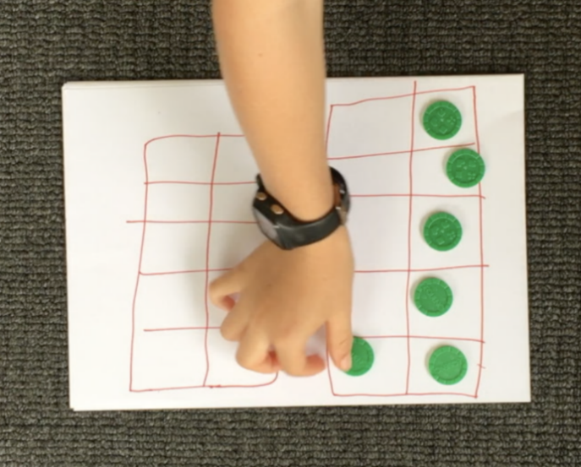
Target number 24
Player A: 1, 2, 3...
Player B: 4...
Player A: 5, 6...
Player B: 7, 8, 9…
Player A: 10, 11, 12...
Player B: 13…
Player A: 14...
Player B: 15, 16...
Player A: 17...
Player B: 18...
Player A: 19...
Player B: 20, 21...
Player B: 22, 23, 24!
Play again, starting at 24 and counting backwards to zero.
Variations:
- Students select a different target number, such as 12.
- You can also count in multiples. For example, you can start at 0 and aim for 20, counting by twos.
Reflection questions:
- What would happen if I had said....instead of ...?
- How could we change the game to make it more/less challenging? What did you notice about playing the game by counting backwards? Did it make your brain work harder or was it less difficult?
- Did you work out a way to play this game so that you didn’t lose? What was your strategy? Did it work?

- Basketball toss Basketball toss provides a fun context to develop skills in statistics and measurement. It supports one-to-one correspondence, subitising, counting, comparing collections, interpreting data and measuring using informal units.
- Digital: Class to collaborate online. Use Activity 6 PowerPoint slides
- Non-digital: Students need:
- pair of socks
- basket, bucket or container
- a clear space
- 1 piece of paper
- pencils or markers
- 10 pegs
- a ten-frame

Your challenge: See how many times you can successfully shoot your rolled up socks into the basket.
Make your recording chart for on one piece of paper (you can get someone to help you write the labels)
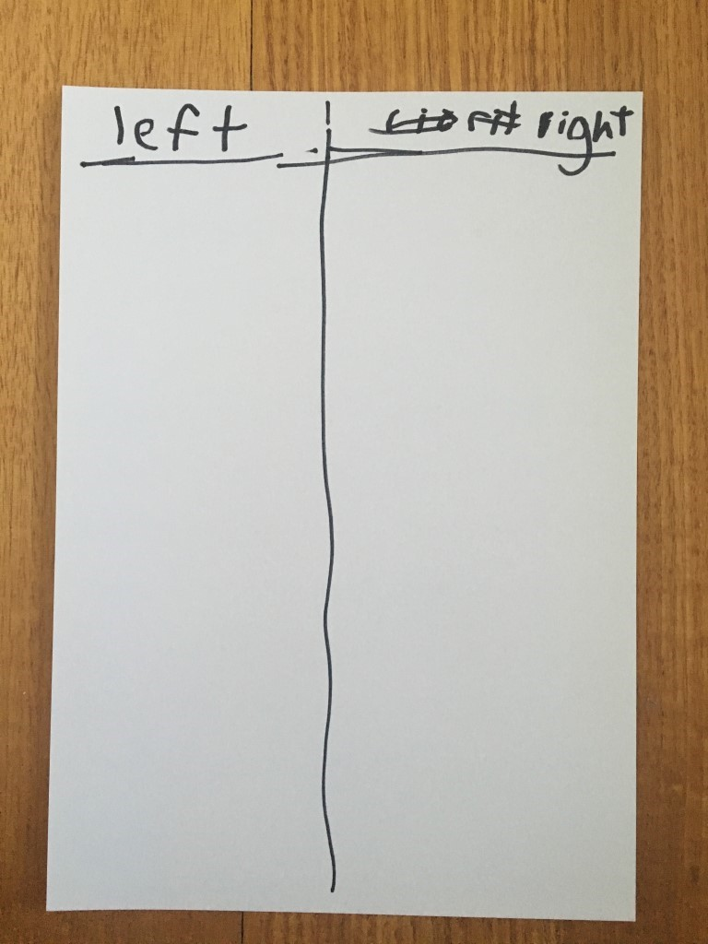
Mark a clear ‘starting line’ for your Basketball toss.
Take 3 big steps from your starting line and place a basket or container at the end.
Stand at your starting line and throw your socks. Throw your socks with your right hand.
Each time you get a sock in the basket, clip a peg onto your chart.
Go back to your starting line and have your second throw.
Repeat this until you have thrown your socks 10 times with your right hand and 10 times with your left hand.
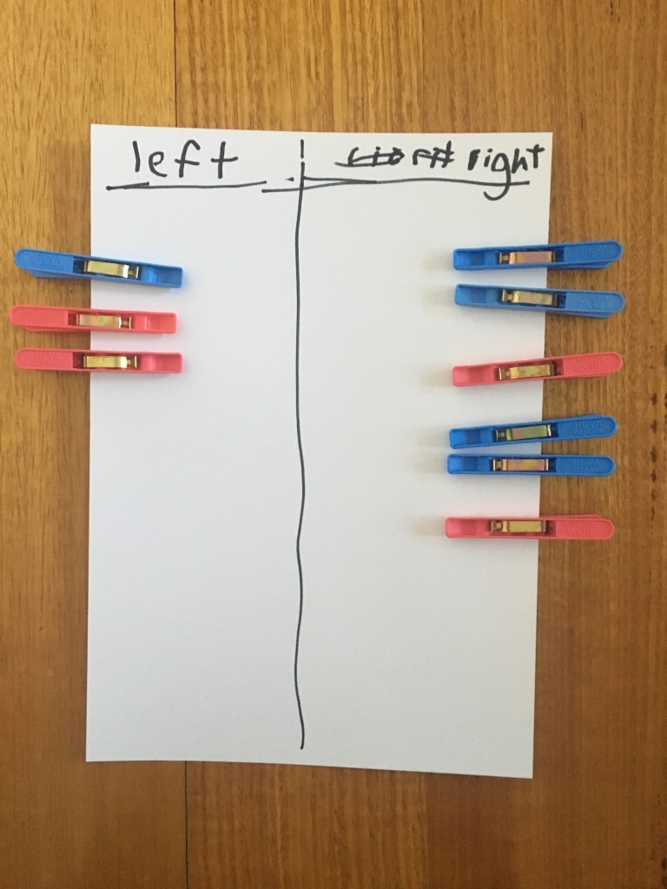
Draw a picture of your chart in your workbook.
How many baskets did you get when you used your left hand?
How many baskets did you get when you used your right hand?
How many did you get altogether?
You can support students by having them use direct comparison to help them work out/prove which one had more.
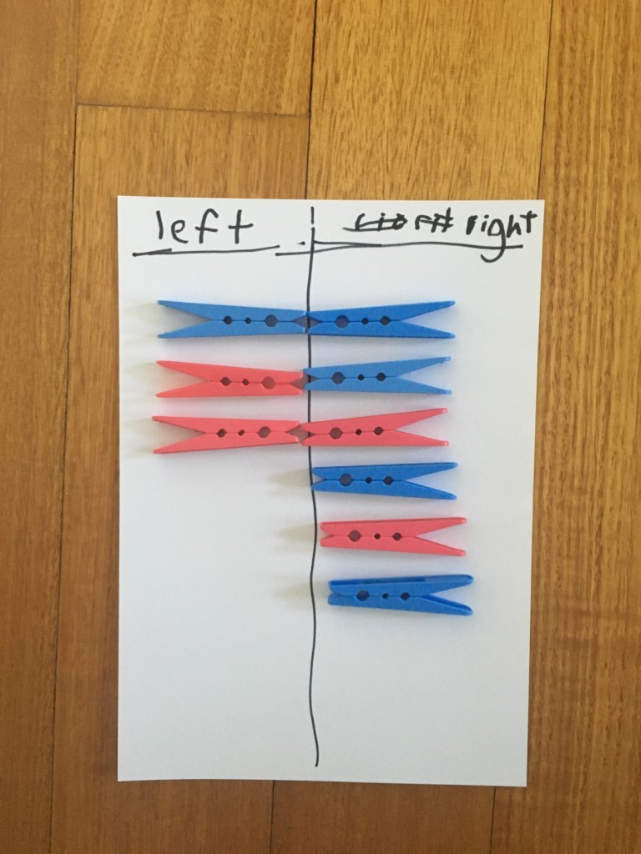

They can also put their pegs onto a familiar structure, like a ten-frame. It’s important to have them use what they know about this structure to help them. So, if I see 1 box is left empty, I know I got 9 baskets because 1 less than 10 is 9.
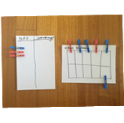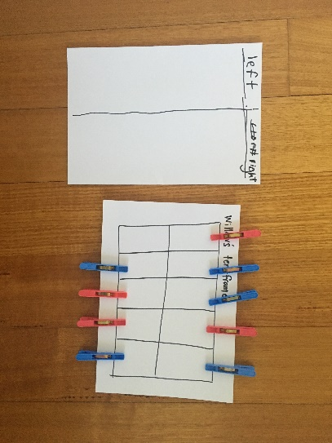
Other people in your family might have been playing basketball toss today too. If they’re taller than you, they might have had their baskets in a different spot. Using some blocks or spoons, for example, work out how far you had to throw your socks and then work out how far someone else had to throw theirs.
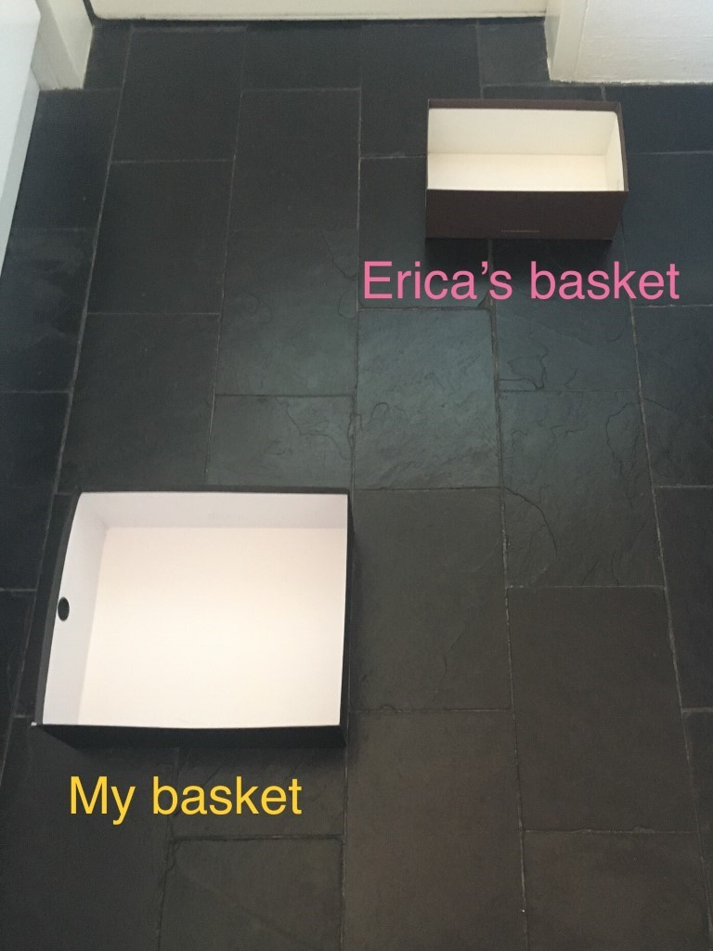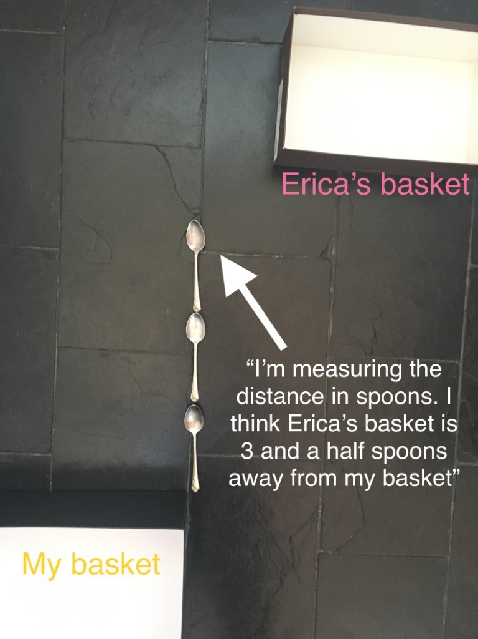
Draw a picture to show your measuring.
Can you create a new game your family and friends could play at home?

- Long creatures! (adapted from NRICH maths https://nrich.maths.org/9717)
  - Digital: Class to collaborate online. Use Activity 7 PowerPoint slides.
  - Non-digital: Students will need:
- cardboard (cut into thin strips)
- craft materials
- markers
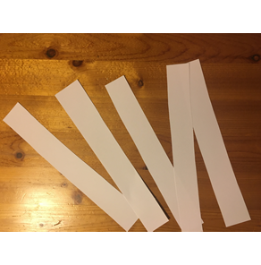
Ask students to fold the strips into different lengths.
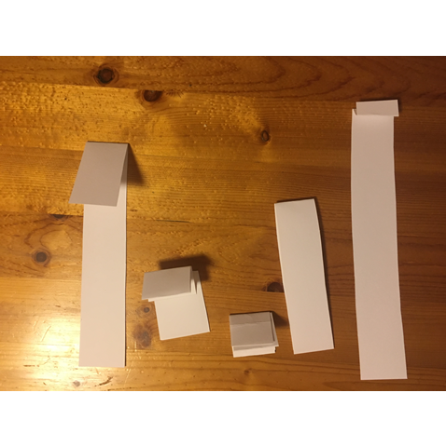
Then, ask students to decorate their cardboard strips to help them come to life!
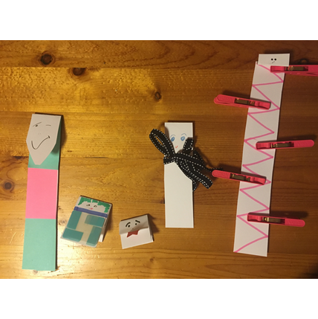
Invite students to order their creatures from the shortest to tallest (for example).
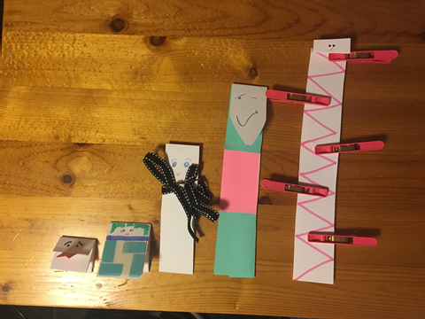
Ask students to draw their creatures in their mathematics workbook.
Show this image and ask students if they agree with this way of ordering from tallest to shortest. Ask them to explain why/why not. Support them in understanding that to measure accurately, we need to make sure we are starting from the same place.
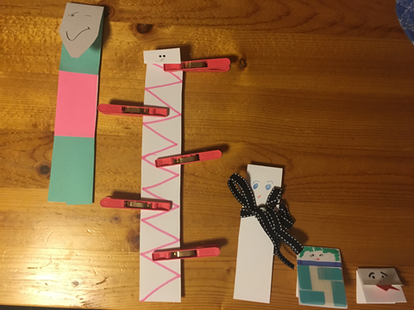
Ask a student to choose their shortest creature and one of their longer creatures. Ask them to determine how may short creatures are needed to be the same height as the taller creature.
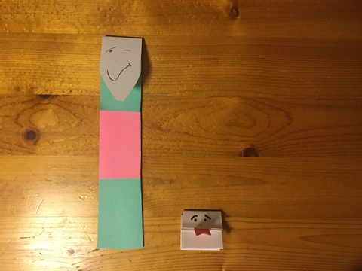
Draw a picture to show you measuring how tall the creature is that you just measured.

- Pinch a ten (from Teaching Mathematics, 2015 Marilyn Burns)
This activity is helpful for building student's estimation skills and their feel for quantity. It also aids students in deepening their awareness of the relationship between quantities (such as less than and more than).
In this version of the game, we used a known pattern for 10 – our 10 fingers. Teachers should decide when it is appropriate to use an alternative representation of 10.
- Digital: Class to collaborate online. Use Activity 8 PowerPoint slides
- Non-digital: Students need:
- small bag of dried beans or counters
- pencils or markers
- your mathematics workbook
Ask students to take a pinch of the dried beans and determine how many they have in their collection. Is it:
- Less than 10
- 10
- More than 10
Complete the chart as the game progressing, repeating the process. Ask students to use what they know about numbers and counting to determine whether they have more than 10, less than 10, or exactly 10.
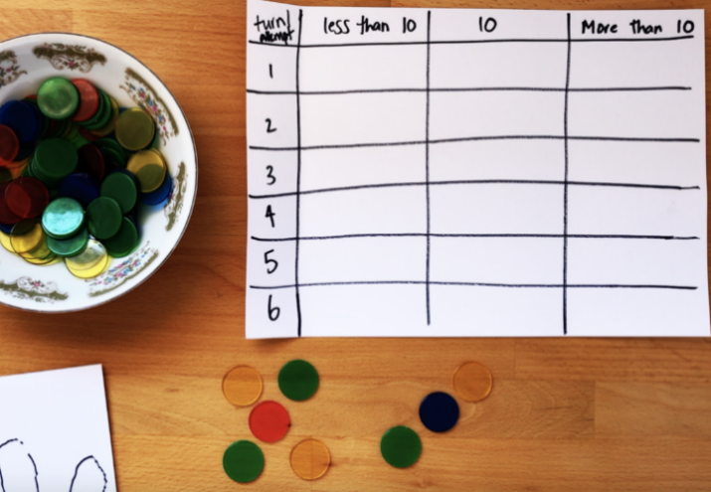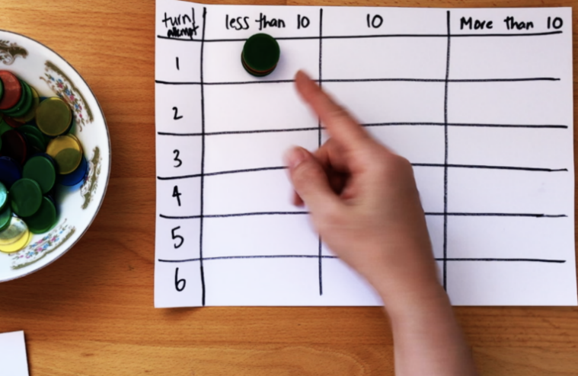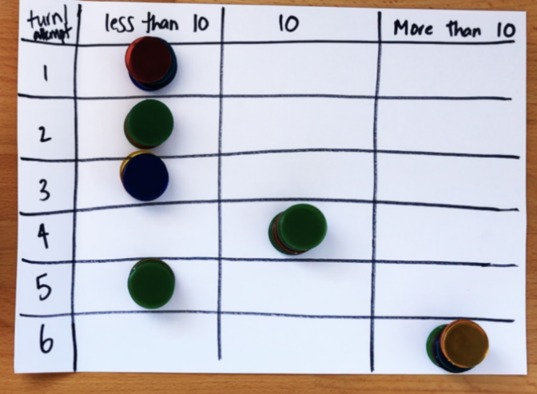
When playing the game on different occasions, students should be encouraged to use different strategies for determining how many they have. Using different objects (such as dried pasta and dried beans, blocks, etc.) will also be helpful in supporting students to get a feel for estimating quantities.
Reflection
- How did you work out how many you pinched?
- What do you notice about your chart?

- Building towers
This activity helps develop mathematical reasoning and communicating whilst also supporting number sense. For some students, you can emphasise one-to-one number correspondence and the use of direct comparison to describe relationships between quantities. For other students, you can use this game to support their use of part-part-whole number knowledge.
- Digital: Class to collaborate online. Use Activity 9 PowerPoint slides
- Non-digital: Give students 4 numbers to build as their tower (for example, 5, 7, 11 and 3), some blocks and a dice (or a spinner and numeral cards).
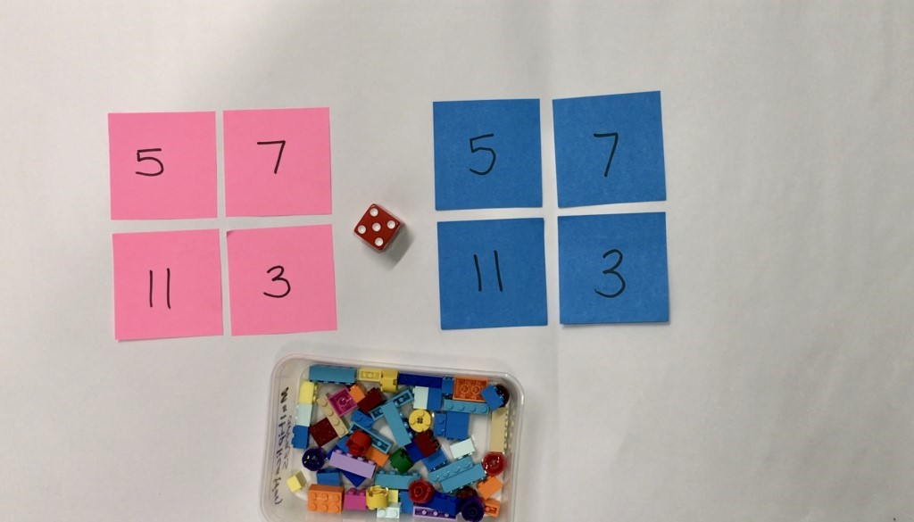

Students take turns to roll a dice and use the corresponding number of bricks to build up their towers. Towers can be built up in any way students choose. Students take turns building up their towers until one student gets the exact roll to complete the last tower.
Students can also play this in reverse.
Students should be encouraged to talk about how many they have, how many more they need and what strategies and knowledge they are applying.
Variations:
- Once students build the towers, play in reverse, taking away each time until there are no blocks left
- Change the number of towers students build, and, change the number of bricks needed for each tower
Reflection:
If you were to play the game again tomorrow, what is one thing you would do differently? Why?
Draw a picture that shows the towers you built in order of shortest to tallest.

- Let’s explore patterns It is often said that patterns are at the heart of mathematics.
Mathematical patterns are those that are made up of elements that repeat over and over and over. One key concept in the early years involves students being able to identify the pattern core (e.g. a repeating pattern ABABAB). Some other important concepts involve students being able to copy, extend, create and ‘translate’ patterns.
It is suggested teachers view videos about patterning.
- XXX

These tasks are designed to support a very broad range of needs and understanding.
- Digital: Class to collaborate online. Use Activity 10 PowerPoint slides
- Non-digital: Ask students to gather a collection of objects.
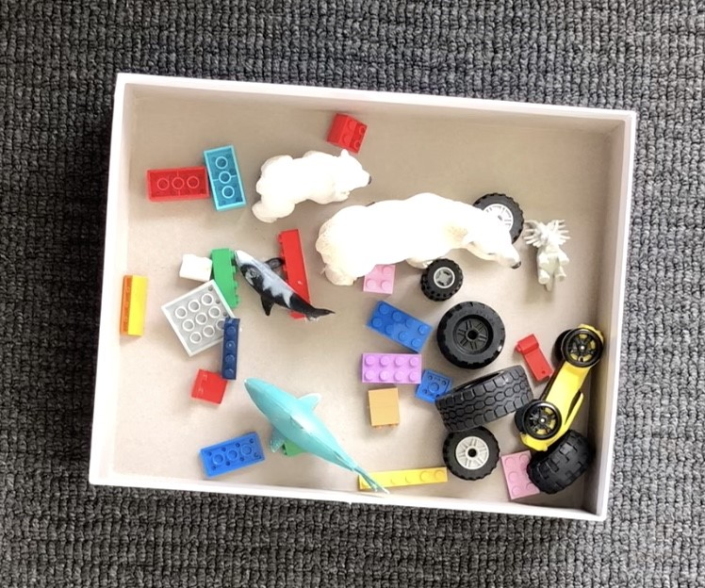
Invite students to think about the different ways they can sort and categorise their collection of shapes. Someone at home could help the student record their ways of thinking.
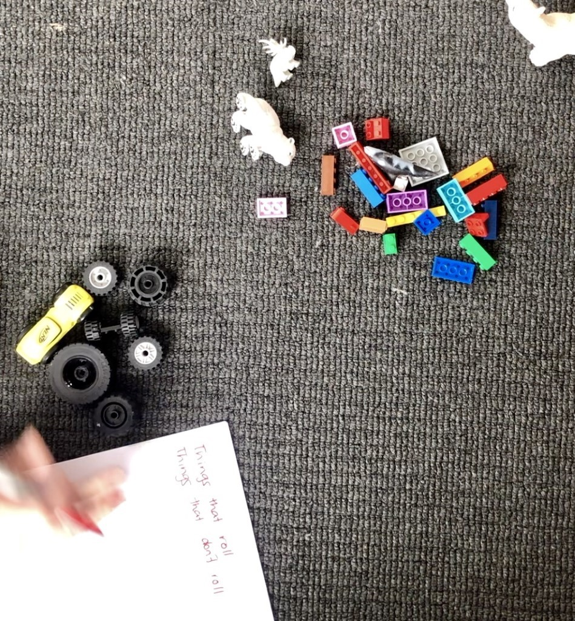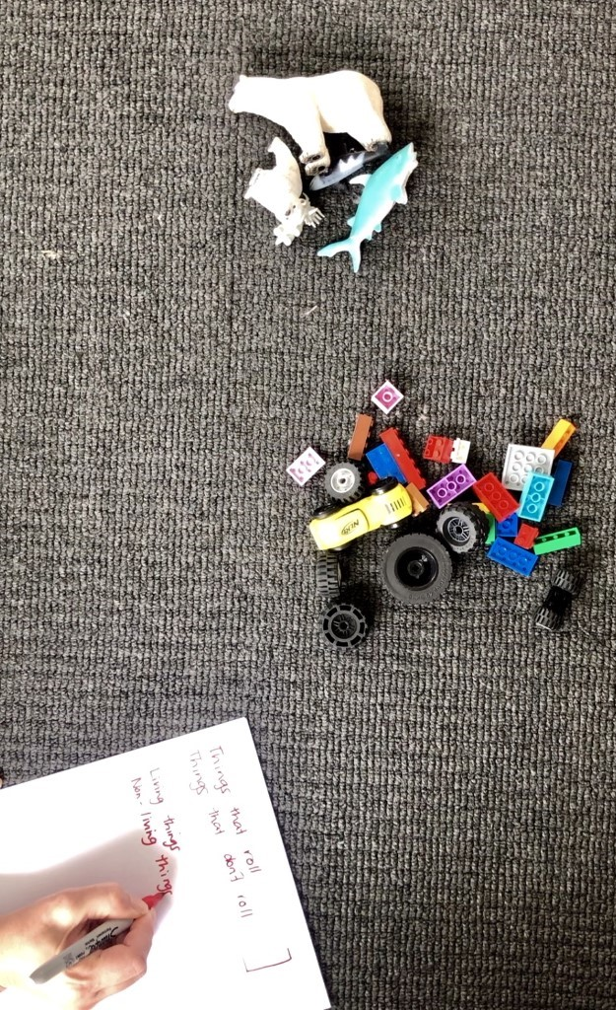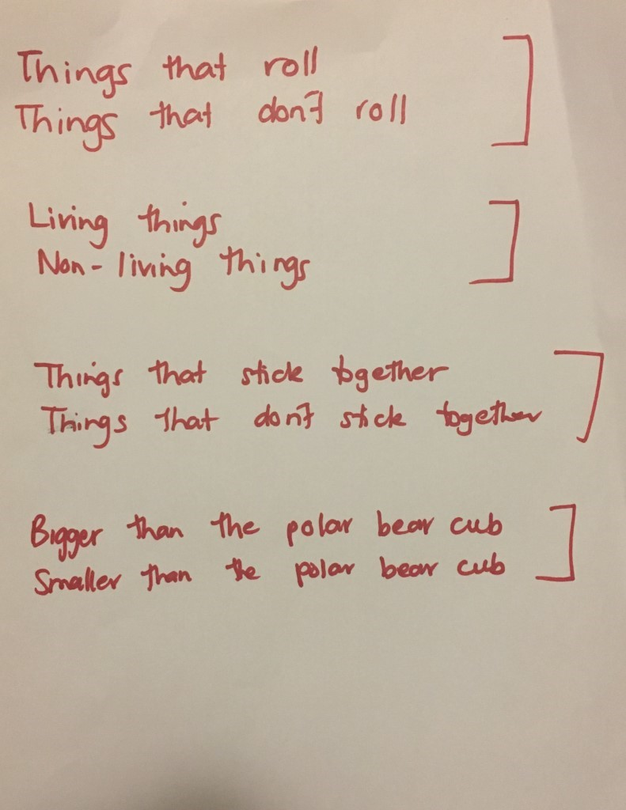
Talk to the students about what defines a pattern. Show this pattern to students.
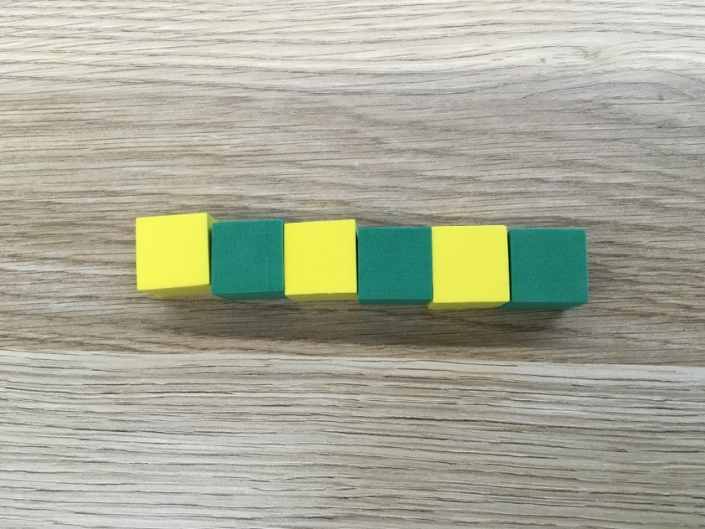
Ask them to describe the pattern. Ask students to explain how they know it is a pattern and how they would describe the part that repeats.
Ask students to make an AB pattern using different equipment.
Show students this image. Ask:
- How are these patterns the same?
- How are they different?
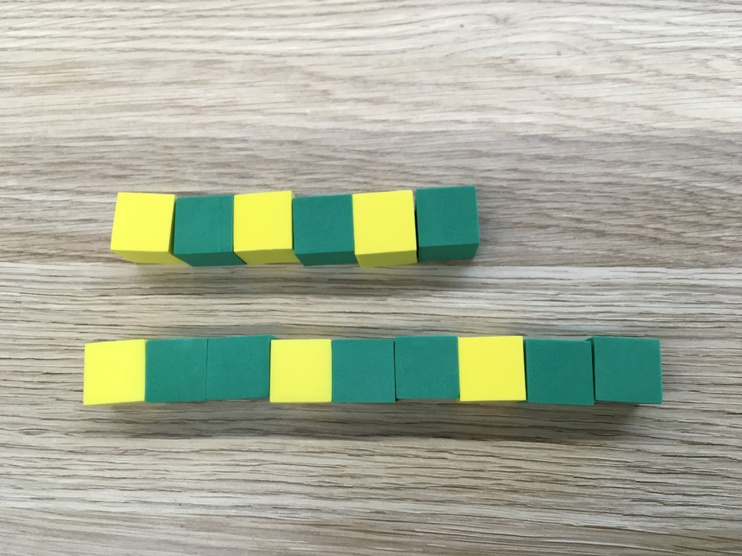
Construct, copy or extend a pattern that follows an ABB pattern.

Differentiation
Differentiation is a targeted process recognising that individuals learn at different rates and in different ways. Differentiation refers to deliberate adjustments to meet the specific learning needs of all students.
Here are some questions that you might consider when adapting the learning sequence to meet the needs of your students:
- What adjustments might you put in place for students who require additional support to access the task? For example, how will they get help when needed?
- Do you need to adjust the content to ensure it is adequately challenging and allows students to operate at their own level of thinking, skill and knowledge?
- Will you adapt the instructions so they are provided in a way that EAL/D students can easily interpret them? For example, through the use of visuals, checklists, diagrams or flow charts.
- Could you suggest ways that home language can be used as a tool to support learning? For example, bilingual dictionaries.
- Can you demonstrate that you value the Identity, culture, heritage and language of your Aboriginal students through your teaching practices?

Assessment
Using the aims of the lesson sequence as a guide, what do these tasks reveal about the knowledge, skills, understanding and interest of your students? You may like to take notes based on what you notice during conversations, student posts to digital platform and within student work samples.

Activity resources
- Online teaching resource (For example, PowerPoint)
- Student mathematics workbooks
- Parent/carer advice: Parents may like to support their children by playing and talking to them about their experiences and their learning. It is strongly suggested they supervise their children when they are online. Teachers often find it beneficial to watch the videos like those included a few times to assist with developing confidence in noticing, wondering, talking, questioning, testing and playing like mathematicians. Feel free to play any of the games and activities more than once. These experiences are adaptable and so can be played with family and community members, who can join in on the fun!

