Mathematics workbook Stage 2
Name:
Class:

Overview
For the next 2 weeks, we hope you will be having some fun with mathematics – getting sweaty brains, thinking hard and feeling successful when you solve a problem, develop more confidence or understand something better. Many of these activities are games and investigations that you can play with your family, friends and classmates. Have fun and think deeply!
Most of these tasks have a video and some have downloadable resources to support your learning. You can find these using the digital student resource link on the Learning from home, Teaching and learning resources, K-6 resources page.

Day 1
Today we have 4 tasks. These tasks are designed to get us talking about different ways we can think about numbers, have some fun whilst working with the operations and make some squares we will need later in the week.
Resources – colour pencils/ markers, device to view videos, 5 pieces of A4 or A5 paper, dice or numeral cards 1-6, 0-9 spinner (appendix)

Dot card talk – 2
View video – Dot card talk – 2 video
Imagining the other collections reforming into arrays… Draw what they would look like.

How do people in your family see the representation?

Dicey addition
(Adapted from NRICH maths)
View Dicey addition video
How to play?
Find a partner and a 0-9 dice or spinner. Draw your gameboard so you each have one. (We used this one to start with: _ _ _ + _ _ _ + _ _ _ = ________ You can start with something different if you like). Each player takes a turn to spin the spinner and decide where to play that digit in your number sentence (equation). Spin the spinner 9 times each. The person whose sum is closest to 1000 is the winner!
Enjoy playing dicey addition with your family members. Record your games.

How to make a square
View video – How to make a square
Follow the steps in the video to make 5 squares and keep them ready for Day 2!

101 and you’re out
View video – 101 and you’re out
How to play?
This game comes from Marilyn Burns.
Make a game board by drawing a 6 x 4 table. Label the first column as ‘tens’, the second column as ‘ones’, the third column as number and forth column as total. Each time you roll the dice (or flip a card) you have to decide whether the number is representing ‘ones’ or ‘tens’. For example, if I roll a 3, I could use it as 3 ones (3) or 3 tens (which we rename as 30). If you choose to use your 3 as 3 ones, record the number in the ones column. If you choose to use your 3 as 3 tens (30), record your number in the left column. Continue to play for six rolls. Once you write a number, you can’t change it. The winner is the player with the sum that is closest to 100 without going over!
Draw up 4 new game boards. Using the same numbers you rolled, use the game boards to get closer to 100 than you did in your first game.
Play again with someone at home!
Other ways to play:
- Increase the challenge by using numbers from 0-9. You can also use playing cards, make cards or make a spinner at home.
- Roll the dice 4 times and only use four lines on the game board.
This game can be played individually, competitively or collaboratively.
Play, explore and record your ideas for 101 and you’re out.

Reflection
Share or record your thinking about:
- What made you think hard when you played Dicey Addition?
- What advice would you give to someone playing this game for the first time?
- What will you do differently next time?

Day 2
Today we have 3 tasks. We are going to spend some time talking about different ways we could solve the same problem...and then you’re going to have to think about how you could apply those strategies to a different context. We also have a puzzling problem for you using the squares you made in Day 1.
Resources – device to view videos, coloured pencils/ markers, 5 paper squares0-119 bottoms up hundreds chart (game board), 2 spinners, 2 counters, 1 or 2 paperclips, 1 pencil or pen

Let’s talk 1 – Stage 2
View video Let’s talk 1 – Stage 2 video
How could you use the strategies shared by the blue team‘s thinking (strong man), green team‘s thinking (robot) and purple team’s thinking (flamingo) to solve your problem?

Write a problem where you could use renaming to help you work out a solution.

Pentominoes 1
Find all the unique shapes you can make using all 5 squares. Remember, the edges of each square must join other squares perfectly and of the shapes you make must be different. That means that two shapes are considered the same if one can be fitted exactly on top of the other, even if you have to turn it around or turn it over.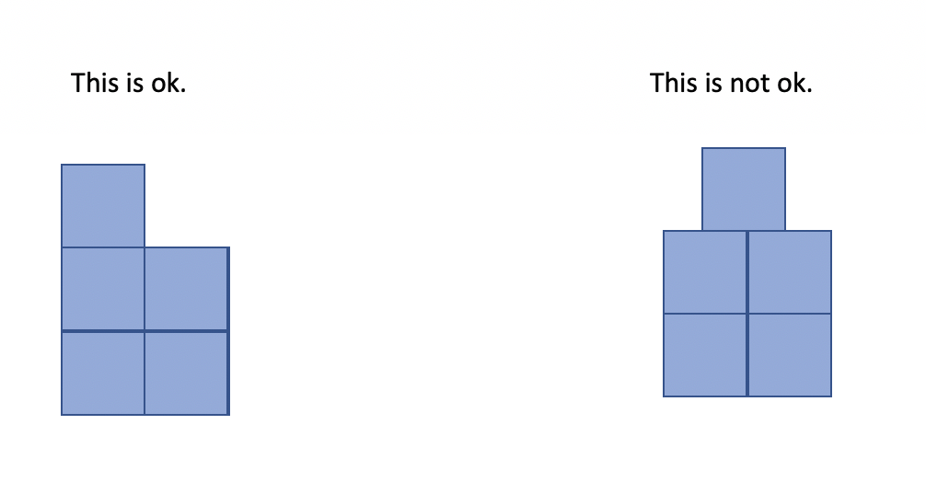
Record your thinking on this grid paper.

Race to zero
View video Race to zero
How to play?
Players place their counters at the end of 119. The person whose birthday is closest to February 29 goes first. Players take turns to spin both spinners and decide which to use, subtracting the amount from their current position. For example, a player rolled 60 and 4. He or she can choose to subtract 60 or 4. Players explain where they need to move their counter to and explain their thinking. If their partner agrees, they move the counter to the corresponding position. Players take turns until someone has been able to land exactly on zero. Students miss a turn if they cannot move. If a roll means they would move into negative numbers, they have to move their counter back to 25.
Another way to play:
- Use a 0-119-chart cut into a number strip as a game board

Play Race to zero!
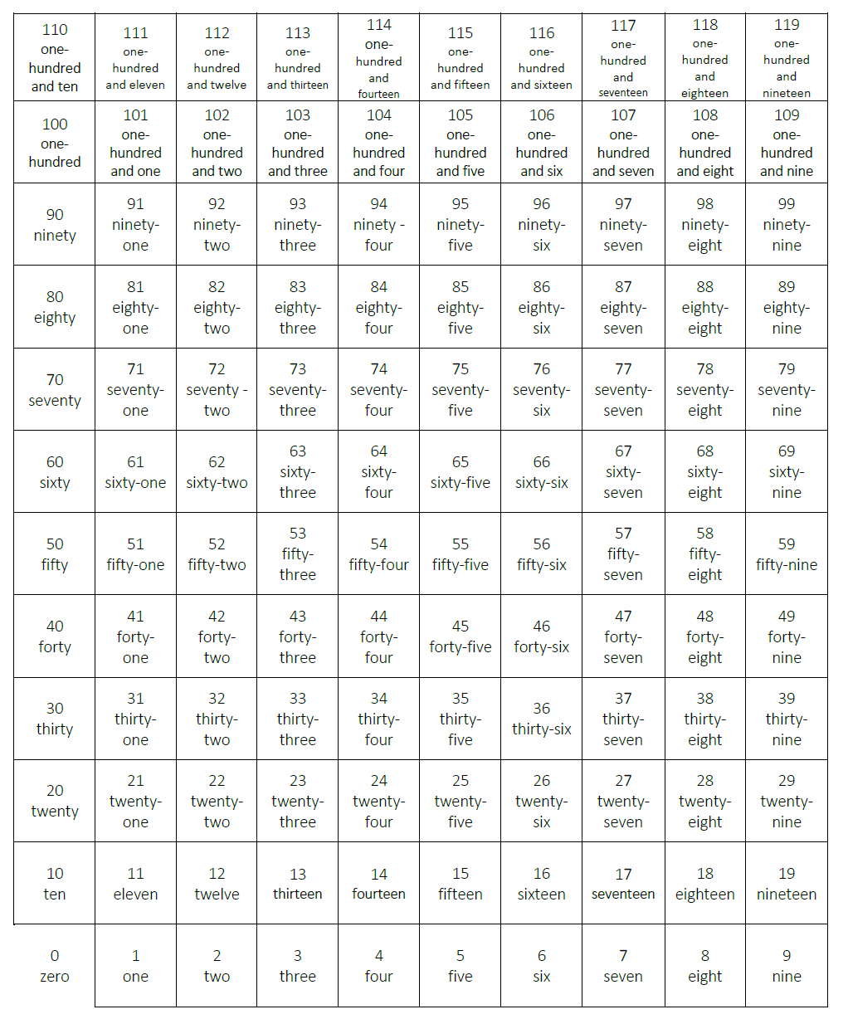

Reflection
You might have had a sweaty brain today looking at a strategy we could use to solve 230 – 190. Your brain might also have felt excited! Draw a picture to show what your brain was thinking as we investigated strategies for solving 230 – 190.

Day 3
Today we have 3 tasks. We are going to deeply consider one of the strategies we spoke about yesterday, explore the role of structure in helping us determine how many there are in a collection, and, keep puzzling with pentominoes!
Resources – device to view videos, scissors, colour pencils

Dot card talk 3
View video on Dot card talk 3 page.

Let’s investigate 1 – S1 and S2
View video on Let’s investigate 1 – S1 and S2 page.

How could you use this strategy to solve 73 - 29? Record your thinking in your student workbook.

Pentominoes 2
(Adapted from Pentominoes zoo)
What other shapes can you make by joining your pentominoes together? Show your thinking on the grid paper.
- Can you make a rectangle?
- Can you make more than one rectangle?
- Form a rectangle with the smallest possible perimeter.
- Form a rectangle with the largest possible perimeter.

Can you make some of these animals from Abaroth’s World? After making them, you may like to colour them in to match your pentominoes.
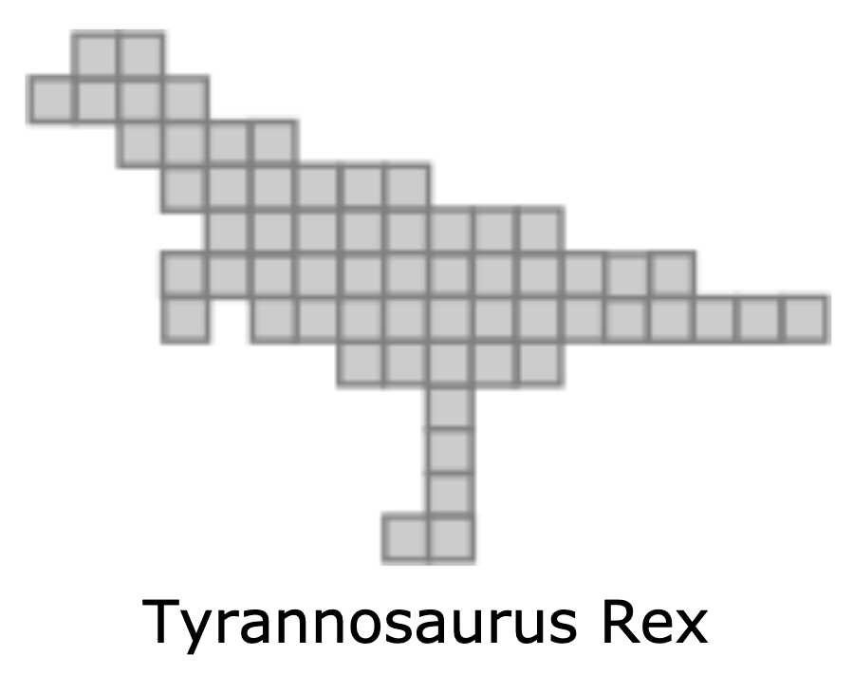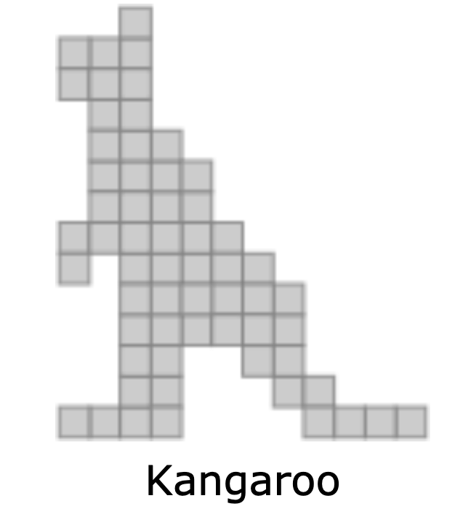
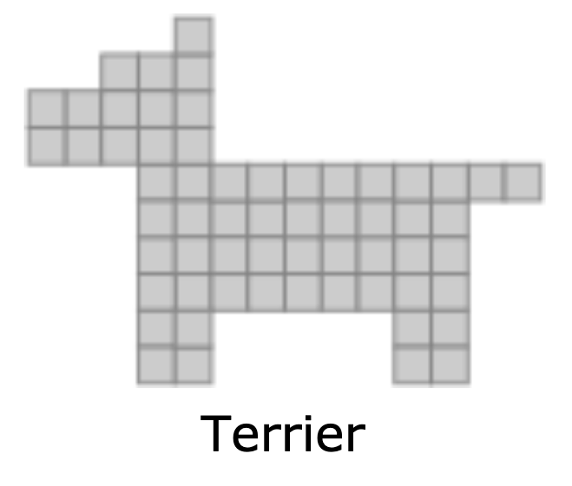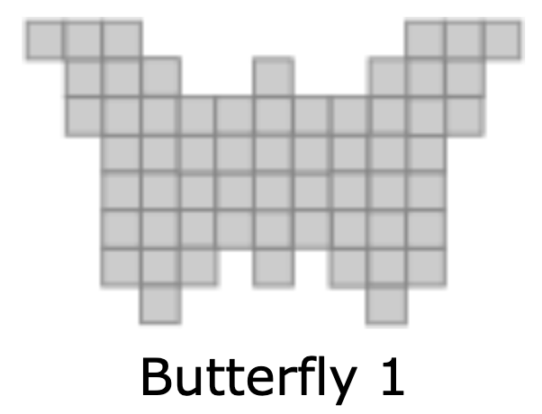
- If you need some clues take a peep in the appendix.
- Have a go at creating your own animal. What can you create?

Reflection
Draw a picture to show what your brain was thinking as we explored the strategy of ’constant difference’ today.

Write another problem where you might use this strategy to help you find a solution.

Day 4
Today we have 3 tasks. We are going to continue working on our mathematical reasoning as we explore similarities and differences between different mental computation strategies, and develop various mathematical arguments. We will also have some fun making origami cubes!
Resources – device to view videos, pencils, 6 paper squares

Which one doesn’t belong? 1
View video Which one doesn’t belong? 1.
What’s your initial thinking for which one doesn’t belong? Why?

Now, make a case for why each domino doesn’t belong.

Record any additional reasons why each domino doesn’t belong?

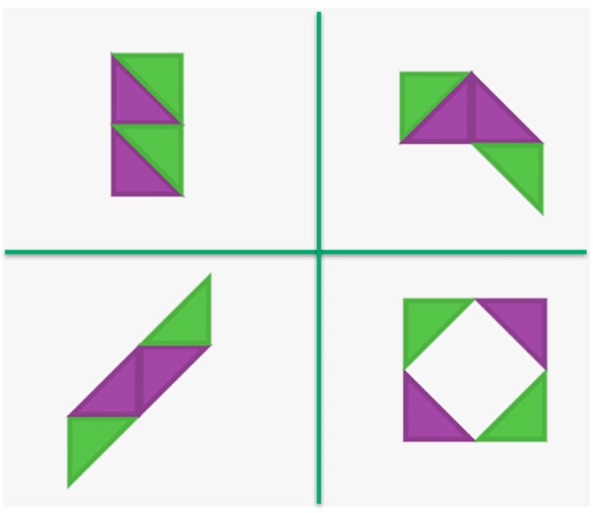
Collaborate with others to discuss and record, which one doesn’t belong using the image above. Challenge yourselves to come up with an argument for each image.

Let’s explore 1
View Let’s explore 1 video
Reflect on the strategies you used to solve 230 – 190 and identify the most efficient strategy you used.

How many steps did it take?

Do you think you could use the same strategy with other problems? Record your thinking.

Origami cube
View Origami cube video
Create 1 or 2 (or more if you like!) origami cubes.

Reflection
Talk about what you have discovered and learnt about today with someone at home.

Day 5
Today we have 3 tasks. We are going to continue working on our mathematical reasoning as we consider the different contexts where one strategy works...and when it doesn’t. We will also use our origami cubes to investigate some interesting things about nets!
Resources – pencils, device to view videos, pair of scissors, cube made on day 4, paper,

Let’s generalise 1
View the video Let’s generalise 1
What happens with addition? Can we use the same strategy we used with subtraction is the exact same way?
Use any numbers you feel comfortable working with to investigate this idea.
Record your thinking using pictures, as well as words and symbols.

Net exploration
View Net exploration video
Create the net in the video and then use your cube to explore and make the other 10 nets.

Watch Look Kool cubes episode
View episode Look Kool Series 1 cubes on ABC iview.

Reflection
Talk about what you have discovered and learnt about today with someone at home.

Day 6
Today we have 2 tasks. We are going to get creative thinking about numbers within numbers as well as explore a problem with cubes.
Resources – device to view videos, colour pencils, 5 cubes

youcubed number visuals
View– youcubed number visuals video
Explore the number visuals and record the different ways you see each number visual made up of other numbers.
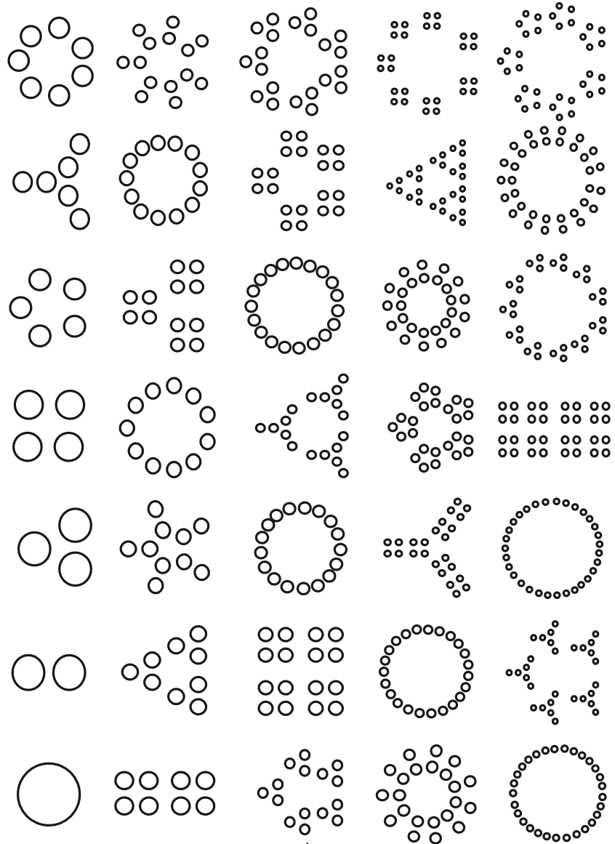
(from youcubed)

Brushloads
(from NRICH maths)
View video on Brushloads page.
Can you find ways of arranging 5 cubes so that:
- you need as few BLs (brushloads) as possible?
- you need as many BLs (brushloads) as possible?
Record your thinking.

Reflection
Draw a picture or write about 1 or 2 things that made your brain think hard today (that made your brain get sweaty).

Draw a picture or write about 1 or 2 things that you realised today about numbers or maths that you may never have really thought about before.

Day 7
Today we have 3 tasks. We are going to continue exploring different ways of representing (and thinking about) numbers as well as explore some big ideas around how something can look quite different and still share some important commonalities.
Resources – device to view videos, pencil, coloured pencils

Same...and different
(Using youcubed and mathforlove)
View video on Same...and different video page.
What do you notice?
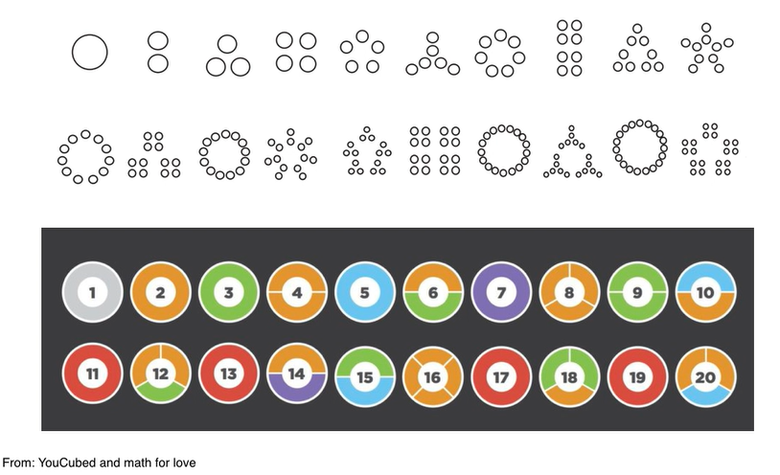What’s the same in these visual representations of the numbers 1- 20?

What’s different?

What are some things you find cool and/or curious?

Area vs perimeter
Area vs perimeter page
Remember our pentomino challenge from Day 3? We asked you to make some rectangles – one with the smallest possible perimeter and one with the largest possible perimeter. Looking at numbers in different ways has reminded us of this challenge! We’re realising that numbers can have the same value but look quite different. Look at these two rectangles:
Here’s one rectangle I could have made using all 12 pentomino pieces.
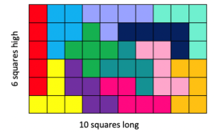
It forms a rectangle with boundaries of 6+10+6+10 making the perimeter 32 squares long. The area inside the rectangle is 60 squares.
Here’s a different rectangle I could have made using all 12 pentomino pieces.
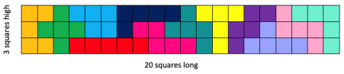
It forms a rectangle with boundaries of 3+20+3+20 making the perimeter 46 squares long. The area inside the rectangle is 60 squares.
They look pretty different...and they still have the same area!
View episode MathXplosion –area vs perimeter on ABC splash.
https://education.abc.net.au/home#!/media/2971335/area-vs-perimeter
What other rectangles can you make that have an area of 60 squares? You can use your pentomino pieces to help you, or some grid paper. Try to find 2 other rectangles and record their perimeter and area.

Let’s talk 2 – S2
View video on Lets talk 2 – S2 video page.
We found 3 different strategies we could use to solve the same problem… Can you think of another 2 strategies to solve the problem 5 nines (5×9)?

How could use any of the strategies shared in the video to solve 6 nines (6×9)?

Reflection
What 2 things made you think: ”Oh! that‘s cool/interesting!‘ today?

Day 8
Today we have 4 tasks. We are going to try to get inside other people’s thinking and play around with arrays and problems involving multiplicative thinking.
Resources – device to view videos, 0-9 dice or spinner (appendix) and 3 counters for each player (of the same colour), cut out youcubed math cards downloadable, scissors

Let’s investigate 2 S2
View Let’s investigate 2 S2 video
Use diagrams, drawings and/ or materials to represent how you might use these strategies to think about for 6 nines (6×9).

reSolve fruit shop – part 1
View reSolve fruit shop – part 1 video and pause it as the questions are asked. Use this space to record your mathematical thinking.
How are the mangoes and apples similar and different? 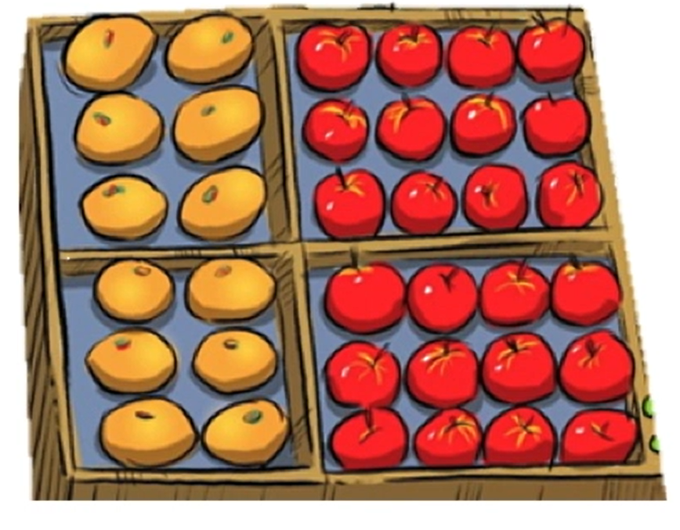

What else is can you add about something similar or different?

How are the two boxes of oranges similar and different?
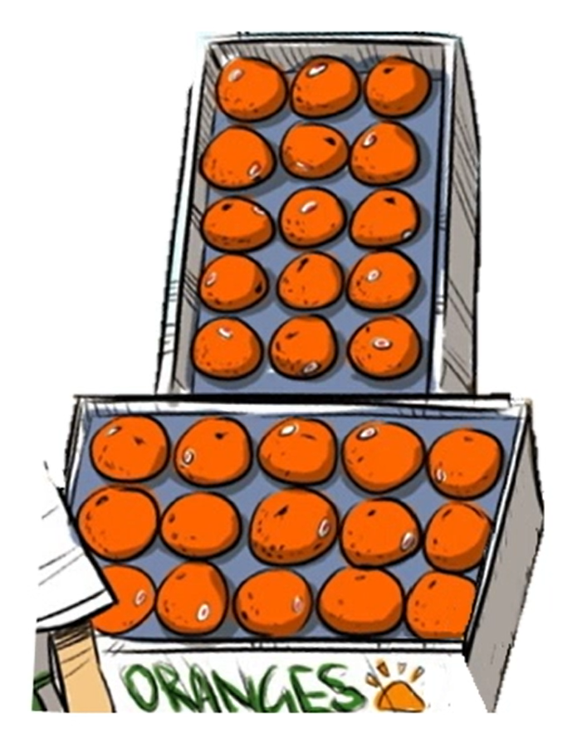
How else could you use what you know about the mangoes to help you work out the number of blueberry punnets?
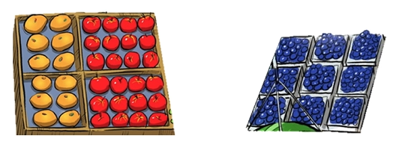

Can you use the number of apples to help you work out the number of peaches? Can you draw some diagrams for us, to share your amazing thinking?
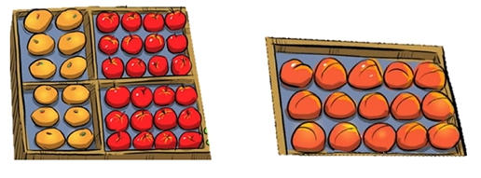

Can you make any other connections using any of the fruit?
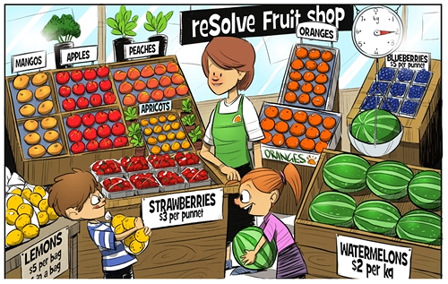

youcubed math cards
(from youcubed)
Visit youcubed math cards page
How to play?
You can play this game like Memory or Concentration. Using the youcubed math cards, you are aiming to match cards with the same value shown through different representations. Lay all the cards down on a table and then take turns to pick them up, looking for a match.
For example 9 fours can be shown with an area model, a set of objects such as dominoes, and the number sentence (equation) as well as the product, 36. When players match the cards they should explain how they know that the different cards are equivalent in value.
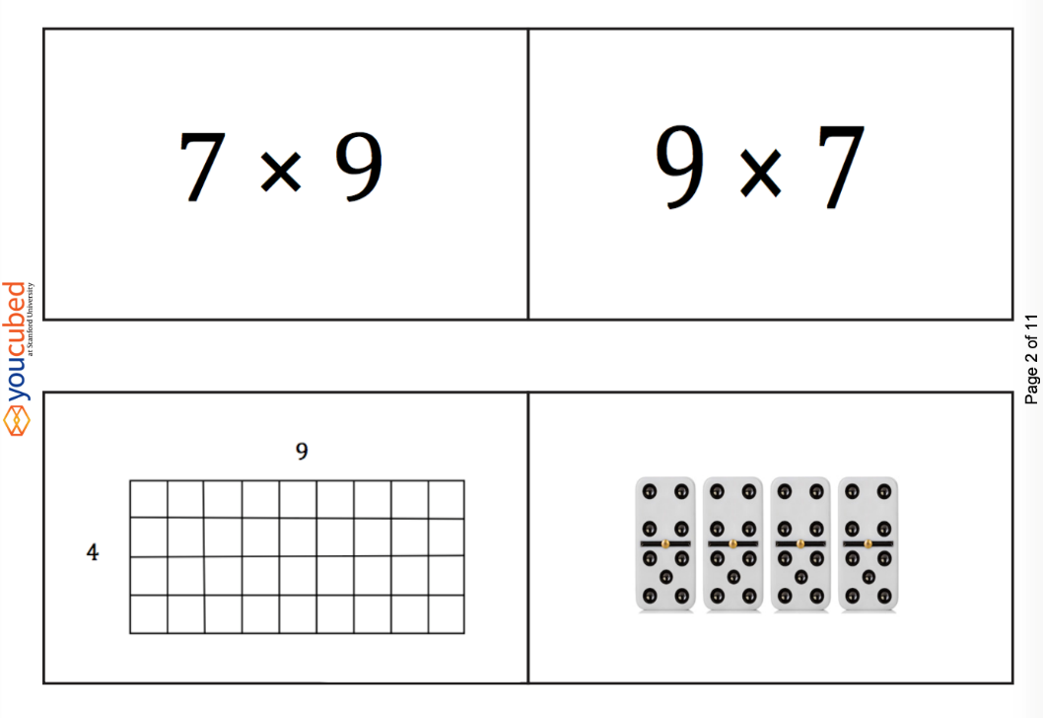
Play youcubed math cards. You can play this by yourself, with family members, friends or your classmates.
Explain how you knew that one set of different cards are equivalent in value.

Multiples madness: fives
How to play?
Multiple madness: fives video
Players take turns to roll the dice or spin the spinner and multiply the number selected (for example 6) by the number rolled and work out the product, explaining their thinking to their partner. The partner records their thinking and if they agree, the first player is able to place one of their counters on the number on the game board, claiming that place. If the number is taken, players miss a turn. A player wins by getting three counters in a row (in any orientation). Since players only have 3 counters, they will need to choose which counter to move once all 3 have been placed on the game board.
Other ways to play:
- play with 4 counters to win
- only allow 3 counters each
- play with a multiplication grid to check your partners answer, giving players an opportunity to have a second attempt if they answer incorrectly initially.
- Play multiple madness: twos, multiple madness: tens or make your own!
Play Multiples madness: fives

45 | 5 | 10 | 15 | 40
25 | 5 | 40 | 35 | 15
20 | 25 | 0 | 20 | 25
10 | 30 | 35 | 45 | 5
0 | 20 | 15 | 30 | 10
Recording sheet fives
Player 1 |  |  |  |  | Player 2
Rolled | Number sentence | Covered |  | Rolled | Number sentence | Covered

Reflection
Imagine yourself feeling good about mathematics. Draw a picture to show what you‘re doing when you feel good about mathematics.

Day 9
Today we have 3 tasks. We are going to warm up our brain with a task from Math for Love, continue our problem with the ReSolve fruit shop and return to a maths game and give it a new twist.
Resources – device to view videos

Broken calculator
View Broken calculator video.
(Adapted from mathforlove)
What are some other ways we can get to a total of 33 on this broken calculator?
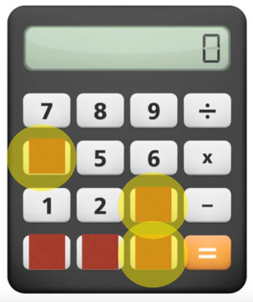

Write some of your own challenges for your family, classmates or teachers!

reSolve fruit shop – part 2
View reSolve fruit shop – part 2 video
There are four bags of lemons. The owner of the fruit shop wants to take the lemons out of the bags and arrange them in a box like the oranges, apples, peaches, apricots and mangos. She wants more than one lemon in each row and column.
How could the owner arrange all the lemons in an array? Can you find more than one way?
Draw pictures of the arrays so the owner can make some decisions about which one she likes.

Dicey addition
(Adapted from NRICH maths)
View Dicey addition video
Play Dicey addition again – but this time, create a game board using multiplication or division.

Reflection
Draw a picture or write about 1 or 2 things that made your brain think hard today (that made your brain get sweaty).

Day 10
Today we have 1 task. You will use your number knowledge and skills and knowledge in reasoning and multiplication and division! Have fun playing!
Resources – device to view videos, 0-9 spinner (appendix), colour pencils or markers, paperclip, pen

Multiplication toss
(From Dianne Siemon, RMIT University)
Video on multiplication toss page.
How to play?
You can play this by yourself or players take turns to spin the spinners. If a 3 and 6 are spun, players can enclose either block out 3 rows of 6 (3 sixes) or 6 rows of 3 (6 threes). The game continues with no overlapping areas. The winner is the player with the largest area blocked out after 10 spins. Eventually the space on the grid paper gets really small.
Then, you have to think:
What if my 3 sixes won’t fit as 3 sixes or as 6 threes?
Players can partition to help them! So, for example, I can rename 3 sixes as 2 sixes and 1 six (if that helps me fit the block into my game board).
Play multiplication toss.
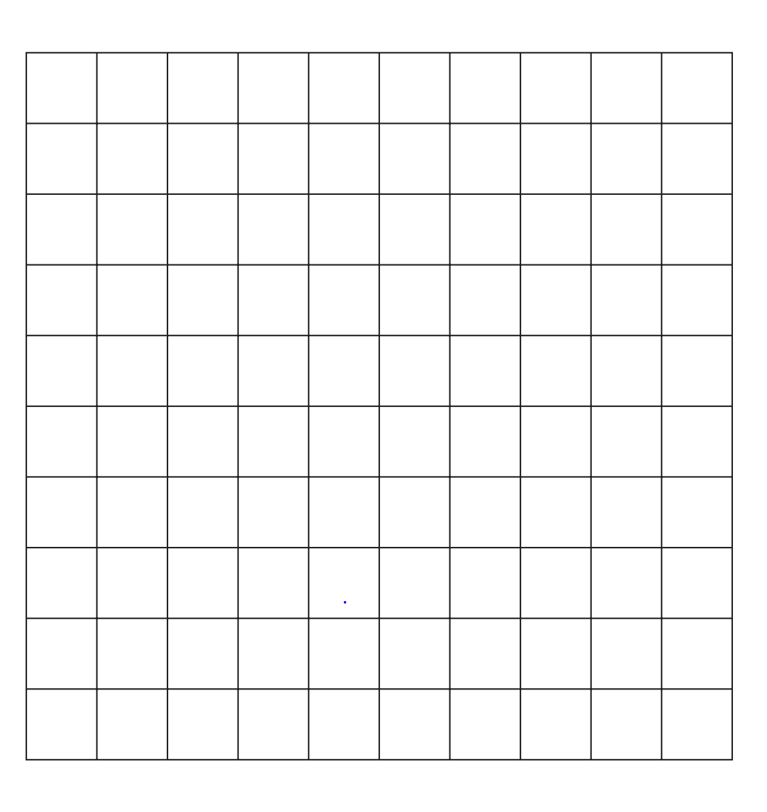

Reflection
Use the ThinkBoard to represent a problem that leaves you with none.
Story

Drawing

Concrete materials

Symbols

Spinners for day 1 race to zero
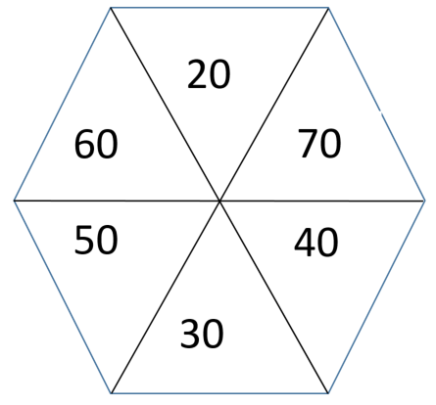
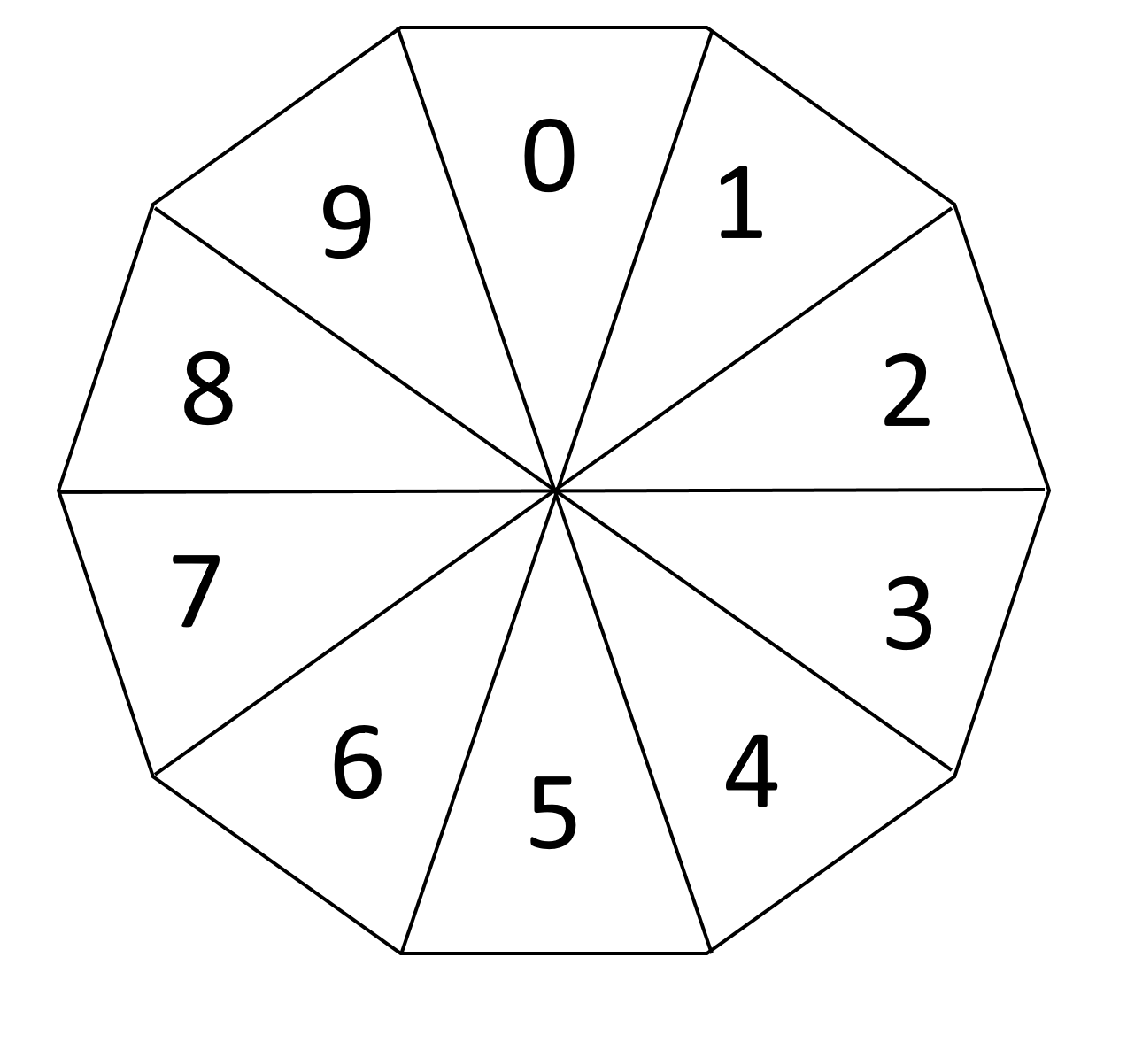

Day 3 pentominoes 2
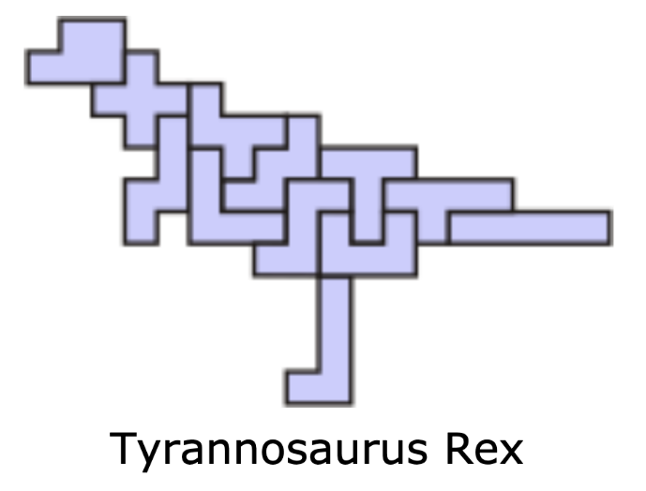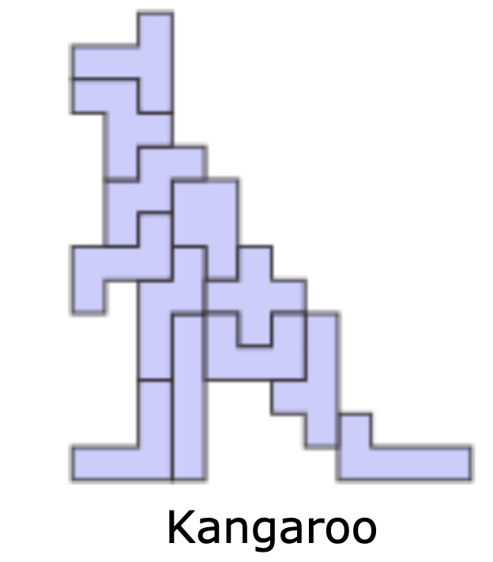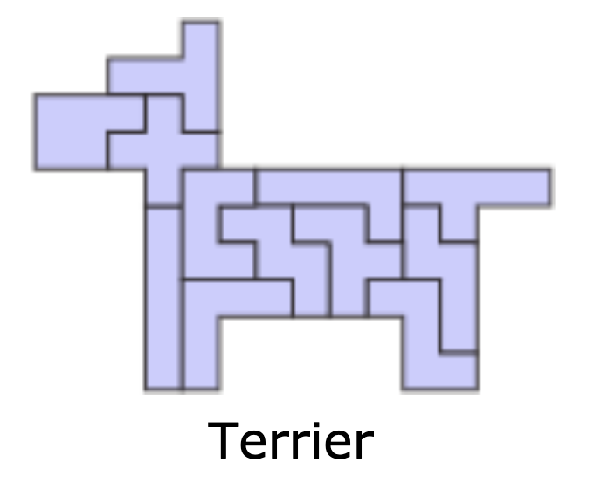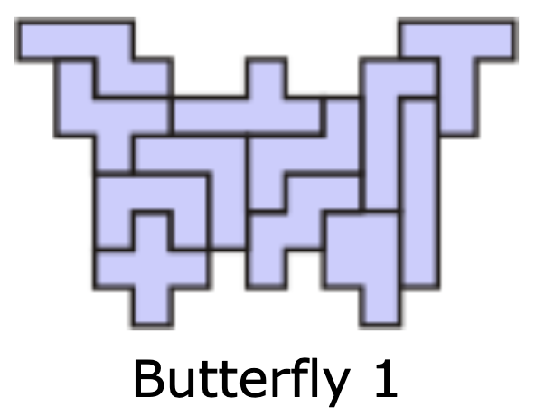

Spinner for day 10 multipliation toss

