How can I use tactics to be successful in games? – Early Stage 1
PDHPE unit.

Table of contents

Big idea and key concept 3
Essential question 3
Unit description 3
Contextual statement 3
Propositions in action 4
Focus on educative purpose 4
Take a strengths-based approach 4
Value movement 4
Skills in focus 5
Lesson 1 – Tactical use of movement 6
Key inquiry questions and syllabus content 6
Teaching and learning activities 7
Activity 1 – Ten times (fast start) 7
Activity 2 – Cross the ocean 8
Lesson 2 – Tactical use of movement 11
Key inquiry questions and syllabus content 11
Teaching and learning activities 13
Activity 1 – Ten times (fast start) 13
Activity 2 – Zebra hunt 14
Activity 3 – Zebra hunt (variation 1) 15
Activity 4 – Zebra hunt (variation 2) 16
Lesson 3 – Maintaining possession 17
Key inquiry questions and syllabus content 17
Teaching and learning activities 18
Activity 1 – Magnets (fast start) 19
Activity 2 – Cross the ocean 19
Activity 3 – Cross the ocean (variation 1) 20
Activity 4 – Cross the ocean (variation 2) 20
Activity 5 – Bumper cars 21
Lesson 4 – Tactical use of space and position 22
Key inquiry questions and syllabus content 23
Teaching and learning activities 24
Activity 1 – Magnets (fast start) 24
Activity 2 – Hungry birds 25
Activity 3 – Hungry birds (variation) 28
Lesson 5 – Tactical use of time 30
Key inquiry questions and syllabus content 30
Teaching and learning activities 31
Activity 1 - Tap and run (fast start) 32
Activity 2 – Magpie in the middle 33
Activity 3 – Timing challenges 35
Activity 4 – Timing challenges/team relays 36
Lesson 6 – Tactical use of time 38
Key inquiry questions and syllabus content 38
Teaching and learning activities 39
Activity 1 – Tap and run (fast start) 39
Activity 2 – Magpie in the middle 40
Activity 3 – Ready or not? 40
Activity 4 – Class challenge 41
Lesson 7 – Tactical use of equipment 43
Key inquiry questions and syllabus content 43
Teaching and learning activities 44
Activity 1 – Stork tag (fast start) 44
Activity 2 – Over and under ball 45
Activity 3 – Over and under ball (variation) 46
Lesson 8 – Adjusting tactics for specific equipment 47
Key inquiry questions and syllabus content 47
Teaching and learning activities 48
Activity 1-Stork tag 49
Activity 2 – Scoop tag 49
Activity 3 – Scoop tag (variation) 51
Lesson 9 – Adjusting tactics in response to new rules 52
Key inquiry questions and syllabus content 52
Teaching and learning activities 53
Activity 1 – Corners (fast start) 55
Activity 2 – Zebra hunt (variation 3) 55
Activity 3 – Zebra hunt (variation 4) 56
Lesson 10 – Adjusting tactics in response to new rules 57
Key inquiry questions and syllabus content 57
Evaluation 59
Glossary 60
Appendix 1 – Self assessment 61
Appendix 2 – Rule changes 62
Appendix 3 – Images to support key terms 63
Appendix 4 – Physical literacy continuum cluster markers 78
Movement competencies 78
Tactical movement 78
Motivation and behavioural skills 78
Personal and social attributes 78

Outcomes and other syllabus material in this document are copyright.
PDHPE K-10 Syllabus © NSW Education Standards Authority (NESA) for and on behalf of the Crown in right of the State of New South Wales 2018.

Big idea and key concept
The big idea is the over-arching concept that is being addressed or challenges throughout the unit.
Tactical application of movement concepts influences success in a game. Spatial awareness, relationships with people, objects and space.

Essential question
This question drives both teaching and learning within the unit. Every activity should be working towards answering this question:
How can I use tactics to be successful in games?

Unit description
Students test, apply and combine various tactics incorporating movement, space, time, equipment and rules to improve their chance of success in territory games. They use movement skills to solve games-based problems. For example, they may apply various movement skills to a game situation and evaluate which skill increased their chances of success.
The unit of learning may be more suitable for delivery later in the school year when class routines and expectations are well established.

Contextual statement
Developing an understanding of tactics will support students to make decisions in more dynamic game-based movement environments. It will also allow students to apply movement skills and sequences in a more effective way.
Improving their ability to select, apply and modify tactical decisions will increase students’ chances of success in games. Achieving regular success contributes positively to student’s lifelong participation in physical activity.

Propositions in action
This describes how specific propositions are embedded throughout the unit of work. The 5 propositions are outlined on pages 24-25 of the PDHPE K-10 syllabus.

Focus on educative purpose
Students develop their knowledge, understanding and skills of how to select and apply appropriate tactics/strategies to be successful in game play. They start to understand how movement, space, time, equipment choice and rule changes impact their tactical decision-making.

Take a strengths-based approach
Students will be encouraged to draw upon their own strengths and capabilities to further strengthen their knowledge, skills and understandings while they explore how to effectively select and apply various tactics in game play.

Value movement
Students participate in a wide range of movement experiences to develop skills across all 3 domains and understand how these skills can transfer to different contexts.
Activities are modified to meet student needs and interests through engaging tactical game play.
Students explore tactics and strategies to learn what can influence their level of success in game play.

Skills in focus
What specific skills are being learned, developed and applied throughout this unit of work? Refer to pages 27-30 of the PDHPE K-10 syllabus.
Self-management skills (S)
- Self-awareness
  - reflective practice
- Decision making and problem solving
  - finding solutions to problems
  - analysis.
Interpersonal skills (I)
- Communication
  - giving and receiving feedback
- Collaboration, inclusion and relationship-building
  - recognising and using their own abilities and strengths and those of others.
Movement skills (M)
- Fundamental and specialised movement skills and concepts
  - non-locomotor skills (body control, body positioning, spatial awareness, direction, force, precision)
  - locomotor skills (travel, rhythm, body control, coordination, safe landing, agility, direction, object locomotion).
- Tactical and creative movement
  - selecting, applying, transferring, adapting and evaluating movement skills
  - applying movement concepts, rules, strategies and tactics
  - assessing rules, strategies and tactics and how they influence movement and performance when applied across different movement contexts.
- Health and fitness enhancing movement
  - managing risk and promoting safety.

Lesson 1 – Tactical use of movement
Lesson 1 – Assessment framework
Outcomes | Unit learning goals  Students are learning to | Evidence of learning  Students can
PDe-4 practises and demonstrates movement skills and sequences using different body part. | Trial and practise a number of locomotor skills in game play. | Move at different speeds and in different directions within the playing area (activity 2).
PDe-5 explores possible solutions to movement challenges through participation in a range of activities | - Explore and trial different tactics during game play.  - Reflects on previous performances to identify factors that can contribute to future success. | - Identify and demonstrate appropriate locomotor movements as required in the game to improve the chances of success (activity 1, 2).  - Identify how and when to move safely in open space (activity 1, 2).
PDe-11 demonstrates how the body moves in relation to place, time, objects, effort and people. | Perform locomotor skills in any direction. | - Move in general space in a controlled manner to avoid contact with people and objects (activity 2).  - Move at different speeds inside the playing area in response to instructions or stimulus (activity 2).  - Move towards an end point, target or goal – invasion games (activity 2).

Key inquiry questions and syllabus content
How do we move our bodies?
Identify and describe how their body moves in relation to space, time, objects, effort and people, for example:
- Move at different speeds, different levels and in different directions with others in a designated area.

Demonstrate a variety of movement skills and movement sequences, for example:
- Perform locomotor skills in any direction from one point to another, such as walking, running, galloping hopping, jumping, skipping, rocking, side rolls, swinging, turning, sliding, leaping, following a line.
How can we solve problems when moving?
Test possible solutions to movement challenges through trial and error, for example:
- Identify options and make positive choices when faced with a decision about how they participate in a movement activity.
- Trial a number of techniques when trying new movement activities for example, position, focus, direction.

Teaching and learning activities

Activity 1 – Ten times (fast start)
Equipment
- markers for playing area
- bibs/braids (optional).
Vocabulary:
- tactic, movement, success, tag.
How to play
Position students in their own space within a designated area.
Students follow simple directions such as jump 10 times, hop 10 times – change legs, jog on the spot, march on the spot swinging your arms, walking with high knee lift, sprint on the spot.
Variations
- students take turns to communicate/call out the actions
- change the speed of each movement.

Discussion
Explore the following questions:
- When playing a game of tag which form of movement would you use? What makes you say that?
- When could you use hopping? What makes you say that?
Teacher notes
Explain to students that when participating in games people need to make decisions in order to be successful. For example, where to run, how to move, speed of movement, when to pass, who to pass to, how hard to pass. These decisions are called tactics.
Discussion
Explain to students that when participating in games people need to make decisions in order to be successful. For example, where to run, how to move, speed of movement, when to pass, who to pass to, how hard to pass. These decisions are called tactics.
Explore the following question:
- What do you think success looks like when playing a game?
Students may suggest it means winning or getting the ‘best result’. This may form part of being successful. Emphasise with students that success can also mean improving their ability to perform a movement skill, increasing their knowledge, increasing their confidence, learning to communicate more effectively with others, improving their decision-making to solve a movement challenge.

Activity 2 – Cross the ocean
Teacher notes
For safety reasons it is recommended that no more than 10 players (1 shark and 9 fish, 2 sharks and 8 fish) are in the same game. Divide the class to provide separate games side-by-side. Depending on class size, this may be 2-3 games. For example, a class of 30 students would have 3 games side-by-side.
The focus for students in this game is to understand that selecting an effective movement style can influence performance/success.
How to play
The playing area for 10 students should be approximately 10 metres x 10 metres although can be adjusted accordingly to match the student skill level and available facilities.
Designate one student as the ‘shark’ and stand them in the centre of the play area. The other students are the fish and line up along one end of the area. The fish call out in unison, Shark, shark, may we cross your ocean?
The fish attempt to reach the far side of the play area, trying to avoid being ‘eaten’ (tagged) by the shark. If a fish is tagged, they then become a second shark and works with the first shark to tag other fish. The game is over when there’s only one fish left.
Alternatively, the class may participate in groups of 10 within the game. Each group of fish run at a different time. If a fish is tagged, the sharks score a point. The fish don’t become a shark. Students rotate to have turns.
Repeat the game with students using a different locomotor movement. For example, students use hop instead of run. Repeat the game and allow the shark to run but the fish are to hop.
Discussion
Explore the following questions at the end of the game:
- Which was the most effective way to move?
  - For example, running or hopping? What makes you say that? Sample student answers may include, running because I could move faster to the other end so the shark could not tag me.
- When the fish ‘swam’ moved across the ocean where did you ‘swim’ (move)?
  - Towards the shark or away from the shark? Sample student answers may include, away from the shark because there was space for me to move quickly.
  - With other fish or by yourself? Sample student answers may include, with other fish so the shark would get them first. By myself so other fish did not get in my way.
  - How could you prevent other ‘fish’ from getting in your way? Sample student answers may include, move towards the empty spaces, line up away from them at the start line.
Repeat the game twice allowing students to select their movement style.
- Game 1 – choose between the two movements identified that enables participation of all students. For example, skipping or walking, crawling or rolling.
- Game 2 – choose between the two movements identified that enables participation of all students. For example, two-foot jumps or hopping, walking or side-stepping.
Teacher notes
Ensure students use the movement of choice for the entire game, whether they are a shark or fish.
Discussion
Explore the question:
- Which movement style was most effective? What makes you say that?
Reflection
Students reflect upon the learning in this activity/lesson and consider how it contributes towards answering the essential question, ‘How can I use tactics to be successful in games?’

Lesson 2 – Tactical use of movement
Lesson 2 – Assessment framework
Outcomes | Unit learning goals  Students are learning to | Evidence of learning  Students can
PDe-4 practises and demonstrates movement skills and sequences using different body part. | Trial and practise a number of locomotor skills in game play. | Move at different speeds and in different directions within the playing area (activity 2, 3, 4).
PDe-5 explores possible solutions to movement challenges through participation in a range of activities. | - Explore and trial different tactics during game play.  - Reflects on previous performances to identify factors that can contribute to future success. | - Identify and demonstrate appropriate locomotor movements as required in the game to improve the chances of success (activity 1, 2, 3, 4).  - Identify how and when to move safely in open space (activity 1, 2, 3).
PDe-11 demonstrates how the body moves in relation to place, time, objects, effort and people. | Perform locomotor skills in any direction from one point to another, for example:  - Walking, running, galloping, hopping, jumping, skipping, side rolls, swinging, turning, sliding, leaping, following a line. | - Move in general space in a controlled manner to avoid contact with people and objects (activity 2, 3, 4).  - Move at different speeds inside the playing area in response to instructions or stimulus (activity 2, 3, 4).  - Move towards an end point, target or goal – invasion games (activity 2, 3, 4).

Key inquiry questions and syllabus content
How can we move our bodies?
Identify and describe how their body moves in relation to space, time, objects, effort and people, for example:
- Move at different speeds, different levels and in different directions with others in a designated area.
Demonstrate a variety of movement skills and movement sequences, for example:
- Perform locomotor skills in any direction from one point to another for example, walking, running, galloping hopping, jumping, skipping, rocking, side rolls, swinging, turning, sliding, leaping, following a line.
How can we solve problems when moving?
Test possible solutions to movement challenges through trial and error, for example:
- Identify options and make positive choices when faced with a decision about how they participate in a movement activity.
- Trial a number of techniques when trying new movement activities, for example, position, focus, direction.
- Attempt different ways to solve a movement challenge and discuss which ways were successful or not, for example, use signals, cooperation, modify rules, change formations.
How do we participate with others when we are active?
Collaborate with others and follow rules when participating in physical activities, for example:
- Identify boundaries, for example, personal space and playing area.
What choices can help make me safe, supported and active?
Perform new movement tasks and make positive choices when faced with decisions about how they participate in physical activities, for example:
- Participate in games and physical activities that require awareness of personal safety and boundaries for example, individual and team physical activities and games.

Teaching and learning activities
Equipment
- markers
- one bean bag per student.
Resources
- How do lions hunt – 4:19 min
- Appendix 1 – Self-assessment.
Vocabulary
- tactic, movement, sneaking, tag, capture.
Teacher notes
Prior to this lesson, students may watch part of the video (optional) to understand that changing the speed of our movements can increase our chances of success in the game. For example, sometimes moving slowly is a better tactic than running quickly.

Activity 1 – Ten times (fast start)
Play ‘Ten times (fast start)’ with instructions from lesson 1, activity 1.
Discussion
Different sample questions are provided below to explore how knowledge, understanding and skills have developed further.
- Which movement was the easiest for you? What makes you say that?
- Which movement was the hardest for you? What makes you say that?
- Which movement was your favourite? What makes you say that?
- When playing ‘Cross the ocean’, what movement was most effective to use? Sample student answers may include, running as fast as you can to improve your chance of not being tagged by the shark. What makes you say that?
- Is running as fast as you can always the best tactic in games?

Teacher notes
In this lesson students continue to build upon their tactical knowledge. It allows students to select between various movements in order to find which one tactically, is the best to use to achieve success in a game situation.
Explore the following questions:
- When playing ‘Cross the ocean’ (lesson 1 – activity 2), what movement was most effective to use? Sample student answers may include, running as fast as you can to improve your chance of not being tagged by the shark. What makes you say that?
- Is running as fast as you can always the best tactic in games?
The focus of the video, How do lions hunt – 4:19, is to understand that changing the speed of our movements can increase our chances of success in the game. For example, sometimes moving slowly is a better tactic than running quickly. The beginning stages of this lesson involves watching a video.
After watching the video ‘How do lions hunt’, explore the following questions:
- How does the lion move? Sample student answers may include, the lion is moving slowly and stopping often, she is creeping, she isn’t moving in a straight line, she is moving quietly, she always has her eye on the target.
- Why does she move slowly and stop often instead of just running as fast as she can? Sample student answers may include, she is trying sneak up close to another animal without being noticed.
- What decision/s is the lion making? Sample student answers may include, she is deciding where to run, how fast to run and when to run so other animals cannot see her.
In activity 2, remind students to reflect on the lion’s movements and tactics from the clip and think about how they could use similar movements.

Activity 2 – Zebra hunt
How to play
One student, the ‘zebra’, stands with their back to the group. Beanbags are lined up parallel on the ground behind the zebra. Include 1 beanbag per lion.
The lions (the other students) sneak up on the zebra from a starting point 15 metres away approximately, (this distance may be changed to meet the skill level of students).
The zebra turns around at random intervals to try and catch the lions moving. The lions try to sneak up without being seen to move. If seen moving, the zebra calls their name and they return to the starting position.
Teacher notes
To maintain a safe learning environment, it may be suitable to divide the class into two games, 9 lions 1 zebra approximately.
Discussion
Ask students to describe their tactics. What worked? What didn’t?
Sample student answers may include, sneaking up on their tip toes means the zebra may not hear the lion, whereas jumping will create noise for the zebra to hear.
Variations
- Vary the distance for lions to run once they have collected the bean bag.
- Movement styles (once the beanbag is captured the lions have to hop and the zebra can run or vice versa).
- Time limit (for example, lions have 1 minute to capture the beanbag).
- More than one zebra.

Activity 3 – Zebra hunt (variation 1)
Repeat the game ‘Zebra hunt’ (lesson 2 – activity 2) with a new zebra and all lions must sprint to capture the beanbag instead of sneaking. Once the beanbag is captured all lions must walk when returning to the starting position.
Discussion
Explore the following question:
- Which tactic worked best for the lion? Sneaking up to the zebra and then running away with the beanbag or sprinting up to the zebra and then walking away with the beanbag? What makes you say that?
Teacher notes
This second game is designed to be extremely difficult for the lions, allowing students to clearly distinguish which movements/tactics help them to be successful and when to use them.

Activity 4 – Zebra hunt (variation 2)
Repeat the original game of ‘Zebra hunt’ (lesson 2 – activity 2), allowing students to select their own movement style that suits their strengths and the size of the playing field.
Reflection
Students reflect upon the learning in this activity/lesson and consider how it contributes towards answering the essential question, how can I use tactics to be successful in games? by completing the self-assessment on ‘Appendix 1’. Alternatively, the self-assessment in ‘Appendix 1’ may be adapted using one or more of the assessment tools available by means of the Digital Learning Selector.

Lesson 3 – Maintaining possession
Lesson 3 – Assessment framework
Outcomes | Unit learning goals  Students are learning to | Evidence of learning  Students can
PDe-4 practises and demonstrates movement skills and sequences using different body part. | Trial and practise a number of locomotor skills in game play. | Move at different speeds and in different directions within the playing area (activity 1, 2, 3, 4).
PDe-5 explores possible solutions to movement challenges through participation in a range of activities. | - Explore and trial different tactics during game play.  - Reflects on previous performances to identify factors that can contribute to future success. | - Identify and demonstrate appropriate locomotor movements as required in the game to improve the chances of success (activity 1, 2, 3, 4).  - Identify how and when to move safely in open space (activity 1, 2, 3, 4).
PDe-11 demonstrates how the body moves in relation to place, time, objects, effort and people. | Perform locomotor skills in any direction. | - Move in general space in a controlled manner to avoid contact with people and objects (activity 1, 2, 3, 4).  - Move at different speeds inside the playing area in response to instructions or stimulus (activity 2, 3, 4).  - Move towards an end point, target or goal – invasion games (activity 2, 3, 4).

Key inquiry questions and syllabus content
How can we move our bodies?
Identify and describe how their body moves in relation to space, time, objects, effort and people, for example:
- Move at different speeds, different levels and in different directions with others in a designated area.
Demonstrate a variety of movement skills and movement sequences, for example:
- Perform locomotor skills in any direction from one point to another, such as walking, running, galloping hopping, jumping, skipping, rocking, side rolls, swinging, turning, sliding, leaping, following a line.
How can we solve problems when moving?
Test possible solutions to movement challenges through trial and error, for example:
- Identify options and make positive choices when faced with a decision about how they participate in a movement activity.
- Trial a number of techniques when trying new movement activities, for example, position, focus, direction.
- Attempt different ways to solve a movement challenge and discuss which ways were successful or not, for example, use signals, cooperation, modify rules, change formations.
What choices can help make me safe, supported and active?
Perform new movement tasks and make positive choices when faced with decisions about how they participate in physical activities, for example:
- participate in games and physical activities that require awareness of personal safety and boundaries for example, individual and team physical activities and games.

Teaching and learning activities
Equipment
- markers
- hoops (1 per student).
Resources
- Appendix 1
Vocabulary
- tactic, locomotor movement, success, catch, space.

Activity 1 – Magnets (fast start)
Students perform a locomotor skill to move around a designated playing area, avoiding contact with other students. As a number is called out, students form groups of that size, for example, three.
Variations
- Students move to music. When the music stops a number is called and students form groups.
- Vary the locomotor movement used, for example, hop, skip, jump, side gallop, and/or leap.
Discussion
- When performing the different movements in the game how did you avoid bumping into other students?
- Where did you look when performing the movements to avoid other students?
Ask students what tactics they used to be successful in lesson 2. Sample student answers may include, movement (running slowly, sneaking). Explain that using space in different ways is an effective tactic to achieve success in games.

Activity 2 – Cross the ocean
Designate three students to be sharks. They stand in the field of play.
Teacher notes
For safety, it is recommended that no more than 10 players (3 sharks and 7 fish) run at any one time. Divide the class to provide separate games side-by-side. Depending on class size, this may be 2-3 games. For example, a class of 30 students would have 3 games side-by-side.
Alternatively, the class may participate in groups of 10 within the game. Each group of fish run at a different time. If a fish is tagged, the sharks score a point. The fish don’t become a shark. Students rotate to have turns as a shark.
Before play ask students:
- How will starting with 3 sharks affect the playing space? Sample student answers may include, there are more sharks so less space for the fish to run in, more likely for the fish to be caught.
- Where are you going to try and run?
Play the game ‘Cross the ocean’ with 3 sharks and 7 fish.

Activity 3 – Cross the ocean (variation 1)
Repeat the game ‘Cross the ocean’ with a smaller playing area than the previous lesson.
Before play ask students:
- How does a smaller playing area effect your chances of success? Sample student answers may include, there is less space so it will be more difficult to pass the sharks and succeed.
- Where are you going to run now there is less space?

Activity 4 – Cross the ocean (variation 2)
Repeat the game ‘Cross the ocean’ with an enlarged playing field.
Before play ask students:
- How does a larger playing area effect your chances of success? Sample student answers may include, there is more space so it will be easier to pass the sharks and succeed.
- Where are you going to run now there is more space?
Discussion
Explore the following questions:
- How did you change your tactics depending on the space available?
- How did the amount of space change:
  - where you ran?
  - how you ran?
- If we reduced the number of sharks in the playing area how would this effect the fish? Sample student answers may include, the playing area would have more space for the fish to run in giving a better chance of success.
- If we increased the number of sharks in the playing area how would this effect the fish? Sample student answers may include, when there are more sharks the playing area would have less space for the fish making them easier to catch.

Activity 5 – Bumper cars
Each student spreads out within the space with a hoop held at waist level. Explain that this is their ‘personal space car’ and they should not touch any other student’s car.
Students move freely in the space provided and travel in a variety of ways (for example, skip, run, walk, leap, hop and/or two-foot jump) and in different directions in response to teacher instructions. Call out directions such as stop, go, balance on one foot, stand up and sit down.
Reflection
Students reflect upon the learning in this activity/lesson and consider how it contributes towards answering the essential question How can I use tactics to be successful in games?

Lesson 4 – Tactical use of space and position
Lesson 4 – Assessment framework
Outcomes | Unit learning goals  Students are learning to | Evidence of learning  Students can
PDe-4 practises and demonstrates movement skills and sequences using different body part. | Trial and practise a number of locomotor skills in game play. | Move at different speeds and in different directions within the playing area (activity 1, 2, 3, 4).
PDe-5 explores possible solutions to movement challenges through participation in a range of activities. | - Explore and trial different tactics during game play.  - Reflects on previous performances to identify factors that can contribute to future success. | - Identify and demonstrate appropriate locomotor movements as required in the game to improve the chances of success (activity 1, 2, 3).  - Identify how and when to move safely in open space (activity 1, 2, 3).  - Identify how and when to move safely in open space (activity 1, 2, 3).
PDe-11 demonstrates how the body moves in relation to place, time, objects, effort and people. | Perform locomotor skills in any direction from one point to another, for example:  - Walking, running, galloping, hopping, jumping, skipping, side rolls, swinging, turning, sliding, leaping, following a line. | - Move in general space in a controlled manner to avoid contact with people and objects (activity 1, 2, 3, 4).  - Move at different speeds inside the playing area in response to instructions or stimulus (activity 2, 3).  - Move towards an end point, target or goal – invasion games (activity 2, 3).

Key inquiry questions and syllabus content
How can we move our bodies?
Identify and describe how their body moves in relation to space, time, objects, effort and people, for example:
- Move at different speeds, different levels and in different directions with others in a designated area.
Demonstrate a variety of movement skills and movement sequences, for example:
- Perform locomotor skills in any direction from one point to another, such as walking, running, galloping hopping, jumping, skipping, rocking, side rolls, swinging, turning, sliding, leaping, following a line.
How can we solve problems when moving?
Test possible solutions to movement challenges through trial and error, for example:
- Identify options and make positive choices when faced with a decision about how they participate in a movement activity.
- Trial a number of techniques when trying new movement activities, such as position, focus, direction.
- Attempt different ways to solve a movement challenge and discuss which ways were successful or not, for example, use signals, cooperation, modify rules, change formations.
How do we participate with others when we are active?
Collaborate with others and follow rules when participating in physical activities, for example:
- Identify boundaries, for example, personal space and playing area.
- What choices can help make me safe, supported and active?
Perform new movement tasks and make positive choices when faced with decisions about how they participate in physical activities, for example:
- Participate in games and physical activities that require awareness of personal safety and boundaries for example, individual and team physical activities and games.

Teaching and learning activities
Equipment
- bean bags
- hoops
- markers.
Resources
- Appendix 1
Vocabulary
- tactic, success, space, tag, fair.

Activity 1 – Magnets (fast start)
Refer to instructions in lesson 3 – activity 1. Different sample questions are provided below to explore how knowledge, understanding and skills have developed further.
Discussion
Explore the following questions:
- How did you stay in your own space before making the groups?
- What could/did you do if someone came into your personal space before making the groups?
Teacher notes
In this lesson students will continue to build upon their tactical knowledge. The activities allow students to develop a better understanding of space and how to use it to gain a tactical advantage.
For the game below, designate a playing area large enough for the mother birds to be successful but challenged, even when the hoops are spread out (the boundaries may need to be adjusted as the game proceeds to achieve the lesson goals).
This game will be repeated three times:
- The first two games have the nests positioned providing a lot of space for the mother birds to be successful.
- The third game allows baby birds to position their own nests. This is where students need to be encouraged to cover as much space as possible.

Activity 2 – Hungry birds
Divide students into teams. Approximately a third of the students are mother birds and the remaining are babies in nests (this ratio can be changed to meet student needs and skill levels).
The aim of the game is for the mother birds to avoid being tagged by the hungry baby birds (students standing in hoops) as they make their way from the starting point to their teams’ nest.
- At the starting point place a pile of beanbags (food for the baby birds).
- Mother birds must transport all the beanbags from one end to the other past all the baby birds in nests.
- Each mother bird may only carry one beanbag at a time.
- All mother birds may leave the starting point at the same time. Mother birds do not have to take turns, but they may attempt the challenge whenever they are ready.
- The baby birds may step out of their hoop to reach a mother bird, however one foot must remain within in the nest (hoop) at all times.
- If tagged the mother bird gives the beanbag to the baby bird that tagged her.
- When mother birds have either lost their food to the babies or put their food at the end point they run back around the playing field and begin again.
- When all beanbags have been used the team (mother birds or baby birds) with the most beanbags win.
Swap roles as necessary between games.
Hungry birds – game 1
Cluster all the nests (hoops) in the middle of the playing area. Once the game is finished ask students:
- Was the game fair? What makes you say that? Sample student answers may include, no because the baby birds could not reach the mother birds at all.
- What needs to happen to make the game fairer? Sample student answers may include, nests need to spread out or the playing space could be made smaller.
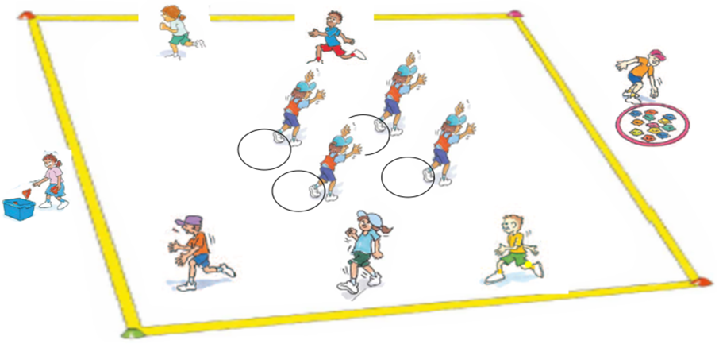
‘Hungry birds – Illustration 1’, Adapted from ‘Playing for life’ – Australian Sports Commission, https://www.sportaus.gov.au.
Hungry birds – game 2
Spread the nests in a single line from the start point to the mothers’ nests. This will allow for the mother birds to easily use the space around the nests and be successful.
- Was the game fair? What makes you say that? No, because again the baby birds could not reach the mother birds at all.
- What needs to happen to make the game fairer? Sample student answers may include, nests need to spread out to cover as much of the field as possible or the playing space could be made smaller.
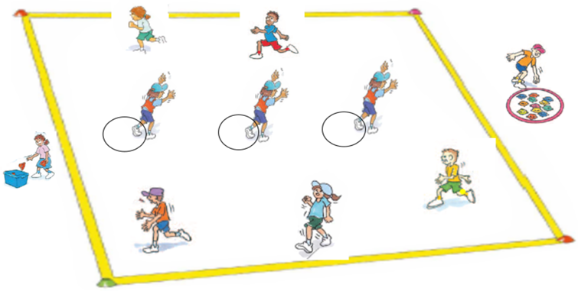
Hungry birds – Illustration 2’, Adapted from ‘Playing for life’ – Australian Sports Commission, https://www.sportaus.gov.au.
Hungry birds – game 3
Assist students to make decisions as to where they may place their nests within the playing fields for the baby birds to be more successful.
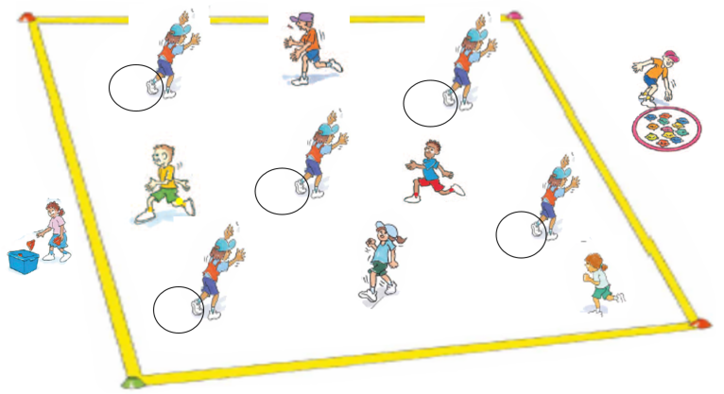
Hungry birds – Illustration 3’, Adapted from ‘Playing for life’ – Australian Sports Commission, https://www.sportaus.gov.au.

Discussion
Explore the following questions:
- As a mother bird, which game were you most successful in? Why? Sample student answers may include, one of the first two games because the baby birds were clumped together. There was more space to run in.
- As a baby bird which game were you most successful in? Why? Sample student answers may include, the last game because we were spread out and covering more space.
- As a mother bird what tactics did you change? Sample student answers may include, slowed down, ducked/weaved/dodged, plan how to use the space effectively.

Activity 3 – Hungry birds (variation)
Remind students about using movement as a tactic from the previous lessons. Explain that in this next game of ‘Hungry birds’ students will need to combine their tactical knowledge of movement and space to be successful.
Play the game again where mother birds must balance a beanbag on their head instead of carrying it in their hand. If the bean bag falls from the mother birds head it is automatically given to the nearest baby bird.
Teacher notes
It may assist students to have a brief discussion revising the forms of movement that may be applied during the game. For example, sneaking can be just as effective as running, depending on the game situation.
Variations
- Number of babies in a nest. For example, two students means that both sides of the nest can be covered.
- When tagged a mother birds becomes a baby bird, positioning a new nest in the playing field.
- Change the equipment from bean bags to balls that must be dribbled or bounced through the field.
- Increase/decrease the size of the playing field.
- Increase/decrease the size of the nests for further reach.
- Change the style of movement. For example, walking, jumping, hopping, walking backwards, side gallop.
Reflection
Students reflect upon the learning in this activity/lesson and consider how it contributes towards answering the essential question ‘How can I use tactics to be successful in games?’ by completing the self–assessment on ‘Appendix 1’. Alternatively, the self-assessment in ‘Appendix 1’ may be adapted using one or more of the assessment tools available by means of the Digital Learning Selector.

Lesson 5 – Tactical use of time
Lesson 5 – Assessment framework
Outcomes | Unit learning goals  Students are learning to | Evidence of learning  Students can
PDe-5 explores possible solutions to movement challenges through participation in a range of activities. | - Explore and trial different tactics during game play.  - Reflects on previous performances to identify factors that can contribute to future success. | - Identify and demonstrate an appropriate time to pass a ball to a team member (activity 2).  - Identify use and adjust appropriate tactics to succeed in game play that applies time restrictions (activity 3, 4).  - Identify strategies that may contribute to success in a fast-start game/challenge (activity 2, 4).
PDe-11 demonstrates how the body moves in relation to place, time, objects, effort and people. | Perform locomotor skills in any direction from one point to another, for example:  - Walking, running, galloping, hopping, jumping, skipping, side rolls, swinging, turning, sliding, leaping, following a line. | - Move at different speeds inside the playing area in response to instructions or stimulus (activity 2, 3).  - Move towards an end point, target or goal – invasion games (activity 3, 4).

Key inquiry questions and syllabus content
How can we move our bodies?
Identify and describe how their body moves in relation to space, time, objects, effort and people, for example:
- Move at different speeds, different levels and in different directions with others in a designated area.

Demonstrate a variety of movement skills and movement sequences, for example:
- Perform locomotor skills in any direction from one point to another, for example, walking, running, galloping hopping, jumping, skipping, rocking, side rolls, swinging, turning, sliding, leaping, following a line.
How can we solve problems when moving?
Test possible solutions to movement challenges through trial and error, for example:
- Identify options and make positive choices when faced with a decision about how they participate in a movement activity.
- Trial a number of techniques when trying new movement activities, for example, position, focus, direction.
How do we participate with others when we are active?
Collaborate with others and follow rules when participating in physical activities, for example:
- Identify boundaries such as personal space and playing area.
Collaborate with others and follow rules when participating in physical activities, for example:
- Work with a partner or small group to complete a movement task or challenge.
What choices can help make me safe, supported and active?
Perform new movement tasks and make positive choices when faced with decisions about how they participate in physical activities, for example:
- Participate in games and physical activities that require awareness of personal safety and boundaries, for example, individual and team physical activities and games.

Teaching and learning activities
Equipment
- large soft balls
- tennis racquets
- small balls
- markers.
If using variations egg and spoon kit (or similar), variety of ball sizes (for students to hold between their knees), bean bags.
Vocabulary
- tactic, movement, success, chaser, runner, tap, throw, timing, passing, balancing.

Activity 1 - Tap and run (fast start)
In pairs, students stand facing each other on either side of the start line. Student A is the chaser and stands behind the line facing student B the runner.
- The chaser holds one hand out, palm up straight in front of them.
- The runner taps lightly 3 times on the chaser’s hand. The runner chooses how fast or slow the taps occur. For example, 2 quick taps, 1 slow pause, third tap or 3 quick taps in a row. On the third tap the runner turns and sprints to the designated end point.
- The chaser tries to tag the runner before they reach the finish line.
Students play the game several times swapping roles and changing their tapping sequence.
Teacher notes
For safety it is recommended pairs are spread approximately 2-metres apart along the start line. Pair students with similar running ability where possible.
Variations
- Vary the locomotor movement used, for example, hop, skip, jump, side gallop, and leap.
- Increase/decrease the distance from the start line to the finish line.

Discussion
Explore the question:
- ‘How did the tapping sequence help the runner?’ Sample student answers may include, allowed me to be in control of when to run, it also allowed me to confuse the chaser.
Explore with students what tactics they have used in previous lessons. For example, movement (running slowly, sneaking), running into space.
Explain that timing is an effective tactic to achieve success in games. Timing when to pass, kick or throw an object to your team mate, timing when to move, and changing your tactics depending on how much time you have.

Activity 2 – Magpie in the middle
In small groups (3 or 4 students) students use a large soft ball and play.
- One student as the magpie and the others keeping the ball from them. The students will play 3 games, each with varying time limits placed on how long they can hold the ball.
- Keep the same magpie for all 3 games so comparisons can be made. Game time would be suited to 1-2 minute intervals.
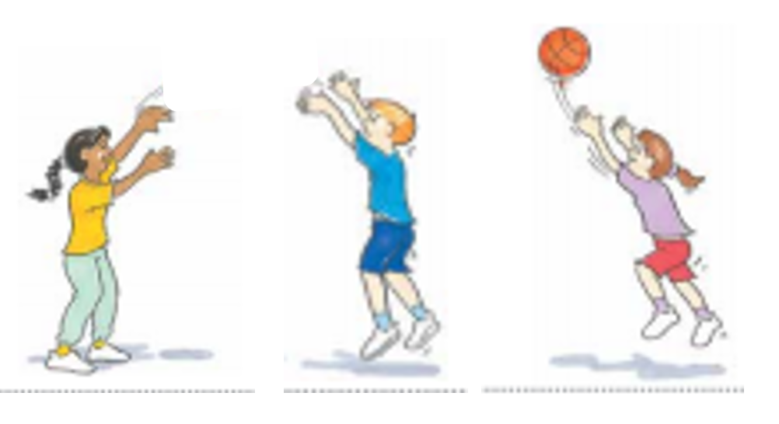
‘Magpie in the middle – Illustration 1’, Adapted from ‘Playing for life’ – Australian Sports Commission, https://www.sportaus.gov.au.
Teacher notes
As the time for holding the ball shortens the students should be changing their tactics to avoid the magpie intercepting the ball. For example, with shortened time the team members should be moving into space more frequently.
Game 1
Students are allowed to hold the ball as long as they wish before throwing it to a team member.
Discussion
Explore the questions:
- Did having as long as you want to throw the ball make it easier for you to keep it from the magpie? What makes you say that? Yes. Sample student answers may include, I had time to think where I could throw the ball safely and a better chance of succeeding by keeping possession of the ball.
- As the magpie was it harder for you to be successful when the other team could take as long as they wanted with the ball? What makes you say that? Yes. Sample student answers may include, they didn’t have to pass it so it made it hard to know when they might pass it.
Game 2
Students with the ball have a maximum of 5 seconds before they must pass it.
Discussion
Explore the questions:
- How did having a shorter time limit effect how you kept the ball away from the magpie? Sample student answers may include, I had less time to think about the pass I would use and to see where the magpie was moving.
- As the magpie, was it harder or easier for you to be successful when the other team had to pass the ball within 5 seconds? Explain. Easier. Sample student answers may include, I had a greater chance to intercept the ball because it was thrown more often. The thrower had less time to think about where to throw and could make more mistakes.
Game 3
Students with the ball have a maximum of 2 seconds before they must pass it.
Discussion
Explore the questions:
- Did having an even shorter time to throw the ball make it easier or harder for you to keep it from the magpie? Explain. Harder. Sample student answers may include, very little time to make a decision and mistakes were very common.
- As the magpie which was the hardest game to be successful in? Why?
- As the magpie which was the easiest game to be successful in? Why?
Variations
- Introduce more magpies.
- Reduce the number of throwers.
- Propel the ball using a different method, for example, roll the ball.
Discussion
Explore with students the idea that when someone has less time to make a decision or perform an action it may require them to adjust their tactics. For example, less time means you may need to move more quickly so running may be a more appropriate movement.

Activity 3 – Timing challenges
Students line up at a starting line with the finish line approximately 20 metres away.
Each student must travel from the start line to the finish line balancing a small ball on a tennis racquet.
Emphasise that students have as long as they need to complete the task as long as the ball does not drop. If the ball drops from the racquet students return to the start line and begin again.
Teacher notes
Equipment can be adapted to meet the students’ ability. For example, some students may need to balance a beanbag while others balance a ball on the tennis racquet.
Discuss with students prior to the challenge tactics they may consider. For example:
- Ways to hold the racquet. For example, use one or two hands to hold the handle of the racquet, use one hand at each end of the racquet, other ways to hold the racquet.
- The best type of movement to use. For example, walking, running or jumping.
- Space, for example, keeping clear of other people.
Discussion
Explore with students:
- That a time limit will be imposed on them to complete the challenge again.
- How will your tactics change?
Repeat the challenge, allocating a time limit for students to complete the task.
Explore the question:
- Were your tactics successful? What makes you say that?
Teacher notes
Repeat the challenge several times allowing students to attempt and compare the success of their different tactics throughout each challenge.

Activity 4 – Timing challenges/team relays
Repeat the challenge in a ‘team’ relay format (with a partner) so students can apply their tactics in a timed game situation.

Discussion
Explore the question:
- How did racing against other teams effect your tactics and success in the race? Sample student answers may include, there was more pressure to complete the challenge more quickly and be the first team finished. Our techniques/movements were hurried which increased the chances of us making a mistake.
Variations
- Students place a ball between their knees.
- Balance a bean bag on their head.
- Use an ‘egg and spoon’.
Reflection
Students reflect upon the learning in this activity/lesson and consider how it contributes towards answering the essential question How can I use tactics to be successful in games?

Lesson 6 – Tactical use of time
Lesson 6 – Assessment framework
Outcomes | Unit learning goals  Students are learning to | Evidence of learning  Students can
PDe-5 explores possible solutions to movement challenges through participation in a range of activities. | - Explore and trial different tactics during game play.  - Reflects on previous performances to identify factors that can contribute to future success. | - Identify and demonstrate an appropriate time to pass a ball to a team member (activity 2).  - Identify use and adjust appropriate tactics to succeed in game play that applies time restrictions (activity 3, 4).  - Identify strategies that may contribute to success in a fast-start game/challenge (activity 1, 2, 3).
PDe-11 demonstrates how the body moves in relation to place, time, objects, effort and people. | Perform locomotor skills in any direction from one point to another, for example:  - Walking, running, galloping, hopping, jumping, skipping, side rolls, swinging, turning, sliding, leaping, following a line. | - Move at different speeds inside the playing area in response to instructions or stimulus (activity 2).  - Move towards an end point, target or goal – invasion games (activity 3).

Key inquiry questions and syllabus content
How can we move our bodies?
Demonstrate a variety of movement skills and movement sequences, for example:
- Perform locomotor skills in any direction from one point to another, such as. walking, running, galloping hopping, jumping, skipping, rocking, side rolls, swinging, turning, sliding, leaping, following a line.
How can we solve problems when moving?
Test possible solutions to movement challenges through trial and error, for example:
- Identify options and make positive choices when faced with a decision about how they participate in a movement activity.
What choices can help make me safe, supported and active?
Perform new movement tasks and make positive choices when faced with decisions about how they participate in physical activities, for example:
- Participate in games and physical activities that require awareness of personal safety and boundaries such as individual and team physical activities and games.
How do we participate with others when we are active?
Collaborate with others and follow rules when participating in physical activities for example,
- Work with a partner or small group to complete a movement task or challenge.

Teaching and learning activities
Equipment
- a variety of different sized balls/bean bags.
Resources
- appendix 1.
Vocabulary
- tactic, success, pass, tap, team member, receive.

Activity 1 – Tap and run (fast start)
Refer to instructions in lesson 5 – activity 1. Different sample questions are provided below to explore how knowledge, understanding and skills have developed further.
Teacher notes
For safety it is recommended pairs are spread approximately 2-metres apart along the start line. Pair students with similar running ability where possible.

Discussion
Explore the questions:
- How did the runners’ tapping sequence affect the chaser?
Students reflect on the previous lesson when they played ‘Magpie in the middle’ and explore the questions:
- When is a good time to pass to a team member?
- When is a bad time to pass to a team member?
Teacher notes
Modelling examples may assist students to understand tactics such as not passing when the magpie is in front of your team member/s. Timing our pass so that the ball gets to your team member before the magpie can get to the ball.

Activity 2 – Magpie in the middle
In small groups (3 or 4 students) students use a large soft ball and play ‘Magpie in the middle’. One student as the ‘magpie’ and the others keeping the ball from them.
The students will play 3 games. All students have turn of being the ‘magpie’ in the middle.
Discussion
Explore with students how the timing of their pass to their team member can affect success. Sample student answers may include, when their partner is ready to receive a pass, when the magpie is not close to their team member.
Use the previous game as an example when needed. The tactic of timing when passing to a team member can greatly influence success in the following game.

Activity 3 – Ready or not?
In groups of 5 students stand in a circle formation passing 1 ball around the circle.
Emphasise with students that the passer must make sure that the receiver of the ball is ready and looking at them before they pass. Encourage students to call the receivers name when they are ready to pass.
- Repeat the activity with 2 balls per 5 students.
- Repeat the activity with 3 balls per 5 students.
- Repeat the activity with 2 balls per 4 students.
- Repeat the activity with 2 balls per 3 students.
Discussion
Explore the questions:
- When were you most successful? Explain. Sample student answers may include, I was most successful when I had the receiver’s full attention so they could catch the ball.
- What happens when you pass the ball and receiver is not watching? Sample student answers may include, they drop the ball, they could get hurt.

Activity 4 – Class challenge
Repeat the activity with all class members standing in a large circle formation, with every third student holding a ball. The aim of the activity is for all balls to be passed without being dropped as many times as possible.
Teacher notes
Depending on student ability you may wish for every third student to be holding a ball or alternatively beanbags maybe used.
Variations
- size of the balls
- hard or soft balls
- increase/decrease the distance between students
- set time limit for all balls to move around the circle
- increase balls per student ratio.
Reflection
Students reflect upon the learning in this activity/lesson and consider how it contributes towards answering the essential question ‘how can I use tactics to be successful in games?’ by completing the self–assessment on Appendix 1. Alternatively, the self–assessment in Appendix 1 may be adapted using one or more of the assessment tools available via the Digital Learning Selector.

Lesson 7 – Tactical use of equipment
Lesson 7 – Assessment framework
Outcomes | Unit learning goals  Students are learning to | Evidence of learning  Students can
PDe-4 practises and demonstrates movement skills and sequences using different body parts. | Trial and practise a number of locomotor skills in game play. | Move at different speeds and in different directions within the playing area (activity 1).
PDe-5 explores possible solutions to movement challenges through participation in a range of activities. | - Explore and trial different tactics during game play.  - Reflects on previous performances to identify factors that can contribute to future success. | - Identify and demonstrate an appropriate time to pass a ball to a team member (activity 1).  - Identify appropriate tactics when using specific equipment to succeed in game play (activity 2, 3).
PDe-11 demonstrates how the body moves in relation to place, time, objects, effort and people. | Perform locomotor skills in any direction from one point to another, for example:  - Walking, running, galloping, hopping, jumping, skipping, side rolls, swinging, turning, sliding, leaping, following a line. | Move in general space in a controlled manner to avoid contact with people and objects (activity 1).

Key inquiry questions and syllabus content
How can we move our bodies?
Demonstrate a variety of movement skills and movement sequences, for example:
- Perform locomotor skills in any direction from one point to another for example, walking, running, galloping hopping, jumping, skipping, rocking, side rolls, swinging, turning, sliding, leaping, following a line.
How can we solve problems when moving?
Test possible solutions to movement challenges through trial and error, for example:
- Identify options and make positive choices when faced with a decision about how they participate in a movement activity.
What choices can help make me safe, supported and active?
Perform new movement tasks and make positive choices when faced with decisions about how they participate in physical activities, for example:
- Participate in games and physical activities that require awareness of personal safety and boundaries such as individual and team physical activities and games.
How do we participate with others when we are active?
Collaborate with others and follow rules when participating in physical activities, for example:
- Work with a partner or small group to complete a movement task or challenge.

Teaching and learning activities
Equipment
- basketballs
- tennis balls
- ribbons
- markers.
Vocabulary
- tactic, success, tag, equipment.

Activity 1 – Stork tag (fast start)
Mark out a designated playing area approximately 20 metres x 20 metres. Select two or more students to be taggers. Provide 8-10 students with a ball. Balls can be different shapes and sizes.
- The taggers chase the runners. If the runners are tagged, they have to stand on the spot like a stork (static balance).
- A tagged runner can be freed by fellow runners standing in front of them and throwing the ball to them. The stork who catches the ball keeps the ball and re-joins the game.

Variations
Vary the locomotor movement used, for example, hop, skip, jump, side gallop, and leap.
Discussion
Explore the questions:
- Which ball was the easiest to use? What makes you say that?
- What object would be easier to use other than a ball? What makes you say that?
- Ask students to recall some tactics they have used in the unit so far by answering the question ‘What have you thought about or done in the games that have helped you be successful?’ Sample student answers may include, using space, changing movement, timing your pass. Introduce the idea that selecting equipment and the ways we use it can be a tactic that helps improve the chance of being successful.
You may refer to the image below to describe/discuss how different pieces of equipment can be held and used differently.
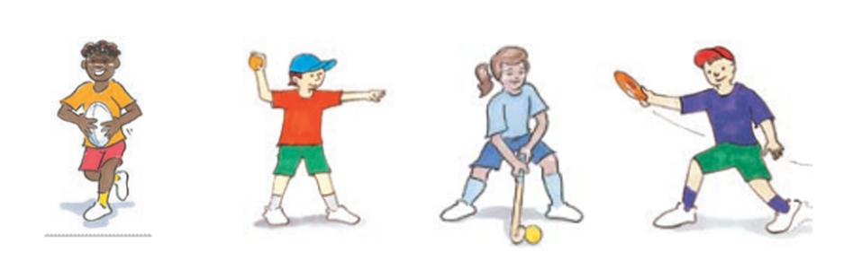
‘Stork tag – Illustration 1’, Adapted from ‘Playing for life’ – Australian Sports Commission, https://www.sportaus.gov.au.

Activity 2 – Over and under ball
Divide class into 3 teams. Members of the teams line up behind each other. Each team has a different item to pass; a tennis ball, a basketball or a ribbon.
Play 3 games with each team having one turn with each item, so that they can make comparisons. In a fourth game, allow students to select their preferred item.

Teacher notes
Suggest that students should identify which piece of equipment is easiest for them to use. It may also be useful to observe what other teams’ have done well (what are their strengths?)
The first member of each team passes the ball/ribbon over their head to the next team member who then passes it under their legs to the next team member. Continue in this pattern until the ball/ribbon reaches the last team member.
This student runs to the front of the line and the pattern is repeated again. Continue until all team members have had a turn at the front of the line.
Each team decides on which piece of equipment they preferred to use and select it for the final game. Teams may select the same item. For example, two teams may use a tennis ball while a third uses a ribbon. 3 pieces of each item/equipment should be available so teams can select their preferred piece of equipment.

Activity 3 – Over and under ball (variation)
Repeat the game of ‘Over and under’ instruct students to pass the ball/ribbon around their body, alternating sides of the body through the team. For example, right side, left side, right side. Ask teams to select their preferred ball/ribbon for this game.
Discussion
When activity 3 has been completed, ask teams if they would they like to swap their current piece of equipment or keep it for the final game. Students explain their choice. Sample student answers may include, the basketball was too big so we will try the tennis ball, the tennis ball rolled away when we dropped it so we will choose the ribbon.
Repeat the game.
Reflection
Students reflect upon the learning in this activity/lesson and consider how it contributes towards answering the essential question How can I use tactics to be successful in games?

Lesson 8 – Adjusting tactics for specific equipment
Lesson 8 – Assessment framework
Outcomes | Unit learning goals  Students are learning to | Evidence of learning  Students can
PDe-4 practises and demonstrates movement skills and sequences using different body parts. | Trial and practise a number of locomotor skills in game play. | Move at different speeds and in different directions within the playing area (activity 1, 2, 3).
PDe-5 explores possible solutions to movement challenges through participation in a range of activities. | - Explore and trial different tactics during game play.  - Reflects on previous performances to identify factors that can contribute to future success. | - Identify and demonstrate an appropriate time to pass a ball to a team member (activity 1).  - Identify appropriate tactics when using specific equipment to succeed in game play (activity 2, 3).  - Identify strategies that may contribute to success in a fast-start game/challenge (activity 1, 2, 3)
PDe-11 demonstrates how the body moves in relation to place, time, objects, effort and people. | Perform locomotor skills in any direction from one point to another, for example:  - Walking, running, galloping, hopping, jumping, skipping, side rolls, swinging, turning, sliding, leaping, following a line. | - Move in general space in a controlled manner to avoid contact with people and objects (activity 1, 2, 3).  - Move at different speeds inside the playing area in response to instructions or stimulus (activity 2, 3).

Key inquiry questions and syllabus content
How can we solve problems when moving?
Test possible solutions to movement challenges through trial and error, for example:
- Identify options and make positive choices when faced with a decision about how they participate in a movement activity.
- Trial a number of techniques when trying new movement activities for example, position, focus, direction.
How do we participate with others when we are active?
Collaborate with others and follow rules when participating in physical activities, for example:
- Identify boundaries such as personal space and playing area.
What choices can help make me safe, supported and active?
Perform new movement tasks and make positive choices when faced with decisions about how they participate in physical activities, for example:
- Participate in games and physical activities that require awareness of personal safety and boundaries such as individual and team physical activities and games.
How do we participate with others when we are active?
Collaborate with others and follow rules when participating in physical activities, for example:
- Work with a partner or small group to complete a movement task or challenge.

Teaching and learning activities
Equipment
Variety of equipment to play scoop ball:
- balls
- braids
- ropes
- skipping ropes
- markers.

Vocabulary
- tactic, success, bounce, throw, tag, touch, roll ball, scoop up.

Activity 1-Stork tag
Refer to instructions in lesson 7 – activity 1. Different sample questions are provided below to explore how knowledge, understanding and skills have developed further.
Discussion
Explore the questions:
- If you bounced the ball instead of throwing it would the game be harder or easier? What makes you say that?
- What is another way to use the ball to make the game easier? Sample student answers may include, roll the ball, handing it over.
Students reflect upon how equipment can impact on the success in a game. Explain that in the following activity students will be using different equipment in the same game. They will need to consider how this effects their tactics.

Activity 2 – Scoop tag
Set up a playing area approximately 10 metres x 10 metres per group. Form groups of 8 (4 pairs of one runner, one tagger).
- Tagger calls out, ‘touch’ or ‘yes’ when they tag their partner.
- The tagged player must immediately perform a ‘roll ball’ (place their ball on the ground between their feet and step over it), and becomes a tagger.
- The tagger scoops the ball up and continues playing as a runner.
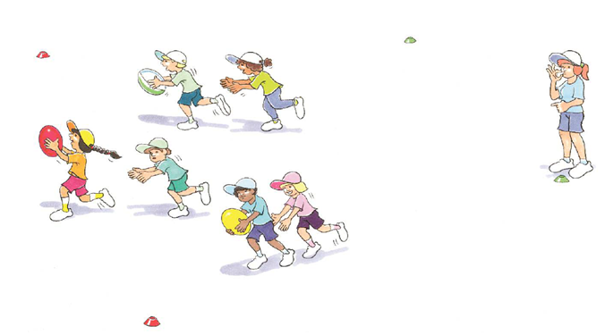
‘Scoop tag – Illustration 1’, Adapted from ‘Playing for life’ – Australian Sports Commission, https://www.sportaus.gov.au.
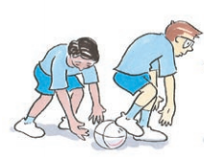
‘Rolling the ball illustration’, Adapted from ‘Playing for life’ – Australian Sports Commission, https://www.sportaus.gov.au.
Discussion
Explore the questions:
- How did you avoid the tagger? Sample student answers may include, I ran quickly and used side step, swerve, dodge movements.
- How did you carry the ball? Sample student answers may include, protected it under my arm so I could move freely.
Teacher notes
Provide enough equipment that allows for students to be in pairs throughout this activity to ensure maximum student participation.
Equipment is interchangeable depending on available school resources. The main focus is for students to make tactical decisions based on which piece of equipment will allow them to be most successful.

Activity 3 – Scoop tag (variation)
Play ‘Scoop tag’ several more times changing the item carried each time. For example, tennis ball, soccer ball, bean bag, braid, skipping rope, plastic markers, buckets.
Discussion
Explore the questions:
- Which item was easiest to scoop up? What makes you say that?
- Which item was easiest to carry? What makes you say that?
- Which item was the hardest to scoop up? What makes you say that?
- Which item was the hardest to carry? What makes you say that?
- Did you have to change how you carried different items? Explain.
If playing again what item would you pick to play with if you were the:
- Tagger to start with?
- Ball carrier to start with?
Reflection
Students reflect upon the learning in this activity/lesson and consider how it contributes towards answering the essential question ‘How can I use tactics to be successful in games?’ by completing the self–assessment on ‘Appendix 1’. Alternatively, the self–assessment in ‘Appendix 1’ may be adapted using one or more of the assessment tools available via the Digital Learning Selector.

Lesson 9 – Adjusting tactics in response to new rules
Lesson 9 – Assessment framework
Outcomes | Unit learning goals  Students are learning to | Evidence of learning  Students can
PDe-4 practises and demonstrates movement skills and sequences using different body parts. | Trial and practise a number of locomotor skills in game play. | Move at different speeds and in different directions within the playing area (activity 1, 2, 3).
PDe-5 explores possible solutions to movement challenges through participation in a range of activities. | - Explore and trial different tactics during game play. | - Identify how and when to move safely in open space (activity 1, 2, 3).  - Identify and adjust tactics to suit rule changes in a game (activity 2, 3).
PDe-11 demonstrates how the body moves in relation to place, time, objects, effort and people. | Perform locomotor skills in any direction from one point to another, for example:  - Walking, running, galloping, hopping, jumping, skipping, side rolls, swinging, turning, sliding, leaping, following a line. | - Move in general space in a controlled manner to avoid contact with people and objects (activity 1, 2, 3).  - Move at different speeds inside the playing area in response to instructions or stimulus (activity 1, 2, 3).  - Move towards an end point, target or goal – invasion games (activity 2, 3)

Key inquiry questions and syllabus content
How can we move our bodies?
Identify and describe how their body moves in relation to space, time, objects, effort and people, for example:
- Move at different speeds, different levels and in different directions with others in a designated area.
Demonstrate a variety of movement skills and movement sequences, for example:
- Perform locomotor skills in any direction from one point to another, such as walking, running, galloping hopping, jumping, skipping, rocking, side rolls, swinging, turning, sliding, leaping, following a line.
How can we solve problems when moving?
Test possible solutions to movement challenges through trial and error, for example:
- Identify options and make positive choices when faced with a decision about how they participate in a movement activity.
- Trial a number of techniques when trying new movement activities, such as position, focus, direction.
How do we participate with others when we are active?
Collaborate with others and follow rules when participating in physical activities, for example:
- Identify boundaries, such as personal space and playing area.
What choices can help make me safe, supported and active?
Perform new movement tasks and make positive choices when faced with decisions about how they participate in physical activities, for example:
- Participate in games and physical activities that require awareness of personal safety and boundaries, such as individual and team physical activities and games.

Teaching and learning activities
Equipment
- markers
- appropriate equipment to suit rule changes.

Resources
- appendix 2.
Vocabulary
- tactic, rule, success, challenge.
Teacher notes
Lessons 9 and 10 are designed to allow students to recognise that if rule changes occur in games, tactics may need to be modified to accommodate the changes. The discussion and the joint construction of Appendix to begin lesson 9, would be best suited to take place in an environment where the Appendix 2 can be displayed.
Once the discussion is complete the lesson can continue and students can implement their rule changes and modified tactics. Remember that not all elements need to be changed. Your students may only be able to comprehend changing movement so time, space and equipment may remain untouched.
Adapt this section of the lesson to your students’ abilities and needs.
Discussion
Explore the idea, that when rules change they can impact on the tactics used in games. For example, when ‘Cross the ocean’ was played in lesson 1 students used the tactic of running as fast as they could to be successful. If the shark was only allowed to hop the fish’s tactics may change to slowing down, changing directions and taking more time to think about how they are going to cross the ocean successfully.
To support student understanding of the concept of rule changing provide Appendix 2 on a whiteboard for student viewing and joint construction.
Discuss and record one student identified rule change and the possible impact on their tactics.
Teacher notes
To ensure maximum participation only discuss one rule change to either movement, space, equipment or time. Students then implement the change in the game.
Further discussion on rule changes can be had while students play and explore how each rule change impacts upon their tactical decision-making.

Activity 1 – Corners (fast start)
Allocate a playing area approximately the size of 20 metres x 20 metres with different coloured markers on each corner. Spread 5 – 10 markers out for each corner section so when students move there they are not all moving to the one cone/specific spot.
- Assign each student a colour that matches a corner so there is an even number of students on each team.
- All students start by jogging, hopping or jumping on the spot in the middle of the area. When the teacher calls out a specific locomotor movement, all students move to their matching corner using the nominated movement.
- Repeat several times for each of the locomotor movements selected.
Discussion
Explore the question:
- What rule/s could you change to make the game more challenging?

Activity 2 – Zebra hunt (variation 3)
Play Zebra hunt from lesson 2 – activity 2.
Rule change/s decided by the teacher/class are applied and students adjust tactics where necessary. Ask students, ‘How did you change your tactics? Did this improve your chances of success? What makes you say that?
Teacher notes
Sample rule changes for example:
- Change in movement – Lions hop when creeping up to the zebra which means I will use small hops so I do not lose balance and be seen by the zebra.
- Change in Space – Wider boundaries for lions to creep up to the zebra which means I can run in a zig zag pattern when creeping so the zebra does not know where I am.
- Change in Equipment – Change the beanbag to a larger ball that is challenging to carry (ensure safety is maintained). This means the lion will need to be closer to pick the item up with two hands and possibly run in a zig zag pattern to avoid capture.
- Change in Time – Lions have only 30 seconds to steal beanbag zebra which means when the lions are creeping they will need to be quicker, plan their route and take more risks when approaching the zebra.

Activity 3 – Zebra hunt (variation 4)
Repeat the game with the teacher nominating a different rule change. Allow students time to consider how this will impact their tactics.
Explore with students:
- How did you change your tactics?
- Did this improve your chances of success? What makes you say that?
Reflection
Students reflect upon the learning in this activity/lesson and consider how it contributes towards answering the essential question How can I use tactics to be successful in games?

Lesson 10 – Adjusting tactics in response to new rules
Lesson 10 – Assessment framework
Outcomes | Unit learning goals  Students are learning to | Evidence of learning  Students can
PDe-4 practises and demonstrates movement skills and sequences using different body parts. | Trial and practise a number of locomotor skills in game play. | Move at different speeds and in different directions within the playing area (activity 1).
PDe-5 explores possible solutions to movement challenges through participation in a range of activities. | - Explore and trial different tactics during game play.  - Reflects on previous performances to identify factors that can contribute to future success. | - Identify and adjust tactics to suit rule changes in a game (activity 2, 3).  - Identify strategies that may contribute to success in a fast-start game/challenge (activity 1, 2, 3).
PDe-11 demonstrates how the body moves in relation to place, time, objects, effort and people. | Perform locomotor skills in any direction from one point to another, for example:  - Walking, running, galloping, hopping, jumping, skipping, side rolls, swinging, turning, sliding, leaping, following a line. | - Move in general space in a controlled manner to avoid contact with people and objects (activity 1).  - Move at different speeds inside the playing area in response to instructions or stimulus (activity 1).

Key inquiry questions and syllabus content
How can we move our bodies?
Identify and describe how their body moves in relation to space, time, objects, effort and people, for example:
- Move at different speeds, different levels and in different directions with others in a designated area
Demonstrate a variety of movement skills and movement sequences, for example:
- Perform locomotor skills in any direction from one point to another for example, walking, running, galloping hopping, jumping, skipping, rocking, side rolls, swinging, turning, sliding, leaping, following a line.
How can we solve problems when moving?
Test possible solutions to movement challenges through trial and error for example:
- Identify options and make positive choices when faced with a decision about how they participate in a movement activity.
- Trial a number of techniques when trying new movement activities for example, position, focus, direction.
How do we participate with others when we are active?
Collaborate with others and follow rules when participating in physical activities, for example:
- Identify boundaries, such as personal space and playing area.
What choices can help make me safe, supported and active?
Perform new movement tasks and make positive choices when faced with decisions about how they participate in physical activities, for example:
- Participate in games and physical activities that require awareness of personal safety and boundaries for example, individual and team physical activities and games.
- Place a braid in a hoop or bucket. Bobcats take the braid out of the hoop, builders place the braid back inside the hoop.

Evaluation
Teacher analysis of the teaching and learning in the entire unit of work. Sample questions to address include:
Unit evaluation and teacher notes
Evaluation | Teacher notes
How well did the class demonstrate understanding of key concepts? | Write notes here.
What concepts/topics will I need to revisit to support student understanding? | Write notes here.
When will these concepts be revisited? | Write notes here.
How well were student learning needs met? | Write notes here.
Did all students have opportunities to demonstrate their knowledge, understanding and skills? | Write notes here.
Did adjustments provide adequate and appropriate access to all activities by all students? | Write notes here.
Were the resources used accessible for all students? | Write notes here.
Which activities in the learning sequence will I need to adapt to ensure better achievement of learning goals? | Write notes here.
Did the learning sequence provide sufficient opportunities to make quality assessment judgements about student achievement? | Write notes here.

Glossary
- Boundaries – A line that marks the outer limits of an area.
- Territory games – Games where the aim is to invade the opponent’s territory and score points while keeping the opposing teams points to a minimum.
- Locomotor skills – Locomotor movement is when you move from one place to another. Locomotor skills include walking, climbing, rolling, balancing, sliding, jogging, running, leaping, jumping, hopping, dodging, galloping, skipping, floating and moving the body through water to safety.
- Modified games – Games or sports that are simplified to suit the skills, strategic understandings and characteristics of students. These changes may include rules, equipment and/or the size of the playing area.
- Non-locomotor skills – Moving on the spot without any change in location. These skills include bending, stretching, twisting, turning, swinging, inverted supports, landing/stopping, balancing.
- Tackle/tackling – Tackle/tackling is a generic term used when a student attempts to gain/re-gain possession of the ball/object from an opposition student. Under no circumstances should students make physical contact with another student to achieve this.
- Tactical knowledge – An understanding of when, how and why to apply tactics in game situations.
- Tactics – A plan, idea or action to successfully achieve a goal or outcome during a movement activity.
- Tag game – Tag is a game involving two or more players' chasing other players in an attempt to "tag" and mark them out of play, usually by touching with a hand.

Appendix 1 – Self assessment
Self-assessment table
Success criteria | I need help to learn: | I am still learning to: | I have learnt to:
By the end of lesson 2: | Select the best movement to improve my chances of success in games. | Select the best movement to improve my chances of success in games | Select the best movement to improve my chances of success in games
By the end of lesson 4: | Use space to improve my chances of success in games. | Use space to improve my chances of success in games. | Use space to improve my chances of success in games.
By the end of lesson 6: | Use time to improve my chances of success in games. | Use time to improve my chances of success in games. | Use time to improve my chances of success in games.
By the end of lesson 8: | Select the most effective equipment to improve my chances of success in games. | Select the most effective equipment to improve my chances of success in games. | Select the most effective equipment to improve my chances of success in games.
By the end of lesson 10: | Select the most effective tactics to succeed when the rules of games have changed. | Select the most effective tactics to succeed when the rules of games have changed | Select the most effective tactics to succeed when the rules of games have changed

Appendix 2 – Rule changes
For each ‘movement’ in the left column address the changes made in the right column with the question ‘what tactical decisions did I make/change?’.
‘Changes made to the movement’ table
Movement | What tactical decisions did I make/change?
Movement | Write notes here.
Space | Write notes here.
Equipment | Write notes here.
Time | Write notes here.

Appendix 3 – Images to support key terms
These images are licensed under CC BY NC ND 3.0 AU. Image modified with the permission of the Australian Sports Commission (for use in this publication only).
Tag – to touch an opponent with your hand or other safe object.
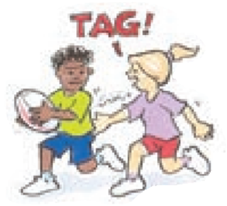
‘Tag illustration’, Adapted from ‘Playing for life’ – Australian Sports Commission, https://www.sportaus.gov.au.
Attackers – team who are to trying score, usually with the ball/object.
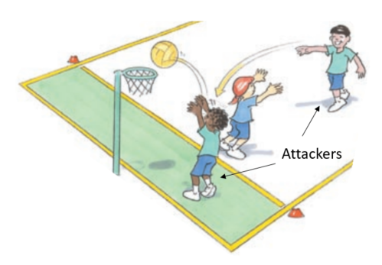
‘Attackers illustration’, Adapted from ‘Playing for life’ – Australian Sports Commission, https://www.sportaus.gov.au.

Defenders – team trying to stop the opposition from scoring.
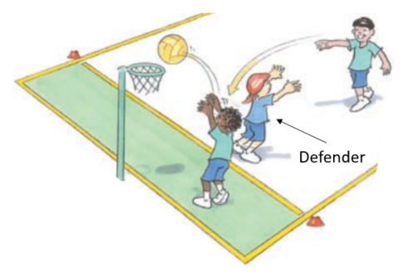
‘Defenders illustration’, Adapted from ‘Playing for life’ – Australian Sports Commission, https://www.sportaus.gov.au.
Equipment – items used to play a game.
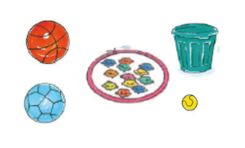
‘Equipment illustration’, Adapted from ‘Playing for life’ – Australian Sports Commission, https://www.sportaus.gov.au.

Space – an area away from other players.
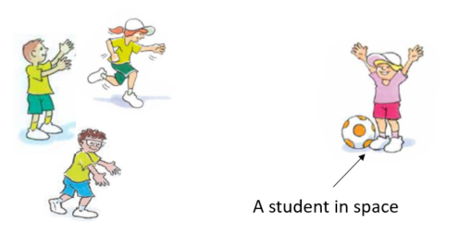
‘Space illustration’, Adapted from ‘Playing for life’ – Australian Sports Commission, https://www.sportaus.gov.au.
Boundaries – the limit of the playing area.
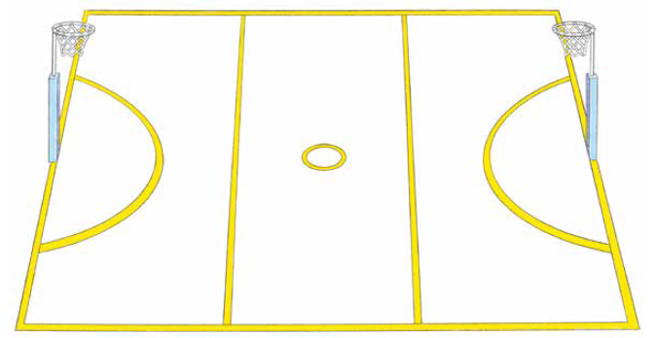
‘Boundaries illustration’, Adapted from ‘Playing for life’ – Australian Sports Commission, https://www.sportaus.gov.au.

Roll ball – to roll a ball under the foot, from front to back.
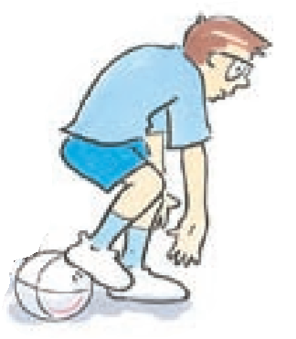
‘Roll ball illustration’, Adapted from ‘Playing for life’ – Australian Sports Commission, https://www.sportaus.gov.au.
Scoop up – to pick the ball up off the ground while moving.
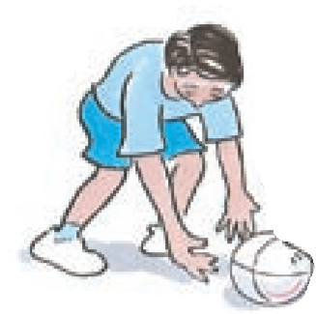
‘Scoop-up illustration’, Adapted from ‘Playing for life’ – Australian Sports Commission, https://www.sportaus.gov.au.

Intercept –to take possession of the ball when the opposition have passed it, usually with a throw, strike or kick.
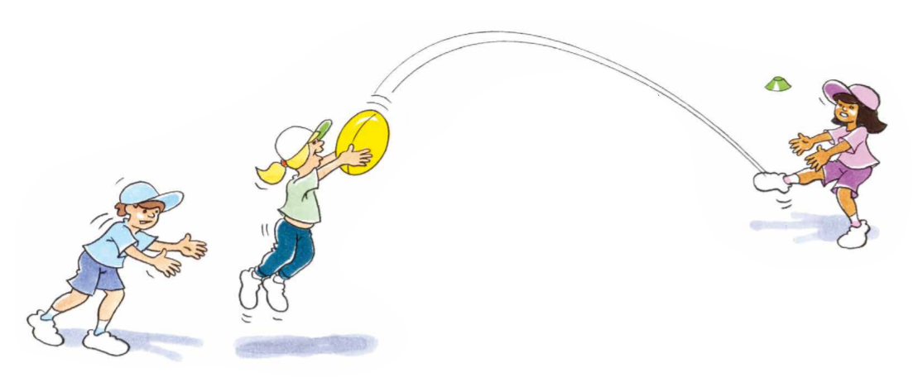
‘Intercept illustration’, Adapted from ‘Playing for life’ – Australian Sports Commission, https://www.sportaus.gov.au.
Team – players who are working together to achieve the same goal.
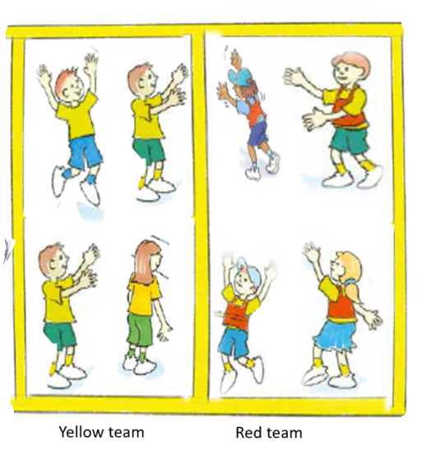
‘Team illustration’, Adapted from ‘Playing for life’ – Australian Sports Commission, https://www.sportaus.gov.au.
Scoring – to achieve the aim of the game, usually by putting an object in a goal or over a line.
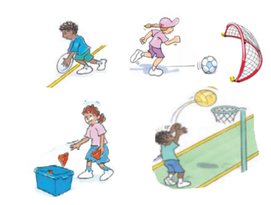
‘Scoring illustration’, Adapted from ‘Playing for life’ – Australian Sports Commission, https://www.sportaus.gov.au.
Dodging – changing directions quickly to avoid an opponent.
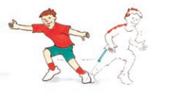
‘Dodging illustration’, Adapted from ‘Playing for life’ – Australian Sports Commission, https://www.sportaus.gov.au.

Kick – to hit an object with the foot.
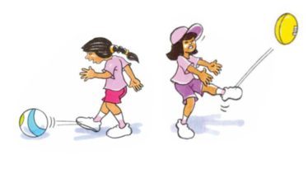
‘Kick illustration’, Adapted from ‘Playing for life’ – Australian Sports Commission, https://www.sportaus.gov.au.
Throw – to release a ball with force from a hand.
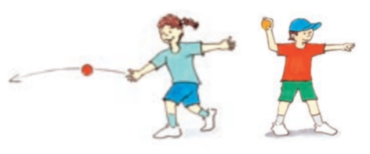
‘Throw illustration’, Adapted from ‘Playing for life’ – Australian Sports Commission, https://www.sportaus.gov.au.

Catch – using hands to prevent a ball from hitting the ground.
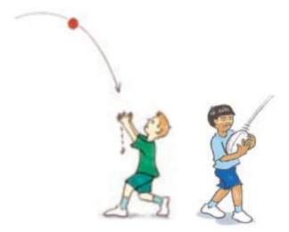
‘Catch illustration’, Adapted from ‘Playing for life’ – Australian Sports Commission, https://www.sportaus.gov.au.
Bounce – to drop or throw a ball to the ground and retain possession.
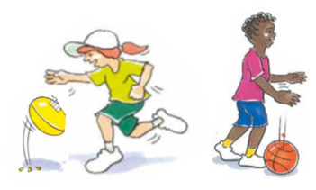
‘Bounce illustration’, Adapted from ‘Playing for life’ – Australian Sports Commission, https://www.sportaus.gov.au.

Balance an object – to keep one object on top of another without it hitting the ground or falling over.
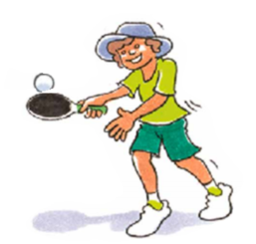
‘Balance an object illustration’, Adapted from ‘Playing for life’ – Australian Sports Commission, https://www.sportaus.gov.au.
Pass – when an object or ball is sent to a team mate, usually by throw, strike or kick.
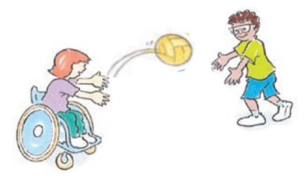
‘Pass illustration’, Adapted from ‘Playing for life’ – Australian Sports Commission, https://www.sportaus.gov.au.

Receive – to get a ball from a team mate, usually from a throw, strike or kick.
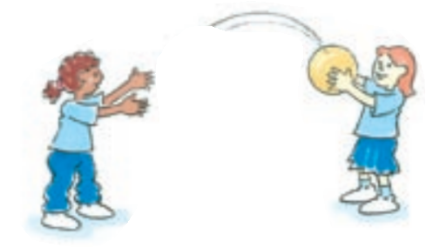
‘Receive illustration’, Adapted from ‘Playing for life’ – Australian Sports Commission, https://www.sportaus.gov.au.
Run – a locomotor movement alternating legs to move across the ground.
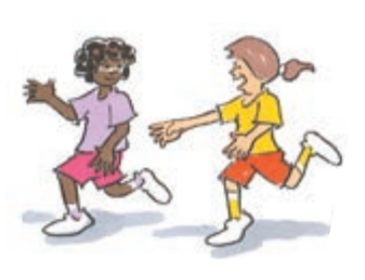
‘Run illustration’, Adapted from ‘Playing for life’ – Australian Sports Commission, https://www.sportaus.gov.au.

Jump – a locomotor movement using two feet to spring up into the air or across the ground.
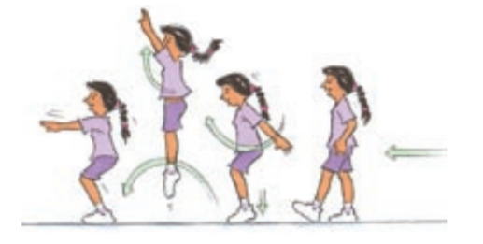
‘Jump illustration’, Adapted from ‘Playing for life’ – Australian Sports Commission, https://www.sportaus.gov.au.
Hop – a locomotor movement using the same foot touching the ground.
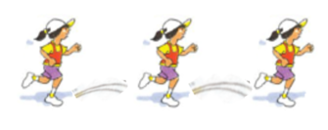
‘Hop illustration’, Adapted from ‘Playing for life’ – Australian Sports Commission, https://www.sportaus.gov.au.

Skip – a locomotor movement using a step-hop pattern or a term used when jumping over a rope.
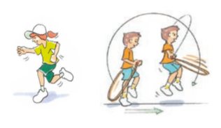
‘Skip illustration’, Adapted from ‘Playing for life’ – Australian Sports Commission, https://www.sportaus.gov.au.
Balance – to maintain stability and avoid falling over.
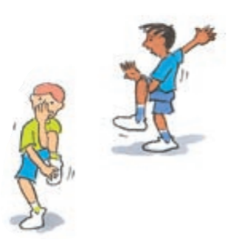
‘Balance illustration’, Adapted from ‘Playing for life’ – Australian Sports Commission, https://www.sportaus.gov.au.

Leap – a locomotor movement using a long stride from one foot and landing on the other.
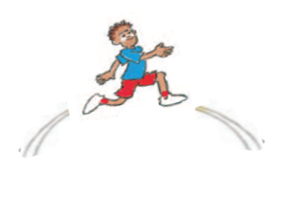
‘Leap illustration’, Adapted from ‘Playing for life’ – Australian Sports Commission, https://www.sportaus.gov.au.
Rolling – to rotate an object or person across the ground.
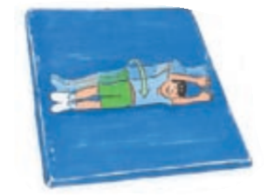
‘Rolling illustration’, Adapted from ‘Playing for life’ – Australian Sports Commission, https://www.sportaus.gov.au.

Striking – to hit an object or ball with another object such as a bat.
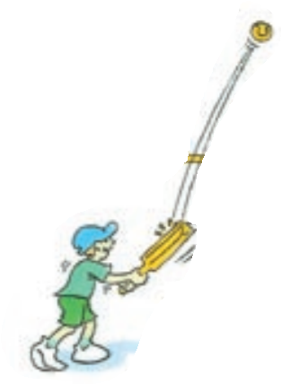
‘Striking illustration’, Adapted from ‘Playing for life’ – Australian Sports Commission, https://www.sportaus.gov.au.
Bend – to move the body by making the joint angles smaller.
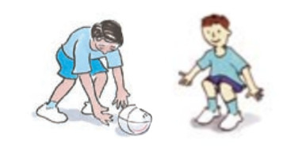
‘Bend illustration’, Adapted from ‘Playing for life’ – Australian Sports Commission, https://www.sportaus.gov.au.

Twist – to rotate the body around a central point.
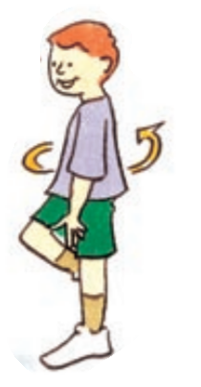
‘Twist illustration’, Adapted from ‘Playing for life’ – Australian Sports Commission, https://www.sportaus.gov.au.

Appendix 4 – Physical literacy continuum cluster markers
The following NSW Physical Literacy Continuum K-10 cluster markers guided the development of the ‘Evidence of Learning’ (EoL) as observable behaviours to address the Student learning goals and identified syllabus outcomes.

Movement competencies
- Moves rhythmically from one point to another, for example, skipping.
- Demonstrates introductory components of locomotor movement skills, for example, high knee lift when running.

Tactical movement
- Participates within the rules of physical activities.
- Identifies rules and tactics within a physical activity.

Motivation and behavioural skills
- Participates in a range of new and unfamiliar physical activities with encouragement and assistance.
- Demonstrates willingness to try new physical activities.

Personal and social attributes
- Follows instructions about safe practices with prompting, for example, controls equipment.
- Communicates ideas when working with others during physical activity.

Appendix 5 – Attributions
© State of New South Wales (Department of Education), 2021. All material in this resource, except as identified below, is licensed under the Creative Commons Attribution 4.0 International Licence. To view a copy of this licence, visit http://creativecommons.org/licenses/by/4.0/.’
Material that is not licensed under the Creative Commons Attribution 4.0 International Licence:
The following images by Australian Sports Commission — https://www.sportaus.gov.au are licensed under CC BY NC ND 3.0 AU. These images have been modified with the permission of the Australian Sports Commission (for use in this publication only):
- Page 26 – Hungry Birds illustration 1.
- Page 27 – Hungry Birds illustration 2, Hungry Birds illustration 3.
- Page 33 – Magpie in the middle illustration 1.
- Page 45 – Stork Tag illustration 1.
- Page 50 – Scoop Tag illustration 1, Rolling the ball illustration.
- Page 63 – Tag illustration, Attackers illustration.
- Page 64 – Defenders illustration, Equipment illustration.
- Page 65 – Space illustration, Boundaries illustration.
- Page 66 – Roll ball illustration, Scoop-up illustration.
- Page 67 – Intercept illustration, Team illustration.
- Page 68 – Scoring illustration, Dodging, illustration.
- Page 69 – Kick illustration, Throw illustration.
- Page 70 – Catch illustration, Bounce illustration.
- Page 71 – Balance objects illustration, Pass illustration.
- Page 72 – Receive illustration, Run illustration.
- Page 73 – Jump illustration, Hop illustration.
- Page 74 – Skip illustration, Balance illustration.
- Page 74 – Leap illustration, Rolling illustration.
- Page 76 – Striking illustration, Bend illustration.
- Page 77 – Twist illustration.

