K-6 PDHPE – Being resilient is brilliant
‘Being resilient is brilliant’ is a multistage unit of learning focused on empowering students to develop resilience that can support them to respond positively to different situations.

Table of contents
K-6 PDHPE – Being resilient is brilliant 0
Duration 3
Essential question 3
Unit description 3
Contextual statement 3
Propositions in action 4
Focus on educative purpose 4
Strength based approach 4
Value movement 4
Critical inquiry 4
Health literacy 4
Skills in focus 5
Self-management skills (S) 5
Interpersonal skills (I) 5
Outcomes 6
Lesson 1 – How can my identity contribute to developing resilience? 7
Resources 7
Vocabulary 7
Key inquiry questions and syllabus content 7
Learning intention and success criteria 9
Teaching and learning activities 9
Lesson 2 – What is important to you? 16
Resources 16
Vocabulary 16
Key inquiry questions and syllabus content 16
Learning intention and success criteria 18
Teaching and learning activities 19
Lesson 3 – How can I think differently? 25
Resources 25
Vocabulary 25
Key inquiry questions and syllabus content 25
Learning intention and success criteria 27
Teaching and learning activities 27
Lesson 4 – How can we use our strengths? 34
Resources 34
Vocabulary 34
Key inquiry questions and syllabus content 34
Learning intention and success criteria 35
Teaching and learning activities 36
Lesson 5 – How can our emotions change? 41
Resources 41
Vocabulary 41
Key inquiry questions and syllabus content 41
Learning intention and success criteria 43
Teaching and learning activities 43
Activity 2 – Which emotion? 45
Activity 3 – Our body’s responses 45
Lesson 6 – How can we manage emotions? 49
Resources 49
Vocabulary 49
Key inquiry questions and syllabus content 49
Learning intention and success criteria 51
Teaching and learning activities 52
Activity 2 – Continuum of emotions 53
Lesson 7 – What strategies work for me? 57
Resources 57
Vocabulary 57
Key inquiry questions and syllabus content 57
Learning intention and success criteria 58
Teaching and learning activities 59
Lesson 8 – Resilient rock stars 63
Resources 63
Vocabulary 63
Key inquiry questions and syllabus content 63
Learning intention and success criteria 65
Teaching and learning activities 66
Unit evaluation 70
Glossary 71
Appendix 1a – A metaphor for resilience 72
Appendix 1b – Resilience tree worksheet 73
Appendix 2 – Resilience class wall display 74
Appendix 3 – Raindrops 75
Appendix 4 – Value cards 76
Appendix 5 – Handprint 77
Appendix 6 – Fixed thinking cards 78
Appendix 7 – Flexible thinking cards 79
Appendix 8 – Scenario cards 80
Appendix 9 – Emotion images 82
Appendix 10 – Body signals images 84
Appendix 11 – Where I feel my emotions 86
Appendix 12 – Rating my strategies 87
Unit learning intentions and success criteria 89

Duration
8 weeks

Essential question
What helps us build resilience and what strategies can we use to respond to challenging situations?

Unit description
This unit of learning provides students with learning opportunities to:
- Explore the importance of resilience in achieving success.
- Set goals for developing skills and strengths that will help them persevere in their day-to-day life.
- Develop strategies for solving problems and dealing with situations in ways that have positive outcomes for themselves and others.
- Explore and develop the skills needed to build resilience and understand how they can respond to adversity and challenges.

Contextual statement
A wide range of factors influence how people develop and build resilience. These include their current knowledge and skills, cultural background, previous experiences, family structure and geographical location. Focusing on students’ ability to use their individual strengths, manage their emotions, find solutions and make decisions, students can develop and build resilience across a wide range of contexts.

Propositions in action
The 5 PDHPE syllabus propositions embedded within this unit support the delivery of the teaching and learning activities.

Focus on educative purpose
Students have learning opportunities to practise, apply and evaluate the knowledge, understanding and skills needed to build resilience and to engage successfully in movement challenges.

Strength-based approach
Acknowledge that all students will face challenges at different stages of life. Build upon their current knowledge, skills and understanding, to develop a range of strategies that will support students to build resilience.

Value movement
Explore and value how a range of physical activities can support emotional regulation and wellbeing to encourage students to lead healthy, safe and active lifestyles.

Critical inquiry
Investigate the contextual factors that influence students’ identities. Students develop skills in identifying, analysing and applying knowledge in different contexts to build resilience.

Health literacy
Identify and enhance students' ability to access health information and services to maintain health, safety and wellbeing.

Skills in focus
The following skills are explicitly addressed in this unit.

Self-management skills (S)
- Strengthening personal identity
- building self-concept
- building self-confidence
- building self-esteem
- self-evaluation
- cultivating resilience
- perseverance
- Self-awareness
- self-monitoring thoughts, feelings and actions
- reflective practice
- Emotion and stress management
- recognising emotions
- optimistic thinking
- coping
- Help-seeking
- accessing support and support networks.

Interpersonal skills (I)
- Communication
- expressing feelings
- Collaboration, inclusion and relationship building
- recognising and using their own abilities and strengths and those of others
- Social awareness
- respecting difference and diversity.

Outcomes
Table 1 – Syllabus outcomes addressed in this unit (Early Stage 1 to Stage 3)
Early stage 1 outcomes | Stage 1 outcomes | Stage 2 outcomes | Stage 3 outcomes
PDe-1 identifies who they are and how people grow and change | PD1-1 describes the qualities and characteristics that make them similar and different to others | PD2-1 explores strategies to manage physical, social and emotional change | PD3-1 identifies and applies strengths and strategies to manage life changes and transitions
PDe-2 identifies people and demonstrates protective strategies that help keep themselves healthy, resilient and safe | PD1-2 recognises and describes strategies people can use to feel comfortable, resilient and safe in situations | PD2-2 explains and uses strategies to develop resilience and to make them feel comfortable and safe | PD3-2 investigates information, community resources and strategies to demonstrate resilience and seek help for themselves and others
PDe-3 communicates ways to be caring, inclusive and respectful of others | PD1-3 recognises and describes the qualities that enhance inclusive and respectful relationships | PD2-3 explains how empathy, inclusion and respect can positively influence relationships | PD3-3 evaluates the impact of empathy, inclusion and respect on themselves and others
 |  | PD2-6 describes how contextual factors are interrelated and how they influence health, safety, wellbeing and participation in physical activity | PD3-6 distinguishes contextual factors that influence health, safety, wellbeing and participation in physical activity which are controllable and uncontrollable
PDe-9 practises self-management skills in familiar and unfamiliar scenarios | PD1-9 demonstrates self-management skills in taking responsibility for their own actions | PD2-9 demonstrates self-management skills to respond to their own and others’ actions | PD3-9 applies and adapts self-management skills to respond to personal and group situations
PDHPE K-10 Syllabus (2018) © 2021 NSW Education Standards Authority (NESA) for and on behalf of the Crown in right of the State of New South Wales.

Lesson 1 – How can my identity contribute to developing resilience?
There are 3 activities in lesson 1.

Resources
- Appendix 1a – A metaphor for resilience
- Appendix 1b – Resilience tree worksheet (A3)
- Appendix 2 – Resilience tree class wall display
- Appendix 3 – Raindrops
- Digital Learning Selector
- Inclusive practice hub – Photovoice, body mapping and Social story: Being different (where appropriate throughout the unit). Resources to help create inclusive education environments for students with disability and additional needs
- Assistive technology

Vocabulary
Resilience, identity, strengths, different, unique, influence, similar.

Key inquiry questions and syllabus content
Syllabus content addressed in this lesson for Early Stage 1 to Stage 3.

Early Stage 1
What makes me unique?
- identify personal strengths and qualities, for example: (ACPPS001)
- identify their unique strengths and qualities.

Stage 1
How does my uniqueness shape who I am?
- describe their own and others’ strengths and achievements and identify how these contribute to personal identity (ACPPS015). For example
- recognise characteristics that make them both similar and different to others.
- describe their unique qualities and strengths and how these can develop resilience.

Stage 2
How does who I am influence others?
- explore how success, challenge and overcoming adversity strengthens identity, for example: (ACPPS033)
- explore factors that influence the development of personal identity. For example, parents or carers, family, friends, school, gender stereotypes and expectations, disability, culture, religion, emerging world issues.

Stage 3
How does my uniqueness change over time?
- examine how identity and behaviour are influenced by people, places and the media, for example: (ACPPS051)
- discuss how personal and cultural identity can change over time. For example, the influence of media
- identify how personal strengths and qualities contribute to identity and inform views

Learning intention and success criteria
Learning intention – Describe what makes me who I am and how this contributes to resilience.
Table 2 – Success criteria for Early Stage 1 to Stage 3
Stage | Students can: | Syllabus outcomes
All students | explain their understanding of resilience.  (Activity 1) | PDe-2; PD1-2; PD2-2; PD3-2
Early stage 1 | identify my unique strengths and qualities. (Activities 2-3) | PDe1, PDe-9
Stage 1 | recognise qualities that make them similar and different to others. (Activities 2-3) | PD1-1, PD1-9
Stage 2 | explain factors that influence the development of personal identity. (Activities 2-3) | PD2-1, PD2-9
Stage 3 | explain how personal identity can change over time. (Activities 2-3) | PD3-1, PD3-9

Teaching and learning activities
Teacher notes
The PDHPE K-10 Syllabus defines resilience as ‘a capacity to deal constructively with change or challenge, allowing a person to maintain or re-establish their social and emotional wellbeing in the face of difficult events. It involves thoughts, feelings, and actions. Resilience is an integral part of learning as it underpins the ability to respond positively to setbacks, mistakes or challenging life experiences.’
Use the syllabus definition as a guide to develop a class definition of resilience. Encourage student voice to promote ownership of the class definition.
Important considerations to reinforce with students throughout the unit where appropriate.
Resilience:
- Is influenced by many contextual factors (individual, environmental, sociocultural and socioeconomic).
- Can exist at many different levels.
- Can change over time and can look different in different situations.
- Is something that all people can learn and develop.

Activity 1 – What is resilience?
Explain to students that the focus of the unit is ‘resilience’ and watch the video Wellbeing for Children: Resilience (7:42).
Teacher notes
The video depicts different situations where students may experience sadness, grief or loss, including losing a family member or someone close to them. Please be mindful that some of these situations may trigger responses that are unsettling or disturbing for students and could remind them of past physical pain. Teachers should carefully monitor students’ reactions as some may not be immediately obvious.
As a class, create a mind map or use another Digital Learning Selector activity to record students’ ideas about what resilience means to them.
Consider reading (and adapting where necessary) Appendix 1a – A metaphor for resilience, to help explain the concept of resilience and how it can be influenced.
Create a class definition of resilience from student responses.
Students record their definition using Appendix 1b – Resilience tree worksheet or work with others to collaboratively develop for the class display.
Revise the message outlined in the ‘Wellbeing for children: Resilience’ video and ‘Appendix 1a – A metaphor for resilience’ that, just as a tree has many different parts, so too does resilience. There are many factors that combine and influence our resilience. We will continue to re-visit the tree and add parts as we learn more about resilience.

Discussion
To explore why developing resilience is important for everyone, discuss the question ‘What might be some benefits of being in a challenging situation?’.
Answers may include that developing resilience helps us to:
- learn new skills and/or do things differently, even if the outcome differs to expectations
- improve our ability to recognise and manage our emotions
- realise our strengths
- increase our self-confidence
- improve our ability to think positively and find solutions
- strengthen relationships when we accomplish a challenge together.
Discuss the question ‘What are some situations that you find challenging at school? How do these situations make you feel?’
Teacher notes
Explain to students that we will relate all our learning to resilience throughout the unit. Establishing a shared definition of resilience will support students to understand how resilience can be influenced, and how it can be further developed. The unit will now begin to explore the many factors that influence how students develop and further build resilience.

Activity 2 – Identity
Teacher notes
Having a strong sense of their own personal identity will support students to confidently make positive decisions when faced with a challenge. They will be able to recognise decisions and actions that are reflective of who they see themselves as and who they want to be.
High Potential and Gifted students often have unfair expectations placed on them when teachers believe that, due to their high cognitive ability, they should demonstrate resilience. Flexible thinking (or a ‘growth mindset’, as introduced in Lesson 3) is important in developing a students’ sense that their identity is not based on their ability alone, but on the effort they put into a task. Elements of maladaptive perfectionism or forced choice dilemma (where a high potential and/or gifted student feels that to 'fit in' they need to ‘dumb themselves down’ and not be true to who they are) can also impede a high potential and/or gifted student's ability to be resilient.
Teachers may use one or both of the following definitions to support learning about identity:
Definition 1 – Identity is a combination of the individual characteristics (including thoughts, ideas, feelings and attitudes towards self-worth) and capabilities of a person, and/or characteristics of a social or cultural group. Identity refers to all things that define who we are at any given moment in our lives. It is not static. Identity is influenced by contextual factors.
Definition 2 – Identity is who you are. This includes the way you think about yourself, the way others see you and the characteristics that make you special or unique. There are many influences on your identity. Our identity can change as we grow and throughout adulthood.
As a class, read Social story – Being different.
Ask students to name some of the things that make up their identity and record student responses. This can be completed in a way that is inclusive to all students learning needs (using, for example, a poster, photovoice, body mapping, video or other forms of assistive technology).
Answers may include:
- cultural background (themselves, their family, their extended family)
- likes/dislikes
- physical appearance (hair colour, height, distinguishing characteristics)
- strengths (what are they good at)
- personality (funny, serious, quirky)
- interests and hobbies
- goals for the future
- the amount of effort given to tasks.
Teacher notes
Discussion of physical appearance for some students, including Aboriginal and Torres Strait Islander students and those with disability, may be sensitive.
Discuss
Ask all students:
- What makes us different or unique from each other?
- Is it okay to be different or unique? What makes you say that?
- How do we show that respect for other people’s feelings, thought and ideas?
- What if we had no identity?
Early stage 1 and Stage 1:
Ask students to explain one thing that they had listed about their identity, and one thing that they are good at.

Stage 2 and Stage 3:
Ask students to consider what factors might influence their identity and choices. Students explore how can these be a positive influence. Influences may include parents or carers, family, friends, culture, school, gender stereotypes and expectations, disability, religion, emerging world issues, social media.

Activity 3 – Roots of our resilience tree
All students:
- list different things that make up their identity on the roots of the tree (Appendix 1b) or add to the class wall display.
- compare similarities and differences with peers.
Stage 2 and Stage 3:
- Using Appendix 3 – Raindrops, include who or what positively influences their identity.
- Ask ‘Will the things that are important to you now be as important when you get older?’ Provide specific examples, such as, ‘no, because parts of your identity change as you grow up’.
Reflection
Students reflect on learning in this lesson and consider how it contributes towards answering the essential question: ‘What helps us build resilience and what strategies can we use to respond to challenging situations?’.
Alternatively, the essential question can be simplified into two separate questions. For example, ‘What helps us build resilience?’ and ‘What strategies can we use to respond to challenging situations?’.
The reflection activity is included at the end of every lesson. This supports students to connect all the knowledge, understanding and skills developed and applied throughout the unit. Students will gradually develop a response to the unit’s essential question as they explore what influences and contributes towards developing resilience. Students will then focus on the strategies they can use to become resilient by managing their emotions, finding information or solutions, and making decisions.
Recording responses will allow students to demonstrate how their understanding has grown and how they can transfer their learning. This may be in a workbook, journal, audio recording, talk-to-text, drawing or other Digital Learning Selector or assistive technology learning tools.

Lesson 2 – What is important to you?
There are 3 activities in lesson 2.

Resources
- Appendix 1b – Resilience tree
- Appendix 4 – Values cards
- Appendix 5 – Handprint
- Brown paper

Vocabulary
Resilience, values, identity, unique, important, support network, strategy.

Key inquiry questions and syllabus content
Syllabus content addressed in this lesson for Early Stage 1 to Stage 3.

Early Stage 1
What makes me unique?
Students:
- identify personal strengths and qualities, for example: (ACPPS001)
- identify their unique strengths and qualities
What choices can help make me safe, supported and active?
Students:
- describe how individuals help one another to stay healthy and safe in various environments. For example
- recognise people they trust, who keep them safe and how they make them feel supported

Stage 1
How does my uniqueness shape who I am?
Students:
- describe their own and others’ strengths and achievements and identify how these contribute to personal identity, for example: (ACPPS015)
- recognise characteristics that make them both similar and different to others.
How can I act to help make my environments healthy, safe and active?
- practise strategies they can use to support their own and others’ health, safety and wellbeing, for example: (ACPMP030)
- recall people they can contact to support themselves and others. For example, phone numbers of organisations, emergency organisations

Stage 2
How does who I am influence others?
Students:
- explore how success, challenge and overcoming adversity strengthens identity, for example: (ACPPS033)
- explore factors that influence the development of personal identity, eg parents/carers, family, friends, school, gender stereotypes and expectations, disability, culture, religion, emerging world issues
How can we manage change?
Students:
- explore strategies to manage physical, social and emotional change, for example: (ACPPS034)
- discuss changes that happen as people get older and how this can impact on how they think and feel about themselves and different situations. For example, friendships, loss and grief, personal identity

Stage 3
What actions positively influence the health, safety and wellbeing of my community?
Students:
- investigate and adopt practices that help promote and maintain health, safety and wellbeing, for example:
- propose a personal network of trusted adults who could provide advice and support. For example, parents or carers, teachers.
How can I manage transitions and challenges?
Students:
- investigate community resources and ways to seek help about health, safety and wellbeing, for example: (ACPPS053)
- identify trusted adults in the community who can provide advice and support and discuss ways to access these people in a range of different contexts. For example, parents/carers, family, community Elders, community organisations, teachers

Learning intention and success criteria
Learning intention – Explain what values are and how they support me to be resilient.
Table 3 – Success criteria for Early Stage 1 to Stage 3
Stage | Students can: | Syllabus outcomes
Early Stage 1 | Identify who and what they value. (Activities 1-2) | PDe1, PDe-9
Early Stage 1 | Identify people and places they can access for support. (Activity 3) | PDe-2, PDe-9
Stage 1 | Explain how their values are different to other peoples. (Activities 1-2) | PD1-1, PD1-9
Stage 1 | Recognise and describe people and places they can access for support. (Activity 3) | PD1-2, PD1-9
Stage 2 | Explain how support networks and services can help them build resilience. (Activity 3) | PD2-2, PD2-9
Stage 2 | Identify factors that influence who and what they value. (Activities 1-2) | PD2-6, PD2-9
Stage 3 | Investigate support networks and services and explain how they can help themselves and others build resilience. (Activity 3) | PD3-2, PD3-9
Stage 3 | Explain factors that influence who and what they value. (Activities 1-2) | PD3-6, PD3-9

Teaching and learning activities
Review
Using the think, pair, share thinking routine, students review learning from the previous lesson by considering the following questions:
All students:
- What is resilience?
- What makes up their identity?
- Which of the examples apply to them?
Stage 2 and Stage 3 students:
- Why is developing resilience important?
- What factors influence our identity?
Teacher notes
When first introducing the thinking routine, teachers may want to remind students to take turns, listen carefully, and ask questions of one another. This can be achieved by telling students that you will be asking some of them to explain their partner’s thinking, as opposed to telling their own thoughts.
Encourage students to make their thinking visible (where appropriate) by asking them to write or draw their ideas in their workbook/journal before and/or after sharing.

Activity 1 – Who do you value?
Teacher notes
Explain that our values consist of the people and things that are important to us. Values help us to decide what is the right thing to do, and guide our behaviour, attitudes and choices when we face challenges.
Explain to students that we may not all share the same values and it is acceptable to have different values to each other.
Students discuss a range of situations where they need to seek help or advice. They consider who they would choose to seek this help or support from.
Explain that these are people the students ‘value’, and who are important to them.
Place a name card/post-it note in each corner of the classroom with names of people that students may value, such as parents or carers, aunts or uncles, brothers or sisters, friends, teacher and others. Provide different scenarios and students decide which person (corner of the classroom) they would go to for help or support. Encourage students to perform a universal movement that all students can perform, such as hopping, skipping, lunging as they move to their person of choice.
Teacher notes
Teachers should be sensitive to all student situations as some students, including those in Out-Of-Home Care, may find it difficult to list a person they can access.
Ensure that one person listed on the cards/post-it notes is ‘teacher’ so all students have at least one person they can access for help and support. This reinforces the teacher as a reliable and safe source of information and support.
Scenarios may include:
- Who can help me if I am injured or hurt?
- Who can I enjoy a game with?
- Who can I tell if I was being bullied?
- Who can help me when I am feeling lonely?
- Who can I count on to be fair if we have to share something?
- Who can make me feel safe?
- Who is a good listener?
- Who can I trust to help me?

Discussion
Throughout this activity, ask the students to explain what they value about the people they have selected. For example, they are kind, a good listener, patient and/or trustworthy.

Activity 2 – What are personal values?
Using Appendix 4 – Personal value cards, students discuss and create a list of their personal values (qualities that are important to them).
Early Stage 1 and Stage 1:
Students share the list of what is important to them with a partner. Students continue to share their list with other partners, to find people with the same values and different values.
Stage 2 and Stage 3:
Discuss the following questions to explore how values may change as we grow:
- What was important to you when you were younger?
- What has stayed the same? Why do you think this is?
- How have some values changed? Why do think these have changed?
- Do you think your parents or carers have the same values as you? What makes you say that?
- What would happen if we had no values?
Students write one of their values on their resilience tree trunk (Appendix 1b) or a piece brown paper to make up the trunk of the class resilience tree.

Activity 3 – My support network
Teacher notes
Identifying trusted and reliable adults that form a person’s support network is part of developing the skill of help-seeking.
Research shows that an important factor in developing resilience in children is having an ongoing, meaningful relationship with at least one significant supportive adult who the child can talk to (such as a family member, teacher or mentor within the community).
Explain that accessing information and support from reliable people and services is a strategy students can use to stay safe and overcome challenges. Explain to students that the people they talk to, or seek help and advice from, are called a support network. By accessing these people and services students improve their ability to understand information, know what is important to them, find solutions and make positive decisions. These can support students to build resilience in different situations.
Family and friends are usually one of the things we value most – even as an adult. Our family and friends can help us to solve any problems and overcome any challenges that we experience. The people that we can talk to, seek help and advice from are called our support network. They might be mum or dad, brothers or sisters, aunt or uncle, grandma or grandpa, friends, a coach or your teacher.
All students
Using Appendix 5 – Handprint, students record their name, draw a picture, or place a photo of themselves in the middle of the palm with the word ‘support network’. The palm might say, for example, ‘Kelly’s support network’.
On each finger, students record a person’s name, draw a picture or place a photo of a person they could talk to about a problem or challenge they have faced.

Early Stage 1 and Stage 1
Students explain why they listed each person and what challenge/problem they think the person could support them to overcome.
Teacher notes
Explain to Stage 2 and 3 students that, while seeking support from their trusted network is a good strategy to access information, it may not always be possible to do so, and that the people that students seek out may not have the relevant information or answers themselves. For this reason, it is important to be able to access reliable information from alternative sources, including the internet (online).
Stage 2 and Stage 3
Students research the Kids Helpline online support service as an addition to their support network. This may be performed accessing the Kids Helpline website online, or by providing students with a selection of printed pages from the website.
Discussion (Stage 2 and Stage 3)
- What support does this service offer?
- What support can this service offer that you can’t get from someone you know?
- What might be some benefits of accessing support online, instead of from a person you know? What might be some disadvantages?
- Why is an adult, such as their teacher, a more reliable source of information than a website? Answers may include that adults have greater knowledge and experience of things including people, places and events; that adults have greater knowledge of what is relevant and age-appropriate information for students; that the internet has a wide range of information, which can make it difficult for students to determine whether that information is accurate or relevant to them.
Teacher notes
Emphasise the importance of accessing information from reliable sources such as trusted adults. One easily accessible source of help and support is their teacher. This may include seeking support face-to-face during class time, or outside of class time.
This is an opportunity to reinforce the possible dangers of trusting strangers, which is commonly known as ‘stranger danger’. Students with a disability might trust all adults, so it is important to establish trusted and known adults.
Developing students’ ability to access reliable information builds confidence and can support them to feel empowered. When someone feels empowered they are more confident to make decisions and take action to achieve a goal.
Students stick their handprints on the class tree. The handprints represent leaves of the tree. More ‘leaves’ will be added when students learn additional strategies to further develop resilience.
Reflection
Students reflect on learning in this lesson and consider how it contributes towards answering the essential question: ‘What helps us build resilience and what strategies can we use to respond to challenging situations?’.
Alternatively, the essential question can be simplified into two separate questions. For example, ‘What helps us build resilience?’ and ‘What strategies can we use to respond to challenging situations?’.

Lesson 3 – How can I think differently?
There are 3 activities in lesson 3.

Resources
- Appendix 6 – Fixed thinking cards
- Appendix 7 – Flexible thinking cards

Vocabulary
Fixed thinking, flexible thinking, strengths, challenge, solution, identity, strategy.

Key inquiry questions and syllabus content
Syllabus content addressed in this lesson for Early Stage 1 to Stage 3.

Early Stage 1
What makes me unique?
- Students identify personal strengths and qualities, for example: (ACPPS001)
- recognise that people have different thoughts, feelings and responses to different situations
- identify ways they can use their strengths to help themselves and others to stay safe in various situations.

Stage 1
How does my uniqueness shape who I am?
Students:
- describe their own and others’ strengths and achievements and identify how these contribute to personal identity, for example: (ACPPS015)
- describe their unique qualities and strengths and how these can develop resilience
- describe how others’ strengths contribute to successful outcomes. For example, by participating in games and/or physical activities

Stage 2
How does who I am influence others?
Students:
- explore how success, challenge and overcoming adversity strengthens identity, for example: (ACPPS033)
- explain how persistence and meeting challenges strengthens identity.
- propose ways to respond positively to challenge and overcoming adversity. For example, positive self-talk, optimistic thinking and help-seeking behaviours, appropriate expression of feelings
What skills and strategies do we need to be healthy, safe and empowered?
Students:
- analyse physical and emotional responses that indicate when they and others feel safe or empowered, for example:
- explain how accomplishing challenges makes them feel good about themselves and builds confidence to try new things. For example, positive risk-taking

Stage 3
What actions positively influence the health, safety and wellbeing of my community?
Students:
- plan and practise assertive responses, behaviours and actions that protect and promote health, safety and wellbeing, for example: (ACPPS054)
- identify personal strategies and responses that model assertiveness and resilience in challenging situations. For example, saying no if offered alcohol or cigarettes.

How does my uniqueness change over time?
Students:
- examine how identity and behaviour are influenced by people, places and the media, for example: (ACPPS051)
- identify how personal strengths and qualities contribute to identity and inform views

Learning intention and success criteria
Learning intention – Explain how we can think differently to overcome challenges.
Table 4 – Success criteria for Early Stage 1 to Stage 3
Stage | Success criteria – students can | Syllabus outcomes
All students | Identify fixed and flexible mindsets. (Activities 1-3) | PDe-1; PD1-1; PD2-1; PD3-1
Early stage 1 | Recognise that people have different thoughts, feelings and responses to different situations. (Activities 1-3) | PDe-1, PDe-9
Stage 1 | Describe how people have different thoughts, feelings and responses to different situations. (Activities 1-3) | PD1-1, PD1-9
Stage `1 | Describe how people can use their strengths to think positively about challenges. (Activities 2-3) | PD1-2, PD3-9
Stage 2 | explain how they feel when they overcome challenges and how this supports them to face future challenges. (Activities 2-3) | PD2-1, PD2-9
Stage 2 | Explain and practice how people can use their strengths to apply positive thinking. (Activities 2-3) | PD2-2, PD2-9
Stage 3 | Explain how overcoming a challenge can contribute to our identity and the way we feel about future challenges. (Activities 2-3) | PD3-1, PD3-9
Stage 3 | Explain and demonstrate how people can use a range of strategies to overcome challenges. (Activities 2-3) | PD3-2, PD3-9

Teaching and learning activities
Review
Using the think, pair, share thinking routine, students review learning from the previous lesson/s by considering:
All students:
- what are our values?
- why do we need a support network?
- what makes up our identity?
Stage 2 and Stage 3 students:
- how do your values help you to develop resilience?
- what factors influence our identity?

Activity 1 – Think on it
Ask students, ‘Where do our thoughts come from?’
Possible answers may include:
- Our brains or heads (for example, what do I already know).
- The things we see and hear (for example, our previous and current experiences).
- Our senses (for example, sight, hearing, taste, smell, touch).
Ask students whether they think everyone has the same thoughts. Explain to students that people often think differently and that there is no right or wrong way to think. Explain that students can use steps to help them think more positively.
Teacher notes
The concept of fixed and flexible thinking is a model (similar to growth mindset) that helps develop strategies to change the way that we think about a problem. Fixed thinking is the belief that you cannot grow your knowledge and skills and that if you can’t do or understand something immediately, you never will. Flexible thinking is the belief that you can grow, adapt and change to meet the demands of challenges. Flexible thinking is often referred to as ‘positive self-talk’.
Applying a more positive approach to thinking about problems can increase students’ self-confidence and their willingness to attempt and persist with challenges.
If the concept of fixed or flexible thinking is too difficult for some students to understand, teachers may consider replacing ‘fixed thinking’ with ‘negative self-talk’, and replacing ‘flexible thinking’ with ‘positive self-talk’.
Students stand in a circle with an object in the middle. While looking at the object, students consider the size, shape and material. Encourage students to think creatively and find an alternative use for it. For example, if a sausage roll is placed in the middle of the circle, students might say it could be a mobile phone, a pencil case, a shoe, a banana or a tissue box. Repeat this challenge using a variety of objects.

Discussion
Explore the following questions with students:
- Did we all see the same things?
- Did we all think about it in the same way? What makes you say that?
Explain to students that what we see is influenced by our identity, values and our experiences. This also applies to how we see problems or challenges. There are two ways that we can think about problems or challenges:
Fixed thinking – this can stop us from learning and bouncing back from challenges. These are thoughts that may sometimes stop us from trying. An example of fixed thinking is saying ‘I can’t do it’.
Flexible thinking – this is where we think of different ways to view a challenge and solve problems. An example of flexible thinking is saying ‘I can’t do it yet, but I will find a way’.

Activity 2 – Fixed and flexible thinking role plays
Teacher notes
Identifying our own strengths further builds and reinforces personal identity and supports in developing the skill of self-awareness. Through developing their ability to self-monitor thoughts, feelings and actions, students become more self-aware.
Each student selects a card (Appendix 6 and 7) and decides if the thought is fixed or flexible. Using role play, students complete the task assigned on their card.
Early Stage 1 and Stage 1
Students take a ‘Flexible thinking’ card (Appendix 7) and share a challenging scenario where they could use the statement on their card. For example, ‘I can’t do it yet’ could be used when learning to ride a bike.
Stage 2 and Stage 3
In pairs, students take a ‘Fixed thinking’ card (Appendix 6) and create a scenario that begins by using fixed thinking, but that changes to apply flexible thinking.
Choose one flexible leaf message and place it on a branch of the resilience tree (or Appendix 1b).
Teacher notes
Reinforce with students that, to support us in applying a flexible mindset, we should consider how we can use our own or others’ strengths to overcome the challenge. Considering what they or other people already know or can do, supports students to find solutions and make decisions.
Overcoming difficult challenges supports us to develop and build resilience. Explain that students can use their experiences and apply what they have learned to consider how they might overcome a different challenge.

Activity 3 – Using our strengths to think flexibly
Explain to students that, when they begin with a fixed mindset, identifying strengths will support them to shift their thinking to a flexible mindset.
Recognising what they already know and can do, helps students to apply positive self-talk and start finding solutions to their problems.
Using the scenarios created by students in Activity 2, students practice identifying how their own strengths and those of others can be used to overcome the given challenge. Repeat this process by allowing students to share different scenarios.
Discussion
Explore the following questions with students:
Early stage 1 and Stage 1:
- What strengths can you use to overcome this challenge?
- How can overcoming this challenge support you to tackle future challenges?
Stage 2 and Stage 3:
- Explain how overcoming challenges and completing tasks makes you feel.
- How does overcoming challenges build confidence to try new things? Answers may include, it showed me that I can use my strengths to find a range of solutions; most problems can be solved in several ways so, if I don’t know the solution straight away, I can most likely figure one out or I can seek help.
Stage 3:
Describe how accomplishing tasks can contribute to students’ identity. For example, when I solve a problem using one of my strengths it creates positive feelings and reinforces how I see myself. It reinforces that all the parts that make up my identity are important to me.
Reflection
Students reflect on learning in this lesson and consider how it contributes towards answering the essential question: ‘What helps us build resilience and what strategies can we use to respond to challenging situations?’.
Alternatively, the essential question can be simplified into two separate questions. For example, ‘What helps us build resilience?’ and ‘What strategies can we use to respond to challenging situations?

Lesson 4 – How can we use our strengths?
There are 3 activities in lesson 4.

Resources
- After The Fall - How Humpty Dumpty Got Back Up Again by Dan Santat (Roaring Brook Press) video (4:09 min)
- ‘Overcoming Obstacles' TED-Ed talk video (4:22 min)
- Appendix 8 – Scenario cards
- ‘Character strengths poster’ and ‘We all have strengths poster’

Vocabulary
Resilience, fixed thinking, flexible thinking, problem, solution, success, persistence, strength, influence, identity, strategy.

Key inquiry questions and syllabus content
Syllabus content addressed in this lesson for Early Stage 1 to Stage 3.

Early Stage 1
How can we care for and include each other?
- identify and describe emotional responses people may experience in different situations, for example: (ACPPS005)
- read and view stories about adventures and communicate how characters feel and react when facing challenges, taking risks or during emergencies

Stage 1
How does my uniqueness shape who I am?
- describe their own and others’ strengths and achievements and identify how these contribute to personal identity, for example: (ACPPS015)
- access stories where characters demonstrate strength and how these help the character achieve positive outcomes (ACPPS001)

Stage 2
How does who I am influence others?
- explore how success, challenge and overcoming adversity strengthens identity, for example: (ACPPS033)
- explain how persistence and meeting challenges strengthens identity
What skills and strategies do we need to be healthy, safe, and empowered?
- analyse physical and emotional responses that indicate when they and others feel safe or empowered, for example:
- predict and reflect on how other students might feel in a range of challenging or unsafe situations and discuss how they can respond to support others to feel safe and empowered.

Stage 3
What actions positively influence the health, safety, and wellbeing of my community?
- investigate and adopt practices that help promote and maintain health, safety and wellbeing, for example:
- investigate actions that support their own mental health and that of others. For example, talking to a parent or friend, positive self-talk, regular sleep

Learning intention and success criteria
Learning intention – Explain how we can use our strengths to overcome challenges.
Table 5 – Success criteria for Early Stage 1 to Stage 3
Stage | Success criteria – students can | Syllabus outcomes
Early stage 1 | Recognise that people have different thoughts, feelings and responses to different situations. (Activities 1-3) | PDe-1, PDe-9
Stage 1 | Describe how others’ strengths contribute to successful outcomes. (Activities 1-3) | PD1-1, PD1-9
Stage 2 | Explain how persistence and meeting challenges strengthens identity. (Activities 1-3) | PD2-1, PD2-9
Stage 2 | Explain and practice how persistence can help solve problems or challenges faced by others. (Activities 1-3) | PD2-2, PD2-9
Stage 3 | Identify how personal strengths and qualities contribute to identity and inform views. (Activities 1-3) | PD3-1, PD3-9
Stage 3 | Explain and demonstrate how using our strengths and being persistent can benefit themselves and others. (Activities 1-3) | PD3-2, PD3-9

Teaching and learning activities
Review
Using the think, pair, share thinking routine, students review learning from the previous lesson/s by considering the following questions:
All students:
- How would you explain flexible thinking, using an example?
- What are 3 of your strengths?
- What are values?
Stage 2 and stage 3 students:
- How does flexible thinking support you to develop resilience?
- How do your strengths influence your identity?
Activity 1 – After the fall
Discussion
Explain to students that an important part of developing resilience is other people demonstrate it for us. This can be at home, at school, and within our community. There are also examples in books, on TV, and in other parts of our life. Stories are a valuable way to share knowledge and develop skills, particularly for Aboriginal students.
The focus of this lesson is to:
- Explore examples of characters demonstrating resilience
- Identify how the characters use their strengths to overcome a challenge.
Share and review the original story of Humpty Dumpty to support student learning of the alternative version.
Discuss what could have happened to Humpty Dumpty after he fell?
Watch the After The Fall - How Humpty Dumpty Got Back Up Again by Dan Santat (Roaring Brook Press) video (4:09 min)
Discussion
Explore the following questions
All students:
- Why did Humpty stop sitting on the wall?
- Do you think this is an example of fixed or flexible thinking? What makes you say that?
- What did you notice when Humpty was learning to make paper aeroplanes? Answers may include, it was difficult at times, he made several mistakes and he got frustrated.
- What strengths did Humpty use throughout the story? Answers may include his ability to climb, his ability to focus his attention on just climbing and not his previous fall, his creativity to think of different ways he could enjoy being up high.

Stage 2 and Stage 3:
- What factors influenced Humpty’s identity (the way he saw himself)? Answers may include his previous experience of falling off the wall changed the way he saw himself and the activities undertook.
- How did Humpty’s previous fall affect how he was able to live in a way that was reflective of his values? Answers may include he stopped climbing (which he liked doing).
- How did Humpty’s persistence support him to achieve his goals?

Activity 2 – Overcoming obstacles
Watch the ‘Overcoming Obstacles' TED-Ed talk video (4:22 min) by Steven Claunch’.
Explore students’ thoughts and feelings about Steven’s story of resilience by sharing what they liked about the video and their responses to the following questions.
Discussion
All students:
- What are some of Steven’s strengths?
- How did Steven use his strengths to achieve positive outcomes?
- How did Jim Abbott (the one-handed baseball player) use his strengths to overcome an obstacle so that he could play baseball? Answers may include, he shifted his thinking from fixed to flexible by focusing on what he could do, rather than what he couldn’t or what he didn’t have.
Reflect upon the learning from previous lessons where students discussed ‘what makes me who I am?’ (Lesson 1). Discuss some of the strengths that students identified and explore how they can use them to build resilience and achieve positive outcomes.
Stage 2 and Stage 3:
- How might Steven’s strengths influence some of his decisions and attitudes?
- What are some of the obstacles that Steven listed that could provide a barrier for people to achieve their goals? Answers may include, living in a poor neighbourhood, people offering negative comments or doubting that you can achieve your goals, people thinking that you’re ‘dumb’, people judging you based on the colour of your skin or family background.
- What were the benefits of Steven demonstrating resilience, both for himself and for others around him?
- What are the connections/relationships between resilience, identity and strengths?

Activity 3 – Recognising and using my strengths
Discuss with students how Humpty Dumpty and the people in the previous video (Steven and Jim) were able to focus on the knowledge and skills they had to overcome challenges and demonstrate resilience.
Explain that, sometimes, using our strengths may seem like a difficult task, because it can be hard to recognise how they will help us overcome a challenge.
This activity will focus on:
- Recognising knowledge and/or skills that are relevant to the challenge.
- Finding possible solutions that use our strengths.
- Practising and refining our communication skills in order to seek support and recognise how our strengths can help us to overcome challenges.
Teacher notes
Well-developed social skills are a key factor in building resilience in children. Addressing the questions below will support students to articulate problems, collaboratively find solutions, and recognise and manage emotions.
In pairs, all students:
- Select one of the Appendix 8 – Scenario cards.
- Roleplay the situation depicted on the card and respond to all of the questions:
- What is the problem?
- How does this challenge make you feel?
- How do you think you will feel if you do/do not overcome the challenge?
- What do you know about this situation? What do you need to do?
- Have you seen or experienced this challenge (or similar) before?
- What are some ways you think you could solve this problem/challenge?
- What are some things that you know how to do, that might be worth trying?
- What have you tried so far?
After completing one scenario, access and discuss the Inclusive practice hub – ‘Character strengths poster’ and ‘We all have strengths poster’. Re-visit the scenario so students can discuss their strengths again and provide more detail. Repeat the process for several different scenarios.
Teacher notes
Teachers should review and remove any scenarios that may be problematic for students. For some students, including those from refugee backgrounds who may have past traumatic experiences, some scenarios may trigger responses that are unsettling or disturbing for the student, could bring back negative memories, or remind students of past physical pain. Teachers should carefully monitor students’ reactions as some may not be immediately obvious.
Reflection
Students reflect on learning in this lesson and consider how it contributes towards answering the essential question: ‘What helps us build resilience and what strategies can we use to respond to challenging situations?’.
Alternatively, the essential question can be simplified into two separate questions. For example, ‘What helps us build resilience?’ and ‘What strategies can we use to respond to challenging situations?

Lesson 5 – How can our emotions change?
There are 4 activities in lesson 5.

Resources
- Appendix 9 - Emotion images
- Inclusive practice hub – Emotion cards
- Identify the emotion (4:16 mins) video
- Appendix 10 – Body signals images
- Appendix 11 – Where I feel my emotions
- multiple decks of cards

Vocabulary
Emotions, body signals, resilience, problem, solution, strength, influence, identity, strategy.

Key inquiry questions and syllabus content
Syllabus content addressed in this lesson for Early Stage 1 to Stage 3.

Early Stage 1
How can we care for and include each other?
- identify and describe emotional responses people may experience in different situations, for example: (ACPPS005
- identify and describe different emotions. e.g. people who are happy, sad, anxious, excited, tired, angry, or confused.

Stage 1
How can we be inclusive and respectful?
- identify and practise physical and emotional responses that account for their own and others’ feelings, For example (ACPPS020)
- predict how a person might feel based on the words used, facial expressions and/or body language
- identify the body’s reaction to a range of situations, including safe and unsafe situations, and comparing the different emotional responses.

Stage 2
How can we manage change?
- investigate how emotional responses vary in depth and strength, for example: (ACPPS038)
- recognise their own emotional responses to different situations and how these might differ to others. For example, anxious, worried, happy, excited.
What skills and strategies do we need to be healthy, safe and empowered?
- discuss the contextual factors influencing personal choices and decisions around health, safety and physical activity, for example:
- share ideas, feelings and opinions about the influence of peers and significant others on various issues

Stage 3
How do empathy, inclusion and respect have an impact on myself and others?
- examine the influence of emotional responses on behaviour and relationships. For example: (ACPPS056)
- analyse situations where emotions can influence decision-making
- explore how emotions can vary according to context and be unpredictable. For example, loss and grief.
How do empathy, inclusion and respect have an impact on myself and others?
- examine the influence of emotional responses on behaviour and relationships. For example: (ACPPS056)
- explore contextual factors that influence the expression of emotions. For example, peer pressure, cultural norms, gender expectations.

Learning intention and success criteria
Learning intention – Describe our emotions and how they can change.
Table 6 – Success criteria for Early Stage 1 to Stage 3
Stage | Success criteria – students can | Syllabus outcomes
Early stage 1 | Identify and describe different emotions. (Activities 1-4) | PDe-3, PDe-9
Stage 1 | Describe different emotions based on people’s reactions, body language and what they say. (Activities 1-4) | PD1-3, PD1-9
Stage 2 | Identify and describe their own emotions and how they may be different to other peoples in various situations. (Activities 1-4) | PD2-3, PD2-9
Stage 2 | Recognise different influences on our emotions. (Activities 1-4) | PD2-6, PD2-9
Stage 3 | Explain how our emotions can influence our decision-making. (Activities 1-4) | PD3-3, PD3-9
Stage 3 | Explain different influences on our emotions. (Activities 1-4) | PD3-6, PD3-9

Teaching and learning activities
Review
Using the think, pair, share thinking routine, students review learning from the previous lesson/s by considering the following questions:
All students:
- What are 3 of your strengths?
- How can they help you overcome challenges?
- What is flexible thinking? Use an example to show how to turn fixed thinking into flexible thinking.
Stage 2 and stage 3 students:
- How does identifying and using your strengths support you to develop resilience?
- How do your strengths influence your identity?
- What are the connections/relationships between resilience, identity and strengths?

Activity 1 – Identifying emotions
Explain to students that this lesson focuses on emotions, how they can change, and the impact they can have on our decision-making. This will support students to manage their own behaviour and make informed decisions when faced with a challenge.
Reinforce that, because we are all unique, we may think and feel differently about challenges that we face.
Using Appendix 9 – Emotion images and/or Inclusive practice hub – Emotion cards, students identify the different emotions displayed in each picture. Teachers may choose to cut up the images so students can match the images with the correct term.
Teacher notes
Some students, including those on the autism spectrum, may find it difficult to recognise emotions. They may need additional support with activities related to identifying, understanding and managing emotions. Appendix 9 - Emotion cards, Inclusive practice hub – Emotion cards and additional images of faces may be used to support all relevant activities. Teachers may like to access the Inclusive practice hub – Teaching emotions to view examples of explicit teaching of emotional regulation.
Explore the following questions:
- How do you think the person in the picture are feeling? What makes you say that?
- What their body language is telling you?
- Do you think boys and girls express their emotions in different ways? What makes you say that?
- Is it ok for girls to show anger? What makes you say that?
- Is it ok for boys to show sadness? What makes you say that?
- Do you think boys and girls should be expected to show their emotions in different ways? What makes you say that?
- What would happen if we had no emotions?

Activity 2 – Which emotion?
Watch Identify the emotion (4:16 mins) video from the movie ‘Inside out’.
Students use the think, pair, share routine to answer the following question during the video:
- What emotion do you think is shown? For example, anger, sadness, disgust, fear, joy.
Watch the video again and pause after each section where Riley (the female character in the movie) and her internal characters demonstrate the behaviour linked to the emotion (0:54, 1:41, 2:30, 3:18, 4:12).
Early stage 1 and Stage 1:
- What facial expressions, body language or actions help you to identify the emotion they are showing and experiencing?
Stages 2 and Stage 3
- How might your emotions have been similar or different to the characters in the video? Why do you think that may be?
- Describe different situations where you have experienced these emotions. Discuss and compare these situations with your peers.
Stage 3
- What do you think may influence the emotions you or the characters experienced?’. Answers may include, my parents often react in a similar way to these situations, I react this way to display certain behaviour in front of my peers, the level of importance/significance I place on the particular situation/event.

Activity 3 – Our body’s responses
Teacher notes
Explain to students that our body can respond in various ways as we experience different emotions. Our emotions can affect different parts of our bodies. For example, when I am nervous or anxious, I might get butterflies in my tummy.
If we are feeling happy, excited or confident our body lets us know we are in a good situation and it is ok to stay. These are also known as ‘yes feelings’.
When we are feeling scared, worried or sad our body lets us know that we are feeling uncomfortable. These are also known as ‘no feelings’.
Explain to students that body signals can give us warning signs when we are unsafe. It is important to listen to our body signals.
Explore the question:
- How does your body respond when you experience the 5 emotions in the video? (Anger, sadness, disgust, fear, joy).
Where necessary, refer to Appendix 10 – Body signals images to support student understanding of how their body may respond when experiencing different emotions.
Students pick a different colour for the 5 emotions from in the movie (anger, sadness, disgust, fear and joy).
All students
Using Appendix 11 – Where I feel my emotions, students colour or draw on the gingerbread person where a given emotion affects their body. Alternatively, students may draw an outline of their body on a large piece of paper or use chalk on the ground.
Discuss:
- How can we use body signals to help us understand what is happening? For example, body signals can help us to identify if a situation is safe or unsafe.
- Ask students to identify body signals that they may get when they have ‘yes feelings’ and feel safe. Repeat with body signals that students may have when they have ‘no feelings’ and don’t feel safe.
Stage 2 and Stage 3
Discuss:
- How might your body respond the same way for different emotions? For example, I may get sweaty hands when I am both nervous or angry.
Teacher notes
Discuss with students that our body can respond to different situations in various ways. Recognising and understanding body signals can support us to find solutions and make decisions. This can help keep us safe and also build resilience when attempting to overcome challenges.
Explain that sometimes we cannot change how we feel. For example, we may experience a negative event and be sad. But other times we can use a strategy to help us focus our thoughts and to take positive actions. Being able to respond positively to a range of situations, including when we are sad, scared or angry can support us to build resilience. Explain that, as a class, you will explore a range of strategies over the next few lessons. Note that, the same way people think and feel differently, different strategies work for different people.

Activity 4 – Five finger breathing
Teacher notes
Explain that ‘five finger breathing’ is a simple guided breathing exercise that can be used to help us pay attention to our thoughts and body’s responses. It can also be used to recognise thoughts and feelings that are affecting us negatively. By becoming more aware of our thoughts and body responses, and developing the ability to focus on more positive thoughts, this strategy can support us to think clearly, find solutions to a problem and make positive decisions.
Watch the Five finger breathing video (2:11 min) and model the strategy with students.
House of cards challenge
In pairs or small groups, students build a house of cards. If (and when) the house of cards falls, and some students become frustrated, ask them to practise their five-finger breathing strategy.
Alternative challenges may be provided. The house of cards challenge has been suggested at it usually requires students to focus on precise movements and to remain calm. Small errors often result in the collapse of the house of cards.
Discuss the following reflection questions:
- How did you feel when the house of cards fell?
- Where did you feel it in your body?
- What flexible thinking statement could you use when the house of cards fell?
- How did the five-finger breathing strategy help you to focus your thoughts and make a positive decision?
Using Appendix 12 – Rating my resilience strategies, students evaluate the five-finger breathing strategy.
Reflection
Students reflect on learning in this lesson and consider how it contributes towards answering the essential question: ‘What helps us build resilience and what strategies can we use to respond to challenging situations?’.
Alternatively, the essential question can be simplified into two separate questions. For example, ‘What helps us build resilience?’ and ‘What strategies can we use to respond to challenging situations?

Lesson 6 – How can we manage emotions?
There are 3 activities in lesson 6.

Resources
- Appendix 12 – Rating my resilience strategies
- What is mindfulness? video (1:00 min)
- Appendix 9 - Emotion images (where appropriate to support student learning)
- Inclusive practice hub – Emotion cards (where appropriate to support student learning)
- Inclusive practice hub – Relaxation breathing script

Vocabulary
Resilience, strengths, strategy, successful, emotion, body signals.

Key inquiry questions and syllabus content
Syllabus content addressed in this lesson for Early Stage 1 to Stage 3.

Early Stage 1
How can we care for and include each other?
- identify and describe emotional responses people may experience in different situations, for example: (ACPPS005)
- recall and share emotional responses to different situations
- learn and use appropriate strategies to communicate their feelings in different situations.

Stage 1
How can we be inclusive and respectful?
- identify and practise physical and emotional responses that account for their own and others’ feelings, for example (ACPPS020)
- recognise own emotions and demonstrate positive ways to respond to different situations. For example, kinds of touch, assertiveness, seeking help, loss of a family pet
- identify the body’s reaction to a range of situations, including safe and unsafe situations, and comparing the different emotional responses.

Stage 2
How can we manage change?
- investigate how emotional responses vary in depth and strength, for example: (ACPPS038)
- describe strategies they can use to predict and manage their emotions before making a decision. For example, calm down before responding, walk away from an emotional situation, consider the alternatives for the situation.
How does who I am influence others?
- explore how success, challenge and overcoming adversity strengthens identity, for example: (ACPPS033)
- propose ways to respond positively to challenge and overcoming adversity. For example, positive self-talk, optimistic thinking and help-seeking behaviours, appropriate expression of feelings.

Stage 3
How do empathy, inclusion and respect have an impact on myself and others?
- examine the influence of emotional responses on behaviour and relationships, for example: (ACPPS056)
- analyse situations where emotions can influence decision-making
- explore how emotions can vary according to context and be unpredictable. For example, loss and grief.
What actions positively influence the health, safety and wellbeing of my community?
Students:
- plan and practise assertive responses, behaviours and actions that protect and promote health, safety and wellbeing, for example: (ACPPS054)
- identify personal strategies and responses that model assertiveness and resilience in challenging situations, e.g. saying no if offered alcohol or cigarettes.

Learning intention and success criteria
Learning Intention – Describe strategies to help manage emotions.
Table 7 – Success criteria for Early Stage 1 to Stage 3
Stage | Success criteria – students can | Syllabus outcomes
Early Stage 1 | Identify and describe different emotions. (Activities 1-3) | PDe-3, PDe-9
Early Stage 1 | Recall and share emotional responses to different situations. (Activities 1-3) | PDe-3, PDe-9
Stage 1 | Identify positive ways to respond to different situations. (Activities 1-3) | PD1-2, PD1-9
Stage 1 | Recognise their own emotions and body reactions to a range of situations. (Activities 1-3) | PD1-3, PD1-9
Stage 2 | Describe strategies to manage their emotions and make a positive decision. (Activities 2-3) | PD2-2, PD2-9
Stage 2 | Identify and describe their own emotions and how they may be different to other peoples in various situations. (Activities 1-3) | PD2-3, PD2-9
Stage 3 | Explain how emotional responses can influence our decision-making. (Activities 2-3) | PD3-2, PD3-9
Stage 3 | Plan and practice personal strategies to manage emotions and respond positively to challenges. (activity 3) | PD3-2, PD3-9
Stage 3 | Describe how emotional responses can vary according to the situation. (Activities 1-3) | PD3-3, PD3-9

Teaching and learning activities
Review
Using the think, pair, share thinking routine, students review learning from the previous lesson/s by considering the following questions:
All students:
- What are emotions?
- How can you recognise your own emotions, or those of others?
- Why is it important to recognise your strengths? Use an example.
Stage 2 and Stage 3 students:
- How does recognising and managing your emotions support you to develop resilience?
- How does our identity influence the way we express our emotions?

Activity 1 – Emotions
Teacher notes
High performing and/or gifted students often have unfair expectations placed on them as some people believe that students’ social and emotional abilities should align with their intellectual ability. This is known as asynchronous development.
This can result in the ‘forced-choice dilemma’, where students feel they must make a choice between social acceptance and underachievement, or social isolation. It may also cause students to become frustrated when they think of advanced ideas or concepts, such as an idea for a story or an artwork, but their skills are not yet sufficiently developed to achieve their vision.
Your school counsellor can provide advice for individual students in relation to this issue.
In pairs, students ‘turn and talk’ to discuss the following.
All students:
- Name as many emotions as you can.
- What can you use to help identify someone else’s emotions? For example, body language, facial expressions, words.
Stage 2 and Stage 3:
- How might the same situation result in people displaying different emotions? For example, display various images on whiteboard such as an Olympian winning a gold medal, people crying and crowds cheering. People can react or respond in different ways to the same event. Supporters of the winning athlete may cheer, while supporters of the losing athlete may become upset. Their responses can be determined by a person’s situation, attitude, previous experiences and identity.
Teacher notes
Strategies to manage emotions aim to support students to self-regulate and more effectively approach challenges and respond appropriately to situations.
Explain that being resilient does not mean we always feel good, or that we have fewer emotional responses to situations. Rather, developing resilience means that we are more effective at managing and responding to our emotions in a healthy and positive way.
Recognising and understanding other people’s emotions can support the development of empathy.

Activity 2 – Continuum of emotions
Using the 5 emotions identified in the ‘Inside out’ video (Lesson 4 – Activity 2 - anger, sadness, disgust, fear, joy):
Early stage 1 and Stage 1 students
Explain how each emotion may be:
- ‘Not helpful’ to overcoming a challenge. For example, I was angry after I missed a goal when playing soccer. This made me play worse and I ended up getting upset.
- ‘Helpful’ in overcoming a challenge. For example, I was angry after I missed a goal when playing soccer. This made me concentrate more next time and I scored a goal. This made me happy.
Stage 2 and 3 students
Explain:
- Some strategies that students can use to support themselves or others, to ensure each emotion can be ‘helpful’ as opposed to being ‘not helpful’.
- How emotions may vary across different situations.
- The connections/relationships between resilience, emotions, identity and strengths.
Discuss how some emotions, such as joy, may be more likely to affect us in a positive way. Students:
- Consider an emotion (such as ‘nervous’) and decide whether the emotion might be helpful or not helpful.
- Provide examples of how being nervous could affect them negatively and positively.
- Suggest strategies to change the emotion from not helpful to helpful.
Teacher notes
Emphasise with students that all emotions are natural, and it is ok to have a wide range of emotions. Explain that the ways in which we manage our emotions and the decisions we make can strongly affect how well we overcome challenges and build resilience.

Activity 3 – Let’s try different strategies (part 1)
Remind students of the strategies that they have previously learned (including using their support network of trusted adults and online services, flexible thinking and five-finger breathing) and reflect upon important messages for using each strategy. Explain that students will attempt two new strategies in this lesson.
Discuss the following questions with students before practising the strategies. This will allow them to pay attention to their thoughts and feelings throughout. Share responses as a group or class after using the strategy.
- What did you notice when applying each strategy?
- What did you think about?
- How did it make you feel?
- What did you like about each strategy?
Using Appendix 12 – Rating my resilience strategies, students provide responses after completing the activities.
Teacher notes
Mindfulness is the ability to pay attention to the present moment. It has many health benefits and can be developed through the practice of meditation.
Explain that mindfulness can be used to strengthen a person’s ability to recognise body signals and thoughts, which can help students to regulate their emotions. This can support students through improved concentration, an increased sense of connection with others and improved decision-making ability.
Note that some students, including some students on the autism spectrum, may find relaxation and mindfulness activities stressful, because it lacks structure and a clear goal or purpose.
- Mindfulness – Smiling Minds.
- Introduce mindfulness and the strategy of meditation by watching the What is mindfulness? video (1:00 min).
- Download the ‘Smiling Minds’ app and access the ‘Mindfulness for Educators’ section. (This requires teachers to create a free account. Smiling Minds is endorsed by the NSW Department of Education).
- Select and participate in the ‘Get started 1 minute practice’ (3:41 min) and the ‘Exploring the breath’ (7:04 min) meditations. Alternatively, you may use the Inclusive practice hub – Relaxation breathing script.
- Physical activity – students perform short bursts of moderate to vigorous physical activity. This may include an individual or group activity. Examples might include:
- A student created challenge (such as 10 jumps, 10 horizontal air punches, 10 star jumps). Complete as many rounds in 1 minute. Rest and repeat. Attempt to complete more rounds.
- A Fast Start activity – students and/or teacher select an activity that allows moderate to vigorous physical activity.
- An energiser – Energisers are short, often classroom-based activities designed to get students up and moving, away from their desks, for 2–5 minutes. For example, perform 1 star jump as you say each letter of the alphabet.
- A short obstacle course/run – students create their own safe running challenge to complete.
Reflection
Students reflect on learning in this lesson and consider how it contributes towards answering the essential question: ‘What helps us build resilience and what strategies can we use to respond to challenging situations?’.
Alternatively, the essential question can be simplified into two separate questions. For example, ‘What helps us build resilience?’ and ‘What strategies can we use to respond to challenging situations?

Lesson 7 – What strategies work for me?
There are 2 activities in lesson 7.

Resources
- Appendix 12 – Rating my resilience strategies
- Appendix 5 - Handprint

Vocabulary
Resilience, challenge, problem, solution, setback, mistake, strategy.

Key inquiry questions and syllabus content
Syllabus content addressed in this lesson for Early Stage 1 to Stage 3.

Early Stage 1
How can we care for and include each other?
- identify and describe different emotions
- learn and use appropriate strategies to communicate their feelings in different situations
- communicate in appropriate ways. For example, use verbal and nonverbal communication to demonstrate understanding.

Stage 1
How can we be inclusive and respectful?
- identify and practise physical and emotional responses that account for their own and others’ feelings, for example: (ACPPS020)
- recognise own emotions and demonstrate positive ways to respond to different situations
- identify the body’s reaction to a range of situations, including safe and unsafe situations, and comparing the different emotional responses.

Stage 2
How does who I am influence others?
- explore how success, challenge and overcoming adversity strengthens identity, for example: (ACPPS033)
- propose ways to respond positively to challenge and overcoming adversity. For example, positive self-talk, optimistic thinking and help-seeking behaviours, appropriate expression of feelings.

Stage 3
What actions positively influence the health, safety and wellbeing of my community?
Students:
- plan and practise assertive responses, behaviours and actions that protect and promote health, safety and wellbeing, for example: (ACPPS054)
- identify personal strategies and responses that model assertiveness and resilience in challenging situations, e.g. saying no if offered alcohol or cigarettes.

Learning intention and success criteria
Learning Intention – Describe strategies that can support me to build resilience.
Table 8 – Success criteria for Early Stage 1 to Stage 3
Stage | Success criteria – students can | Syllabus outcomes
Early stage 1 | Recall and share emotional responses to different situations. (Activities 1-2) | PDe-3, PDe-9
Stage 1 | Identify positive ways to respond to different situations. (Activities 1-2) | PD1-2, PD1-9
Stage 1 | Recognise their own emotions and body reactions to a range of situations. (Activities 1-2) | PD1-3, PD1-9
Stage 2 | Describe and practice ways to respond positively to challenge and overcoming adversity. (Activities 1-2) | PD2-2, PD2-9
Stage 2 | Identify and describe their own emotions and how they may be different to other peoples in various situations. (Activities 1-2) | PD2-3, PD2-9
Stage 3 | Plan and practice personal strategies to manage emotions and respond positively to challenges. (Activities 1-2) | PD3-2, PD3-9
Stage 3 | Explain how strategies used may vary for different situations and other people. (Activities 1-2) | PD3-3, PD3-9

Teaching and learning activities
Review
Using the think, pair, share thinking routine, students review learning from the previous lesson/s by considering the following questions:
All students:
- How can you recognise your own or others’ emotions?
- How can our emotions vary in different situations?
- How can we use our support network when we need help to manage our emotions?
Stage 2 and Stage 3 students:
- how does recognising and managing your emotions support you to develop resilience?
- how does our identity influence the way we express our emotions?
- what are the connections/relationships between resilience, identity, emotions and strengths?

Activity 1 – Let’s try different strategies (Part 2)
Ask students ‘what strategies have we learnt to seek help and manage our emotions?’. Strategies include five-finger breathing, physical activity, flexible thinking, meditation and talking to their support network.
Explain that these strategies can help students to recognise and manage their emotions, access information about a problem/challenge, identify possible solutions and focus their attention to make positive decisions.
Discussion
Ask students, ‘Why do you think being in a challenging situation can be a good thing?’. To support students, you may choose to refer back to Appendix 8 – Scenario cards.
Benefits of experiencing manageable levels of challenge/stress include:
- Recognising our own strengths and our ability to use them in a variety of ways.
- Learning to do things differently and develop new skills.
- Increasing self-confidence and motivation to face future challenges.
- Increasing confidence in and connection with people who provided help and support.
Ask students ‘What are some situations that you find challenging at school? How do these situations make you feel?’.
Teacher notes
Explain to students that you will continue to exploring different strategies that may be used to help manage their emotions and focus their attention. These strategies may be used when faced with a difficult challenge or when they feel a little overwhelmed. Students and/or teachers select multiple strategies to explore.
Again, discuss the following questions with students before practising the strategies. This will allow them to pay attention to their thoughts and feelings throughout. Share responses as a group or class after using the strategy.
– What did you notice when applying each strategy?
– What did you think about?
– How did it make you feel?
– What did you like about each strategy?
Using Appendix 12 – Rating my resilience strategies, students provide responses after completing the activities.
- Walk and talk – In pairs or small groups, students walk calmly in a safe place and talk about anything they feel comfortable discussing.
- Read a book – Students choose a book, magazine or other material to sit quietly and read undisturbed. The reading material is ideally about something the student is deeply interested in.
- Time Out – This can look like many things. Some examples may be, getting a drink from the bubbler, taking some deep breaths, going to a quiet place, colouring in, doing a job/chore, or going for a walk alone in a safe place.
- Listen to music – This may be from the student’s favourite song/band list, or some calm relaxing music.
- Move and groove – Students and/or teacher select a music video or song to dance to. This may include copying performers on video and/or creating their own dance.
- Cosmic Kids Yoga – Students and/or teacher select a yoga session for students to follow and participate in.
- Unique individual strategy – Students select or create their own strategy that is safe and may support them to access support, manage their emotions and focus their attention.
Teacher notes
All practices and references to yoga have no connection to religion. All yoga practices in PDHPE are performed solely for the purpose of exploring movement. Teachers may decide not to incorporate yoga practices to ensure cultural and religious sensitivity in their local school community context.

All students
Students review all strategies used throughout the unit (as documented on Appendix 12 – Rating my resilience strategies). Discuss which of these strategies they enjoyed using and why.
Stage 2 and Stage 3
Students review all strategies and discuss:
- Situations where each strategy may be helpful.
- Factors that influence which strategy they would choose.

Activity 2 – The leaves on my resilience tree are growing
Using Appendix 5 – Handprint, students write a strategy on each finger that worked for them, or one that they would like to try in the future if they were faced with a problem or challenge.
Students place their handprint on the class tree.
Reflection
Students reflect on learning in this lesson and consider how it contributes towards answering the essential question: ‘What helps us build resilience and what strategies can we use to respond to challenging situations?’.
Alternatively, the essential question can be simplified into two separate questions. For example, ‘What helps us build resilience?’ and ‘What strategies can we use to respond to challenging situations?

Lesson 8 – Resilient rock stars
There are 2 activities in lesson 8.

Resources
All resources used throughout the unit.

Vocabulary
Resilience, identity, different, unique, influence, strengths, strategy, similarities, differences.

Key inquiry questions and syllabus content
Syllabus content addressed in this lesson for Early Stage 1 to Stage 3.

Early Stage 1
How can we care for and include each other?
Students:
- Identify and describe emotional responses people may experience in different situations, for example: (ACPPS005)
- learn and use appropriate strategies to communicate their feelings in different situations
- communicate in appropriate ways. For example, use verbal and nonverbal communication to demonstrate understanding
- recall and share emotional responses to different situations.

Stage 1
How can we be inclusive and respectful?
Students:
- Identify and practise physical and emotional responses that account for their own and others’ feelings, for example: (ACPPS020)
- recognise own emotions and demonstrate positive ways to respond to different situations, e.g. kinds of touch, assertiveness, seeking help, loss of a family pet
How can I act to help make my environments healthy, safe and active?
- Practise strategies they can use to support their own and others’ health, safety and wellbeing, for example: (ACPMP030)
- demonstrate help-seeking strategies they can use when they feel unsafe, frightened, lost, upset, excluded or require assistance. For example, No-Go-Tell.

Stage 2
How does who I am influence others?
Students:
- Explore how success, challenge and overcoming adversity strengthens identity, for example: (ACPPS033)
- propose ways to respond positively to challenge and overcoming adversity, e.g. positive self-talk, optimistic thinking and help-seeking behaviours, appropriate expression of feelings.
What skills and strategies do we need to be healthy, safe and empowered?
- Discuss the contextual factors influencing personal choices and decisions around health, safety and physical activity, for example:
- explain how accomplishing challenges makes them feel good about themselves and builds confidence to try new things. For example, positive risk-taking.

Stage 3
How does my uniqueness change over time?
Students:
- Examine how identity and behaviour are influenced by people, places and the media, for example: (ACPPS051)
- identify how personal strengths and qualities contribute to identity and inform views.
How responsible am I for my own and others’ health, safety and wellbeing?
- Recommend appropriate actions to improve health, safety, wellbeing or physical activity issues within the school or wider community, for example:
- discuss the importance of health, safety and wellbeing services in supporting children and share information about local services using ICT tools. For example, online collaboration, multimedia presentation
How does a healthy, safe and active lifestyle enhance connection with others?
- Examine how a connection to the local community, environment or special places can influence community health and wellbeing, for example:
- investigate how personal identity is influenced by groups, cultures, places and communities to which they belong and feel connected.

Learning intention and success criteria
Learning Intention – Understand people’s responses and strategies they can use to overcome challenges and demonstrate resilience.

Table 9 – Success criteria for Early Stage 1 to Stage 3
Stage | Success criteria – students can: | Syllabus outcomes
Early Stage 1 | recognise that people have different thoughts, feelings and responses to different situations. (Activities 1-2) | PDe-1, PDe-9
Early Stage 1 | recall and share emotional responses to different situations. (Activities 1-2) | PDe-3, PDe-9
Stage 1 | identify a challenging situation and demonstrate a strategy they can use to respond positively. (Activities 1-2) | PD1-2, PD1-9
Stage 1 | recognise their own emotions and body reactions to a range of situations. (Activities 1-2) | PD1-3, PD1-9
Stage 2 | explain how they feel when they overcome challenges and how this supports them to face future challenges. (Activities 1-2) | PD2-1, PD2-9
Stage 2 | describe and practice ways to respond positively to challenge and overcoming adversity. (Activities 1-2) | PD2-2, PD2-9
Stage 3 | explain how overcoming challenges strengthens their identity. (Activities 1-2) | PD3-1, PD3-9
Stage 3 | plan and practice personal strategies to manage emotions and respond positively to challenges. (Activities 1-2) | PD3-2, PD3-9
Stage 3 | explain how strategies used may vary for different situations and other people. (Activities 1-2) | PD3-3, PD3-9

Teaching and learning activities
Review
Using the think, pair, share thinking routine, students review learning from the previous lesson/s by considering the following:

All students:
- Name 3 strategies you can use to manage your emotions and focus your attention.
- What makes up your identity?
- How can your strengths help you to overcome a challenge?
Stage 2 and Stage 3 students:
- How does knowing a range of strategies to manage our emotions and focus our attention support you to develop resilience?
- How do the many factors that make up our identity influence how we develop and demonstrate resilience?

Activity 1 – Strategies that work for me
Students form a yarning circle to reflect upon their understanding of resilience and discuss strategies they can use to support them in overcoming a challenge.
Teacher notes
Explain the respectful way to conduct a Yarning Circle. This includes sitting together in a circle and passing a ‘talking piece’ (an object used to identify the speaker) around.
Explain the rules for talking and listening: Source – Adapted from the NSW Schools Reconciliation Challenge
1. Speak from the heart (share your honest thoughts and feelings).
2. Listen from the heart (pay attention to others, without judgement).
3. Be spontaneous (share what comes to mind).
4. Be concise (talk only about what is being discussed).
5. Confidentiality (we do not share or discuss what other people have shared once the yarning circle is finished).
6. Show respect for others’ contributions.
Using Appendix 8 – Scenario cards, students:
- Select a scenario they have experienced or are familiar with.
- Consider what they did to overcome the challenge.
- Share what strategy they used with the class, speaking for no more than 1-2 minutes. If the strategy was successful, the student places their card with writing facing upwards in the centre of the circle. If the strategy was not successful, the card should be place face-down.
Teacher can assist by:
- Highlighting the strategy that the student used.
- Asking the student:
- Why do think the strategy was successful/unsuccessful? (all students)
- Is this the only time you can use this strategy? (all students)
- Is it the only strategy you could have used? What makes you say that? (all students)
- What factors influenced your decision to use this strategy? (Stage 2 and Stage 3)
- How did the outcome (successful or unsuccessful) influence how you felt about yourself and your sense of identity? (Stage 2 and Stage 3)
- Offering opportunities for other students to share their thoughts and suggestions for overcoming a similar challenge in the future.
Discussion
Ask students ‘Do we always select the most appropriate strategy?’. Acknowledge that, most likely, people do not. Explain that, often, it takes time and several attempts to understand the most appropriate strategy to manage emotions, identify solutions and make decisions. This usually means practicing, selecting and applying strategies to improve how well we overcome challenges. For example, in basketball or netball, to improve your success at scoring, you often need to practice shooting regularly. The more you practise this skill, the better you get.

Activity 2 – We are resilient rock stars!
Students create a presentation about the class resilience tree for their parents/carers or teacher. Allow all students to respond in a way that is inclusive to their learning needs. Examples may include a written response, drawn image, role play, video, podcast, digital learning selector and/or assistive technology.
In pairs, all students emphasise:
- What makes them unique.
- Their strengths that support them to be resilient.
- Strategies they can confidently use to overcome a challenge.
Stage 2 and Stage 3 students emphasise:
- Factors that influence their identity.
- How their identity influences
- How they manage their emotions
- What strategies they choose to support in overcoming a challenge
- How they view their level of resilience.
Reflection
Students reflect on learning in this lesson and consider how it contributes towards answering the essential question: ‘What helps us build resilience and what strategies can we use to respond to challenging situations?’.
Alternatively, the essential question can be simplified into two separate questions. For example, ‘What helps us build resilience?’ and ‘What strategies can we use to respond to challenging situations?

Unit evaluation
Teacher analysis of the teaching and learning in the entire unit of work.
Table 10 – Sample questions to support self or collaborative reflection of the teaching and learning program
Evaluation | Teacher notes
How well did the class demonstrate understanding of key concepts?
What concepts/topics will I need to revisit to support student understanding?
When will these concepts be revisited?
How well were student learning needs met?

Did all students have opportunities to demonstrate their knowledge, understanding and skills?
Did adjustments provide adequate and appropriate access to all activities by all students?
Were the resources used accessible for all students?
Which activities in the learning sequence will I need to adapt to ensure better achievement of learning goals?
Did the learning sequence provide sufficient opportunities to make quality assessment judgements about student achievement?
Which activities and tasks were most engaging and effective?

Glossary
Key terms that will deepen student knowledge and understanding of concepts and skills addressed throughout the unit of work.
- Adversity – Hardship, or a difficult or unpleasant situation.
- Identity – Definition 1: individual characteristics (including thoughts, ideas, feelings and attitudes towards self-worth) and capabilities of a person, or characteristics of a social or cultural group. Identity refers to all things that define who we are at any given moment in our lives. It is not static, identity is influenced by contextual factors.
Definition 2: identity is who you are. This includes the way you think about yourself, the way others see you and the characteristics that make you special or unique. There are many influences on your identity. Our identity can change as we grow and throughout adulthood.
- Resilience – a capacity to deal constructively with change or challenge, allowing a person to maintain or re-establish their social and emotional wellbeing in the face of difficult events. It involves thoughts, feeling and actions. Resilience is an integral part of learning as it underpins the ability to respond positively to setbacks, mistakes or challenging life experiences.
- Resilient – able to deal constructively with change or challenge, allowing them to maintain or re-establish their social and emotional wellbeing in the face of difficult events.
- Strategies – a plan or set of ideas. These are usually developed before beginning a task or activity to successfully achieve a goal or outcome.
- Wellbeing – a sustainable state characterised by predominantly positive feelings, attitudes and relationships. It involves resilience, self-efficacy and a high level of satisfaction with self.
- Yarning Circle – an initiative used in a range of contemporary Aboriginal contexts to reinforce customary cultural practices of communication where each participant’s contribution is equally valued.

Appendix 1a – A metaphor for resilience
One way of explaining the concept of resilience is to imagine a plane in mid-flight encountering poor weather such as strong winds and heavy rain. The poor weather represents adversity (challenging and/or difficult times).
The ability of the plane to get through the poor weather and reach its destination depends on its level of resilience, including factors related to:
- The pilot (the child).
- The co-pilot, the flight crew and the ground crew (parents, siblings, grandparents, aunts and uncles, other extended family, ECEC practitioners, teachers, health practitioners).
- The equipment available to the pilot, flight and ground crews (the resources available to the child, family, services and practitioners).
- The type of plane (child temperament, age).
- How severe and how long the poor weather lasts (how bad the challenging or difficulty is and how long it lasts).
All these factors will determine how much the plane is able to stay on course.
Different planes will respond to poor weather conditions in different ways, in the same way that different children respond to the same adversity in different ways.
Regardless of this, the pilot cannot handle the poor weather adequately without the assistance of the flight and ground crews (the child’s resilience depends upon the support they get from the people around them). The pilot, flights and ground crews all rely upon the equipment available to them to ensure the plane gets through the poor weather safely (the people around the child need resources to support the child).
Although the plane itself cannot be made stronger by the challenge or difficulty, the pilot (child) will likely have improved skills and capabilities as a result, as will the ground crew (family, practitioners etc.).
Source: Beyond Blue Ltd. (2017). Building resilience in children aged 0–12: A practice guide. Used and adapted with permission.

Appendix 1b – Resilience tree worksheet
I think resilience means…
_______________________________________________________________________________________________________________________________________________________________________________________________________________________________________________________________________________________________________________________________________________________________________
Figure 1 – Resilience tree

Appendix 2 – Resilience class wall display
Raindrops – influencing factors. For example, parents or carers, family, friends, school, gender stereotypes and expectations, disability, culture, religion, emerging world issues.
Leaves – strategies.
Trunk – values.
Roots – identity. For example, physical appearance, my cultural background, my strengths, my interests or hobbies, my personality, my goals for the future.
Figure 2 – Resilience tree template

Appendix 3 – Raindrops
Figure 3 – Raindrops – influences on our identity

Appendix 4 – Value cards
Table 11 – Personal value cards
Fairness | Courage
Teamwork | Friendship
Fun | Generosity
Honesty | Kindness
Loyalty | Respect
Cooperation | Patience
Working hard | Trust
Pride in your work | Forgiveness

Appendix 5 – Handprint
Figure 4 – Handprint

Appendix 6 – Fixed thinking cards
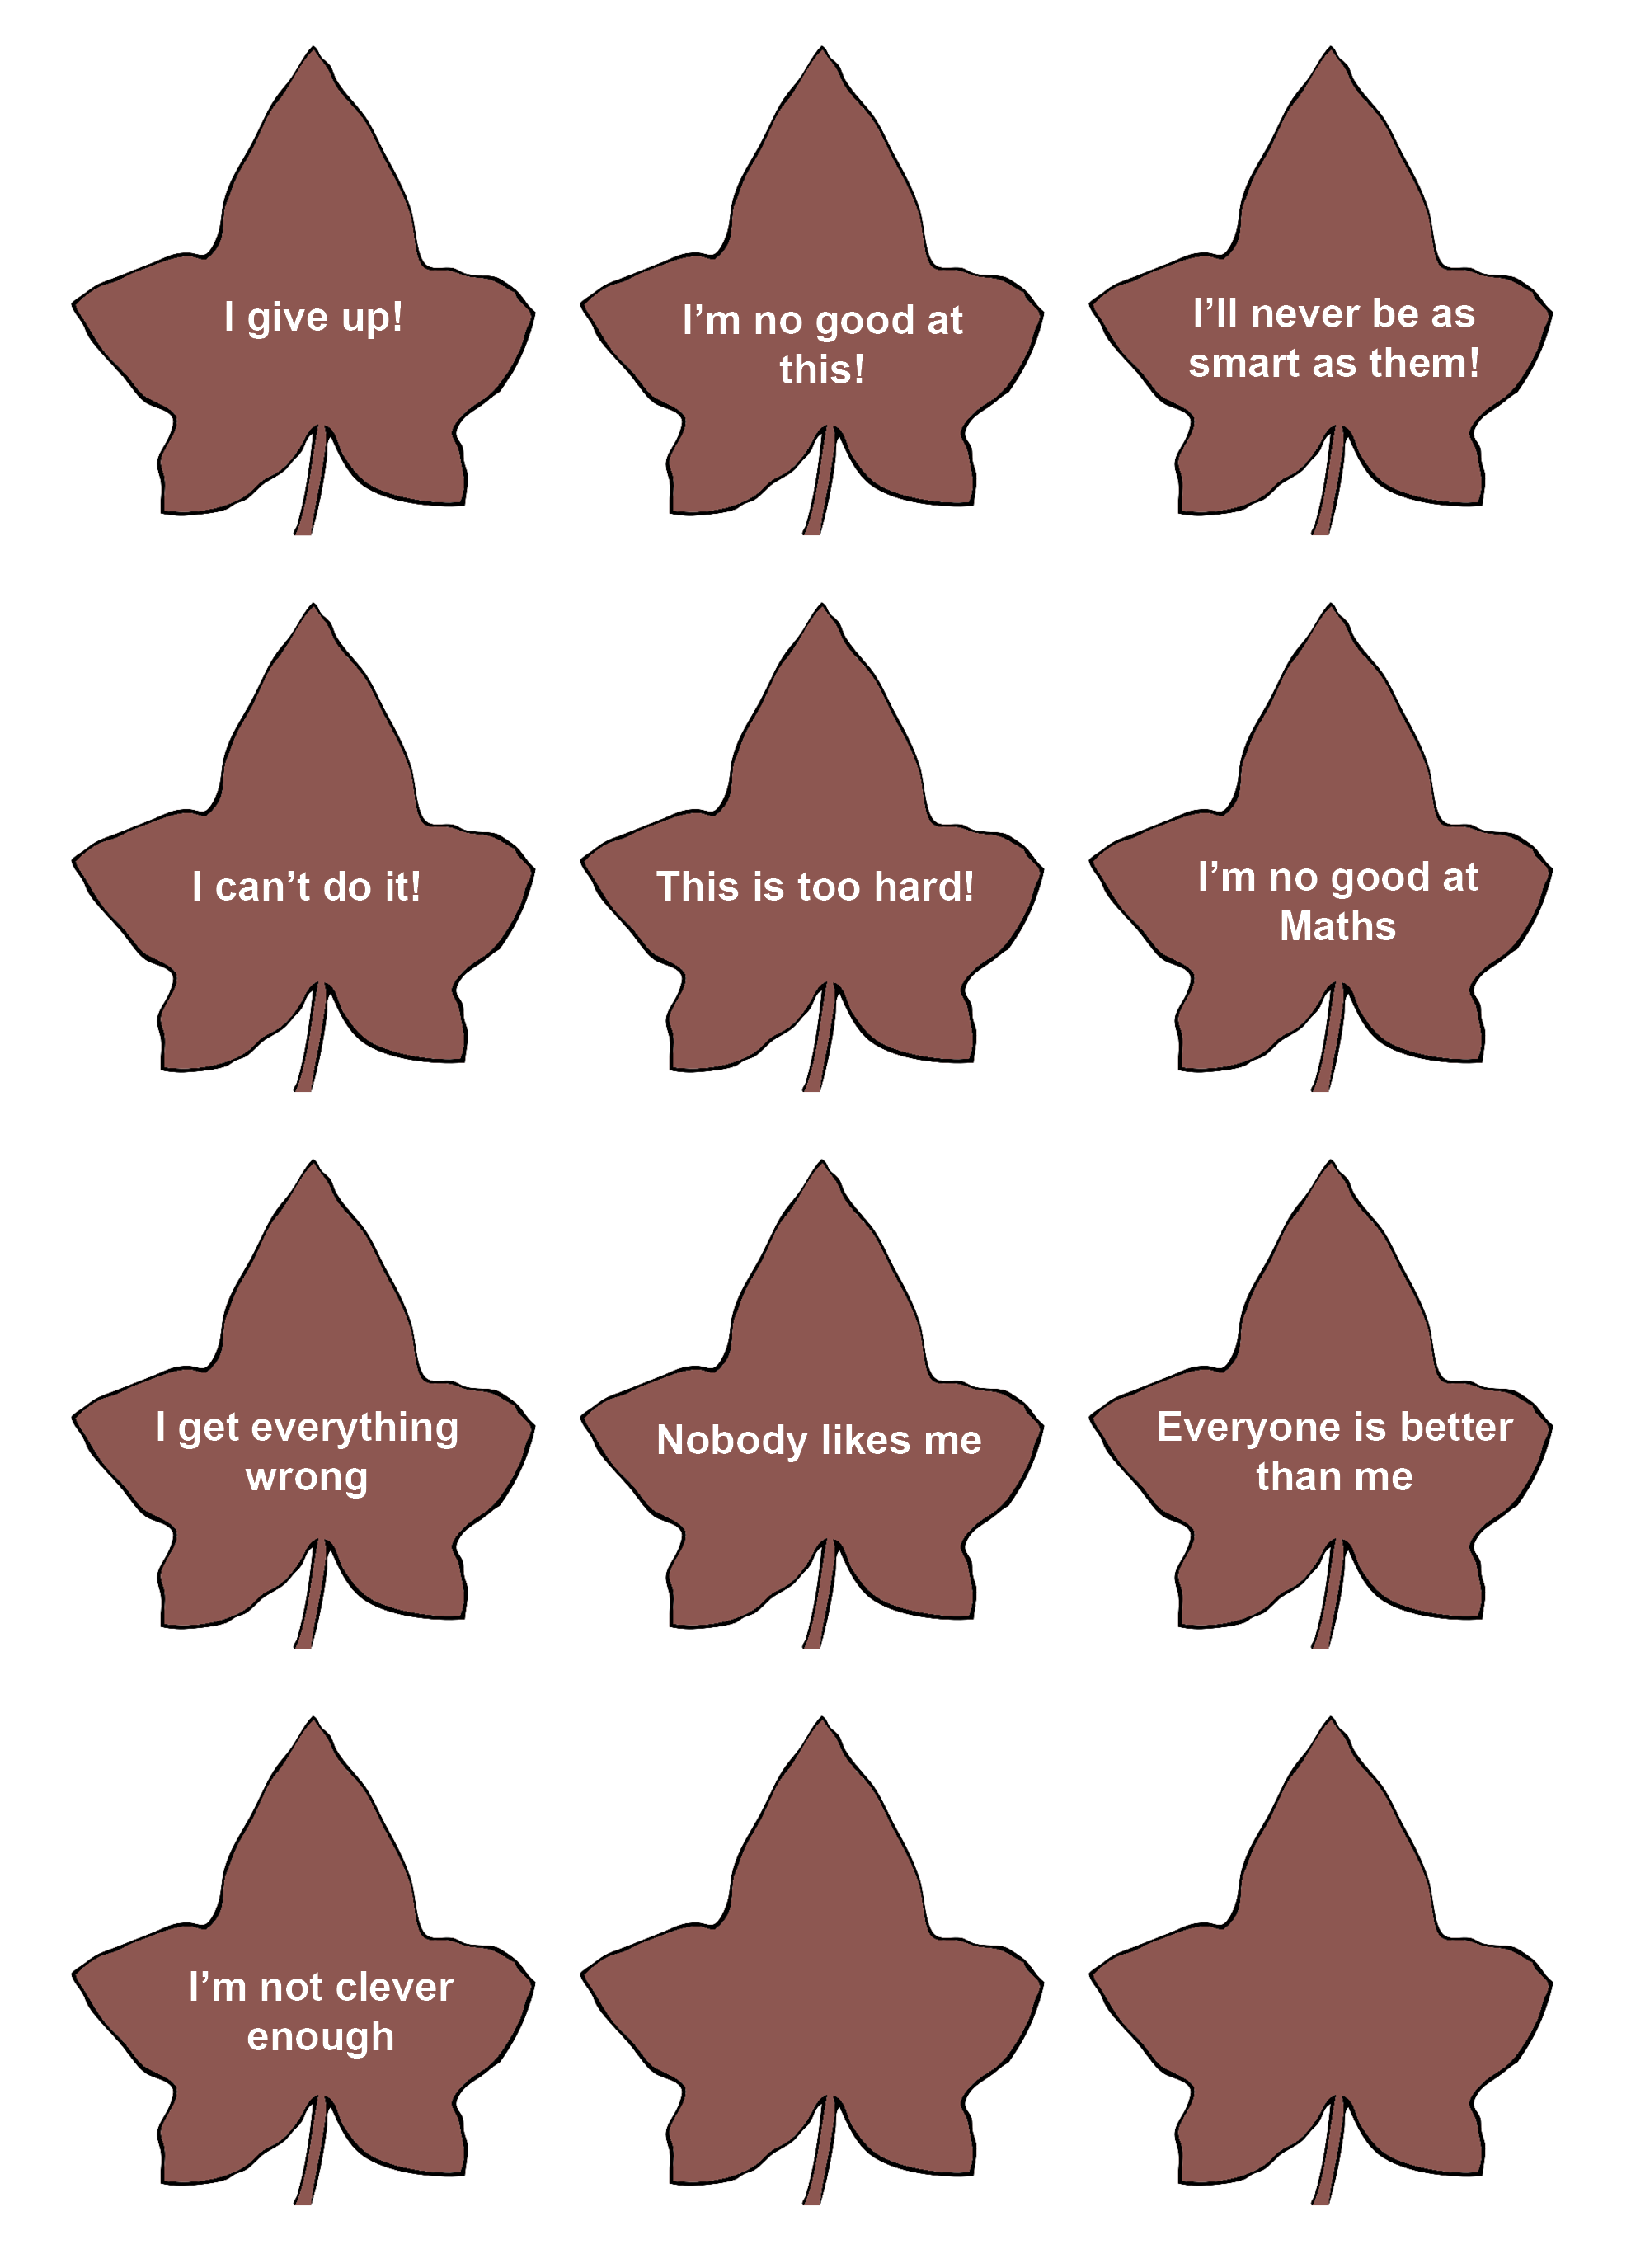Figure 5 – Fixed thinking cards

Appendix 7 – Flexible thinking cards
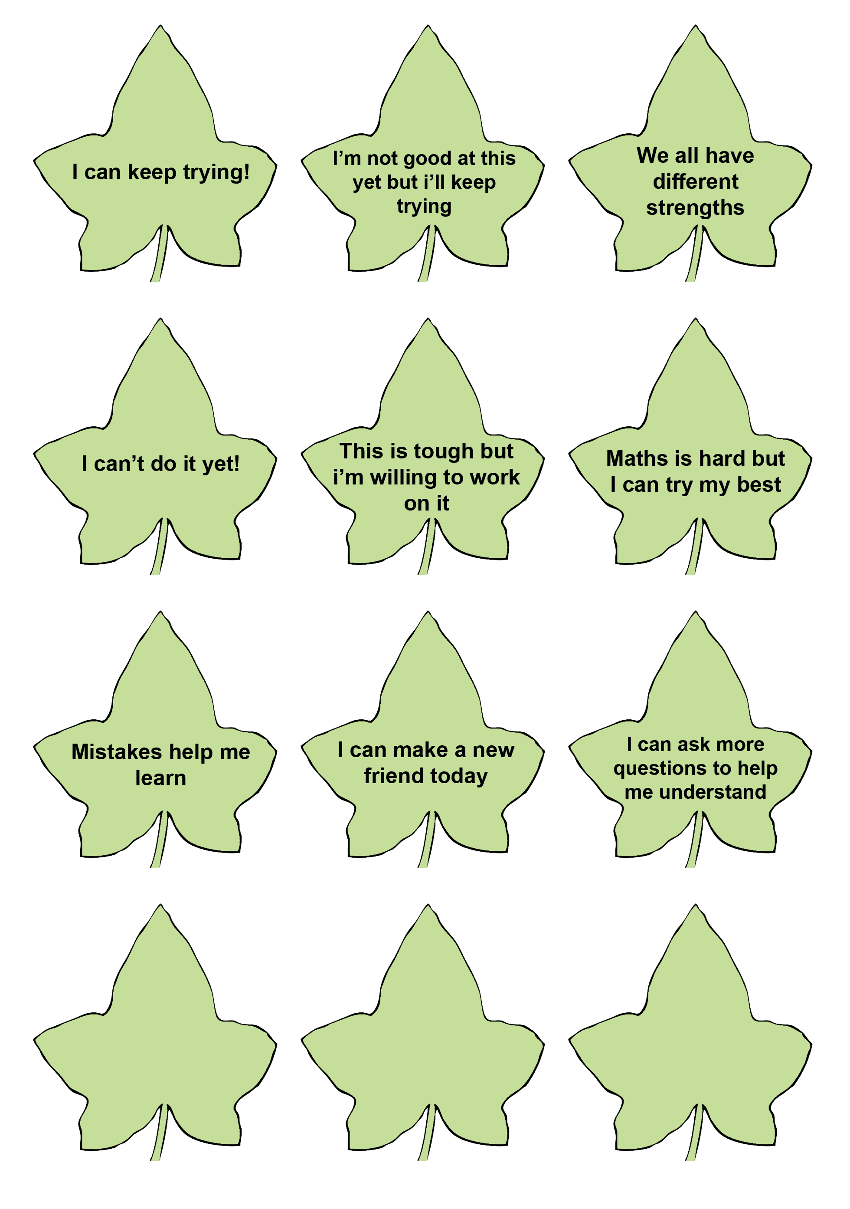
Figure 6 – Flexible thinking cards

Appendix 8 – Scenario cards
When my parents go out | When my pet died
Being in large crowds | Being alone in my bedroom or house
When I hear loud thunder and/or see lightening | Having disagreements with my friends
When I am left out of a game | When I feel embarrassed
When I see scary news on the internet or TV | When I do not understand something in class
Being scared of the dark | Saying goodbye to my parents
Getting lost | When I forget to bring my hat to school
When I have to start a new school | When I start a new school year or new class
When I can not find my friend(s) on the playground | When I forget to bring my lunch to school
When I feel like I do not fit in | When my best friend makes a new friend
Being scared of monsters under my bed | When I get into trouble at school
When I have a test at school | [create your own situation]

Appendix 9 – Emotion images
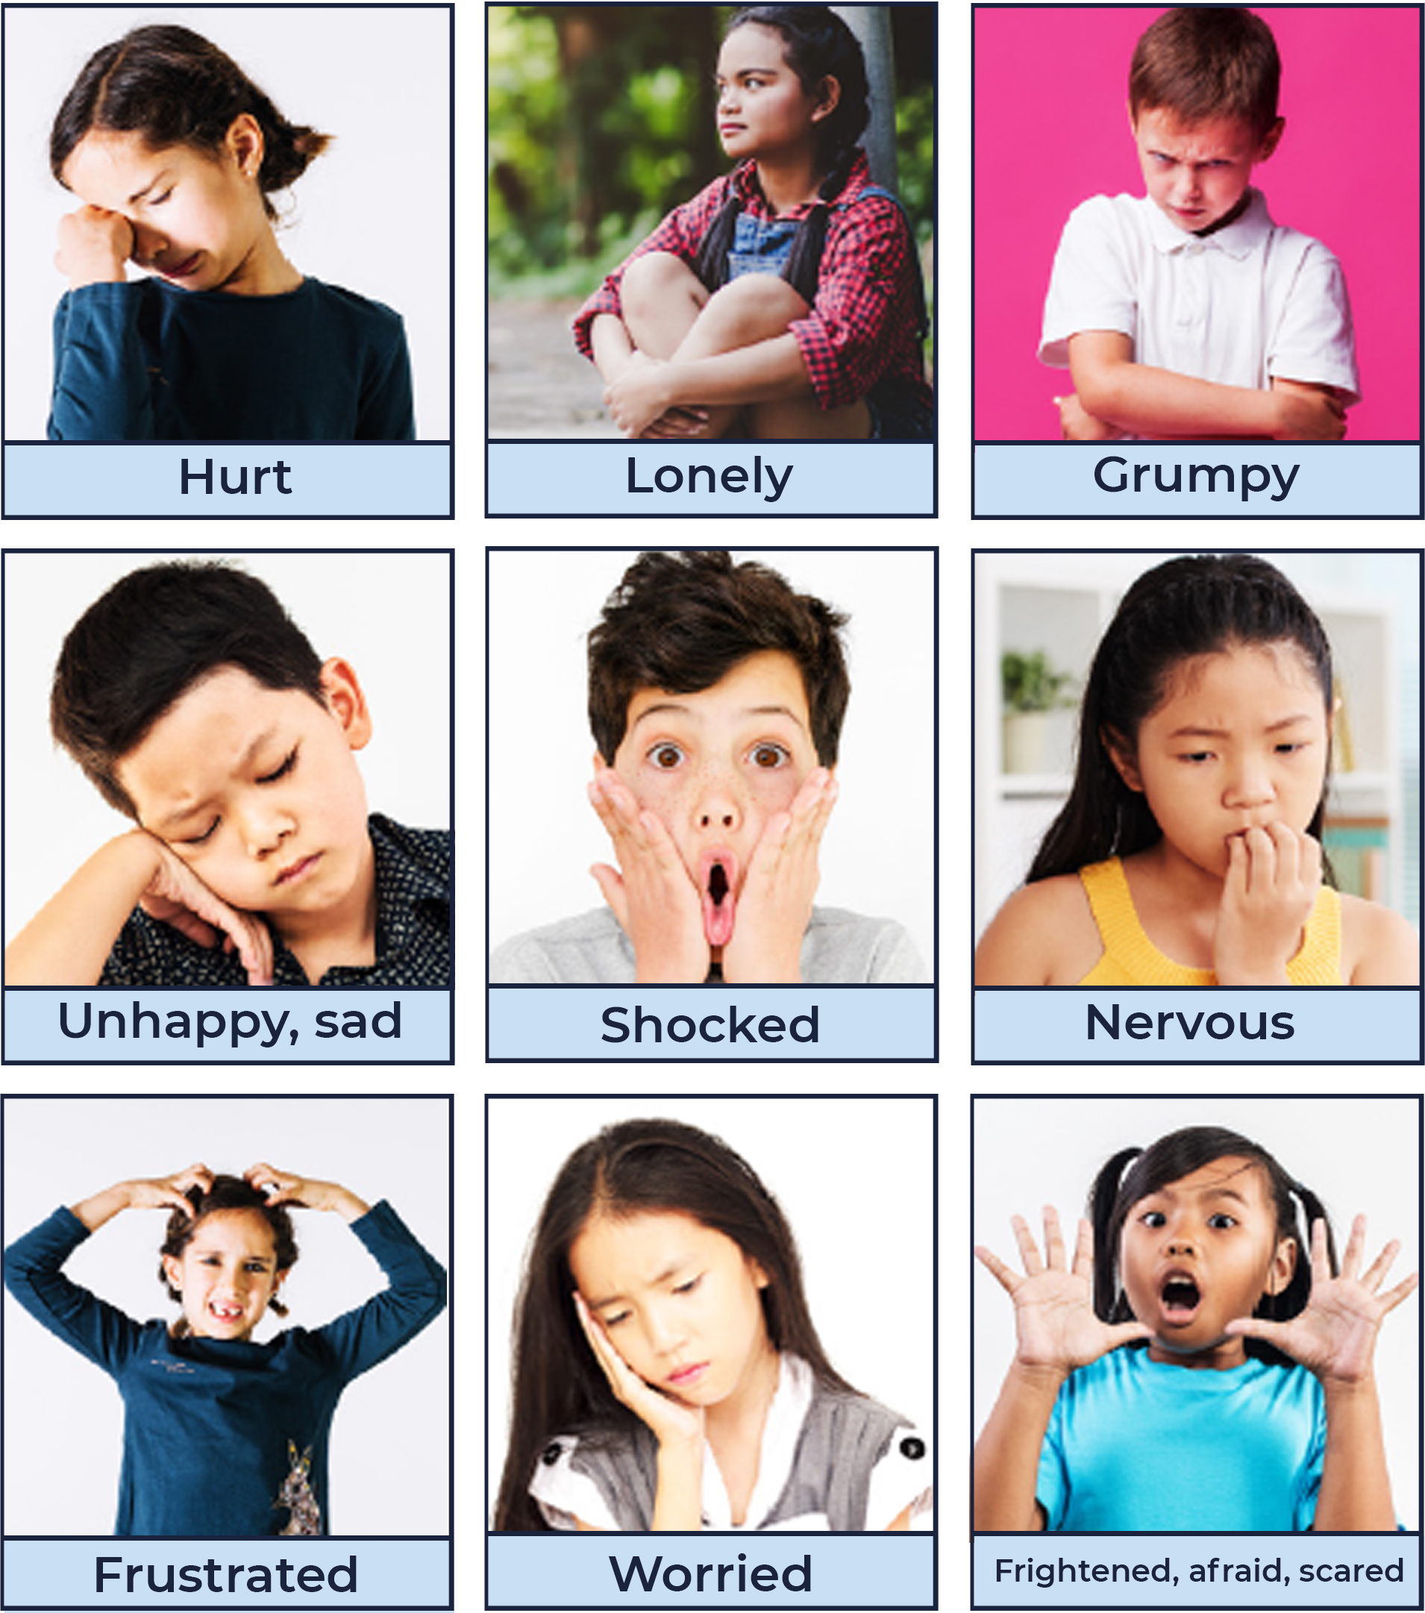
Figure 7 – ‘Emotion cards 1’ – Child Protection Education Resources Stage 1 by PDHPE, Curriculum Early Years and Primary Learners, Image has been created using resources from Freepik.com and is licensed under CC BY 4.0. See Appendix 8 for specific attributions.

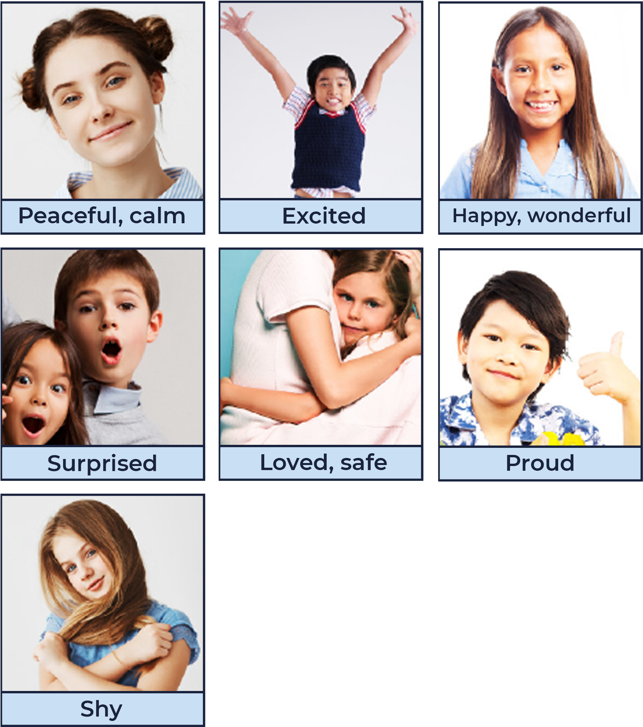
Figure 8 – ‘Emotion cards 2 – Child Protection Education Resources Stage 1 by PDHPE, Curriculum Early Years and Primary Learners, Image has been created using resources from Freepik.com and is licensed under CC BY 4.0.

Appendix 10 – Body signals images
49 | 50
Butterflies in your tummy | Quick breathing
51 | 52
Racing heart | Shaky knees
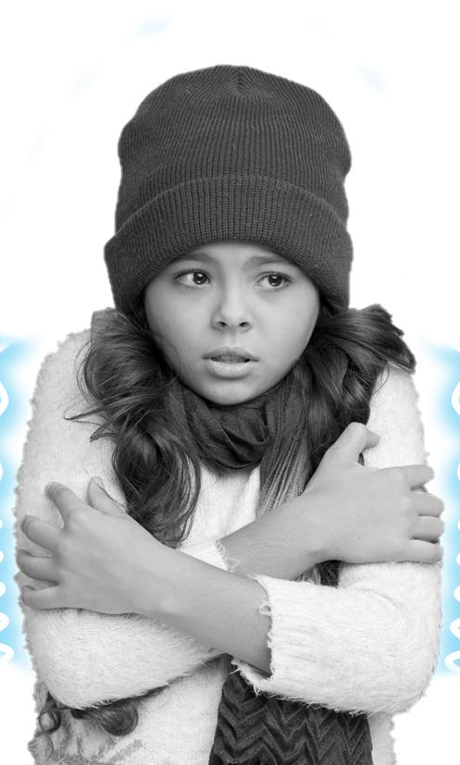 53 | 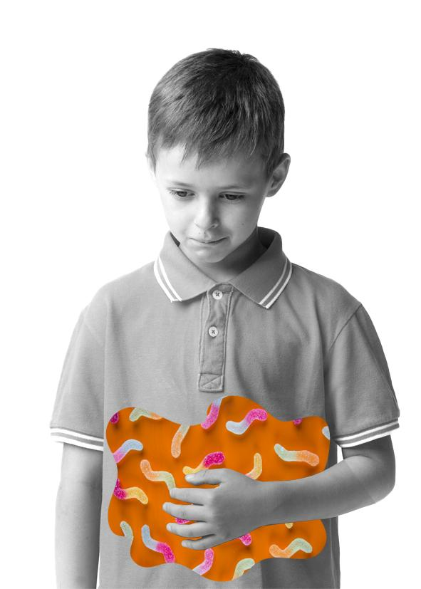54
Cold-shivery body | Squirmy tummy
55 | 56
Sweaty hands | Warm body
‘Body signal images – Child Protection Education Resources by PDHPE, Curriculum Early Years and Primary Learners, Image has been created using resources from Freepik.com and is licensed under CC BY 4.0.

Appendix 11 – Where I feel my emotions
Figure 9 – Emotions person outline

Appendix 12 – Rating my strategies
Strategy name:

What I like about this strategy:

When do I think I can use this strategy?

Strategy name:

What do I like about this strategy?

When do I think I can use this strategy?

Strategy name:

What do I like about this strategy?

When do I think I can use this strategy?
Strategy name:

What do I like about this strategy:

When do I think I can use this strategy?

Strategy name:

What do I like about this strategy:

When do I think I can use this strategy?

Strategy name:

What do I like about this strategy:

When do I think I can use this strategy?

Unit learning intentions and success criteria

Lesson 1
What makes me who I am?
Learning intention – Describe what makes me who I am.
Table 12 – Lesson 1 success criteria
All students | Stage 1 | Stage 2 | Stage 3
Identify my unique strengths and qualities. | Recognise qualities that make them similar and different to others. | Explain factors that influence the development of personal identity. | Explain how personal identity can change over time.

Lesson 2
What is important to you?
Learning intention – Explain what values are and how they support me to be resilient.
Table 13 – Lesson 2 success criteria
All students | Stage 1 | Stage 2 | Stage 3
- Identify who and what they value.  - Identify people and places they can access for support. | Explain how their values are different to other peoples. | Identify factors that influence who and what they value. | Explain factors that influence who and what they value.

Lesson 3
How can I think differently?
Learning intention – Explain how we can use our strengths to overcome challenges.
Table 14 – Lesson 3 success criteria
All students | Stage 1 | Stage 2 | Stage 3
- Identify fixed and flexible mindsets.  - Recognise that people have different thoughts, feelings and responses to different situations. | Describe how people can use their strengths to think positively about challenges. | Explain how people can use their strengths to apply optimistic thinking and how overcoming challenges can make them feel good. | Explain how people can use a range of strategies to overcome challenge and how this can contribute to our identity and the way we feel about future challenges.

Lesson 4
How can we use our strengths?
Learning intention – Explain how we can use our strengths to overcome challenges.
Table 15 – Lesson 4 success criteria
All students | Stage 1 | Stage 2 | Stage 3
Recognise that people have different thoughts, feelings and responses to different situations. | Describe how others’ strengths contribute to successful outcomes. | - Explain how persistence can help solve problems or challenges faced by others.  - Explain how persistence and meeting challenges strengthens identity. | Identify how personal strengths and qualities contribute to identity and inform views.

Lesson 5
How can my emotions change?
Learning intention – Describe our emotions and how they can change.
Table 16 – Lesson 5 success criteria
All students | Stage 1 | Stage 2 | Stage 3
Identify and describe different emotions | Describe different emotions based on people’s reactions, body language and what they say. | - Identify and describe their own emotions and how they may be different to other peoples in various situations.  - Recognise different influences on our emotions. | - Explain different influences on our emotions.  - Explain how our emotions can influence our decision-making.

Lesson 6
How can we manage emotions?
Learning intention – Describe strategies to help manage emotions.
Table 17 – Lesson 6 success criteria
All students | Stage 1 | Stage 2 | Stage 3
Recall and share emotional responses to different situations. | Recognise positive ways to respond to different situations. | Describe strategies to manage their emotions and make a positive decision. | - Explain how emotional responses can influence our decision-making.  - Describe how emotional responses can vary according to the situation.

Lesson 7
What strategies work for me?
Learning intention – Describe strategies that can support me to build resilience.
Table 18 – Lesson 7 success criteria
All students | Stage 1 | Stage 2 | Stage 3
Communicate their thoughts and feelings in a variety of ways. | Recognise their own emotions and body reactions to a range of situations and identify positive ways to respond. | Describe and practice ways to respond positively to challenge and overcoming adversity. | - Plan and practice personal strategies to manage emotions and respond to challenges.  - Explain how strategies used may vary for different situations and other people.

Lesson 8
Resilient rock stars
Learning intention – Describe strategies to help manage emotions.
Table 19 – Lesson 8 success criteria
All students | Stage 1 | Stage 2 | Stage 3
- Recognise that people have different thoughts, feelings and responses to different situations.  - Communicate their thoughts and feelings in a variety of ways. | - Recognise their own emotions and body reactions to a range of situations.  - Identify a challenging situation and demonstrate a strategy they can use to respond positively. | - Describe and practice ways to respond positively to challenge and overcoming adversity.  - Explain how they feel when they achieve success and how this supports them to face future challenges. | - Plan and practice personal strategies to manage emotions and respond to challenges.  - Explain how strategies used may vary for different situations and other people.  - Explain how overcoming challenges strengthens their identity.

