How can I keep myself and others safe?
PDHPE Early Stage 1

10 weeks Term – Year –
Big idea and key concept 2
Essential question and unit title 2
Unit description 2
Contextual statement 2
Skills and propositions 2
Observational framework 4
Organisation of teaching and learning activities 5
Lesson 1 6
Lesson 2 8
Lesson 3 10
Lesson 4 12
Lesson 5 14
Lesson 6 16
Lesson 7 18
Lesson 8 21
Lesson 9 22
Lesson 10 25
Evaluation 26
Resources 26
Vocabulary/glossary 27
Appendix 1 – people who keep me safe 29
Appendix 2 – how this person keeps me safe 31
Appendix 3 – safe places to play 32
Appendix 4 – rules to keep safe 33
Appendix 5 – identifying safe and unsafe situations 34
Appendix 6 – making a situation safer 35
Appendix 7 – feelings images 36
Appendix 8 – Harry the friendly dog 35
Appendix 10 – signs and symbols 36
Appendix 11 – my sign or symbol 37
Appendix 12 – No-Go-Tell flash cards 38
Appendix 13 – No-Go-Tell worksheet 39
Outcomes and other syllabus material in this document are copyright.
PDHPE K-10 Syllabus © NSW Education Standards Authority (NESA) for and on behalf of the Crown in right of the State of New South Wales 2018.

Big idea and key concept
The ‘big idea’ is the over-arching concept that is being addressed or challenged throughout the unit. For example, “risk-taking is healthy”.
People may approach safety differently. These approaches can change over time.

Essential question and unit title
This question drives both teaching and learning within the unit. Every activity should be working towards answering this question. For example, “How can I manage risk and still have fun?”
How can I keep myself and others safe?

Unit description
Students investigate safe and unsafe features of specific environments and explore actions to enhance their own and others’ safety and wellbeing. Through practical application students develop help-seeking skills and adopt strategies to help keep themselves and others safe. Students develop their ability to analyse and gather information in order to make informed decisions, assess risk and find solutions in order to promote their own and others’ health, safety and wellbeing.

Contextual statement
The evidence collected to support the development of this unit.
As students are entering the school environment, they need to develop their self-awareness and take greater responsibility for their actions, feelings and behaviours. By creating an awareness of safe behaviours people are empowered to use strategies that will help to promote their own and others health, safety and wellbeing. All students have the right to feel safe and should be supported to develop help-seeking strategies and a network of trusted adults.

Skills and propositions

Skills in focus
What specific skills are being learned, developed and applied throughout this unit of work? Refer to pages 27-30 of the PDHPE K-10 syllabus

Self-management skills (S)
- Strengthening personal identity
  - self-evaluation.
- Self-awareness
  - self-monitoring thoughts, feelings and actions
  - developing greater control and responsibility for our actions, feelings and behaviours
and weaknesses.
- Emotion and stress management
  - recognising emotions.
- Decision making and problem solving
  - finding solutions to problems
- Help-seeking
  - recognising when help is needed
  - accessing support and support networks.

Interpersonal skills (I)
- Communication
  - expressing emotions.
- Collaboration, inclusion and relationship-building
- Social awareness
  - perspective taking.

Movement skills (M)
- Health and fitness enhancing movement
  - Managing risk and promoting safety.

Propositions

Focus on educative purpose
Students develop the knowledge and skills required to recognise emotional and behavioural warning signs in unsafe situations and to react in safe and positive ways. They will create, practise and evaluate strategies to keep themselves safe.

Take a strengths-based approach
Students will be encouraged to draw upon their own strengths and capabilities to further strengthen their knowledge, skills and understandings, while they are learning to deal with safe and unsafe situations.

Critical inquiry approach
Students are supported to question and challenge the actions of others that impact on their own health and safety. This enables students to develop skills to recognise safe and unsafe situations, identify warning signs and learn help-seeking strategies.

Health literacy
Students explore who they can access to support their own and others safety. They identify environmental supports that maintain and promote safety for themselves and others. For example, rules, safety signs and support personnel.

Organisation of teaching and learning activities

Key inquiry questions and syllabus content
What syllabus content is being addressed in each teaching and learning activity?

Teaching and learning activities
A detailed description of the teaching and learning strategies that the teacher will provide for students to learn, develop and apply knowledge, understanding and skills. The following sub-headings are used.

Activity
A description of the suggested teaching and learning activity.

Teacher notes
Information that may support teachers with delivery of the teaching and learning activities. This may include concepts and content that may be deemed to be sensitive and/or controversial.

Discussion
The suggested discussion opportunities should be delivered in a manner that best suits your context. These can be between peers, in small groups, as a whole class or a one-on-one teacher-student conference. Sample questions and scenarios may be adapted to meet student needs in a manner that is reflective of school and community context.

Reflection
The suggested reflection that links to the essential question that is also the unit title. This question drives teaching and learning and all activities have been designed to enable students to answer it. This reflection provides further opportunity to reinforce student learning and may act as an ongoing demonstration of student knowledge, understanding and skills.

Resources
A list of resources required to deliver the lesson as described. Teachers may choose to use alternative learning tools and activities that best meet student needs. Alternative examples include learning tools and activities from the department’s Digital Learning Selector.

Lesson 1
Lesson 1 – Assessment framework
Outcomes | Unit learning goals – students are learning to | Evidence of learning – students can
PDe-2 identifies people and demonstrates protective strategies that help keep themselves healthy, resilient and safe. | identify help-seeking and protective strategies including trusted adults that help keep them safe. | identify their support network. Activity 2, 3

Key inquiry questions and syllabus content
How can we care for and include each other?
- Practise interpersonal skills to interact positively with others for example:
  - identify people that can help in different situations eg when injured, hurt, upset or worried about a family member or friend.
What helps us stay healthy and safe?
- Describe how individuals help on another to stay healthy and safe in various environments; for example:
  - Recognise people they trust, who keep them safe and how they make them feel supported.

Teaching and learning activities
Teaching considerations

Lesson 1 – support networks

Teacher notes
Explain to students that this unit focuses on safety and how they can keep themselves and others safe.

Activity 1
Pose the question ‘What is safety?’ Compose a class definition of what safety is, for display.

Teacher notes
Safety means to be protected and kept from harm or danger.

Discussion
Sometimes to keep safe we/they may need other people to help us. Discuss with students that we have relationships with people we know. We are connected to people in different ways.

Activity 2
Brainstorm and record people they know that fit under the three categories,
- family (mother, father, siblings, aunty, uncle, step-family members, foster parent, grandparents, cousins)
- friends (from school, sports team/club, with similar interests/hobbies/likes, music club)
- other people who help me (teacher, doctor, shop keeper, neighbour, coach, police officer).
Responses may be displayed by individual students or collated by the teacher and displayed for the whole class.

Teacher notes
Teachers should be mindful that for some EAL/D students, particularly those from refugee backgrounds, their experiences with other people may differ from their peers. People that we perceive as safe, for example, the police, may not be viewed in the same way by some of our students due to their experiences. Clarification with students may be required.

Discussion
Students respond to the following questions,
- What is trust? (We feel safe and supported by people we trust and know that they’ll do the right thing.)
- Can you trust everyone you know? What makes you say that?
Students think, pair, share who they have a relationship with, who they trust and why.

Activity 3
My support network – hand tracing activity. Students:
- trace an outline of their hand.
- identify up to 5 people who they have a trusted relationship with.
- record the names of the people along the fingers of the hand outline.

Discussion
Invite students to share their hand outlines with the class and discuss how each trusted person makes them feel supported and safe. Encourage students to explain when they might seek help from that person. For example, Teacher – when I have a problem on the playground.

Teacher notes
Trusting relationships are based on shared, prior experiences which form the basis for trust. For example, you cannot trust strangers as you do not as yet have a relationship with them.
Teachers should acknowledge and understand the significance of different family and kinship structures within Aboriginal families, and how these influence social and cultural relationships, and connections to personal health decisions, behaviours and choices.

Reflection
The reflection activity is included at the end of every lesson. This supports students to connect all the knowledge, understanding and skills developed and applied throughout the unit. Students will gradually develop a response to the unit’s essential question (unit title) as they first safe and unsafe environments before focusing on the strategies they can use to manage them.
Students reflect upon the learning in this activity/lesson and consider how it contributes towards answering the essential question “How can I keep myself and others safe?” Students may record responses in a variety of ways this may include student journal, illustrations, recorded verbal response, written response or digitally.

Resources
Paper, pencils (lead and coloured)

Lesson 2
Lesson 2 – Assessment framework
Outcomes | Unit learning goals – students are learning to | Evidence of learning – students can
PDe-2 identifies people and demonstrates protective strategies that help keep themselves healthy, resilient and safe. | identify help-seeking and protective strategies including trusted adults that help keep them safe. | identify specific adults who keep them safe and how they do this. Activity 1, 2

Key inquiry questions and syllabus content
What helps us stay healthy and safe?
- Describe how individuals help one another to stay healthy and safe in various environments, for example:
  - recognise what makes an environment safe and supportive e.g. ‘no hat, no play, rule’.
  - recognise people they trust, who keep them safe and how they make them feel supported.

Teaching and learning activities
Teaching considerations

Lesson 2 – people who keep me safe – in specific environments

Discussion
Students respond to the question, ‘Who can help to keep you safe on the school playground?’
Examples may include teachers on duty, a friend, school leader, buddy, canteen helper, principal.

Activity 1
Students draw and label two people who help to keep them safe in the school playground (Appendix 1 – People who keep me safe). Students discuss how these people keep them safe.

Discussion
There are possible dangers in all environments for students. Possible dangers could be equipment or lack of, time of day, people and supervision, physical factors such as depth of water or traffic. Some of these environments include
- playing in the park/playground
- riding your bike/scooter
- playing at the pool/dam/river/beach
- crossing the road.
Students respond to the following questions for each situation listed above.
- What are the possible dangers?
- Who can help the students stay safe?
- How these people can help the students?
- What else could make these environments safe?

Teacher notes
- When discussing the possible dangers ensure the locations are relevant to the students to maintain an authentic learning experience. For example, when discussing the dangers of crossing the road use the road that the school is on.
- Student discussions should not be limited just to these examples of environments. Other environments may be identified by students. For example, a friend’s farm, home, ski fields.

Activity 2
Students select one environment and draw a picture of how the chosen person can keep them safe. For example, students may draw a picture of the crossing supervisor helping them cross the road (Appendix 2 – How this person keeps me safe).

Reflection
Students reflect upon the learning in this activity/lesson and consider how it contributes towards answering the essential question “How can I keep myself and others safe?” Students may record responses in a variety of ways this may include student journal, illustrations, recorded verbal response, written response or digitally.

Resources
- Appendix 1 – People who keep me safe
- Appendix 2 – How this person keeps me safe

Lesson 3
Lesson 3 – Assessment framework
Outcomes | Unit learning goals – students are learning to | Evidence of learning – students can
PDe-6 explores contextual factors that influence an individual’s health, safety, wellbeing and participation in physical activity. | explore the safety of various environments, relationships, rules and procedures. | identify features of a specific environment that make it safe or unsafe. Activity 1  identify rules to keep themselves and others safe. Activity 2

Key inquiry questions and syllabus content
What helps us stay healthy and safe?
- Describe how individuals help one another to stay healthy and safe in various environments, for example:
  - recognise what makes an environment safe and supportive e.g. ‘no hat, no play, rule’.
  - recognise people they trust, who keep them safe and how they make them feel supported.
How do we make healthy and safe choices in different situations?
- identify a number of possible skills and strategies to stay safe and be supportive, for example:
  - discuss different ways that the community and built environments support people and help to keep them safe, eg fences around playgrounds.

Teaching and learning activities
Teaching considerations

Lesson 3 – identifying safe places to play and rules that keep us safe

Discussion
Students respond to the following questions,
- Where are safe places to play? What makes them safe? For example, the park where an adult is watching me, the playground where the ground is ‘soft fall’/rubber, our backyard that is fenced and away from the road, the bike track with safety signs and rules to follow.
- Where are unsafe places to play? What makes them unsafe? For example, the driveway where a car may move, the road with traffic, the garage with tools, the laundry with cleaning chemicals, the garden shed with no adult supervision.

Activity 1
Students draw a picture of one safe place to play (Appendix 3 – Safe place to play). Ensure students include features that make it safe, for example, a teacher watching and gates around the playground.
Students discuss what makes the place they have drawn safe? (Appendix 3 – Safe place to play)

Teacher notes
- Encourage students to elaborate on features, supervision and rules that make this space safe. Features may include fences, soft fall ground cover, distance away from a road, equipment is good condition, safety chains on swings.
- To stimulate discussion, posters/digital images of your local environments that are safe to play in may be displayed to support students in recognising suitable examples.

Discussion
Students respond to the question, ‘What makes a school playground safe?’
Examples may include soft grass, line markings on stairs or out of bound areas, railings on stairs, soft fall under the playground equipment, teachers on duty, playground rules and consequences, active and passive areas.
Students respond to the following questions:
- What are rules? For example, instructions we need to follow.
- What do rules do? For example, keep people safe, protect people.
- Why are rules important? For example, without them people would get hurt.
- What are some rules we follow at school? For example, PBL, no hat no play.

Activity 2
Students write or draw 3 playground rules that help keep them safe (Appendix 4 – Rules to keep safe). School playground rules may include no running on the concrete, taking turns on the play equipment, sit down while eating, no hat – no play.

Reflection
Students reflect upon the learning in this activity/lesson and consider how it contributes towards answering the essential question “How can I keep myself and others safe?” Students may record responses in a variety of ways this may include student journal, illustrations, recorded verbal response, written response or digitally.

Resources
- Appendix 3 – Safe place to play
- Appendix 4 – Rules to keep safe

Lesson 4
Lesson 4 – Assessment framework
Outcomes | Unit learning goals – students are learning to | Evidence of learning – students can
PDe-6 explores contextual factors that influence an individual’s health, safety, wellbeing and participation in physical activity. | explore the safety of various environments, relationships, rules and procedures. | identify features of a specific environment that make it safe or unsafe. Activity 1, 2
PDe-2 identifies people and demonstrates protective strategies that help keep themselves healthy, resilient and safe. | identify help-seeking and protective strategies including trusted adults that help keep them safe. | identify features to improve the safety of an environment. Activity 3

Key inquiry questions and syllabus content
What helps us to stay healthy and safe?
- Describe how individuals help one another to stay healthy and safe in various environments, for example:
  - recognise what makes an environment safe and supportive, eg ‘no hat, no play’ rule, vegetable garden.

Teaching and learning activities
Teaching considerations

Lesson 4 – investigating safe and unsafe places to play

Discussion
The safety of an environment can depend on both the safety features present and the activity the person is completing.
Students respond to the question, ‘Why isn’t it safe to play handball in the kitchen. For example, breaking something, hurt yourself on something sharp like glass or knives, the floor could be slippery, you could burn yourself on the oven.

Activity 1
Students walk to and observe the school play equipment to identify and discuss,
- safe and unsafe features of the play equipment
- safe and unsafe activities to do on the play equipment.

Teacher notes
If the school does not have play equipment use another play area such as the COLA, school oval, handball courts.
Students look at the images in Appendix 5 – safe and unsafe situations and consider how safe the pictured environment is to play. They record their answers on the traffic lights using the following codes,
- Red means stop. This is not a safe place to play.
- Orange means wait. This place may or may not be safe to play.
- Green means go. This is a safe place to play.

Teacher notes
Ask students to consider things like adult supervision, weather, protective clothing and equipment, time of day, type of activity, personal strengths, self-confidence, number of participants.

Activity 2
- Students think/pair/share why they have chosen that colour for each image.
- Teacher selects one of the images and as a class students discuss how it could be made safer.

Teacher notes
Images selected do not have to be from the appendix. You may choose to return to the playground setting from earlier in the lesson instead of using an image. This may provide a more authentic learning experience.

Activity 3
Students look at the image in Appendix 6 - Making a situation safer. They identify how the situation could be made safer by drawing/labelling specific safety features. For example, student behaviour – walking to the crossing to cross the road, physical features and/or people to be included or removed – a crossing supervisor could be present.

Teacher notes
The image in Appendix 6 could be replaced with images from your local area or school. The environment/situation can be changed to suit the needs of the students.
If appropriate when using an alternative picture, teachers may make links to the connection to Country and importance of the land to Aboriginal people. Teachers should investigate if the land holds any cultural significance and may ask the students if they know of any significance to the land in the pictures.

Reflection
Students reflect upon the learning in this activity/lesson and consider how it contributes towards answering the essential question “How can I keep myself and others safe?” Students may record responses in a variety of ways this may include student journal, illustrations, recorded verbal response, written response or digitally.

Resources
- Appendix 5 – Safe and unsafe situations
- Appendix 6 – Making a situation safer

Lesson 5
Lesson 5 – Assessment framework
Outcomes | Unit learning goals – students are learning to | Evidence of learning – students can
PDe-9 practises self-management skills in familiar and unfamiliar scenarios. | self-monitor thoughts feelings and actions. | identify yes/no feelings, when they can occur and who can support them. Activity 1, 2

Key inquiry questions and syllabus content
How can we care for and include each other?
- Identify and describe emotional responses people may experience in different situations for example:
  - recognise emotional responses and experiences that can indicate unsafe situations eg scared, worried.

Teaching and learning activities
Teaching considerations

Lesson 5 – yes/no feelings

Discussion
Revise with students the places or situations in which they feel safe or unsafe. Students respond to the following questions:
- What is a ‘Yes’ feeling? For example, the way I feel when something happens to me that I like.
- What are some examples of a ‘Yes’ feeling? For example, happy, excited, proud.
- What are some examples of times you may have a ‘Yes’ feeling?
- Who might cause you to have ‘Yes’ feelings? For example, someone you trust.
- What is a ‘No’ feeling? For example, the way I feel when something happens to me that I don’t like.
- What are some examples of a ‘No’ feeling? For example, sad, angry, uncomfortable, worried.
- When are some examples of times you may have a ‘No’ feeling? For example, being alone with someone you don’t trust.
- Who might cause you to have ‘No’ feelings? For example, someone you don’t know or trust.

Teacher notes
It is important that teachers are prepared to use protective interrupting if a student begins to disclose private information publicly.
It is also important to avoid categorising a smile as an indication of a YES feeling. A smile for some cultural groups could mean embarrassment, hurt, a put-down or other feelings. This may need to be discussed with students. It should also be explained that it is difficult to know how another person is feeling and it is wrong to assume to know without checking.
When assessing Aboriginal and Torres Strait Islander students, teachers should acknowledge and be sensitive to the different ways of expressing emotions which may impact student involvement and contribution. For example, their use of non-verbal responses, common use of silence, lack of eye-contact and feelings of shame.
Appendix 7 has images of emotional responses which may be used to prompt student’s thoughts.
Teachers may change the picture to provide opportunities for students to see representations of themselves.

Activity 1
Read each scenario. If students think they will experience a ‘Yes’ feeling they should use a ‘thumbs up’ gesture. If they think they would experience a ‘No’ feeling they use a ‘thumbs down’ gesture. Ask students to explain their choice.
For each scenario that evokes a ‘No’ feeling response ask the question, ‘Is there anyone that could help ease that ‘No’ feeling? If so who? For example, being alone in the dark, an adult could turn on the night light.
- being alone in the dark
- lost in the shopping centre/supermarket
- winning a game
- missing the bus home
- seeing a snake while walking in the park
- riding on a roller coaster
- receiving an award at assembly
- going on holidays to the beach
- falling over and hurting your arm really badly
- walking into a spider web.

Teacher notes
Be aware that there may be no one who can ease a student’s ‘No’ feelings. For example, on a roller coaster, no one may ease the fear. Remind students that this is perfectly fine and acceptable. This may lead a discussion about what they might do if there is no one who can ease the ‘No’ feeling. The ‘No Go Tell’ strategy will be covered later in the unit.
Ensure the strategy used allows students to share responses and provides them the opportunity to remain discrete.
Variations for this lesson may include:
- ‘Think and Move’ where students move to a designated ‘Yes’ location in the room or a designated ‘No’ location in the room.
- Using traffic light symbols of Red, Amber and Green (Amber may be used for students that may experience both Yes and No feelings in the same situation. This would require students to explain their choice in greater detail.)
- Plickers – a simple and interactive formative assessment tool.

Activity 2
Students divide a piece of paper in half (A3 or ‘art paper’). On one side the students draw or paint a picture to match the following sentence: “I get a Yes feeling when…”
On the other side draw or paint a picture to match the sentence: “I get a No feeling when…”
Invite students to share their drawings/paintings with the class and discuss the Yes and No feelings for their chosen situations.

Teacher notes
It is important that teachers are prepared to use protective interrupting if a student begins to disclose private information publicly.

Reflection
Students reflect upon the learning in this activity/lesson and consider how it contributes towards answering the essential question “How can I keep myself and others safe?” Students may record responses in a variety of ways this may include student journal, illustrations, recorded verbal response, written response or digitally.

Resources
Large paper such as A3 or ‘art paper’.

Lesson 6
Lesson 6 – Assessment framework
Outcomes | Unit learning goals – students are learning to | Evidence of learning – students can
PDe-9 practises self-management skills in familiar and unfamiliar scenarios. | self-monitor thoughts feelings and actions. | identify yes/no feelings, when they can occur and who can support them. Activity 1
PDe-9 practises self-management skills in familiar and unfamiliar scenarios. | recognise when help is needed and access the appropriate support. | identify warning signals that the body can experience when faced with an unsafe situation. Activity 1

Key inquiry questions and syllabus content
What choices can help make me safe, supported and active?
- Make connections between feelings thoughts, body reactions and body language for example:
  - discuss the concept of privacy and recognise reactions and body signs to safe and unsafe situations.
  - communicate thoughts and feelings about safe and unsafe situations and compare how characters in stories think, feel and react in different situations.

Teaching and learning activities
Teaching considerations

Lesson 6 – warning signals

Discussion
Explore the question, ‘What is a signal?’ Lead discussion towards the definition that a signal is something that sends us a message. Students brainstorm signals they need to take special notice of. For example:
- school bell
- evacuation/lock down alarm
- teacher signals (finger to the lips, hand raised to be quiet)
- a red traffic light
- an ambulance siren
- thunder in the sky
- a burglar alarm
- a bike bell
- a whistle (in a game of netball)
- dog growling.

Teacher notes
Try to develop an understanding that a warning signal doesn’t always have to be something negative.

Discussion
Explore the following questions:
- What message do each of the above signals give?
- What action should you take when you hear/see them?

Activity 1
Explore with students that our bodies have signals which give us special messages. Watch the eBook Mr Jelly by Roger Hargreaves.
Explore the following question, ‘What signal does Mr Jelly get when he is afraid?’ For example, shaky, wobbly tummy.
Introduce the term ‘warning signal’. This can be described as a signal that goes with NO feelings. We can experience these warning signals when we feel unsafe.
Trace outline of one student on large sheet of paper.
Brainstorm a list of situations where students experience NO feelings and warning signals. Record these warning signals students may experience – inside and around the body outline.
Body signals could include – butterflies in tummy, squirmy tummy, warm body, cold-shivery body, feeling sick, sweaty hands, quick breathing, racing heart, frozen heart, smiley face, crying eyes, open eyes, shaky knees, feet stuck, goose bumps, needing to go to the toilet, shaking all over.

Discussion
Explore the following questions:
- What should we do if we have any of these feelings?
- Who could you talk to?

Reflection
Students reflect upon the learning in this activity/lesson and consider how it contributes towards answering the essential question “How can I keep myself and others safe?” Students may record responses in a variety of ways this may include student journal, illustrations, recorded verbal response, written response or digitally.

Resources
eBook – Mr Jelly by Roger Hargreaves.

Lesson 7
Lesson 7 – Assessment framework
Outcomes | Unit learning goals – students are learning to | Evidence of learning – students can
PDe-9 practises self-management skills in familiar and unfamiliar scenarios. | recognise when help is needed and access the appropriate support. | identify feelings/emotions in safe and unsafe situations and who can support them.  Activity 1, 2  identify the feeling/emotions of others and when support is needed. Activity 3

Key inquiry questions and syllabus content
What choices can help make me safe, supported and active?
Students:
- make connections between feelings, thoughts, body reactions and body language, for example:
  - communicate thoughts and feelings about safe and unsafe situations and compare how characters in stories think, feel and react in different situations.

Teaching and learning activities
Teaching considerations

Lesson 7 – communicating feelings in safe & unsafe situations in environments

Activity 1
Discuss what feelings students may experience when playing in:
- safe situations. For example, happy, excited, relaxed
- unsafe situations. For example, scared, confused, worried, sad
Discuss that everybody can have different feelings for the same situation. For example, the class are going on an excursion and will be travelling by bus. Some students might be excited and others might be worried because they suffer from travel sickness.
Display feelings images from Appendix 7 around the classroom. Read each scenario and ask students to move to the corresponding image that matches how they would feel. Once students have moved to the corresponding image ask students to explain why they have chosen that feeling.
Scenarios:
- You are waiting at the bus stop and the bus is late.
- You are going on a beach holiday with your family.
- School bell rings for the end of the day and you cannot remember who is picking you up.
- There is a thunder storm at night and all the lights go out.
- You had to wait until mum finished her lunch before you can swim in the water.
- You fall off your bike and hurt your knee.

Activity 2
Explain that sometimes unsafe situations can make us feel scared. Read the scenario below.
‘Imagine you are lost. It could be in a supermarket, at a fair, in the bush or at the beach.’
Through a class discussion students respond to the following questions:
- What would you be thinking?
- How would you be feeling?
- Who would you tell and what would you say?

Teacher notes
To improve the authenticity of learning teachers may adapt the scenario to match a local context.
When assessing Aboriginal and Torres Strait Islander students, teachers should acknowledge and be sensitive to the different ways of expressing emotions and communicating those emotions, which may impact student involvement and contribution. For example, their use of non-verbal responses, common use of silence, lack of eye-contact and feelings of shame.

Activity 3
Read the story ‘Harry the friendly dog’ while displaying the image in Appendix 8 – What would others think, feel and do?
‘Harry the friendly dog’
“Harry the friendly dog has escaped from his backyard.
He is super excited to see some friends to play with.
Jack and Ryan have been playing hide and seek at the park all morning.
They both hear footsteps and turn to see Harry running towards them.
Jack loves dogs, but Ryan is not so sure………”
In response to the ‘Harry the friendly dog’ story, students think/pair/share the following questions:
- What would Jack and Ryan be thinking?
- How would Jack and Ryan be feeling?
- What would Jack do next?
- What would Ryan do next?
- Which boy would you be similar to?
Students complete Appendix 9 – What might others think, feel and do?
Ask students to share their responses and discuss any differing opinions/responses.
Discuss the following question:
- Which boy would need support?
- How would you support them?

Reflection
Students reflect upon the learning in this activity/lesson and consider how it contributes towards answering the essential question “How can I keep myself and others safe?” Students may record responses in a variety of ways this may include student journal, illustrations, recorded verbal response, written response or digitally.

Resources
- Appendix 7 – Feelings images
- Appendix 8 – Harry the friendly dog
- Appendix 9 – What might others think, feel and do?

Lesson 8
Lesson 8 – Assessment framework
Outcomes | Unit learning goals – students are learning to | Evidence of learning – students can
PDe-6 explores contextual factors that influence an individual’s health, safety, wellbeing and participation in physical activity. | explore the safety of various environments, relationships, rules and procedures. | identify and construct signs and/or symbols that help keep them safe. Activity 1, 2

Key inquiry questions and syllabus content
How do we make healthy and safe choices in different situations?
Students:
- identify a number of possible skills and strategies to stay safe and be supportive, for example:
  - discuss different ways that the community and built environments support people and help to keep them safe, eg fences around playgrounds. recognise safety symbols and procedures for their own and others’ safety in various water environments, eg never swim alone; swim between the red and yellow flags.

Teaching and learning activities
Teaching considerations

Lesson 8 – Identifying signs and symbols to keep us safe

Activity 1
Display images of various environments where signs and symbols are present. For example, local pool, pedestrian crossing, bus stop, main street of your town. Discuss with students what they observe in the images.

Teacher notes
Lead discussion to identification of signs and symbols. Images that relate to your local community could provide a more authentic learning experience. Alternately, images can be found on the Safety Town website.
When students identify signs and symbols pose the questions:
- What do signs and symbols do? For example, provide information and give direction.
- What type of information/direction can they provide? For example, safety messages, warnings, rules.
Explain to students that signs and symbols can be designed to help keep us safe, for example, do not run sign at the swimming pool.
Ask students to identify what signs they know or have seen that help keep them safe.
Students complete Appendix 10 – Signs and symbols, by matching the sign or symbol with their meaning.
Discuss some of the symbols in Appendix 10, asking students what action they would take if they saw that sign/symbol?

Activity 2
Discuss safety rules of the classroom/playground. Students use Appendix 11 – My sign/symbol, to create a safety sign based on a rule they chose. For example, walk in the classroom, sit down while eating lunch.
Students explain their symbol to the class.

Teacher notes
Ensure students are making a sign that reflects a rule that keeps them safe. For example, listen while others are speaking is a rule regarding manners rather than safety.

Reflection
Students reflect upon the learning in this activity/lesson and consider how it contributes towards answering the essential question “How can I keep myself and others safe?” Students may record responses in a variety of ways this may include student journal, illustrations, recorded verbal response, written response or digitally.

Resources
- Safety Town website
- Appendix 10 – Signs and symbols
- Appendix 11 – My sign/symbol

Lesson 9
Lesson 9 – Assessment framework
Outcomes | Unit learning goals – students are learning to | Evidence of learning – students can
PDe-2 identifies people and demonstrates protective strategies that help keep themselves healthy, resilient and safe. | identify help-seeking and protective strategies including trusted adults that help keep them safe. | demonstrate the protective strategy No-Go-Tell in various scenarios. Activity 1, 2

Key inquiry questions and syllabus content
How do we make healthy and safe choices in different situations?
- identify a number of possible skills and strategies to stay safe and be supportive, for example:
  - practise ways of seeking help in a range of different scenarios e.g. call 000 during an emergency , use No-Go-Tell when feeling unsafe.

Teaching and learning activities
Teaching considerations

Lesson 9 – safety procedure No-Go-Tell

Discussion
Read the scenario. You are waiting in line at the canteen to buy your recess. An older student waiting in line says to you, ‘Give me your money!’
Explore the following questions:
- How would this make you feel?
- What warning signals would you feel?

Teacher notes
Expected responses could include the warning signals or ‘NO feelings’ mentioned in previous lessons – refer to body outline with warning signals labelled.

Activity 1
Explain that No-Go-Tell is a strategy they could use in the scenario above.
Brainstorm with student the meaning of each step in No-Go-Tell.
- No – voicing an assertive “no”.
- Go – moving away to a safe environment or adult.
- Tell – tell a trusted person from their support network.
Introduce the No-Go-Tell flashcards found on Appendix 12.
Model the ‘No’ strategy. Teacher and a volunteer role play the above scenario with the teacher playing the role of the younger student:
- modelling an assertive “No”
- modelling a passive “No”
- modelling an aggressive “No”.
Explore which ‘No’ is the most successful in dealing with the situation. Why?

Teacher notes
Be mindful of aggressive “Nos” when role playing assertive “No”. Ensure students understand the difference and possible consequences of an aggressive ‘No’.
Explore the following scenarios and identify what warning signals may be felt:
- Your friend tells you to jump off the top of the climbing equipment.
- A stranger asks you to help them find their lost dog.
- A neighbour you do not know very well has offered to drive you home from school, without your parents telling you that this is the arrangement.
Students role play the above scenarios, taking turns being each character – practising assertive ‘No’ and responding to the following questions’:
- Where would they go?
- When would they go?
- Who would they tell?
- What would they say?
Choose one or more students to demonstrate their role play.

Teacher notes
A stranger is someone you do not know or have a relationship with.

Discussion
Explore the effectiveness of each role play.

Activity 2
Consider the following scenario ‘a neighbour you do not know very well has offered to drive you home from school, without your parents telling you that this is the arrangement.’
Students draw or write their ‘No-Go-Tell’ response in Appendix 13 – No-Go-Tell worksheet, for the scenario.

Teacher notes
Explain to students that sometimes it is hard to say ‘No’ and ‘Go’ but there is something else we can do. If someone has made us feel ‘NO feelings’, has hurt us or touched parts of our bodies that we don’t want them to touch we can tell a trusted person. We can find a trusted person we feel safe with and ‘Tell’ them what has happened. We can tell them how we feel. If they don’t listen or believe us, we can ‘Tell’ them again or ‘Tell’ another a trusted person.

Reflection
Students reflect upon the learning in this activity/lesson and consider how it contributes towards answering the essential question “How can I keep myself and others safe?” Students may record responses in a variety of ways this may include student journal, illustrations, recorded verbal response, written response or digitally.

Resources
- Appendix 12 – ‘No-Go-Tell’ flash cards
- Appendix 13 – ‘No-Go-Tell’ worksheet

Lesson 10
Lesson 10 – Assessment framework
Outcomes | Unit learning goals – students are learning to | Evidence of learning – students can
PDe-2 identifies people and demonstrates protective strategies that help keep themselves healthy, resilient and safe. | identify help-seeking and protective strategies including trusted adults that help keep them safe. | identify and develop a safety procedure.  Activity 1

Key inquiry questions and syllabus content
How do we make healthy and safe choices in different situations?
Students:
- identify a number of possible skills and strategies to stay safe and be supportive, for example:
  - recognise safety symbols and procedures for their own and others’ safety in various water environments, eg never swim alone; swim between the red and yellow flags.

Teaching and learning activities
Teaching considerations

Lesson 10 – safety procedures

Activity 1
Introduce the term ‘procedures’ to students, explaining that a procedure is series of steps or actions. Students respond to the question ‘What is a safety procedure?’
Refer students back to ‘No-Go-Tell’ as a safety procedure.
Students brainstorm safety procedures they follow at school, for example, emergency evacuation, lockdown, using the crossing, eating lunch, before school/early arrival, in the classroom.
Take students to the school exit and discuss the procedure for crossing the road. Emphasise the importance of the order of steps. Ask students to predict possible outcome if the order of steps changed.
Construct a class safety procedure for riding a bike/scooter /skateboard. For example:
- Ask permission from parent/caregiver
- Wear shoes and protective clothing
- Put helmet and protective equipment on
- An adult check your bike/scooter
- Ride in a safe place with supervision.
Students draw or write their own safety procedure for the classroom or school.

Teacher notes
A safety procedure for students should be limited to 5 steps maximum. The class constructed safety procedure can vary to suit the context of the school/community and student needs. For example, safety procedures for bus lines, safety procedures for wet weather.

Reflection
Students reflect upon the learning in this activity/lesson and consider how it contributes towards answering the essential question “How can I keep myself and others safe?” Students may record responses in a variety of ways this may include student journal, illustrations, recorded verbal response, written response or digitally.

Resources
Paper for safety procedure (A4 or A3)

Observational framework for assessment
Outcomes | Unit learning goals – students are learning to | Evidence of learning – students can
The syllabus outcomes that will be assessed against throughout this unit of work. Refer to pages 14-19 of the PDHPE K-10 syllabus. | What students are expected to know, understand and do as a result of the learning within this unit of work. These are derived from the identified syllabus outcomes, content ‘dot’ and dash’ points and the ‘big idea/key concept’. | The specific behaviours you will expect to observe and use as an indicator of student learning towards the unit learning goals and syllabus outcomes.
PDe-2 identifies people and demonstrates protective strategies that help keep themselves healthy, resilient and safe. | identify help-seeking and protective strategies including trusted adults that help keep them safe. | identify their support network.  Lesson 1 – Activity 2, 3  identify specific adults who keep them safe and how they do this. Lesson 2 – Activity 1, 2  identify features to improve the safety of an environment.  Lesson 4 – Activity 3  demonstrate the protective strategy No-Go-Tell in various scenarios. Lesson 9 – Activity 1, 2  identify and develop a safety procedure.  Lesson 10 – Activity 1
PDe-6 explores contextual factors that influence an individual’s health, safety, wellbeing and participation in physical activity. | explore the safety of various environments, relationships, rules and procedures. | identify features of a specific environment that make it safe or unsafe.  Lesson 3 – Activity 1  Lesson 4 – Activity 1, 2  identify rules to keep themselves and others safe.  Lesson 3 – Activity 2  identify and construct signs and/or symbols that help keep them safe. Lesson 8 – Activity 1, 2
PDe-9 practises self-management skills in familiar and unfamiliar scenarios. | self-monitor thoughts feelings and actions. | identify yes/no feelings, when they can occur and who can support them  Lesson 5 – Activity 1, 2  Lesson 6 – Activity 1
PDe-9 | recognise when help is needed and access the appropriate support. | identify warning signals that the body can experience when faced with an unsafe situation.  Lesson 6 – Activity 1  identify feelings/emotions in safe and unsafe situations and who can support them.  Lesson 7 – Activity 1, 2  identify the feeling/emotions of others and when support is needed.  Lesson 7 – Activity 3

Appendix 1 – people who keep me safe

Person 1
Label:

Person 2
Label:

Appendix 2 – how this person keeps me safe
This person keeps me safe by…
This person:
Keeps me safe by:

Appendix 3 – safe places to play
My safe place to play is:
Because of:

Appendix 4 – rules to keep safe
Draw or write 3 rules that keep you safe.
Rule 1 | Rule 2 | Rule 3

Appendix 5 – identifying safe and unsafe situations
Playing on the equipment at the playground – how safe?
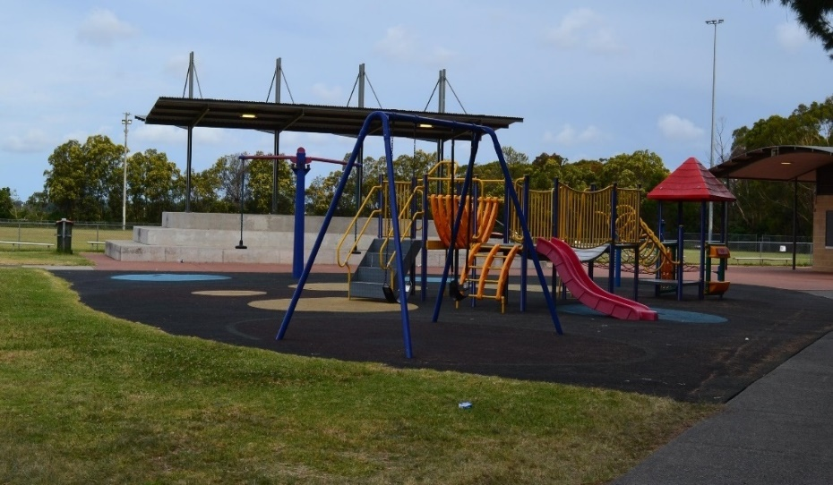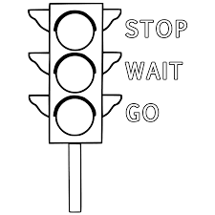
Riding your scooter, bike or skateboard at the skate park – how safe?
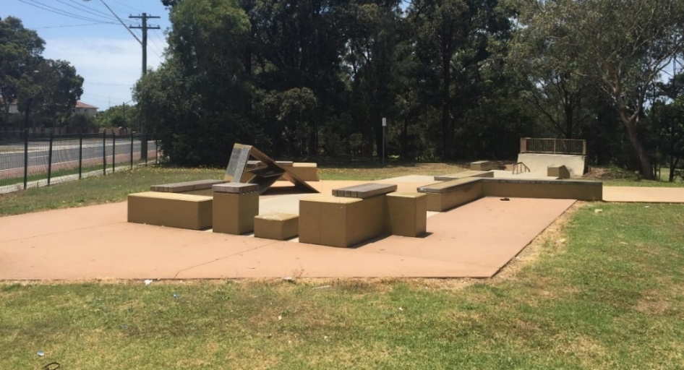
Playing with a ball on the driveway beside the road.
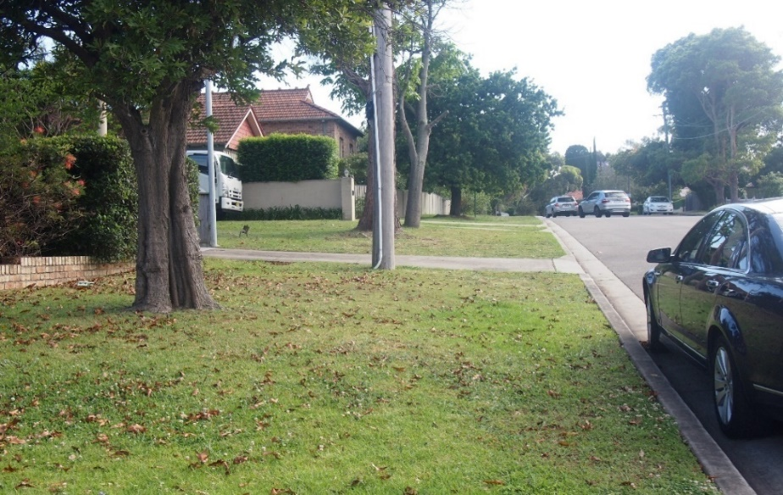
Swimming with friends at the local swimming pool without a life guard.
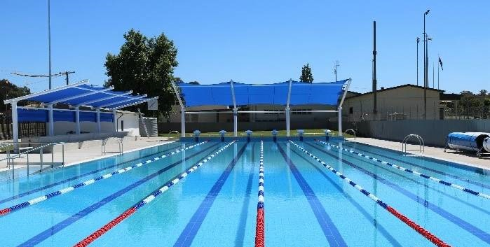

Appendix 6 – making a situation safer

Situation
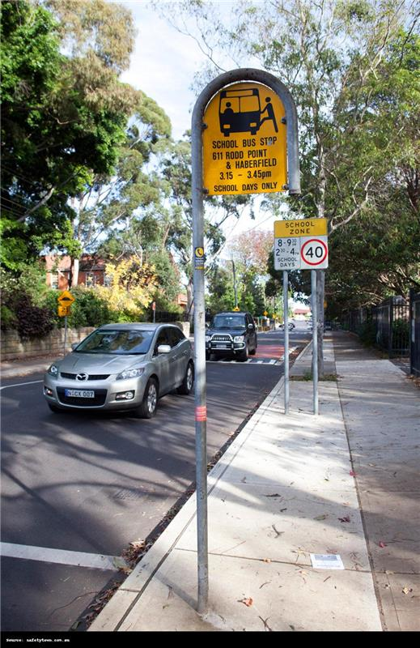

Making a situation safer

Appendix 7 – feelings images
Images from freepik

Excited
Confused
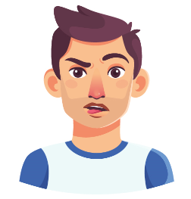
Happy
Scared
Worried
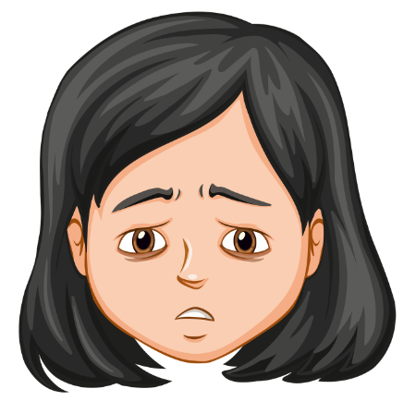
Frustrated
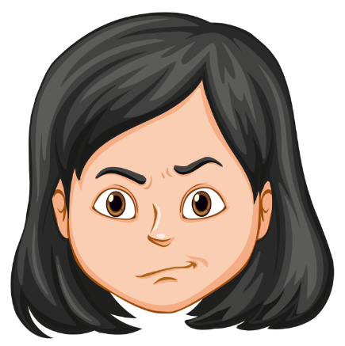
Proud
Sad
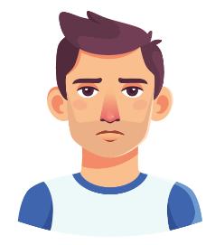

Appendix 8 – Harry the friendly dog

Story
“Harry the friendly dog has escaped from his backyard.
He is super excited to see some friends to play with.
Jack and Ryan have been playing hide and seek at the park all morning.
They both hear footsteps and turn to see Harry running towards them.
Jack loves dogs, but Ryan is not so sure………”

Image
Image from freepik-dog, freepik-scared-boy, freepik-happy-boy.
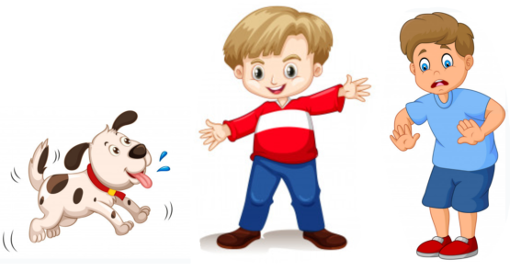

Appendix 9 - What might others think, feel and do?
Character | Circle what each boy is thinking? | Draw how each boy may be feeling? | Predict what they do next
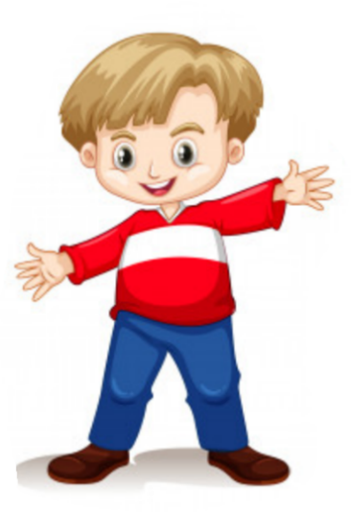  Jack  Image from freepik-happy-boy | Great I love dogs.  Oh no, it’s a big dog.
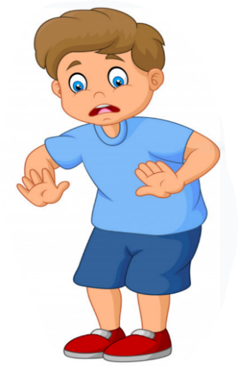  Ryan  Image from freepik-scared-boy | Great I love dogs.  Oh no, it’s a big dog.

Appendix 10 – signs and symbols

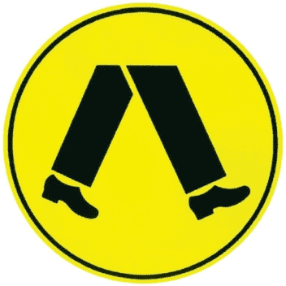
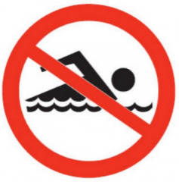
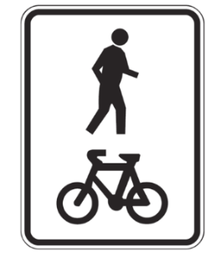
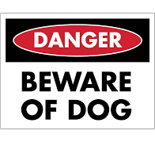
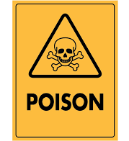
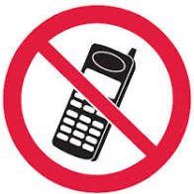
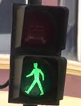
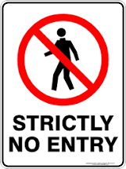
A shared path for pedestrians and cyclists

A pedestrian crossing

A dangerous dog is in here

No swimming

It is safe to cross the road

Do not enter

This is poisonous

Do not use a mobile phone

Appendix 11 – my sign or symbol
My sign or symbol means:

Appendix 12 – No-Go-Tell flash cards
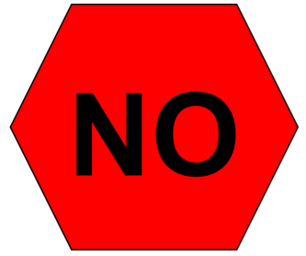
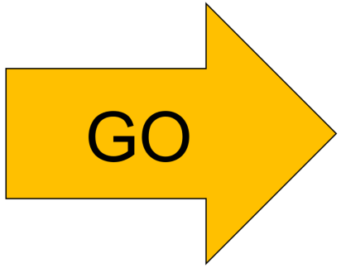
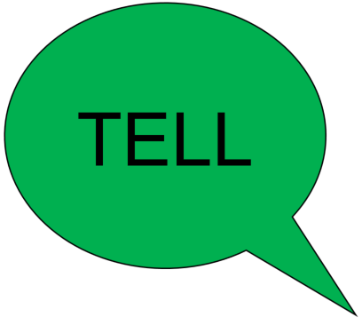

Appendix 13 – No-Go-Tell worksheet

No

Go

Tell

Resources
What resources will the teacher require to deliver this unit of work as planned in the ‘teaching and learning activities’?
- Lesson 1 – paper, pencils (lead and coloured)
- Lesson 2 – appendix 1 – People who keep me safe, Appendix 2 – How this person keeps me safe
- Lesson 3 – appendix 3 – Safe place to play, Appendix 4 – Rules to keep safe
- Lesson 4 – appendix 5 – Identifying safe and unsafe situations, Appendix 6 – Making a situation safer
- Lesson 5 – large paper such as A3 or ‘art paper’
- Lesson 6 – text ‘Mr Jelly’ by Roger Hargraves
- Lesson 7 – Appendix 7 – Feelings images, Appendix 8 – Harry the friendly dog, Appendix 9 – What might others think, feel and do?
- Lesson 8 – Safety Town website, Appendix 10 – Signs and symbols, Appendix 11 – My sign/symbol
- Lesson 9 – Appendix 12 – No-Go-Tell flash cards, Appendix 13 – No-Go-Tell worksheet
- Lesson 10 – Paper for safety procedure (A4 or A3)

Vocabulary/glossary
What are the key terms used throughout this unit of work that will deepen student knowledge and understanding of key concepts and skills addressed throughout the unit of work?
- Safe/Safety – to be protected and kept from harm or danger.
- Unsafe – to be unprotected from harm or danger.
- Personal support network – a group of trusted people that a child can access for support and advice about their safety and wellbeing.
- Support services – a person, group or agency, either in the community or online, that children can access to gain advice and information in regard to their safety and wellbeing.
- Trusted adult – an adult who a child can turn to for help and support.
- Supervision – an adult observing a child to ensure their safety.
- Yes feelings – the way a person feels when something happens to them that they like.
- No feelings – the way a person feels when something happens to them that they don’t like.
- Warning signals – something that sends us a message about harm or danger.
- Warning signals the body gives – a feeling or bodily function/action that signals danger or elicits ‘No’ feelings.
- Communication – the conveying and listening to specific information, knowledge, understanding to and from others.
- Rules – instructions that should be followed to maintain safety.
- No-Go-Tell – an assertiveness strategy which encourages students when they feel hurt or have warning signs to say no, if they can, go if they can, and always tell someone.
- Safety procedure – a set of steps/actions to follow to ensure safety.
- Protective strategies – plans, steps and/or actions that a person may take to help prevent harm or injury.

Evaluation
Teacher analysis of the teaching and learning in the entire unit of work. Sample questions to address include are below.
Evaluation | Teacher notes
How well did the class demonstrate understanding of key concepts? | Write notes here.
What concepts/topics will I need to revisit to support student understanding? | Write notes here.
When will these concepts be revisited? | Write notes here.
How well were student learning needs met? | Write notes here.
Did all students have opportunities to demonstrate their knowledge, understanding and skills? | Write notes here.
Did adjustments provide adequate and appropriate access to all activities by all students? | Write notes here.
Were the resources used accessible for all students? | Write notes here.
Which activities in the learning sequence will I need to adapt to ensure better achievement of learning goals? | Write notes here.
Did the learning sequence provide sufficient opportunities to make quality assessment judgements about student achievement? | Write notes here.
Which activities and tasks were most engaging and effective? | Write notes here.
Did the adjustments provide adequate and appropriate access to all activities by all students? | Write notes here.

