How can we include others and build respectful relationships? – Stage 1
PDHPE unit.
Duration: 5 weeks.

Table of contents
Big idea and key concept 2
Essential question 2
Unit description 2
Contextual statement 2
Propositions in action 3
Skills in focus 3
Lesson 1 – Identifying strengths in others and self 5
Key inquiry questions and syllabus content 5
Teaching and learning activities 5
Lesson 2 – Identifying strengths in others and self through physical activity 9
Key inquiry questions and syllabus content 9
Teaching and learning activities 10
Lesson 3 – Exploring groups we belong to and their importance 14
Key inquiry questions and syllabus content 14
Teaching and learning activities 15
Lesson 4 – Developing inclusive and respectful relationships through physical activity 21
Key inquiry questions and syllabus content 21
Teaching and learning activities 22
Lesson 5 – How respect, cooperation and fair play build an inclusive environment 27
Key inquiry questions and syllabus content 27
Teaching and learning activities 27
Teaching and learning activities 28
Lesson 6 – How does respect, cooperation and fair play impact on physical activity? 31
Key inquiry questions and syllabus content 31
Teaching and learning activities 31
Lesson 7 – Communication skills 36
Key inquiry questions and syllabus content 36
Teaching and learning activities 36
Lesson 8 – Developing positive communication and fair play through physical activities 41
Key inquiry questions and syllabus content 41
Teaching and learning activities 41
Lesson 9 – Week 5 Emotional responses 46
Key inquiry questions and syllabus content 46
Teaching and learning activities 46
Evaluation 49
Appendix 1 – Glossary 50
Appendix 2 – Assessment framework 51
Appendix 3 – Physical literacy continuum cluster markers 53
Movement competencies 53
Tactical movement 53
Motivation and behavioural skills 53
Personal and social attributes 53
Appendix 4 – Hand template 54
Appendix 5 – Flower template 55
Appendix 6 – What if everyone did that? 56
Appendix 7 – Emotion cards 57
Appendix 8 – Attributions 60

Outcomes and other syllabus material in this document are copyright.
PDHPE K-10 Syllabus © NSW Education Standards Authority (NESA) for and on behalf of the Crown in right of the State of New South Wales 2018.

Big idea and key concept
The big idea is the over-arching concept that is being addressed or challenged throughout the unit.
Creating a respectful inclusive environment is everyone’s responsibility.

Essential question
This question drives both teaching and learning within the unit. Every activity should be working towards answering this question:
How can we include others and build respectful relationships?

Unit description
Students:
- Learn to value diversity and foster connection with others through recognising similarities and differences within groups.
- Develop social awareness through participating in group activities (such as yarning circles).
- Explore ways to interact with others that promotes inclusion.
- Identify and demonstrate ethical behaviour that supports safety and fair play in movement settings (such as rule identification and sharing equipment).

Contextual statement
Everyone has the right to be respected, valued and treated equally. Changes in attitudes and behaviours can be achieved when positive attitudes, behaviours and equality are lived across the school community, and when classroom learning is reinforced by what is modelled in our school community. Developing an understanding of different values and attitudes supports students to build and maintain inclusive, caring and respectful relationships.

Propositions in action
Focus on Educative Purpose
Students will have explicit learning opportunities to practise, apply and evaluate their understanding of inclusivity and participation through physical and group activities.
Strengths Based Approach
Students are encouraged to draw on their own and others strengths and capabilities to develop skills, understanding and attitudes that help them to be inclusive and build respectful relationships.
Value Movement
Students will participate in movement skills and learn concepts that will develop their confidence to participate harmoniously/respectfully and safely.
Critical Inquiry
Students develop an understanding of individual differences in people and explore ways to improve participation in games and movement.

Skills in focus
Self-management skills (S)
- Self-awareness
  - Developing greater control and responsibility for our actions, feelings and behaviours.
  - Awareness of rights and responsibilities, influences, values, attitudes, strengths and weaknesses.
- Emotion and stress management.
  - Recognising emotions.
- Decision making and problem solving
  - Finding solutions to problems.

Interpersonal skills (I)
- Communication
  - Verbal and nonverbal communication.
  - Listening, for example, active.
  - Expressing feelings.
- Collaboration, inclusion and relationship-building
  - Expressing respect for others’ contributions.
  - Recognising and using their own abilities and strengths and those of others.
- Empathy building
  - Understanding others’ views.
  - Understanding of others’ needs and circumstances.
- Social awareness
  - Respecting difference and diversity.
Movement skills (M)
- Health and fitness enhancing movement
  - Fair and ethical participation.

Lesson 1 – Identifying strengths in others and self
Week 1.
Assessment framework
Outcomes | Unit learning goals – students are learning to | Evidence of learning – students can
PD1-3 recognises and describes the qualities that enhance inclusive and respectful relationships | Recognise their own and others’ strengths and achievements and identify how these enhance inclusive and respectful relationships. | - Identify their own and others strengths (Activity 1, 2 ,3).  - Identify how other students' strengths have contributed to classroom activities/games being successful (Activity 3, 4).

Key inquiry questions and syllabus content
How does my uniqueness shape who I am?
Describe their own and others’ strengths and achievements and identify how these contribute to personal identity, for example:
- Describe how others’ strengths contribute to successful outcomes for example, by participating in games and/or physical activities.

Teaching and learning activities
Resources
- Appendix 4 – Handprint
- Video Being Agatha – 4:51 min by Anna Pignataro.
Vocabulary
strengths, feelings, special, unique

Discussion
Explore the question: What is a strength?
Teacher notes
Explain that identifying your strengths supports people to be optimistic, overcome challenges and bounce back from setbacks. When someone can identify their strengths this can support them to achieve their goals.
It is important in the discussion that students are aware of the following:
- strengths can change over time
- everybody's good at something
- everybody is unique
- people are good at different activities because they have different strengths
- people have different strengths.

Activity 1 – Finding my strengths
Brainstorm what you think are strengths. What do you think are your strengths?
Explore the following questions:
- What are some ways that you can discover what your strengths are? For example, listening to feedback, looking at what you really like doing, looking at what you are successful at, things you are consistently asked to do.
- What are character strengths? For example, being kind, caring, respectful, thoughtful, inclusive, honest, loyal.
- What are social strengths? For example, being a good listener, taking turns, sharing, relationship building, helping others
- What are academic strengths? For example, reading, writing, speaking, mathematics, comprehending, art, drawing, drama.
- What are movement strengths? For example, playing specific sports such as soccer or netball, running, swimming, dancing, balancing, specific fundamental movement skills such as jumping or throwing.
- Record and display student responses for character, social, academic and movement strengths. This can be referred to during the unit.

Activity 2 – My strengths
Students consider their own strengths and record 1 from each of the categories mentioned above (total of 4). Using Appendix 5 – Handprint record one strength on each finger. Students share and explain their strengths.

Activity 3 – Recognising others’ strengths
Explore the text Being Agatha by Anna Pignataro through modelled reading session or the online version in the resources section.
Teacher notes
This text explores how Agatha cannot identify something she is good at. She hides in shame until the class helps her to identify what is her strength.
Discussion
Explore the concept of identifying others’ strengths by addressing the following questions:
- What did the class identify as Agatha’s strengths?
- How did Agatha feel after her class identified her strengths? For example, she felt happy, proud and satisfied.

Activity 4 – Recording the strengths of others
Students reflect upon the learning in this activity/lesson and consider how everyone has different strengths and that these strengths make everyone unique and special. Everyone's strengths have led to the class achieving success in many ways.
For example:
- Strengths in sport leads to success in games.
- Strengths in reading leads to peers exploring and learning from a wide range of books.
- Strengths in communication supports others to successfully work together.
In pairs, students swap their Appendix 4 – handprint. They Identify a strength of their peer and record it on the palm of their partner’s Appendix 4 – handprint.
Students explain why they have written this strength about their peer. A class display of strengths can support this activity.
Teacher notes
Remind students that identifying strengths in others is a positive way to make people feel good. Students need to be considerate of people's feelings when they identify the strengths of others.
Reflection
Students reflect upon the learning in this activity/lesson and consider how it contributes towards answering the essential question How can we include others and build respectful relationships?

Lesson 2 – Identifying strengths in others and self through physical activity
Week 1.
Assessment framework – Lesson 2
Outcomes | Unit learning goals  Students are learning to: | Evidence of learning  Students can:
PD1-3 recognises and describes the qualities that enhance inclusive and respectful relationships. | Recognise their own and others’ strengths and achievements and identify how these enhance inclusive and respectful relationships. | Identify their own and others strengths (Activity 1, 2)  Identify how other students' strengths have contributed to classroom activities/games being successful (Activity 2).
PD1-10 describes and practises interpersonal skills to promote inclusion to make themselves and others feel they belong. | - Recognise that a sense of belonging to a group promotes a feeling of inclusion.  - Demonstrate ways to include others and develop respectful relationships in a range of classroom and physical activities. | Demonstrate, cooperation, turn taking, positive communication and following rules during classroom activities/physical activities (Activity 1, 2).

Key inquiry questions and syllabus content
How does my uniqueness shape who I am?
- Describe their own and others’ strengths and achievements and identify how these contribute to personal identity, for example:
  - Describe how others’ strengths contribute to successful outcomes for example, by participating in games and/or physical activities.

Teaching and learning activities
Equipment
Playing area of approximately 20 x 20 metres, markers, A4 paper, small balls, large balls, egg and spoon, hoops for each pair to complete the relays.
Vocabulary
- identity
- respect
- inclusion
- exclusion
- relationships
- strengths.
Teacher notes
Strengths are patterns of thinking, feeling or behaving that, when exercised, can excite, engage and energise you and allow you to perform at your best.
Remind students that:
- Strengths are things that they are good at.
- People’s strengths may differ and that is okay.
- There are categories of strengths.
- Strengths can help us to have fun, feel good about ourselves, win the game, get along with others and be part of a team.
Discussion
Revise the understanding of ‘What a strength is’ from Lesson 1.

Activity 1 – Form a group (Fast start)
- Students move about within the playing area, performing an action selected by the teacher. For example, skipping, hopping, jumping.
- The teacher blows the whistle and calls out a number. The players quickly form groups matching the number called out. For example, the teacher calls "3", players must form groups of three.
- Games where all students do not fit into groups evenly allows discussion about exclusion and how to solve a problem. For example, if 2 students are not included in the groups in game 1, ask the class how these students would feel and what can be done to make sure they are included in the next round. For example, in the next round these two students form a new group before other groups are allowed to form.
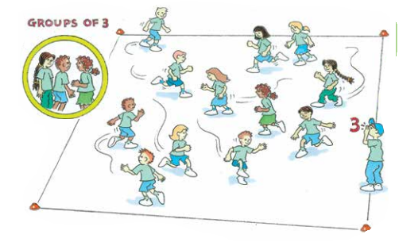
‘Forming a group illustration’, Adapted from ‘Playing for life’ – Australian Sports Commission, https://www.sportaus.gov.au.
Discussion
Explore the following questions:
- Which movement strength did you display? For example, skipping was my strength because I felt comfortable doing that action and I could move faster, hopping was a strength because I am tall and can hop longer distances and I enjoy hopping.
- Which character strength did you display? For example, I was respectful and helped others by moving to another group when my group had too many.
- Which social strength did you display? For example, I built relationships by making sure the student who was excluded in the last game was included into my group in the next game.
- Who had a strength like yours? What makes you say that?

Activity 2 – Paired relays
Teacher notes
These relays are designed for students to develop teamwork, recognise and use each other’s strengths to improve their chance of success and ensure each team member is actively involved and engaged in the physical activity.
- Define a playing area large enough for students in pairs to safely compete in relays approximately 10 metres long.
- Each relay is completed twice, with pairs using the following questions to review their performance after the first relay to apply to the second. Relay examples may include:
  - walking together while balancing a ball on an A4 sheet of paper, 2 students inside a hoop walking together, walking back-to-back with a large ball between pairs, running with linked arms, egg and spoon race.
Consider these questions:
- Which movement strength did you use?
- Which character strength did you use?
- Which social strength did you use?
Discussion
Discuss with students ‘What do you think success looks like when completing an activity or playing a game?’
Students may suggest it means winning or getting the ‘best result’. This may form part of being successful.
Emphasise with students that success can also mean improving their ability to perform a movement skill, increasing their knowledge, increasing their confidence, learning to communicate more effectively with others, improving their decision-making to solve a movement challenge. It does not have to mean ‘winning’. When students discuss questions during lessons or reflect at the completion of the lesson, they may consider that they have been successful for various reasons. This may be discussed and decided upon by the student and teacher.
On completion of the lesson explore the following questions:
- What strengths were common for success in all the relays?’ For example, teamwork, collaboration, relationship building, cooperation, respect.
- What strengths did your partner use to successfully complete one of the relays? For example, one student may be good at balancing the egg in the egg and spoon relay which meant they finished quickly and were able to support their partner to finish.
Reflection
Students reflect upon the learning in this activity/lesson and consider how it contributes towards answering the essential question How can we include others and build respectful relationships?

Lesson 3 – Exploring groups we belong to and their importance
Week 2.
Lesson 3 – Assessment framework
Outcomes | Unit learning goals  Students are learning to: | Evidence of learning  Students can:
PD1-3 recognises and describes the qualities that enhance inclusive and respectful relationships | Recognise ways to develop inclusive and respectful relationships. | - Describe and practice ways of what it means to be inclusive and respectful to others (activity 3, 4).  - Identify how people feel when they are included and excluded from groups and activities (activity 4).
PD1-10 describes and practises interpersonal skills to promote inclusion to make themselves and others feel they belong | - Recognise that a sense of belonging to a group promotes a feeling of inclusion.  - Demonstrate ways to include others and develop respectful relationships in a range of classroom and physical activities. | - Identify groups they belong to and why these groups are important (activity 1, 2).  - Demonstrate, cooperation, turn taking, positive communication and following rules during classroom activities/physical activities (activity 1, 3, 4).

Key inquiry questions and syllabus content
How can we be inclusive and respectful?
Describe and practise ways to develop caring and respectful relationships and include others to make them feel they belong for example:
- Identify groups people belong to and why they are important for example, support from family, friends and cultural groups.
- Demonstrate cooperation and observe rules in group activities for example, taking turns, communicate and respond to others appropriately, express appreciation to others
- Recognise how people feel when they are included and excluded from groups and activities.
- Demonstrate an understanding of what it means to be inclusive and respectful to others for example, peers, people with disability.

Teaching and learning activities
Equipment
- 3 hoops
- whiteboards or chalk
- sticky notes
- Appendix 5 – Flower template.
Resources
Video Willy and Hugh by Anthony Browne – 3:36 min.
Vocabulary
- belonging, being inclusive, friendships, exclusion, groups.
Discussion
Explore the following questions:
- What groups do you belong to? For example, school/class, friendship groups, family groups, community, sport groups, dance, drama, music.
- How does it make you feel to be part of a group? For example, being part of my class group makes me feel included, happy and excited to come to school, being part of my soccer team makes me feel healthy and happy because I have made new friends and learnt new skills.
- What roles do people have within your groups? For example, soccer team has a coach who helps us and teaches us new skills, netball has a club president who supports everyone involved in the club, and an orchestra has a conductor who directs when to play the instrument.
Groups can be categorised. How might groups that you belong to be categorised? For example:
- choir is a school group
- soccer team is a community group
- church is a family/community group.
Teacher notes
Record nominated groups onto individual pieces of paper or sticky notes to be used in Activity 1.

Activity 1 – What are different types of groups we belong to?
- Place 3 hoops or circles drawn on the carpet or headings on a white board.
- Give each student a sticky note with a particular group recorded on it. Students discuss with a partner whether it is a school, community or family group.
- Students then place the post note in the group they think is most appropriate.
Explore the following questions in small groups:
- What would you gain from being part of the community groups? For example, playing soccer or netball, making new friendship, learning new skills such as teamwork.
- What would you miss out on if you were not part of school groups? For example, learning, making new friendships, joining groups like the choir, band, dance, drama, gardening club.
- What would you miss out on if you were not in any family groups? For example, socialising with my family, religious and personal celebrations such as birthdays, support when I have a problem.
Teacher notes
Being inclusive and sensitive to everyone and celebrating their strengths helps to build a sense of belonging. Just like people, the groups we belong to can be diverse as well. The groups students belong to are important to them and it is important that students are respectful of others when sharing their groups.

Activity 2 – Which groups do I belong to?
Complete Appendix 5 – Flower templates. Students record their name in the middle of the flower and the names of groups they belong to on each petal. Cut out and make a class garden wall display.
Teacher notes
Remind students that not all petals need to have a response. As a variation, students could include the name of a person from the group on the petal. For example, soccer team coach Ms Smith, class at school 2J Mr Jones.
Discussion
Explore the following questions:
- What does ‘being inclusive’ mean? For example, including everyone no matter their gender, ability, likes, dislikes, culture/religion.
- What does ‘being respectful’ mean? For example, accepting someone for who they are, even if they are different or don’t agree with them.
- How can we show respect in the classroom? For example, listening to the teacher, being kind to our peers, being polite and using manners, not judging other people thoughts and feelings, follow school rules.
Teacher notes
Discuss the difference between inclusion and exclusion and emphasise that if people wish to be alone this is be okay as well.

Activity 3 – What does inclusion and exclusion mean?
Arranged in groups of 3, each group role plays one of the scenarios below that involves inclusion or exclusion. After the role play, students explore questions to create a solution to the problem.

Role play 1
Student A and Student B establish a boys only toy car club at school and bring in their own cars to play in the playground. Student B is best friends with a girl, student C. She has her own cars and asks to play. Student A tells her, ‘It is boys only! Go away!’.
- How would Student C feel? For example, she would feel upset and lonely. She may not understand why it is ‘boys only’ as she always plays with Student B.
- How would Student B feel? For example, Student B would feel confused and worried. He wants Students C to play as she is his best friend, but he does not want to upset student A by including a girl into the ‘boys club’.
- What could be a solution?
Role play 2
A group of students are kicking a soccer ball at the goals. A student in a wheelchair asks to play.
- How may the group of students feel? For example, confused at how to include him/her, concerned he/she may be hurt if included, worried he/she will ruin the game, relieved because they needed an extra player to even the teams, happy they are able to include him/her.
- If the group of students do not include the student in the wheelchair how would he/she feel? For example, he/she could feel upset and angry at not being included, discouraged to ask in the future to play, frustrated that he/she is in a wheelchair and it is the reason he/she is being excluded, lonely that no one will include him/her.
- How can the student in the wheelchair be included? For example, change the rules, change the equipment, change the surface to aid his/her movement, take turns at assisting him/her, ask the student in the wheelchair what he/she needs to be included.
Role play 3
Student A asks his/her friends can he/she play with them during lunch time. They said, ‘No you are in a different class, not ours.
- How might Student A feel? For example, upset that he/she is being excluded, confused he/she thought they were his/her friends, lonely as he/she has no one else to play with.
- What might Student A’s body language look like? For example, shoulders slumped, looking towards the ground, sad face, slow walk, kicking the ground, arms folder or in her pockets.
- What could be the solution? For example, Student A could reply confidently that being in separate classes does not mean they cannot play together, Student A could seek the advice and support of a teacher, one of the friends could be an up stander and include him/her.
Role play 4
A group of children are playing ‘Snakes and Ladders’. Each group has a dice. Student A keeps rolling the dice and moving his/her marker when it's not his/her turn. Everyone in the group becomes frustrated and angry. Student A is unaware of the rules and that they are upsetting the group of students.
- How might the group of students be feeling? For example, frustrated that the game keeps being interrupted, angry at Student A for not following the rules or asking what the rules are, disappointed as they really like the game.
- How might Student A be feeling? For example, confused as they do not know the rules, frustrated that the other students are angry at him/her and keep telling him/her to stop playing.
- How can the group of students support Student A? For example, the group of students could explain the rules to Student A and restart the game, ask Student A to wait their turn, all students buddy up with a partner to play, thus providing support for Student A by using an inclusive practice where everyone is treated the same.

Activity 4 – How does it feel to be excluded?
Explore the text, ‘Willy and Hugh’ by Anthony Browne through either a modelled reading session or an online version.

Discussion
Explore the following questions:
- Willy was lonely. How do you think this made him feel? For example, sad, unhappy, disappointed.
- The gorillas excluded Willy from the games because they said he was useless. Is it ok to exclude someone from a game because you think they ‘might’ be useless? What makes you say that?
- How did we know Willy was feeling upset/excluded? For example, he said he was lonely, he walked with his hands in his pockets and head down and looked sad.
- If Willy asked you could he join in your game how would you respond? For example, tell Willy he could join in the game, explain the rules so he knew how to play and introduce him to everyone so he felt included and happy.
Reflection
Students reflect upon the learning in this activity/lesson and consider how it contributes towards answering the essential question ‘How can we include others and build respectful relationships?

Lesson 4 – Developing inclusive and respectful relationships through physical activity
Week 2.
Lesson 4 – Assessment framework
Outcomes | Unit learning goals  Students are learning to: | Evidence of learning  Students can:
PD1-3 recognises and describes the qualities that enhance inclusive and respectful relationships | Recognise their own and others’ strengths and achievements and identify how these enhance inclusive and respectful relationships. | Identify their own and others strengths (Activity 4).
PD2-9 demonstrates self-management skills to respond to their own and others actions | Identify and demonstrate how to include others in activities including physical activities. | Demonstrate ability to manage emotions while responding to stressful situations (Activity 1, 2, 3, 4).

Key inquiry questions and syllabus content
How can I act to help make my environments healthy, safe and active?
Practise strategies they can use to support their own and others’ health, safety and wellbeing, for example:
- Develop respectful relationships with peers and other people through interaction and cooperation in organised group activities.
- Use positive communication to encourage others and express appreciation when others give help.
- Develop and demonstrate inclusive strategies to work cooperatively in games and physical activities.

How can we move and improve our involvement in physical activity?
Use strategies in group situations when participating un physical activity for example:
- Communicate positively when working in groups to encourage others to promote inclusion.
- Describe and/or demonstrate how to include others in physical activity.
- Suggest and trial how an activity or game can be changed so that everyone can be involved.

Teaching and learning activities
Resources
- River Crossing – Great Team Building Game – 0:40 min.
- Circle spot markers Google image search.
- Video The Inspirational Story Of 9 Year Old Ezra Frech 2017 – 4:27 min) for optional Activity 4.
Equipment
- playing area of approximately 20 metres x 10 metres
- markers
- 1 piece of A4 paper per child or a circle spot marker.
Vocabulary
- communication, respect, difference, being inclusive, resilience.

Activity 1 – Mirror, mirror (Fast start)
In groups of 3-4, a leader performs a variety of movements to create a sequence, no longer than 4 movements. For example, running on the spot, star jumps, skipping, touching toes. The remaining students mirror these movements. Students swap roles, so all students have a turn of being the leader.

Teacher notes
The aim of the fast start activity is for every student to be and feel included. To support students' confidence, allow them to practice movement skills independently before the activity begins. Reinforce that it is okay for students to repeat movements they have seen. If students request not to be a leader this is okay.
Discussion
Following the completion of the fast start, explore the following questions:
- How was everyone included? For example, we shared the role of being a leader, groups were small so everyone had the opportunity to be a leader in the time given.
- What did your group do to make your fast start successful? For example, listened to the leader, communicated movement sequences so everyone could hear and be included, took turns at being a leader, respected the leader’s choice of movements.

Activity 2 – Crossing the river
Set up playing area of approximately 20 metres x 10 metres. In groups of 4, each student has a piece of A4 paper or circle spot marker. The aim of the game is for all students in the group to move from one end to the other.
- When moving, students must work as a team to place their paper or circle spot marker on the ground to cross the river. Students may pick up the paper or circle spot marker when it is under their foot, but be careful not to place their foot in the river when removing it.
- At least one student’s foot needs to be on the paper or circle spot marker when it is placed on the ground otherwise or it will be removed by the teacher.
- If any student steps in the river their team returns to the start and begins again.
Teacher notes
Crossing the River develops teamwork, promotes communication and trust. Little guidance is given by the teacher the first-time students engage in the Crossing the River activity.
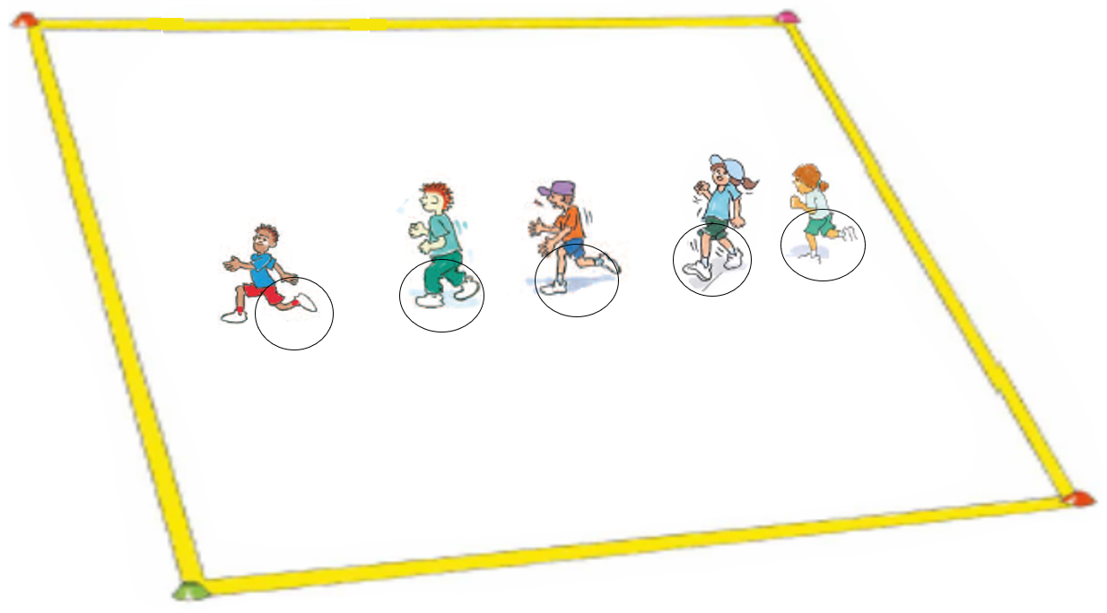
‘Crossing the river illustration’, Adapted from ‘Playing for life’ – Australian Sports Commission, https://www.sportaus.gov.au.
Discussion
Upon completion of the first game of Crossing the River explore the following questions:
- Was your group successful? What makes you say that?’ For example, we were successful because we communicated positively, assigned roles, worked collaboratively by taking turns, we were not successful because we yelled at each other and argued the best way to cross the river, kept going back to the start.
- How can you communicate positively amongst your group to be more successful and to promote inclusion? For example, assign roles so everyone is included, listen to the person talking, talk in a calm voice, use kind words and encouraging phrases to support each other.

Activity 3 – Cross the river 2.0
Each group discusses strategies before playing Cross the River 2.0. Teams then play the game again.
Discussion
Explore the following questions:
- In which game of Crossing the River were you most successful? What makes you say that?
- What strategies did your group apply to reach the other end safely?
- Would you make any further changes to make the game more successful and inclusive? For example, reduce the distance or number in each team, increase the size of the equipment.

Activity 4 – Ezra’s story (optional)
This activity has been included to support the learning from the previous three activities. It reinforces the importance of inclusive behaviour and social awareness. It highlights the role of resilience in overcoming challenges. Watch the video pausing at suggested intervals below to form reflective discussions with students.
Explore the following questions at 0:43 min:
- Do you think Ezra plays sports? Explain your answer
- What sports do you think Ezra could play?
Explore the following questions at 1:00 min:
- How do you think Ezra feels when people stop & stare at him?
- Why do you think people stare at Ezra?
- What could people do if they see Ezra? (Student answers provide a positive response such as greet him to make him feel welcome)
Explore the following questions at the end:
- Did you think Ezra was going to be able to play the sports/games that he does? Why to do you say that?
- What strengths does Ezra have? For example, character strengths – he didn’t see his physical disability as an excuse not to play, where he could he doesn’t allow himself to feel different when participating in sport, V movement strengths – he adapted using his leg and hand to play the game, he has worked hard to improve his movement skills, social strengths – he uses communication skills to make friends, he speaks positively to others.
- Why is it important that everyone be included in activities/sports/games? For example, everyone has the right to feel included regardless of their ability.
Reflection
Students reflect upon the learning in this activity/lesson and consider how it contributes towards answering the essential question How can we include others and build respectful relationships?

Lesson 5 – How respect, cooperation and fair play build an inclusive environment
Week 3.
Lesson 5 – Assessment framework
Outcomes | Unit learning goals  Students are learning to: | Evidence of learning  Students can:
PD1-7 explores actions that help make home and school healthy, safe and physically active spaces. | Propose and develop new rules that allow peers to participate safely in classroom and playground physical activities. | Identify and explain rules that keep themselves and others safe during activities and why these rules are important to include everyone (Activity 1, 2, 3).

Key inquiry questions and syllabus content
How can I act to help make my environments healthy, safe and active?
Explore actions and opportunities to promote and celebrate healthy, safe and active living for example:
- Describe how being fair, respectful and inclusive during activities contributes to their own and others’ health, safety and wellbeing
- Implement sustainable practices in the classroom to improve health and wellbeing of the class for example, developing class rules, regularly scheduling opportunities to eat fruit and drink water.

Teaching and learning activities
Resources
- Video What If Everybody Did That? by Ellen Javernick & Illustrated by Colleen M. Madden – 4:35 min.
- Video Be Responsible, Safe and Respectful for Children, Kids and Toddlers by Patty Shukla – 2:23 min.
Equipment
- large sheets of paper such as butcher’s paper
- marker pens.

Appendix 6 – What if everyone did that?
Vocabulary
- being fair, respect, rules, cooperation
Discussion
Explore the following questions:
- Why should we respect rules and follow them? For example, cooperating with others, ensure safety of ourselves and others, provides order and fairness.
- What does fair play look like? For example, following the rules, listening to peers and teachers, including others, being respectful.
- What are the advantages of fair play in games? For example, safe and supportive environment, safety for participants, enjoyment and challenge.
Teacher notes
The aim of this lesson is for students to identify the purpose of applying rules and ways that they provide order, fairness and safety at school.

Teaching and learning activities

Activity 1
Explore the text What if everybody did that? through either modelled reading or the video.
Discussion
Explore the following questions:
- What would happen if everyone threw one piece of rubbish on the ground? For example, the environment would become polluted and therefore unhealthy and unsafe, the environment would become dangerous for people and animals.
- What would happen to the school grounds if all the students threw one piece of rubbish on the ground every day and they were not picked up? For example, the playground would smell, it would not be enjoyable playing around rubbish, students and teachers could become sick from the germs.

Activity 2
Record a list of rules that should be followed in the classroom to build respect, cooperation and fair play. For example, walk in the classroom, pack away toys after play, raise our hands when wanting to speak, use manners, be kind and respectful to others.
Discussion
Why is it important to follow rules in the classroom? For example:
- To keep everyone safe, to allow students to feel like they belong to the school community, supports students to learn, to maintain a level of respect and cooperation.

Activity 3
Compose a class version of What if everybody did that? as a big book. The story applies a strengths-based approach where the question is posed from a positive perspective focusing on positive behaviours. For example:
- We pack away the toys after play. What if everybody did that? Our classroom would be tidy and we would be safe from tripping over the toys.
- We are kind and respectful to others. What if everybody did that? Everybody would feel happy and be included.
- We walk inside the classroom. What if everybody did that? We would be safe and no one would get hurt.
- We demonstrate fair play other during activities. What if everybody did that? We would all feel included, respected and valued.

Teachers notes
Encourage students to select rules that are in context with your school and student needs. The main aim of rules is to promote safety however the focus of this unit is respecting others, inclusion and fair play and rules that demonstrate this should be addressed. For example, place rubbish in the bin, follow the rules of the games at lunch time and play fairly, listen to the teacher and peers, include others in games. The collection of students’ What if everyone did that? work samples can be used to develop a class big book.
Reflection
Students reflect upon the learning in this activity/lesson and consider how it contributes towards answering the essential question ‘How can we include others and build respectful relationships?

Lesson 6 – How does respect, cooperation and fair play impact on physical activity?
Week 3.
Lesson 6 – Assessment framework
Outcomes | Unit learning goals  Students are learning to: | Evidence of learning  Students can:
PD1-7 explores actions that help make home and school healthy, safe and physically active spaces. | Propose and develop new rules that allow peers to participate safely in classroom and playground physical activities. | Identify and explain rules that keep themselves and others safe during activities and why these rules are important to include everyone (Activity 1, 2, 3, 4).
PD1-9 demonstrates self-management skills in taking responsibility for their own actions. | Identify and demonstrate how to include others in activities including physical activities. | Communicate positively when working in groups to encourage others and promote inclusion (Activity 1, 2, 3, 4).

Key inquiry questions and syllabus content
How can we participate safely and fairly during physical activity?
Identify rules and fair play when participating in physical activities for example:
- Explain why rules are needed in games and physical activities.
- Explain how rules contribute to personal safety and fair play and apply them in group activities.
- Communicate how and when they and others demonstrate safety and fair play.

Teaching and learning activities
Equipment
- markers
- coloured braids to identify cats.
Vocabulary
- rules, safety, inclusion, enjoyment
Discussion
Explore the following:
- What if we were all respectful, cooperative and played fairly in games/activities? How would that impact the game? For example, makes the game safer and more enjoyable for everyone, challenging, allows for achievement, makes everyone feel included, happy and valued, reduces conflicts and the need for adult involvement.
- Explain why rules are needed in games and physical activities? For example, to improve the safety and protection of everyone playing, promotes equity and fairness, provides structure, gives guidance and direction on how to play and techniques to use.

Activity 1 – Mirror, mirror (Fast start)
Refer to instructions for Mirror, Mirror in Lesson 4 Activity 1.
Discussion
Explore the following questions:
- What would have happened if everybody did not follow the leader? For example, it would not be the game ‘Mirror, mirror’, everyone would have been disrespecting the leader, the game wouldn’t be fair.
- What did your group do to make your fast start successful? For example, listened to the leader, communicated movement sequences so everyone could hear and be included, took turns at being a leader, respected the leader’s choice of movements.

Activity 2 – Cat and mice (Fast start)
Define a playing area approximately 20 metres x 20 metres (or 1 student per metre). There are two safety zones at each end.
- Begin the game with all students (mice) at one end of a playing area. One student is selected to be a tagger (cat) waiting in the centre of the playing area.
- The cat counts down from 5 to zero and then all mice must leave their safety zone and move to the safety zone at the opposite end, trying not to be tagged.
- If students are tagged, they perform a physical activity outside the playing area for example 5 knee bends, and then return to game.
- Interchange the students taking on the role of cat throughout the 10-minute game.
Teacher notes
The aim is for the ‘cat’ to feel that the game is unfair and how this can have an impact on the enjoyment for everyone participating.
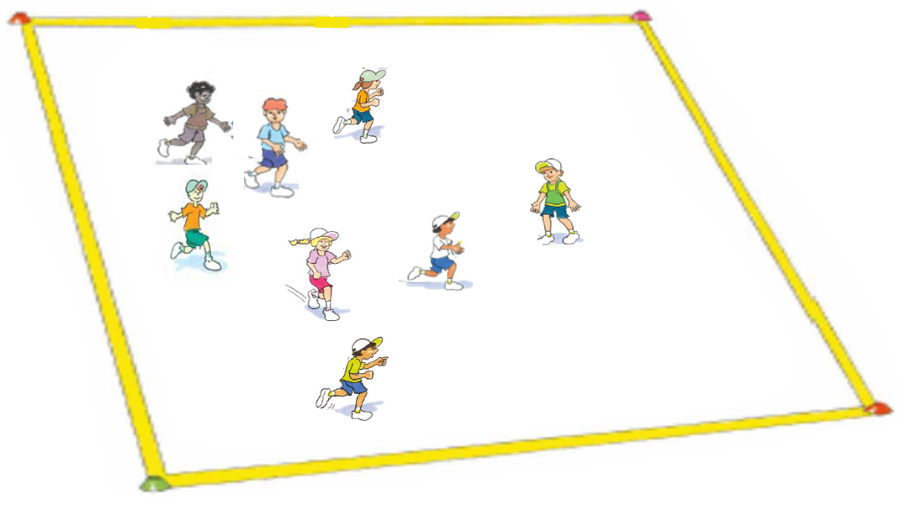
‘Mirror, mirror illustration’, Adapted from ‘Playing for life’ – Australian Sports Commission, https://www.sportaus.gov.au.
Discussion
Explore the following questions:
- Was the game fair? Why do you say that? For example, No, the game wasn’t fair because there was only one cat and it made it easy for the mice to move from one playing area to the other without being tagged.
- How did this impact the game? For example, the cat felt it was unfair because they couldn’t catch all the mice, they did not enjoy the game, they were unhappy. The mice were bored as they were not challenged and could easily make it from one playing end to the other.
- How could the game be adapted to be fair for everyone? For example, change the rules to increase the number of cats, the mice could run in groups or teams, rotate roles of mice and cats.

Activity 3 – Cat and mice 2.0
Play cat and mice again using one or more of the suggested changes below:
- Increase the size of the playing area.
- Increase the number of cats.
- Mice must run in groups, for example, in pairs.
- Introduce teams and each team needs to collect as many tags from the mice as possible.
Discussion
Explore following questions:
- Was the game fair? Why do you say that? For example, yes because there were more cats to tag the mice, it made it harder for the mice to reach the end of the playing area.
- How could we change the game and it still be fair? For example, the mice can run, but the cats must walk, the mice cannot be tagged until the halfway mark of the playing area, include a designated safe space within the playing area with a time limit where mice cannot be tagged.
- How did the cats achieve success by tagging the mice? For example, the cats all cooperated with each other by having designated areas on the playing area where they would tag the mice, they helped each other by encouraging them to run towards a mouse, they worked as a team.
- Was the game played respectfully? For example, yes because people followed the rules, people encouraged each other, people took turns at different roles.

Activity 4 – Cat and mice 3.0
Play cat and mice again using one or more of the suggested changes below:
- Increase the size of the playing area.
- Increase the number of cats.
- Mice must run in groups, for example, in pairs.
- Introduce teams and each team needs to collect as many tags from the mice as possible.
Discussion
Explore the question:
- Which game of cat and mice was the fairest? What makes you say that?
Teacher notes
The aim of this game of Cat and Mice is for the students to see how the adaptation of rules has impacted the game. The third version should be the fairest and therefore most enjoyable.
Reflection
Students reflect upon the learning in this lesson and consider how it contributes towards answering the essential question How can we include others and build respectful relationships?

Lesson 7 – Communication skills
Week 4.
Lesson 7 – Assessment framework
Outcomes | Unit learning goals  Students are learning to: | Evidence of learning  Students can:
PD1-9 demonstrates self-management skills in taking responsibility for their own actions. | Identify and demonstrate how to include others in activities including physical activities. | Communicate positively when working in groups to encourage others and promote inclusion (Activity 1, 2, 3, 4).

Key inquiry questions and syllabus content
How can I act to help make my environments healthy, safe and active?
Practise strategies they can use to support their own and others’ health, safety and wellbeing for example:
- Develop respectful relationships with peers and other people through interaction and cooperation in organised group activities.
- Use positive communication to encourage others and express appreciation when others give help.
- Develop and demonstrate inclusive strategies to work cooperatively in games and physical activities.

Teaching and learning activities
Equipment
- recyclable materials such as cardboard tubes
- newspapers
- egg cartons for each group
- tape.

Resources
- Video Birds on a wire – for the birds – 3:14 min.
- Video Saying What You Mean – A Children's Book About Communication Skills – 11:28 min.
Vocabulary
- communication, body language, facial expressions, taking turns, cooperation.

Activity 1 – Exploring forms of communication
Watch the Birds on a Wire video pausing at the suggested intervals below to form reflective discussions with students.
Discussion
Address the following questions after pausing the video at 0.43 min:
- Why was the first bird unhappy when the second bird arrived? For example, it was unhappy because the second bird was too close to its space on the wire.
- How did you know the bird was unhappy? For example, it moved its body away and squawked at the other bird.
Address the following questions after pausing the video at 3:14 min:
- What facial expressions did you see during the video? For example, poking tongue out, rolled eyes, angry eyes.
- What body language did you see during the video? For example, positive body language such as smiles, negative body language such as pushing the bird away, fluffing of feathers.
- What is the advantage of being able to understand body language? For example, being able to read messages that are sent from other’s body language (non-verbal) such as arms folded and head down. These can mean that a person is upset, angry or frustrated.

Activity 2 – Telephone message
Discussion
Reading and understanding body language is very important when playing games and working with friends as we can tell if people are happy and feel included. Communication helps us to understand other people's feelings and get along with others. It needs to be timely and clear to ensure it is effective.
Explore the skill of communication. Communication can be verbal or non-verbal.
- Students sit or stand in a circle of 8-10. Teacher formulates a secret simple message that is whispered to Student A.
- Student A will repeat this message to Student B and the process continues around the circle.
- The last recipient announces the message they received. Be aware that students with low levels of English proficiency or who have strong accents may mispronounce words or find it difficult hearing what students say without being able to read lips at the same time. It is important that students are respectful during the activity and don't blame others due to difference.
Discussion
Explore the following questions:
- Was the final message accurate? Yes or No.
- If the message was accurate, why? For example, the messages were passed on clearly and slowly, it was a short concise message.
- If the message was inaccurate, Why? For example, the message was really long and was easily forgotten, it had complicated words, some people were hard to hear.
- What contributes to successful communication? For example, looking at the person when speaking to them (in some cultures this may not be seen as respectful), speaking slowing, asking politely do they understand, repeating phrases if needed.

Activity 3 – Saying what you mean
Watch the Saying what you mean video to form discussions with students.
Discussion
How can you use positive communication to encourage others? For example, non-verbal – clapping, waving your hands are positive ways to encourage someone to finish something, continue a race, verbal – saying positive words and phrases such as congratulations, keep trying hard, well done, thank you for being a kind friend.

Activity 4 – Collaborative instruction
Teacher notes
Review the importance of effective communication, taking turns, co-operating and following rules. Discuss whether there are some simple rules required to support the group to work effectively.
To groups of 4, equally distribute recycled materials to build a tall free-standing tower. Suggested roles could be given. For example:
- Architect – design the tower/draw it.
- Site manager – Organise and manage the construction.
- Safety inspector – suggests and checks the stability of the tower.
- Builder – join materials together with tape.
Students are given time to construct their towers. Encourage students to continue to support the construction of the tower once they have completed their role.
Discussion
Following the activity explore the questions:
- Were you successful in building a tower? Wat makes you say that? For example yes – we all cooperated and helped each other, we respected each other by sharing and listening to everyone’s ideas. no – we ran out of time, we couldn’t decide what to build.
- Did you have rules for your group? For example, Yes by assigned roles, listening to each other, being respectful of everyone’s ideas, encouraging each other.
- How did you select the roles? For example, by person’s interests, drew names out of a hat, guessed a number, the teacher allocated roles because we could not decide.
- What made or could have made your group successful? Explain.
- What were the challenges? Explain.
Teacher notes
Be an active observer throughout the construction process and ensure there are times for reflection during and after depending on student responses.
Reflection
Students reflect upon their learning in this lesson and consider how it contributes towards answering the essential question How can we include others and build respectful relationships?

Lesson 8 – Developing positive communication and fair play through physical activities
Week 4.
Lesson 8 – Assessment framework
Outcomes | Unit learning goals  Students are learning to: | Evidence of learning  Students can:
PD1-7 explores actions that help make home and school healthy, safe and physically active spaces. | Propose and develop new rules that allow peers to participate safely in classroom and playground. | Identify and explain rules that keep themselves and others safe during activities and why these rules are important to include everyone (Activity 1, 2, 3,).

Key inquiry questions and syllabus content
How can we participate safely and fairly during physical activity?
Identify rules and fair play when participating in physical activities, for example:
- Demonstrate turn-taking and safe sharing of equipment when participating in physical activities and minor games
- Explain how rules contribute to personal safety and fair play and apply them in group activities
- Communicate how and when they and others demonstrate safety and fair play

Teaching and learning activities
Equipment
- markers to set up playing area (25 students = 25m x 25 m approximately)
- 1 braid per pair (Horse and Jockey)
- 15 bean bags, 5 hoops (Hungry Rabbits).
Vocabulary
- fair play, communication, sharing, following rules, safety.

Activity 1 – Jockeys and horses (Fast start)
- Divide class into two groups called the horses and jockeys.
- The horses wear braids and run freely around the playing area (paddock).
- Teacher gives signal, and jockeys attempt to tag (catch) a horse and run back to a corner stable with it.
- The horses try to avoid being captured by dodging the jockeys.
- As soon as each jockey gets their horse back to the stable, they swap roles (braids). Jockey counts to 5 to give horse time to move back to the paddock.
Teacher notes
The aim is for students to see how a game is successful when clear rules and expectations are set. Intervene when necessary to keep the activity going and all students on task and engaged whilst playing fairly.
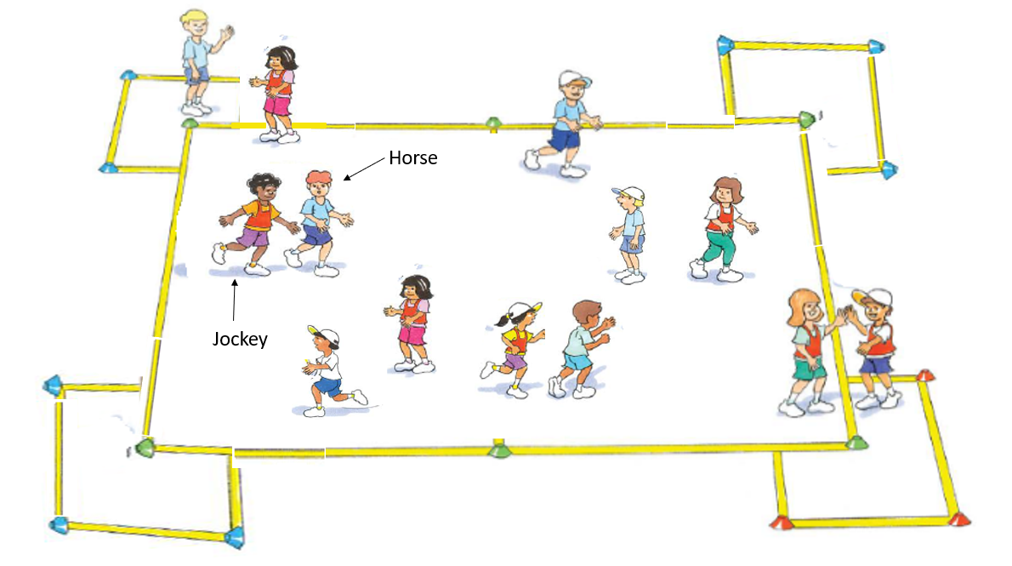
‘Jockeys and horses illustration’, Adapted from ‘Playing for life’ – Australian Sports Commission, https://www.sportaus.gov.au.

Discussion
Explore the following questions:
- What made the activity successful? For example, communication through the teacher, clear instructions, turn taking, rules were explained, we cooperated with each other, everyone was included.
- Was the activity safe? For example, the rules kept students safe, the teacher managed everyone by making sure they followed the rules.
- Was everyone included? How did this happen?

Activity 2 – Hungry rabbits (variation of rob the nest)
Play the game with minimal teacher intervention and applying the rules below:
- Students are divided into 4 teams, each located on a corner or side of the field with each team allocated a rabbit hole (hoop).
- All carrots (bean bags) are placed in the centre of the playing field to begin the game.
- On the teacher’s signal, each team runs to the centre to collect as many carrots.as they can.
- They return and place the carrots in the hole.
- Teams can steal carrots from any team, at any time.
- If a team does not have any more carrots in their hole they must stop and sit down.
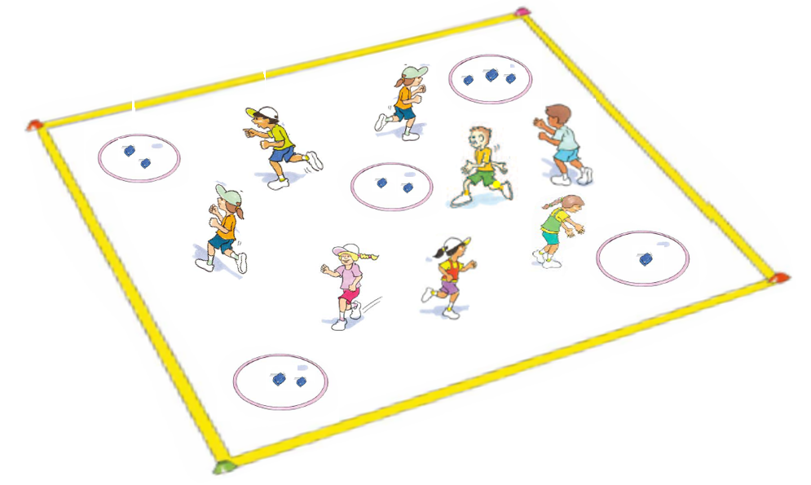
‘Hungry rabbits illustration’, Adapted from ‘Playing for life’ – Australian Sports Commission, https://www.sportaus.gov.au.
Discussion
Students reflect on the game:
What it was like playing with these rules? Was everyone included? Was the game safe? For example, we didn’t get to play as long as other teams and had to sit down, it was not fun, we all did not get a turn, it was not safe as too many players were running at the one time, it was not fair
How could we change the game? For example:
- limit the number of carrots which can be stolen to 1 at a time
- only one player at a time can steal,
- stealing from other teams can only occur after all have been taken from the centre
- encourage every team to keep participating until the time limit has expired (no team is eliminated).

Activity 3 – Hungry rabbits 2.0
Students replay the game applying additional rule changes with the teacher enforcing the rules.
Discussion
- What happened this time? Was the game fair?
- Was the game more enjoyable to play? Explain.
- Were more or less people included? How do you know? Was it fairer this time?
- Were you able to build positive and respectful relationships during the game?
- Was the game safe? Explain.
Reflection
Students reflect upon the learning in this lesson and consider how it contributes towards answering the essential question How can we include others and build respectful relationships?

Lesson 9 – Week 5 Emotional responses
Lesson 9 – Assessment framework
Outcomes | Unit learning goals  Students are learning to: | Evidence of learning  Students can:
PD1-3 recognises and describes the qualities that enhance inclusive and respectful relationships. | Recognise ways to develop inclusive and respectful relationships. | Describe and practice ways of what it means to be inclusive and respectful to others (Activity 3).
PD1-9 demonstrates self-management skills in taking responsibility for their own actions. | Recognise physical and emotional responses that account for their own and others’ feelings. | - Identify how a person might feel based on words used, facial expressions and/or body language (Activity 1,2).  - Recognise own emotions and demonstrate positive ways to respond to different situations (Activity 2).

Key inquiry questions and syllabus content
How can we be inclusive and respectful?
Identify and practise physical and emotional responses that account for their own and others’ feelings, for example:
- Predict how a person might feel based on the words used, facial expressions and/or body language.
- Recognise own emotions and demonstrate positive ways to respond to different situations, for example, kinds of touch, assertiveness, seeking help, loss of a family pet.
- Understand how a person’s reaction to a situation can affect others’ feelings.

Teaching and learning activities
Resources
Appendix 7 – Emotion cards
Vocabulary
- emotions, facial expressions, body language.

Activity 1 – Non-verbal emotional charades
- Students select a partner and choose an emotion from the Emotions Cards (Appendix 7).
- Students warm up by selecting an emotion card and then demonstrating it using only facial expressions to their partner who tries to guess the emotion.
- Swap and repeat the process.
Play the game:
- Select an emotion from the Emotion list (Appendix 7).
- Think of a memory or experience when you felt this way, then act out the emotion using facial expressions and body movements. Students are reminded to use their eyes, eyebrows, mouth, nose, shoulders, arms, hands, feet, legs and more to act out the emotion.
Discussion
Explore the following questions:
- How did you know which emotion was being displayed?
- Which emotions are easier to recognise? What makes you say that?
- What emotions were harder to recognise? What makes you say that?
Teacher notes
Provide a variety of simple emotions with situations for students unable to think of their own. For example, winning a grand final, losing a favourite toy, being left out of a game, not understanding the rules of a game. If there are any students that are blind or have poor vision describe expressions and the gestures made. Students may not always be aware of the faces they make or the gestures and posture they use.

Activity 2 – How would you respond?
Students swap partners and this time the partner needs to respond to the emotion in an appropriate way. Students may use verbal and non-verbal communication to respond to the emotion cards. For example, Student A turns over the emotion card ‘upset’. Student B responds in an appropriate way such as placing a hand on the shoulder of the person, show them a seat to sit down, ask them are they okay, do they need help.

Activity 3 – How can we include others and build respectful relationships?
Brainstorm a list of behaviours that show how a student can include others and build respectful relationships. For example:
- identify strengths in others
- use positive communication
- accept everyone has differences
- encourage others to join in games or activities
- change the rules to make games inclusive
- follow the rules inside and outside the classroom.
Reflection
Students draw an image of themselves and list the behaviours they need to demonstrate to include others and build a respectful relationship.

Evaluation
Teachers can answer these questions to complete their evaluation of the unit.
Questions
- Did all students demonstrate an understanding of the key concepts?
- What concepts within the unit will I need to revisit to ensure understanding?
- When will I/ can I revisit these concepts?
- Did I meet the learning needs of all students?
- Did all students have an opportunity to demonstrate their knowledge, understanding and skills?
- Did the adjustments provide adequate and appropriate access to all activities by all students?
- Were the resources used accessible for all students?
- Which activities in the learning sequence will I need to adapt to ensure my learning goals are achieved next time?
- Did the learning sequence provide sufficient opportunities to make quality assessment judgements about student achievement?
- Which activities and tasks were most engaging and effective?

Appendix 1 – Glossary
- Cooperation – Working together to achieve a common goal.
- Communicate – To convey and listen to specific information, knowledge, understanding to and from others.
- Emotions – Responses occurring in the brain that create biochemical reactions in the body altering the physical state.
- Empathy – The ability to share and understand the emotions of others.
- Fair play – Participation in sport should be based on the concepts of fairness, fun, sportsmanship, respect, safety, policies and procedures.
- Fast starts – short activity that engages students in moderate to vigorous physical activity.
- Resilience – An ability to deal with change or challenge by responding positively to setbacks, mistakes or challenging life experiences.

Appendix 2 – Assessment framework
Assessment framework
Outcomes | Unit learning goals  Students are learning to: | Evidence of learning  Students can:
These syllabus outcomes will be assessed throughout this unit of work. Refer to pages 14-19 of the PDHPE K-10 syllabus. | What the students are expected to know, understand and do as a result of the learning within this unit of work. These are derived from the identified syllabus outcomes. | What specific behaviours will you expect to observe and use as an indicator of student learning towards the learning goals. For the lesson activities that include physical activity these are derived from the Student learning goals, NSW Physical Literacy Continuum K-10 cluster markers and cluster examples. Refer to Appendix 2 for more detail.
PD1-3 recognises and describes the qualities that enhance inclusive and respectful relationships. | Recognise their own and others’ strengths and achievements and identify how these enhance inclusive and respectful relationships. | - Identify their own and others strengths  Lesson 1 – Activity 2, 4  Lesson 2 – Activity 1, 2  Lesson 4 – Activity 1.  - Identify how other students' strengths have contributed to classroom activities/games being successful  Lesson 1 – Activity 3, 4  Lesson 2 – Activity 2.
PD1-3 recognises and describes the qualities that enhance inclusive and respectful relationships. | Recognise ways to develop inclusive and respectful relationships. | - Describe and practice ways of what it means to be inclusive and respectful to others  Lesson 3 – Activity 3, 4  Lesson 4 – Activity 1, 2  Lesson 9 – Activity 3.  - Identify how people feel when they are included and excluded from groups and activities  Lesson 3 – Activity 4  Lesson 4 – Activity 1, 2.
PD1-7 explores actions that help make home and school healthy, safe and physically active spaces. | Propose and develop new rules that allow peers to participate safely in classroom and playground physical activities. | Identify and explain rules that keep themselves and others safe during activities and why these rules are important to include everyone  Lesson 4 – Activity 3, 4  Lesson 5 – Activity 1, 2, 3  Lesson 6 – Activity 1, 2, 3, 4  Lesson 8 – Activity 1, 2, 3, 4.
PD1-9 demonstrates self-management skills in taking responsibility for their own actions. | Identify and demonstrate how to include others in activities including physical activities. | Communicate positively when working in groups to encourage others and promote inclusion  Lesson 4 – Activity 1, 2, 3, 4  Lesson 6 – Activity 1, 2, 3, 4  Lesson 7 – Activity 1, 2, 3, 4.
PD1-9 demonstrates self-management skills in taking responsibility for their own actions. | Recognise physical and emotional responses that account for their own and others’ feelings. | - Identify how a person might feel based on words used, facial expressions and/or body language.  Lesson 9– Activity 1,2.  - Recognise own emotions and demonstrate positive ways to respond to different situations  Lesson 9– Activity 2.
PD1-10 describes and practises interpersonal skills to promote inclusion to make themselves and others feel they belong. | Recognise that a sense of belonging to a group promotes a feeling of inclusion. | Identify groups they belong to and why these groups are important Lesson 3 – Activity 1, 2.
PD1-10 describes and practises interpersonal skills to promote inclusion to make themselves and others feel they belong. | Demonstrate ways to include others and develop respectful relationships in a range of classroom and physical activities. | Demonstrate, cooperation, turn taking, positive communication and following rules during classroom activities/physical activities  Lesson 2 – Activity 1, 2  Lesson 3 – Activity 1, 3, 4.

Appendix 3 – Physical literacy continuum cluster markers
The following NSW Physical Literacy Continuum K-10 cluster markers guided the development of the ‘Evidence of Learning’ (EoL) as observable behaviours to address the Student learning goals and identified syllabus outcomes. These are specific to lesson activities that include physical activity.

Movement competencies
- Demonstrates proficiency in object control skills when practised in isolation.
- Demonstrates proficiency in locomotor movement skills when practised in isolation.

Tactical movement
- Applies different movement skills and concepts to achieve success within the rules of a physical activity, e.g. uses dodge to avoid others and move into space.
- Identifies the underlying reasons for rules within a physical activity.
- Identifies appropriate tactics within a physical activity to influence achievement or success.

Motivation and behavioural skills
- Persists in a range of physical activities regardless of success

Personal and social attributes
- Follows instructions, rules and safety procedures in physical activities.
- Uses equipment appropriately and safely in physical activities.
- Shows awareness of strategies to negotiate conflict situations as they arise in physical activity.
- Demonstrates cooperative behaviour towards others during physical activity.
- Listens to others and communicates appropriately in a variety of physical activities.
- Demonstrates willingness and capacity to work with a variety of partners.

Appendix 4 – Hand template
Name:
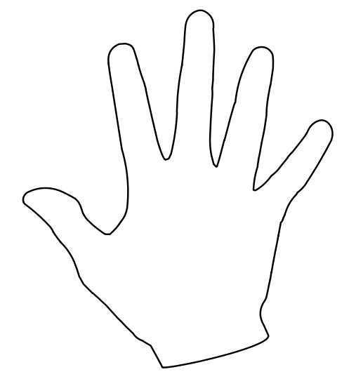
'Hand outline' by English Wikipedia is licensed under CC BY 4.0.

Appendix 5 – Flower template
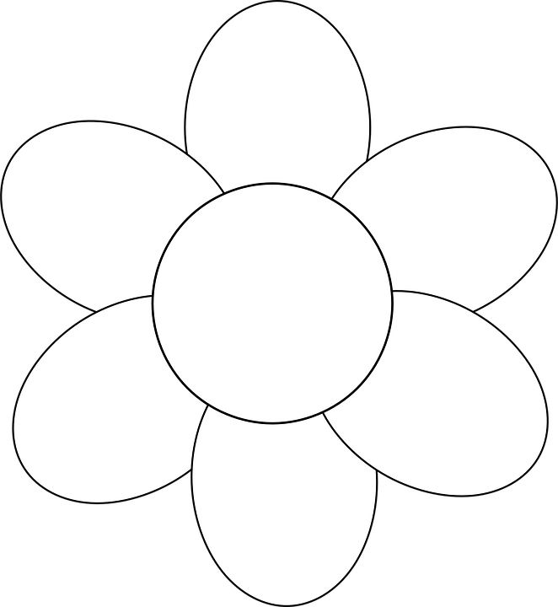
'Flower simple outline' by Open clipart vectors is licensed under CC BY 4.0

Appendix 6 – What if everyone did that?
Name:
Question – What if everybody did that?
If we all:
Everybody could:
Illustration

Appendix 3 – Emotional cards
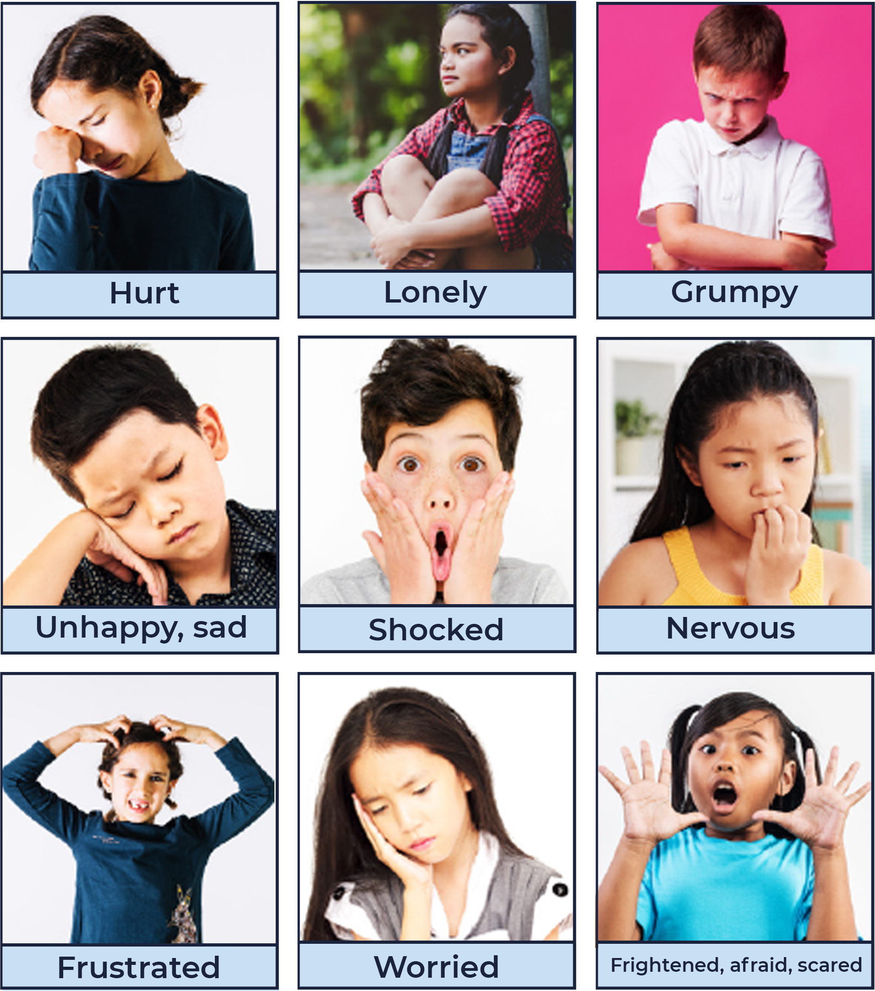
‘Emotion cards 1’ – Child Protection Education Resources Stage 1 by PDHPE, Curriculum Early Years and Primary Learners, Image has been created using resources from Freepik.com and is licensed under CC BY 4.0.

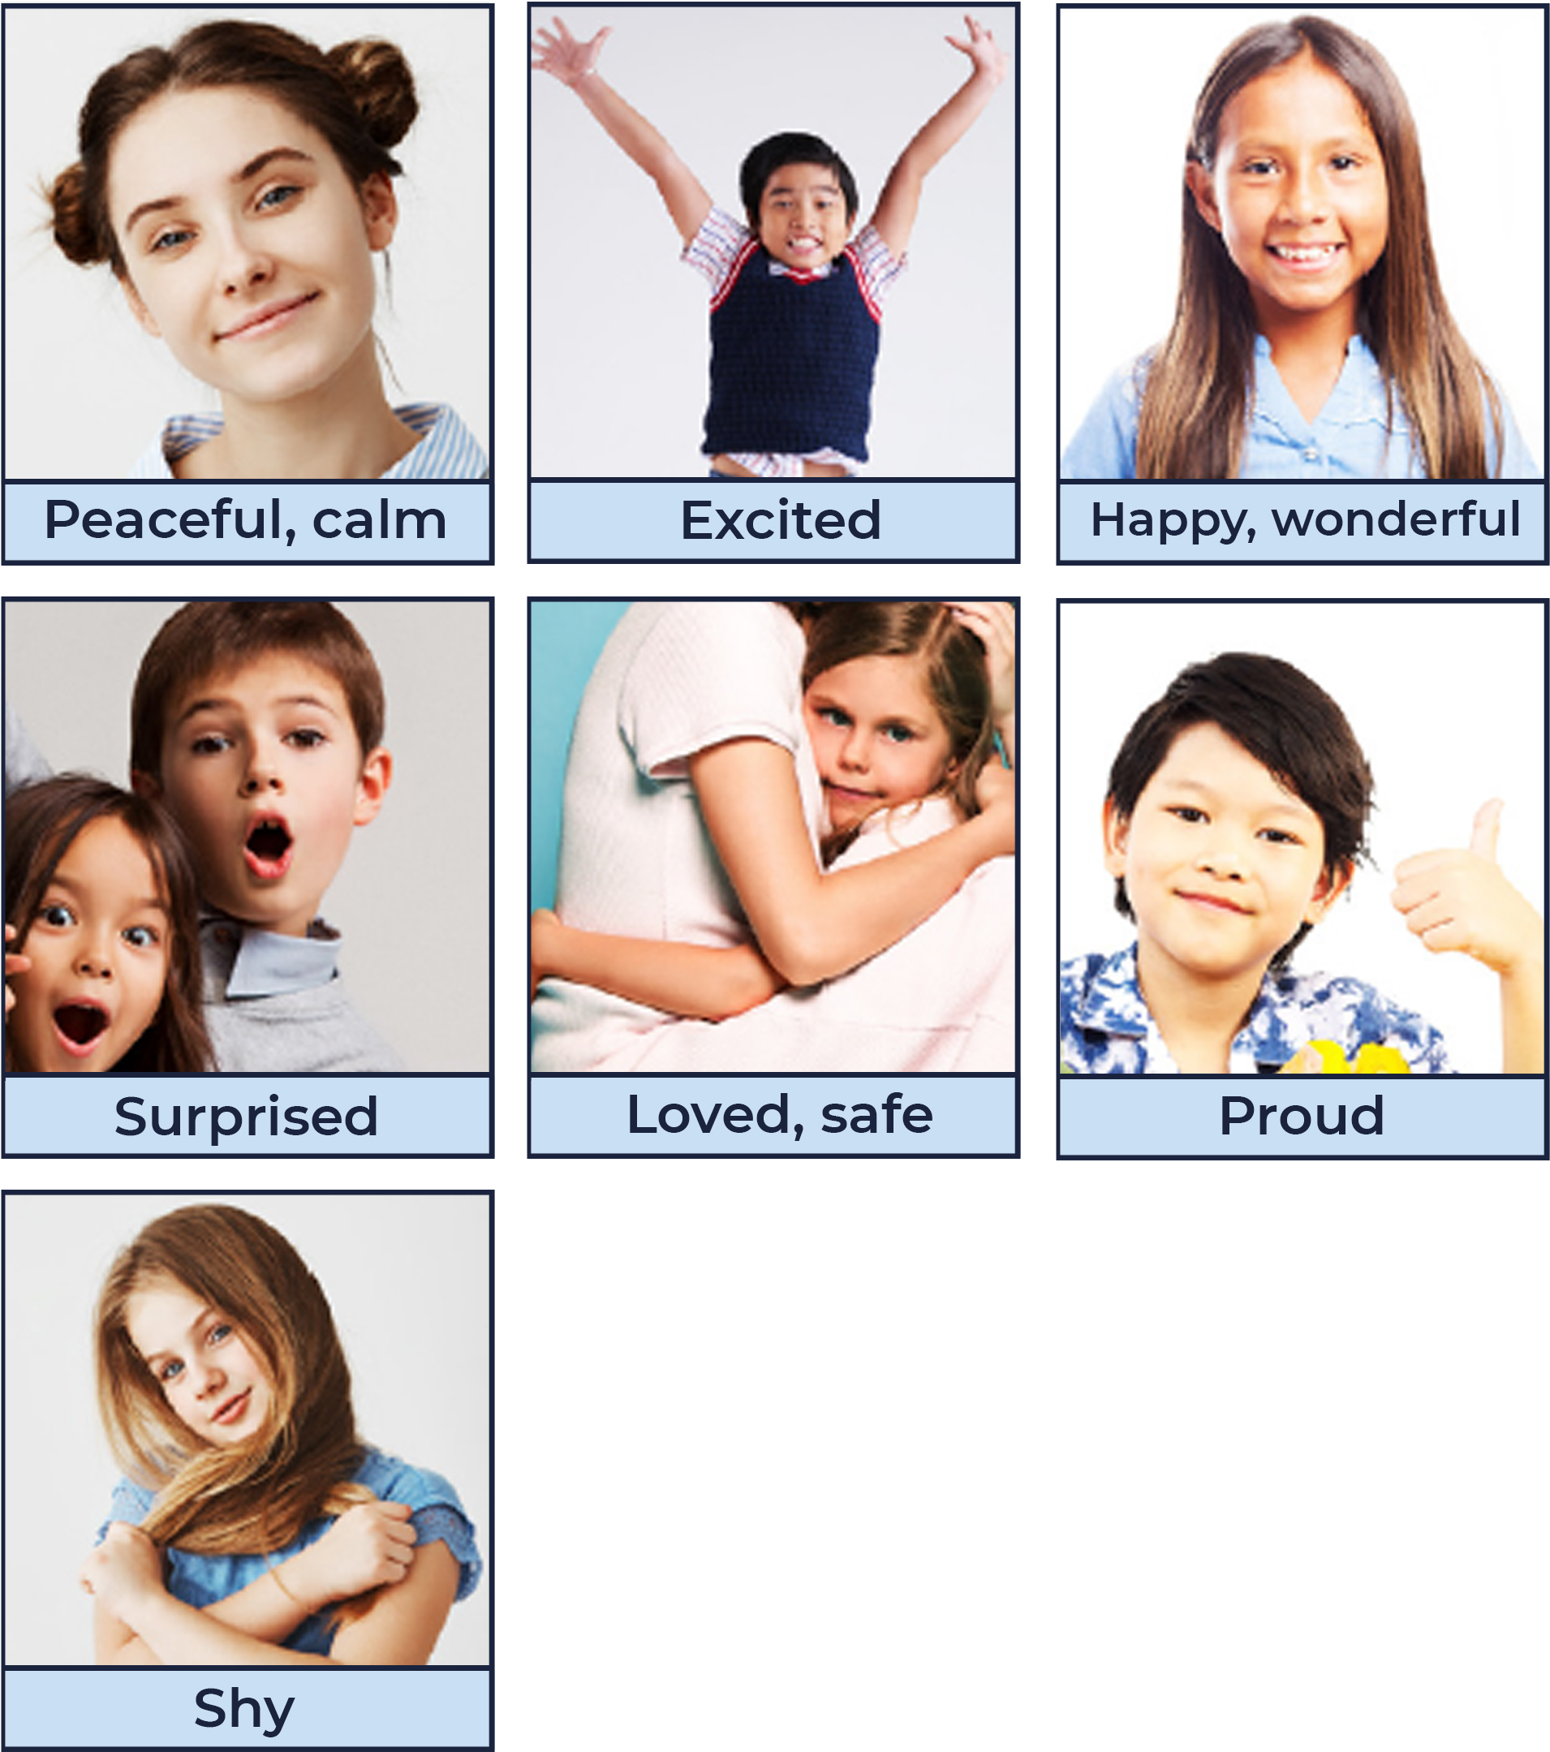
‘Emotion cards 2 – Child Protection Education Resources Stage 1 by PDHPE, Curriculum Early Years and Primary Learners, Image has been created using resources from Freepik.com and is licensed under CC BY 4.0.

Appendix 8 – Attributions
© State of New South Wales (Department of Education), 2021. All material in this resource, except as identified below, is licensed under the Creative Commons Attribution 4.0 International Licence. To view a copy of this licence, visit http://creativecommons.org/licenses/by/4.0/.’
Emotion Cards
- Angry: Education photo created by freepik – www.freepik.com
- Confused: People photo created by cookie_studio – www.freepik.com
- Disgusted: Woman photo created by cookie_studio – www.freepik.com
- Frightened: Kids photo created by freepik – www.freepik.com
- Frustrated: Girl photo created by freepik – www.freepik.com
- Grumpy: Designed by Freepik – www.freepik.com
- Sad/hurt: Girl photo created by freepik – www.freepik.com
- Lonely: People photo created by jcomp – www.freepik.com
- Nervous: Designed by pressfoto – www.freepik.com
- Shocked Designed by Freepik – www.freepik.com
- Unhappy: Designed by jcomp – www.freepik.com
- Worried: Designed by jcomp – www.freepik.com
- Peaceful/calm: Woman photo created by cookie_studio – www.freepik.com
- Excited: People photo created by jcomp – www.freepik.com
- Happy: Designed by Asier_Relampagoestudio – www.freepik.com
- Loved/safe: Family photo created by master1305 – www.freepik.com
- Proud: Designed by jcomp – www.freepik.com
- Shy: For websites: Designed by cookie_studio – www.freepik.com
- Surprised: People photo created by drobotdean – www.freepik.com

Material that is not licensed under the Creative Commons Attribution 4.0 International Licence:
The following images by Australian Sports Commission – https://www.sportaus.gov.au are licensed under CC BY NC ND 3.0 AU. These images have been modified with the permission of the Australian Sports Commission (for use in this publication only):
- Page 11 – Forming a group illustration.
- Page 23 – Crossing the river illustration.
- Page 32 – Mirror, mirror illustration.
- Page 41 – Jockeys and horses illustration.
- Page 42 – Hungry rabbits illustration.

