How can I solve problems while moving?
PDHPE Stage 1

10 weeks Term – Year –
Big idea and key concept 1
Essential question and unit title 1
Unit description 1
Contextual statement 1
Skills and propositions 2
Observational framework 3
Organisation of teaching and learning activities 4
Lesson 1 5
Lesson 2 8
Lesson 3 11
Lesson 4 15
Lesson 5 19
Lesson 6 22
Lesson 7 25
Lesson 8 28
Lesson 9 31
Lesson 10 34
Evaluation 36
Resources 36
Vocabulary/glossary 37
Appendix 1 – snakes alive 37
Appendix 2 – bullseye 38
Appendix 3 – overarm throw – Stage 1 38
Appendix 4 – 1 base throwball 39
Appendix 5 – 2 vs 2 target bombard 39
Appendix 6 – boccia 40
Appendix 7 – step or no step examples 41
Appendix 8 – kick – Stage 1 42
Appendix 9 – kick croquet 42
Appendix 10 43
Outcomes and other syllabus material in this document are copyright.
PDHPE K-10 Syllabus © NSW Education Standards Authority (NESA) for and on behalf of the Crown in right of the State of New South Wales 2018.

Big idea and key concept
The ‘big idea’ is the over-arching concept that is being addressed or challenged throughout the unit. For example, “risk-taking is healthy”.
Using my body to solve problems. Solutions to challenges come in many different forms.
Effort awareness, spatial awareness, relationships with people, objects and space. (Movement concepts – page 133 PDHPE K-10 syllabus).

Essential question and unit title
This question drives both teaching and learning within the unit. Every activity should be working towards answering this question. For example, “How can I manage risk and still have fun?”
How can I solve problems while moving?

Unit description
Students will test and create solutions to a variety of movement challenges through modifying movement sequences and games. For example, they may explore different ways to propel an object accurately within the playing area.

Contextual statement
Further development of problem-solving skills will support students to maintain their involvement in physical activity. Learning how to create a relevant and meaningful movement challenge and to solve the problem within the activity, will provide students with the knowledge, understanding and skills to create lifelong physical activity experiences for themselves and others.

Skills and propositions

Skills in focus
What specific skills are being learned, developed and applied throughout this unit of work? Refer to pages 27-30 of the PDHPE K-10 syllabus

Self-management skills (S)
- Self-awareness
  - reflective practice
- Decision making and problem solving
  - finding solutions to problems
  - analysis

Interpersonal skills (I)
- Communication
  - giving and receiving feedback
- Collaboration, inclusion and relationship-building
  - recognising and using their own abilities and strengths and those of others

Movement skills (M)
- Fundamental and specialised movement skills and concepts
  - object control
- Tactical and creative movement
  - selecting, applying, transferring, adapting and evaluating movement skills
  - applying movement concepts, rules, strategies and tactics
  - assessing rules, strategies and tactics and how they influence movement and performance when applied across different movement contexts.
- Health and fitness enhancing movement
  - managing risk and promoting safety

Propositions
Describe how specific propositions are embedded throughout the unit of work. The 5 propositions are outlined on pages 24-25 of the PDHPE K-10 syllabus.

Focus on educative purpose
Students develop their knowledge, understanding and skills of how to move their body to send and object towards a target. They start to understand how moving their body in different ways affects the way the object travels (direction, distance, height, speed).

Take a strengths-based approach
Students will be encouraged to draw upon their own strengths and capabilities to further strengthen their knowledge, skills and understandings while they explore how to effectively play and adapt movement challenges.

Value movement
Students participate in a wide range of movement experiences to develop skills across all 3 domains and understand how these skills can transfer to different contexts.
Regular modification of movement challenges to meet student needs and interests while maintaining relevancy and engagement.
Students explore movement and compare different techniques/styles to learn what can influence the quality and effectiveness of the movement.

Organisation of teaching and learning activities

Key inquiry questions and syllabus content
What syllabus content is being addressed in each teaching and learning activity?

Teaching and learning activities
A detailed description of the teaching and learning strategies that the teacher will provide for students to learn, develop and apply knowledge, understanding and skills. The following sub-headings are used.

Activity
A description of the suggested teaching and learning activity

Teacher notes
Information that may support teachers with delivery of the teaching and learning activities. This may include concepts and content that may be deemed to be sensitive and/or controversial.

Discussion
The suggested discussion opportunities should be delivered in a manner that best suits your context. These can be between peers, in small groups, as a whole class or a one-on-one teacher-student conference. Sample questions and scenarios may be adapted to meet student needs in a manner that is reflective of school and community context.

Reflection
The suggested reflection that links to the essential question that is also the unit title. This question drives teaching and learning and all activities have been designed to enable students to answer it. This reflection provides further opportunity to reinforce student learning and may act as an ongoing demonstration of student knowledge, understanding and skills.

Resources
A list of resources required to deliver the lesson as described. Teachers may choose to use alternative learning tools and activities that best meet student needs. Alternative examples include learning tools and activities from the department’s Digital Learning Selector.

Lesson 1
Lesson 1 – Assessment framework
Outcomes | Student learning goals – students are learning to | Evidence of learning – students can
PD1-4 performs movement skills in a variety of sequences and situations | uses movement skills separately or in combination while participating in a movement challenge/game  demonstrate a variety of throws with accuracy | - selects and performs skill/s relevant to the quick-start activity with control.  Activity 1  describes a variety of throws how their body moved differently for each one.  Activity 2
PD1-5 proposes a range of alternatives to solve movement challenges through participation in a range of activities | practise and compare different types of throws | identify which throw/s are easier, harder, and why. Activity 2
PD1-9 demonstrates self-management skills in taking responsibility for their own actions | reflect upon their performance to identify and describe ways to perform more successfully | identifies and describes strategies that may contribute to success in a quick-start game/challenge.  Activity 1
PD1-9 demonstrates self-management skills in taking responsibility for their own actions | demonstrate safe play through using equipment appropriately and selecting objects that are suitable to use. | participates in games and challenges in a manner that is reflective of the agreed class safety rules.  Activities 1-2

Key inquiry questions and syllabus content
What are the different ways we can move our body? Students:
- demonstrate movement skills and movement sequences in a variety of contexts, for example:
  - perform locomotor skills using different body parts to travel in different directions, eg walking, running, galloping, hopping, sliding, skipping, jumping, leaping, rolling M
  - use a variety of equipment to perform object control skills to send, control and receive objects, eg bouncing, rolling, throwing, catching, kicking, striking, dribbling, rolling M
- apply movement concepts to create and perform movement sequences, for example:
  - perform movements using relationships, eg under, over, through and between objects, people and equipment M
How can we move and improve our involvement in physical activity?
- propose a range of alternatives and test their effectiveness when solving movement challenges, for example: (ACPMP031)
  - select and implement different movement skills and concepts to be successful in a game and/or physical activity S M
  - identify appropriate strategies and/or tactics to influence achievement in games and physical activities S M
  - compare different types of movements and identify which ones are easier and harder, eg locomotor, non-locomotor and object control skills S M
  - predict possible outcomes of alternative actions and decide which is likely to be the most effective S M
  - reflect on performance and identify and demonstrate ways to perform a skill more successfully S M
- use strategies to work in group situations when participating in physical activities, for example: (ACPMP030)
  - work cooperatively with a partner when practising new skills I M
How can we participate safely and fairly during physical activity? Students:
- identify rules and fair play when participating in physical activities, for example: (ACPMP032)
  - demonstrate turn-taking and safe sharing of equipment when participating in physical activities and minor games I M

Teaching and learning activities
Teaching considerations

Activity 1 – fast start – colours
Teacher:
- Selects a playing area and mark boundaries.
- Spread cones of several different colours inside the playing area (supply enough cones so that on average only 2-3 students are reaching for the correct coloured cone).
Students:
- Start moving around inside the playing area when the teacher calls “Go!”
- Respond to the teacher’s call of a colour, for example, “red!” by moving quickly to touch one of the red cones with their toes/shoe (without standing on the cone).
- Begin moving in the playing area when the teacher calls “Go!” again.
Variations:
- Once students demonstrate safe movement inside the area and when touching the cone, you can ask them to touch the cone with their fingertips. Remember to remind students to be careful when reaching to prevent bumping heads.
- Place a ball on top of the cones. The first person to the ball on the respective colour picks it up, passes to another student who catches it then returns it to the cone.
- Students use different locomotor movements (for example, jump, hop, skip, gallop, animal walk).

Sample questions
- How did you use your body to move quickly to the cone?
- How did you quickly decide which cone was closer to you?

Teacher notes
A fast start activity provides an opportunity to:
- Engage in moderate to vigorous physical activity (huff ‘n’ puff).
- Explore and practise movement skills (fundamental and specialised movement skills and concepts, tactical and creative movement, health and fitness enhancing movement).
- Reinforce an inclusive learning environment that supports positive interactions and ongoing collaboration.
- Become familiar with equipment and space.
- Use age and stage appropriate language and concepts that act as a ‘hook’ to engage students.
- Make planning adjustments based on observations of the physical preparedness of students and the group dynamic.

Activity 2 – snakes alive (appendix 1)
Teacher:
- Organises students into pairs.
- Chooses a ‘starting point’ or throwing line that allows for students to safely throw a ball/object from.
Students:
- Take turns to underarm throw one object at a time, aiming to place each object behind the previous one. This will form a ‘snake’.
  - Underarm throw the first object and mark where it lands. This creates the ‘head’ of the snake.
  - Underarm throw the next object trying to land it before the ‘head’.
  - Repeat the underarm throws with your remaining throwing objects.
Teacher:
- Asks sample questions after students have played the game 5-10 times. This will enable students to reflect upon their performances.
- Instructs students to play ‘Snakes alive’ again using an overarm throw.
- Asks sample questions.
- Instructs students to play ‘Snakes alive’ again using their own throwing style.
- Asks sample questions.
- Instructs students to play ‘snakes alive again allowing them to choose the type of throw they use at any time.

Sample questions
- Describe how you performed the underarm throw/overarm throw/your own throwing style.
- How did you adjust the way you used your body to throw the object a different distance? Was it effective? What makes you say that? Why not?
- What type of throw was easier? What makes you say that?
- What type of throw was harder? What makes you say that?
- Which object was easier to throw? What makes you say that? (if a variety of objects were used)
- Which object was harder to throw? What makes you say that? (if a variety of objects were used)
- When you were able to choose the type of throw to use, when was each throw most effective? What makes you say that?

Reflection
Students reflect upon the learning in this activity/lesson and consider how it contributes towards answering the essential question “How can I solve problems while moving?” Students discuss with their partner and/or teacher. Record responses in their learning journal (if appropriate).

Resources
- Cones/markers to identify boundaries for Fast start activity.
- 5 balls/objects to throw per pair.

Lesson 2
Lesson 2 – Assessment framework
Outcomes | Student learning goals – students are learning to | Evidence of learning – students can
PD1-4 performs movement skills in a variety of sequences and situations | uses movement skills separately or in combination while participating in a movement challenge/game  demonstrate a variety of throws with accuracy | selects and performs skill/s relevant to the quick-start activity with control  Activity 3  describes a variety of throws and how their body moved differently for each one  Activity 4
PD1-5 proposes a range of alternatives to solve movement challenges through participation in a range of activities | practise and compare different types of throws  predict possible outcomes while using different types of throws and pieces of equipment | identify which throw/s are easier, harder, and why Activity 4  predicts possible outcome of throws and explains how/why predictions were made  Activity 4
PD1-5 proposes a range of alternatives to solve movement challenges through participation in a range of activities | apply a scoring system for different movement challenges | adapts and applies a scoring system for different targets/goals based on the game situation (difficulty of the challenge) Activity 4
PD1-9 demonstrates self-management skills in taking responsibility for their own actions | reflect upon their performance to identify and describe ways to perform more successfully | identifies and describes strategies that may contribute to success in a quick-start game/challenge  Activity 3  reflect upon their performance to identify ways to perform the overarm throw more successfully Activity 4
PD1-9 demonstrates self-management skills in taking responsibility for their own actions | demonstrate safe play through using equipment appropriately and selecting objects that are suitable to use. | participates in games and challenges in a manner that is reflective of the agreed class safety rules  Activities 3-4

Key inquiry questions and syllabus content
What are the different ways we can move our body? Students:
- demonstrate movement skills and movement sequences in a variety of contexts, for example:
  - perform locomotor skills using different body parts to travel in different directions, eg walking, running, galloping, hopping, sliding, skipping, jumping, leaping, rolling M
  - use a variety of equipment to perform object control skills to send, control and receive objects, eg bouncing, rolling, throwing, catching, kicking, striking, dribbling, rolling M
- apply movement concepts to create and perform movement sequences, for example:
  - perform movements using relationships, eg under, over, through and between objects, people and equipment M
How can we move and improve our involvement in physical activity?
- propose a range of alternatives and test their effectiveness when solving movement challenges, for example: (ACPMP031)
  - select and implement different movement skills and concepts to be successful in a game and/or physical activity S M
  - identify appropriate strategies and/or tactics to influence achievement in games and physical activities S M
  - compare different types of movements and identify which ones are easier and harder, eg locomotor, non-locomotor and object control skills S M
  - predict possible outcomes of alternative actions and decide which is likely to be the most effective S M
  - reflect on performance and identify and demonstrate ways to perform a skill more successfully S M
- use strategies to work in group situations when participating in physical activities, for example: (ACPMP030)
  - work cooperatively with a partner when practising new skills I M
How can we participate safely and fairly during physical activity? Students:
- identify rules and fair play when participating in physical activities, for example: (ACPMP032)
  - demonstrate turn-taking and safe sharing of equipment when participating in physical activities and minor games I M

Teaching and learning activities
Teaching considerations

Activity 3 – fast start – colours
Refer to instructions in lesson 1 – activity 1. Different sample questions are provided below to explore how knowledge, understanding and skills have developed further.

Sample questions
- How did you move so you avoided bumping into other students?
- What words would you use to describe the way you touched the cone? (For example, reach, stretch, bend, twist, lean).

Activity 4 – bullseye (appendix 2)
Teacher:
- Organises students into pairs.
- Chooses a ‘starting point’ or throwing line that allows for students to safely throw a ball/object from.
- Refer to Appendix 2.
Students:
- Select or create a target they can safely throw a soft object towards. If possible, create 1-2 larger rings around the centre target to create a ‘bullseye’. For example, a cone/marker with a skipping rope laid in a circle around it.
- Develop a scoring system that reflects the target (its size and distance from the throwing line). It may be 3 points for the centre target, 2 points for the inner ring, 1 point for the outer ring
- Reflect upon previous lesson by answering sample questions.
- Play ‘Bullseye’.

Sample questions
- What types of throw did you use in the previous lesson?
- Which type of throw did you prefer to use? What makes you say that?
- Which throwing style do you think will score most points? What makes you say that? (Throwing styles are underarm, overarm and your own chosen style)
- How is your throw affected if you choose to take a step forward when you throw? Compare this to when you stand and throw.
- What benefit may you gain from stepping forward when you throw?

Teacher notes
- Allow students to play the game of ‘Bullseye’ 5-10 times using an underarm throw. Allow students to adjust the target as they are playing by asking, “How can you adjust the target so it meets your level of challenge?”
- Students repeat the game using an overarm throw (5-10 times) followed by their own throwing style. Discuss the games using the sample questions.

Sample questions
- Which type of throw was most successful? What makes you say that?
- How are you deciding what a successful throw is?
- How did you adjust each throwing style to be more accurate and to cater for the change in distance to the target?
- Was your prediction for the type of throw to score most points correct?
If time allows, play another round where students select the type of throw they prefer. Ask them to describe what changes that could make to their throwing style to be more successful.

Reflection
Students reflect upon the learning in this activity/lesson and consider how it contributes towards answering the essential question “How can I solve problems while moving?” Students discuss with their partner and/or teacher. Record responses in their learning journal (if appropriate).

Resources
- Cones/markers to identify boundaries for Fast start activity.
- 3 balls/objects to throw per pair.

Lesson 3
Lesson 3 – Assessment framework
Outcomes | Student learning goals – students are learning to | Evidence of learning – students can
PD1-4 performs movement skills in a variety of sequences and situations | uses movement skills separately or in combination while participating in a movement challenge/game  demonstrate a variety of throws with accuracy | selects and performs skill/s relevant to the quick-start activity with control  Activity 5  describes a variety of throws and how their body moved differently for each one  Activity 6
PD1-4 performs movement skills in a variety of sequences and situations | demonstrate the overarm throw and identify key components that may contribute towards an effective throw | identifies the 4 key components of an overarm throw  Activity 6
PD1-5 proposes a range of alternatives to solve movement challenges through participation in a range of activities | predict possible outcomes while using different types of throws and pieces of equipment | predicts possible outcome of throws/kicks and explains how/why predictions were made Activity 6
PD1-5 proposes a range of alternatives to solve movement challenges through participation in a range of activities | apply a scoring system for different movement challenges | adapts and applies a scoring system for different targets/goals based on the game situation (difficulty of the challenge) Activity 6
PD1-9 demonstrates self-management skills in taking responsibility for their own actions | reflect upon their performance to identify and describe ways to perform more successfully | identifies and describes strategies that may contribute to success in a quick-start game/challenge  Activity 5  reflect upon their performance to identify ways to perform the overarm throw more successfully Activity 6
PD1-9 demonstrates self-management skills in taking responsibility for their own actions | demonstrate safe play through using equipment appropriately and selecting objects that are suitable to use. | participates in games and challenges in a manner that is reflective of the agreed class safety rules  Activities 5-6

Key inquiry questions and syllabus content
What are the different ways we can move our body? Students:
- demonstrate movement skills and movement sequences in a variety of contexts, for example:
  - perform locomotor skills using different body parts to travel in different directions, eg walking, running, galloping, hopping, sliding, skipping, jumping, leaping, rolling M
  - use a variety of equipment to perform object control skills to send, control and receive objects, eg bouncing, rolling, throwing, catching, kicking, striking, dribbling, rolling M
- apply movement concepts to create and perform movement sequences, for example:
  - perform movements using relationships, eg under, over, through and between objects, people and equipment M
How can we move and improve our involvement in physical activity?
- propose a range of alternatives and test their effectiveness when solving movement challenges, for example: (ACPMP031)
  - select and implement different movement skills and concepts to be successful in a game and/or physical activity S M
  - identify appropriate strategies and/or tactics to influence achievement in games and physical activities S M
  - compare different types of movements and identify which ones are easier and harder, eg locomotor, non-locomotor and object control skills S M
  - predict possible outcomes of alternative actions and decide which is likely to be the most effective S M
  - reflect on performance and identify and demonstrate ways to perform a skill more successfully S M
- use strategies to work in group situations when participating in physical activities, for example: (ACPMP030)
  - work cooperatively with a partner when practising new skills I M
How can we participate safely and fairly during physical activity? Students:
- identify rules and fair play when participating in physical activities, for example: (ACPMP032)
  - demonstrate turn-taking and safe sharing of equipment when participating in physical activities and minor games I M

Teaching and learning activities
Teaching considerations

Activity 5 – fast start – flip it
Select a playing area and mark boundaries. Divide the class into two even groups. Each student is given a cone/marker.
Students:
- Move to a space inside the playing area away from other students.
- Place their cone on the ground (half of the class place their cone with round side down, the other half of the class place their cone with round side up).
- Start moving around the playing area to turn over as many of the oppositions cones as possible.
- Stop immediately upon the teachers whistle or call of “Stop!”
Repeat the game by asking students to ‘swap teams’. They now turn cones over the opposite way.

Sample questions
- How did you decide where to move to turn over the most cones quickly?
- What type of movement skills did you use in this game? (For example, run, bend, twist, dodge, jump, leap).

Activity 6 – the overarm throw – stations

Teacher note
Before the lesson, view the example of the overarm throw by accessing video example or Appendix 3 ‘overarm throw stage 1’ card. This may be an effective stimulus to share with students at the beginning of the lesson as well.
Focus students on the four introductory components of:
- ‘eyes focused on the target’
- ‘stand side on’
- ‘step towards target area with opposite foot to throwing arm’
- ‘throwing arm follows through, down and across the body’
Reinforce this by using the cues of:
- Eyes
- Side on
- Step
- Follow through

Sample questions
- What makes a throw successful? (For example, it hits the target, my partner can catch it, it goes through the goal.)
- What helped you to perform a successful throw in the activities you completed in previous weeks? (Using different types of throw – stand and throw, step and throw, underarm, overarm, your own style.)
- What type of throw was more successful? What makes you say that?
- Which type of throw do you think will be more successful in the games of ‘Snakes alive’ and ‘Bullseye’?

Throwing stations
Teacher:
- Explains to students that they will use the overarm throw at the throwing stations in the lesson.
- Demonstrates (in person, via video or task card) the four cues of ‘Eyes’, ‘Side-on’, ‘Step’ and ‘Follow-through’.
- Organises students into pairs.
- Familiarises students with each of the two stations. These are activities used in previous lessons with students now using the overarm throw.
- Refers to appendix 1 and 2 to view suggestions for activity set-up.
- Explains that students perform the chosen locomotor skill to return to their partner. For example, Student 1 throws the ball, they then jump out to the ball, pick it up and jump back to Student 2 who repeats. This will speed up the activity and increase the amount of moderate-vigorous physical activity. Vary the locomotor movement used.
Students:
- Throw the ball/object towards the target. They should aim to hit the target.
- Pick up the ball/object (when appropriate).
- Use the chosen locomotor skill to pick up the ball and return. For example, jump, run, hop, skip, gallop.
- Take turns in their small group and repeat the challenge as many times as possible until the teacher calls “Stop!

Station A – snakes alive
Students play the game of ‘snakes alive’ as they did in lesson 1 focusing on using the overarm throw as outlined above.

Station B – bullseye
Students play ‘bullseye’ as they did in lesson 2 focusing on using the overarm throw as outlined above.

Sample questions
- Can you identify any differences in the way you performed the overarm throw to when you performed it in previous lessons?
- Do you think the focus on the four key components of the overarm throw helped you in the games? What makes you say that?
- How did you adjust your throwing technique to throw the ball different directions and/or distances?

Teacher note
Encourage students to adjust the size of and/or distance of the goals/targets according to their own confidence and ability. The goal/target should be placed so it provides a suitable level of challenge. This may be different for each student or group of students.
Allow students to play the games again after adjusting the size and location of the target. Another alternative may include using different objects to throw and/or allowing pairs to play against another pair in the two games. Re-visit the sample questions for students to reflect upon their learning.

Reflection
Students reflect upon the learning in this activity/lesson and consider how it contributes towards answering the essential question “How can I solve problems while moving?” Students discuss with their partner and/or teacher. Record responses in their learning journal (if appropriate).

Resources
- Cones/markers to identify boundaries for fast start activity.
- 5 balls/objects to throw per pair for each station.

Lesson 4
Lesson 4 – Assessment framework
Outcomes | Student learning goals – students are learning to | Evidence of learning – students can
PD1-4 performs movement skills in a variety of sequences and situations | uses movement skills separately or in combination while participating in a movement challenge/game  demonstrate a variety of throws with accuracy | selects and performs skill/s relevant to the quick-start activity with control  Activity 7  describes a variety of throws and how their body moved differently for each one  Activity 8
PD1-4 performs movement skills in a variety of sequences and situations | demonstrate the overarm throw and identify key components that may contribute towards an effective throw | identifies the 4 key components of an overarm throw  Activity 8
PD1-5 proposes a range of alternatives to solve movement challenges through participation in a range of activities | apply a scoring system for different movement challenges | adapts and applies a scoring system for different targets/goals based on the game situation (difficulty of the challenge) Activity 8
PD1-9 demonstrates self-management skills in taking responsibility for their own actions | reflect upon their performance to identify and describe ways to perform more successfully | identifies and describes strategies that may contribute to success in a quick-start game/challenge  Activity 7  reflect upon their performance to identify ways to perform the overarm throw more successfully Activity 8
PD1-9 demonstrates self-management skills in taking responsibility for their own actions | demonstrate safe play through using equipment appropriately and selecting objects that are suitable to use. | participates in games and challenges in a manner that is reflective of the agreed class safety rules  Activities 7-8

Key inquiry questions and syllabus content
What are the different ways we can move our body? Students:
- demonstrate movement skills and movement sequences in a variety of contexts, for example:
  - perform locomotor skills using different body parts to travel in different directions, eg walking, running, galloping, hopping, sliding, skipping, jumping, leaping, rolling M
  - use a variety of equipment to perform object control skills to send, control and receive objects, eg bouncing, rolling, throwing, catching, kicking, striking, dribbling, rolling M
- apply movement concepts to create and perform movement sequences, for example:
  - perform movements using relationships, eg under, over, through and between objects, people and equipment M
How can we move and improve our involvement in physical activity?
- propose a range of alternatives and test their effectiveness when solving movement challenges, for example: (ACPMP031)
  - select and implement different movement skills and concepts to be successful in a game and/or physical activity S M
  - identify appropriate strategies and/or tactics to influence achievement in games and physical activities S M
  - compare different types of movements and identify which ones are easier and harder, eg locomotor, non-locomotor and object control skills S M
  - predict possible outcomes of alternative actions and decide which is likely to be the most effective S M
  - reflect on performance and identify and demonstrate ways to perform a skill more successfully S M
- use strategies to work in group situations when participating in physical activities, for example: (ACPMP030)
  - work cooperatively with a partner when practising new skills I M
How can we participate safely and fairly during physical activity? Students:
- identify rules and fair play when participating in physical activities, for example: (ACPMP032)
  - demonstrate turn-taking and safe sharing of equipment when participating in physical activities and minor games I M

Teaching and learning activities
Teaching considerations

Activity 7 – fast start – flip it
Refer to instructions in lesson 3 – activity 5. Different sample questions are provided below to explore how knowledge, understanding and skills have developed further.

Sample questions
How did you aim to improve your performance in the game from last week? Was it successful? What makes you say that?

Activity 8 – overarm throwing stations
Review previous lessons by asking students to reflect upon the different types of throws they have used in previous weeks and how they used the overarm throw in the games played.

Sample questions
- How effective was your application of the overarm throw in the previous lesson? Explain your answer.
- Considering the different throws you have used in previous lessons, do you think different types of throws are better suited to different targets or distances? What makes you say that?
Teacher:
- Explains to students that they will use the overarm throw at the throwing stations in the lesson.
- Re-visits the overarm through demonstration (in person, via video or task card) of the four cues of ‘Eyes’, ‘Side-on’, ‘Step’ and ‘Follow-through’
- Organises students into pairs. Each pair will either play together against another pair or form a small group where each student will take turns.
- Familiarises students with each of the three stations.
- Refers to appendix 4, 5 and 6 to view suggestions for activity set-up.
- Explains that students perform the chosen locomotor skill to return to their partner. For example, Student 1 throws the ball, they then jump out to the ball, pick it up and jump back to Student 2 who repeats. This will speed up the activity and increase the amount of moderate-vigorous physical activity. Vary the locomotor movement used.
Students:
- Throw the ball/object towards the target. They should aim to hit the target.
- Pick up the ball/object (when appropriate).
- Use the chosen locomotor skill to pick up the ball and return. For example, jump, run, hop, skip, gallop.
- Take turns in their small group and repeat the challenge as many times as possible until the teacher calls “Stop!”

Throwing stations
Variations for all stations:
- Use different locomotor movements (for example, jump, hop, skip, gallop, animal walk) when collecting the ball/object.
- Embed high intensity movements into the game. For example, perform 1 vertical jump immediately after you throw, when waiting for your turn perform 1 or more squats.

Station A – 1-base throw ball (appendix 4)
1 student stands in the throwing hoop and performs an overarm throw. The aim is to throw the ball into a space so they can complete as many runs to one of the bases and bases back to the hoop as possible. Run to the base – 1 run. Run to the base and back to the hoop – 2 runs.
The fielder who gathers the ball and holds it up in the air. This is when the thrower stops running.
A new student becomes the thrower.
Variations:
- All fielders must stand in one line behind the person who gathers it. This is when the thrower stops running.
- Fielders must return the ball to the hoop. This is when the thrower stops running.

Station B – 2 vs 2 target bombard (appendix 5)
Pairs stand on opposite side of the target zone. Pairs take turns to throw their ball/object at the targets. A point is scored if a target is hit. Throws must be performed with feet behind the throwing line.
Variations:
- Place a large target on top of a base. For example, a large soft ball on top of a cone. The larger the target, the more often students will score points.
- Remove a target once it has been hit. This will reduce the number of targets to hit and increase the difficulty. Once all targets have been hit the game is over. Replace all targets and start again.
- Place movable targets in the target zone, for example, a large soft ball. A point is scored if the ball rolls across the oppositions throwing line. This allows for a moving target and for teams to counteract opposing throws.

Station C – boccia (appendix 6)
Students stand behind the ‘throwing line’. They take turns to throw their ball/object. Students try to land their ball/object as close to the ‘jack’ as possible. The ‘jack’ is the target that is thrown out at the beginning of each game. Each team takes turns throwing the jack at the beginning of each game.
Variations:
- Increase/decrease the size of the jack.
- Increase/decrease the distance of the jack from the trowing line.
- Introduce additional rules to progress the game to reflect the traditional Indigenous game ‘Weme’.

Sample questions
- (in 1-base throw ball) Where did you throw the ball so you could score runs?
- How did you adjust your throw to send the ball into a gap/space?
- How did you adjust your throw to send the ball at the target?
- How did you adjust any of the four components of the overarm throw to change the direction or amount of force?

Teacher note
- Encourage students to adjust the size of and/or distance of the goals/targets according to their own confidence and ability. The goal/target should be placed so it provides a suitable level of challenge. This may be different for each student or group of students.
- Allow students to play the games again after adjusting the size and location of the target. Re-visit the sample questions for students to reflect upon their learning.

Reflection
Students reflect upon the learning in this activity/lesson and consider how it contributes towards answering the essential question “How can I solve problems while moving?” Students discuss with their partner and/or teacher. Record responses in their learning journal (if appropriate).

Resources
- Each station requires cones to mark the ‘throwing line’ (if current landmarks are not available, for example, painted lines).
- Cones, balls or other suitable objects to act as a target.
- Soft balls, bean bags or other soft objects that are suitable to throw.

Lesson 5
Lesson 5 – Assessment framework
Outcomes | Student learning goals – students are learning to | Evidence of learning – students can
PD1-4 performs movement skills in a variety of sequences and situations | uses movement skills separately or in combination while participating in a movement challenge/game  demonstrate a variety of throws with accuracy | selects and performs skill/s relevant to the quick-start activity with control  Activity 9  describes a variety of throws and how their body moved differently for each one  Activity 10
PD1-4 performs movement skills in a variety of sequences and situations | demonstrate the overarm throw and identify key components that may contribute towards an effective throw | identifies the 4 key components of an overarm throw  Activity 10
PD1-5 proposes a range of alternatives to solve movement challenges through participation in a range of activities | apply a scoring system for different movement challenges | adapts and applies a scoring system for different targets/goals based on the game situation (difficulty of the challenge) Activity 10
PD1-9 demonstrates self-management skills in taking responsibility for their own actions | reflect upon their performance to identify and describe ways to perform more successfully | identifies and describes strategies that may contribute to success in a quick-start game/challenge  Activity 9  reflect upon their performance to identify ways to perform the overarm throw more successfully Activity 10
PD1-9 demonstrates self-management skills in taking responsibility for their own actions | demonstrate safe play through using equipment appropriately and selecting objects that are suitable to use. | participates in games and challenges in a manner that is reflective of the agreed class safety rules  Activities 9-10

Key inquiry questions and syllabus content
What are the different ways we can move our body? Students:
- demonstrate movement skills and movement sequences in a variety of contexts, for example:
  - perform locomotor skills using different body parts to travel in different directions, eg walking, running, galloping, hopping, sliding, skipping, jumping, leaping, rolling M
  - use a variety of equipment to perform object control skills to send, control and receive objects, eg bouncing, rolling, throwing, catching, kicking, striking, dribbling, rolling M
- apply movement concepts to create and perform movement sequences, for example:
  - perform movements using relationships, eg under, over, through and between objects, people and equipment M
How can we move and improve our involvement in physical activity?
- propose a range of alternatives and test their effectiveness when solving movement challenges, for example: (ACPMP031)
  - select and implement different movement skills and concepts to be successful in a game and/or physical activity S M
  - identify appropriate strategies and/or tactics to influence achievement in games and physical activities S M
  - compare different types of movements and identify which ones are easier and harder, eg locomotor, non-locomotor and object control skills S M
  - predict possible outcomes of alternative actions and decide which is likely to be the most effective S M
  - reflect on performance and identify and demonstrate ways to perform a skill more successfully S M
- use strategies to work in group situations when participating in physical activities, for example: (ACPMP030)
  - work cooperatively with a partner when practising new skills I M
How can we participate safely and fairly during physical activity? Students:
- identify rules and fair play when participating in physical activities, for example: (ACPMP032)
  - demonstrate turn-taking and safe sharing of equipment when participating in physical activities and minor games I M

Teaching and learning activities
Teaching considerations

Activity 9 – fast start – hot potato
Teacher:
- Selects a playing area and mark boundaries.
- Selects a small number of students to start with a ‘hot potato’ (bean bag, tennis ball, braid). All other students move to a space inside the playing area away from other students.
Students:
- With the ‘hot potato’ try to tag another student so they can give them the ‘hot potato’. All students should try to avoid being tagged.
Teacher stops the game after 1-2 minutes and asks the students in possession of the ‘hot potato’ to pass it to a student who has not been tagged yet.
Variations:
- Students use different locomotor movements (for example, jump, hop, skip, gallop, animal walk).
- Introduce more ‘hot potato’s’.
- Increase or decrease the size of the playing area.

Sample questions
- How strategy did you use to avoid being tagged? Was it successful?
- How could you refine your strategy to be more successful?

Activity 10 – throwing stations
- This lesson re-visits the stations from the previous lesson with some adjustments to refine the overarm throw and increases student agency in the construction and placement of goals/targets and choice of throwing objects. Suggestions of modifications for each station are provided in the descriptions below.
- Schedule rotations so that students can play each game twice. In the second rotation allow students to use the type of throw they think is best for the situation. For example, overarm, underarm, roll, their own style.
- Ask students to reflect upon the previous lesson by identifying ways they could be more successful.

Sample questions
- What contributed to an effective throw in the previous lesson?
- How could you refine your throwing to be more effective in the games?

Station A – 1-base throw ball (appendix 4)
Additional variations may include:
- Bases placed at different distances from the throwing hoop. Therefore, each base has a different point value. The thrower can choose which base they run to.
- The thrower can throw multiple balls/objects. Fielders are not allowed to move until the last ball is thrown.

Station B – 2 vs 2 target bombard (appendix 5)
Additional variations may include:
- Introducing targets of different sizes. Therefore, each target has a different point value.

Station C – boccia (appendix 6)
Additional variations may include:
- Introducing multiple ‘jacks’ at different distances. Therefore, each ‘jack’ has a different point value.
- Introduce additional rules to progress the game to reflect the traditional Indigenous Game ‘Weme’.

Sample questions
- How did you use the overarm throw to be successful in the games?
- How do you think you could refine your throwing to be more successful?
- What type of throws did you use in the second round of games?
- When did you use each type of throw? Why? What effect did this have?

Reflection
Students reflect upon the learning in this activity/lesson and consider how it contributes towards answering the essential question “How can I solve problems while moving?” Students discuss with their partner and/or teacher. Record responses in their learning journal (if appropriate).

Resources
- Each station requires cones to mark the ‘throwing line’ (if current landmarks are not available, for example, painted lines).
- Cones, balls or other suitable objects to act as a target.
- Soft balls, bean bags or other soft objects that are suitable to throw.

Lesson 6
Lesson 6 – Assessment framework
Outcomes | Student learning goals – students are learning to | Evidence of learning – students can
PD1-4 performs movement skills in a variety of sequences and situations | uses movement skills separately or in combination while participating in a movement challenge/game  demonstrate a variety of kicks with accuracy | selects and performs skill/s relevant to the quick-start activity with control  Activity 11  describes a variety of kicks and how their body moved differently for each one  Activity, 12
PD1-4 performs movement skills in a variety of sequences and situations | demonstrate the kick and identify key components that may contribute towards an effective kick | identifies the 4 key components of a kick  Activity 12
PD1-5 proposes a range of alternatives to solve movement challenges through participation in a range of activities | practise and compare different types kicks  predict possible outcomes while using different types kicks and pieces of equipment | identify which throw/s and kicks are easier, harder, and why Activity 12  predicts possible outcome of kicks and explains how/why predictions were made  Activity 12
PD1-5 proposes a range of alternatives to solve movement challenges through participation in a range of activities | apply a scoring system for different movement challenges | adapts and applies a scoring system for different targets/goals based on the game situation (difficulty of the challenge) Activity 12
PD1-9 demonstrates self-management skills in taking responsibility for their own actions | reflect upon their performance to identify and describe ways to perform more successfully | identifies and describes strategies that may contribute to success in a quick-start game/challenge  Activity 11  reflect upon their performance to identify ways to perform the kick more successfully  Activity 12
PD1-9 demonstrates self-management skills in taking responsibility for their own actions | demonstrate safe play through using equipment appropriately and selecting objects that are suitable to use. | participates in games and challenges in a manner that is reflective of the agreed class safety rules  Activities 11-12

Key inquiry questions and syllabus content
What are the different ways we can move our body? Students:
- demonstrate movement skills and movement sequences in a variety of contexts, for example:
  - perform locomotor skills using different body parts to travel in different directions, eg walking, running, galloping, hopping, sliding, skipping, jumping, leaping, rolling M
  - use a variety of equipment to perform object control skills to send, control and receive objects, eg bouncing, rolling, throwing, catching, kicking, striking, dribbling, rolling M
- apply movement concepts to create and perform movement sequences, for example:
  - perform movements using relationships, eg under, over, through and between objects, people and equipment M
How can we move and improve our involvement in physical activity?
- propose a range of alternatives and test their effectiveness when solving movement challenges, for example: (ACPMP031)
  - select and implement different movement skills and concepts to be successful in a game and/or physical activity S M
  - identify appropriate strategies and/or tactics to influence achievement in games and physical activities S M
  - compare different types of movements and identify which ones are easier and harder, eg locomotor, non-locomotor and object control skills S M
  - predict possible outcomes of alternative actions and decide which is likely to be the most effective S M
  - reflect on performance and identify and demonstrate ways to perform a skill more successfully S M
- use strategies to work in group situations when participating in physical activities, for example: (ACPMP030)
  - work cooperatively with a partner when practising new skills I M
How can we participate safely and fairly during physical activity? Students:
- identify rules and fair play when participating in physical activities, for example: (ACPMP032)
  - demonstrate turn-taking and safe sharing of equipment when participating in physical activities and minor games I M

Teaching and learning activities
Teaching considerations

Activity 11 – fast start – hot potato
Refer to instructions in lesson 5 – activity 9. Different sample questions are provided below to explore how knowledge, understanding and skills have developed further.

Sample questions
- Was the game easier or harder when you used a different locomotor movement? What makes you say that?
- How might you be able to work with other students to tag them with the ‘hot potato’?

Activity 12 – Kicking – step or no step? (appendix 7)
- Reflect upon the previous lesson by discussing the overarm throw and what contributed to a successful throw. Use this to introduce the skill of kicking.
- Explain that in an earlier lesson, students experimented and compared throws to find which was most successful.
- This lesson their challenge is to compare two different ways to kick a ball. The two ways are
  - Stand and kick.
  - Step forward and kick.

Sample questions
- What specific parts of the throw contributed to a successful throw in the activities you completed in earlier lessons? (refer to the four words ‘eyes’, side-on’, ‘step’, ‘follow-through’ first, then ask if there was anything else)
- Do you think any of these things could help you when kicking? How?
- Which type of kick do you think will be most successful? What makes you say that?

Kicking stations
Teacher:
- Explains to students that they will use the kick at the stations in the lesson.
- Demonstrate a ‘step and kick’ and a ‘stand and kick’.
- Organises students into pairs.
- Familiarises students with each of the three stations.
- Refers to appendix 7 to view suggestions for activity set-up.
- Explains that students perform the chosen locomotor skill to return to their partner. For example, Student 1 kicks the ball, they then jump out to the ball, pick it up and jump back to Student 2 who repeats. This will speed up the activity and increase the amount of moderate-vigorous physical activity. Vary the locomotor movement used. For example, run, jump, hop, skip, gallop.
Students:
- Kick the ball/object towards the goal/target. They should aim to hit the target/score a goal.
- Alternate each kick between a ‘step and kick’ with a ‘stand and kick’.
- Pick up the ball/object (when appropriate).
- Use the chosen locomotor skill to pick up the ball and return. For example, jump, run, hop, skip, gallop.
- Take turns in their small group and repeat the challenge as many times as possible until the teacher calls “Stop!”

Station A – AFL goals
Students aim to score a goal by kicking the ball through the cones. The smaller goal is worth more points. Students can determine the points value based on the size of the goal and the distance from the kicking line.

Station B – tunnels
Student 1 stands 5-10 metres from the kicking line with feet apart (forming a ‘tunnel’). Student 2 kicks the ball aiming to kick it along the ground and between the legs of Student 1. Each time the ‘train’ (the ball) goes through the tunnel the kicker scores a point. Aim to score as many points as possible as a pair within the time allowed.

Station C – kick for distance
Each student is given three different cones. After each kick, students mark where the ball stops. After 3 kicks, if the ball stops past one of the three cones, the closest cone is picked up and moved forward to the point where the ball is.

Sample questions
- Which type of kick did you prefer to use? Why?
- Which allowed you to kick the ball further? Why do you think that is?
- Which type of kick allowed you to kick the ball more accurately? Why do you think that is?
- How did you adjust each type of kick for each game? What effect did this have?

Reflection
Students reflect upon the learning in this activity/lesson and consider how it contributes towards answering the essential question “How can I solve problems while moving?” Students discuss with their partner and/or teacher. Record responses in their learning journal (if appropriate).

Resources
- Each station requires cones to mark the ‘kicking line’ (if current landmarks are not available, for example, painted lines).
- Cones, balls or other suitable objects to act as a target/goal.
- Soft balls or other soft objects that are suitable to kick.

Lesson 7
Lesson 7 – Assessment framework
Outcomes | Student learning goals – students are learning to | Evidence of learning – students can
PD1-4 performs movement skills in a variety of sequences and situations | uses movement skills separately or in combination while participating in a movement challenge/game  demonstrate a variety of kicks with accuracy | selects and performs skill/s relevant to the quick-start activity with control  Activity 13  describes a variety of kicks and how their body moved differently for each one  Activity 14
PD1-4 performs movement skills in a variety of sequences and situations | demonstrate the kick and identify key components that may contribute towards an effective kick | identifies the 4 key components of a kick  Activity, 14
PD1-5 proposes a range of alternatives to solve movement challenges through participation in a range of activities | apply a scoring system for different movement challenges | adapts and applies a scoring system for different targets/goals based on the game situation (difficulty of the challenge) Activity 14
PD1-9 demonstrates self-management skills in taking responsibility for their own actions | reflect upon their performance to identify and describe ways to perform more successfully | identifies and describes strategies that may contribute to success in a quick-start game/challenge  Activity 13  reflect upon their performance to identify ways to perform the kick more successfully  Activity 14
PD1-9 demonstrates self-management skills in taking responsibility for their own actions | demonstrate safe play through using equipment appropriately and selecting objects that are suitable to use. | participates in games and challenges in a manner that is reflective of the agreed class safety rules  Activities 13-14

Key inquiry questions and syllabus content
What are the different ways we can move our body? Students:
- demonstrate movement skills and movement sequences in a variety of contexts, for example:
  - perform locomotor skills using different body parts to travel in different directions, eg walking, running, galloping, hopping, sliding, skipping, jumping, leaping, rolling M
  - use a variety of equipment to perform object control skills to send, control and receive objects, eg bouncing, rolling, throwing, catching, kicking, striking, dribbling, rolling M
- apply movement concepts to create and perform movement sequences, for example:
  - perform movements using relationships, eg under, over, through and between objects, people and equipment M
How can we move and improve our involvement in physical activity?
- propose a range of alternatives and test their effectiveness when solving movement challenges, for example: (ACPMP031)
  - select and implement different movement skills and concepts to be successful in a game and/or physical activity S M
  - identify appropriate strategies and/or tactics to influence achievement in games and physical activities S M
  - compare different types of movements and identify which ones are easier and harder, eg locomotor, non-locomotor and object control skills S M
  - predict possible outcomes of alternative actions and decide which is likely to be the most effective S M
  - reflect on performance and identify and demonstrate ways to perform a skill more successfully S M
- use strategies to work in group situations when participating in physical activities, for example: (ACPMP030)
  - work cooperatively with a partner when practising new skills I M
How can we participate safely and fairly during physical activity? Students:
- identify rules and fair play when participating in physical activities, for example: (ACPMP032)
  - demonstrate turn-taking and safe sharing of equipment when participating in physical activities and minor games I M

Teaching and learning activities
Teaching considerations

Activity 13 – fast start – hoop island
Teacher:
- Selects a playing area and mark boundaries.
- Scatters hoops randomly inside the playing area (hoops may slide on a smooth surface so it may be more suitable to play on grass or to substitute the hoops for a cone or bean bag).
- Nominates three students to be the ‘taggers’. Taggers wear a braid or carry a small soft item (for example, a bean bag). The taggers try to tag the other students who are in the playing area.
Students:
- Move inside the playing area while trying to avoid being tagged.
- May stand on the island to avoid being tagged. They can stay on the island for a maximum of 3 seconds. (Encourage these students to count “1, 2, 3” aloud to prevent them staying there too long).
- Swap roles with the tagger if they are tagged.
Stop the game after 1-2 minutes to allow different students to be taggers.
Variations:
- Students use different locomotor movements (for example, jump, hop, skip, gallop, animal walk).
- Introduce more ‘taggers’.
- Increase or decrease the size of the playing area.

Sample questions
- What strategy did you use to avoid being tagged? Was it successful? What makes you say that?
- How did you change your running speed during the game? Why did you do that?

Activity 14 – The kick
Before the lesson, view the example of the kick by accessing video example or the ‘kick stage 1’ card (appendix 8). This may be an effective stimulus to share with students at the beginning of the lesson as well.
Focus students on the four components of:
- ‘Eyes focused on the ball’.
- ‘Step forward to place non-kicking leg next to ball’.
- ‘Forward and sideward swing of opposite hand to kicking leg’.
- ‘Contact ball with top of the foot (a ‘shoelace’ kick).
Reinforce this by using the cues of:
- Eyes
- Hand
- Step
- Shoelaces

Kicking stations (Appendix 7)
Students will re-visit the 3 stations from the previous lesson while attempting to perform the kick as outlined above. This will allow students to refine their strategy within the games at each station while they also practise and reflect upon how they perform the kick.

Station A – AFL goals
Additional variations:
- Add a third cone in the centre of the small goal. Students decide upon a points value depending on the size and distance from the kicking line.
- The partner of the kicker makes a small adjustment to the goal after each kick based upon the result of the previous kick.

Station B – tunnels
Additional variations:
- The kicker has 5 consecutive kicks towards the tunnel. Every time the train (ball) goes through the tunnel, the tunnel moves a step (or two) further away. How far can the kicker move the tunnel away in their 5 kicks.

Station C – kick for distance
Additional variations:
- Partners stand opposite each other 15-30 metres apart. They place their own cone down on the ground. The goal is to kick the ball past their partners cone. They score a point if they do.
- When they kick the ball past their partner’s cone their partner may also move the cone 1-2 steps further back to make the challenge more difficult. Students try to move their partner’s cone as far away as possible.

Sample questions
- Did you prefer to use the kicking technique we focused on or one from previous weeks? Why?
- How did the technique we used help you to kick the ball a long distance? What part of the technique helped with kicking the ball further?
- How did you adjust the kick to improve accuracy?
- Explain how you think you could improve your kicking accuracy.
- Explain how you think you could increase the distance you kick the ball.

Reflection
Students reflect upon the learning in this activity/lesson and consider how it contributes towards answering the essential question “How can I solve problems while moving?” Students discuss with their partner and/or teacher. Record responses in their learning journal (if appropriate).

Resources
- Each station requires cones to mark the ‘kicking line’ (if current landmarks are not available, for example, painted lines).
- Cones, balls or other suitable objects to act as a target/goal.
- Soft balls or other soft objects that are suitable to kick.

Lesson 8
Lesson 8 – Assessment framework
Outcomes | Student learning goals – students are learning to | Evidence of learning – students can
PD1-4 performs movement skills in a variety of sequences and situations | uses movement skills separately or in combination while participating in a movement challenge/game  demonstrate a variety of kicks with accuracy | selects and performs skill/s relevant to the quick-start activity with control  Activity 15  describes a variety of kicks and how their body moved differently for each one  Activity 16
PD1-4 performs movement skills in a variety of sequences and situations | demonstrate the kick and identify key components that may contribute towards an effective kick | identifies the 4 key components of a kick  Activity 16
PD1-5 proposes a range of alternatives to solve movement challenges through participation in a range of activities | apply a scoring system for different movement challenges | adapts and applies a scoring system for different targets/goals based on the game situation (difficulty of the challenge) Activity 16
PD1-9 demonstrates self-management skills in taking responsibility for their own actions | reflect upon their performance to identify and describe ways to perform more successfully | identifies and describes strategies that may contribute to success in a quick-start game/challenge  Activity 15  reflect upon their performance to identify ways to perform the kick more successfully  Activity 16
PD1-9 demonstrates self-management skills in taking responsibility for their own actions | demonstrate safe play through using equipment appropriately and selecting objects that are suitable to use. | participates in games and challenges in a manner that is reflective of the agreed class safety rules  Activities 15-16

Key inquiry questions and syllabus content
What are the different ways we can move our body? Students:
- demonstrate movement skills and movement sequences in a variety of contexts, for example:
  - perform locomotor skills using different body parts to travel in different directions, eg walking, running, galloping, hopping, sliding, skipping, jumping, leaping, rolling M
  - use a variety of equipment to perform object control skills to send, control and receive objects, eg bouncing, rolling, throwing, catching, kicking, striking, dribbling, rolling M
- apply movement concepts to create and perform movement sequences, for example:
  - perform movements using relationships, eg under, over, through and between objects, people and equipment M
How can we move and improve our involvement in physical activity?
- propose a range of alternatives and test their effectiveness when solving movement challenges, for example: (ACPMP031)
  - select and implement different movement skills and concepts to be successful in a game and/or physical activity S M
  - identify appropriate strategies and/or tactics to influence achievement in games and physical activities S M
  - compare different types of movements and identify which ones are easier and harder, eg locomotor, non-locomotor and object control skills S M
  - predict possible outcomes of alternative actions and decide which is likely to be the most effective S M
  - reflect on performance and identify and demonstrate ways to perform a skill more successfully S M
- use strategies to work in group situations when participating in physical activities, for example: (ACPMP030)
  - work cooperatively with a partner when practising new skills I M
How can we participate safely and fairly during physical activity? Students:
- identify rules and fair play when participating in physical activities, for example: (ACPMP032)
  - demonstrate turn-taking and safe sharing of equipment when participating in physical activities and minor games I M

Teaching and learning activities
Teaching considerations

Activity 15 – fast start – hoop island
- Refer to instructions in Lesson 7 - Activity 13. Different sample questions are provided below to explore how knowledge, understanding and skills have developed further.

Sample questions
- How did you change your strategy from the previous lesson when avoiding the taggers?
- Was it successful? What makes you say that?
- How did you change your body position to change directions when running?

Activity 16 – kicking stations (appendix 4, 5 and 6)
Review the kicking technique introduced in the previous lesson. Discuss how the four components identified help when performing the kick.

Sample questions
- What were the four components we identified in the previous lesson? (Eyes, Hand, Step, Shoelaces)
- How did they help you when performing the kick?
- How did you adjust how you used/applied these components to kick the ball a different direction?
- How did you adjust how you used/applied these components to kick the ball a different distance?
Students will participate in the same games from lessons 4 and 5. This will allow for a quick familiarisation of the stations and an opportunity to transfer and refine strategies used when they performed the overarm throw.
All stations may need to be adjusted to accommodate the skill of kicking. For example, increase the distance to the target as generally students may find it easier to send the ball/object further than throwing. However, this does not necessarily mean they will be more accurate. Make adjustments based on student need. As much as possible allow students to make the decisions in consultation with other students and/or the teacher.
- Station A – 1-base kick ball
- Station B – 2 vs 2 target bombard
- Station C – kick boccia or kick Weme

Sample questions
- Was it easier or harder to play these games when using the kick compared to the overarm throw? What makes you say that?
- When did you use a small/soft kick? Why was that important?
- When did you use a long/hard kick? Why was that important?

Reflection
Students reflect upon the learning in this activity/lesson and consider how it contributes towards answering the essential question “How can I solve problems while moving?” Students discuss with their partner and/or teacher. Record responses in their learning journal (if appropriate).

Resources
- Each station requires cones to mark the ‘kicking line’ (if current landmarks are not available, for example, painted lines).
- Cones, balls or other suitable objects to act as a target.
- Soft balls or other soft objects that are suitable to kick.

Lesson 9
Lesson 9 – Assessment framework
Outcomes | Student learning goals – students are learning to | Evidence of learning – students can
PD1-4 performs movement skills in a variety of sequences and situations | uses movement skills separately or in combination while participating in a movement challenge/game  demonstrate a variety of kicks with accuracy | selects and performs skill/s relevant to the quick-start activity with control  Activity 17  describes a variety of kicks and how their body moved differently for each one  Activity 18
PD1-4 performs movement skills in a variety of sequences and situations | demonstrate the kick and identify key components that may contribute towards an effective kick | identifies the 4 key components of an overarm a kick  Activity 18
PD1-5 proposes a range of alternatives to solve movement challenges through participation in a range of activities | practise and compare different types of kicks  predict possible outcomes while using different types of kicks and pieces of equipment | identify which kicks are easier, harder, and why  Activity 18  predicts possible outcome of kicks and explains how/why predictions were made  Activity 18
PD1-5 proposes a range of alternatives to solve movement challenges through participation in a range of activities | apply a scoring system for different movement challenges | adapts and applies a scoring system for different targets/goals based on the game situation (difficulty of the challenge) Activity 18
PD1-9 demonstrates self-management skills in taking responsibility for their own actions | reflect upon their performance to identify and describe ways to perform more successfully | identifies and describes strategies that may contribute to success in a quick-start game/challenge  Activity 17  reflect upon their performance to identify ways to perform the kick more successfully  Activity 18
PD1-9 demonstrates self-management skills in taking responsibility for their own actions | demonstrate safe play through using equipment appropriately and selecting objects that are suitable to use. | participates in games and challenges in a manner that is reflective of the agreed class safety rules  Activities 17-18

Key inquiry questions and syllabus content
What are the different ways we can move our body? Students:
- demonstrate movement skills and movement sequences in a variety of contexts, for example:
  - perform locomotor skills using different body parts to travel in different directions, eg walking, running, galloping, hopping, sliding, skipping, jumping, leaping, rolling M
  - use a variety of equipment to perform object control skills to send, control and receive objects, eg bouncing, rolling, throwing, catching, kicking, striking, dribbling, rolling M
- apply movement concepts to create and perform movement sequences, for example:
  - perform movements using relationships, eg under, over, through and between objects, people and equipment M
How can we move and improve our involvement in physical activity?
- propose a range of alternatives and test their effectiveness when solving movement challenges, for example: (ACPMP031)
  - select and implement different movement skills and concepts to be successful in a game and/or physical activity S M
  - identify appropriate strategies and/or tactics to influence achievement in games and physical activities S M
  - compare different types of movements and identify which ones are easier and harder, eg locomotor, non-locomotor and object control skills S M
  - predict possible outcomes of alternative actions and decide which is likely to be the most effective S M
  - reflect on performance and identify and demonstrate ways to perform a skill more successfully S M
- use strategies to work in group situations when participating in physical activities, for example: (ACPMP030)
  - work cooperatively with a partner when practising new skills I M
How can we participate safely and fairly during physical activity? Students:
- identify rules and fair play when participating in physical activities, for example: (ACPMP032)
  - demonstrate turn-taking and safe sharing of equipment when participating in physical activities and minor games I M

Teaching and learning activities
Teaching considerations

Activity 17 – fast start – hips and hearts tag
Teacher:
- Selects a playing area and mark boundaries.
- Divides the class into two even groups. Half the class are ‘hips’ and the other half are ‘hearts’.
Students:
- Move to a space inside the playing area away from other students. ‘Hips’ hold one hand on their hip. ‘Hearts’ hold one hand on their heart. Both teams are trying to tag the opposition.
- Begin moving around the playing area on the call of “Go!”
- Attempt to tag as many of the opposition as possible.
- Become a member of the opposition if they are tagged first (Swap where they hold one hand).
The game is finished when all students become either a hip or a heart or the time is up.
Variations:
- Students use different locomotor movements (for example, jump, hop, skip, gallop, animal walk).
- Introduce a third team called the ‘heads’.
- Increase or decrease the size of the playing area.

Sample questions
- How did you communicate with members of your team during the game? Was that successful? What makes you say that?
- How could you improve communication in your team next time?

Activity 18 – kick vs punt
Explain that in an earlier lesson, students experimented and compared ways to kick a ball to determine which was most successful (stand and kick vs step forward and kick).
This lesson their challenge is to compare two different ways to kick a ball. The two ways are
- Step forward and kick (same technique explored in lessons 7 and 8).
- Punt kick.
Review the video example for a demonstration of the punt kick. This may also support students to understand the difference between a standard kick and a punt kick. A punt can be performed usinga round or egg-shaped ball.
Students participate in the same games from Lessons 4, 5 and 8. This will allow for a quick familiarisation of the stations and an opportunity to transfer and refine strategies used when they performed the overarm throw and kick. Each game should look slightly different from earlier lessons as you consider how the different skills applied require the challenge to be modified. For example, increased playing area to accommodate the kick or punt compared to the overarm throw.

Station A – 1-base kick ball
Additional variations:
- One of the fielders can roll the ball to the kicker instead of them kicking a stationary ball (this is not an option when performing the punt kick).

Station B – 2 vs 2 target bombard
Additional variations:
- Change the target for a small goal and move the kicking line further back to allow students to kick the ball hard.
- As students will be kicking towards a target with opponents behind it, a safety distance should be agreed upon to ensure students are not too close to the ball being kicked towards them.

Station C – kick boccia or kick Weme
Additional variations:
- Multiple ‘jacks’ with different point values will support students of differing abilities.
- Place ‘jacks’ further away from the kicking line to allow students to kick the ball hard.

Sample questions
- When do you think each kick would be most suitable?
- What are the advantages of each kick? (For example, punt kick is useful when trying to kick the ball high, kick on the ground is easier and is good for kicking the ball along the ground)
- How did you adjust each kick to be accurate?

Reflection
Students reflect upon the learning in this activity/lesson and consider how it contributes towards answering the essential question “How can I solve problems while moving?” Students discuss with their partner and/or teacher. Record responses in their learning journal (if appropriate).

Resources
- Each station requires cones to mark the ‘kicking line’ (if current landmarks are not available, for example, painted lines).
- Cones, balls or other suitable objects to act as a target.
- Soft balls or other soft objects that are suitable to kick.

Lesson 10
Lesson 10 – Assessment framework
Outcomes | Student learning goals – students are learning to | Evidence of learning – students can
PD1-4 performs movement skills in a variety of sequences and situations | uses movement skills separately or in combination while participating in a movement challenge/game  demonstrate a variety of kicks with accuracy | selects and performs skill/s relevant to the quick-start activity with control  Activity 19  describes a variety of kicks and how their body moved differently for each one  Activity 20
PD1-4 performs movement skills in a variety of sequences and situations | demonstrate the kick and identify key components that may contribute towards an effective kick | identifies the 4 key components of a kick  Activity 20
PD1-5 proposes a range of alternatives to solve movement challenges through participation in a range of activities | apply a scoring system for different movement challenges | adapts and applies a scoring system for different targets/goals based on the game situation (difficulty of the challenge) Activity 20
PD1-9 demonstrates self-management skills in taking responsibility for their own actions | reflect upon their performance to identify and describe ways to perform more successfully | identifies and describes strategies that may contribute to success in a quick-start game/challenge  Activity 19  reflect upon their performance to identify ways to perform the kick more successfully  Activity 20
PD1-9 demonstrates self-management skills in taking responsibility for their own actions | demonstrate safe play through using equipment appropriately and selecting objects that are suitable to use. | participates in games and challenges in a manner that is reflective of the agreed class safety rules  Activities 19-20

Key inquiry questions and syllabus content
What are the different ways we can move our body? Students:
- demonstrate movement skills and movement sequences in a variety of contexts, for example:
  - perform locomotor skills using different body parts to travel in different directions, eg walking, running, galloping, hopping, sliding, skipping, jumping, leaping, rolling M
  - use a variety of equipment to perform object control skills to send, control and receive objects, eg bouncing, rolling, throwing, catching, kicking, striking, dribbling, rolling M
- apply movement concepts to create and perform movement sequences, for example:
  - perform movements using relationships, eg under, over, through and between objects, people and equipment M
How can we move and improve our involvement in physical activity?
- propose a range of alternatives and test their effectiveness when solving movement challenges, for example: (ACPMP031)
  - select and implement different movement skills and concepts to be successful in a game and/or physical activity S M
  - identify appropriate strategies and/or tactics to influence achievement in games and physical activities S M
  - compare different types of movements and identify which ones are easier and harder, eg locomotor, non-locomotor and object control skills S M
  - predict possible outcomes of alternative actions and decide which is likely to be the most effective S M
  - reflect on performance and identify and demonstrate ways to perform a skill more successfully S M
- use strategies to work in group situations when participating in physical activities, for example: (ACPMP030)
  - work cooperatively with a partner when practising new skills I M
How can we participate safely and fairly during physical activity? Students:
- identify rules and fair play when participating in physical activities, for example: (ACPMP032)
  - demonstrate turn-taking and safe sharing of equipment when participating in physical activities and minor games I M

Teaching and learning activities
Teaching considerations

Activity 19 – fast start – hips and hearts tag
- Refer to instructions in lesson 9 – activity 17. Different sample questions are provided below to explore how knowledge, understanding and skills have developed further.

Sample questions
- How did you change your strategy from last lesson? Was it successful? What makes you say that?
- Did you focus on tagging other students or avoiding being tagged? Or both? What makes you say that?

Activity 20 – kicking croquet
This lesson will allow students to demonstrate a range of kicking styles and to select the style that they think is most suitable to the game situation. In pairs, students:
- Create an obstacle course of 5 goals to kick their ball through. A goal is created using two cones of the same colour.
- Take turns to kick their own ball. They move to their ball when it stops. This is where they take their next kick from. The first student who kicks their ball through all goals in the correct order wins. The ball must travel through each of the goals in the order identified by students.
- Select and use the type of kick they think is most suitable for the game situation and one that they are comfortable to use.
- Adjust their obstacle course after the first game to increase or decrease the difficulty.
- Play against another pair once they have played their own game 3-5 times. Pairs should play on both obstacle courses.

Teacher notes
It may be appropriate for all pairs to create an obstacle like one modelled by the teacher. Once students understand the game they can make adjustments to suit their own ability and interests.
You may also allow students to choose which ball they use in the game. It may be a round ball or an egg-shaped ball.

Sample questions
- Which ball did you choose to use? Why? What effect did this have?
- Which type/s of kick did you use in the game? When was each type of kick most appropriate? What makes you say that?

Reflection
Students reflect upon the learning in this activity/lesson and consider how it contributes towards answering the essential question “How can I solve problems while moving?” Students discuss with their partner and/or teacher. Record responses in their learning journal (if appropriate).

Resources
- Each pair requires 12 cones to mark the ‘kicking line’ (if current landmarks are not available, for example, painted lines) plus 5 goals (or gates).
- Soft balls or other soft objects that are suitable to kick.

Observational framework for assessment
Outcomes | Student learning goals – students are learning to | Evidence of learning – students can
The syllabus outcomes that will be assessed against throughout this unit of work. Refer to pages 14-19 of the PDHPE K-10 syllabus. | What students are expected to know, understand and do as a result of the learning within this unit of work. These are derived from the identified syllabus outcomes, content ‘dot’ and dash’ points and the ‘big idea/key concept’. | The specific behaviours you will expect to observe and use as an indicator of student learning towards the Student learning goals and syllabus outcomes.  These are derived from the Student learning goals, NSW Physical Literacy Continuum K-10 cluster markers and cluster examples. Refer to Appendix 10 for more detail.
PD1-4 performs movement skills in a variety of sequences and situations | uses movement skills separately or in combination while participating in a movement challenge/game  demonstrate a variety of throws and kicks with accuracy | selects and performs skill/s relevant to the quick-start activity with control  Activities 1, 3, 5, 7, 9, 11, 13, 15, 17, 19  describes a variety of throws and kicks and how their body moved differently for each one  Activities 2, 4, 6, 8, 10, 12, 14, 16, 18, 20
PD1-4 performs movement skills in a variety of sequences and situations | demonstrate the overarm throw/kick and identify key components that may contribute towards an effective throw | identifies the 4 key components of an overarm throw and a kick Activities 6, 8, 10, 12, 14, 16, 18, 20
PD1-5 proposes a range of alternatives to solve movement challenges through participation in a range of activities | practise and compare different types of throws and kicks  predict possible outcomes while using different types of throws, kicks and pieces of equipment | identify which throw/s and kicks are easier, harder, and why Activity 2, 4, 12, 18  predicts possible outcome of throws/kicks and explains how/why predictions were made Activities 4, 6, 12, 18
PD1-5 proposes a range of alternatives to solve movement challenges through participation in a range of activities | apply a scoring system for different movement challenges | adapts and applies a scoring system for different targets/goals based on the game situation (difficulty of the challenge) Activities 4, 6, 8, 10, 12, 14, 16, 18, 20
PD1-9 demonstrates self-management skills in taking responsibility for their own actions | reflect upon their performance to identify and describe ways to perform more successfully | identifies and describes strategies that may contribute to success in a quick-start game/challenge  Activities 1, 3, 5, 7, 9, 11, 13, 15, 17, 19  reflect upon their performance to identify ways to perform the overarm throw more successfully Activities 4, 6, 8, 10  reflect upon their performance to identify ways to perform the kick more successfully  Activities 12, 14, 16, 18, 20
PD1-9 demonstrates self-management skills in taking responsibility for their own actions | demonstrate safe play through using equipment appropriately and selecting objects that are suitable to use. | participates in games and challenges in a manner that is reflective of the agreed class safety rules  Activities 1-20

Appendix 1 – snakes alive
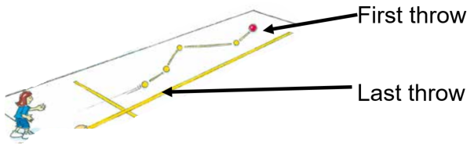
Adapted from Sport Australia 2019 © Playing for life

Appendix 2 – bullseye
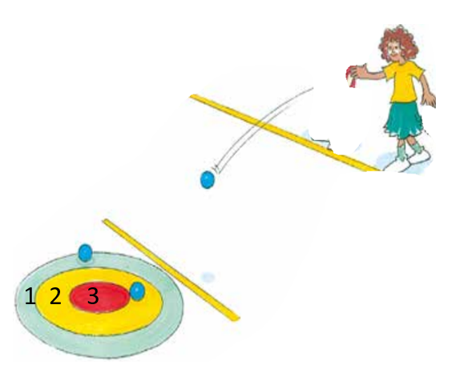
Adapted from Sport Australia 2019 © Playing for life

Appendix 3 – overarm throw – Stage 1
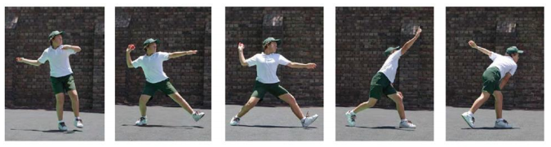
To perform the overarm throw focus on the four key components of:
- eyes focused on the target
- stand side on
- step towards target area with opposite foot to throwing arm
- throwing arm follows through, down and across the body.
Remember:
- eyes
- side on
- step
- follow through.

Appendix 4 – 1 base throwball
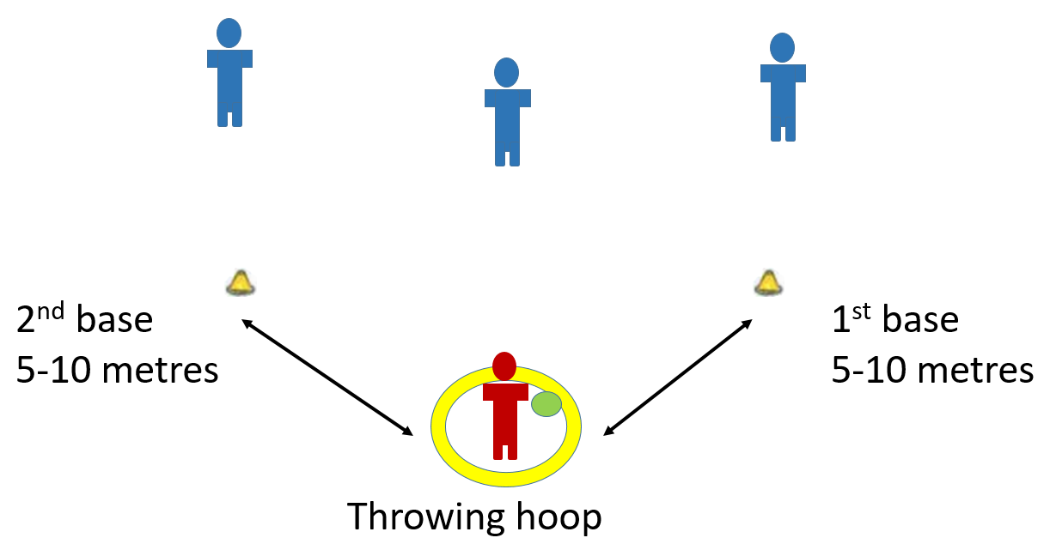

Appendix 5 – 2 vs 2 target bombard
Adapted from Sport Australia 2019 Playing for life Bombard
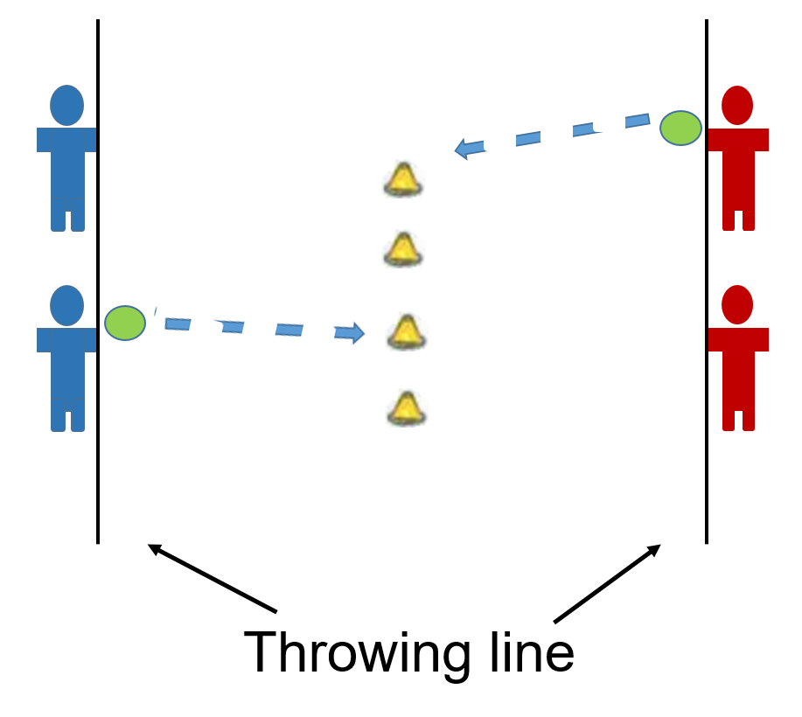

Appendix 6 – boccia
Adapted from Sport Australia 2019 Playing for life Boccia
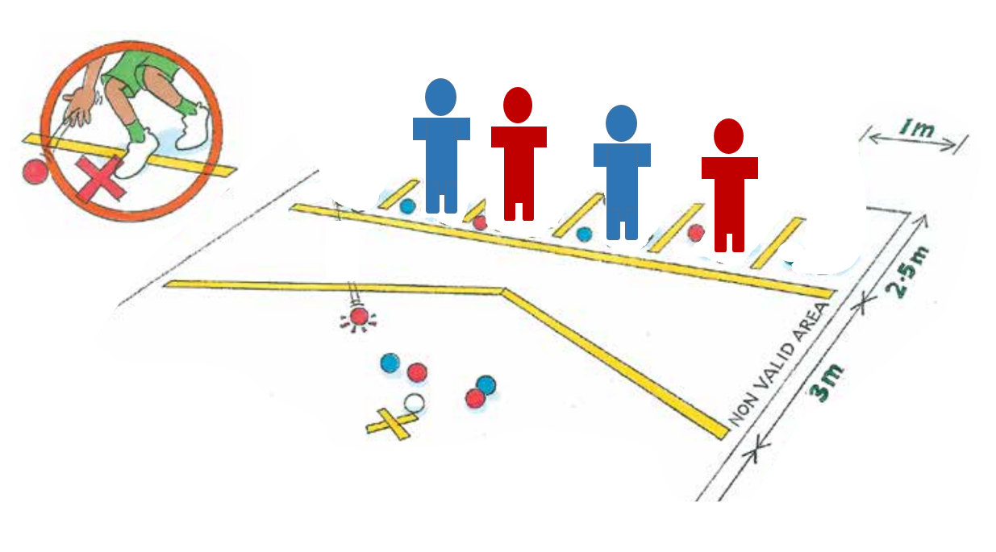

Appendix 7 – step or no step examples
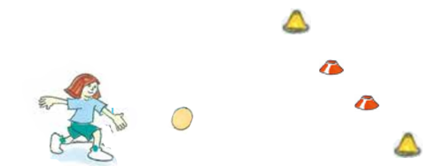
AFL goals – two red cones form the small goal. Two yellow cones form the large goal.
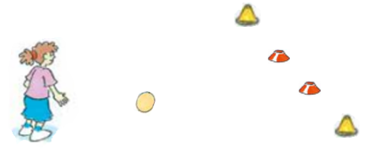
AFL goals – two red cones form the small goal. Two yellow cones form the large goal.
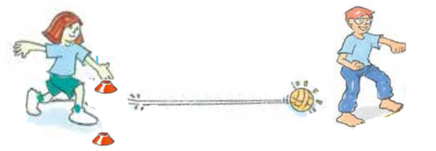
Tunnels. Images Adapted from Sport Australia 2019 © Playing for life
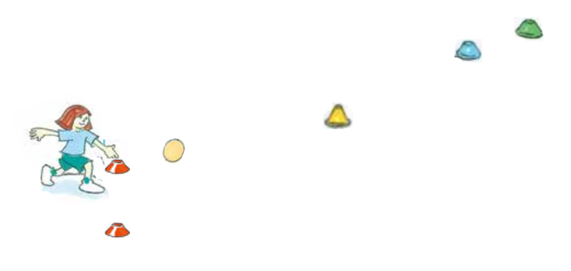
Kick for distance

Appendix 8 – kick – Stage 1
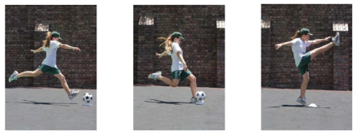
To perform the kick focus on the four key components of:
- eyes focused on the ball
- forward and sideward swing of opposite hand to kicking leg
- step-forward to place non-kicking leg next to ball
- contact ball with top of the foot (a ‘shoelace’ kick).
Remember:
- eyes
- hand
- step
- (shoelaces) kick.

Appendix 9 – kick croquet
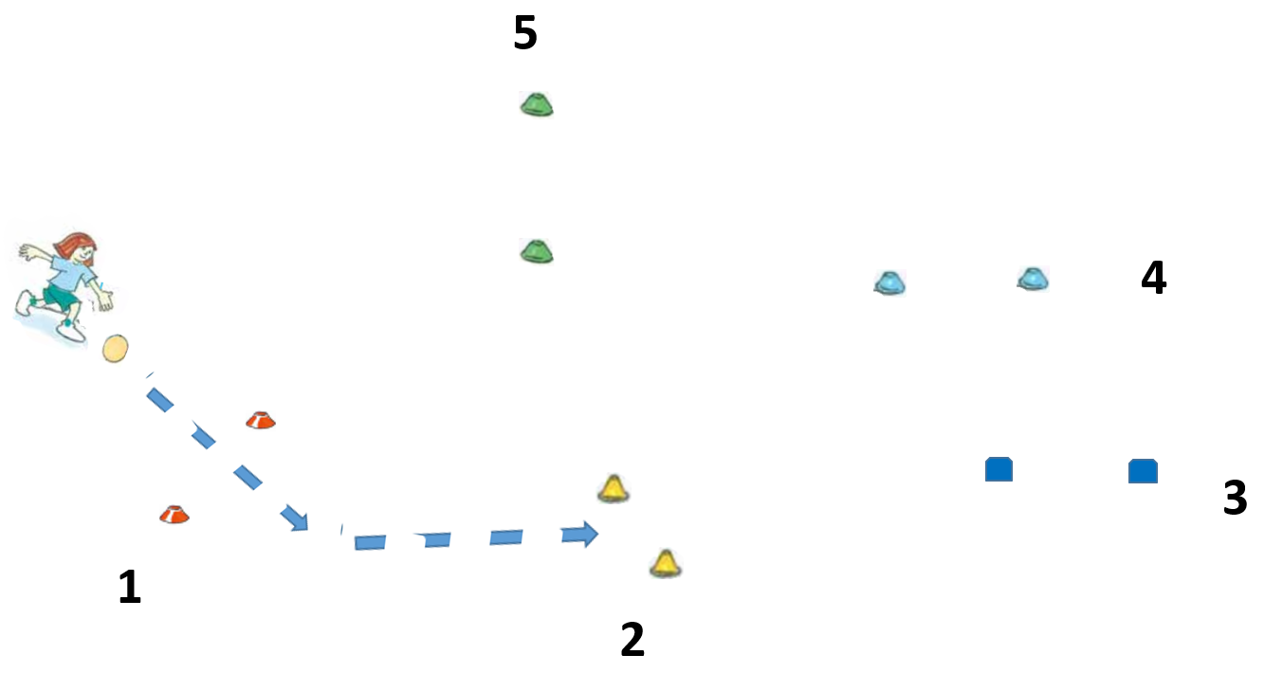

Appendix 10
The following NSW Physical Literacy Continuum K-10 cluster markers guided the development of the ‘Evidence of Learning’ (EoL) as observable behaviours to address the Student learning goals and identified syllabus outcomes.

Movement competencies
- Demonstrates stable head and trunk position while moving, for example, leap.
- Demonstrates correct head and trunk position and coordination of arms and legs to remain stable.
- Demonstrates proficiency in object control skills when practised in isolation.
- Demonstrates proficiency in locomotor movement skills when practised in isolation.

Tactical movement
- Applies different movement skills and concepts to achieve success within the rules of a physical activity, for example, uses dodge to avoid others and move into space.
- Identifies appropriate tactics within a physical activity to influence achievement or success.

Motivation and behavioural skills
- Demonstrates motivation to try new physical activities.
- Persists in a range of physical activities regardless of success.

Personal and social attributes
- Follows instructions, rules and safety procedures in physical activities.
- Uses equipment appropriately and safely in physical activities.

Resources
What resources will the teacher require to deliver this unit of work as planned in the teaching and learning activities?
- Lessons 1-10 – fast start activities require cones to mark boundaries for the playing area. Most Fast start activities can be played within a 20-metre x 20 metre area. Cones may not be required if current landmarks support these games. For example, line markings on a basketball or netball court.
- Lessons 1-5 require each pair to have an object to throw. This may be a soft ball (for example, tennis ball), bean bags or another soft object.
- Lessons 6-9 require each pair to have a ball to kick. This can include both round and egg-shaped balls.
- Lesson 10 each student requires a ball to kick.

Vocabulary/glossary
What key terms will deepen student knowledge and understanding of key concepts and skills addressed throughout the unit of work?
- Target, goal, send, throw, kick, punt, accuracy, strategy, adjust, distance, force, increase, decrease, difficulty.

Evaluation
Teacher analysis of the teaching and learning in the entire unit of work. Sample questions to address include are below.
Evaluation | Teacher notes
How well did the class demonstrate understanding of key concepts? | Write notes here.
What concepts/topics will I need to revisit to support student understanding? | Write notes here.
When will these concepts be revisited? | Write notes here.
How well were student learning needs met? | Write notes here.
Did all students have opportunities to demonstrate their knowledge, understanding and skills? | Write notes here.
Did adjustments provide adequate and appropriate access to all activities by all students? | Write notes here.
Were the resources used accessible for all students? | Write notes here.
Which activities in the learning sequence will I need to adapt to ensure better achievement of learning goals? | Write notes here.
Did the learning sequence provide sufficient opportunities to make quality assessment judgements about student achievement? | Write notes here.
Which activities and tasks were most engaging and effective? | Write notes here.
Did the adjustments provide adequate and appropriate access to all activities by all students? | Write notes here.

