How can I keep myself and others safe?
PDHPE Stage 1

10 weeks Term – Year –
Big idea and key concept 2
Essential question and unit title 2
Unit description 2
Contextual statement 2
Skills and propositions 2
Observational framework 4
Organisation of teaching and learning activities 6
Lesson 1 7
Lesson 2 9
Lesson 3 10
Lesson 4 12
Lesson 5 15
Lesson 6 17
Lesson 7 20
Lesson 8 22
Lesson 9 24
Lesson 10 27
Evaluation 30
Resources 30
Vocabulary/glossary 31
Appendix 1 – evaluating safety 32
Appendix 2 – my feelings 33
Appendix 3 – warning signs 35
Appendix 4 – support network 36
Appendix 5 – can you Go? 36
Appendix 6 – using No-Go-Tell 37
Appendix 7 – support network/emergency or non-emergency 38
Appendix 8 – support network/emergency services 39
Appendix 9 – calling emergency services 40
Appendix 10 – buckle 10 41
Outcomes and other syllabus material in this document are copyright.
PDHPE K-10 Syllabus © NSW Education Standards Authority (NESA) for and on behalf of the Crown in right of the State of New South Wales 2018.

Big idea and key concept
The ‘big idea’ is the over-arching concept that is being addressed or challenged throughout the unit. For example, “risk-taking is healthy”.
People may approach safety differently. These approaches can change over time.

Essential question and unit title
This question drives both teaching and learning within the unit. Every activity should be working towards answering this question. For example, “How can I manage risk and still have fun?”
How can I keep myself and others safe?

Unit description
Students investigate safe and unsafe features of specific environments and explore actions to enhance their own and others’ safety and wellbeing. Through practical application students develop help-seeking skills and adopt strategies to help keep themselves and others safe.

Contextual statement
The evidence collected to support the development of this unit.
As students continue develop and grow, they need to improve their self-awareness skills and take greater responsibility for their actions, feelings and behaviours. By creating an awareness of safe behaviours people are empowered to use strategies that will help to promote their own and others health, safety and wellbeing. All students have the right to feel safe and should be supported to develop help-seeking strategies and a network of trusted adults.

Skills and propositions

Skills in focus
What specific skills are being learned, developed and applied throughout this unit of work? Refer to pages 27-30 of the PDHPE K-10 syllabus.

Self-management skills (S)
- Self-awareness
  - self-monitoring thoughts, feelings and actions
  - developing greater control and responsibility for our actions, feelings and behaviours
- Emotion and stress management
  - recognising emotions
- Decision making and problem solving
  - finding solutions to problems
  - analysis
- Help-seeking
  - accessing support and support networks

Interpersonal skills (I)
- Communication
  - verbal and nonverbal communication
  - expressing feelings
- Empathy building
  - understanding others’ views
- Social awareness
  - perspective taking

Movement skills (M)
- Health and fitness enhancing movement
  - Managing risk and promoting safety

Propositions
Describe how specific propositions are embedded throughout the unit of work. The 5 propositions are outlined on pages 24-25 of the PDHPE K-10 syllabus.

Focus on educative purpose
Students are provided with opportunities to develop the knowledge and skills required to recognise emotional and behavioural warning signs of unsafe situations and react in safe and positive ways. They will create, apply, practise and evaluate strategies to keep themselves safe.

Take a strengths based approach
Students will be encouraged to draw upon their own strengths and capabilities to further strengthen their knowledge, skills and understandings, while they are learning to deal with safe and unsafe situations.

Critical inquiry approach
Students are supported to question and challenge the actions of others that impact on their own health and safety. They have opportunities to develop skills to recognise safe and unsafe situations, identify warning signs and learn help-seeking strategies.

Health literacy
Students explore who they can access to support their own and others safety. They identify environmental supports that maintain and promote safety for themselves and others. For example, rules, safety signs and support personnel.

Observational framework
Outcomes | Unit learning goals – students are learning to | Evidence of learning – students can
What syllabus outcomes will be assessed against throughout this unit of work? Refer to pages 14-19 of the PDHPE K-10 syllabus. | What are students expected to know, understand and do as a result of the learning within this unit of work? These are derived from the identified syllabus outcomes. | What specific behaviours will you expect to observe and use as an indicator of student learning towards the unit learning goals and syllabus outcomes.
PD1–2 recognises and describes strategies people can use to feel comfortable, resilient and safe in situations | recognise and describe specific safety strategies and procedures | identify and use NO GO TELL. (Lesson 5 – Activity 1, Lesson 6 – Activity 1, 2).
PD1–2 | recognise people they can contact to support themselves | identify up to 5 people in their own personal support network. (Lesson 4 – Activity 2)  identify people from their support network to support them in specific situations. (Lesson 4 – Activity 3)
PD1–2 | recognise situations that require help from emergency services | identify emergency situations. (Lesson 7 – Activity 1)  identify which emergency service to call for a specific emergency. (Lesson 7 – Activity 2)
PD1–2 | recognise safe decisions when online and accessing the internet | identify strategies to stay safe online. (Lesson 8 – Activity 1,2)
PD1–2 | recognise safe decisions when travelling | identify safe behaviours and actions when travelling in a car. (Lesson 9 – Activity 1,2)
PD1–2 | recognise safe decisions when out in the sun | identify safe behaviours and actions when using other forms of transport. (Lesson 9 – Activity 3)  selecting appropriate safety measures when spending time in the sun. (Lesson 10 – Activity 1)
PD1–2 | recognise safe decisions when in or around water | selecting appropriate decisions to maximise safety around water. (Lesson 10 – Activity 2)
PD1–6 understands contextual factors that influence themselves and others’, health, safety, wellbeing and participation in physical activity | recognise safe and unsafe situations within specific environments | evaluate the safety of a familiar environment. (Lesson 1 – Activity 1, Lesson 8 – Activity 1, 2, Lesson 9 – Activity 1, 2)
PD1–6 | recognise the safety of various scenarios and the impact people have in these | identify whether a scenario is safe or unsafe depending on the people involved. (Lesson 2 – Activity 1, Lesson 5 – Activity 1, Lesson 6 – Activity 1, 2)
PD1–9 demonstrates self-management skills in taking responsibility for their own actions | self-monitoring feelings they experience during safe and unsafe situations | recognise their specific feelings in safe and unsafe situations. (Lesson 2 – Activity 2, Lesson 3 – Activity 1)  recognise feelings as warning signs. (Lesson 4 – Activity 1, 3, Lesson 5 – Activity 1, Lesson 6 – Activity 1, 2)

Organisation of teaching and learning activities

Key inquiry questions and syllabus content
What syllabus content is being addressed in each teaching and learning activity?

Teaching and learning activities
A detailed description of the teaching and learning strategies that the teacher will provide for students to learn, develop and apply knowledge, understanding and skills. The following sub-headings are used.

Activity
A description of the suggested teaching and learning activity

Teacher notes
Information that may support teachers with delivery of the teaching and learning activities. This may include concepts and content that may be deemed to be sensitive and/or controversial.

Discussion
The suggested discussion opportunities should be delivered in a manner that best suits your context. These can be between peers, in small groups, as a whole class or a one-on-one teacher-student conference. Sample questions and scenarios may be adapted to meet student needs in a manner that is reflective of school and community context.

Reflection
The suggested reflection that links to the essential question that is also the unit title. This question drives teaching and learning and all activities have been designed to enable students to answer it. This reflection provides further opportunity to reinforce student learning and may act as an ongoing demonstration of student knowledge, understanding and skills.

Resources
A list of resources required to deliver the lesson as described. Teachers may choose to use alternative learning tools and activities that best meet student needs. Alternative examples include learning tools and activities from the department’s Digital Learning Selector.

Lesson 1

Key inquiry questions and syllabus content
How can I be responsible for my own, and others’ health, safety and wellbeing?
Students:
- describe situations where they are required to make healthy and/or safe decisions, for example: (ACPPS018)
  - predict outcomes of personal choices in order to make safe decisions
What influences my decisions and actions to be healthy, safe and physically active?
Students:
- examine contextual factors that influence their own and others’ decisions and behaviours, for example: (ACPPS021)
  - describe choices and factors that have an impact on their own and others’ health and safety, eg smoking, fast food, pollution.

Teaching and learning activities
Teaching considerations

Lesson 1
Recognising safe and unsafe situations within an environment

Teacher notes
Explain to students that this unit focuses on safety and how they can keep themselves and others safe.
Teachers should consider how they best create a supportive learning environment that enables students to feel safe, learn and ask questions. This is particularly important when discussing issues that may be deemed sensitive or controversial.

Discussion
Students respond to the following questions:
- What is safety? Compose a class definition of what safety is (for display within the class).
- Why is safety important?
- Who is responsible for our safety?

Teacher notes
Safety means to be protected and kept from harm or danger.

Discussion
Explore with the students the idea that places can be safe or unsafe depending on the situation. For example, who is with them (supervision), time of day, weather conditions, and quality of equipment or physical features such as grass?
Have students observe a section of the playground and distinguish what makes it safe or unsafe.
Sample questions:
- What time of day is it safe to play here? For example, recess and lunch time.
- What time of day is it not safe to play here? For example, after school, during class time.
- Who can help make this a safe place to play and how? For example, a teacher on duty by checking the equipment for damage, yourself by following the rules.
- Who can make this an unsafe place to play and how? For example, a stranger by approaching you, older children by playing roughly, yourself by not following the rules.
- What type of weather would make this place safe to play and why? For example, sunny it is not slippery.
- What type of weather would make it unsafe to play and way? For example, it rains so the surface becomes slippery.
- What makes the equipment/physical features here safe to use? For example, soft grass to prevent injury, safety rules on a sign.
- What could the equipment/physical features look like to make it unsafe? For example, broken chain, loose screws, wet grass, and incorrect use of equipment /physical feature.
- How could the environment be made safer?

Activity 1
Brainstorm other locations where students will have to assess the environment to make decisions around their own safety. For example, riding their bikes, outside the school at home time, local pool, back yard, beach.
Students complete their own evaluation (Appendix 1 – Evaluating safety) of selected environment using the same questions. For example, bike riding, going home, crossing the road, local pool, home backyard.

Reflection
Students reflect upon the learning in this activity/lesson and consider how it contributes towards answering the essential question “How can I keep myself and others safe?” Students may record responses in a variety of ways this may include student journal, illustrations, recorded verbal response, written response or digitally.

Resources
Appendix 1 – Evaluating safety.

Lesson 2

Key inquiry questions and syllabus content
How can we be inclusive and respectful?
- identify and practise physical and emotional responses that account for their own and others’ feelings. For example:
  - Identify the body’s reactions to a range of situations, including safe and unsafe situations, comparing the different emotional responses
How can I be responsible for my own, and others’ health, safety and wellbeing?
- describe situations where they required to make healthy and/or safe decisions, for example:
  - recognise safe choices for a variety of situations e.g. not sharing information online, walking on the foot path

Teaching and learning activities
Teaching considerations

Lesson 2
Recognising safe and unsafe situations with people.

Activity 1
Explore with students the idea that places can be safe or unsafe depending on the situation and who is involved. Teacher lists situations and students vote yes or no if they feel each situation is safe. After each vote teacher asks students to explain their response (what makes them feel this situation is safe or unsafe. For example, a stranger asks you to get in their car, no it is not safe and I felt scared and had tummy butterflies (warning signs).
Example scenarios may include:
- a stranger asks you to get into their car.
- An adult tells you to keep a secret from your parent/caregiver.
- Someone wants to show you what is under their clothes and asks to see what is under yours.
- A person wants you to go for a walk with them without letting your parent/carer know.
- Your parent/caregiver lets you go to the shop with a trusted family member.
- A person says hello to you when you are walking with your parent/caregiver.
- You are lost and a police officer offers to help you.
- Your parent/carer takes you to the doctor, who checks your body when you are sick or hurt.

Teacher note
Each situation/scenario may have scope for further discussion on possible difference of opinion. This may lead to students understanding they have control on what happens to their body.

Activity 2
Brainstorm and list emotions/feelings students can experience during safe and unsafe situations. For example, fear, worried, happy, excited. Students read each scenario in Appendix 2 – My feelings and draw their matching emotion on the face provided to represent how they would feel. Students complete the sentence explaining why they would feel that way.
Selected students share their responses with the class.

Teacher note
Display the list of emotions/feelings that have been identified by students to use as a reference in completing Appendix 2 – My feelings.

Resources
Appendix 2 – My feelings.

Lesson 3

Key inquiry questions and syllabus content
How can I be responsible for my own, and others’ health, safety and wellbeing?
- describe situations where they are required to make healthy and/or safe decisions, for example:
  - describe feelings, reactions and warning signs that can help them recognise safe or unsafe situations e.g. excitement, feeling anxious, fear

Teaching and learning activities
Teaching considerations

Lesson 3
Recognising warning signs.

Discussion
Explore the following question, ‘What is a warning sign?’ Lead discussion and direct the focus towards the definition of a warning sign being something that sends us a message about the situation. For example, warning signs from our body may let you know when a situation is safe or unsafe.
Students brainstorm the different feelings, reactions and warning signs that can help them recognise safe or unsafe situations. For example, feeling worried, quick heartbeat, butterflies in the stomach.

Activity 1
Using Appendix 3 – My warnings signs, students identify whether specific physical reactions are related to unsafe or safe feelings. Students then describe when someone might experience them.

Teacher notes
It is important that students are aware that no particular warning sign given by the body is in itself positive (‘Yes feeling’) or negative (‘No feeling’) but can have different meanings in different situations. For example, butterflies in the tummy could mean a person is nervous, scared or excited.
Warning signs might include – bouncy tummy, squirmy tummy, lumpy tummy, warm body, cold-shivery body, clapping hands, fidgety hands, sweaty hands, quick breathing, shallow breathing, gaspy breathing, racing heart, stopped heart, goose bumps, body hair standing up, sick sensation, smiley face, tight scrunched face (frown), tears, open eyes, red hot face, shaky knees, wobbly legs or dry mouth.
Explain how warning signs can sometimes be either positive or negative depending on each situation.
For example, a student may feel a bouncy/squirmy tummy when they are going to a birthday party because they are excited or to a dentist because they are feeling nervous.
Provide students with the following scenarios including the warning signs and have them determine whether each scenario is safe or unsafe. Ask students to explain why they have chosen safe or unsafe for each scenario and suggest how they may respond. (This could be a written scaffolded task/activity using a template).

Scenario 1
You are shopping with your parent/caregiver when the shop assistant says hello, asks your name and how old you are. You are a bit shy and feel your face becomes hot and your mouth dry.

Scenario 2
While playing with a friend and you run away and hide together. Your friend then shows you their private parts and asks you to show them yours. You say no and try to run back to the group. They respond by grabbing your arm and telling you to keep it a secret. You are embarrassed, your heart is racing and you feel sick in the tummy.

Scenario 3
An adult that your parents/caregivers know pulls up at the school bus stop and tells you they are there to pick you up. They say that your parents/carer have sent them to collect you, as they are running late, which has never happened before. You feel confused, have shallow breathing and your hands are fidgeting.

Teacher notes
Although it is not always possible, the teacher should try to select a situation that students in the class are likely to have not personally experienced. Teachers also need to be sensitive to any strong emotional reactions from students which may indicate that they are reminded of a stressful experience.

Reflection
Students reflect upon the learning in this activity/lesson and consider how it contributes towards answering the essential question “How can I keep myself and others safe?” Students record responses in their learning journal.

Resources
Appendix 3 – My warnings signs.

Lesson 4

Key inquiry questions and syllabus content
How can I act to help make my environments healthy, safe and active?
- practise strategies they can use to support their own and others’ health, safety and wellbeing, for example:
  - recall people they can contact to support themselves and others e.g. phone numbers of organisation, emergency organisations

Teaching and learning activities
Teaching considerations

Lesson 4
Support networks.

Discussion
Explore the following questions:
- What does it mean to trust someone? For example, to believe someone is reliable, honest and will not harm you.
- What does trust look like to you? For example, I can physically recognise these people and know I can seek support from.
- What does trust feel like to you? For example, I feel I can tell them anything no matter how embarrassing or sensitive. I feel happy, safe, comfortable and supported.
- How might we know which people we can trust? For example, I get ‘YES’ feelings when I am with the trusted person. They will keep me safe. The person will listen to you and respond appropriately. They support me when I need it.
- Why is it important to know who we can trust? For example, to help keep me safe, so I can talk to someone about important things like being hurt or feeling unsafe.

Activity 1
Brainstorm the following questions to create a class definition.
- What is a support network? For example, a small number of people who you can trust to keep you safe by listening to you, believing you and supporting you at all times.
- Why is it important to have a support network? For example, when you are hurt, feeling unsafe, confused, scared or worried these people can help keep us safe. In addition, they can teach us strategies to maintain positive health, safety and wellbeing.

Teacher notes
The definition and reasons of why a support network is important may be displayed in the room for future reference by students.

Activity 2
Using Appendix 4 – Support network, students complete their own support network by listing specific names of people that they trust under the headings – family, friends, familiar adults and community members.
- Students tick the people they know how to contact.
- Students select 2 people from any category and describe why they chose them to be in their support network.
- Students share their responses with the class.

Teacher notes
Emphasise with students that the people listed should be good at listening to them, will believe and support them with appropriate advice at all times. Remind students that it is acceptable for their support network to be less than 5 people. Therefore, all spaces on the table do not necessarily have to be filled. Ensure that students understand what an ‘adult’ is and that it is their responsibility to keep children safe, although not all adults do.

Activity 3
Think, pair, share – Students share the name of a person they believe they could trust to help them in the following scenarios. They also explain why they chose the specific person. For example, I am being teased at school (No feelings) and I told my teacher because I know she will support me/make me feel better (Yes feelings) and make the other children stop.

Teacher notes
Allowing students to refer to their completed support network (Appendix 4) may aide their thought processes. You may create more appropriate scenarios to suit the needs of your students and local context.
Who would you go to for help if you were? Why would you go to this person?
- lost at the shopping centre
- being teased at school
- hurt or injured at home
- told by your friend that they were being hurt by someone they know
- feeling confused and scared about something that has happened to you
- uncomfortable about something you saw online
- worried about something you were asked to do
- told to get into a car by an adult you do not know
- told to keep a secret from your parent/carer

Reflection
Students reflect upon the learning in this activity/lesson and consider how it contributes towards answering the essential question “How can I keep myself and others safe?” Students record responses in their learning journal.

Resources
Appendix 4 – Support network.

Lesson 5

Key inquiry questions and syllabus content
How can I act to help make my environments healthy, safe and active?
- practise strategies they can use to support their own and others’ health, safety and wellbeing, for example:
  - demonstrate help-seeking strategies they can use when they feel unsafe, frightened, lost, upset, excluded or require assistance e.g. No-Go-Tell
How can I be responsible for my own, and others’ health, safety and wellbeing?
- describe situations where they are required to make healthy and/or safe decisions, for example:
  - predict outcomes of personal choices in order to make safe decisions

Teaching and learning activities
Teaching considerations

Lesson 5
No-Go-Tell (focus on No).

Teacher notes
Scenarios may be best adapted to suit the students’ needs and context of the school and community. The scenarios here are generalised so adaptation may be required. Be aware that some scenarios may be sensitive for specific students so exercise caution when deciding on scenarios.

Discussion
Explore with students the following questions:
- What is a protective strategy? For example, a plan or set of steps taken to protect an individual from injury or harm.
- What are some protective strategies we have here at school? For example, lock down, evacuation, wet weather, medical emergency/ health plans.
- When would we use a protective strategy? For example, when they feel unsafe (body signals, Yes/No feelings), frightened, lost, upset, excluded or require assistance.
- What are some personal strategies that can be used? For example, No Go Tell, mindfulness, seek help from a trusted adult, breathing techniques.
Explain that No-Go-Tell is an excellent strategy that could be used in any unsafe or uncertain situation. Break each step down by asking students what they think each step means.
For example, No – voicing an assertive “no”, Go – moving away to a safe location, Tell – tell a trusted person from their support network.

Teacher notes
It is important that students understand that NO GO TELL is a protective strategy not a rule. As it is recognised that children cannot always use this strategy it is crucial that they do not feel somehow to blame in an abusive situation because they did not ‘follow’ the strategy.

Activity 1
Using the scenario below, teacher models saying NO in the three specific ways;
- Passive. For example, use a soft voice, hunched/defensive body language, no eye contact, fidgeting.
- Aggressive. For example, use an angry voice, invading personal space, clenched fists/puffed chest.
- Assertive. For example, use a firm voice, direct eye contact, standing tall, execute with confidence, and correct tone of voice.
Students explore which one they feel would be the most effective and predict outcomes if each one were used.
Scenario – Petra and Molly are playing on the school oval. Molly decides she wants to leave the school grounds and go to the nearby park. As Molly leaves the gate, she tries to convince Petra to go along. The teacher demonstrates assertive behaviour “No, we are not allowed!”
Discuss with students the benefits of providing a reason when they say No. For example, the message is more assertive as it explains the reason for your answer.

Teacher note
Ensure students understand that providing a reason helps with the assertiveness of the response but it doesn’t need to be detailed – for example, ‘I don’t want to’, rather than ‘I think crossing the road is dangerous and we don’t have an adult with us’. Also ensure students understand that there may be times when they are unable to give a reason and it is acceptable to just say No.
Brainstorm with students some general reasons they could give when saying No. For example, I do not want to, I am not allowed, It is dangerous, It is unsafe, I do not feel safe, I will get into trouble, my parent/caregiver said I am not allowed.
Students work in pairs and practise saying No to one of the below scenarios. Students also practise giving a reason if they can, eg “No, it’s too dangerous!” This should not be said in an aggressive or offensive way. Reaffirm with students that tone of voice is very important when being assertive.
- A friend wants you to cross a busy road. There is no pedestrian crossing.
- Some friends want you to go to their house to play. Your parents told you to come straight home.
- Your brother wants you to bike ride in the school grounds on the weekend but the Principal has said you do not have permission.
- Your uncle wants you to sit on his lap and cuddle him. You do not like his rough beard.
- Your older sister wants you to watch a scary movie. You do not want to.
- Your friend wants you to catch tadpoles but you know that it is unsafe and you do not have your parents’ permission.
Students demonstrate their response to the class for feedback.

Reflection
Students reflect upon the learning in this activity/lesson and consider how it contributes towards answering the essential question “How can I keep myself and others safe?” Students record responses in their learning journal.

Resources
Space for role play.

Lesson 6

Key inquiry questions and syllabus content
How can I act to help make my environments healthy, safe and active?
- practise strategies they can use to support their own and others’ health, safety and wellbeing, for example:
  - demonstrate help-seeking strategies they can use when they feel unsafe, frightened, lost, upset, excluded or require assistance e.g. No-Go-Tell
How can I be responsible for my own, and others’ health, safety and wellbeing?
- describe situations where they are required to make healthy and/or safe decisions, for example:
  - predict outcomes of personal choices in order to make safe decisions

Teaching and learning activities
Teaching considerations

Lesson 6
No-Go-Tell (focus on Go Tell).

Discussion
Explore with students the idea that sometimes it can be very difficult to say “No” when you are faced with an uncomfortable and/or unsafe situation. Students respond to the question, ‘Is it always possible to Go when you feel your warning signs?’
Teacher revisits the scenario about Petra and Molly.
Scenario – Petra and Molly are playing on the school oval. Molly decides she wants to leave the school grounds and go to the nearby park. As Molly leaves the gate, she tries to convince Petra to go along.
Students explore whether Petra can Go, after telling Molly No. Students respond to the following questions.
- Can Petra Go? For example, yes she can leave the oval.
- Where could Petra Go? For example, to a teacher, the office, to her classroom.

Activity 1
In small groups students discuss one of the following situations, addressing the questions from Appendix 5 – Can you Go?
- Hannah is at her uncle’s place without her parents in an unfamiliar suburb. Her uncle is sitting too close to her while watching TV and she feels her warning signals.
- Steven is at home and his parent/caregiver is shouting at him. He is feeling scared.
- Louise is in a car with an adult who wants her to touch his private parts. The doors are locked.
Groups report back to the class.

Teacher notes
Acknowledge that it may not always be possible to Go from unsafe situations but it is always important to try to Tell. Accept all options but check each one with students to assess whether it is a safe option by focussing on, ‘What might happen then? Would this be a safe option?’ Do not refer to individual students who volunteered options nor disregard suggestions made by students. It is important that the option of not being able to Go from each situation is discussed. Always reinforce the concept that children are never to blame if they cannot say No or Go from a situation but they should always Tell someone as soon as they can.

Discussion
Remind students that sometimes it can be hard to Tell because they might feel scared, embarrassed, threatened, uncomfortable or worried about possible consequences, for example, someone getting in trouble.
Using the scenario with Petra and Molly, explore who Petra could tell and what would she say? For example, Petra could find the teacher on duty and say, ‘Molly has left the school grounds and I am worried about her safety.’
Students review their support network from Lesson 4 – Support networks, and respond to the following questions
- Who could you Tell if you are feeling unsafe? Refer to your support network.
- If any of the scenarios happened to you who would you tell and what would you say?

Teacher notes
Remind students of other adults that they could Tell if they are feeling unsafe, including teachers, coaches, youth group leaders, case workers, doctors, online support such as Kids Help Line, emergency and family services.

Activity 2
Students demonstrate their understanding of No-Go-Tell by completing the 3 steps for the scenario on Appendix 6 – Using No-Go-Tell.
‘While playing at the park a stranger asks if you would like to come to their car to get a special present. Your trusted adult is over on the other side of the play equipment sitting on the bench having coffee with their friends. How would you use No-Go-Tell?’
Students write
- What reason they may give for saying No?
- If they can Go, where would they go to?
- Who would they Tell and what would they say?

Reflection
Students reflect upon the learning in this activity/lesson and consider how it contributes towards answering the essential question “How can I keep myself and others safe?” Students record responses in their learning journal.

Resources
- Appendix 5 – Can you Go?
- Appendix 6 – Using No-Go-Tell

Lesson 7

Key inquiry questions and syllabus content
What can I be responsible for my own, and others’ health, safety and wellbeing?
- describe situations where they are required to make healthy and/or safe decisions, for example: (ACPPS018)
  - recognise situations that require help from emergency and other support services and demonstrate what to do in an emergency
How can I act to help make my environments healthy, safe and active?
- practise strategies they can use to support their own and others’ health, safety and wellbeing, for example: (ACPMP030)
  - recall people they can contact to support themselves and others, eg phone numbers of organisations, emergency organisations
  - demonstrate actions they can use to seek help for or support others in different situations

Teaching and learning activities
Teaching considerations

Lesson 7
Emergencies and who can help.

Discussion
Explore the following questions, using the students’ support networks (Appendix 4 – Support network).
- In your support network did you include police officers, ambulance officers and firefighters?
- These people are part of the emergency services. What is an emergency? For example, an emergency is a serious, unexpected and often dangerous situation requiring immediate action.
- Why should emergency services personnel be included in your support network? For example, some support requires professional skills such as an ambulance officer giving medicine or special equipment such as a firefighter with their hose.
- When should we seek help from these emergency services? For example, when we need specialised skill or equipment for an emergency where someone is badly hurt or in danger of serious injury.
- Brainstorm the difference between emergency and non-emergency situations. An emergency can be:
  - a big accident. For example, someone is knocked out (unconscious) at soccer, car crash.
  - a dangerous situation. For example, a house fire, someone is lost.
  - a serious illness. For example, severe asthma attack.
  - an allergic reaction. For example, peanuts, bee stings.

Activity 1
Students read the situations in Appendix 7 – Support network/emergency or non-emergency and identify the situation as an emergency or non-emergency.
Using their support network sheet (Appendix 4 – Support network) and knowledge of emergency services students determine who could help with each situation.
Students justify their selections with the class.

Discussion
Explore the following questions:
- ‘What could you do in an emergency?’ For example, tell an adult, call triple zero, move away from the emergency and make sure you are safe, warn others, follow directions from people in charge such as teachers or police, stay calm and listen to instructions.
- Does anyone know what triple zero is?
- How many zeros in triple zero?
- When should we call triple zero? For example, if someone has been badly injured or is sick, a serious accident has occurred.

Teacher notes
All children should be aware of what they could do if they are faced with a real-life emergency. One of those things being call triple zero. Triple zero should never be called unless it is a real emergency.

Activity 2
Discuss with students when they call triple zero, they will need to tell the operator which emergency service they need – Police, Fire or Ambulance. Students read the scenarios in Appendix 8 – Support network/emergency services and identify which emergency service they would call. For example, ambulance officers help people who are sick or hurt, police officers help keep the community is safe and firefighters put out fires and perform rescues.
Students justify their selections to the class.

Discussion
Explore the following questions:
- How would you call triple zero on a mobile phone? For example, on a mobile phone you do not need to unlock the phone. You can swipe the screen up and press ‘emergency’. Display Appendix 9 – Images of mobile and home phones.
- How would you call triple zero on a home phone? For example, on a phone at home you would pick up the phone and press 000. Display Appendix 9 – Images of mobile and home phones.

Teacher notes
It is important that children know what to expect and how to answer questions asked by an emergency operator, it is not something children should fear doing though. Be sure to reiterate that calling triple zero 000 as a joke is not funny or acceptable. It could result in serious consequences and delay help reaching someone who needs it.

Reflection
Students reflect upon the learning in this activity/lesson and consider how it contributes towards answering the essential question “How can I keep myself and others safe?” Students record responses in their learning journal.

Resources
- Appendix 7 – Support network/emergency or non-emergency
- Appendix 8 – Support network/emergency services
- Appendix 9 – Images of mobile and home phones

Lesson 8

Key inquiry questions and syllabus content
How can I be responsible for my own and others’ health, safety and wellbeing?
- describe situations where they are required to make healthy and/or safe decisions, for example: (ACPPS018)
  - recognise safe choices for a variety of situations, eg not sharing information online
How can we be inclusive and respectful?
- identify and practise physical and emotional responses that account for their own and others’ feelings, for example;
  - recognise own emotions and demonstrate positive ways to respond to different situations, eg seeking help.

Teaching and learning activities
Teaching considerations

Lesson 8
Safe decisions – online safety

Discussion
Explore with students that there are times when we need to make decisions to keep ourselves and others safe. For example, swimming in a pool, using the internet, at the beach or in a dam, riding a bike/scooter, traveling in a car, walking across the road as a pedestrian, being out in the sun playing.
Explore with students how they access the internet. For example, online gaming, learning/researching, watching YouTube/Netflix and communicating with known people through Skype, Zoom, Snapchat, TikTok, Google classroom, email.
Explore the following questions,
- What do you think about when you hear the words ‘cyber safety’? For example, cyber safety is the safe and responsible use of information and communication technology. It is about keeping information safe and secure, but also about being responsible with that information, being respectful of other people online and using good 'netiquette' (internet etiquette).
- What are the warning signs that you might feel if you are unsure whether something you see online is real or fake, suitable or unsuitable?
- What could you do to keep yourself safe? Who could you speak to?

Activity 1
Guide students through an exploration of the e-safety kids tab and view the Be Curious and Be kind features with students.

Discussion
Explore the following question, ‘What information is safe or unsafe to share on the internet?’ For example, name, address, personal photos, birth date, phone number, favourite things. Students explain why each suggestion is safe or unsafe.
Explore the e-safety kids - Be safe webpages which develop students’ online safety skills.

Activity 2
Students design a poster about how to stay safe online. Considerations for the poster:
- What information should or should not be shared online?
- What to do if someone asks for your personal information?
- Who can you seek help from?
Select specific students to share and explain their poster.

Teacher note
Encourage students to use a strengths-based approach by referencing what people should be doing to be safe online rather than what they should not be doing.

Reflection
Students reflect upon the learning in this activity/lesson and consider how it contributes towards answering the essential question “How can I keep myself and others safe?” Students record responses in their learning journal.

Resources
e-safety kids tab.

Lesson 9

Key inquiry questions and syllabus content
How can I be responsible for my own, and others’ health, safety and wellbeing?
- describe situations where they are required to make healthy and/or safe decisions, for example:
  - predict outcomes of personal choices in order to make safe decisions
  - recognise safe choices for a variety of situations, eg walking on the footpath, safe places to cross the road
How can I act to help make my environment healthy, safe and active?
- practise strategies they can use to support their own and others’ health, safety and wellbeing, for example:
  - describe preventive practices to improve health and safety, eg wear protective clothing and equipment, sun protection
- explore actions and opportunities to promote and celebrate healthy, safe and active living, for example:
  - describe and demonstrate what is needed to travel safely, eg cross at pedestrian crossing, ride on the footpath

Teaching and learning activities
Teaching considerations

Lesson 9
Safe decisions – safe travel

Discussion
Reflect upon the previous lesson how there are times when we need to make decisions to keep ourselves and others safe. For example, swimming in a pool, using the internet, at the beach or in a dam, riding a bike/scooter, traveling in a car, walking across the road as a pedestrian, being out in the sun playing.
Explain this lesson is about making safe decisions either when travelling.
Explore the following questions
- When do you travel in a car?
- Why is it important to be safe when travelling in a car?
- What are some decisions you make when travelling in car? For example, this morning travelling to school in the car I put my seatbelt on and had mum check it.
- Why is it important for you to sit in a booster seat?
- Why should a grown up always check that you are buckled up properly?

Activity 1
Discuss with students that when they are buckled up in the correct car seat for their age and size, they are well protected if involved in a crash. This is because the seatbelt crosses the strong bones in their shoulders and hips and helps keep them protected in the seat. Have students feel their collar bones and pelvis/hip bones, informing students that this is the position of where the seatbelt should sit.
Students use Appendix 10 – Buckle up, to draw a picture of themselves safely buckled up in the booster seat. Make sure they draw the seatbelt in the correct position on their body.

Teacher notes
To further support the buckle up activity students can complete the epuzzle activity ‘EveryBody’ buckle up on the Safety Town © State of New South Wales (Transport for NSW) website.

Discussion
Explain to students that wearing a seatbelt is just one way to stay safe while travelling in a car. (INCOMPLETE SENTENCE). There are other ways they can keep themselves and others safe.
Explore the following question, ‘What are some behaviours and actions as well as equipment that could keep you safe when travelling in a car?’ For example, equipment could be having the correct booster seat, behaviour/actions could be not distracting the driver, keeping hands inside the car, exit the car on the kerb side (safety door).

Activity 2
Brainstorm and record a class list of the ways that people can keep safe when travelling in a car.

Discussion
Explain to students that they can travel to school in many ways. They have looked at how to stay safe when travelling in a car.
Explore with students ways they could stay safe when travelling to school by:
- riding their bike, scooter or skateboard. For example, have adult supervision, wearing protective gear such as a helmet, clothing and footwear, travel on the footpath.
- walking to school. For example, adult supervision, hold an adult's hand when crossing the road, use safety infrastructure such as lights, crossings, pedestrian islands, pay attention to what is happening around you.
- travelling by bus to school. For example, stay seated, wear a seatbelt if available, do not distract the driver, embark and disembark the bus safely, wait at the bus stop in safe manner back from the road, wait for the bus to completely stop before approaching.

Teacher notes
Be aware some students may travel by train or others means of transport. Ensure that these examples are relevant to the context of your school.

Activity 3
Students use Appendix 11 – Safe ways to travel to school, to draw and label a picture that shows how they would stay safe when travelling to school in each of the 3 ways:
- riding their bike, scooter or skateboard.
- walking.
- travelling by bus.
Students share and explain their drawings.

Reflection
Students reflect upon the learning in this activity/lesson and consider how it contributes towards answering the essential question “How can I keep myself and others safe?” Students record responses in their learning journal.

Resources
- Appendix 10 – Buckle up.
- Appendix 11 – Safe ways to travel to school.

Lesson 10

Key inquiry questions and syllabus content
How can I be responsible for my own, and others’ health, safety and wellbeing?
- describe situations where they are required to make healthy and/or safe decisions, for example:
  - Predict outcomes of personal choices in order to make safe decisions
How can I act to help make my environment healthy, safe and active?
- practise strategies they can use to support their own and others’ health, safety and wellbeing, for example:
  - describe preventive practices to improve health and safety, eg wear protective clothing and equipment, sun protection
- explore actions and opportunities to promote and celebrate healthy, safe and active living, for example:
  - explore actions to stay safe in a range of water environments, eg safe places to swim

Teaching and learning activities
Teaching considerations

Lesson 10
Safe decisions – sun safety/water safety

Discussion
Revisit with students that there are times when we need to make decisions to keep ourselves and others safe. For example, swimming in a pool, using the internet, at the beach or in a dam, riding a bike/scooter, traveling in a car, walking across the road as a pedestrian, being out in the sun playing.
Explain this lesson is about making safe decisions when being in the sun and/or around water.
Explore the following questions:
- Why is it important to make safe decision when being in the sun? For example, the sun can course long term damage to your body that can lead to serious health issues. The sun can cause short term injury/illness such as heat stroke and sunburn.
- How do you stay safe from the sun? For example, select appropriate time of day and year to be in the sun, select an appropriate amount of time to be in the sun, wear protection such as a hat, long sleeves, sunscreen, sunglasses, reapply sunscreen frequently, seek shade, drink water
- What does UV mean? For example, the part of the Sun’s rays that causes damage are the UV (ultraviolet) rays. Sunscreen and sunglasses help block these.
- What does SPF mean? For example, the SPF (sun protection factor) rating on sunscreen provides an amount of protection. The higher the number the better the protection. Just as sunscreen helps your skin from UV damage you should wear sunglasses that have UV protection as well. Wearing sunglasses without UV protection can cause damage. Some swimsuits and rash shirts ‘rashies’ have UV/SPF ratings.

Activity 1
Students read Appendix 12 – 5 ways to protect themselves from the sun when they are outside. Students complete Appendix 13 – Sun safety decisions, by selecting the appropriate item that will maximise their safety in the sun. Students justify their selections.

Discussion
Explore the following questions:
- What are some decisions we need to make to stay safe when at the local pool? For example, enter the pool safely, make sure a trusted adult is supervising you, ask permission from adult before going swimming, walk around the pool, use sun safety decisions such as applying sun screen, follow the pool rules, check the depth of the water before entering, swimming in the appropriate pool for your skill level (baby/infant pool, adult pool).
- If around other forms of water (beach/dam/river/backyard pools) what safety decisions from the pool would be the same? For example, check the depth of the water before entering, enter water safely (walking into the dam/river/beach, check for sunken objects or sandbars), make sure an adult is watching you, ask permission from adult before going swimming, use sun safety decisions such as applying sun screen.
- If around other forms of water (beach/dam/river/backyard pools) what safety rules would be different? For example, check for the flow of the water, rips, no swimming signs, dangerous animals, dangerous objects such as logs, keep the pool gate closed, ask permission from adult before going swimming.

Teacher notes
Be aware not all students may have experienced the local pool, so visual aids may help prompt student responses. When discussing other forms of water make sure these match the context of your school and community.

Activity 2
Students read the scenario in Appendix 14 – Water safety decisions and select appropriate responses that will maximise safety around water.

Reflection
Students reflect upon the learning in this activity/lesson and consider how it contributes towards answering the essential question “How can I keep myself and others safe?” Students record responses in their learning journal.

Resources
- Appendix 12 – 5 steps to sun safety
- Appendix 13 – Sun safety decisions
- Appendix 14 – Water safety decisions

Evaluation
Add your notes in the second column.
Evaluation | Notes
Teacher analysis of the teaching and learning in the entire unit of work. Sample questions to address include:
Did all students demonstrate an understanding of the key concepts?
What concepts within the unit will I need to revisit to ensure understanding?
When will I/ can I revisit these concepts?
Did the learning sequence provide sufficient opportunities to make quality assessment judgements about student achievement?
Which activities and tasks were most engaging and effective?
Which activities in the learning sequence will I need to adapt to ensure my learning goals are achieved next time?

Resources
What resources will the teacher require to deliver this unit of work as planned in the ‘teaching and learning activities?
- Lesson 1 – Appendix 1 – Evaluating safety
- Lesson 2 – Appendix 2 – My feelings
- Lesson 3 – Appendix 3 – My warnings signs
- Lesson 4 – Appendix 4 – Support network
- Lesson 5 – Space for role play
- Lesson 6 – Appendix 5 – Can you GO? Appendix 6 – Using NO GO TELL
- Lesson 7 – Appendix 7 – Support network/emergency or non-emergency, Appendix 8 – Support network/emergency services, Appendix 9 – Calling emergency services
- Lesson 8 – e-safety kids tab
- Lesson 9 – Appendix 10 – Buckle up, Appendix 11 – Safe ways of travelling to school
- Lesson 10 – Appendix 12 – 5 steps to sun safety, Appendix 13 – Sun safety decisions, Appendix 14 – Water safety decisions

Vocabulary/glossary
What key terms will deepen student knowledge and understanding of key concepts and skills addressed throughout the unit of work?
- Unsafe – to be unprotected from harm or danger.
- Personal support network – a group of trusted people that a child can access for support and advice in regard to their safety and wellbeing.
- Support services – a person, group or agency, either in the community or online, that children can access to gain advice and information in regard to their safety and wellbeing.
- Trusted adult – an adult who a child can turn to for help and support.
- Supervision – an adult observing a child to ensure their safety.
- Yes feelings – the way a person feels when something happens to them that they like.
- No feelings – the way a person feels when something happens to them that they do not like.
- Warning signals/signs – something that sends us a message about harm or danger.
- Communication – the conveying and listening to specific information, knowledge, understanding to and from others
- Rules – instructions that should be followed to maintain safety.
- No-Go-Tell – an assertiveness strategy which encourages students when they feel hurt or have warning signs to say no, if they can, go if they can, and always tell someone.
- Safety procedure – a set of steps/actions to follow to ensure safety.
- Protective strategies – plans, steps and/or actions that a person may take to help prevent harm or injury.
- Stranger – someone not known or not familiar.
- Assertive response – responding confidently, saying in a direct what you want or believe.
- Passive response – responding in a way that will not influence or change a situation, allowing other people to be in control.
- Aggressive response – responding in a violent or angry manner to another person.
- Emergency – a serious, unexpected and often dangerous situation requiring immediate action.
- Emergency services – a public organisation that responds to and deals with emergencies when they occur, especially the ambulance service, police and fire brigade.
- Online – any use of the internet including gaming, social media or using websites.

Appendix 1 – evaluating safety
Name of the environment/situation:

What time of day is it safe to play here?

What time of day is it not safe to play here?

Who can help make this a safe place to play and how?

Who can make this an unsafe place to play and how?

What type of weather would make this place safe to play and why?

What type of weather would make it unsafe to play and why?

What makes the equipment/physical features here safe to use?

What could the equipment/physical features look like to make it unsafe?

Appendix 2 – my feelings
The situation | Draw your feelings | Describe my reaction
Example:  I am waiting at the bus stop and the bus is late | 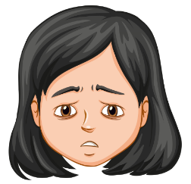 | I am feeling worried because I don’t know how I will get home.
I remember my parents’ phone number in case I get lost. |  | I am feeling:  Because:
An adult tells you to keep a secret from your parent/caregiver |  | I am feeling:  Because:
I remembered to hold an adult’s hand when crossing the road. |  | I am feeling:  Because:
A stranger asks you to get into their car. |  | I am feeling:  Because:
Someone wants to show you what is under their clothes and asks to see what is under yours. |  | I am feeling:  Because:
You are lost and a police officer offers to help you. |  | I am feeling:  Because:
An adult tells you to keep a secret from your parent/caregiver. |  | I am feeling:  Because:
Your parent/caregiver lets you go to the shop with a trusted family member. |  | I am feeling:  Because:
A person says hello to you when you are walking with your parent/caregiver. |  | I am feeling:  Because:

Appendix 3 – warning signs
What? | Safe or unsafe? | When?
Relaxed muscles
Heart beating steadily
Breathing steadily
Tense muscles
Heart beating quickly
Breathing quickly

Appendix 4 – support network
These people are people I can trust. I know they will listen to me and help me if I need it. Put an X for the people you know how to contact.

Family | X

Friends | X

Familiar adults | X
Teacher | X

Community members | X

Select 2 people and use to complete the sentences.
I selected
because they .
I selected
because they .

Appendix 5 – can you Go?
Hannah is at her uncle’s house without her parents in an unfamiliar suburb. Her uncle is sitting too close to her while watching TV and she feels her warning signals.
- Can Hannah go?
- If Hannah can go, where could she go?
- What might happen then?
Steven is at home and his parent/caregiver is shouting at him. He is feeling scared.
- Can Steven go?
- If Steven can go, where could he go?
- What might happen then?
Louise is in a car with an adult who wants her to touch his private parts. The doors are locked.
- Can Louise go?
- If Louise can go, where could she go?
- What might happen then?

Appendix 6 – using No-Go-Tell
While playing at the park a stranger asks if you would like to come to their car to get a special present. Your trusted adult is over on the other side of the play equipment sitting on the bench having coffee with their friends. How would you use No-Go-Tell?
No | Go | Tell
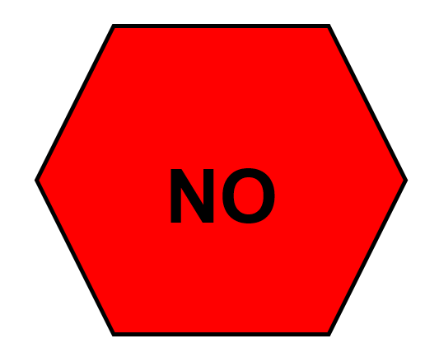 | 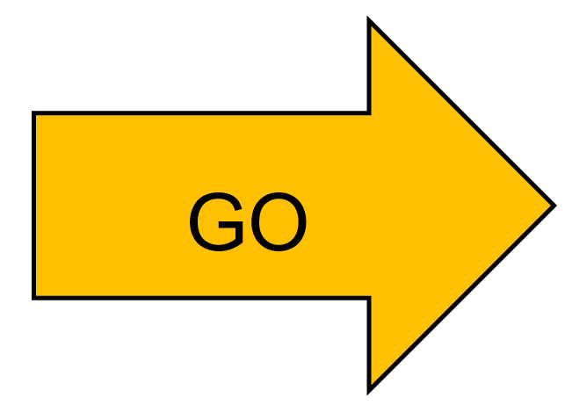 | 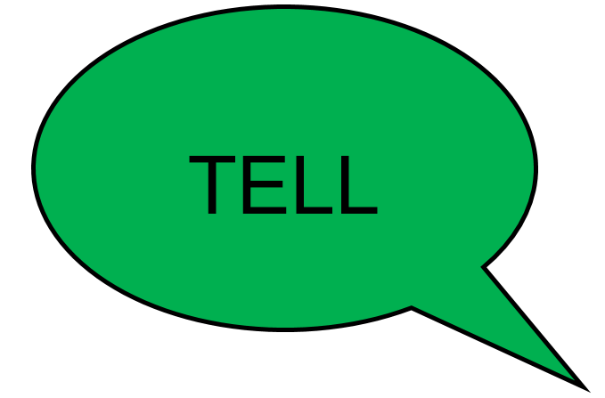
I would say No because: | I would Go to:  Because: | I would tell:  I would say:

Appendix 7 – support network/emergency or non-emergency
Situation | Circle | Who in your support network could help?
A favourite toy breaks. | Emergency  Non-emergency
A person is lost in the bush. | Emergency  Non-emergency
You graze your knee. | Emergency  Non-emergency
Someone is knocked out at soccer. | Emergency  Non-emergency
A house is on fire. | Emergency  Non-emergency
A car crash. | Emergency  Non-emergency

Appendix 8 – support network/emergency services
Circle the emergency service you would call for help.
An adult has fallen from a ladder and can’t move. Who would you call?

Fire fighter
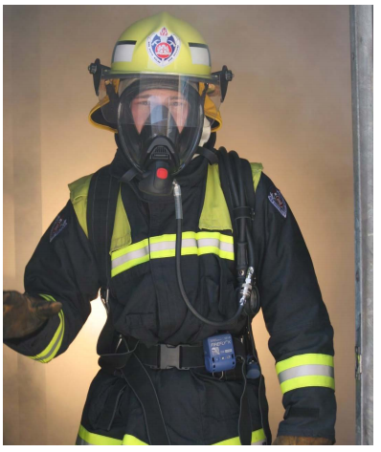
Ambulance officer
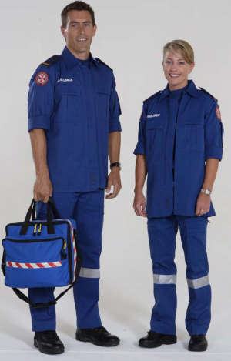
Police officer

A fire starts in a frying pan in the kitchen. Who would you call for help?

Fire fighter
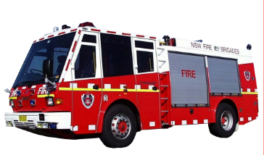
Ambulance officer
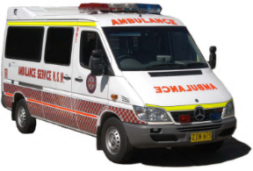
Police officer
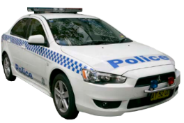

A car is being driven on the streets very dangerously. There has not been an accident yet, but you are worried someone is going to get hurt. Who would you call?

Fire fighter
Ambulance officer
Police officer

Appendix 9 – calling emergency services

Mobile phone
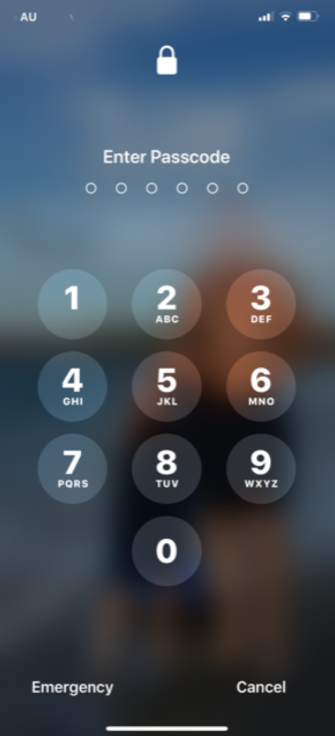
Home phone
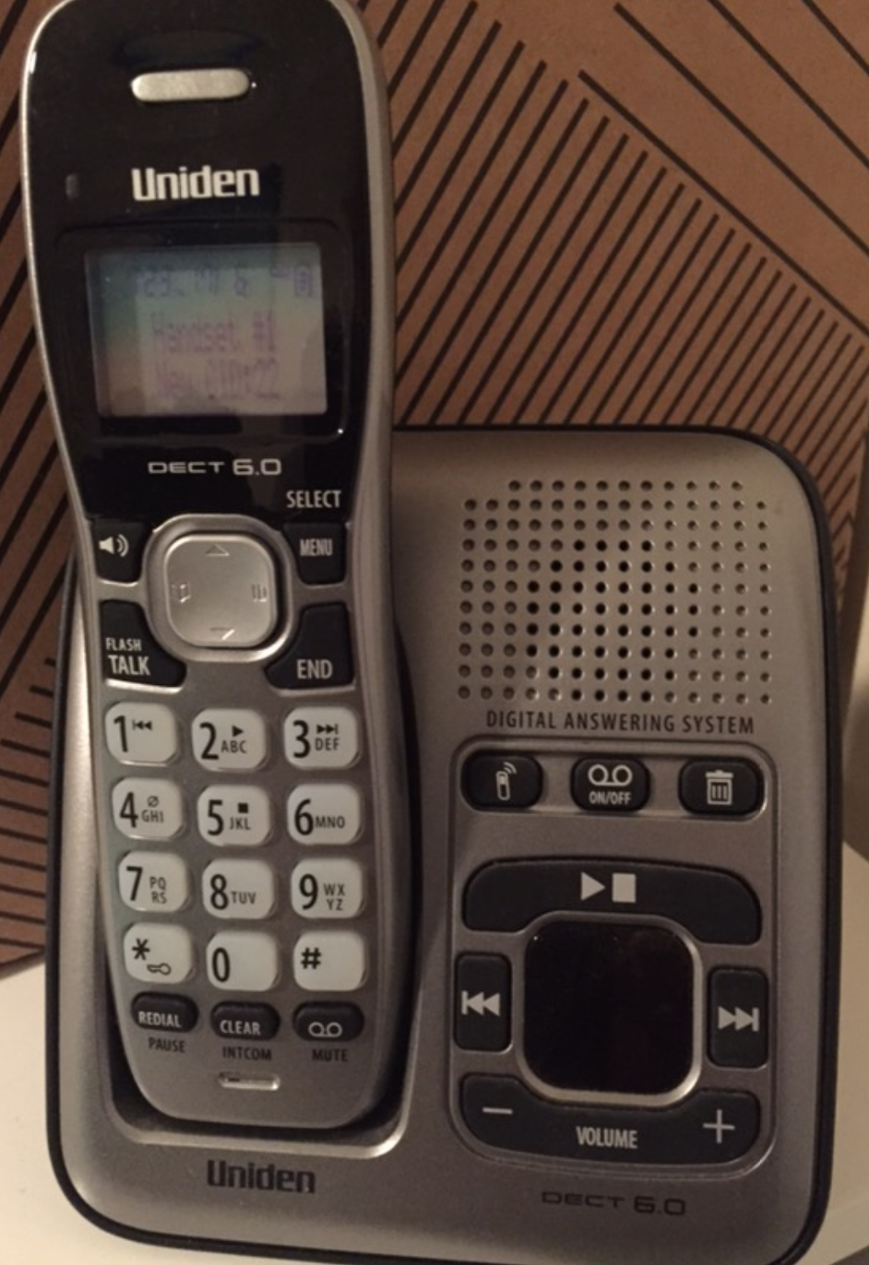

Appendix 10 – buckle 10
Draw a picture of yourself safely buckled up in the booster seat.
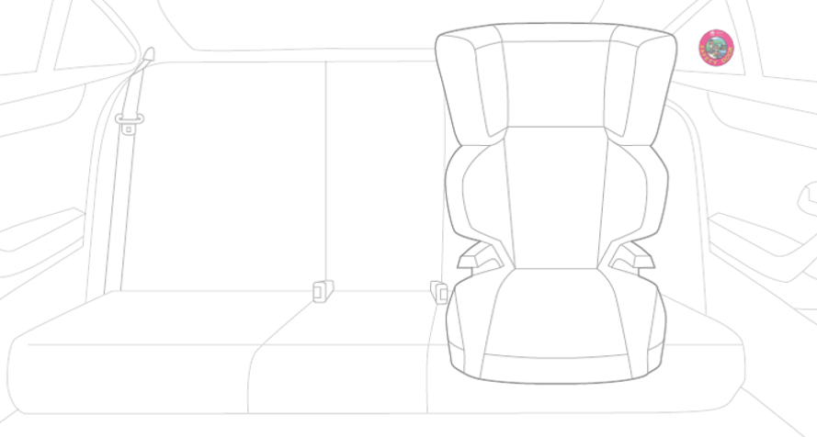
Image from Safety Town © State of New South Wales (Transport for NSW).
List ways that you can keep safe when travelling in a car:

