How can I use tactics to be successful in games? – Stage 2
PDHPE unit.

Table of contents
Big idea and key concept 2
Essential question 2
Unit description 2
Contextual statement 2
Propositions in action 3
Skills in focus 4
Lesson 1 – Maintaining possession 5
Key inquiry questions and syllabus content 6
Teaching and learning activities 6
Lesson 2 – Maintaining possession 13
Key inquiry questions and syllabus content 14
Teaching and learning activities 14
Lesson 3 – Maintaining possession 19
Key inquiry questions and syllabus content 19
Teaching and learning activities 20
Lesson 4 – Defending space 25
Key inquiry questions and syllabus content 26
Teaching and learning activities 26
Lesson 5 – Defending space 32
Key inquiry questions and syllabus content 32
Teaching and learning activities 33
Lesson 6 – Defending space 39
Key inquiry questions and syllabus content 40
Teaching and learning activities 40
Activity 2 – Guard the castle 41
Activity 3 – Guard the castle (advanced) 43
Lesson 7 – Attack the goal 45
Key inquiry questions and syllabus content 45
Teaching and learning activities 46
Lesson 8 – Attack the goal 53
Key inquiry questions and syllabus content 53
Teaching and learning activities 54
Lesson 9 – Attack the goal 58
Key inquiry questions and syllabus content 58
Teaching and learning activities 59
Lesson 10 – Adjusting tactics 63
Teaching and learning activities 63
Appendix 1 – Self assessment 70
Appendix 2 - Evaluation 72
Appendix 3 – Glossary 73
Appendix 4 – Assessment framework 74
Appendix 5 – Images to support key terms 77
Appendix 6 – Physical literacy cluster markers 92
Movement competencies 92
Tactical movement 92
Motivation and behavioural skills 92
Appendix 7 – Attributions 94

Outcomes and other syllabus material in this document are copyright.
PDHPE K-10 Syllabus © NSW Education Standards Authority (NESA) for and on behalf of the Crown in right of the State of New South Wales 2018.

Big idea and key concept
The big idea is the over-arching concept that is being addressed or challenged throughout the unit.
Tactical application of movement concepts influences success in a game. Spatial awareness, relationships with people, objects and space.

Essential question
This question drives both teaching and learning within the unit. Every activity should be working towards answering this question: How can I use tactics to be successful?

Unit description
Students test, apply and combine various tactics incorporating movement, space, time, equipment and rules to improve their chance of success in territory games. They perform and refine movement skills and sequences to solve games-based problems. For example, they may combine various movements, body positions and speeds to move into space, receive a pass and maintain possession.

Contextual statement
Developing an understanding of tactics will support students to make decisions in more dynamic game-based movement environments. It will also allow students to apply movement skills and sequences in a more effective way.
Improving their ability to select, apply and modify tactical decisions will increase students’ chances of success in games. Achieving regular success contributes positively to student’s lifelong participation in physical activity.

Propositions in action
This describes how specific propositions are embedded throughout the unit of work. The 5 propositions are outlined on pages 24-25 of the PDHPE K-10 syllabus.
Focus on educative purpose
Students develop their knowledge, understanding and skills of how to select and apply appropriate tactics to be successful in game play. They continue to develop their understanding of how movement, space, time, equipment choice and rule changes impact their tactics and how to combine these elements.
Take a strengths-based approach
Students will be encouraged to draw upon their own strengths and capabilities to further strengthen their knowledge, skills and understandings while they explore how to effectively select and apply various tactics in game play.
Value movement
Students participate in a wide range of movement experiences to develop skills across all 3 domains and understand how these skills can transfer to different contexts.
Activities are modified to meet the student needs and interests while maintaining relevancy and engagement in tactical game play. Students explore tactics and strategies to learn what can influence their level of success in game play.

Skills in focus
What specific skills are being learned, developed and applied throughout this unit of work? Refer to pages 27-30 of the PDHPE K-10 syllabus.
Self-management skills (S)
- Self-awareness
  - reflective practice
  - Decision making and problem solving
  - finding solutions to problems
  - analysis
Interpersonal skills (I)
- Communication
  - giving and receiving feedback
- Collaboration, inclusion and relationship-building
  - recognising and using their own abilities and strengths and those of others
Movement skills (M)
- Fundamental and specialised movement skills and concepts
  - non-locomotor skills (body control, body positioning, spatial awareness, direction, force, precision)
  - locomotor skills (travel, rhythm, body control, coordination, safe landing, agility, direction, object locomotion)
- Tactical and creative movement
  - selecting, applying, transferring, adapting and evaluating movement skills
  - applying movement concepts, rules, strategies and tactics
  - assessing rules, strategies and tactics and how they influence movement and performance when applied across different movement contexts
- Health and fitness enhancing movement
  - managing risk and promoting safety
  - participating actively

Lesson 1 – Maintaining possession
Lesson 1 – Assessment framework
Outcomes | Unit learning goals  Students are learning to: | Evidence of learning  Students can:
PD2-4 performs and refines movement skills in a variety of sequences and situations | Perform and refine movement skills in a variety of activities or games. |  | Perform movement sequences with control by combining locomotor, object control and/or stability skills while participating in an activity or game. (activity 1, 2, 3).
PD2-5 applies strategies to solve movement challenges | Use knowledge of previous performances to propose solutions to movement challenges. |  | Reflect on previous performances to propose, test and modify alternative problem-solving strategies to movement challenges and predict the effectiveness of each (activity 1, 2, 3).
PD2-10 demonstrates a range of interpersonal skills that build and enhance relationships and promote inclusion in various situations | Demonstrate inclusive practices and team work when participating in physical activities. |  | Work collaboratively with team members to solve problems, including maintaining possession in a game (activity 2, 3).
PD2-11 combines movement skills and concepts to effectively create and perform movement sequences | Practise and apply movement concepts and skills in game play. |  | Combine elements of space/positioning, movement, time, use of equipment and communication to maintain possession (activity 1, 2, 3).

Key inquiry questions and syllabus content
How can we move our bodies to perform skills in different ways?
Perform and refine movement skills in a variety of movement sequences and contexts for example:
- Perform activities where locomotor, object control and stability skills are combined to complete a movement sequence, activity or game, for example, swerving, sidestepping, running, dodging, skipping, hopping, jumping, landing, balancing, swinging, climbing, rolling
- Adapt movement skills to improve accuracy and control in a variety of contexts
Practise and apply movement concepts and movement skills to create and perform movement sequences for example:
- Combine elements of space, time, objects, effort and people when performing movement sequences
How can we demonstrate our understanding of movement to solve challenges?
Pose questions, test solutions and use problem-solving strategies to solve movement challenges, for example:
- Identify how to modify plans within a game to achieve success
- Participate in physical activities which require problem-solving and persistence to achieve a goal
Adopt inclusive practices when participating in physical activities, for example:
- Use interpersonal skills to complete a movement task, for example, a partner balance, partner passing strategy or team strategy
- Work collaboratively with team members to maintain possession in a game

Teaching and learning activities
Equipment
- basketballs (1 per student)
- netballs (1 per group)
- bibs (optional)
Resources
Territory/Invasion games (1:36 min)
Vocabulary
- tactic, movement, possession, success, tag, challenge, rule, attack, defend, bounce, time, space
Teacher notes
This unit is designed to help students develop their tactical decision-making in territory games. It builds upon knowledge, understanding and skills developed in Early Stage 1 and Stage 1 units, ‘how can I use tactics to be more successful’. Discuss students understanding of ‘what are tactics?’ and ‘why are they important?’. Tactics are a plan, idea or action to successfully achieve a goal or outcome during a movement activity.
Discuss with students ‘What do you think success looks like when playing a game?’ Students may suggest it means winning or getting the ‘best result’. This may form part of being successful. Emphasise with students that success can also mean improving their ability to perform a movement skill, increasing their knowledge, increasing their confidence, learning to communicate more effectively with others, improving their decision-making to solve a movement challenge. It does not have to mean ‘winning’.
When students discuss questions during lessons or reflect at the completion of the lesson, they may consider that they have been successful for various reasons. This may be discussed and decided upon by the student and teacher.

Activity 1 – Guard it (Fast start)
Students move within the playing area (approximately 20 metres x 20 metres) while bouncing a basketball (or similar).
Students attempt to tap/touch someone else’s ball without losing control of their own. For each touch the students score 1 point.

Discussion
Explore the questions:
- How did you defend/guard your ball from someone else? Sample student answers may include, I bounced it on the other side of my body, I turned my body between them and the ball, I moved away from them.
- How did you attack/touch someone else’s ball? Sample student answers may include, I had to make sure my ball was controlled, I had to time my movement for when they were not touching the ball, I had to position my ball away from them while my body was close to them.
- What if we used tennis balls instead? How would your tactics change? Why? Sample student answers may include, it will be harder to touch so I will need to be quicker and more accurate with my movement, it will be easier to guard my ball so I will not have to move away so quickly or use my body as much.
Teacher notes
A Fast start activity provides an opportunity to engage in moderate to vigorous physical activity (huff ‘n’ puff).
- Explore and practise movement skills (fundamental and specialised movement skills and concepts, tactical and creative movement, health and fitness enhancing movement).
- Reinforce an inclusive learning environment that supports positive interactions and ongoing collaboration.
- Become familiar with equipment and space.
- Use age and stage appropriate language and concepts that act as a ‘hook’ to engage students.
Discussion
Explore the question:
- What are tactics? Sample student answers may include, an action or strategy carefully planned to achieve a specific goal.
- What are some tactics you use when playing territory games? (for example, touch football, netball, soccer, capture the flag, AFL) Sample student answers may include, pass to a team member in space, move into space, change how I move to dodge defenders.
Explain that this lesson will focus on the tactic/s that will support them to maintain possession and understand why it is important to do so in game play.
Explore with students that they will need to consider how they can use the following to maintain possession:
- Movement – type of movement they use, the speed of their movement.
- Space and positioning – where they stand, where they move to, how they support team members, where they pass to.
- Timing – when they move, pass or tackle (for example, tackling in soccer).
- Equipment – how they use the equipment (for example, passing style), the force applied to the equipment.
- Communication – types of communication, what can be communicated to help the team (for example, signal for the ball, tell a team member they are marked, tell a team member where to pass the ball – ‘up the line’, pass it back’).
View the Territory/Invasion games video and allow students to reflect upon their responses of how they may use movement, space and positioning, timing, equipment and/or communication to maintain possession in a territory game.
Teacher notes
You may choose frame these four points as questions to test students’ prior knowledge. For example, how can you move in different ways to help your team maintain possession?
Tackle/tackling is a generic term used when a student attempts to gain/re-gain possession of the ball/object from an opposition student. Under no circumstances should students make physical contact with another student when tackling.

Activity 2 – Four square
Divide students into groups of 6, a team of 4 attackers and 2 defenders. Mark a playing area approximately 6 metres x 6 metres, separated into 4 even squares (3 metres x 3 metres each).
One attacker stands in each square. Each defender selects which 2 squares they will defend and move between (not diagonal squares). The attackers take possession of the ball (netball or similar) and try to pass the ball as many times as possible between team-mates. The defenders try to intercept the ball.
Once the attackers complete the agreed number of passes in a row (for example, it may be agreed to set 5, 8, or 10 passes as the target), students swap roles, until all players have been a defender.
Students can pass in any direction. No moving with the ball.
All attackers must remain in their own square. Defenders must remain in their nominated 2 squares.
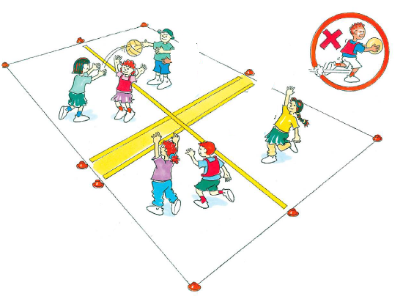
‘Four square illustration’, Adapted from ‘Playing for life’ – Australian Sports Commission, https://www.sportaus.gov.au.
Discussion
Explore the questions:
- How did the attackers maintain possession of the ball? How did they use movement? Sample student answers may include, I moved quickly to a position/space, I used dodge skills to evade the defender.
- How did the attackers maintain space and positioning? Sample student answers may include, I moved away from the defenders, I moved closer to my team mates so they could use a short pass to avoid the defenders intercepting the ball, I moved away from my team mate so they could use a lob or bounce pass, I moved so the defender was not between my team mate and me.
- How did the attackers maintain timing? Sample student answers may include, I passed the ball when my team mate was free/not near a defender.
- How did the attackers maintain equipment? Sample student answers may include, I changed how I passed the ball depending on where my team mate was (chest pass, one hand shoulder pass, bounce pass, roll).
- How did the attackers maintain communication? I signalled for the ball when I was not near a defender, I told my team member how to pass it (lob pass, bounce pass, roll).

Activity 3 – Four square advanced
Repeat the game ‘Four square’ with the introduction of a third defender. Students swaps roles throughout the game.
Teacher notes
The introduction of a third defender will require some groups to be split. To ensure maximum student participation you may need to extend/vary numbers in a game. For example, from 4 attackers and 3 defenders to 5 attackers and 3 defenders. Increasing the number of defenders and attackers increases the complexity of the game by increasing the number of options and information to consider. This is increasing the complexity of the tactical decision making for students. To support students learning, try not to increase group sizes unnecessarily.

Discussion
Explore the following question:
- How did the inclusion of another defender change the tactics you used? Sample student answers may include, there was not as much space to pass the ball to team members so I had to make sure my passes were accurate, I had to communicate more often to signal when I was free/available, I had to increase the speed of my movement, move more often and change directions to evade defenders.
Variations
- Introduce a time limit for the attackers to hold the ball, for example, maximum 5 seconds.
- Change the ball used, for example, smaller (tennis ball) different shape (AFL ball), not a ball (bean bag, quoit).
Reflection
Students reflect upon the learning in this activity/lesson and consider how it contributes towards answering the essential question, ‘How can I use tactics to be successful in games?’.

Lesson 2 – Maintaining possession
Lesson 2 – Assessment framework
Outcomes | Unit learning goals  Students are learning to: | Evidence of learning  Students can:
PD2-4 performs and refines movement skills in a variety of sequences and situations. | Perform and refine movement skills in a variety of activities or games. |  | Perform movement sequences with control by combining locomotor, object control and/or stability skills while participating in an activity or game. (activity 1, 2, 3).
PD2-5 applies strategies to solve movement challenges. | Use knowledge of previous performances to propose solutions to movement challenges. |  | Reflect on previous performances to propose, test and modify alternative problem-solving strategies to movement challenges and predict the effectiveness of each (activity 1, 2, 3)
PD2-10 demonstrates a range of interpersonal skills that build and enhance relationships and promote inclusion in various situations. | Demonstrate inclusive practices and team work when participating in physical activities. |  | Work collaboratively with team members to solve problems, including maintaining possession in a game (activity 2, 3).
PD2-11 combines movement skills and concepts to effectively create and perform movement sequences. | Practise and apply movement concepts and skills in game play. |  | Combine elements of space/positioning, movement, time, use of equipment and communication to maintain possession (activity 1, 2, 3).

Key inquiry questions and syllabus content
How can we move our bodies to perform skills in different ways?
Perform and refine movement skills in a variety of movement sequences and contexts for example:
- Perform activities where locomotor, object control and stability skills are combines to complete a movement sequence, activity or game, such as swerving, sidestepping, running, dodging, skipping, hopping, jumping, landing, balancing, swinging, climbing, rolling.
- Adapt movement skills to improve accuracy and control in a variety of contexts.
Practise and apply movement concepts and movement skills to create and perform movement sequences for example:
- Combine elements of space, time, objects, effort and people when performing movement sequences.
How can we demonstrate our understanding of movement to solve challenges?
Pose questions, test solutions and use problem-solving strategies to solve movement challenges for example:
- Apply movement skills and respond to feedback to solve movement challenges.
- Identify how to modify plans within a game to achieve success.
- Participate in physical activities which require problem-solving and persistence to achieve a goal.
Adopt inclusive practices when participating in physical activities for example:
- Use interpersonal skills to complete a movement task, for example, a partner balance, partner passing strategy or team strategy.
- Work collaboratively with team members to maintain possession in a game.

Teaching and learning activities
Equipment
- tennis balls (or similar) 1 per student
- 1 netball (or similar) per group
- bibs (optional)
Vocabulary
- tactic, movement, possession, time, communication, space, equipment, success, tag, challenge, rule, attack, defend, bounce, kick, intercept

Activity 1 – Guard it using a tennis ball (Fast start)
Refer to instructions in Lesson 1 – Activity 1, where appropriate, allow students to use a tennis ball in place of a basketball. Ask students to reflect on the tactics they used in Lesson 1.
Sample student answers may include:
- I bounced it on the other side of my body
- I turned my body between the other students and the ball
- I moved away from other students
- I had to make sure my ball was controlled
- I had to time my movement for when the other students were not touching the ball
- I had to position my ball away from other students
Refer to instructions in Lesson 1 – Activity 1. During this fast start frequently change the students’ style of movement. For example, in game 1 ‘Frosts’ run and ‘Thaws’ hop, in game 2 allow students in each role/character to swap the movements used. This will allow students to explore how their knowledge, understanding and skills have developed further.
Discussion
Explore the questions:
- Was it harder for you to defend/guard the tennis ball rather than the basketball? Explain.
- Was it harder for you to attack/touch someone else’s tennis ball? Explain.
- How did you change your tactics to compensate for the different ball?
- What if we used soccer balls and had to kick it instead? Would your tactics change? How and why? Sample student answers may include, it will be easier to kick someone else’s ball so I will not have to move as fast, it will be harder to guard my ball so I will have to move away quickly or use my body to protect the ball more.

Activity 2 – Goal line
Discussion
Explain that this lesson will again focus on the tactic/s that will support them to maintain possession. Remind students of the importance of maintaining possession and how the elements of movement, space and positioning, timing, using equipment and communication as discussed in lesson 1 can be used to achieve this.
Mark a playing area approximately 10 metres x 10 metres. Divide students into groups of 6, 4 attackers and 2 defenders, (these numbers can be adjusted to suit students’ skill level, with more defenders being added if needed.).
- Attackers and defenders spread throughout the playing area. One attacker stands on a goal line with the ball.
- The aim is for the attackers to pass the ball from one goal line to the other, placing the ball on the ground over the goal line. An attacker is not allowed to move when in possession of the ball. 1 point is scored each time the ball is placed over the line.
- 5 points are scored if every attacker touches the ball. Defenders try to intercept the ball and score 1 point for each intercept. Swap roles regularly.
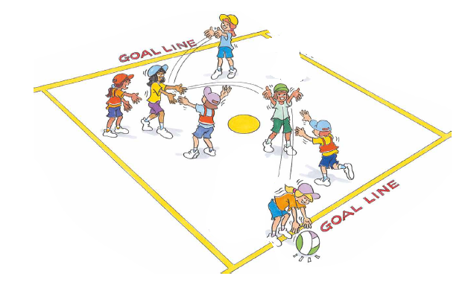
‘Goal line illustration’, Adapted from ‘Playing for life’ – Australian Sports Commission, https://www.sportaus.gov.au.
Discussion
Explore the questions:
- How did the attackers maintain the ball? How did they use movement? Sample student answers may include, I moved quickly to a position/space, I used dodge skills to evade the defender.
- How did the attackers maintain space and positioning? Sample student answers may include, I moved away from the defenders, I moved closer my team mates so they could use a short pass to avoid the ball being intercepted, I moved away from my team mate so they could use a lob or bounce pass, I moved so the defender was not between my team mate and me.
- How did the attackers maintain timing? Sample student answers may include, I passed the ball when my team mate was free / not near a defender.
- How did the attackers maintain equipment? Sample student answers may include, I changed how I passed the ball depending on where my team mate was (chest pass, one hand shoulder pass, bounce pass, roll).
- How did the attackers maintain communication? I signalled for the ball when I was not near a defender, I told my team member how to pass it (lob pass, bounce pass, roll).

Activity 3 – Goal line advanced
Repeat the game of Goal line while incorporating the following changes:
- An even number of attackers and defenders.
- Each team will need to attack and defend. Team A attacks one goal line while Team B attack the opposite goal line. When either team scores, he opposing team begin with the ball from their defensive goal line. If either team intercept the ball while defending, they begin to attack from where they intercepted the ball.
- A point is scored for each ball over the goal line and 3 points if each team member touches the ball. No points are scored for intercepts.
First team to 10 points wins.
Discussion
Explore the question:
- How did having even teams effect your tactics?’ Sample student answers may include, I had to move more often, I had to use movements such as dodge more, I had to time my passing, I had to communicate directions rather than calling a name, I had to vary how I passed the ball, I had to move into space and continue to reposition myself.
Variations
- Introduce a time limit for the attackers to hold the ball, for example, maximum 5 seconds.
- Change the ball used, for example, smaller (tennis ball) different shape (AFL ball), not a ball (bean bag).
Reflection
Students reflect upon the learning in this activity/lesson and consider how it contributes towards answering the essential question ‘How can I use tactics to be successful in games?

Lesson 3 – Maintaining possession
Lesson 3 – Assessment Framework
Outcomes | Unit learning goals  Students are learning to: | Evidence of learning  Students can:
PD2-4 performs and refines movement skills in a variety of sequences and situations. | Perform and refine movement skills in a variety of activities or games. |  | Perform movement sequences with control by combining locomotor, object control and/or stability skills while participating in an activity or game. (Activity 1, 2, 3).
PD2-5 applies strategies to solve movement challenges. | Use knowledge of previous performances to propose solutions to movement challenges |  | Reflect on previous performances to propose, test and modify alternative problem-solving strategies to movement challenges and predict the effectiveness of each (Activity 1, 2, 3).
PD2-10 demonstrates a range of interpersonal skills that build and enhance relationships and promote inclusion in various situations. | Demonstrate inclusive practices and team work when participating in physical activities. |  | Work collaboratively with team members to solve problems, including maintaining possession in a game (Activity 2, 3).
PD2-11 combines movement skills and concepts to effectively create and perform movement sequences. | Practise and apply movement concepts and skills in game play. |  | Combine elements of space/positioning, movement, time, use of equipment and communication to maintain possession (Activity 1, 2, 3).

Key inquiry questions and syllabus content
How can we move our bodies to perform skills in different ways?
Perform and refine movement skills in a variety of movement sequences and contexts, for example:
- Perform activities where locomotor, object control and stability skills are combines to complete a movement sequence, activity or game, for example, swerving, sidestepping, running, dodging, skipping, hopping, jumping, landing, balancing, swinging, climbing, rolling.
- Adapt movement skills to improve accuracy and control in a variety of contexts.
Practise and apply movement concepts and movement skills to create and perform movement sequences, for example:
- Combine elements of space, time, objects, effort and people when performing movement sequences.
How can we demonstrate our understanding of movement to solve challenges?
Pose questions, test solutions and use problem-solving strategies to solve movement challenges, for example:
- Apply movement skills and respond to feedback to solve movement challenges.
- Identify how to modify plans within a game to achieve success.
- Participate in physical activities which require problem-solving and persistence to achieve a goal.
Adopt inclusive practices when participating in physical activities, for example:
- Use interpersonal skills to complete a movement task, such as a partner balance, partner passing strategy or team strategy.
- Work collaboratively with team members to maintain possession in a game.

Teaching and learning activities
Equipment
- Soccer balls or similar (1 per student)
- various other balls or equipment to pass such as AFL balls
- netballs, basketballs
- bean bags
- rugby league balls
- vortex
- soft frisbees
Resources
Appendix 1.
Vocabulary
- tactic, movement, possession, time, communication, space, equipment, success, tag, challenge, rule, attack, defend, bounce, kick, intercept

Activity 1 – Guard it using a soccer ball (Fast start)
Refer to instructions in Lesson 1 – Activity 1 with the following change where appropriate.
Students use a soccer ball in place of a basketball, controlling the ball with their feet instead of bouncing it. The aim remains the same to touch someone else’s’ ball with their foot/feet instead of hands. Remind students of the tactics they used in Lesson 1 and 2.
Before play explore with students the following question:
- Will your tactics be the same when using a soccer ball as they were when you used a basketball or tennis ball?
- How might they be the same? Sample student answers may include, I can still move my body to defend/guard the ball, I will still have to time my movement to touch someone else’s ball, I can still use dodge to avoid other students.
- How might they change? Sample student answers may include, it is harder to defend/guard a soccer ball so I might not go as close to other students, it is easier to touch someone else’s ball so I may not have to be as accurate with my timing.
Discussion
Explore the questions:
- How did having a soccer ball and using your feet change your tactics? Explain.
- Which ball was the hardest or easiest to defend/guard, basketball, tennis ball, soccer ball? Explain.

Activity 2 – Space Invaders
Discussion
Explain that this lesson will again focus on the tactic/s that will support them to maintain possession. Remind students of the importance of maintaining possession and how the elements of movement, space and positioning, timing, using equipment and communication as discussed in Lessons 1 and 2 can be used to achieve it.
- Divide students into groups of 7, 3 pairs with a soccer ball per pair and one defender (the space invader).
- Mark a playing area of approximately 5 metres x 5 metres per group.
- The space invader stands in the playing area without a ball, while the other students (the astronauts) face their partner from opposite ends of the playing area.
- The astronauts pass their ball backwards and forwards to their partner across the playing area while the space invader attempts to intercept any ball. Space invaders are only allowed to move in a straight line across the playing area.
- 1 point is scored for each pass completed and 1 point for each intercept. When a team reaches the agreed number of points, for example 10 points, a new game begins.
In each new game rotate students until everyone has had a turn as a space invader.
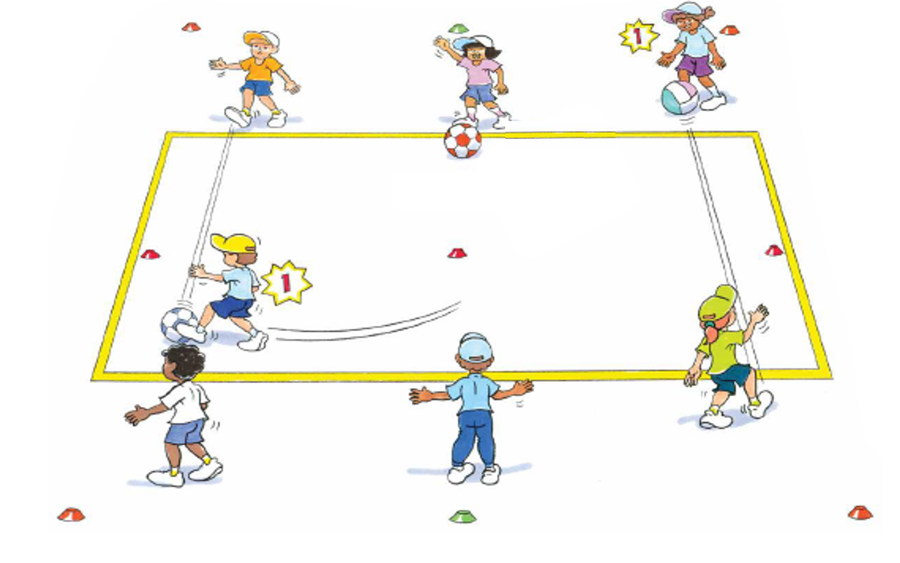
‘Space invaders illustration’, Adapted from ‘Playing for life’ – Australian Sports Commission, https://www.sportaus.gov.au.
Teacher notes
This game can be modified to allow students to throw/pass a netball, rugby or tennis ball, rolling a larger ball, hand balling an AFL ball. These variations can be used to accommodate students’ individual interests and skill level. They can also be used as variations allowing students to change their tactics depending on the equipment.
Discussion
Explore the question:
- To maintain possession, what did the astronauts do? Sample student answers may include, watch for when the defender was not in their way, apply an appropriate amount of force, time the pass correctly, communicate with my partner as to when they could pass it, use an effective passing technique.

Activity 3 – Space invaders advanced
Repeat the game Space invaders with 2 defenders.
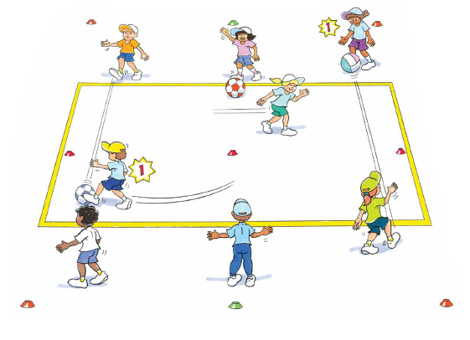
‘Space invaders advanced illustration’, Adapted from ‘Playing for life’ – Australian Sports Commission, https://www.sportaus.gov.au.

Teacher notes
This second game will require reorganising students into pairs. Ideally, each group will have 8 students, 4 pairs that can rotate through all roles/positions during the game.
Discussion
Explore the questions:
- How did a second space invader (defender) effect the game? Sample student answers may include, it was harder to keep possession, it was easier for the defenders to intercept the ball.
- Did your tactics change? How? Why? Sample student answers may include, I had to be more accurate with my timing of the pass, I needed to be clearer with my communication, my passes needed be more accurate.
Reflection
Students reflect upon the learning in this activity/lesson and consider how it contributes towards answering the essential question How can I use tactics to be successful in games? by completing the self–assessment on ‘Appendix 1’. Alternatively, the self–assessment in ‘Appendix 1’ may be adapted using one or more of the assessment tools available via the Digital Learning Selector.

Lesson 4 – Defending space
Lesson 4 – Assessment framework
Outcomes | Unit learning goals  Students are learning to: | Evidence of learning  Students can:
PD2-4 performs and refines movement skills in a variety of sequences and situations. | Perform and refine movement skills in a variety of activities or games. |  | Perform movement sequences with control by combining locomotor, object control and/or stability skills while participating in an activity or game (activity 1, 2, 3).
PD2-5 applies strategies to solve movement challenges. | Use knowledge of previous performances to propose solutions to movement challenges. |  | Reflect on previous performances to propose, test and modify alternative problem-solving strategies to movement challenges and predict the effectiveness of each (activity 1, 2, 3).
PD2-10 demonstrates a range of interpersonal skills that build and enhance relationships and promote inclusion in various situations. | Demonstrate inclusive practices and team work when participating in physical activities. |  | Work collaboratively with team members to solve problems, including defending space in a game (activity 1).
PD2-11 combines movement skills and concepts to effectively create and perform movement sequences. | Practise and apply movement concepts and skills in game play. |  | Combine elements of space/positioning, movement, time, use of equipment and communication to defend space (activity 1, 2, 3).

Key inquiry questions and syllabus content
How can we move our bodies to perform skills in different ways?
Perform and refine movement skills in a variety of movement sequences and contexts for example:
- Perform activities where locomotor, object control and stability skills are combines to complete a movement sequence, activity or game, for example, swerving, sidestepping, running, dodging, skipping, hopping, jumping, landing, balancing, swinging, climbing, rolling.
- Demonstrate variations of force and speed in movement, for example, slow, fast, light, strong, sudden, sustained, using body and objects.
Practise and apply movement concepts and movement skills to create and perform movement sequences for example:
- Combine elements of space, time, objects, effort and people when performing movement sequences.
- Combine locomotor and non-locomotor movement to create and perform movement sequences.
How can we demonstrate our understanding of movement to solve challenges?
Pose questions, test solutions and use problem-solving strategies to solve movement challenges, for example:
- Participate in physical activities which require problem-solving and persistence to achieve a goal.

Teaching and learning activities
Equipment
- markers
- soccer balls (or similar) 1 per student
- balls of any type or Scatter Tag (4 per group)

Resource
Territory and Invasion Games – 1:36 min
Vocabulary
- tactic, movement, possession, time, communication, space, equipment, success, tag, challenge, rule, attack, defend, kick, intercept, scatter, goal, shoot

Activity 1 – Scatter tag (Fast start)
Organise students into groups of 8, (4 attackers and 4 defenders). Mark a playing area approximately 10 metres x 10 metres per group.
- Attackers each hold a football and move clockwise inside a circle marked by cones.
- Defenders (without a ball) move around the outside of the circle in the opposite direction. When the teacher calls ‘Scatter!’ all players from the attacking team run in any direction towards a boundary line while the defenders chase them.
- Attackers score one point if they reach a boundary line without being tagged by a defender. Each team has three turns as attackers before swapping roles.
- Points are combined for the three rounds. The team with the highest score wins.
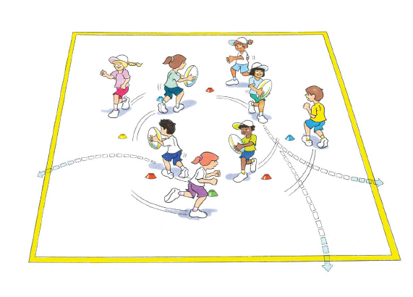
‘Scatter tag illustration’, Adapted from ‘Playing for life’ – Australian Sports Commission, https://www.sportaus.gov.au.
Discussion
Explore the questions:
- What made this game challenging for defenders? Sample student answers may include, two defenders running after the same attacker, attackers running anywhere, attackers being able to score in any direction (360 degrees).
- How could the defenders make it easier for themselves? Sample student answers may include, communicate to each other as to who will chase who, agree that each defender will mark either a player or a zone.
Explain that this lesson will focus on defending space and why it is important in game play. Explore with students that they will need to consider how they can use the following to defend space effectively.
Movement – type of movement they use, the speed of their movement.
Space and positioning – where they stand, where they move to, how they use their body to block opposition players.
Timing – when they move, when they move to intercept a pass, when they attempt to tackle
Communication – what signals/calls can help the team (for example, tell a team member who they are marking, tell a team member when to tackle, agree with team members about who is standing where.)
View the ‘Territory/Invasion games’ video and allow students to reflect upon their responses of how they may use movement, space and positioning, timing, equipment and/or communication to defend space in a territory game.
Teacher notes
Depending on time, these four points may be framed as questions to test students’ prior knowledge.
Tackle/tackling is a generic term used when a student attempts to gain/re-gain possession of the ball/object from an opposition student. Under no circumstances should students make physical contact with another student to achieve this.

Activity 2 – Crazy keeper
Mark a playing area approximately 10 metres x 10 metres, split into halves. Designate 4-5 students per playing area, each with a soccer ball (or similar).
- Students try to score a goal by kicking the ball past the ‘Crazy Keeper’ into one of the two small goals.
- Place 2 small goals at one end of the playing area. The size of the goals should be adjusted to suit the skill level of the students. One student, the Crazy Keeper, stands between the goals on the end line. Another student, the ‘Fetcher’ stands behind the goals /end line. The other students, the ‘Shooters’, line up behind the start line.
- The first shooter yells ‘Go’ and dribbles their ball into the playing area, towards the half way line. The Crazy Keeper also enters the playing field and moves towards the half way line.
- The Shooter may kick the ball towards either of the goals, trying to score. The Crazy Keeper tries to close down/decrease the space between themselves and the ‘Shooter’ to make it harder for the Shooter to score.
- Neither player may step over the half way line.
- If the Shooter scores they gain a point. If the Crazy Keeper intercepts the ball they score a point.
- Students swap roles. Shooter becomes the Crazy Keeper, Crazy Keeper becomes the Fetcher, the ‘Fetcher’ gathers the ball, runs around the outside of the field to join in with the Shooters.
- The next Shooter calls out ‘Go’ and the game continues until all students have had at least 3 attempts at goal. Students with the highest score wins.
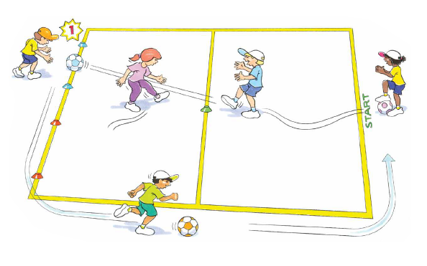
‘Crazy keeper illustration, Adapted from ‘Playing for life’ – Australian Sports Commission, https://www.sportaus.gov.au.
Variations
- increase or decrease the distance of the shooting line
- increase or decrease the distance between goals
- shooters use only their left or right foot as selected by the teacher/students
Teacher notes
Remind students that the ball must be passed along the ground as it is safer for the ‘Crazy keeper’ and harder to defend.
Discussion
Explore the questions:
- How could the Crazy Keeper make it harder for the Shooter? Sample student answers may include, by running in quickly to be closer to the Shooter, by moving to the side of the playing area that the Shooter is aiming for, by being prepared to move quickly and block the shot.
- What would happen if the Crazy Keeper stood in one of the goals? Sample student answers may include, it would be easier for the Shooter to aim a shot at the empty goal, the Shooter would have more time to aim and shoot, the Shooter would have more space to place their pass/kick.
- Why was it harder for the Shooter when the keeper closed/decreased the space in front of them? Sample student answers may include, they had less space to aim their shot, it reduced the angles available to the Shooter (there was a reduced range/amount of space open), it put pressure on the ‘Shooter’ and forced a mistake.

Activity 3 – Crazy keeper (advanced)
Repeat the game of Crazy Keeper, allowing the defender to cross the half way line if they wish to.
Reflection
Students reflect upon the learning in this activity/lesson and consider how it contributes towards answering the essential question How can I use tactics to be successful in games?

Lesson 5 – Defending space
Lesson 5 – Assessment framework
Outcomes | Unit learning goals  Students are learning to: | Evidence of learning  Students can:
PD2-4 performs and refines movement skills in a variety of sequences and situations. | Perform and refine movement skills in a variety of activities or games. |  | Perform movement sequences with control by combining locomotor, object control and/or stability skills while participating in an activity or game. (activity 1, 2, 3).
PD2-5 applies strategies to solve movement challenges. | Use knowledge of previous performances to propose solutions to movement challenges |  | Reflect on previous performances to propose, test and modify alternative problem-solving strategies to movement challenges and predict the effectiveness of each (activity 1, 2, 3).
PD2-10 demonstrates a range of interpersonal skills that build and enhance relationships and promote inclusion in various situations. | Demonstrate inclusive practices and team work when participating in physical activities. |  | Work collaboratively with team members to solve problems, including defending space in a game (activity 1).
PD2-11 combines movement skills and concepts to effectively create and perform movement sequences. | Practise and apply movement concepts and skills in game play. |  | Combine elements of space/positioning, movement, time, use of equipment and communication to defend space (activity 1, 2, 3).

Key inquiry questions and syllabus content
How can we move our bodies to perform skills in different ways?
Perform and refine movement skills in a variety of movement sequences and contexts for example:
- Perform activities where locomotor, object control and stability skills are combines to complete a movement sequence, activity or game, for example, swerving, sidestepping, running, dodging, skipping, hopping, jumping, landing, balancing, swinging, climbing, rolling.
- Demonstrate variations of force and speed in movement, for example, slow, fast, light, strong, sudden, sustained, using body and objects.
Practise and apply movement concepts and movement skills to create and perform movement sequences, for example:
- Combine elements of space, time, objects, effort and people when performing movement sequences.
- Combine locomotor and non-locomotor movement to create and perform movement sequences.
How can we demonstrate our understanding of movement to solve challenges?
Pose questions, test solutions and use problem-solving strategies to solve movement challenges, for example:
- Participate in physical activities which require problem-solving and persistence to achieve a goal.

Teaching and learning activities
Equipment
- markers
- footballs
- various balls and equipment to use instead of footballs
Vocabulary
- tactic, movement, possession, time, communication, space, equipment, success, tag, challenge, rule, attack, defend, kick, intercept, scatter, goal, shoot, pass

Activity 1 – Scatter tag (fast start)
Refer to instructions in Lesson 4 – Activity 1, incorporating a new rule that where the defenders do not have to run in an anti-clockwise direction but may position themselves in the space around the attackers with the ball.
Remind students of the tactics they used in Lesson 4 (both ‘Scatter tag’ and ‘Crazy Keeper’) and how defending space rather than marking a team member from the opposition allows the team to cover more area and make it more difficult for the opposing team.
Discussion
Explore the questions:
- In this game where the defenders were marking a space, instead of running around, was it easier or harder for them to stop the attackers? Explain. Sample student answers may include, it was easier because we did not run into each other, we were able to concentrate on our own area, we were able to select an area to defend.
- What if there were more defenders than attackers? How would your tactics change? Sample student answers may include, defenders could each mark a player with some defenders spare to help catch any attackers who avoided them, defenders may not have to run as much because there are many defenders filling up the space.
- What if there were more attackers than defenders? How would the tactics change? Defenders would have to move a lot quicker to tag attackers, defenders work as a team to cover as much space as possible.
Explain that this lesson will again focus on the tactic/s that will support them to defend space. Remind students of the importance of defending space and how the elements of movement, space and positioning, timing, and communication as discussed in Lesson 4 can be used to stop the opposition.

Activity 2 – Spare square
Explain that this game is designed to be very difficult for defenders, so students need to try various tactics such as defending space in order to improve their chance of success.
- Students form groups of 4. (1 defender and 3 attackers).
- Using markers, mark a playing area approximately 3 metres x 3 metres.
- The 3 attackers each stand at a separate marker.
- The attackers must pass the ball to each other, aiming to achieve the agreed number of passes in a row. For example, 10 in a row.
- The ball can only be passed along the sides of the square, from marker to marker.
- The attackers may run to the spare marker to be available for a pass.
- The ball must not be passed diagonally across the square. The ball should only ever be in the hands of an attacker standing at a marker.
- Attackers may not move while holding the ball.
- The defender moves around the square, trying to intercept the ball or cause the attackers to drop the ball.
- When the ball is intercepted or dropped, the defending player scores a point. If the attackers lose possession of the ball, it is handed back to them to continue until the time has ended. Each defender has approximately 1-2 minutes before swapping roles/positions with group members.
- Ensure all students have a turn as a defender.
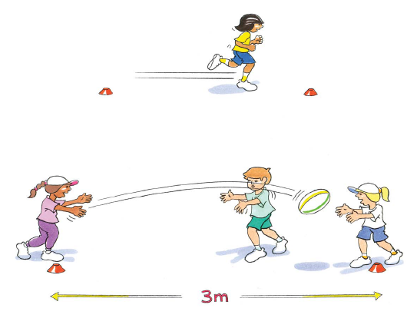
‘Spare square illustration’, Adapted from ‘Playing for life’ – Australian Sports Commission, https://www.sportaus.gov.au.
Teacher notes
Ball selection may be based on the interest and skills of the students.
Variations
- Introduce a second defender
- Introduce a time limit for attackers to hold the ball. For example, 5 seconds.
Discussion
Explore the question:
- When the defender is outnumbered, what tactics can they use to improve their chance of success? Sample student answers may include, move quickly to the player as they receive the ball and close/decrease their space, they can anticipate when the ball will be passed so they can intercept it.

Activity 3 – Round the bend
Mark a playing area approximately 10 metres x 10 metres. Divide students into groups of 6 per playing area (3 pairs).
- One pair of students become defenders and the other pairs are attackers. Defenders and attackers stand on opposite sides of the playing area.
- On the teacher’s signal two attackers (with one football) and one defender run around designated markers and enter the playing area from opposite ends.
- The aim for the attackers is to carry the ball over the opposite goal line from where they entered. They may pass it to each other or pretend to pass (throw a dummy pass) to trick the defender.
The defender tries to:
- tag an attacker in possession of the ball
- intercept the ball
- knock the ball down to prevent the pass
When either the ball has been placed over the goal by the attackers or intercepted or knocked down by the defender, another pair of attackers and the other defender take a turn.
The game continues until all students have had several turns as defenders.
One point is awarded to the attacking players when they place the ball over the goal line and the defender when they tag, intercept or knock down the ball.
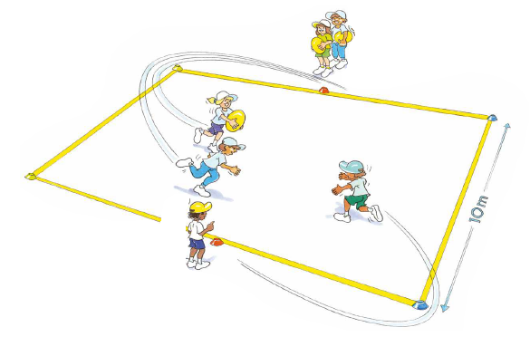
‘Round the bend illustration’, Adapted from ‘Playing for life’ – Australian Sports Commission, https://www.sportaus.gov.au.
Teacher notes
Remind the students of the tactics used in the previous game ‘Spare square’. To challenge students the ball may be changed to:
- a ball that is easier to carry and pass, but harder to catch like a tennis ball
- a ball that is harder to carry and pass but easier to catch, like a large soft rubber ball
- a different piece of equipment such as a bean bag, quoit or vortex
Discussion
Explore the questions:
- Even though the defender was outnumbered, what tactics could the defender use to be successful? Sample student answers may include, by moving towards the player with ball I could close down/decrease their space and be ready to move into the space between the ball carrier and receiver when the ball was passed.
- What if another defender was introduced? How would the defenders tactics change? Sample student answers may include, each defender could mark an attacker instead of marking the space in between.
Reflection
Students reflect upon the learning in this activity/lesson and consider how it contributes towards answering the essential question How can I use tactics to be successful in games?

Lesson 6 – Defending space
Lesson 6 – Assessment framework
Outcomes | Unit learning goals  Students are learning to: | Evidence of learning  Students can:
PD2-4 performs and refines movement skills in a variety of sequences and situations. | Perform and refine movement skills in a variety of activities or games. |  | Perform movement sequences with control by combining locomotor, object control and/or stability skills while participating in an activity or game. (Activity 1, 2, 3).
PD2-5 applies strategies to solve movement challenges. | Use knowledge of previous performances to propose solutions to movement challenges. |  | Reflect on previous performances to propose, test and modify alternative problem-solving strategies to movement challenges and predict the effectiveness of each (Activity 1, 2, 3).
PD2-10 demonstrates a range of interpersonal skills that build and enhance relationships and promote inclusion in various situations. | Demonstrate inclusive practices and team work when participating in physical activities. |  | Work collaboratively with team members to solve problems, including defending space in a game. (Activity 1, 2, 3).
PD2-11 combines movement skills and concepts to effectively create and perform movement sequences. | Practise and apply movement concepts and skills in game play. |  | Combine elements of space/positioning, movement, time, use of equipment and communication to defend space (Activity 1, 2, 3).

Key inquiry questions and syllabus content
How can we move our bodies to perform skills in different ways?
Perform and refine movement skills in a variety of movement sequences and contexts, for:
- Perform activities where locomotor, object control and stability skills are combines to complete a movement sequence, activity or game, for example, swerving, sidestepping, running, dodging, skipping, hopping, jumping, landing, balancing, swinging, climbing, rolling.
- Demonstrate variations of force and speed in movement, for example slow, fast, light, strong, sudden, sustained, using body and objects.
Practise and apply movement concepts and movement skills to create and perform movement sequences, for example:
- Combine elements of space, time, objects, effort and people when performing movement sequences.
- Combine locomotor and non-locomotor movement to create and perform movement sequences.
How can we demonstrate our understanding of movement to solve challenges?
Pose questions, test solutions and use problem-solving strategies to solve movement challenges, for example:
- Participate in physical activities which require problem-solving and persistence to achieve a goal.

Teaching and learning activities
Equipment
- markers
- footballs
- various balls and equipment to challenge students, for example, tennis balls, large soft rubber balls, bean bags, quoits or vortex

Resource
Appendix 1
Vocabulary
- tactic, movement, possession, time, communication, space, equipment, success, tag, challenge, rule, attack, defend, kick, intercept, scatter, goal, shoot, pass

Activity 1- Scatter tag (Fast start)
Refer to instructions in Lesson 4 – Activity 1, with the following adjustment:
- Game 1 – 4 attackers and 5 defenders per group
- Game 2 – 4 attackers and 3 defenders per group
Encourage students to reflect on the previous lesson to recall the tactics they used in Lesson 4 (both ‘Scatter tag’ and ‘Crazy Keeper’) and how defending space rather than marking a player allows the team to cover more area and make it more difficult for the opposing team.
Discussion
- Explore the following question, As a defender, which game was harder? Why? Sample student answers may include, Game 2 was harder because there were too many attackers to tag them all and we could not cover all the space.
- Explain that this lesson will again focus on the tactic/s that will support them to defend space. Remind students of the importance of defending space and how the elements of movement, space and positioning, timing, and communication as discussed in Lesson 4 and 5 can be used to stop the opposition.

Activity 2 – Guard the castle
Mark a playing area approximately 20 metres x 20 metres, with end zones 2 metres deep and a half way line. Divide students into groups of 10, 5 castle guards (defenders) and 5 invaders (attackers).
- Castle guards stand 3 metres apart and can only move sideways in a line.
- The invaders carry a football each and attempt to pass the guards and into the castle without being tagged or colliding with other attackers.
- Once inside the castle and past the guards the ‘invader’ touches the ball on the ground in the end zone and scores 5 points. They then move around the side of the playing area, returning to the starting zone at the other end of the playing area to begin again.
- Once a guard tags an invader, the invader moves to the dungeon area in the starting end zone. To be released from the dungeon the ‘invader’ must throw their ball in the air and clap before catching it.
- Repeat this 5 times and they may re-join the game.
- Castle guards score one point for each tag.
- Teams swap roles after an allotted time determined by the teacher (suggested time approximately 10 minutes).
- Once both teams have had a turn as invaders, the team with the highest score of balls in the castle wins.
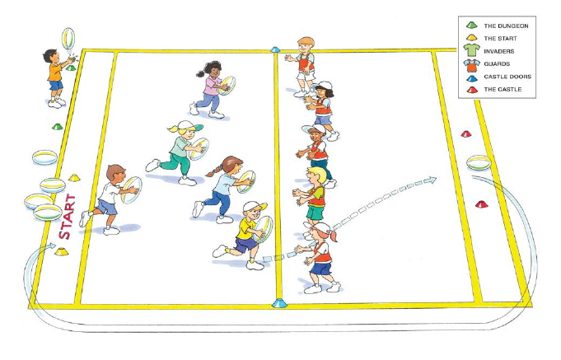
‘Guard the castle illustration’, Adapted from ‘Playing for life’ – Australian Sports Commission, https://www.sportaus.gov.au.

Teacher notes
To challenge students the ball may be changed to:
- a ball that is easier to carry like a tennis ball
- a ball that is harder to carry like a large soft rubber ball
- a different piece of equipment such as a bean bag, quoit or vortex
Discussion
Explore the questions:
What tactics did the defenders use to be successful? Sample student answers may include, we communicated with each other about who we were going to tag, we made sure we spread out along the line to cover as much space as possible.
What if there were fewer defenders and more attackers? How would the defender’s tactics change? Sample student answers may include, we would have to spread out further to cover more space, we would have to communicate effectively to ensure only one defender went to one attacker, we would have to move quickly into position to make a tag, we would have to recover their position quickly once we have made a tag so we can make another tag.

Activity 3 – Guard the castle (advanced)
Students repeat the game of Guard the castle with 6 ‘invaders’ (attackers) and 4 castle guards.
Teacher notes
Team members may have to change teams in order to ensure that all students have a turn as an outnumbered defender. This may also require games to be shorter in time. The aim is for all students to experience being outnumbered as a defender and adjusting their tactics to be successful.

Discussion
Explore the questions:
- Did having fewer defenders make it harder for the castle guards to be successful? Explain. Sample student answers may include, yes because we were unable to mark all the opponents and there was more space for them to run into.
- What tactics did defenders use to be successful when outnumbered? Sample student answers may include, we communicated about where we would position ourselves and who we were going to tag, we moved quickly into position to tag opponents, we needed to recover our position quickly after tagging an opponent, we needed to spread out further to cover more space.
Variations
Place a time limit on ‘invaders’ for them to reach the end zone, for example, 2 minutes.
Reflection
Students reflect upon the learning in this activity/lesson and consider how it contributes towards answering the essential question ‘How can I use tactics to be successful in games?’ by completing the self–assessment on ‘Appendix 1’. Alternatively, the self–assessment in ‘Appendix 1’ may be adapted using one or more of the assessment tools available via the Digital Learning Selector.

Lesson 7 – Attack the goal
Lesson 7 – Assessment framework
Outcomes | Unit learning goals  Students are learning to: | Evidence of learning  Students can:
PD2-4 performs and refines movement skills in a variety of sequences and situations. | Perform and refine movement skills in a variety of activities or games. |  | Perform movement sequences with control by combining locomotor, object control and/or stability skills while participating in an activity or game. (Activity 1, 2, 3).
PD2-5 applies strategies to solve movement challenges. | Use knowledge of previous performances to propose solutions to movement challenges. |  | Reflect on previous performances to propose, test and modify alternative problem-solving strategies to movement challenges and predict the effectiveness of each (Activity 1, 2, 3).
PD2-11 combines movement skills and concepts to effectively create and perform movement sequences. | Practise and apply movement concepts and skills in game play. |  | Combine elements of space/positioning, movement, time, use of equipment and communication to attack a goal (Activity 1, 2, 3).

Key inquiry questions and syllabus content
How can we move our bodies to perform skills in different ways?
Perform and refine movement skills in a variety of movement sequences and contexts for example:
- Perform activities where locomotor, object control and stability skills are combines to complete a movement sequence, activity or game, for example swerving, sidestepping, running, dodging, skipping, hopping, jumping, landing, balancing, swinging, climbing, rolling.
- Demonstrate variations of force and speed in movement, for example slow, fast, light, strong, sudden, sustained, using body and objects.
- Adapt movement skills to improve accuracy and control in a variety of contexts.
Practise and apply movement concepts and movement skills to create and perform movement sequences, for example:
- Combine elements of space, time, objects, effort and people when performing movement sequences.
How can we demonstrate our understanding of movement to solve challenges?
Pose questions, test solutions and use problem-solving strategies to solve movement challenges, for example:
- Identify how to modify plans within a game to achieve success.
- Participate in physical activities which require problem-solving and persistence to achieve a goal.
- Demonstrate movement concepts and strategies to create scoring opportunities.

Teaching and learning activities
Equipment
- markers
- soccer balls or variety of other balls to suit skill level
- bean bags
- hoops
Resource
Territory and Invasion Games video (1:36)
Vocabulary
- tactic, movement, possession, time, communication, space, equipment, success, challenge, rule, attack, defend, kick, pass

Activity 1 – Rob the nest (fast start)
Mark a playing area approximately 5 metres x 5 metres with 4 students in each.
- A hoop is placed in each corner of the playing area. One hoop has 5 beanbags placed in it, each student stands in one of the remaining hoops (their nest).
- The aim is for a student to have 3 beanbags in their hoop (their nest), to win the game.
- On the teacher’s signal students run to any of the other nests and take one beanbag and return it to their own nest.
- Students continue to take one beanbag at a time from other nests and return it to their own nest until someone has 3 beanbags in their nest.
- Students are only allowed to carry one beanbag at a time back to their hoop (nest).
- Students are not allowed to throw beanbags, but must drop them into their hoop (nest).
- If a bean bag is dropped/placed on the hoop or outside the hoop, the student must not pick up another beanbag until the misplaced beanbag has been repositioned into the hoop. Other students may take bean bags from any position, inside or outside a hoop.
- Remind students to continue looking at other students and the surrounds to reduce chances of a collision.
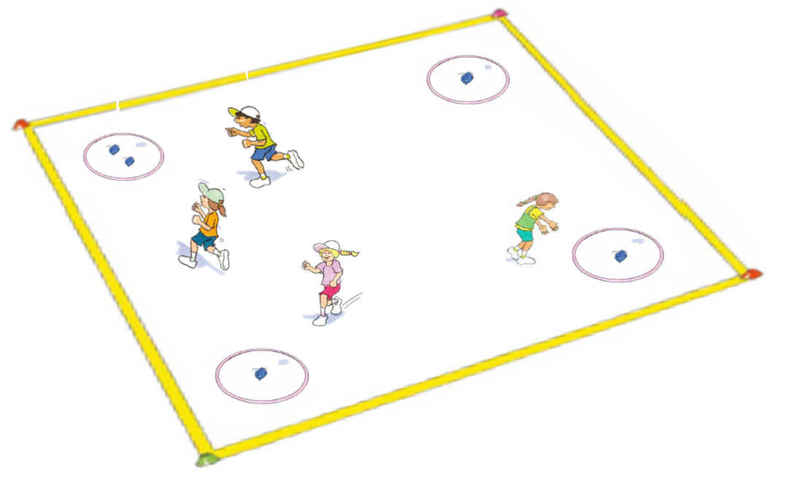
‘Rob the nest illustration’, Adapted from ‘Playing for life’ – Australian Sports Commission, https://www.sportaus.gov.au.
Variations
- Change the movement used by students. For example, from running to skipping, hopping, jumping or side galloping.
- Increase/decrease playing area.
Discussion
Explore the questions:
- What tactics did you use to make sure the bean bags remained in the hoop? Sample student answers may include, I placed the bean bags in the hoop instead of tossing/dropping them, I slowed down when placing a beanbag in the hoop so I was balanced and the bean bag did not fall onto the edge or outside of the hoop.
- What if tennis balls were used instead of bean bags? Sample student answers may include, my movements to approach the hoop and when placing the bean bag would need to be slowed, the ball would need to placed more carefully to ensure it did not roll away, I may have to position myself at the hoop for slightly longer to ensure that the ball is not going to roll out of the hoop, I would have to be careful when placing balls in the hoops that they do not bump other balls out of the hoop.
Explain that this lesson will focus on using tactics that support them to attack a goal. Explore with students that they will need to consider how they can use the following to maintain possession:
- Movement – type of movement they use, the speed of their movement.
- Space and positioning – where they stand, where they move to, how they support team members, where they aim their shot for goal (kick or throw).
- Timing – when they move, when they shoot for goal.
- Equipment – how they use the equipment (how they hold the ball, how they kick the ball), the force applied to the equipment (how hard or soft they pass or shoot).
- Communication – what signals/calls can help the team (for example, tell a team member when they should or should not shoot).
View the ‘Territory/Invasion games’ video and allow students to reflect upon their responses of how they may use movement, space and positioning, timing, equipment and/or communication to attack the goal in a territory game.

Activity 2 – Back to back
Divide students into pairs. Pairs place four markers to create 2 end lines approximately 10 metres apart.
- The markers at one end should be placed to create a goal (approximately 5 metres apart to begin with, however this distance can be adjusted to suit the skill level of the students, and as they develop their understanding and skills as the activity progresses).
- A ball is placed on the end line without the goal. Students stand back-to-back in the centre of the playing area. When the student facing the ball calls out ‘Go!’ both students run to opposite ends of their pitch and around a marker. The student who was facing the ball collects it and attempts to kick the ball through the goal at the other end. Students take turns facing the ball and calling ‘Go!’.
- Students are not allowed to stand in the goal to defend.
- After each student has had a turn at ‘attacking the goal’, reduce the size of the goal so students may have to adjust their tactics.
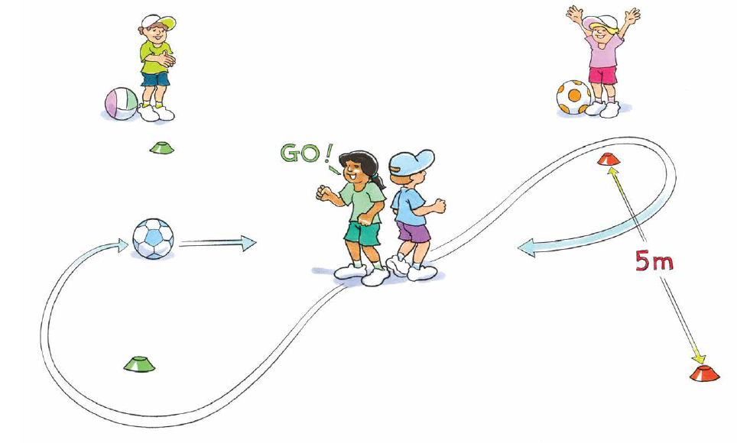
‘Back to back illustration’, Adapted from ‘Playing for life’ – Australian Sports Commission, https://www.sportaus.gov.au.

Variations
- Allow defenders to stand in the goal.
- Move the ‘starting position’ so the attacker/defender has less/more distance to travel.
Teacher notes
Encourage students to investigate their own tactics to score a goal. For example, do they kick the ball straight away when they are far away from the goal but have space as the defender is not near them? Or do they dribble the ball, getting closer to the goal but subsequently having the defender closer and obstructing them.
This game can be adapted to suit students’ interests. For example, a netball or basketball may be thrown into a hoop/bucket, hockey sticks may be used to shoot a hockey ball at small goal, rugby league balls may be passed through a goal or an AFL ball hand-passed through.
Discussion
Explore the questions:
- What tactics did you use to try to score a goal? Sample student answers may include, I looked at where I wanted to kick the ball, I aimed and kicked the ball at the goal before the defender closed my space, I slowed my movement as I went to shoot to ensure I was balanced, I moved the ball into a better position closer to the goal, I aimed the ball away from the defender.
- How did making the goal smaller change your tactics? Sample student answers may include, I had to move closer to the goal which allowed the defender to move closer to me so I had to be more accurate with my shot, I had to make sure I did not try to kick the ball too hard so that I could be better balanced and more accurate, my movements had to be precise so that I was in an appropriate position to shoot the ball.

Activity 3 – Tricky goal line
Create several games with up to 8 students in each game. In each game, organise students into two groups at diagonal points of the playing area that is approximately 10 metres x 10 metres. Use markers to set up two small goals, approximately 2 metres wide on the opposite sides to the attacker. Dimensions of each game may vary depending on the skill level of students.
- Attackers line up behind a marker with a soccer ball each. The first attacker calls out ‘Go’ and enters the playing area. On hearing ‘Go’ the first defender enters the playing area. The attacker’s aim is to kick the ball through one of the goals. The defender’s aim to stop a goal being scored by using the defensive tactics learned in earlier lessons in this unit.
- Once the attacker has tried to score a goal, both students leave the playing area. The defender collects the ball and joins the line of attackers and the attacker joins the line of defenders. The game continues until all students have had several attempts at scoring a goal.
- On each student’s subsequent attempts, reduce the size of the goals so that tactics may have to change. Ensure the size of the goals do not become too small and make scoring a goal too difficult.
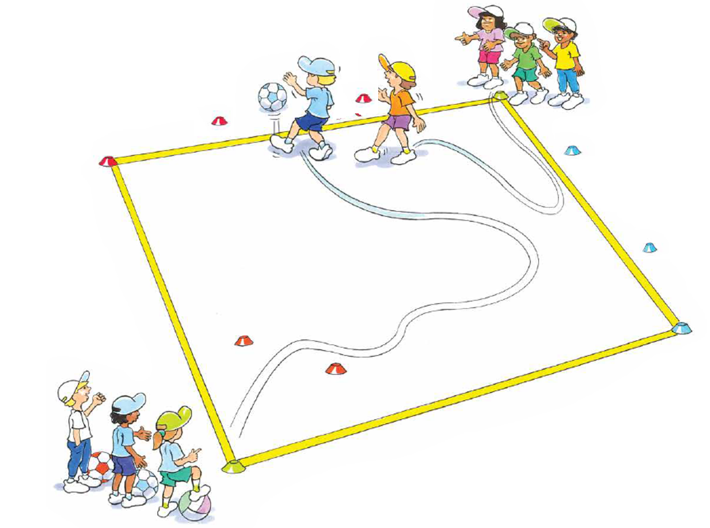
‘Tricky goal line illustration’, Adapted from ‘Playing for life’ – Australian Sports Commission, https://www.sportaus.gov.au.

Teacher notes
Encourage students to investigate their own tactics to score a goal. For example, do they kick the ball straight away when they are far away from the goal but have space as the defender is not near close to them? Or do they dribble the ball, getting closer to the goal but allowing the defender to get closer and block them.
This game can be adapted to suit students’ interests. For example, a netball or basketball may be thrown into a hoop/bucket, hockey sticks may be used to shoot a hockey ball at small goal, rugby league balls may be passed through a goal or an AFL ball hand-passed through.
Discussion
Explore the questions:
- Did you use similar tactics to the game ‘Back to back’? Explain how and why your tactics were,
  - similar
  - different
- As the goals were made smaller, how did your tactics change? Were the changes similar to the ones made in the game ‘Back to back’ when those goals were reduced in size?
Reflection
Students reflect upon the learning in this activity/lesson and consider how it contributes towards answering the essential question How can I use tactics to be successful in games?

Lesson 8 – Attack the goal
Lesson 8 – Assessment framework
Outcomes | Unit learning goals  Students are learning to: | Evidence of learning  Students can:
PD2-4 performs and refines movement skills in a variety of sequences and situations. | Perform and refine movement skills in a variety of activities or games. |  | Perform movement sequences with control by combining locomotor, object control and/or stability skills while participating in an activity or game. (activity 1, 2, 3).
PD2-5 applies strategies to solve movement challenges. | Use knowledge of previous performances to propose solutions to movement challenges. |  | Reflect on previous performances to propose, test and modify alternative problem-solving strategies to movement challenges and predict the effectiveness of each (activity 1, 2, 3).
PD2-11 combines movement skills and concepts to effectively create and perform movement sequences. | Practise and apply movement concepts and skills in game play. |  | Combine elements of space/positioning, movement, time, use of equipment and communication to attack a goal (activity 1, 2, 3).

Key inquiry questions and syllabus content
How can we move our bodies to perform skills in different ways?
Perform and refine movement skills in a variety of movement sequences and contexts, for:
- Perform activities where locomotor, object control and stability skills are combines to complete a movement sequence, activity or game for example, swerving, sidestepping, running, dodging, skipping, hopping, jumping, landing, balancing, swinging, climbing, rolling.
- Demonstrate variations of force and speed in movement for example, slow, fast, light, strong, sudden, sustained, using body and objects.
- Adapt movement skills to improve accuracy and control in a variety of contexts.
Practise and apply movement concepts and movement skills to create and perform movement sequences, for example:
- Combine elements of space, time, objects, effort and people when performing movement sequences.
How can we demonstrate our understanding of movement to solve challenges?
Pose questions, test solutions and use problem-solving strategies to solve movement challenges for example:
- Identify how to modify plans within a game to achieve success.
- Participate in physical activities which require problem-solving and persistence to achieve a goal.
- Demonstrate movement concepts and strategies to create scoring opportunities.

Teaching and learning activities
Equipment
- markers
- hoops
- tennis balls
Vocabulary
- tactic, movement, possession, time, communication, space, equipment, success, challenge, rule, attack, defend, kick, intercept, goal, shoot, pass

Activity 1 – Rob the nest (Fast start)
Refer to instructions in Lesson 7 – Activity 1 and introduce the rule/modification that students collect tennis balls (or similar) instead of bean bags.
Discussion
Explore the questions:
- How did using tennis balls instead of bean bags change your tactics? Sample student answers may include, my movements to approach the hoop and when placing the bean bag would need to be slowed, the ball would need to placed more carefully to ensure it did not roll away, I may have to position myself at the hoop for slightly longer to ensure that the ball is not going to roll out of the hoop, I would have to be careful when placing balls in the hoops that they do not bump other balls out of the hoop.
- What if basketballs were used instead of bean bags? Sample student answers may include, all my tactics for using tennis balls would be the same however they would be exaggerated – greater care when placing the balls in the hoops, slower movements when approaching the hoop, more time needed to ensure the balls remain in the hoop.
- Explain that this lesson will again focus on using tactics that support them to attack a goal. Remind students of how they may use the elements of movement, space and positioning, timing, and communication to be successful, as discussed in Lesson 7.

Activity 2 – Sensational striker (also called crazy keeper)
Refer to instructions in Lesson 4 – Activity 2.
‘Sensational striker illustration’, Adapted from ‘Playing for life’ – Australian Sports Commission, https://www.sportaus.gov.au.

Teacher notes
Sensational striker is the same game as ‘Crazy keeper’ in Lesson 4. However, the focus for this game and discussions are now placed on students attacking the goals.
Discussion
Explore the questions:
- What tactics did you use to try to score a goal? Sample student answers may include, I looked at where I wanted to kick the ball, I shot before the defender closed/decreased my space, I slowed my movement as I went to shoot to ensure I was balanced, I moved the ball into a better position closer to the goal, I aimed the ball away from the defender.
Variations
- increase or decrease the distance of the shooting line
- increase or decrease the distance between goals
- shooters use only their left or right foot as selected by the teacher/students

Activity 3 – Sensational striker 2.0
Repeat the game Sensational striker and introduce the rule/modification that students carry a ball in their hands and throw/pass/roll the ball into the goals.
Teacher notes
This game allows flexibility for students to use equipment and transfer skills from games they have played previously and/or are interested in. For example, students who like netball may chest pass a netball, while students who like AFL might hand-pass an AFL ball. Therefore, students have the opportunity to identify connections and similarities in tactical decisions between games.
Discussion
Explore the questions:
- Did you use similar tactics to the previous sensational striker game? Explain how and why your tactics were
  - similar
  - different
Reflection
Students reflect upon the learning in this activity/lesson and consider how it contributes towards answering the essential question How can I use tactics to be successful in games?

Lesson 9 – Attack the goal
Lesson 9 – Assessment framework
Outcomes | Unit learning goals  Students are learning to: | Evidence of learning  Students can:
PD2-4 performs and refines movement skills in a variety of sequences and situations. | Perform and refine movement skills in a variety of activities or games. |  | Perform movement sequences with control by combining locomotor, object control and/or stability skills while participating in an activity or game (activity 1, 2).
PD2-5 applies strategies to solve movement challenges. | Use knowledge of previous performances to propose solutions to movement challenges. |  | Reflect on previous performances to propose, test and modify alternative problem-solving strategies to movement challenges and predict the effectiveness of each (activity 1, 2).
PD2-10 demonstrates a range of interpersonal skills that build and enhance relationships and promote inclusion in various situations. | Demonstrate inclusive practices and team work when participating in physical activities. |  | Work collaboratively with team members to solve problems, including attacking a goal in a game (activity 2).
PD2-11 combines movement skills and concepts to effectively create and perform movement sequences. | Practise and apply movement concepts and skills in game play. |  | Combine elements of space/positioning, movement, time, use of equipment and communication to attack a goal (activity 1, 2).

Key inquiry questions and syllabus content
How can we move our bodies to perform skills in different ways?
Perform and refine movement skills in a variety of movement sequences and contexts for example:
- Perform activities where locomotor, object control and stability skills are combines to complete a movement sequence, activity or game, for example, swerving, sidestepping, running, dodging, skipping, hopping, jumping, landing, balancing, swinging, climbing, rolling.
- Demonstrate variations of force and speed in movement, for example, slow, fast, light, strong, sudden, sustained, using body and objects.
- Adapt movement skills to improve accuracy and control in a variety of contexts.
Practise and apply movement concepts and movement skills to create and perform movement sequences, for example:
- Combine elements of space, time, objects, effort and people when performing movement sequences.
How can we demonstrate our understanding of movement to solve challenges?
Pose questions, test solutions and use problem-solving strategies to solve movement challenges for example:
- Participate in physical activities which require problem-solving and persistence to achieve a goal.
- Demonstrate movement concepts and strategies to create scoring opportunities.
How can we include others in physical activity?
Adopt inclusive practices when participating in physical activities, for example:
- Use interpersonal skills to complete a movement task, for example, a partner balance, partner passing strategy or team strategy.
- Work collaboratively with team members to maintain possession in a game.

Teaching and learning activities
Equipment
- markers
- hoops
- basketballs
- tennis balls

Resources
Appendix 1
Vocabulary
- tactic, movement, possession, time, communication, space, equipment, success, challenge, rule, attack, defend, kick, intercept, goal, shoot, pass

Activity 1 – Rob the nest (Fast start)
Refer to instructions in Lesson 7 – Activity 1 and introduce the rule/modification that students collect basket balls (or similar) instead of tennis balls.
Discussion
Explore the question:
- How did using basketballs instead of tennis balls change your tactics?’ Sample student answers may include, I needed to be more careful with the basketballs than the tennis balls, I needed to carry the basketballs with two hands and take more care when placing them in the hoop.
Teacher notes
This game of ‘Rob the nest’ highlights that specific tactics may be suited to changes in equipment. Focus may be placed on how the piece of equipment is held and/or used to improve chances of success.
Discussion
Explain that this lesson will again focus on using tactics that support them to attack a goal. Remind students of how they could use the elements of movement, space and positioning, timing, and communication as discussed in Lesson 7 and 8 to be successful.

Activity 2 – Knock it off
Create several games with at least 8 students in each game. In each game, organise students into two even teams with a playing area approximately 20 metres x 20 metres for each game.
- In each half, mark out a small rectangular area for the markers/tennis balls to be positioned in. Each team starts the game with 4 markers/tennis balls.
- The aim of the game is to kick the soccer ball into the opposition’s goal area to knock all the tennis ball from the top of the opposition’s markers. Students must be in their own half for the start of play.
- A minimum of two students on the team must have touched the ball before a goal can be scored (knocking one ball of a marker scores one goal).
- After a tennis ball has been knocked off, the team that conceded the goal starts with the soccer ball from the halfway mark.
- Only one tennis ball may be knocked down at a time. Any other balls knocked off need to be returned to the marker before plays starts again. Students can score from the front, sides or back of the goal area. The first team to knock down all the opposing team’s balls wins. Encourage players to pass the ball if the zone is being blocked/defended.
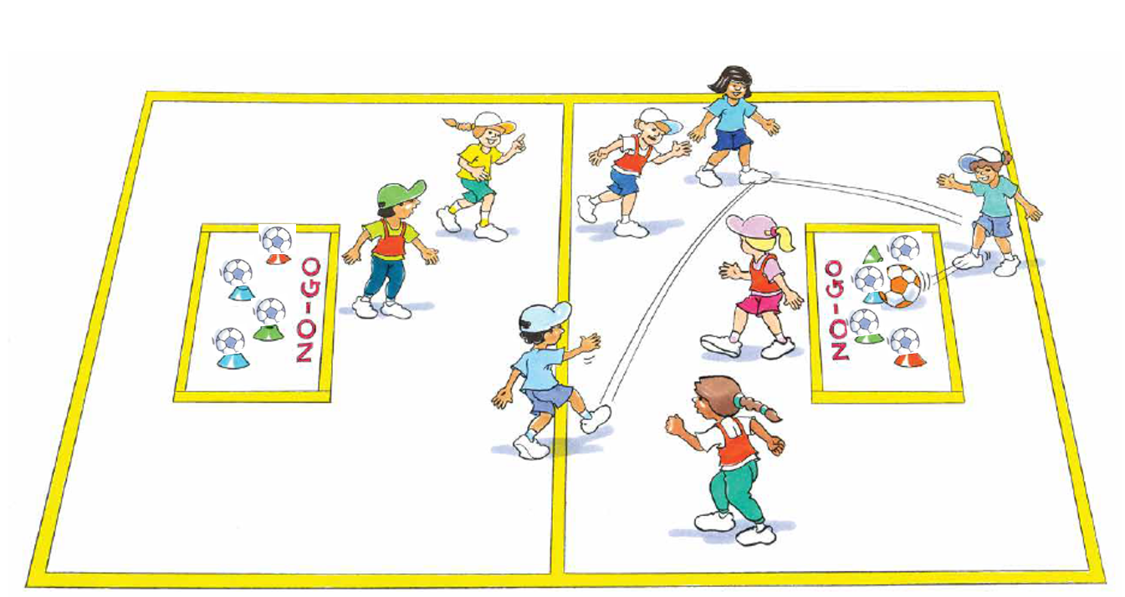
‘Knock it off illustration’, Adapted from ‘Playing for life’ – Australian Sports Commission, https://www.sportaus.gov.au.
Teacher notes
This game can be changed to suits students’ interests and skills. Instead of using soccer as the basis for the game, students may hand-ball an AFL ball, pass a netball or rugby league ball, bounce a basketball. Not all groups have to use the same ball or passing style. This can demonstrate to students that similar tactics can be used across different games.
Variations
- Change the weight of the ball on each marker, making it easier or harder to knock off.
- Increase the number of students that must touch the ball before a goal is scored.
- Increase or decrease the number of markers/tennis balls.
Discussion
Explore the following question, ‘How did your tactics change from previous lesson where you did not have team members?’ Sample student answers may include, I was able to pass the ball to players in a better position to score, I needed to watch where my team members were so we did not move into the same space, I needed to communicate clearly with my team members for success.
Reflection
Students reflect upon the learning in this activity/lesson and consider how it contributes towards answering the essential question ‘How can I use tactics to be successful in games?’ by completing the self–assessment on ‘Appendix 1’. Alternatively, the self–assessment in ‘Appendix 1’ may be adapted using one or more of the assessment tools available via the Digital Learning Selector.

Lesson 10 – Adjusting tactics
Assessment framework – Lesson 10
Outcomes | Unit learning goals  Students are learning to: | Evidence of learning  Students can:
PD2-4 performs and refines movement skills in a variety of sequences and situations. | Perform and refine movement skills in a variety of activities or games. |  | Perform movement sequences with control by combining locomotor, object control and/or stability skills while participating in an activity or game (activity 1, 2, 3).
PD2-5 applies strategies to solve movement challenges. | Use knowledge of previous performances to propose solutions to movement challenges. |  | Reflect on previous performances to propose, test and modify alternative problem-solving strategies to movement challenges and predict the effectiveness of each (activity 1, 2, 3).
PD2-10 demonstrates a range of interpersonal skills that build and enhance relationships and promote inclusion in various situations. | Demonstrate inclusive practices and team work when participating in physical activities. |  | Work collaboratively with team members to solve problems, including adjusting tactics in a game (activity 1, 2, 3).
PD2-11 combines movement skills and concepts to effectively create and perform movement sequences. | Practise and apply movement concepts and skills in game play. |  | Combine elements of space/positioning, movement, time, use of equipment and communication to adjust tactics in response to rule changes (activity 2, 3).

Teaching and learning activities
How can we move our bodies to perform skills in different ways?
Perform and refine movement skills in a variety of movement sequences and contexts, for:
- Perform activities where locomotor, object control and stability skills are combines to complete a movement sequence, activity or game, for example, swerving, sidestepping, running, dodging, skipping, hopping, jumping, landing, balancing, swinging, climbing, rolling.
- Demonstrate variations of force and speed in movement, for example, slow, fast, light, strong, sudden, sustained, using body and objects.
- Adapt movement skills to improve accuracy and control in a variety of contexts.
Practise and apply movement concepts and movement skills to create and perform movement sequences, for example:
- Combine elements of space, time, objects, effort and people when performing movement sequences.
- Combine locomotor and non-locomotor movement to create and perform movement sequences.
How can we demonstrate our understanding of movement to solve challenges?
Pose questions, test solutions and use problem-solving strategies to solve movement challenges, for example:
- Identify how to modify plans within a game to achieve success.
- Participate in physical activities which require problem-solving and persistence to achieve a goal.
- Demonstrate movement concepts and strategies to create scoring opportunities.
How can we include others in physical activity?
Adopt inclusive practices when participating in physical activities, for example:
- Use interpersonal skills to complete a movement task, for example, a partner balance, partner passing strategy or team strategy.
- Work collaboratively with team members to maintain possession in a game.
Equipment
- markers
- large balls
Resources
Appendix 1
Vocabulary
- tactic, movement, possession, time, communication, space, equipment, success, challenge, rule, attack, defend, intercept, pass

Activity 1 -Bobcats and builders (Fast start)
Scatter a large number of markers in a large playing area. Divide the class into two teams, bobcats and builders. The bobcat team try to tip over or knock down as many markers as possible. The builder team try to repair or turn back over as many cones as possible.
Teacher notes
When tipping over the markers ensure students use their hands and place the marker in the correct position. For safety, remind students that they are not to kick or throw the markers.
Variations
- Balance a ball on the marker. The bobcats turn the marker over and place the ball inside.
- Increase/decrease the playing area.
- Place a braid in a hoop or bucket. Bobcats take the braid out of the hoop, builders place the braid back inside the hoop.
Discussion
Explain that this lesson will focus on adjusting tactics when rules change. Explore with students that they will need to consider how they can utilise the following to be successful.
- Movement – type of movement they use, the speed of their movement.
- Space and positioning – where they stand, where they move to, how they support team members, where they aim their pass, kick or throw.
- Timing – when they move, when they pass, kick or throw, when they attempt to intercept.
- Equipment – how they use the equipment (how they hold the ball, how they pass, kick or throw the ball), the force applied to the equipment (how hard or soft they pass, kick or throw).
- Communication – what signals/calls can help the team (for example, tell a team member they are going to pass to them or are ready to receive a pass).

Activity 2 – End ball
Mark a playing area approximately 20 metres x 10 metres. Divide the playing area into half and add an extra 2 metre end zone at each end.
- Divide students into groups of 12-14 (2 teams of 6-7) per playing area. Each team is divided in two with 3-4 students starting in their respective half, the other 3 students start in their respective end zone.
- Each team has 2 ball large balls (netball or similar).
- The aim of the game is for each team to pass the balls to their team members in the end zone.
- Students may move with a ball inside their own half but must not cross the halfway line.
- When a successful pass is completed to a team member in the end zone the two students swap positions. For each completed pass, the team scores 1 point.
- The opposing team attempts to intercept or knock down the pass. Each intercept or knock down scores 1 point and the ball is returned to the team who passed it.
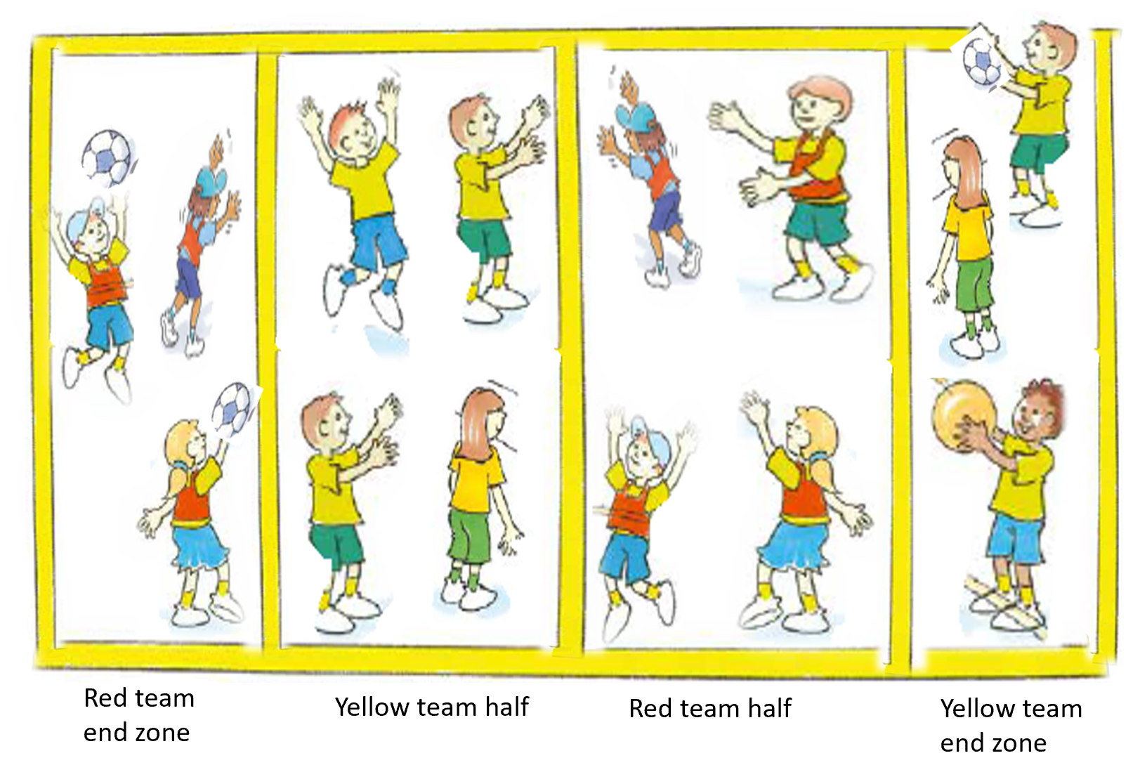
‘End ball illustration’, Adapted from ‘Playing for life’ – Australian Sports Commission, https://www.sportaus.gov.au.
Discussion
Explore the questions:
- What tactics did you use as a defender? Sample student answers may include, timed my movements in order to complete successful intercepts, moved quickly into the path of the ball to incept the pass, used different movements such as dodge and jump depending on where the balls were passed, positioned myself further back from the half line, communicated with team members as to who could intercept which ball.
- What tactics did you use as an attacker? Sample student answers may include, aimed my passes away from the defenders, used different passes such as chest, shoulder and lob pass, positioned myself on the halfway line to complete an effective pass, communicated with team members so they could receive the ball successfully.
Variations
Students must pass to a team member before passing to the end zone.

Activity 3 – End ball advanced
Repeat the game of End Ball and introduce rule changes for ‘End ball advanced’ as follows.
- Only 1 team member begins the game in the end zone, all other team members begin in the playing area.
- The aim is to have all team members in the end zone.
- Each team begins with two large balls in their playing area.
- Students attempt to pass the ball to their team member in the end zone. If the pass is completed the student who passes the ball moves to the end zone. Students do not swap positions unlike the previous game.
- The first team to have all team members in the end zone wins. No points are allocated in this game.
- Students must have both feet in the end zone to complete a pass.
- Any intercepted or knocked down balls are returned to the passing team.
- When students in the end zone complete a pass, they return the ball to the playing area by rolling it down the sideline.
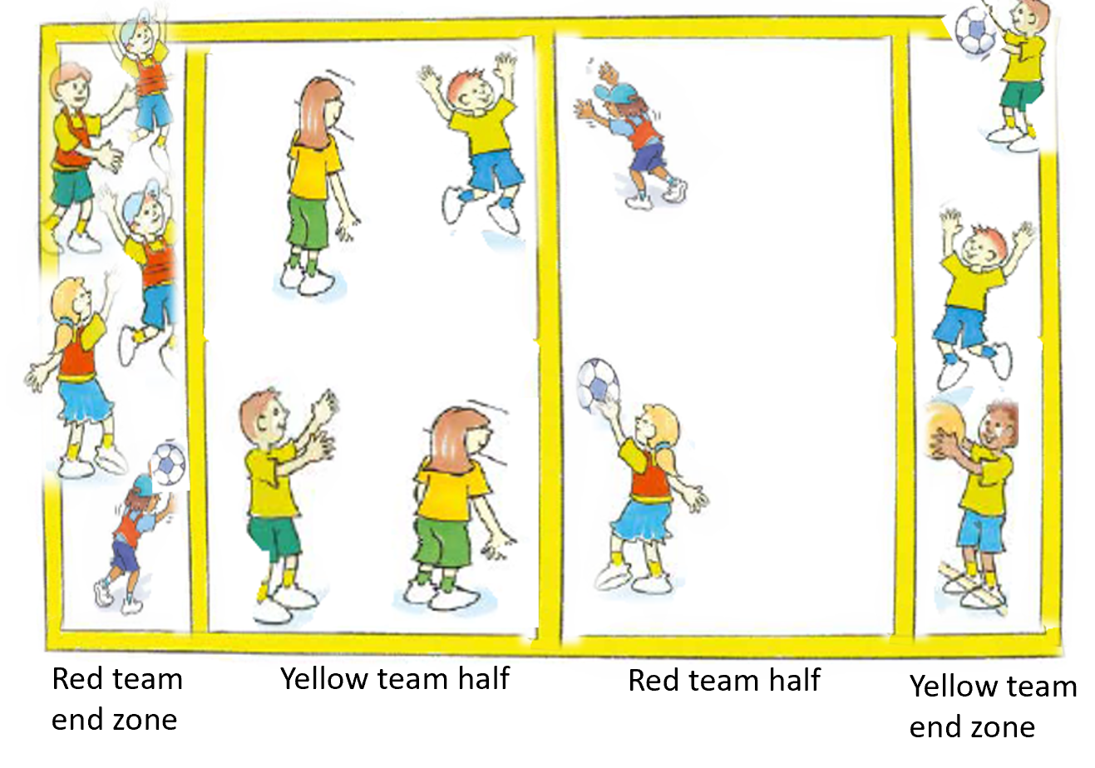
‘End ball advance illustration’, Adapted from ‘Playing for life’ – Australian Sports Commission, https://www.sportaus.gov.au.
Discussion
Explore the questions:
- How did your tactics remain the same from the first game of ‘End ball’? Sample student answers may include, movements still needed to be quick, use the same type of movements, needed to accurately time our passes.
- How did your tactics change from the first game of ‘End ball’? Sample student answers may include, when there were fewer team members in the end zone our communication needed to be very clear to pass successfully, we needed to be more accurate with our passing, when there were fewer defenders we needed to be more efficient at defending the space.
Variations
- end zones reduced in size
- roll the ball to the end zone
- change the size of the balls
- increase or decrease the size of the playing area
Teacher notes
Teachers are encouraged to implement the variations and play multiple versions of the game to allow students to adjust tactics and reflect upon the effectiveness of each one.
Reflection
Students reflect upon the learning in this activity/lesson and consider how it contributes towards answering the essential question How can I use tactics to be successful in games? by completing the self–assessment on Appendix 1. Alternatively, the self–assessment in Appendix 1 may be adapted using one or more of the assessment tools available via the Digital Learning Selector.

Appendix 1 – Self assessment
Student name:
Circle or colour the most appropriate box.
Self-assessment table
Success criteria | I need help to learn: | I am still learning to: | I have learnt to:
By the end of lesson 3 | Combine and use elements of space/positioning, movement, time, use equipment and communication to maintain possession. | Combine and use elements of space/positioning, movement, time, use equipment and communication to maintain possession. | Combine and use elements of space/positioning, movement, time, use equipment and communication to maintain possession.
By the end of lesson 3 | Work collaboratively with team members to maintain possession in a game. | Work collaboratively with team members to maintain possession in a game. | Work collaboratively with team members to maintain possession in a game.
By the end of lesson 6 | Combine and use elements of space/positioning, movement, time, use equipment and communication when defending space. | Combine and use elements of space/positioning, movement, time, use equipment and communication when defending space. | Combine and use elements of space/positioning, movement, time, use equipment and communication when defending space.
By the end of lesson 6 | Work collaboratively with team members to defend space in a game. | Work collaboratively with team members to defend space in a game. | Work collaboratively with team members to defend space in a game.
By the end of lesson 9 | Combine and use elements of space/positioning, movement, time, use equipment and communication when attacking a goal. | Combine and use elements of space/positioning, movement, time, use equipment and communication when attacking a goal. | Combine and use elements of space/positioning, movement, time, use equipment and communication when attacking a goal.
By the end of lesson 9 | Work collaboratively with team members to attack a goal in a game. | Work collaboratively with team members to attack a goal in a game. | Work collaboratively with team members to attack a goal in a game.
By the end of lesson 10 | Combine and use elements of space/positioning, movement, time, use equipment and communication when adjusting tactics. | Combine and use elements of space/positioning, movement, time, use equipment and communication. | Combine and use elements of space/positioning, movement, time, use equipment and communication.
By the end of lesson 10 | Work collaboratively with team members to adjust tactics in a game. | Work collaboratively with team members to adjust tactics in a game. | Work collaboratively with team members to adjust tactics in a game.

Appendix 2 - Evaluation
Teacher analysis of the teaching and learning in the entire unit of work. Sample questions to address include:
Unit evaluation and teacher notes
Evaluation | Teacher notes
How well did the class demonstrate understanding of key concepts? | Write notes here.
What concepts/topics will I need to revisit to support student understanding? | Write notes here.
When will these concepts be revisited? | Write notes here.
How well were student learning needs met? | Write notes here.
Did all students have opportunities to demonstrate their knowledge, understanding and skills? | Write notes here.
Did adjustments provide adequate and appropriate access to all activities by all students? | Write notes here.
Were the resources used accessible for all students? | Write notes here.
Which activities in the learning sequence will I need to adapt to ensure better achievement of learning goals? | Write notes here.
Did the learning sequence provide sufficient opportunities to make quality assessment judgements about student achievement? | Write notes here.

Appendix 3 – Glossary
Attackers – A team who are trying to score, usually with a ball/object.
Boundaries – A line which marks the limits of an area.
Defenders – A team trying to stop the opposition (attackers) from scoring.
Territory games – Games, usually team based, which the purpose is to invade the opponent’s territory and score points while keeping the opposing teams points to a minimum.
Locomotor skills – Locomotor movement is when you move from one place to another. Locomotor skills include walking, climbing, rolling, balancing, sliding, jogging, running, leaping, jumping, hopping, dodging, galloping, skipping, floating and moving the body through water to safety.
Modified games – Games or sports that are simplified to suit the skills, strategic understandings and characteristics of students through changes to the game’s constraints such as rules, equipment and/or the sizer of the playing area.
Non-locomotor skills – Moving on the spot without any change in location. These skills include bending, stretching, twisting, turning, swinging, inverted supports, landing/stopping, balancing.
Tackle/tackling – Tackle/tackling is a generic term used when a student attempts to gain/re-gain possession of the ball/object from an opposition student. Under no circumstances should students make physical contact with another student to achieve this.
Tactical knowledge – An understanding of when, how and why to apply tactics in game situations.
Tactics – A plan, idea or action to successfully achieve a goal or outcome during a movement activity.

Appendix 4 – Assessment framework
Assessment framework
Outcomes | Unit learning goals  Students are learning to: | Evidence of learning  Students can:
What syllabus outcomes will be assessed throughout this unit of work. Refer to pages 14-19 of the PDHPE K-10 syllabus. | What are students expected to know, understand and do as a result of the learning within this unit of work. These are derived from the identified syllabus outcomes. | What specific behaviours will you expect to observe and use as an indicator of student learning towards the Student learning goals.  These are derived from the Student learning goals, NSW Physical Literacy Continuum K-10 cluster markers and cluster examples. Refer to Appendix 2 for more detail.
PD2-4 performs and refines movement skills in a variety of sequences and situations. | Perform and refine movement skills in a variety of activities or games. | Perform movement sequences with control by combining locomotor, object control and/or stability skills while participating in an activity or game.  Lesson 1 – Activity 1, 2, 3  Lesson 2 – Activity 1, 2, 3  Lesson 3 – Activity 1, 2, 3  Lesson 4 – Activity 1, 2, 3  Lesson 5 – Activity 1, 2, 3  Lesson 6 – Activity 1, 2, 3  Lesson 7 – Activity 1, 2, 3  Lesson 8 – Activity 1, 2, 3  Lesson 9 – Activity 1, 2  Lesson 10 – Activity 1, 2, 3
PD2-5 applies strategies to solve movement challenges. | Use knowledge of previous performances to propose solutions to movement challenges. | Reflect on previous performances to propose, test and modify alternative problem-solving strategies to movement challenges and predict the effectiveness of each.  Lesson 1 – Activity 1, 2, 3  Lesson 2 – Activity 1, 2, 3  Lesson 3 – Activity 1, 2, 3  Lesson 4 – Activity 1, 2, 3  Lesson 5 – Activity 1, 2, 3  Lesson 6 – Activity 1, 2, 3  Lesson 7 – Activity 1, 2, 3  Lesson 8 – Activity 1, 2, 3  Lesson 9 – Activity 1, 2  Lesson 10 – Activity 1, 2, 3
PD2-10 demonstrates a range of interpersonal skills that build and enhance relationships and promote inclusion in various situations. | Demonstrate inclusive practices and team work when participating in physical activities. | - Work collaboratively with others to solve problems, including maintaining possession in a game.  Lesson 1 – Activity 2, 3  Lesson 2 – Activity 2, 3  Lesson 3 – Activity 2, 3)  - Work collaboratively with team members to solve problems, including defending space in a game.  Lesson 4 – Activity 1  Lesson 5 – Activity 1  Lesson 6 – Activity 1, 2, 3  - Work collaboratively with team members to solve problems, including attacking a goal in a game.  Lesson 9 – Activity 2  - Work collaboratively with team members to solve problems, including adjusting tactics in a game.  Lesson 10 – Activity 1, 2, 3
PD2-11 combines movement skills and concepts to effectively create and perform movement sequences. | Practise and apply movement concepts and skills in game play. | - Combine elements of movement (space/positioning, movement, time), use of equipment and/or communication to maintain possession.  Lesson 1 – Activity 1, 2, 3  Lesson 2 – Activity 1, 2, 3  Lesson 3 – Activity 1, 2, 3  - Combine elements of movement (space/positioning, movement, time), use of equipment and/or communication to defend space.  Lesson 4 – Activity 1, 2, 3  Lesson 5 – Activity 1, 2, 3  Lesson 6 – Activity 1, 2, 3  - Combine elements of movement (space/positioning, movement, time), use of equipment and/or communication to attack a goal.  Lesson 7 – Activity 1, 2, 3  Lesson 8 – Activity 1, 2, 3  Lesson 9 – Activity 1, 2  - Combine elements of movement (space/positioning, movement, time), use of equipment and/or communication to adjust tactics in response to rule changes.  Lesson 10 – Activity 2, 3

Appendix 5 – Images to support key terms
These images are licensed under CC BY NC ND 3.0 AU. Image modified with the permission of the Australian Sports Commission (for use in this publication only).
Tag – to touch an opponent with your hand or other safe object.
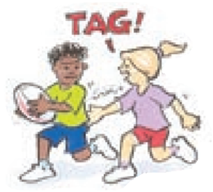
‘Tag illustration’, Adapted from ‘Playing for life’ – Australian Sports Commission, https://www.sportaus.gov.au.
Attackers – team who are to trying score, usually with the ball/object.
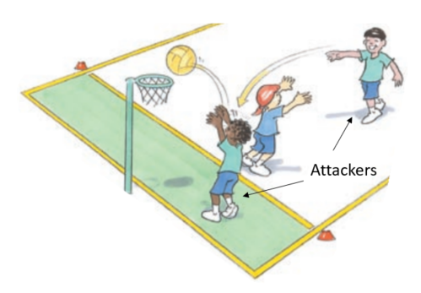
‘Attackers illustration’, Adapted from ‘Playing for life’ – Australian Sports Commission, https://www.sportaus.gov.au.

Defenders – team trying to stop the opposition from scoring.
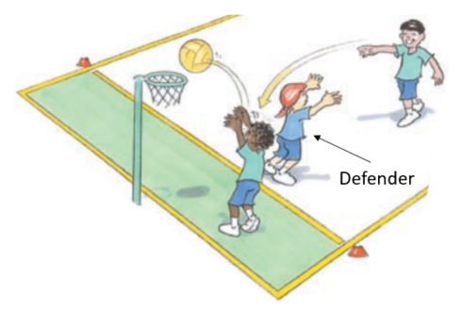
‘Defenders illustration’, Adapted from ‘Playing for life’ – Australian Sports Commission, https://www.sportaus.gov.au.
Equipment – items used to play a game.
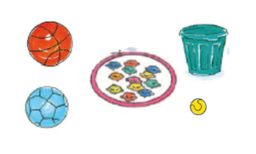
‘Equipment illustration’, Adapted from ‘Playing for life’ – Australian Sports Commission, https://www.sportaus.gov.au.

Space – an area away from other players.
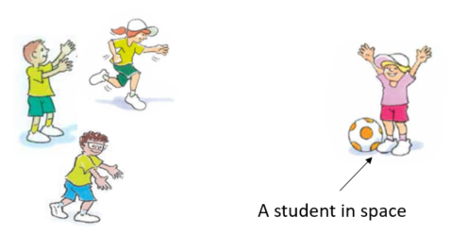
‘Space illustration’, Adapted from ‘Playing for life’ – Australian Sports Commission, https://www.sportaus.gov.au.
Boundaries – the limit of the playing area.
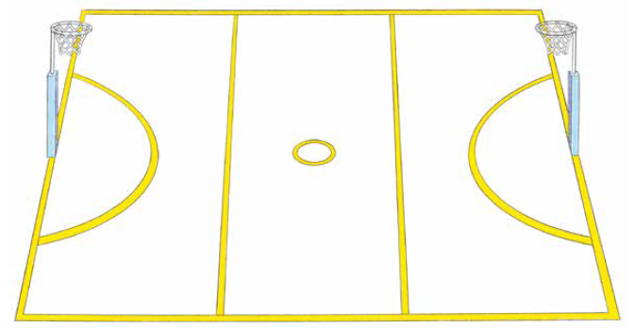
‘Boundaries illustration’, Adapted from ‘Playing for life’ – Australian Sports Commission, https://www.sportaus.gov.au.

Roll ball – to roll a ball under the foot, from front to back.
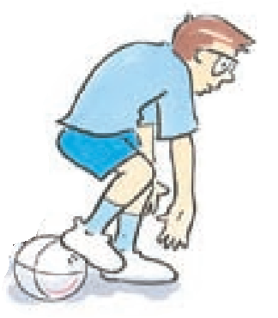
‘Roll ball illustration’, Adapted from ‘Playing for life’ – Australian Sports Commission, https://www.sportaus.gov.au.
Scoop up – to pick the ball up off the ground while moving.
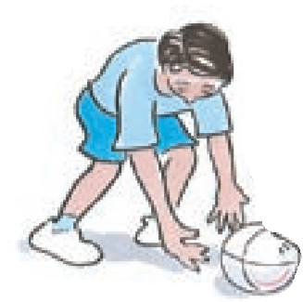
‘Scoop-up illustration’, Adapted from ‘Playing for life’ – Australian Sports Commission, https://www.sportaus.gov.au.

Intercept –to take possession of the ball when the opposition have passed it, usually with a throw, strike or kick.
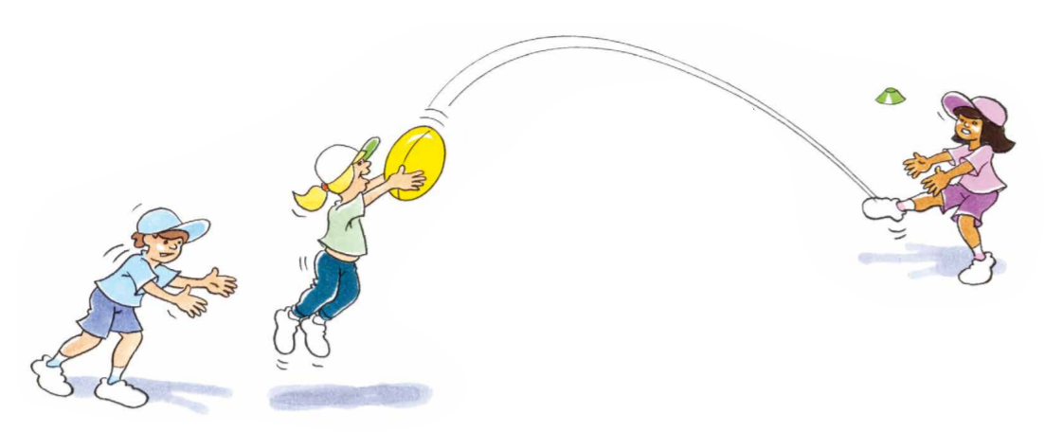
‘Intercept illustration’, Adapted from ‘Playing for life’ – Australian Sports Commission, https://www.sportaus.gov.au.
Team – players who are working together to achieve the same goal.
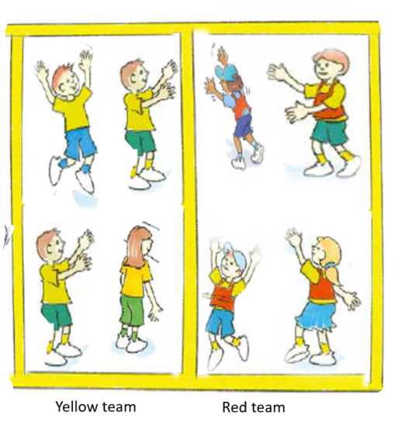
‘Team illustration’, Adapted from ‘Playing for life’ – Australian Sports Commission, https://www.sportaus.gov.au.
Scoring – to achieve the aim of the game, usually by putting an object in a goal or over a line.
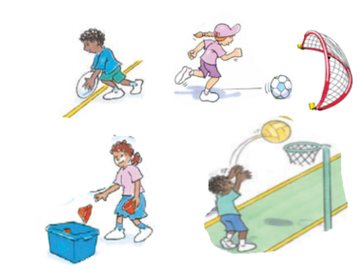
‘Scoring illustration’, Adapted from ‘Playing for life’ – Australian Sports Commission, https://www.sportaus.gov.au.
Dodging – changing directions quickly to avoid an opponent.
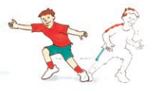
‘Dodging illustration’, Adapted from ‘Playing for life’ – Australian Sports Commission, https://www.sportaus.gov.au.

Kick – to hit an object with the foot.
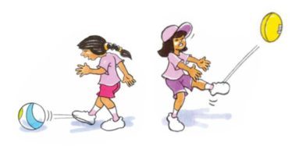
‘Kick illustration’, Adapted from ‘Playing for life’ – Australian Sports Commission, https://www.sportaus.gov.au.
Throw – to release a ball with force from a hand.
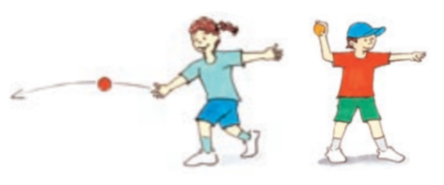
‘Throw illustration’, Adapted from ‘Playing for life’ – Australian Sports Commission, https://www.sportaus.gov.au.

Catch – using hands to prevent a ball from hitting the ground.
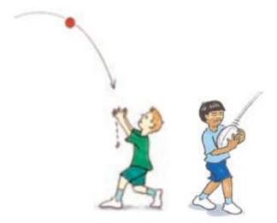
‘Catch illustration’, Adapted from ‘Playing for life’ – Australian Sports Commission, https://www.sportaus.gov.au.
Bounce – to drop or throw a ball to the ground and retain possession.
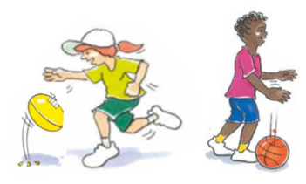
‘Bounce illustration’, Adapted from ‘Playing for life’ – Australian Sports Commission, https://www.sportaus.gov.au.

Balance an object – to keep one object on top of another without it hitting the ground or falling over.
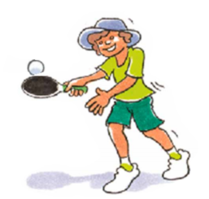
‘Balance an object illustration’, Adapted from ‘Playing for life’ – Australian Sports Commission, https://www.sportaus.gov.au.
Pass – when an object or ball is sent to a team mate, usually by throw, strike or kick.
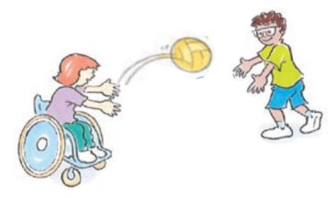
‘Pass illustration’, Adapted from ‘Playing for life’ – Australian Sports Commission, https://www.sportaus.gov.au.

Receive – to get a ball from a team mate, usually from a throw, strike or kick.
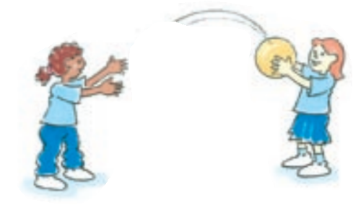
‘Receive illustration’, Adapted from ‘Playing for life’ – Australian Sports Commission, https://www.sportaus.gov.au.
Run – a locomotor movement alternating legs to move across the ground.
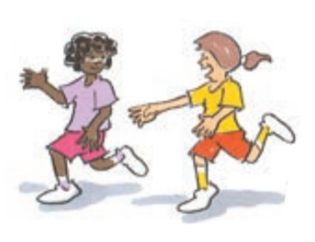
‘Run illustration’, Adapted from ‘Playing for life’ – Australian Sports Commission, https://www.sportaus.gov.au.

Jump – a locomotor movement using two feet to spring up into the air or across the ground.
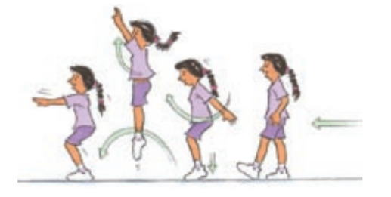
‘Jump illustration’, Adapted from ‘Playing for life’ – Australian Sports Commission, https://www.sportaus.gov.au.
Hop – a locomotor movement using the same foot touching the ground.
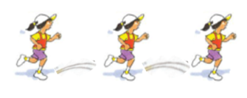
‘Hop illustration’, Adapted from ‘Playing for life’ – Australian Sports Commission, https://www.sportaus.gov.au.

Skip – a locomotor movement using a step-hop pattern or a term used when jumping over a rope.
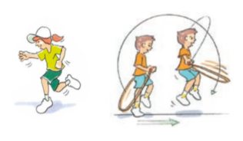
‘Skip illustration’, Adapted from ‘Playing for life’ – Australian Sports Commission, https://www.sportaus.gov.au.
Balance – to maintain stability and avoid falling over.
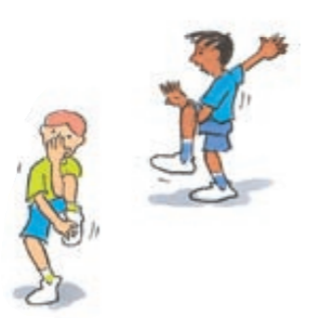
‘Balance illustration’, Adapted from ‘Playing for life’ – Australian Sports Commission, https://www.sportaus.gov.au.

Leap – a locomotor movement using a long stride from one foot and landing on the other.
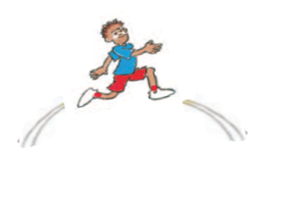
‘Leap illustration’, Adapted from ‘Playing for life’ – Australian Sports Commission, https://www.sportaus.gov.au.
Rolling – to rotate an object or person across the ground.
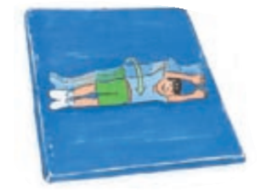
‘Rolling illustration’, Adapted from ‘Playing for life’ – Australian Sports Commission, https://www.sportaus.gov.au.

Striking – to hit an object or ball with another object such as a bat.
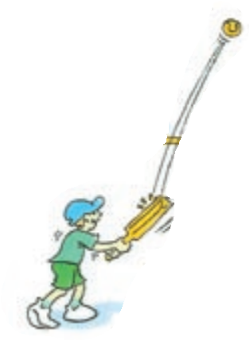
‘Striking illustration’, Adapted from ‘Playing for life’ – Australian Sports Commission, https://www.sportaus.gov.au.
Bend – to move the body by making the joint angles smaller.
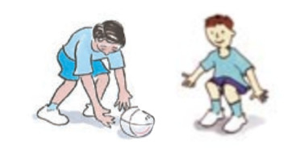
‘Bend illustration’, Adapted from ‘Playing for life’ – Australian Sports Commission, https://www.sportaus.gov.au.

Twist – to rotate the body around a central point.
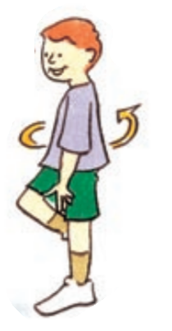
‘Twist illustration’, Adapted from ‘Playing for life’ – Australian Sports Commission, https://www.sportaus.gov.au.

Appendix 6 – Physical literacy cluster markers
The following NSW Physical Literacy Continuum K-10 cluster markers guided the development of the ‘Evidence of Learning’ (EoL) as observable behaviours to address the Student learning goals and identified syllabus outcomes.

Movement competencies
- Performs object control skills with control and precision in a variety of ways depending on the context, for example, using different levels of force to place an object where intended.
- Performs locomotor movement skills with control and precision in a range of contexts, for example, using different speeds, levels, directions, pathways and relationships to equipment and others depending on the context.
- Connects a variety of stability, object control and locomotor skills to perform quality movement sequences in a range of controlled environments, for example, balance (stability) to a roll (locomotor) to a jump (locomotor).

Tactical movement
- Applies a specific tactic to achieve success in a single physical activity, for example, shows an understanding of when, where and how to move.
- Implements a tactic based in individual strengths within a physical activity.
- Describes the intent of tactics used in different physical activities.
- Identifies how to modify tactics within the rules to influence achievement or success within a physical activity.

Motivation and behavioural skills
- Participates in physical activity with confidence.
- Personal and social attributes.
- Modifies actions to ensure safety in physical activity without prompting.
- Demonstrates respect for self, others, rules and equipment and the environment during physical activity.
- Cooperates when working in a group.

Appendix 7 – Attributions
© State of New South Wales (Department of Education), 2021. All material in this resource, except as identified below, is licensed under the Creative Commons Attribution 4.0 International Licence. To view a copy of this licence, visit http://creativecommons.org/licenses/by/4.0/.’
Material that is not licensed under the Creative Commons Attribution 4.0 International Licence
The following images by Australian Sports Commission – https://www.sportaus.gov.au are licensed under CC BY NC ND 3.0 AU. These images have been modified with the permission of the Australian Sports Commission (for use in this publication only):
- Page 9 – Four square illustration.
- Page 16 – Goal line illustration.
- Page 21 – Space invaders illustration.
- Page 22 – Space invaders advanced.
- Page 26 – Scatter tag illustration.
- Page 29 – Crazy keeper illustration.
- Page 34 – Spare square illustration.
- Page 36 – Round the bend illustration.
- Page 41 – Guard the castle illustration.
- Page 46 – Rob the nest illustration.
- Page 48 – Back to back illustration.
- Page 50 – Sensational striker illustration.
- Page 60 – Knock it off illustration.
- Page 66 – End ball illustration.
- Page 67 – End ball advanced illustration.
- Page 63 – Tag illustration, Attackers illustration.
- Page 64 – Defenders illustration, Equipment illustration.
- Page 65 – Space illustration, Boundaries illustration.
- Page 66 – Roll ball illustration, Scoop-up illustration.
- Page 67 – Intercept illustration, Team illustration.
- Page 68 – Scoring illustration, Dodging, illustration.
- Page 69 – Kick illustration, Throw illustration.
- Page 70 – Catch illustration, Bounce illustration.
- Page 71 – Balance objects illustration, Pass illustration.
- Page 72 – Receive illustration, Run illustration.
- Page 73 – Jump illustration, Hop illustration.
- Page 74 – Skip illustration, Balance illustration.
- Page 74 – Leap illustration, Rolling illustration.
- Page 76 – Striking illustration, Bend illustration.
- Page 77 – Twist illustration.

