How am I responsible for my increasing independence? Stage 3
PDHPE unit.

Table of contents
Big idea and key concept 1
Essential question 1
Unit description 1
Contextual statement 1
Propositions in action 2
Propositions 2
Skills in focus 2
Lesson 1 – How do my character strengths change over time? 3
Key inquiry questions and syllabus content 3
Lesson 2 – How do the decisions I need make change over time? 5
Key inquiry questions and syllabus content 6
Teaching and learning activities 6
Lesson 3 – How can emotions influence my decision making? 9
Key inquiry questions and syllabus content 9
Teaching and learning activities 10
Lesson 4- How do my decisions impact on others? 12
Key inquiry questions and syllabus content 13
Teaching and learning activities 13
Lesson 5- Who is my support network in the- community? 16
Key inquiry questions and syllabus content 17
Teaching and learning activities 17
Lesson 6 – What actions positively influence the health, safety and wellbeing of my community? 20
Key inquiry questions and syllabus content 21
Teaching and learning activities 21
Lesson 7 – How does an emergency situation affect my decision making? 23
Key inquiry questions and syllabus content 24
Teaching and learning activities 24
Lesson 8 – Do peers affect my decision making? 27
Key inquiry questions and syllabus content 28
Teaching and learning activities 29
Lesson 9 – How does assertive behaviour help my decision making? 33
Key inquiry questions and syllabus content 34
Teaching and learning activities 34
Appendix 1 – Evaluation 36
Appendix 2- Glossary 37
Appendix 3 – Assessment framework 38
Appendix 4 – My character strengths 42
Appendix 5 – Decisions and influences mind map example 43
Appendix 6 – Decisions and influences mind map 44
Appendix 7 – Decisions and emotions table example 45
Appendix 8 – Decisions and emotions table 46
Appendix 9 – Consequences 47
Appendix 10 – Consequences (example 1) 48
Appendix 11 – Consequences (example 2) 49
Appendix 12 – Web of support example 50
Appendix 13 – Web of support 51
Appendix 14 – Safe actions flow chart example 52
Appendix 15 – Safe actions flow chart 53
Appendix 16 – Emergency procedures flow chart example 54
Appendix 17 – Emergency procedures flow chart 55
Appendix 18 – Peer influence vs peer pressure example 56
Appendix 19 – Peer influence vs peer pressure table 57

Outcomes and other syllabus material in this document are copyright.
PDHPE K-10 Syllabus © NSW Education Standards Authority (NESA) for and on behalf of the Crown in right of the State of New South Wales 2018.

Big idea and key concept
The big idea is the over-arching concept that is being addressed or challenged throughout the unit.
Independence and responsibilities change as we grow and there are many different ways to manage changes.

Essential question
This question drives both teaching and learning within the unit. Every activity should be working towards answering this question.
How am I responsible for my managing my increasing independence?

Unit description
Students investigate how their level of independence changes over time. They identify influences which can affect decision making and that decision making affects their personal safety and that of others within their community. Students explore networks which can provide advice and support in their community.

Contextual statement
As students grow, they develop an ever-growing sense of independence and greater responsibility for their own safety. Activities such as independent travel and unsupervised social activities mean students need to develop a greater understanding of how they can manage risk and the consequences of their actions in promoting safety for themselves and others. Students need to develop their decision-making skills in order to maintain/improve their self-esteem, self-confidence and self-control. Issues that are explored include the social and emotional changes that occur during puberty as well as the impact of peer influence.

Propositions in action

Propositions
Describe how specific propositions are embedded throughout the unit of work. The 5 propositions are outlined on pages 24-25 of the PDHPE K-10 syllabus.
Focus on educative purpose
Students will have explicit learning opportunities to evaluate their current knowledge, understanding and skills and create, practise and apply new knowledge, understanding and skills needed to lead healthy, safe and active lives.
Take a strengths-based approach
Students will be encouraged to draw upon their own strengths and capabilities to further strengthen their decision-making skills to promote their own and others safety in a range of situations. They will be further developing their capacity to problem solve in situations where their own and other’s safety might be at risk.
Critical inquiry approach
Students will be provided the opportunity to recognise that values, behaviours, priorities and actions related to health, safety, wellbeing reflect varying contextual factors and influence the way people live. Throughout this unit students develop skills in analysing, applying and appraising knowledge in movement contexts.

Skills in focus
Self-management skills (S)
- Self-awareness
  - self-monitoring thoughts, feelings and actions
  - develop greater control and responsibility for our actions, feelings and behaviours
  - reflective practice
- Decision making and problem solving
  - finding solutions to problems
  - analysis
- Help seeking
  - recognising when help is needed
  - accessing support and support networks

Lesson 1 – How do my character strengths change over time?
Lesson 1 – Assessment framework
Outcomes | Unit learning goals  Students are learning to: | Evidence of learning  Students can:
PD3-1 identifies and applies strengths and strategies to manage life changes and transitions PD. | Identify personal strengths and apply them to decision making strategies to improve their own and others’ health, safety and wellbeing. | Identify personal traits that help them make responsible/effective/safe decisions. (Activity 1).

Key inquiry questions and syllabus content
How does my uniqueness change over time?
Students examine how identity and behaviour are influenced by people, places and the media, for example:
- identify how personal strengths and qualities contribute to identity and inform views
Resources
- 24 Character strengths video (8:24)
- Appendix 4 – My character strengths
Teacher notes
Emphasise that feedback provided by students should be applying a strengths-based approach.

Activity 1
In pairs or small groups, discuss the question, ‘What are character strengths?’. For example, character strengths are the positive parts of your personality that impact how you think, feel and behave. Share responses and provide examples.
- Watch the video 24 Character Strengths and pause to clarify meaning where necessary.
- Using ‘Appendix 4 – My character strengths’, students identify which character strengths best describe themselves.
Discussion
- In pairs or small groups, decide which character strengths are most important for safe and effective decision making. Share responses using examples during whole class discussion.
- Students reflect on the strengths their partner has identified and discuss whether they agree or disagree on these selections and why.
Reflection
Students reflect upon the learning in this activity/lesson and consider how it contributes towards answering the essential question, ‘How am I responsible for my managing my increasing independence?’

Lesson 2 – How do the decisions I need make change over time?
Lesson 2 – Assessment framework
Outcomes | Unit learning goals  Students are learning to: | Evidence of learning  Students can:
PD3-1 identifies and applies strengths and strategies to manage life changes and transitions. | Identify personal strengths and apply them to decision making strategies to improve their own and others’ health, safety and wellbeing. | Explain who makes decisions and why these decisions are made (activity 1, 2, 3).  Communicate strategies they employ when making decisions (activity 1, 2, 3).
PD3-6 distinguishes contextual factors that influence health, safety, well-being and participation in physical activity which are controllable and uncontrollable. | Distinguish contextual factors, both controllable and uncontrollable, within their community that influence their decision making. | Students can:  - Identify contextual factors that are controllable and uncontrollable (activity 1, 2, 3).  - Recognise how different contextual factors within their community influence their decisions (activity 1. 2. 3).
PD3-9 applies and adapts self-management skills to respond to personal and group situations. | Identify and develop self-management skills; strengthening personal identity, self-awareness, emotion and stress management, decision-making and problem-solving and help seeking to respond to different situations. | Recognise situations where independent decision making is needed to promote their safety and the safety of others (activity 1, 2, 3).

Key inquiry questions and syllabus content
How does my uniqueness change over time?
Students examine how identity and behaviour are influenced by people, places and the media, for example:
- explore the factors that influence how individuals interact and the personal choices they make for example, body image, gender stereotypes and expectations, rights and responsibilities in relationships.
How do empathy, inclusion and respect have an impact on myself and others?
Students examine the influence of emotional responses on behaviour and relationships, for example:
- analyse situations where emotions can influence decision-making
- explore contextual factors that influence the expression of emotions, for example, peer pressure, cultural norms, gender expectations.

Teaching and learning activities
Resources
- Class chart – Controllable and uncontrollable influences
- Appendix 5 – Decisions and influences mind map example
- Appendix 6 – Decisions and influences mind map
Discussion
Students explore the decision-making process by addressing the following questions:
- What is a decision? For example, a conclusion or resolution reached after consideration.
- Who makes decisions for you? For example, parents or carers, teachers, coaches, bus drivers, governments, principals.
- What are some of the decisions made by these people?
- Why are they made? For example, personal safety, safety of others.
- What are the decisions you have control over? For example, clothes choice, what to play and who with in the playground, how to behave, drinks/snacks, when travelling to or from school, with specific events at home, during games or sport.
- Why do you think that you have been given control of these decisions? For example, I have demonstrated responsibility in the task previously under adult supervision, there is minimal or no risk involved.

Activity 1- Decision-making processes
- Brainstorm a process we may go through when making decisions. For example, observe situation, gather information, assess possibilities, ask advice, consider consequences.
- Students record the process identified using a graphic organisers such as a mind map, Pluses, Minuses and Interesting (PMIs) cause and effect flowchart. Examples can be found using the Digital Learning Selector.

Activity 2- Influences on decision making
Discussion
- What influences my decision making? For example, the internal factors such as feelings, emotions, wants, needs or external factors such as peers, family, gender expectations, culture, media, social media. Students record their responses.
- Which influences are controllable and uncontrollable?’ For example, feelings, emotions, wants and needs are controllable. Peers, family, gender expectations, culture, media are uncontrollable. Some aspects of social media are controllable and uncontrollable. Students record their responses for display and future reference.

Activity 3- Decisions
Students analyse the decision-making process individually or in pairs by:
- identifying situations in their life where they need to make an independent decision. For example, wear a helmet when riding a bike
- identifying controllable and uncontrollable influences that can occur when faced with this decision.
- creating a flow chart of the decision, the influence on the decision and the possible consequences. For an example see Appendix 5 and use Appendix 6 for students.
- reviewing their flow chart and consider how this decision may affect other people.
Discussion
Students reflect on the range of influences that affect someone’s decision making by sharing their responses.
Teacher notes
- Providing opportunities to practice decision-making in different contexts will further strengthen student learning and skill development. This may be supported through additional activities such as role plays.
- Teacher mentions the influence of emotions, if students don’t identify it as an influence. Allow students to discuss further.
Reflection
Students reflect upon the learning in this activity/lesson and consider how it contributes towards answering the essential question, ‘How am I responsible for my managing my increasing independence?’

Lesson 3 – How can emotions influence my decision making?
Lesson 3 – Assessment Framework
Outcomes | Unit learning goals  Students are learning to: | Evidence of learning  Students can:
PD3-1 identifies and applies strengths and strategies to manage life changes and transitions. | Identify personal strengths and apply them to decision making strategies to improve their own and others’ health, safety and wellbeing. | Communicate strategies they employ when making decisions (activity 1).
PD3-6 distinguishes contextual factors that influence health, safety, well-being and participation in physical activity which are controllable and uncontrollable. | Distinguish contextual factors, both controllable and uncontrollable, within their community that influence their decision making. | - Identify contextual factors that are controllable and uncontrollable (activity 1).  - Recognise how different contextual factors within their community influence their decisions. (activity 1).

Key inquiry questions and syllabus content
How do empathy, inclusion and respect have an impact on myself and others?
Students examine the influence of emotional responses on behaviour and relationships by:
- analysing situations where emotions can influence decision-making
- exploring contextual factors that influence the expression of emotions, for example, peer pressure, cultural norms, gender expectations.

Teaching and learning activities
Resources
- Appendix 7 – Decisions and emotions table example
- Appendix 8 – Decisions and emotions table

Discussion
Explore the effect emotions can have on a person’s decision making by addressing the following questions:
- Do emotions affect someone’s decision making? What makes you say that?
- Which emotions affect people’s decision making the most? For example, fear, anxiety, anger, happiness, love, excitement.
- Which emotions affect people’s decision making the most? For example, fear, anxiety, anger, happiness, love, excitement.
- How do they affect a person's decision making? For example, emotions can lead to a lack of analysis of consequences and irrational behaviours and actions.
- Can other people’s emotions influence your decisions?
- What situations may involve emotional responses that could influence our decision making? For example, while taking a penalty in a game of soccer your team and spectators are yelling and cheering (emotionally reacting). This may affect your decision making as you find it difficult to concentrate with the added pressure of their emotional response.
- Are there times or situations where you don’t feel like you can show your true emotions? Explain.

Activity 1- Emotions and decision making
Students choose a scenario in their life where emotions could influence their decision making and:
- Reflect and record how the scenario would play out if the emotions were altered. For example, using a table or flow chart. For an example see Appendix 7 and use Appendix 8 for students.
- Examine the consequences and effects of the decisions.
Discussion
Students consider, reflect and discuss:
- which emotions they find easiest to control and why do you feel that way?
- if emotional responses are the same for everybody.
- what can cause differences in emotional responses by people to the same situation?
Teacher notes
Providing opportunities to practice decision-making in different contexts will further strengthen student learning and skill development. This may be supported through additional activities such as role plays.
Reflection
Students reflect upon the learning in this activity and consider how it contributes towards answering the essential question ‘How am I responsible for my managing my increasing independence?’

Lesson 4- How do my decisions impact on others?
Lesson 4 – Assessment framework
Outcomes | Unit learning goals  Students are learning to: | Evidence of learning  Students can:
PD3-7 proposes and implements actions and protective strategies that promote health, safety, well-being and physically active spaces. | Propose and implement actions and strategies that support them to make independent decisions that keep them and others healthy and safe. | - Identify and implement decisions (independently made, enforced by an adult or organisation) that ensure their own safety, well-being and that of others (Activity 1, 2, 3).  - Propose possible consequences of their described actions. (Activity 1, 2, 3).
PD3-9 applies and adapts self-management skills to respond to personal and group situations. | Identify and develop self-management skills; strengthening personal identity, self-awareness, emotion and stress management, decision-making and problem-solving and help seeking to respond to different situations. | Recognise situations where independent decision making is needed to promote their safety and the safety of others (Activity 1, 2, 3).

Key inquiry questions and syllabus content
How responsible am I for my own and others health, safety and wellbeing?
Students recommend appropriate actions to improve health, safety, wellbeing or physical activity issues within the school or wider community, for example:
- reflect on the impact of their choices and decisions on the health, safety or wellbeing of their community.
- propose a personal network of trusted adults who could provide advice and support, for example, parents/carers, teachers.

How do empathy, inclusion and respect have an impact on myself and others?
Students examine the influence of emotional responses on behaviour and relationships, for example:
- analyse situations where emotions can influence decision-making.

Teaching and learning activities
Resources
- Appendix 9– Consequences example 1
- Appendix 10 – Consequences
- Appendix 11 – Consequences example 2
- Class chart or Interactive Whiteboard
Discussion
Explore some of the independent decisions that students make in their everyday lives (revisited from Lesson 2).

Activity 1- Consequences of decisions
Select a common decision that most students would make. For example, go home from school when a parent/carer had said to do so.
Teacher creates a visual representation on a class chart or IWB of who might be affected by the decision and how they might be affected.
Teacher notes
For the example use an enlarged version of Appendix 9 – Consequences.
Concentric circles are an excellent representation for this activity as it clearly shows the students that their behaviours/decisions/choices affect many different people in a variety of directions. Just as a small rock will affect the whole pond with ripples that move outwards, their decisions have the same effect on those in their lives. The closer a person is to the student and decision, the greater the effect the decision can have on them.

Activity 2 – Positive consequences from decisions
- Students select a decision they have made that had positive consequences and complete their own visual representation, using Appendix 10. For those students who may not have or cannot think of an experience with positive consequences the teacher may need to provide some general scenarios for students to select from.
- Students review their visual representation with a partner, making suggestions of any other people that may have been affected in the scenario.
Teacher notes
Create a class list of people who students may refer to and can affect their decision making. For example, family members, school staff, friends, local services, sporting teams/coaches, bus drivers.
Discussion
Students reflect on the consequences of their decision and suggest what actions they may have taken to change the consequences. For example, ring parent/carer and ask permission to go to the shops, organise with sibling to care for the pet, organise another time with friends when they have permission.

Activity 3 – Making different decisions and the consequences
In pairs discuss how the consequences would change if they made a different decision in the same scenario. For example, parent/carer said to go straight home from school, but I went to the shops with my friend.
Teacher notes
For examples 1 and 2 see Appendix 9 and Appendix 11 and use Appendix 10 Consequences to recreate a new set of consequences.
Discussion
Explore how the other people in their charts may have felt when the consequences of the decision were played out by discussing:
- Who do you think is most affected by your decision?
- How do you think the people affected by your decision feel?
- Explain why you think they would feel like that?
- What is a decision they could make that would make you feel in a similar way?
- Would you like them to make that decision? What makes you say that?
Reflection
Students reflect upon the learning in this activity/lesson and consider how it contributes towards answering the essential question, ‘How am I responsible for my managing my increasing independence?’

Lesson 5- Who is my support network in the- community?
Lesson 5 – Assessment framework
Outcomes | Unit learning goals  Students are learning to: | Evidence of learning  Students can:
PD3-1 identifies and applies strengths and strategies to manage life changes and transitions | Identify personal strengths and apply them to decision making strategies to improve their own and others’ health, safety and wellbeing. | Communicate strategies they employ when making decisions (activity 1, 2).
PD3-9 applies and adapts self-management skills to respond to personal and group situations | Identify and develop self-management skills; strengthening personal identity, self-awareness, emotion and stress management, decision-making and problem-solving and help seeking to respond to different situations. | Identify actions, strategies and people that they can use to promote their own safety to help develop their help seeking skills. (Activity 1, 2).

Key inquiry questions and syllabus content
What actions positively influence the health, safety and wellbeing of my community?
Students investigate and adopt practices that help promote and maintain health, safety and wellbeing, for example:
- propose a personal network of trusted adults who could provide advice and support, such as parents/carers, teachers.
How can I manage transitions and challenges?
Students investigate community resources and ways to seek help about health, safety and wellbeing, for example:
- identify trusted adults in the community who can provide advice and support and discuss ways to access these people in a range of different contexts, for example, parents/carers, family, community Elders, community organisations, teachers.

Teaching and learning activities
Resources
- Appendix 12 – Web of support example
- Appendix 13 – Web of support
- Digital Learning Selector
Discussion
In small groups explore, ‘What does support mean?’ in relation to decision making. For example, to provide advice, to listen, to suggest options, to warn of dangers.

Activity 1 – Designing a web of support
Using Appendix 12, model the web of support a teacher has within the school. Students provide input to show the type and amount of support. The thicker line suggests the more support available/given and the direction of the arrow shows direction of support. For example, a teacher provides more support to a student so thick arrow is used. A student provides less support to a teacher, so a thinner arrow is used.
Students create their own web of support using ICT or a template downloaded from the Digital Learning Selector, showing who supports them and who they support.
Teacher notes
The Digital Learning Selector could provide a variety of digital examples, alternatively if ICT is unavailable use Appendix 13 – Web of support.
Referring to the character strengths from Lesson 1, students list 1 or 2 main strengths they believe each person in their web of support possess and why these are important to them. Using the examples for a teacher:
- Assistant Principal provides honesty and fairness which means I know the advice they give me will guide me properly
- Principal provides leadership which means I know I can follow their example
- School Counsellor – provides kindness which means I know I can talk to them about a personal issue
- Other teachers – provide teamwork which means I know I can rely on them when things are tough.
Students present their web explaining how they can contact the people in the web. For example, via phone, make a meeting, chat in the playground, internet/social media.

Activity 2- Using my web of support
Create a class list of various scenarios that may occur in the students’ lives where they feel they would need to seek support from someone in their support web.
In pairs or small groups students explore:
- Who they would turn to if they were in that situation?
- How they would broach the subject? (speak in private, complain in public, written note, make an appointment, email/text, phone call)
- What support can that person provide for them?
Teacher notes
Scenarios should be in context for the students’ lives and could include:
- Being bullied at school, online or both
- Knowing a friend is doing something illegal or dangerous or harmful
- Issues at home with family members: any form of abuse, alcohol/drugs
- Issues at school: anxiety with exams/report, loneliness, problem with a staff member
- Eating disorders: either personally or of a friend
- Stress/pressure: for academic performance, sporting performance, from peers
- Students discuss and record how the people in their web support them. For example, advice, physically, listening/sounding board.
Reflection
Students reflect upon the learning in this activity/lesson and consider how it contributes towards answering the essential question, ‘How am I responsible for my managing my increasing independence?’

Lesson 6 – What actions positively influence the health, safety and wellbeing of my community?
Lesson 6 – Assessment framework
Outcomes | Unit learning goals  Students are learning to: | Evidence of learning  Students can:
PD3-1 identifies and applies strengths and strategies to manage life changes and transitions. | Identify personal strengths and apply them to decision making strategies to improve their own and others’ health, safety and wellbeing. | Communicate strategies they employ when making decisions (Activity 1).
PD3-9 applies and adapts self-management skills to respond to personal and group situations. | Identify and develop self-management skills; strengthening personal identity, self-awareness, emotion and stress management, decision-making and problem-solving and help seeking to respond to different situations. | - Recognise situations where independent decision making is needed to promote their safety and the safety of others (Activity 1).  - Identify actions, strategies and people that they can use to promote their own safety to help develop their help seeking skills. (Activity 1).

Key inquiry questions and syllabus content
What actions positively influence the health, safety and wellbeing of my community?
Students investigate and adopt practices that promote and maintain health, safety and wellbeing, for example:
- describe situations that may cause lifestyle diseases or injury and propose actions that promote health and safety for example, not crossing the road when wearing headphones, swimming with supervision, choosing healthy snacks, wearing sunscreen.

Teaching and learning activities
Resources
- Appendix 14 – Safe actions flow chart example
- Appendix 15 – Safe actions flow chart
- Class chart or Interactive Whiteboard (IWB)

Activity 1 – Decisions affecting my health and wellbeing
In small groups list situations where students’ decisions can directly affect their health, safety and wellbeing. For example, using roads, water activities, being in the sun, dietary choice, and home activities. These can be recorded on a class wall chart or IWB for reference.
Individually or in pairs, students select a situation that relates to their life and that they may have been in. Students prepare a presentation (which could include audio, written, illustrated or role play) that details:
- The situation.
- How it could have affected their health, safety or wellbeing?
- The decision that should be made to promote their safety.
- The consequences of acting upon the decision.
Teacher notes
For an example see Appendix 14 and use Appendix 15 for students.
Discussion
Explore the advice and strategies that can be sought and used by students as well as the character strengths needed by addressing the following questions:
- What advice would you give to a friend who was faced with one of the scenarios?
- What possible strategies could you use if they said they would not take your advice, to convince them otherwise? For example, threaten consequences, encourage positive outcomes, physically restrain, show disdain/feign disinterest.
- What character strengths do you need to confront friends in these situations?

Reflection
Students reflect upon the learning in this activity/lesson and consider how it contributes towards answering the essential question, ‘How am I responsible for my managing my increasing independence?’

Lesson 7 – How does an emergency situation affect my decision making?
Lesson 7 – Assessment framework
Outcomes | Unit learning goals  Students are learning to: | Evidence of learning  Students can:
PD3-1 identifies and applies strengths and strategies to manage life changes and transitions. | Identify personal strengths and apply them to decision making strategies to improve their own and others’ health, safety and wellbeing. | Communicate strategies they employ when making decisions (Activity 1).
PD3-7 proposes and implements actions and protective strategies that promote health, safety, well-being and physically active spaces. | Propose and implement actions and strategies that support them to make independent decisions that keep them and others healthy and safe. | Identify and implement decisions (independently made, enforced by an adult or organisation) that ensure their own safety, well-being and that of others (Activity 1).
PD3-9 applies and adapts self-management skills to respond to personal and group situations. | Identify and develop self-management skills; strengthening personal identity, self-awareness, emotion and stress management, decision-making and problem-solving and help seeking to respond to different situations. | - Recognise situations where independent decision making is needed to promote their safety and the safety of others (Activity 1).  - Describe actions they take to promote their own health, safety and wellbeing. (Activity 1).  - Describe how personal identity, self-awareness, emotions, stress and problem-solving skills play a role in making safe decisions to promote their own and others safety (Activity 1).

Key inquiry questions and syllabus content
How responsible am I for my own and others’ health, safety and wellbeing?
Teachers recommend appropriate actions to improve health, safety, wellbeing or physical activity issues within the school or wider community, for example:
- suggest and practise action plans for emergency situations to ensure the safety of themselves and others, for example, basic first aid, DRSABCD, asthma, allergies and anaphylactic reactions.

Teaching and learning activities
Resources
- Appendix 16 – Emergency procedures flow chart example
- Appendix 17 – Emergency procedure low chart
- Class chart or IWB
Discussion
- In small groups students define/discuss ‘What does emergency mean?’ These definitions are then shared with the class.
- Teacher collates the definitions onto a class chart / IWB and as a group develop a class definition.
Teacher notes
An emergency is defined as a serious, unexpected, and often dangerous situation requiring immediate action
Discussion
Teacher refers to Lesson 3 about how emotions can affect decision making. Students then explore the following:
- How people react in emergencies and what emotions they experience.
- How emotions could affect an emergency and how students can control the emotions. For example, control your breathing, try to stay calm, slow down, think clearly and/or seek help.
- What they think emergency procedures are and who they involve?

Activity 1 – Taking actions in an emergency
In small groups: create a list of actions that can be taken in the case of an emergency. For example:
- contact emergency services, use basic first aid or DRSABCD, seek immediate help from those close by, reassure any injured people.
As a class: create a list of scenarios where an emergency can occur and students may have to respond. Encourage the students to provide scenarios in context with their environment. For example:
- a friend hurt at the skate park, person caught in a rip, someone bitten by a snake/spider, see a house/bush fire, witness a car accident, injury due to farm machinery.
Select one of the scenarios and create a flow chart of what to do if an emergency arose in that situation. For an example, see Appendix 16 and use Appendix 17 for students. Alternatively students could present as a role play, audio, illustrated formats or in digital format using the Digital Learning Selector.
Discussion
Students share flow charts and justify their decisions and behaviours if faced with the scenario. For example:
- Why did you walk to the phone, not run?
- Why did you reassure your friend as they were okay?
Reflection
Students reflect upon the learning in this activity/lesson and consider how it contributes towards answering the essential question, ‘How am I responsible for my managing my increasing independence?’

Lesson 8 – Do peers affect my decision making?
Lesson 8 – Assessment framework
Outcomes | Unit learning goals  Students are learning to: | Evidence of learning  Students can:
PD3-1 identifies and applies strengths and strategies to manage life changes and transitions. | Identify personal strengths and apply them to decision making strategies to improve their own and others’ health, safety and wellbeing. | Communicate strategies they employ when making decisions (Activity 1, 2, 3, 4).
PD3-7 proposes and implements actions and protective strategies that promote health, safety, well-being and physically active spaces. | Propose and implement actions and strategies that support them to make independent decisions that keep them and others healthy and safe. | Identify and implement decisions (independently made, enforced by an adult or organisation) that ensure their own safety, well-being and that of others (Activity1, 2, 3).
PD3-9 applies and adapts self-management skills to respond to personal and group situations. | Identify and develop self-management skills; strengthening personal identity, self-awareness, emotion and stress management, decision-making and problem-solving and help seeking to respond to different situations. | - Recognise situations where independent decision making is needed to promote their safety and the safety of others (Activity 1, 2, 3, 4).  - Describe actions they take to promote their own health, safety and wellbeing (Activity 1, 2, 3, 4).  - Describe how personal identity, self-awareness, emotions, stress and problem-solving skills play a role in making safe decisions to promote their own and others safety (Activity 1, 2, 3, 4).

Key inquiry questions and syllabus content
What actions positively influence the health, safety and wellbeing of my community?
Students plan and practise assertive responses, behaviours and actions that protect and promote health, safety and wellbeing, for example:
- Identify situations where personal choices can influence their own and others’ health for example, selecting and preparing healthy food, smoking, recycling, risk-taking.
- Recognise and demonstrate safe behaviours and action for example, developing a personal safety plan, not getting into cars with strangers.
- Select and practise appropriate responses to promote safety in different environments.
- Explore the emotions associated with feeling unsafe and propose strategies for seeking help and managing these feelings, for example, fear, anger, feeling anxious.
Students plan and practice assertive responses, behaviours and actions that protect and promote health, safety and wellbeing, for example:
- Practise safe and supportive upstander behaviour and discuss how they can prevent and/or stop bullying and forms of discrimination and harassment.

Teaching and learning activities
Resources
- Appendix 18 – Peer influence vs peer pressure example
- Appendix 19 – Peer influence vs peer pressure table
- Role play scenario cards
- Class charts or IWB
- Students’ mind maps

Activity 1 – External influences and decision making
Revisit learning from Lesson 2 and 3 about what influences decision making.
Review their mind map and select one external influence that students feel is the most influential.
Teacher notes
Direct students towards the impact of peer influence. As students move into high school one of the strongest influences on behaviour and decisions is peers. It is important to note that direct pressure from peers (peer pressure) rarely occurs, rather peer influence is more common. Peer influence is where individuals make choices based on:
- what they think their peers would do?
- what they think their peers would approve of?
- what decision or behaviour may gain them social status amongst their peers?
Discussion
Explore the following questions:
- What is peer influence? Refer to the definition above.
- Has anyone had peers directly pressure them into making a choice they didn’t want to? Explain.
- Why do some students make poor choices when with peers? For example, to gain social status, to entertain, to fit in / be liked, lack judgment and clear thought due to distraction, not considering the consequences.
- What do students perceive are socially acceptable norms/behaviours amongst their friends? For example, ‘cool/trendy’ clothing, acceptable behaviour, swearing/vocabulary choice or ways of referring to things, likes/dislikes.
Teacher notes
Direct the discussion towards students understanding that individuals make choices based on what they think their peers would do, or what they would approve of, or what decision or behaviour may gain them social status amongst their peers.

Activity 2 -Peer influences on decision making
Create a class list of scenarios where students feel perceived peer influence could lead them to making poor decisions. For example:
- taking a risk crossing the road to be seen as daring, being cool by not wearing safety equipment such as a bike helmet, disobeying carers instruction to be seen as rebellious, being dishonest to cover for poor behaviour.
In pairs or small groups, select a scenario (one student may have been directly involved in would be preferable) and explain to the class how they would best deal with it. Allow students the opportunity to explain their thoughts in a variety of forms (digital/oral/audio/written/illustrations.)
Provide the students with a table below and refer to learning in activity 4 to guide their thinking. For an example, see Appendix 18 and use Appendix 19 for students.
Discussion
Explore the question, ‘How does peer pressure differ from peer influence?’
Teacher notes
Peer pressure is direct and obvious actions being exerted by peers onto another to influence their decision making. Peer influence – refer to definition found earlier in Lesson 8.

Activity 3 – Peer pressure
As a class, create a list of behaviours that demonstrate peer pressure. for example:
- verbal threats, dares, group encouragement/ganging up, physical movement such as pushing, shoving, entering personal space with objects such as cigarettes.
Discussion
Explore how students best deal with these situations by addressing the following questions:
- How do you feel when you are placed in these situations by friends? For example, scared, anxious, upset, nervous, popular, empowered, energised, excited.
- Do you have to do what your friends are pressuring you to do? What makes you think that? For example, I have the right to decide what I do; I have a responsibility to maintain my own safety.
- What are some ways to avoid/deflect/ stop peer pressure? For example, walk away, say no, make a joke or ask for them to respect your decision, be an up stander /provide peer support.
Introduce the concept of assertiveness. Students demonstrate their understanding of the word in relation to peer pressure.
Teacher notes
Assertiveness is confident and forceful behaviour. Students may demonstrate their understanding by using role play
Discussion
Explore the following questions:
- Is assertiveness a character strength? Explain your answer.
- Can it be developed by someone? If so, how?

Activity 4 – Assertive behaviour
In pairs, create a scenario where peer pressure can exist and how students can use assertive behaviour to defuse the situation. Suggest to students that the scenario is in context with their lives. For example:
- for students near the beach, jumping off the rocks to enter the surf.
Students role play the scenario to either another group or in front of the class. Audience suggest other ways to be assertive in the situation.
Teacher notes
- Allow students to demonstrate their learning via other forms if needed.
- Students may need prompt cards with sentence starters to assist with verbal assertiveness. For example,
  - Stop it <name>. I don’t like it when you <action>. It makes me feel <emotion> so please stop.
- Stress that assertiveness isn't just through words and actions but intonation - In linguistics, intonation is variation in spoken pitch to indicate attitudes and emotions.
Reflection
Students reflect upon the learning in this activity/lesson and consider how it contributes towards answering the essential question, ‘How am I responsible for my managing my increasing independence?’

Lesson 9 – How does assertive behaviour help my decision making?
Lesson 9 – Assessment framework
Outcomes | Unit learning goals – students are learning to | Evidence of learning – students can
PD3-1 identifies and applies strengths and strategies to manage life changes and transitions. | Identify personal strengths and apply them to decision making strategies to improve their own and others’ health, safety and wellbeing. | Communicate strategies they employ when making decisions. (Activity 1, 2).
PD3-7 proposes and implements actions and protective strategies that promote health, safety, well-being and physically active spaces. | Propose and implement actions and strategies that support them to make independent decisions that keep them and others healthy and safe. | Identify and implement decisions (independently made, enforced by an adult or organisation) that ensure their own safety, well-being and that of others (Activity 1, 2).
PD3-9 applies and adapts self-management skills to respond to personal and group situations. | Identify and develop self-management skills; strengthening personal identity, self-awareness, emotion and stress management, decision-making and problem-solving and help seeking to respond to different situations. | - Recognise situations where independent decision making is needed to promote their safety and the safety of others (Activity 1, 2).  - Describe actions they take to promote their own health, safety and wellbeing. (Activity 1, 2).  - Describe how personal identity, self-awareness, emotions, stress and problem-solving skills play a role in making safe decisions to promote their own and others safety (Activity 1, 2).

Key inquiry questions and syllabus content
What actions positively influence the health, safety and wellbeing of my community?
Students plan and practice assertive responses, behaviours and actions that protect and promote health, safety and wellbeing, for example:
- explore the emotions associated with feeling unsafe and propose strategies for seeking help and managing these feelings, for example, fear, anger, feeling anxious.

Teaching and learning activities
Resources
- Appendix 20 – Peer influence vs peer pressure example
- Appendix 21 – Peer influence vs peer pressure table
- Role play scenario cards
- Class charts or IWB
- Students’ mind maps
Teacher notes
It is important for students to be able to identify the emotions around feeling safe and unsafe in order to develop the decision-making skills required when in situations where these feelings occur.
Encourage students to recognise their emotions and to speak up when they feel scared or upset may reduce the chance of the child being exposed to offending behaviour.

Activity 1 – Emotions and decision making
Review Lesson 3 and how emotions can affect decisions. Identify emotions that occur when someone is feeling unsafe. For example:
- fear, anger, anxiousness, upset.
Discussion
Propose strategies that can be used to cope with these emotions when feeling unsafe. For example, call someone, breathing exercises, fleeing/moving away from the scene.

Activity 2 – Assertiveness and safety
Repeat the role play task from Lesson 8 using scenarios where students may feel unsafe. For example:
- feeling unsafe in a car due to the way it is driven, being approached by a stranger, alone in a park. Allow students to demonstrate their learning via other forms if needed.
Discussion
Explore:
- How their assertiveness/personal choice influenced their health, safety and wellbeing and that of others. Review Lesson 4 for this.
- How their assertive strategies and emotions/feelings in those situations differed.
- How could those feelings/emotions affect their decisions? For example, panic.
Reflection
Students reflect upon the learning in this activity/lesson and consider how it contributes towards answering the essential question, ‘How am I responsible for my managing my increasing independence?’

Appendix 1 – Evaluation
Teacher analysis of the teaching and learning in the entire unit of work. Sample questions to address are included in the table below.
Unit evaluation and teacher notes
Evaluation | Teacher notes
Did all students demonstrate an understanding of the key concepts? | Write notes here.
What concepts within the unit will I need to revisit to ensure understanding? | Write notes here.
When will I/ can I revisit these concepts? | Write notes here.
Did I meet the learning needs of all students?  Did all students have an opportunity to demonstrate their knowledge, understanding and skills? | Write notes here.
Did the adjustments provide adequate and appropriate access to all activities by all students? | Write notes here.
Were the resources used accessible for all students? | Write notes here.
Which activities in the learning sequence will I need to adapt to ensure my learning goals are achieved next time? | Write notes here.
Did the learning sequence provide sufficient opportunities to make quality assessment judgements about student achievement? | Write notes here.
Which activities and tasks were most engaging and effective? | Write notes here.

Appendix 2- Glossary
- Character strengths – mental and moral qualities distinctive to an individual.
- Controllable influences – influences that can be directed by the student to determine their behaviour.
- Uncontrollable influences – influences that cannot be directed by the student to determine their behaviour.
- Consequences – the results or effects of the student’s behaviour both positive and negative.
- Support – people who are actively interested in and concerned for the student.
- Context to students’ lives – environmental, sociocultural, socioeconomic or individual factors that have an impact on students’ lives
- Emergencies – a serious, unexpected and often dangerous situation requiring immediate action.
- Emergency procedures – set of actions performed to assist in the state of an emergency.
- DRSABCD – D= danger, R = response, S= send for help, A = airway, B = breathing, C = compression/circulation/cardiopulmonary resuscitation (CPR), D = defibrillation.
- Peer pressure – direct pressure from peers to influence behaviour.
- Peer influence – what students think their peers would do, or what they would approve of, or what decision or behaviour may gain them social status amongst their peers.
- External influences – influences that occur from a source outside the student such as peers, family, media, school or advertising.
- Internal influences – influences that occur from within the student such as emotions, feelings or thoughts.
- Assertiveness – confident and forceful behaviour
- Wellbeing – a sustainable state characterised by predominantly positive feelings, attitudes and relationships. It involves resilience, self-efficacy and a high level of satisfaction with self.

Appendix 3 – Assessment framework
Assessment framework
Outcomes | Unit learning goals  Students are learning to: | Evidence of learning  Students can:
What syllabus outcomes will be assessed against throughout this unit of work? Refer to pages 14-19 of the PDHPE K-10 Syllabus. | What are students expected to know, understand and do as a result of the learning within this unit of work? These are derived from the identified syllabus outcomes. | What specific behaviours will you expect to observe and as an indicator of student learning towards the unit learning goals?
PD3-1 identifies and applies strengths and strategies to manage life changes and transitions | Students will be able to:  Identify personal strengths and apply them to decision making strategies to improve their own and others’ health, safety and wellbeing. | Students can:  - Identify personal traits that help them make responsible/effective/safe decisions.  Lesson 1 – Activity 1  - Explain who makes decisions and why these decisions are made.  Lesson 2 – Activity 1, 2, 3  - Communicate strategies they employ when making decisions.  Lesson 2 – Activity 1, 2, 3  Lesson 3 – Activity 1  Lesson 5 – Activity 1, 2  Lesson 6 – Activity 1  Lesson 7 – Activity 1  Lesson 8 – Activity 1, 2, 3, 4  Lesson 9 – Activity 1, 2
PD3-6 distinguishes contextual factors that influence health, safety, well-being and participation in physical activity which are controllable and uncontrollable. | Students will be able to:  Distinguishes contextual factors, both controllable and uncontrollable, within their community that influence their decision making. | Students can:  - Identify contextual factors that are controllable and uncontrollable.  Lesson 2 – Activity 1, 2, 3  Lesson 3 – Activity 1  - Recognise how different contextual factors within their community influence their decisions.  Lesson 2 – Activity 1, 2, 3  Lesson 3 – Activity 1
PD3-7 proposes and implements actions and protective strategies that promote health, safety, well-being and physically active spaces. | Students will be able to:  Propose and implement actions and strategies that support them to make independent decisions that keep them and others healthy and safe. | Students can:  - Identify and implement decisions (independently made, enforced by an adult or organisation) that ensure their own safety, well-being and that of others  Lesson 4 – Activity 1, 2, 3  Lesson 7 – Activity 1  Lesson 8 – Activity1, 2, 3, 4  Lesson 9 – Activity 1, 2  - Propose possible consequences of their described actions.  Lesson 4 – Activity 1, 2, 3
PD3-9 applies and adapts self-management skills to respond to personal and group situations. | Students will be able to:  Identify and develop self-management skills; strengthening personal identity, self-awareness, emotion and stress management, decision-making and problem-solving and help seeking to respond to different situations. | Students can:  - Recognise situations where independent decision making is needed to promote their safety and the safety of others.  Lesson 2 – Activity 1, 2, 3  Lesson 4 – Activity 1, 2, 3  Lesson 6 – Activity 1  Lesson 7 – Activity 1  Lesson 8 – Activity 1, 2, 3, 4  Lesson 9 – Activity 1, 2  - Identify actions, strategies and people that they can use to promote their own safety to help develop their help seeking skills.  Lesson 5 – Activity 1, 2  Lesson 6 – Activity 1  - Describe actions they take to promote their own health, safety and wellbeing.  Lesson 7 – Activity 1  Lesson 8 – Activity 1, 2, 3, 4  Lesson 9 – Activity 1, 2  - Describe how personal identity, self-awareness, emotions, stress and problem-solving skills play a role in making safe decisions to promote their own and others safety.  Lesson 7 – Activity 1  Lesson 8 – Activity 1, 2, 3, 4  Lesson 9 – Activity 1, 2

Appendix 4 – My character strengths
Colour in the strengths that you feel you possess.
Appendix 4 – My character strengths template
Courage | Bravery | Honesty | Perseverance | Open mindedness | Integrity
Justice | Fairness | Leadership | Teamwork | Enthusiasm | Self-control
Humanity | Kindness | Love | Social Awareness | Optimism | Forgiveness
Disciplined | Forgiveness | Humility | Purpose | Self-regulation | Humour
Striving for excellence | Appreciation of beauty | Gratitude | Hope | Spirituality | Curiosity
Wisdom | Creativity | Persistence | Love of learning | Perspective | Zest

Appendix 5 – Decisions and influences mind map example
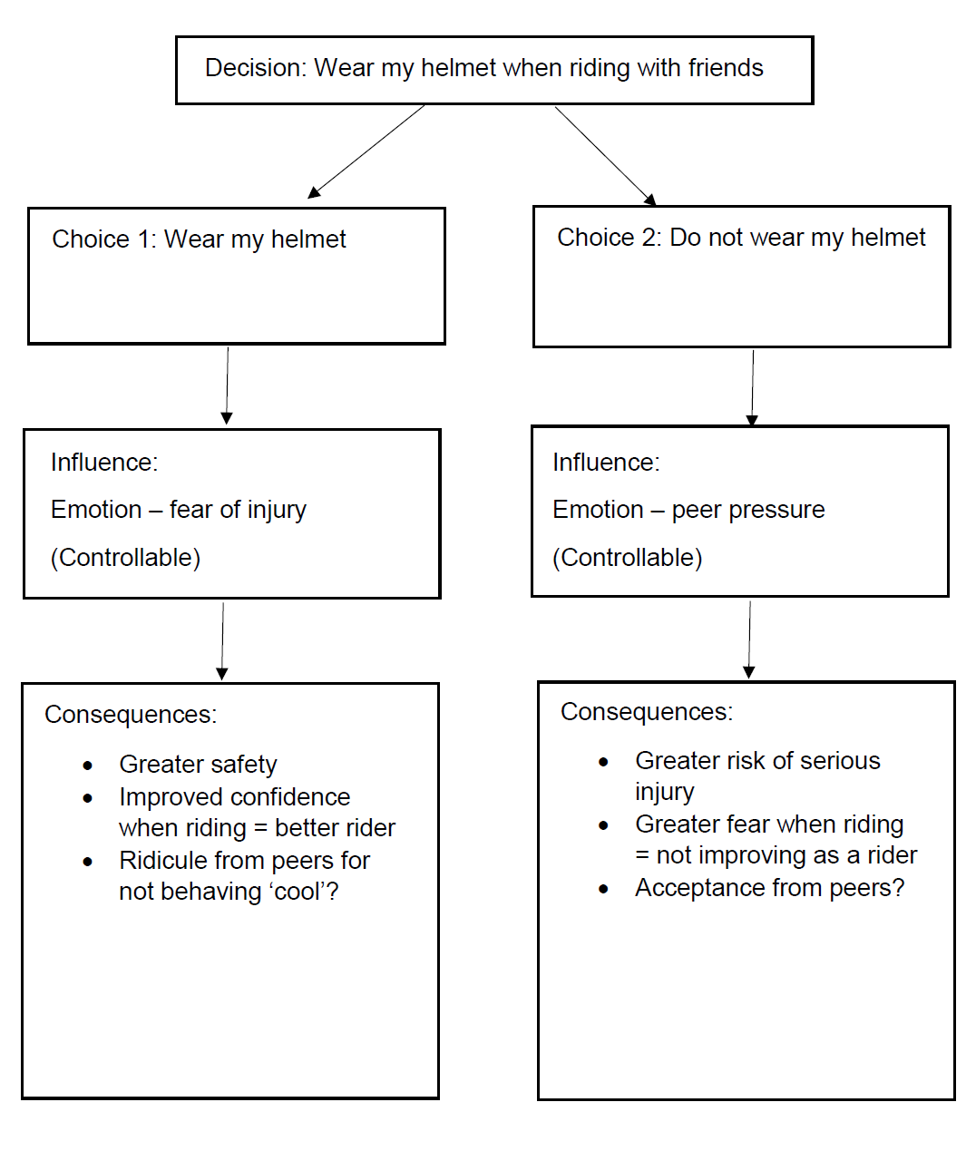
‘Decisions and influences mind map example’ by PDHPE – Curriculum Early Years and Primary Learners, © State of New South Wales (NSW Department of Education), 2021.

Appendix 6 – Decisions and influences mind map
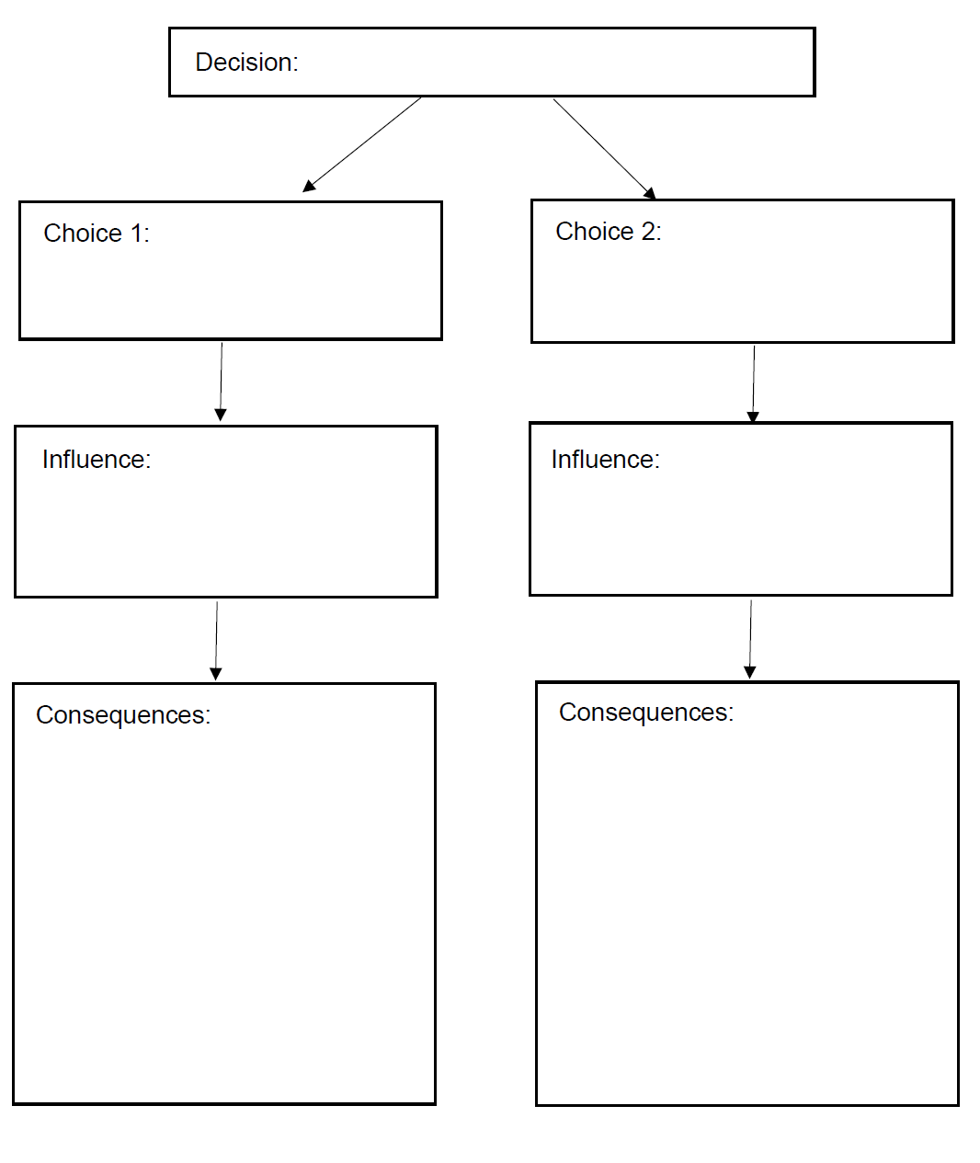
‘Decisions and influences mind map template’ by PDHPE – Curriculum Early Years and Primary Learners, © State of New South Wales (NSW Department of Education), 2021.

Appendix 7 – Decisions and emotions table example
Scenario – riding my bike home after not making the soccer team
Appendix 7 – Decisions and emotions table example
Possible emotions | Anger I missed out | Happy that I tried my best
Possible consequences | - Not concentrating on the traffic  - Riding too quickly  - Taking unnecessary risks  - Not checking helmet properly | - Concentrate on the traffic  - Riding at a safe pace  - Clipping up helmet correctly  - Staying calm
Who it affects and how | - Me- possible injury  - Carers – upset if I’m injured, concerned that I didn’t handle the disappointment well  - Drivers – upset that I’ve been injured  - Friends – I am unable to play with them as I’m injured | - Me- staying safe  - Carers – proud of my response to disappointment  - Friends – uninjured means I can play with them again  - Coach – likes my attitude to disappointment  - Drivers – can drive safely without a distraction

Appendix 8 – Decisions and emotions table
Scenario –
Appendix 8 – Decisions and emotions table
Possible emotions
Possible consequences
Who it affects and how

Appendix 9 – Consequences
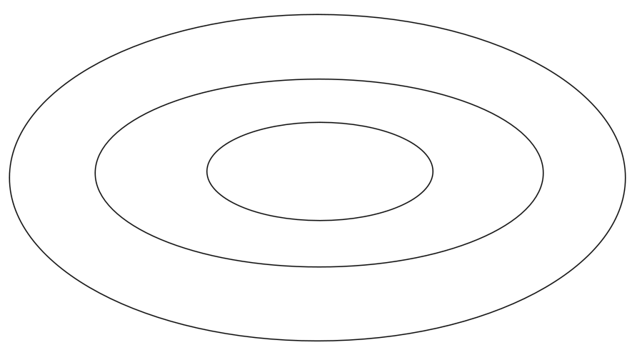
‘Consequences template’ by PDHPE – Curriculum Early Years and Primary Learners, © State of New South Wales (NSW Department of Education), 2021.

Appendix 10 – Consequences (example 1)
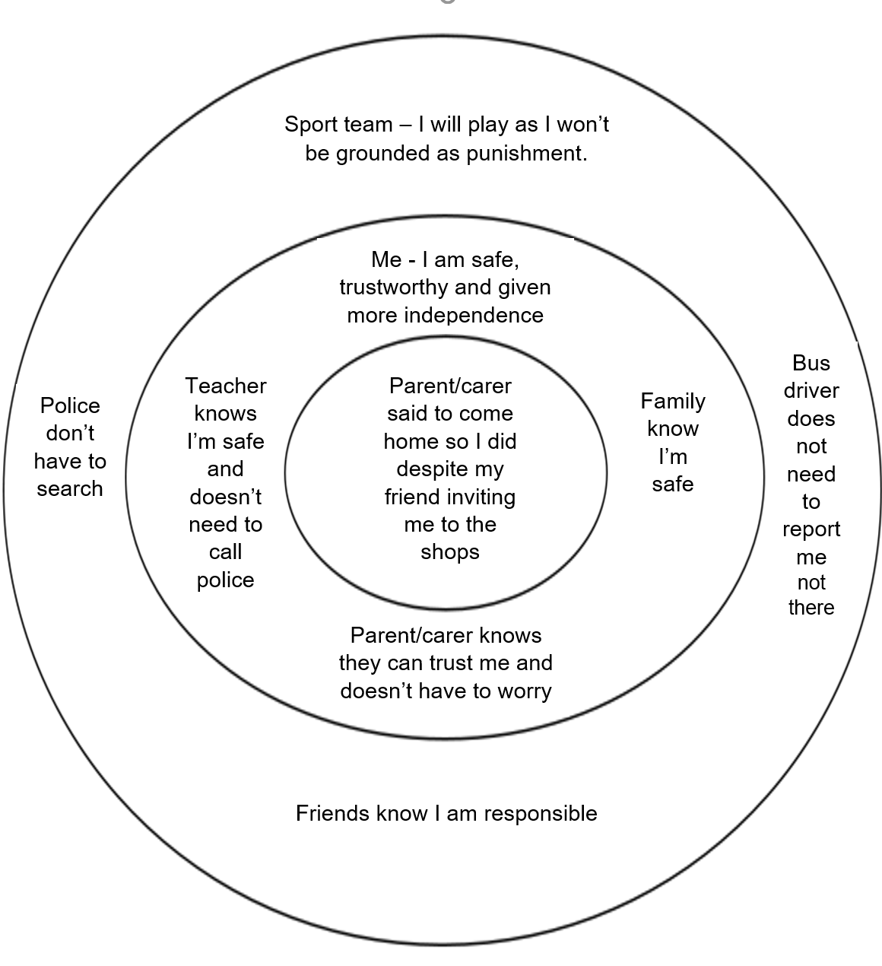
‘Consequences example’ by PDHPE – Curriculum Early Years and Primary Learners, © State of New South Wales (NSW Department of Education), 2021

Appendix 11 – Consequences (example 2)
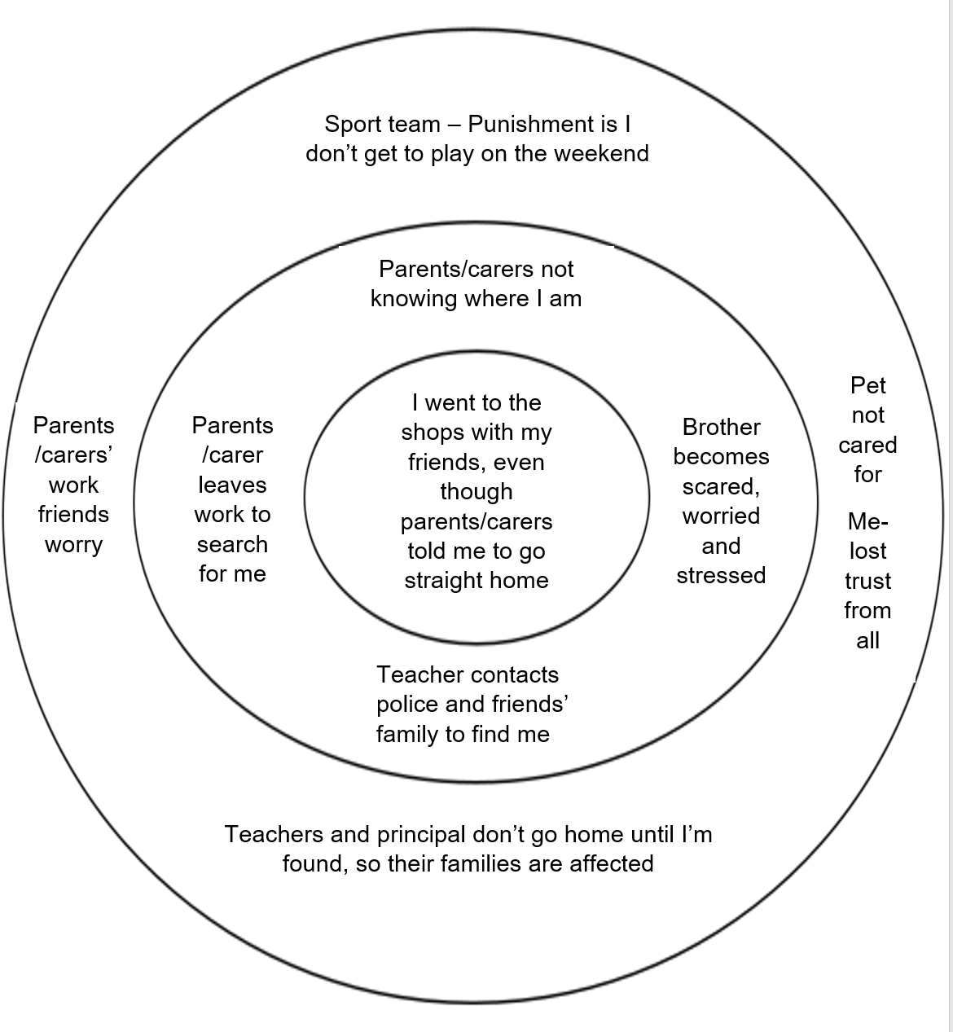
‘Consequences example 2’ by PDHPE – Curriculum Early Years and Primary Learners, © State of New South Wales (NSW Department of Education), 2021

Appendix 12 – Web of support example
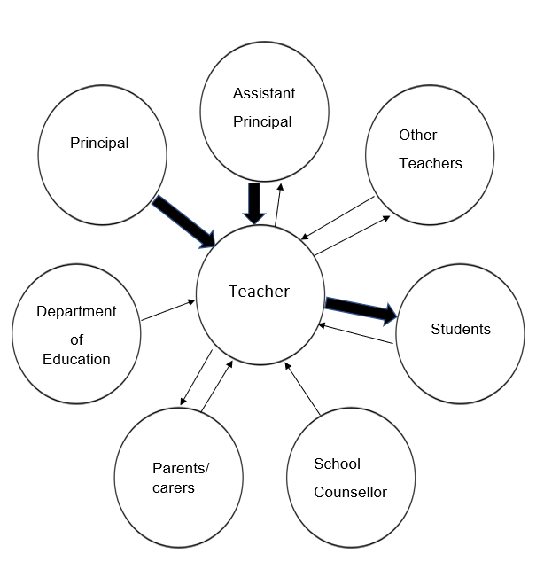
‘Web of support example’ by PDHPE – Curriculum Early Years and Primary Learners, © State of New South Wales (NSW Department of Education), 2021

Appendix 13 – Web of support
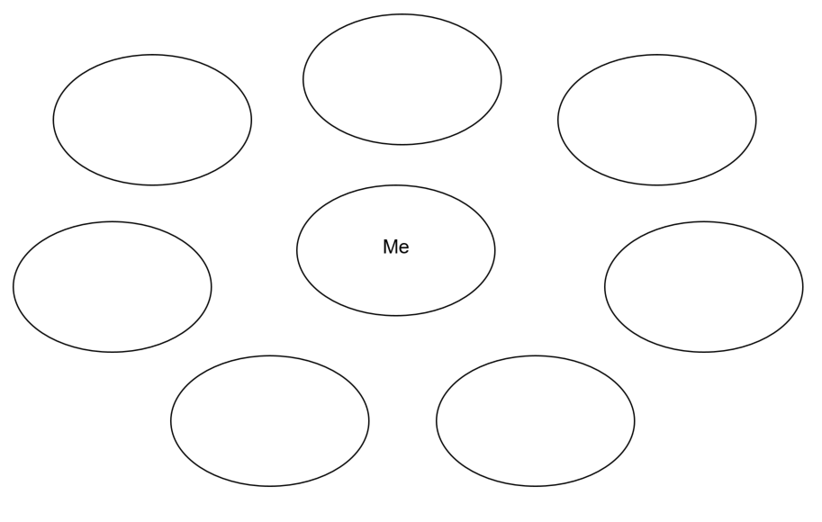
‘Web of support example’ by PDHPE – Curriculum Early Years and Primary Learners, © State of New South Wales (NSW Department of Education), 2021

Appendix 14 – Safe actions flow chart example
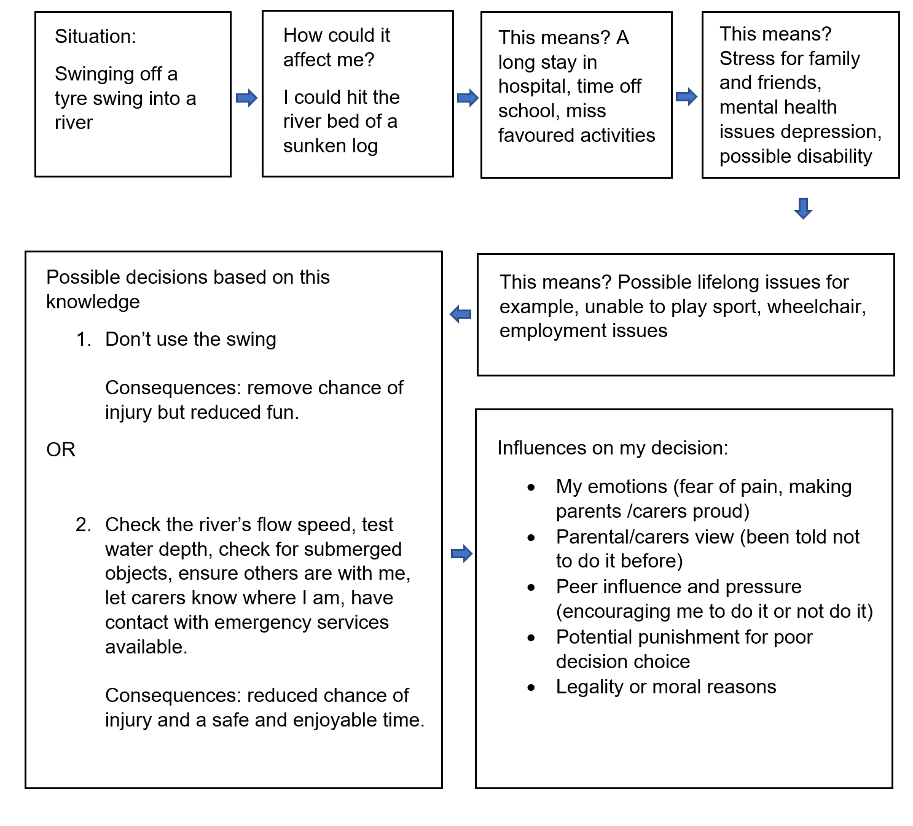
‘Safe actions flow chart example’ by PDHPE – Curriculum Early Years and Primary Learners, © State of New South Wales (NSW Department of Education), 2021

Appendix 15 – Safe actions flow chart
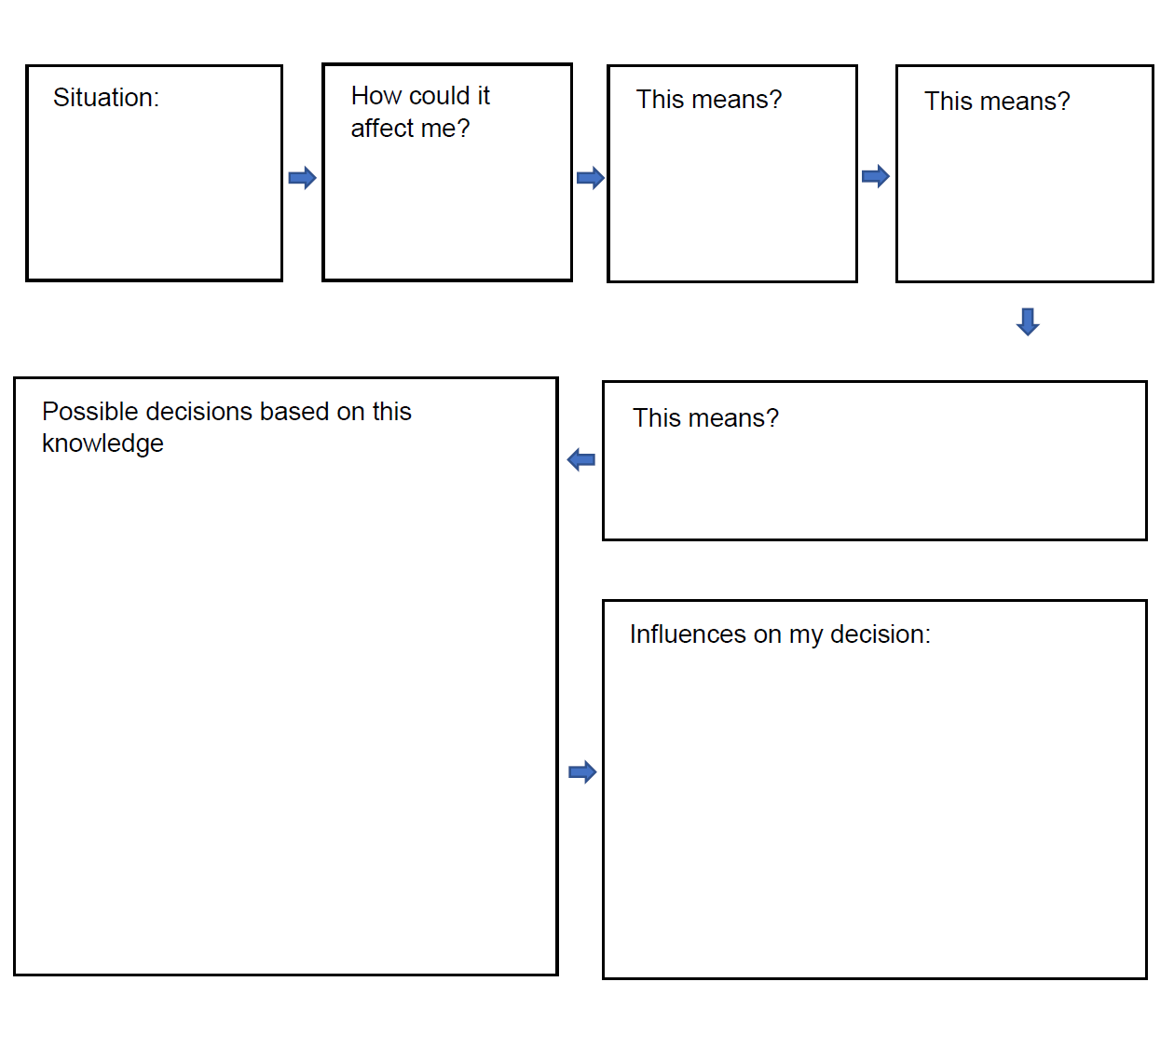
‘Safe actions flow chart template’ by PDHPE – Curriculum Early Years and Primary Learners, © State of New South Wales (NSW Department of Education), 2021

Appendix 16 – Emergency procedures flow chart example
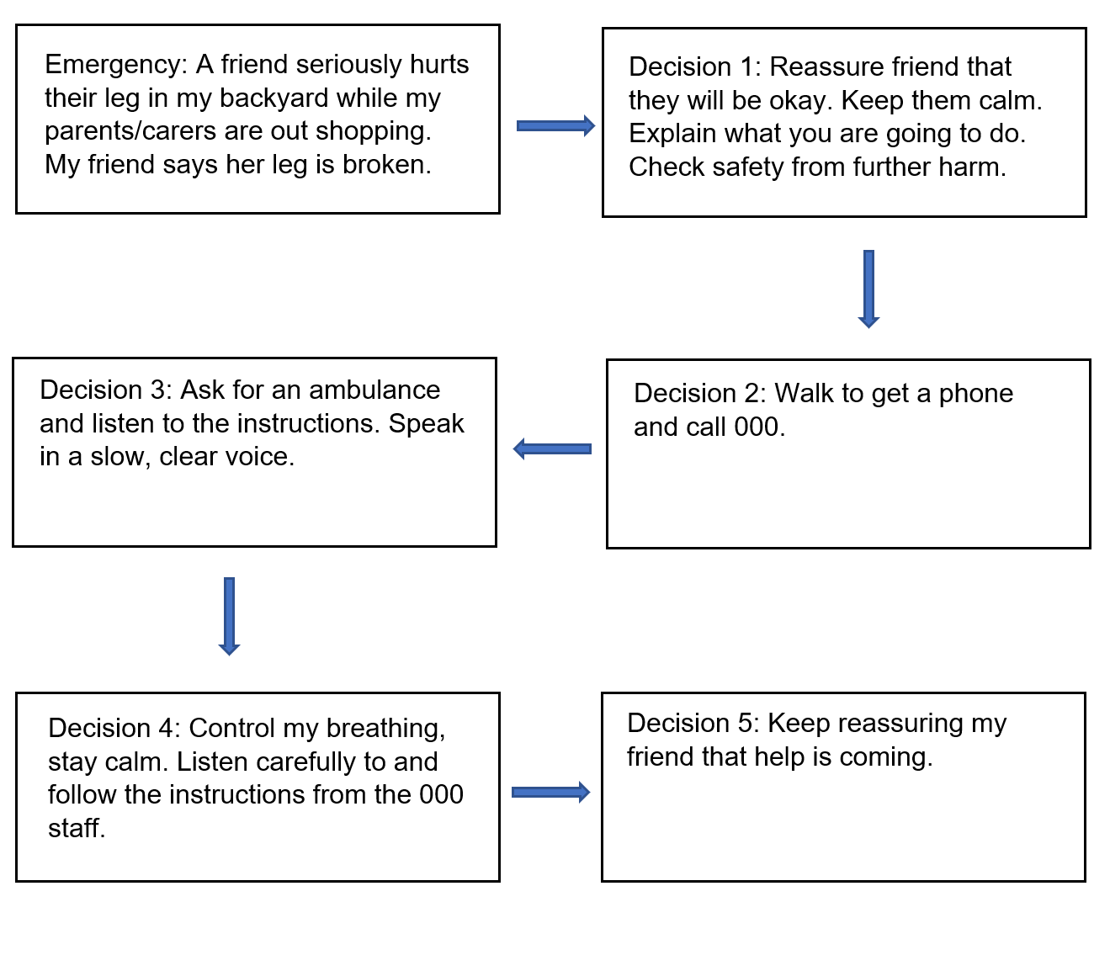
‘Emergency procedures flow chart example’ by PDHPE – Curriculum Early Years and Primary Learners, © State of New South Wales (NSW Department of Education), 2021.

Appendix 17 – Emergency procedures flow chart
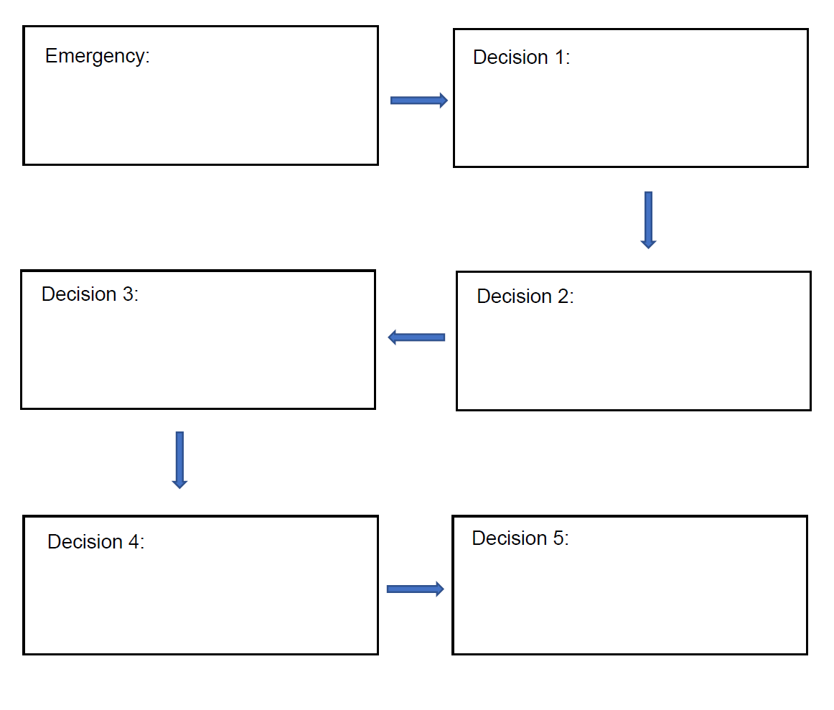
‘Emergency procedures flow chart example’ by PDHPE – Curriculum Early Years and Primary Learners, © State of New South Wales (NSW Department of Education), 2021.

Appendix 18 – Peer influence vs peer pressure example
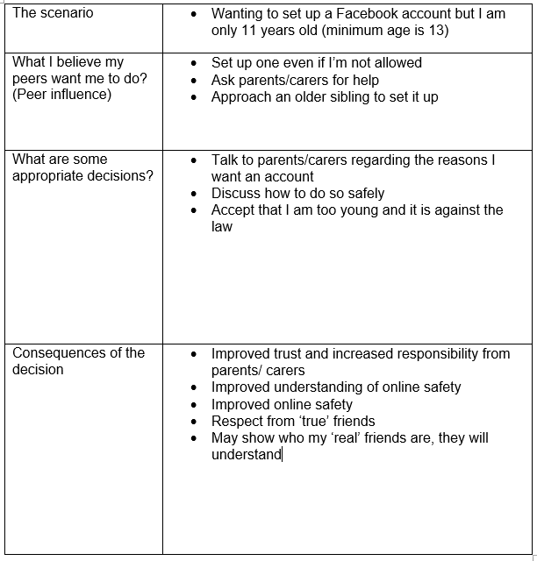
‘Peer influence vs peer pressure example’ by PDHPE – Curriculum Early Years and Primary Learners, © State of New South Wales (NSW Department of Education), 2021.

Appendix 19 – Peer influence vs peer pressure table
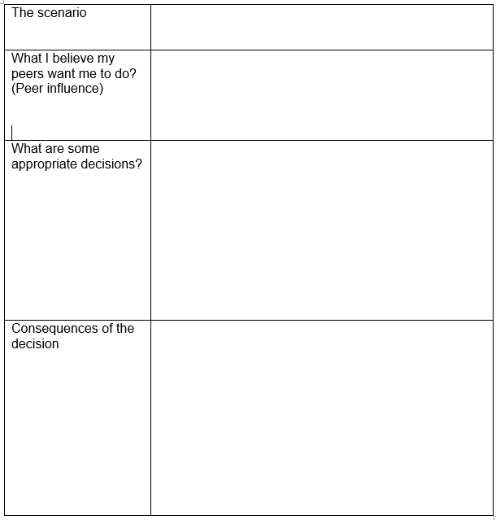
‘Peer influence vs peer pressure template’ by PDHPE – Curriculum Early Years and Primary Learners, © State of New South Wales (NSW Department of Education), 2021.

