Kinaesthetic learning in Stage 6 PDHPE

Blood through the circulatory system
This activity uses kinaesthetic learning by providing a hands-on experience and immersion in the learning experience for students. It is focused on students feeling and experiencing what they are trying to learn.
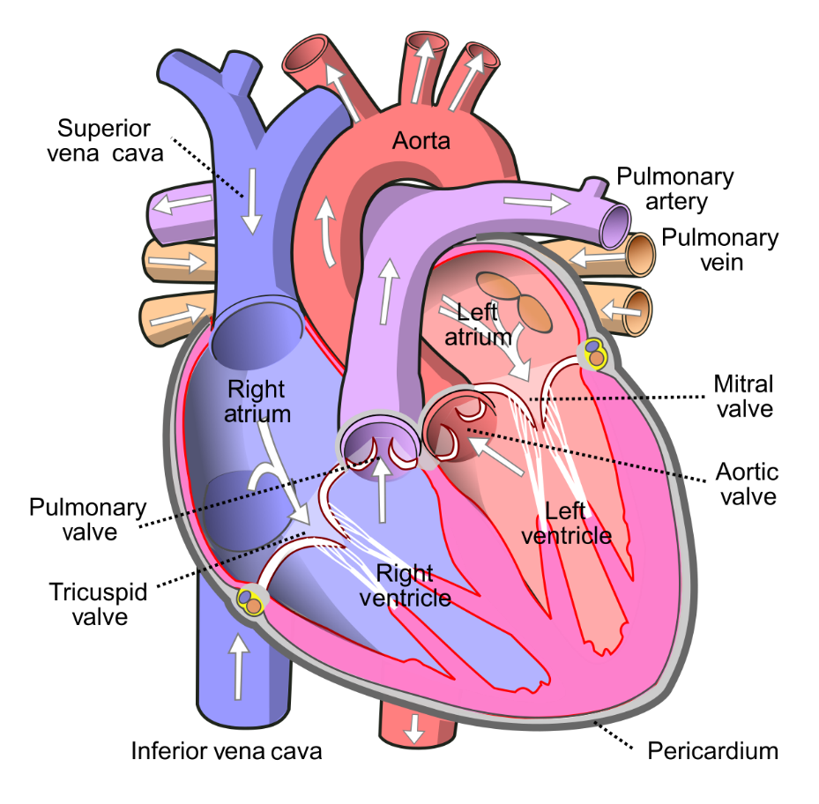
“Diagram of the human heart” by Wapcaplet is licensed under a CC BY-NC-SA 2.0

Educative purpose
Understanding the structure and function of the circulatory system provides a solid foundation for students to recognise how it contributes to efficient movement during exercise.
The circulatory system is an important system within the body. It is responsible for the delivery of oxygen and nutrients to all cells, muscles and organs in the body. It is also responsible for the removal of carbon dioxide and wastes. It can adjust the amount of blood flowing to different parts of the body, depending on what the body needs. The system is complex and works in tandem with the respiratory system.
The use of kinaesthetic learning provides an enriching experience by allowing students to move through the system like a drop of blood, seeing the process from a different lens to support understanding.

Syllabus content

Outcomes
P7: explains how body systems influence the way the body moves

Content
Preliminary Core 2: The Body in motion
How do the musculoskeletal and cardiorespiratory systems of the body influence and respond to movement?
Students learn about | Students learn to
- circulatory system  - components of blood  - structure and function of the heart, arteries, veins, capillaries  - pulmonary and systemic circulation  - blood pressure | - analyse the movement of blood through the body and the influence of the circulatory and respiratory systems on movement efficiency and performance.
Teacher note: Completing this activity in isolation will not meet all outcomes or content presented above. Teachers are to use their professional judgement to ensure outcomes are achieved.

Teaching and learning activity
Explain to students that the circulatory system consists of the heart, blood vessels and blood within the body. It is also known as the cardiovascular system; cardio meaning heart and vascular referring to the vessels. This system works in conjunction with the respiratory system to:
- remove carbon dioxide (CO₂) and waste products from body cells
- transport nutrients, oxygen (O₂) and water to every cell in the body
- circulate the blood throughout the body
- help maintain body temperature.
The heart is a pump that is the size of a clenched fist and is made of strong cardiac muscle. Within the heart there are four hollow chambers that fill with blood and contract, forcing the blood out and around the body. There are valves within the heart that control the direction and speed of this blood through the heart. Blood is pumped by the heart to and from every cell in the body via number of vessels (arteries, capillaries and veins). The blood carries dissolved nutrients and O₂ to the cells of the body and carries CO₂ and waste products away from the cells back to the heart.
To understand the cyclical process of the circulatory system and how the blood travels from the heart, around the body and back, students will create a human life size circulatory system and role play it.

Heart brainstorm and discussion
Students complete a KWL chart. They list what they know and want to know in relation to the heart and circulatory system. For example, the structure of the heart, the heart has four chambers, the function of the heart, how many times it beats on average. Students share with the class.
Discuss the heart structures identified and their function. The circulatory process will be explained and acted out through a role play. As this takes place address some of the ideas and wonders brainstormed through the KWL.

Setting up the body map role play
Students adopt the role of a drop of blood and follow its movements through the circulatory system. They will walk through the system to explore the structure and function of the heart and surrounding vessels. This is designed to help students understand how the heart and blood vessels can help supply O₂ and nutrients to every cell in the body and remove wastes.
Teacher note: To enhance the kinaesthetic learning experience, images and props can be used. For example: skipping ropes to represent vessels (arteries, veins and capillaries), large hoops/chairs/gym mas to represent the chambers of the heart, coloured bibs or braids worn by students (red or blue) to represent oxygenated or deoxygenated blood, an air pump or balloons to represent the lungs. Be as creative as you like with the space and equipment you have available to help represent the parts of the system. The more enjoyment students can gain from the classroom body map role play experience, the greater the learning experience that will assist in understanding and retainment.
As a class, students create a large body map. To create the experience:
- mark the outline of a large body with chalk or masking tape on the floor using as much space as possible
- create the outline of a heart and surrounding vessels for students to actively walk through
- spread pictures or props to represent the internal parts of the circulatory system and some elements of the body. These include:
  - the heart and its chambers
  - valves (aortic, bicuspid and tricuspid)
  - vessels (pulmonary artery, pulmonary vein, superior and inferior vena carva)
  - lungs
  - muscles of the body
  - brain.
- nominate students to play parts of the system. For example, students pretending to be valves that open and shut, travelling down arteries and veins, student pumping air to signify air exchange in the lungs.
- read out the kinaesthetic circulatory system role play script.
  - As it is read, students will act out the process and use the props to tell the story.
  - Encourage students to be dramatic and creative as the process unfolds.
Teacher note: Now that students understand the circulatory system, they can participate in a variety of physical activities at varying intensities to explore the effect these movement activities have on heart rate (the number of times the heart beats per minute). For example, sleeping, at rest, exercising at low intensity and high intensity. Students can discuss what is occurring in their body at the different levels of intensity such as why heart rate and respiration rate changes with greater intensity.

Other opportunities
- Circulatory rap – students listen to the circulatory system rap and follow the lyrics to hear another description of the circulatory system and reinforce understanding.
- Be the respiratory system – students could be the structure and show the function of the respiratory system by role playing the processes that occurs within. They could represent the process of gaseous exchange through the changeover of coloured braids could take place to enrich the learning.
- Be the energy system – students immerse themselves in the learning by role-playing the energy systems and acting out the process of ATP resynthesis. They develop a clear understanding of the chemical reactions that take place within the body to assist in energy production for movement.

Kinaesthetic circulatory system role play script
The following table provides a sample script to follow as you talk through the process of a drop of blood travelling through the circulatory system. A number of props and kinaesthetic learning ideas have been made as suggestions. Be as creative as you like with the equipment you have available.
Process a drop of blood follows | Kinaesthetic learning suggestions
Deoxygenated blood, which is blood low in O₂ but high in waste product such as CO₂, enters the heart via the superior and inferior vena cava. | - Students wear blue bibs to represent deoxygenated blood with no O₂  - Small ball to represent waste that have been carried by the blood back to heart
This is blood that has been used by the cells, organs and muscles of the body and is returning to the heart. It enters the right atrium. | - Two students wearing a blue braid at the same time enter the right atrium.  - One student comes into the right atrium hoop via the superior vena cava represented by skipping ropes from the top of the body. The other comes in from the inferior vena cava represented by skipping ropes from the lower part of the body
The blood moves from the right atrium through the tricuspid valve into the right ventricle. Valves between the atrium and ventricle help slow down the rate of blood flow. | - Two students represent the valve that the blood goes through. They could use their two arms plus a braid to join hands with their partner. By doing this they represent the three strong thin flaps of tissue called leaflets or cusps that open and close the valve.  - When they lift their arms, the valve opens to let the student drops of blood through to the right ventricle. They shut their arms quickly to stop blood moving back.
Once in the right ventricle the blood is pumped through the pulmonary artery to the lungs where gaseous exchange happens. | - Students move from the right ventricle hoop along a skipping rope to represent the pulmonary artery.
In the lungs, CO2 is removed from the blood into lungs and is exhaled. | - Students use a bicycle air pump or balloons to represent the lungs. The air in a balloon could be let out to represent exhale.  - Students could through the small ball to represent wastes being removed
Fresh oxygen is inhaled by the lungs. This is passed back into the blood. The process of O2 and CO2 moving between the bloodstream and lungs is a process called gaseous exchange. | - A balloon is blown up to represent air being inhaled into the lungs or filling up  - Student changes the colour of the bib they are wearing to red to represent them now being oxygenated blood
The oxygenated blood, which means it is high in O2, and low in waste products is transported back to the heart via the pulmonary vein. This is the only vein in the body which carries oxygenated blood. | - Students travel along more skipping ropes this time via the pulmonary vein back to the heart.
When returning back to the heart it enters into the left atrium. | - Students jump into the left atrium hoop.
Blood passes through the left atrium through the bicuspid valve into the left ventricle. | - Two students represent the valve that the blood goes through. They could be facing each other holding hands. They raise their two arms up to represent the two flaps that form part of the bicuspid valve.  - Students jump into the left ventricle hoop.
The left ventricle (large tissue) pumps the blood to the rest of the body via the aorta, arteries, capillaries and into the blood cells. | - Students are given a big push from the left ventricle hoop by other students to represent the left ventricle thick walls that pump and push the blood out of the heart and around to the body.
The oxygen in the blood is used by the tissues throughout the body and then heads back to the heart where the entire cycle begins again. | - Students race up to the top of the body to the brain and bottom of the body to the legs to show the different place that the blood is pushed.  - May like to do running on the sport to represent legs using oxygen or someone.

