Textiles technology

# Loom weaving

Students create a mini-wall hanging by weaving yarn on a basic loom. Students examine different fabric /material structures through using different weaving techniques. Additional research and analysis of fibres, yarns and fabrics could be given for students to submit.

## Outcomes

* **TE4-5AG** investigates how food and fibre are produced in managed environments
* **TE4-9MA** investigates how the characteristics and properties of tools, materials and processes affect their use in designed solutions

[Technology Mandatory 7-8 Syllabus](https://educationstandards.nsw.edu.au/wps/portal/nesa/k-10/learning-areas/technologies/technology-mandatory-7-8-new-syllabus) © NSW Education Standards Authority (NESA) for and on behalf of the Crown in right of the State of New South Wales, 2017.

* **TEX5-1** explains the properties and performance of a range of textile items
* **TEX5-5** investigates and applies methods of colouration and decoration for a range of textile items
* **TEX5-9** critically selects and creatively manipulates a range of textile materials to produce quality textile items

[Textiles technology 7-10 Syllabus](https://educationstandards.nsw.edu.au/wps/portal/nesa/k-10/learning-areas/technologies/textiles-technology-2019) © NSW Education Standards Authority (NESA) for and on behalf of the Crown in right of the State of New South Wales, 2019.

## Suggested strategies

This resource is adaptable for teachers to use with online platforms such as Google Classroom. Links to the videos and websites could be posted for students to access during learning at home. The activities could be set as practical classwork. This lesson sequence could be further developed and include questions and activities related to fibre, yarn and fabric content.

The suggested activities that relate to the listed resources are not an exhaustive list and may be added to or edited to suit your students learning needs.

|  |  |
| --- | --- |
| Focus area | Fibres, yarns and fabrics |
| Syllabus content | Stage 4 technology mandatory – materials   * investigate the characteristics and properties of a range of materials and products * experiment with a range of appropriate techniques to produce a design solution * evaluate the effectiveness and suitability of choices made during the development and production of the solution   Stage 5 textiles technology   * identify fabric structures * identify yarns used in textile items * explore textiles as a medium of self-expression |
| Resources | * [how to make t-shirt yarn](https://www.youtube.com/watch?v=oqyhNDSXEfg) (duration 6:56) * [DIY weaving](https://www.youtube.com/watch?v=RqF-UcWchos) (duration 6:41) * [different types of weaving](https://www.reignwoven.com/just-for-starters)   Students are either given a laser cut mini loom or can be instructed to create their own using strong cardboard (instructions on the following pages).  Students require lengths of yarn in various colours. |
| Activities and or questions | 1. Outline the basic fabric types – woven, knitted and non-woven. 2. Watch [DIY weaving](https://www.youtube.com/watch?v=RqF-UcWchos) (duration 6:41) 3. Students thread up the loom (follow instructions found on [Mollie makes](http://www.molliemakes.com/tutorials/how-to-weave-wall-hanging/) website) 4. Students begin the weaving process. They should attempt a range of different patterns whilst weaving. Use the [different types of weaving](https://www.reignwoven.com/just-for-starters) website to identify and create different fabric types. 5. Using a found stick, slide the top loops off the loom and onto the stick.   Take a picture of the finished product and submit to the teacher. |

## Loom weaving in progress

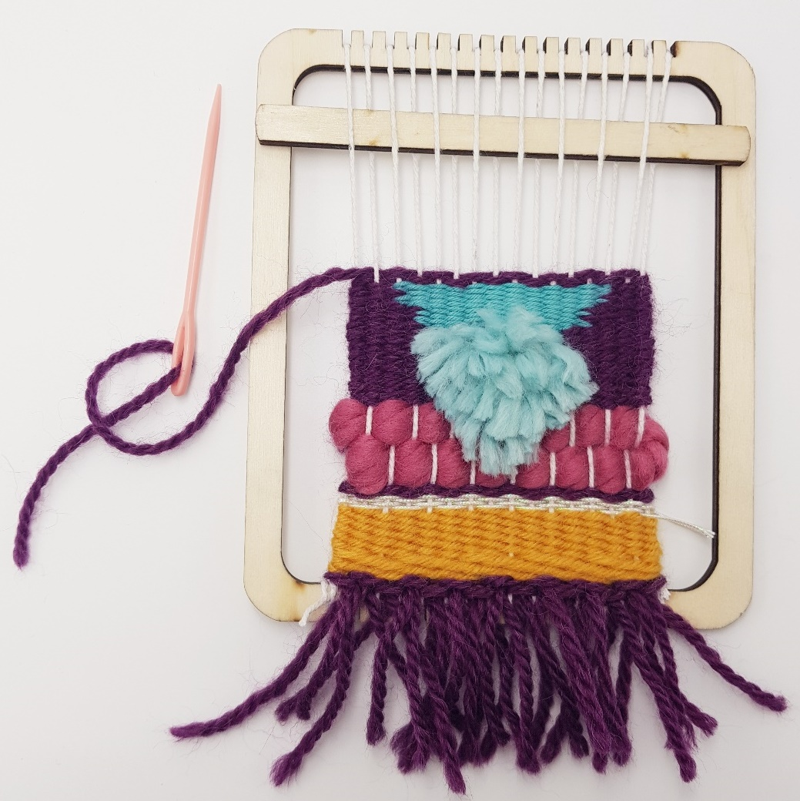

## Loom template for laser cutter

The loom template looks like the image below and can be nested to cut multiples to fit the laser cutter bed.



## Loom template for cardboard

Students could use this to cut out a basic ‘loom’ at home (this can be made to any size, as long as the notches along the top and bottom are still 5mm apart).

