Stage 6 – Engineering Studies

Material Science
This activity is designed to develop student’s knowledge of phases in materials and the conditions which cause phase transitions such as temperature and pressure.

Outcomes
- P1.2 explains the relationship between properties, structure, uses and applications of materials in engineering
- P2.1 describes the types of materials, components and processes and explains their implications for engineering development
Engineering Studies Stage 6 Syllabus (2011) © NSW Education Standards Authority (NESA) for and on behalf of the Crown in right of the State of New South Wales, 2013.

Delivery strategies
This resource is adaptable and could be used in online platforms such as Google classroom. Links to the videos and websites could be posted for students to access for learning at home. The activities and questions are designed for general preliminary materials content, but could be adjusted to suit module specific HSC materials content.

Focus area | Phases and phase diagrams
Syllabus Content | Students learn about:  - Classification of materials  - Properties of materials  - Physical and mechanical properties  - Structure of materials  - Atomic structure  - Bonding  - Crystalline and non-crystalline structures
Resources | Introduction to Materials Science and Engineering UNSW  Complete module 2A introduction to phase diagrams and metal alloys and module 2B phase transformations
Activities/ questions | - What is a ‘phase’?  - What happens to titanium if it is heated above 882°C?  - What is polymorphism?  - List three examples of polymorphic materials.  - What is the stable phase of H₂O at 60°C and 0.005 atm?  - What is an alloy?  - What is the difference between wt% and at%?  - What is the difference between a substitutional solid solution and an interstitial solid solution?  - What is a phase transformation?  - What is a eutectic reaction?  - Draw and label a microstructure diagram of hypoeutectic Pb-Sn and hypereutectic Pb-Sn.
Suggested answers | Suggested answers.  - A phase is a region of a material with uniform physical and chemical properties.  - When titanium is heated above 882°C it changes from a hexagonally close-packed structure to a body-centred cubic structure.  - Polymorphism refers to the ability of a solid material to exist in more than one form of crystal structure.  - Titanium, Pb-Sn, steel  - Water vapour.  - An alloy is a solid solution of a metal with one or more metal or non-metal elements.  - wt% is short for weight % and is the mass of one of the components expressed as a total mass of the sample. at% is short for atomic % and is the number of atoms of one component expressed as a percentage of the total number of atoms in the sample.  - In a substitutional solid solution, the solute atoms replace some of the host atoms in the crystal lattice. In an interstitial solid solution, the solute atoms fit in to the gaps between the host atoms, called the interstices.  - A phase transformation is a change in the number and/or type of the phases present in the microstructure of a material, caused by a change in conditions such as temperature or pressure.  - The point on a phase diagram where the liquid phase transforms isothermally to two solid solution phases.  - Hypoeutectic Pb-Sn  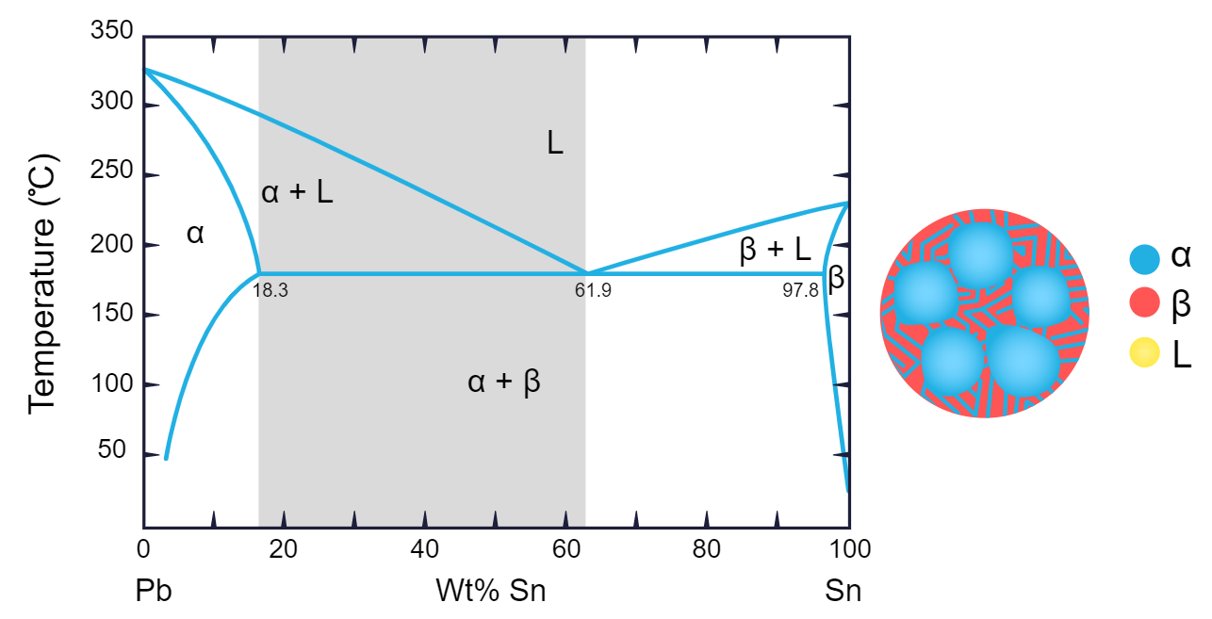  Hypereutectic Pb-Sn  