Mathematics – K-2 multi-age – Year A – Unit 5

Contents
Unit description and duration 4
Student prior learning 5
Lesson overview and resources 6
Lesson 1: Exploring 2D shapes 14
Daily number sense: Guess the mystery number – 10 minutes 15
Creating shapes with a rope – 50 minutes 16
Discuss and connect the mathematics – 10 minutes 19
Lesson 2: Constructing squares 20
Daily number sense: Number bonds to 10 – 10 minutes 20
Making squares from rectangles: Is it possible? – 40 minutes 22
Discuss and connect the mathematics: 10 minutes 26
Lesson 3: Making shapes 27
Daily number sense: Sequence numbers – 10 minutes 28
Paper folding shapes – 50 minutes 30
Discuss and connect the mathematics – 10 minutes 33
Lesson 4: Hexagon filler 36
Daily number sense: Is it a triangle? – 10 minutes 36
Building a hexagon – 40 minutes 37
Discuss and connect the mathematics – 10 minutes 40
Lesson 5: What shapes are hiding inside a square? 41
Daily number sense: Which one does not belong? – 10 minutes 41
Consolidation and meaningful practice: 15 minutes 42
Shapes made by shapes – 25 minutes 43
Discuss and connect the mathematics – 10 minutes 44
Lesson 6: Paper halving 47
Daily number sense – 10 minutes 47
Exploring halves – 20 minutes 48
Discuss and connect the mathematics – 10 minutes 50
Proving halves – 30 minutes 51
Lesson 7: Transform shapes 53
Daily number sense: Shape sides – 10 minutes 54
Translations and reflections – 25 minutes 55
Patterns – 15 minutes 58
Discuss and connect the mathematics – 10 minutes 59
Lesson 8: Symmetry and design 62
Daily number sense: Number bonds to 10 – 10 minutes 62
Finding the line of symmetry and creating pictures – 30 minutes 64
Discuss and connect the mathematics – 20 minutes 66
Resource 1: Stage 1 table 69
Resource 2: Dot talk 71
Resource 3: Folding rhombus 72
Resource 4: Instructions 73
Resource 5: Triangles 74
Resource 6: Hexagon filler gameboard 75
Resource 7: Hexagon filler game cards 76
Resource 8: Assessing gameplay 80
Resource 9: Odd one out 81
Resource 10: Shapes in a hexagon 82
Resource 11: Examples of halves 83
Resource 12: Patterns 84
Resource 13: Translation pattern 85
Resource 14: Reflection image 86
Resource 15: Representations of numbers 87
Resource 16: 2D shape pictures 88
Resource 17: Shapes 90
Resource 18: Images 91
Syllabus outcomes and content 93
References 100

Unit description and duration
This two-week unit develops student knowledge, understanding and skills in the attributes and features of two-dimensional shapes. Students are provided opportunities to:
- identify and describe two-dimensional (2D) shapes
- explore how shapes can be made by joining (combining) and breaking apart (partitioning) existing shapes
- classify shapes based on their attributes as that shape (features of triangles, circles, squares, rectangles, quadrilaterals, hexagons, octagons, polygons)
- manipulate shapes and objects to halve them in different ways. Sometimes, halves are made up of more than one part
- describe the position as about halfway, more than halfway or less than halfway
- create new shapes by adding or removing sides and vertices (corners)
- explore how 2D shapes can be classified into different categories according to their features
- turn shapes to fit into a space or create a design
- create linear patterns with shapes that transform (slide and reflections)
- make designs which have a line of symmetry.
Mathematics K–10 Syllabus © 2022 NSW Education Standards Authority (NESA) for and on behalf of the Crown in right of the State of New South Wales.

Student prior learning
Before engaging in these teaching and learning activities, students would benefit from prior experience with:
- opportunities to investigate 2D shapes through playing with pattern blocks, geoboards, paper folding and cutting
- noticing and using attributes to sort and classify shapes
- distinguishing shapes by their features
- using mathematical language in relation to shapes such as sides, equal, vertices and straight
- measure objects using informal units.

Lesson overview and resources
The table below outlines the sequence and approximate timing of lessons; syllabus focus areas and content groups; and resources.
Lesson | Syllabus focus area and content groups | Resources
Lesson 1: Exploring 2D shapes  70 minutes  Shapes have features which can be used to name them. | Represent whole numbers  Early Stage 1  - Use the counting sequence of ones flexibly  Stage 1 – Part A  - Use counting sequences of ones with two-digit number  Two-dimensional spatial structure  Early Stage 1  - 2D shapes: Sort, describe and name familiar shapes  - 2D shapes: Represent shapes  Stage 1 – Part A  - 2D shapes: Recognise and classify shapes using obvious features  Stage 1 – Part B  - 2D shapes: Represent, combine and separate two-dimensional shapes | - Resource 1: Stage 1 table (printed double sided)  - Burns M (2008) The Greedy Triangle (Silveria G, illus.), Scholastic US. ISBN13: 9780545042208  - Chalk  - Skipping ropes (class set)  - Writing materials
Lesson 2: Constructing squares  60 minutes  Shapes have features which can be used to name them. | Combining and separating quantities  Early Stage 1  - Instantly name the number of objects within small collections  - Identify part-whole relationships in numbers up to 10  Stage 1 – Part A  - Recognise and recall number bonds up to ten  Geometric measure A  Early Stage 1  - Length: Use direct and indirect comparisons to decide which is longer  Stage 1 – Part A  - Length: Measure the lengths of objects using informal units  Two-dimensional spatial structure  Early Stage 1  - 2D shapes: Sort, describe and name familiar shapes  - 2D shapes: Represent shapes  Stage 1 – Part A  - 2D shapes: Recognise and classify shapes using obvious features  Stage 1 – Part B  - 2D shapes: Represent, combine and separate two-dimensional shapes | - Resource 2: Dot talk  - Frayer diagram  - Counters, paperclips, interlocking cubes, or similar informal units  - Modelling clay  - Range of different sized and coloured paper (A2, A3, A4, A5, A6)  - Scissors  - Writing materials
Lesson 3: Making shapes  70 minutes  Shapes can be classified into different categories. | Representing whole numbers  Early Stage 1  - Use the counting sequence of ones flexibly  Stage 1 – Part A  - Representing numbers on a line  Two-dimensional spatial structure  Early Stage 1  - 2D shapes: Sort, describe and name familiar shapes  - 2D shapes: Represent shapes  Stage 1 – Part A  - 2D shapes: Recognise and classify shapes using obvious features  Stage 1 – Part B  - 2D shapes: Represent, combine and separate two-dimensional shapes | - Resource 3: Folding rhombus (one per student)  - Resource 4: Instructions  - Geoboards/pegboards, rubber bands, ribbon, string, tape, straws, pipe cleaners, strips of paper or toothpicks  - Pattern or attribute blocks  - Whiteboards (class set)  - Writing materials
Lesson 4: Hexagon Filler  60 minutes  Smaller shapes are hiding in larger shapes. | Two-dimensional spatial structure  Early Stage 1  - 2D shapes: Sort, describe and name familiar shapes  - 2D shapes: Represent shapes  Stage 1 – Part A  - 2D shapes: Recognise and classify shapes using obvious features  Stage 1 – Part B  - 2D shapes: Represent, combine and separate two-dimensional shapes | - Resource 5: Triangles  - Resource 6: Hexagon filler gameboard (class set)  - Resource 7: Hexagon filler game cards (one set per pair)  - Resource 8: Assessing gameplay  - Video: The Stickie Gang, Episode 3: Identifying 2D Shapes (1:13)  - Pattern blocks
Lesson 5: What shapes are hiding inside a square?  60 minutes  Smaller shapes are hiding in larger shapes. | Representing whole numbers  Early Stage 1  - Recognise dice and domino dot patterns  Two-dimensional spatial structure  Early Stage 1  - 2D shapes: Sort, describe and name familiar shapes  - 2D shapes: Represent shapes  Stage 1 – Part A  - 2D shapes: Recognise and classify shapes using obvious features  Stage 1 – Part B  - 2D shapes: Represent, combine and separate two-dimensional shapes | - Resource 9: Odd one out  - Resource 10: Shapes in a hexagon (print 3 copies)  - Coloured paper squares  - Scissors  - Glue  - Pattern blocks  - Writing materials
Lesson 6: Paper halving  70 minutes  Not all halves look the same but remain equal. | Geometric measure  Early Stage 1  - Length: Create half a length  Stage 1 – Part A  - Length: Subdivide lengths to find halves and quarters  Two-dimensional spatial structure  Stage 1 – Part A  - 2D shapes: Recognise and classify shapes using obvious features  - Area: Measure areas using uniform informal units | - Resource 11: Examples of halves  - Murphy S (1996) Give me half! (Karas B, illus.) HarperCollins US. ISBN13: 9780064467018  - A4 paper  - Interlocking cubes, pattern shapes, sticky notes, or similar informal units  - Pattern blocks  - Pipe cleaners  - Scissors  - Writing materials
Lesson 7: Transform shapes  60 minutes  Objects can be transformed using movement. | Representing whole numbers  Early Stage 1  - Use the counting sequence of ones flexibly  Combining and separating quantities  Stage 1 – Part A  - Recognise and recall number bonds up to ten  Forming groups  Early Stage 1  - Copy, continue and create patterns  Two-dimensional spatial structure  Early Stage 1  - 2D shapes: Sort, describe and name familiar shapes  - 2D shapes: Represent shapes  Stage 1 – Part A  - 2D shapes: Recognise and classify shapes using obvious features  - 2D shapes: Transform shapes with slides and reflections | - Resource 12: Patterns  - Resource 13: Translation pattern  - Resource 14: Reflection image  - Mirrors (class set)  - Pattern and attribute blocks  - Whiteboards (class set)
Lesson 8: Symmetry and design  60 minutes  2D shapes are represented in pictures and designs. A symmetrical object is reflected with the same image. | Representing whole numbers  Early Stage 1  - Identify the number of items in different arrangements  Combining and separating quantities  Early Stage 1  - Model additive relations and compare quantities  - Identify part-whole relationships in numbers up to 10  Stage 1 – Part A  - Recognise and recall number bonds up to ten  Two-dimensional spatial structure  Early Stage 1  - 2D shapes: Sort, describe and name familiar shapes  - 2D shapes: Represent shapes  Stage 1 – Part A  - 2D shapes: Transform shapes with slides and reflections | - Resource 15: Representations of numbers  - Resource 16: 2D shape pictures  - Resource 17: Shapes (one per group)  - Resource 18: Images  - Collection of symmetrical and asymmetrical objects  - Mirrors (class set)  - Pattern and attribute blocks  - Scissors  - Straws, wooden skewers or pipe cleaners (class set)  - Whiteboards (class set)  - Writing materials

Lesson 1: Exploring 2D shapes
Core concept: Features can be used to name shapes.
The table below contains suggested learning intentions and success criteria. These are best co-constructed with students.
Learning intention | Success criteria
All students are learning that two-dimensional shapes have features which determine their name. | All students can identify and describe 2D shapes using correct mathematical language.  In addition, students working towards Early Stage 1 outcomes can:  - build and manipulate 2D shapes  - identify 2D shapes in different environments  - identify and draw straight and curved lines.  In addition, students working towards Stage 1 outcomes can:  - create new shapes from existing shapes by adding one more side  - explain that when a side is added to a shape, a vertex is also added.

Daily number sense: Guess the mystery number – 10 minutes
- Build student understanding of how to describe and locate numbers by asking mathematical questions to find numbers on a number chart.
- Choose a digital number chart and cover all squares. Select a mystery number and have students ask questions to identify the chosen number. Set a goal of uncovering the mystery number in 10 questions or less.
- Students may ask questions such as:
- Is it an odd number?
- Is the number even?
- Is the number more than...?
- Is the number less than...?
- Is the number between...?
- Does the number end in zero?
- After each question, clear the board of the relevant numbers until the mystery number remains. Record questions and reflect on which question generated the highest number of possibilities.
Note: Alternate number charts; Early Stage 1 students with a range from 0-20 and Stage 1 with a range from 0-120.

Creating shapes with a rope – 50 minutes
- Read The Greedy Triangle by Marilyn Burns (2008). Students identify 2D shapes throughout the story and make a list sharing what they know about each shape.
- Looking around the classroom, students identify 2D shapes they can see. For example, the bottom of a drink bottle is a circle; the front of the book is a rectangle, it has 4 sides.
- Take students, along with Resource 1: Stage 1 table, a pencil (Stage 1), chalk and a class set of skipping ropes, to a large space where students will create and draw 2D shapes.
- Looking around the outside space, students identify 2D shapes they can see. For example, a handball square has 4 sides.
- Provide each small group with a rope and ask them to create a straight line. Allow students time to discuss what they notice about the straight line. Challenge them to make straight lines horizontally, vertically, and diagonally and trace them with chalk.
Line: A one-dimensional figure that is straight, has no thickness and extends endlessly.
- Ask student to make a curved line. Allow students time to discuss what they notice about the curved line and what is similar and different to the straight line. Challenge students to make a variety of curved lines and trace them with chalk.
- Have students name any 2D shapes they know which have a curved edge or a straight side.
- Explain to students they are going to build a range of 2D shapes with skipping ropes. They then trace the 2D shape with chalk and identify and record the features.
- Model building a triangle with at least one skipping rope. Students build a triangle with the rope/s and then trace around it with chalk. Have Stage 1 students circle and count the vertices, and tick and count the straight sides. Ask students if they know some of the features of the shape. Draw attention to the correct use of vocabulary, for example, it has 3 straight sides and 3 vertices (corners), and it is a triangle.
Note: Early Stage 1 students should focus on building and drawing 2D shapes and verbally describing their features, for example, a square has 4 straight sides.
- Introduce Stage 1 students to Resource 1: Stage 1 table and together draw and record the features of a triangle, see Figure 1.
Figure 1 – Example of table
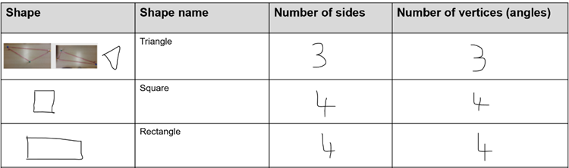
- Have students manipulate the skipping rope/s to show triangles in various orientations and with sides of different lengths. Stage 1 students draw various triangles made, record their features, and name the shape on Resource 1: Stage 1 table. Early Stage 1 students discuss what is similar and different between the triangles they have made.
Note: Tying the ends of the skipping rope together will allow students to create a closed shape. If this is not possible ensure that students understand that the rope must be connected as 2D shapes are closed shapes.
- Students work in small groups and build various 2D shapes. Stage 1 students follow step 13; build, identify, and record the features. Early Stage 1 students focus on building 2D shapes and verbally describing their features.
Note: Early Stage 1 students focus on developing their understanding of triangles, circles, squares, and rectangles before moving onto other 2D shapes.
The table below details assessment opportunities and differentiation ideas.
Assessment opportunities | Too hard? | Too easy?
What to look for:  - Are students able to identify, build and manipulate 2D shapes? (MAE-2DS-01)  - Are students able to identify and draw straight and curved lines? (MAE-2DS-01)  - Are students able to identify that when a side is added to a shape, it creates a new shape and that a vertex is also added? (MA1-2DS-01)  - Can students identify and describe the features of given 2D shapes using appropriate mathematical language? (MAE-2DS-01, MA1-2DS-01)  What to collect:  - Resource 1: Stage 1 table (MA1-2DS-01, MAO-WM-01) | Students find it difficult to describe the features of shapes with appropriate vocabulary.  - Support students to walk around their traced shapes using the correct vocabulary to describe them. For example, ask students to stand on a vertex or straight line.  - Support students to search the classroom for 2D objects with 3 vertices and 3 straight sides.  Students are not confident building 2D shapes.  - Support students to identify the 2D shapes they know and what they know about them.  - Guide students to draw the 2D shape they know with chalk and then use the rope to build the 2D shape. | Students are confident making and describing a range of shapes and identifying their features with the appropriate vocabulary.  - Challenge students to create as many different looking shapes as possible for each number of sides.  - Challenge students to identify and describe the regular and irregular 2D objects from those they have made.

Discuss and connect the mathematics – 10 minutes
- Students look at the 2D shapes built and Resource 1: Stage 1 table. Ask students:
- What 2D shapes did you build?
- How did the 2D shapes change as sides were added?
- What do you notice about the number of sides and number of vertices of a given shape?
- What questions do you still have about the 2D shapes?
- Did changing the look of the shape change the features?
- How did working with others help you as a mathematician?

Lesson 2: Constructing squares
Core concept: Features can be used to name shapes.
The table below contains suggested learning intentions and success criteria. These are best co-constructed with students.
Learning intentions | Success criteria
All students are learning that two-dimensional shapes have necessary features which determine their name.  In addition, students working towards Stage 1 outcomes are learning that quadrilaterals and polygons have necessary features that determine their name. | All students can describe and represent the features of a square.  In addition, students working towards Stage 1 outcomes can recognise and use a range of strategies to confirm the features of a square, for example, measuring the equal sides and checking the angle of the vertices.

Daily number sense: Number bonds to 10 – 10 minutes
- Build student understanding of number bonds to 10 by looking for whole-number combinations.
- Flash Resource 2: Dot talk for 3 seconds and ask students how many dots they see and how do they see them. Students Think-Pair-Share.
Note: Early Stage 1 students may draw their thinking on an individual whiteboard. Focus on what dot patterns they see within the ten-frame.
- Choose different students to share and demonstrate their thinking.
Note: Listen for students who have seen familiar or known chunks of dots within the collection of dots. For example, students see a square and use that to see a chunk of 4. See, Figure 2. Emphasise seeing squares inside the rectangle of dots.
Figure 2 – Possible student responses
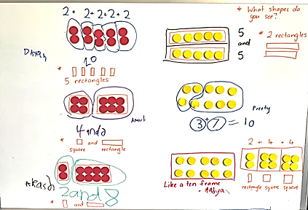

Making squares from rectangles: Is it possible? – 40 minutes
This activity has been adapted from Geo Paper Polygons: Exploring 2D Shapes Through Paper Folding by Burnett et al. (2007).
- Revisit the responses from Daily number sense and how students found squares within the rectangle. Ask students for similarities and differences between a rectangle and a square. Draw both 2D shapes and record student responses.
- Ask Stage 1 students if they can make a square out of a piece of A4 paper (rectangle) and Early Stage 1 students if they can make a square out of modelling clay.
- Provide Stage 1 pairs with multiple pieces of A4 paper and scissors. Students fold and cut the paper to make a square.
- Provide Early Stage 1 students with modelling clay to build a square.
- Students share their square and how they created it. Ask students:
- How do you know you have made a square?
- What features must be included to make it a square?
- What tools could you use to prove your 2D shape is a square?
Note: Not all students will have made a true square. It is important that through this discussion, students understand the features of a square. Stage 1 students may suggest using paperclips, interlocking cubes, or similar informal units to measure and compare the length of the sides to ensure they are equal. Early Stage 1 students may suggest comparing the length of the sides by placing them side by side.
Square: A four-sided shape (quadrilateral and a parallelogram) with all sides of equal length and all 4 interior angles equal (right angles).
- Stage 1 students check their square using informal units to measure if all sides are equal. They record their measurement, for example, 8 counters on each side of their square as in Figure 3.
- Early Stage 1 students compare the lengths of each side by placing them side by side and aligning the ends to check if they are equal, Figure 3.
Figure 3 – Measuring sides
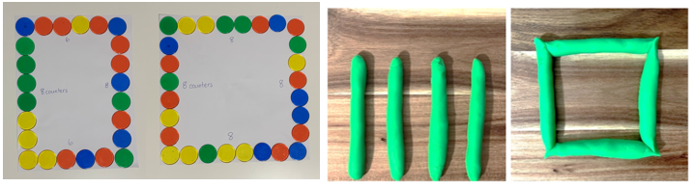
- Students share with the class how they checked that their sides are equal and if they created a square.
- Stage 1 students then check if all 4 vertices (corners) are the same size. Demonstrate overlaying a book on the vertex to see if they align. Students tick all the vertices which align.
- With a partner, students reflect on their square and if they have created a true representation.
Note: If needed, demonstrate to students how to make a square. Watch How to make a square (2:04) to see the 2 methods.
- Provide Stage 1 students with paper of different sizes and colour. Ask if it is possible to make squares with this paper using the same method.
- Stage 1 students create squares using the paper and check if they are a true representation of a square by measuring the sides and vertices. They record their working on the squares they create.
- Early Stage 1 students create squares of different sizes using modelling clay. They compare the length of their sides to ensure they are equal in length.
The table below details assessment opportunities and differentiation ideas.
Assessment opportunities | Too hard? | Too easy?
What to look for.  - Can students describe the features of a square as being 4 equal sides? (MAE-2DS-01)  - Can students compare lengths by directly placing objects side to side and aligning the ends? (MAE-GM-01)  - Can students describe the features of a square as being 4 equal sides and 4 vertices of the same size? (MA1-2DS-01)  - Can students represent the features of a square by creating a true representation? (MAO-WM-01, MAE-2DS-01, MA1-2DS-01)  - Can students use informal units to measure the length of the sides and the vertices? (MA1-GM-02)  What to collect:  - work samples of squares. (MAO-WM-01, MAE-2DS-01, MA1-2DS-01) | Students confuse a rectangle for a square or attend to non-necessary attributes (size, orientation, colour, texture, material) when thinking about what makes a square a square.  - Help students to check their shape against the other examples of squares or known shapes.  - Ask if this shape (square on its point identified by student as a diamond) could be moved or rotated to look like this square.  Students attend to only some features. For example, it is a square because it has 4 sides.  - Help students to check their thinking against the other examples of squares or known shapes.  - For example, explain that a rectangle has 4 sides too, and ask what other features make a square a square.  Students are not confident measuring the lengths of each side.  - Provide a template for students to superimpose their square onto the template and align the sides and vertices.  - Demonstrate how this works with a square and not with a rectangle. | Students record their findings, referencing all features of a square.  - Ask students to consider if a square is a rectangle.  - Prompt students to explain their thinking and write an argument to prove their response.

Discuss and connect the mathematics: 10 minutes
- Display a variety of work samples from both Early Stage 1 and Stage 1 students and co-construct a Frayer diagram, see Figure 4. Draw attention to the different sized squares, non-examples as well as the different colours. Ask students:
- What do all these shapes have in common?
- Do size and colour change what makes a square a square?
- How do you know when something is not a square?
- How did you decide if your shape was a square? What were you looking for?
- Did you find anything challenging when proving your square was a square?
- What are some non-examples of squares and why are they not a square?
Figure 4 – Student work samples
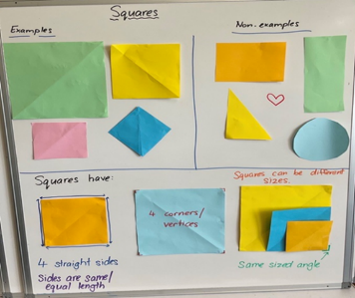

Lesson 3: Making shapes
Core concept: Shapes can be classified into different categories.
The table below contains suggested learning intentions and success criteria. These are best co-constructed with students.
Learning intentions | Success criteria
All students are learning that:  - numbers have a sequence and can be arranged by considering the order and size of the numbers  - shapes can be sorted and classified in more than one category  - quadrilaterals and polygons have necessary features that determine their name. | All students can name and describe the features of 2D shapes using mathematical language.  In addition, students working towards Early Stage 1 outcomes can:  - state the number after or before a given number without counting from one  - sort 2D shapes based on their features (size and shape)  - recognise and explain how a group of 2D shapes have been sorted.  In addition, students working towards Stage 1 outcomes can:  - sequence numbers and arrange them on a number line  - sort and classify quadrilaterals and polygons.

Daily number sense: Sequence numbers – 10 minutes
- Build student understanding of sequencing numbers by considering the order of the given numbers.
- Draw a number line with missing values.
- Using an individual whiteboard, Stage 1 students complete the number line with the missing numbers and Early Stage 1 students state the number after and before the plotted numbers.
- Students share and justify the placement of their numbers on the number line, see Figure 5.
Figure 5 – Number line
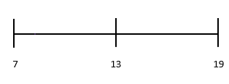
- Continue with a different number range.
The table below details assessment opportunities and differentiation ideas.
Assessment opportunities | Too hard? | Too easy?
What to look for.  - Can students state the number after or before a given number without having to count from one? (MAE-RWN-01)  - Are students able to identify missing numbers and sequence them on a number line? (MA1-RWN-01)  What to collect:  - observational data. (MAO-WM-01, MAE-RWN-01, MA1-RWN-01) | Students are not confident with adding the missing numbers to the number line.  - Use a familiar range for students to plot their initial numbers, for example, 0-10.  - Have students plot from 10-20 and identify the similarities and differences between both lines. Students use these lines to assist them in plotting the missing numbers on other number lines under 30.  Students are not confident plotting the number before and after a given number.  - Students use a number chart to assist them with identifying numbers before a given number.  - Students use a number chart to assist them with identifying numbers after a given number. | Students are confident with adding the missing numbers to the number line.  - Challenge students to plot numbers by counting in twos from the initial number given.  - Students circle odd numbers and underline even numbers.  - Provide students with a number range using three-digit numbers.

Paper folding shapes – 50 minutes
This activity has been adapted from Make a Shape in Mindset Mathematics: Visualising and Investigating Big Ideas, Grade K by Boaler et al. and Geo Paper Polygons: Exploring 2D Shapes Through Paper Folding by Burnett et al. (2007).
- Ask students what it could look like if they were to draw a shape with 3 straight sides. Students turn and talk and then share ideas with the class.
- Ask students to consider what happens to the shape if an additional straight side is added. Students turn and talk and then share ideas with the class.
- Provide a range of materials for creating 2D shapes, for example Geoboards/pegboards and rubber bands, ribbon/string and tape or pipe cleaners. Challenge Early Stage 1 students to work in pairs to create as many different 2D shapes as possible with 3 and 4 sides, see Figure 6.
Figure 6 – Shapes
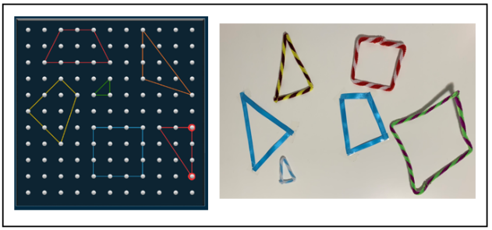
Note: Early Stage 1 students stick their shapes onto large paper to make a poster.
- Display Resource 3: Folding rhombus for Stage 1 students and ask what they know about the 2D shape. Students share their responses.
- Stage 1 students cut out Resource 3: Folding rhombus.
- Display Resource 4: Instructions and direct Stage 1 students to build:
- equilateral triangle – fold the rhombus in half along the dotted line
- hexagon – fold the outer corners of the rhombus inwards so that the corners meet in the middle
- trapezium – take the hexagon and fold it in half
- pentagon – start with your original shape, the rhombus, and fold only one corner in so that it meets the point in the middle.
Note: After building each 2D shape, allow students to share what they notice and discuss the features of each shape. For example, a triangle is a polygon with 3 straight sides and 3 interior angles (vertices).
Polygon: Plane shape bounded by 3 or more line segments.
Quadrilateral: Plane shape bounded by four-line segments.
- Place Stage 1 students in groups of 4. One person from each group builds one of the 4 shapes so that each group has an equilateral triangle, a hexagon, a trapezium and a pentagon. Students label the shape they build. Provide all groups with an original rhombus, Resource 3: Folding rhombus.
- Ask Stage 1 groups to sort and classify their shapes.
- Whilst Stage 1 are sorting their shapes, have Early Stage 1 students share one of the three- and four-sided shapes they made. Ask students:
- How do you know you have made a shape with 3 or 4 sides?
- Do we all agree? Why or why not?
- Which of these three-sided shapes are triangles?
- How do you know these shapes are triangles?
- Which of these four-sided shapes are squares/rectangles?
- How do you know these shapes are squares/rectangles?
Note: Elicit student responses relevant to the features of a triangle, square and rectangle, for example, it has 3 straight sides and 3 corners (vertices). If a student has made a shape like a triangle with 2 of the sides not joined up, explain that 2D shapes need to have all sides joined to be a shape.
- Provide Early Stage 1 pairs with a collection of pattern and attribute blocks. Challenge students to sort the shapes according to features such as size and shape. One student sorts the shapes, and their partner asks questions to determine how they have been sorted. Partners take turns sorting, guessing the sort and explaining how they have sorted the shapes.
- Ask Stage 1 groups to share how they grouped their shapes and provide justifications as to why they have grouped them in certain ways. Highlight sorts where quadrilaterals have been grouped together.
- Display and introduce the terms quadrilateral and polygon. Discuss the features relevant for classifying quadrilaterals and polygons. Students work with their group to identify and group their shapes using these headings.
Note: A 2D shape can be classified into more than one category and have different names. For example, a rectangle is a polygon and a quadrilateral, but a pentagon is only a polygon.
- Provide Stage 1 students with a wide range of materials, for example, Geoboards/pegboards, rubber bands, straws, pipe cleaners or toothpicks. Challenge students to create as many quadrilaterals and polygons as they can. Prompt students to build shapes of 7, 8, 9, 10, 11 and 12 sides.
- As students build their shapes, have them identify which categories their shapes belong to and if the shape belongs to more than one category.
Note: Take photos of how Early Stage 1 and Stage 1 students have sorted and built (Stage 1) their shapes to use in Discuss and connect the mathematics.

Discuss and connect the mathematics – 10 minutes
- Display student work samples and have them examine how they have sorted their shapes. Ask students:
- Which shapes have you built?
- Have you built a shape you do not know the name of?
- Can you name the features of the shapes?
- How do you know if it is a quadrilateral and/or a polygon?
- Why did you sort your shapes in these groups?
- How else could they be sorted?
Note: Looking at work samples, draw attention to any irregular polygons. A regular polygon is where all sides are the same length, and all angles are the same size. If all the sides are not the same length and all the angles are not the same size, it is called an irregular polygon. All closed shapes with straight sides are polygons. Triangles, quadrilaterals, pentagons, hexagons, heptagons, and octagons can all be classified as polygons.
The table below details assessment opportunities and differentiation ideas.
Assessment opportunities | Too hard? | Too easy?
What to look for.  - Are students able to name and describe a triangle, square and rectangle? (MAE-2DS-01)  - Are students able to sort 2D shapes and explain how the shapes have been sorted? (MAO-WM-01, MAE-2DS-01)  - Can students sort and classify quadrilaterals and polygons? (MAO-WM-01, MA1-2DS-01)  - Can students name and describe the features of quadrilaterals and polygons with appropriate mathematical language? (MA1-2DS-01)  What to collect:  - photographs of student work samples. (MAO-WM-01, MA1-2DS-01) | Students are not confident with creating 2D shapes with the materials provided.  - Have students identify any of the shapes they know.  - Find these shapes in the classroom and have students use them as a model to create shapes from the materials provided.  Students are not confident identifying the features of 2D shapes.  - Have students identify the shapes they know and name the features of those shapes.  - Ask if students can see any similarities between the shapes they know and the new shapes.  Students are not confident sorting shapes based on their features.  - Provide students will a smaller collection of shapes and ask them to sort them into the same colour groups.  - Support students to identify that they have been sorted based on one of their features, being colour. | Students are confident with creating and naming a range of shapes and listing the features.  - Have students manipulate their shapes to see if they can find other/smaller 2D shapes within their shape.  - Students combine shapes to create another shape and list the features of their new shape.

Lesson 4: Hexagon filler
Core concept: Smaller shapes are hiding within larger shapes.
The table below contains suggested learning intentions and success criteria. These are best co-constructed with students.
Learning intention | Success criteria
All students are learning that there are many ways to combine two-dimensional shapes to make new two-dimensional shapes. | All students can:  - turn shapes to fit in a space  - create shapes by combining other shapes  - find smaller shapes in larger shapes.

Daily number sense: Is it a triangle? – 10 minutes
- Build student understanding of the attributes of 2D shapes by justifying their reasons when solving a problem.
- Display Resource 5: Triangles and ask students if all the 2D shapes displayed are triangles.
- Students turn and talk to share their thinking with a partner.
- Invite students to share their reasons with the class and record their ideas.
Note: Students may think some of the quadrilaterals are triangles because of the point. Revise the features of a triangle to assist students in distinguishing between examples.

Building a hexagon – 40 minutes
This activity has been adapted from Taking Shape: Activities to Develop Geometric and Spatial Thinking, Grades K-2 by Moss et al. (2016)
- View and discuss The Stickie Gang, Episode 3: Identifying 2D Shapes (1:13)
- Show students Resource 6: Hexagon filler gameboard. Ask students to identify the shape and describe its features.
- Cut up Resource 7: Hexagon filler game cards and display 2 of the cards. Ask students what they notice about the shape/s.
- Choose a student to play against to model the activity. Explain that the aim of the game is to be the first player to fill all the hexagons.
- Select a game card from the deck. Show the card to the students and ask them to identify the shapes. Then find the corresponding pattern block/s for each shape on the card. Place these pattern blocks onto Resource 6: Hexagon filler gameboard.
Note: You can choose to place all the blocks on one hexagon or spread them across several hexagons. Once the blocks have been placed on the gameboard they cannot be moved. Not all the shapes pictured on your selected card need to be used. You can choose to only use some of them.
- The student then selects a game card from the deck, shows the class, names all the shapes and finds the corresponding pattern blocks. They place the pattern blocks onto their own Resource 6: Hexagon filler gameboard.
- For your next turn, choose a game card, name the shapes, and select incorrect pattern blocks and/or deliberately place the blocks incorrectly on the gameboard. Provide time for students to notice the error. If they do not notice the error, ask if they think all the blocks on the gameboard fit.
- Continue playing against the student, ensuring all students understand the rules and how to manipulate the 2D pattern blocks into the hexagons on the gameboard.
- Provide Stage 1 pairs with Resource 6: Hexagon filler gameboard and Resource 7: Hexagon filler game cards to play each other.
- Provide Early Stage 1 pairs with only Resource 6: Hexagon filler gameboard. Challenge students to use pattern blocks to create as many different hexagons as possible within the outline of the hexagon from Resource 6: Hexagon filler gameboard.
Note: Early Stage 1 students may not know the names of all the 2D pattern blocks, for example trapezium and rhombus. The initial focus for Early Stage 1 is on triangles, circles, squares, and rectangles. Students can describe the features of these new 2D shapes and be exposed to their names.
- Use Resource 8: Assessing gameplay as you move around the room and observe students playing the game.
Note: Printing the gameboard and game cards on cardboard will allow you to use this in future activities.
The table below details assessment opportunities and differentiation ideas.
Assessment opportunities | Too hard? | Too easy?
What to look for:  - Are students able to turn shapes to fit into a shape outline? (MAO-WM-01, MAE-2DS-01)  - Are students able to move, flip, or rotate shapes to fit in a hexagon outline? (MAO-WM-01, MA1-2DS-01)  - Can students use pattern blocks to create new shapes by combining them? (MAO-WM-01, MAE-2DS-01, MA1-2DS-01)  - Are students able to identify smaller shapes in larger shapes? (MAO-WM-01, MAE-2DS-01, MA1-2DS-01)  What to collect:  - Resource 8: Assessing gameplay (MAO-WM-01, MAE-2DS-01, MA1-2DS-01)  - photographs of student work (MAO-WM-01, MAE-2DS-01, MA1-2DS-01) | Students are not confident building a hexagon using other 2D shapes.  - Model that shapes can be flipped or turned from the orientation of the shape/s presented on the game card to fit a space on the hexagon.  - Encourage students to flip and turn different blocks to fit within the hexagon.  Students are not confident picking the corresponding pattern block to the game card.  - Model placing the chosen pattern block on top of the corresponding shape on the game card.  - Support students to mirror this task by placing the chosen pattern block on top of the corresponding shape on the game card. | Students can confidently create a hexagon using a variety of pattern blocks.  - Challenge students to build other 2D shapes using a variety of pattern blocks.  - Challenge students to build other 2D shapes using a variety of materials.

Discuss and connect the mathematics – 10 minutes
- Students go on a gallery walk and look at the various gameboards. Discuss what they notice about the hexagons on each gameboard and how they have been made. Encourage students to notice what is the same, what is different, and if there is anything they now wonder.
Note: Take photographs of different gameboards and the way hexagons have been created to use in Lesson 5.
- Select students to share their ideas with the class and what they notice about the way the hexagon has been made.
The table below outlines stimulus prompts to generate conversation, along with anticipated responses from students.
Prompts | Anticipated student responses
What do you notice about the way the hexagon has been made? | - I noticed that these hexagons are made with the same shape of 6 triangles/2 trapeziums/3 rhombuses.  - I noticed that a rhombus and a triangle make a trapezium so there are shapes hiding inside trapeziums too.

Lesson 5: What shapes are hiding inside a square?
Core concept: Smaller shapes are hiding in larger shapes.
The table below contains suggested learning intentions and success criteria. These are best co-constructed with students.
Learning intention | Success criteria
All students are learning that there are many ways to combine two-dimensional shapes to make new two-dimensional shapes. | All students can create 2D shapes by manipulating and combining other 2D shapes.  In addition, students working towards Early Stage 1 outcomes can describe the features of familiar 2D shapes (rectangle, triangle, and square).  In addition, students working towards Stage 1 outcomes can demonstrate and record how to break shapes apart to find smaller shapes inside.

Daily number sense: Which one does not belong? – 10 minutes
- Build student understanding of subitising by viewing different number representations.
- Display Resource 9: Odd one out and ask students to justify which dice does not belong. Provide thinking time.
- Students Think-Pair-Share and then invite students to share their ideas with the class.
- As students are sharing their thinking, invite peers to ask questions and add their ideas.
Note: There could be a case made for each dice not belonging based on the features of the dice or the representations of numbers.

Consolidation and meaningful practice: 15 minutes
- Display photographs from Lesson 4. Students identify and discuss the different shapes used to create a hexagon.
- Display Resource 10: Shapes in a hexagon and ask students if there is another way to build a hexagon without using pattern blocks. Students Think-Pair-Share and then provide examples of how this can be done.
- Cut Resource 10: Shapes in a hexagon to demonstrate some of the suggestions on how to partition the hexagon, see Figure 7. Model recording the shapes that were found in the hexagon.
Figure 7 – Shapes in a hexagon
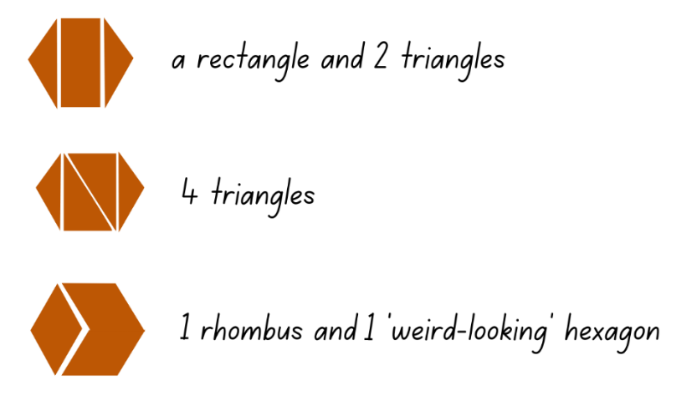

Shapes made by shapes – 25 minutes
- Discuss how it is possible to find different shapes within other shapes and how many were found in a hexagon. Display a square piece of coloured paper and ask if there might be shapes inside the square.
- Stage 1 students investigate the paper squares to find different 2D shapes within it. They can fold, cut and/or draw to investigate the range of shapes. Students glue squares into their book and record the shapes they found, see Figure 8.
Figure 8 – Shapes
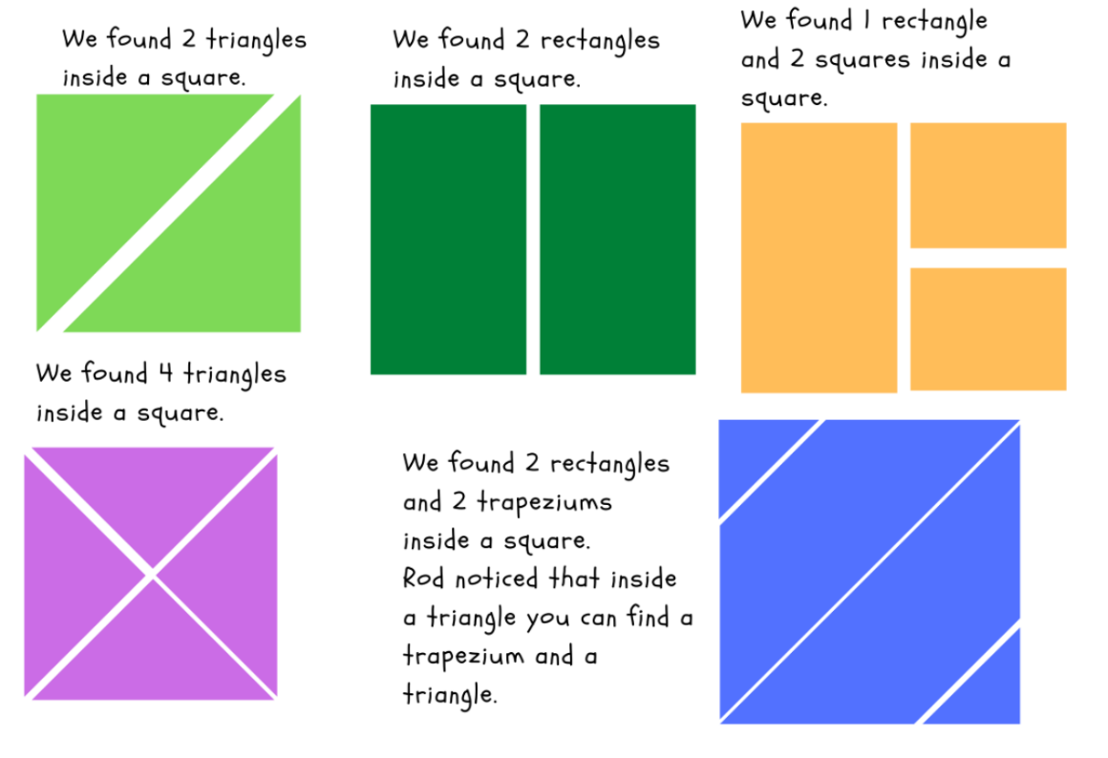
- Provide Early Stage 1 students with a collection of pattern blocks and challenge them to build as many different 2D shapes as they can. After building a 2D shape, students trace around the outside of the 2D shape, verbally name it and its features and if possible, write the name. Students work in pairs to assist each other tracing the 2D shapes, see Figure 9.
Figure 9 – Shape outline
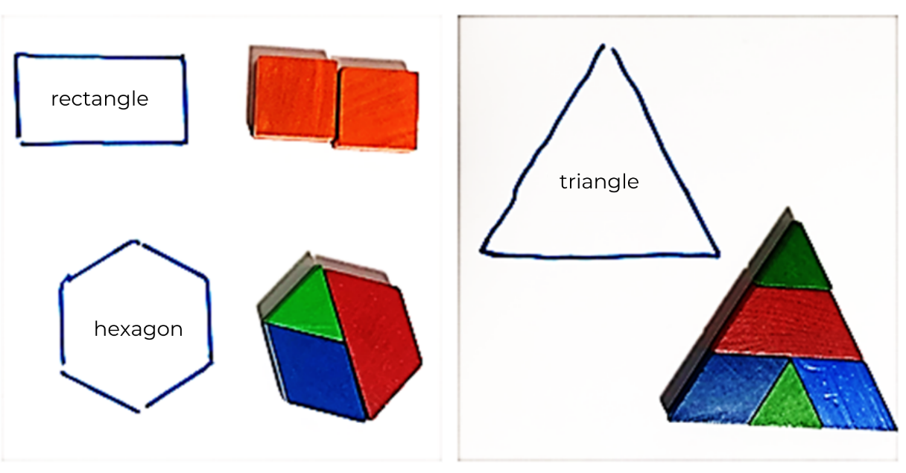
Note: Early Stage 1 students may not know the names of all the 2D pattern blocks or 2D shapes they build, for example trapezium and rhombus. The initial focus for Early Stage 1 is on triangles, circles, squares, and rectangles. Students can describe the features of these new 2D shapes and be exposed to their names.

Discuss and connect the mathematics – 10 minutes
- Stage 1 students provide examples of the different ways they partitioned their square and what 2D shapes they found.
- Early Stage 1 students show some of the 2D shapes they created and what pattern blocks they used.
- Ask students:
- What have we discovered about 2D shapes?
- How did you record your findings/show your thinking?
- How many 2D shapes did you make?
- Can you describe the features of the 2D shapes you made?
- Was there anything you found challenging?
- How did you work like a mathematician today?
The table below details assessment opportunities and differentiation ideas.
Assessment opportunities | Too hard? | Too easy?
What to look for.  - Are students able to name and describe the features of a triangle, square and rectangle? (MAE-2DS-01)  - Are students able to identify and cut a shape to find smaller shapes inside? (MAO-WM-01, MA1-2DS-01)  - Can students create a shape by manipulating and combining other shapes? (MAO-WM-01, MAE-2DS-01, MA1-2DS-01)  What to collect:  - student work samples. (MAO-WM-01, MAE-2DS-01, MA1-2DS-01) | Students find it challenging to build 2D shapes using pattern blocks.  - Provide students with a template of a triangle, square or rectangle to use as a guide.  - Model how to turn pattern blocks to fit like a puzzle within the template.  Students cut their square into many pieces but are unable to reconstruct it back into a square.  - Encourage students to fold the square to partition it into shapes with straight sides.  - Students then unfold the square to see the smaller shapes, colour each shape and then cut along the folds.  Students find it challenging to identify the shapes they have found within the square.  - Have students use Resource 1: Stage 1 table to recall and identify the properties of different 2D shapes.  - Help students make the connection between the shapes in the table and the ones they have found. | Students are confident partitioning squares into smaller shapes and identifying the shapes inside.  - Investigate how other shapes like triangles, pentagons or quadrilaterals might have smaller shapes hiding in them.  - Students manipulate concrete materials to create a range of smaller shapes inside shapes.

Lesson 6: Paper halving
Core concept: Not all halves look the same but remain equal.
The table below contains suggested learning intentions and success criteria. These are best co-constructed with students.
Learning intention | Success criteria
All students are learning that when a whole has been partitioned (shared) equally in 2, the parts created are called halves. | All students can halve shapes and objects into 2 equal parts.  In addition, students working towards Early Stage 1 outcomes can describe the position as about halfway, more than halfway or less than halfway.  In addition, students working towards Stage 1 outcomes can:  - halve the same shape in different ways  - check working to see if equal halves have been created.

Daily number sense – 10 minutes
- Identify a class need through formative assessment data and complete a short, focused activity that targets students’ knowledge, understanding and skills. Example activities may be drawn from the following resources:
- Thinking mathematically Stage 1
- Universal Resources Hub

Exploring halves – 20 minutes
This activity has been adapted from Paper halving – part 1 (11:58) and Paper halving – part 2 (13:46) from Thinking mathematically.
- Read Give Me Half! and highlight how the characters need to share the items equally between them. Ask students:
- Have you ever had to share an item between 2 people?
- How did you make sure you had shared it equally?
- Display Resource 11: Examples of halves. Ask students what they notice, what is the same and what is different about the images.
- Provide individual thinking time before students turn and talk.
- Strategically select students to share their thinking with the class. Ask students:
- What do you notice about the images?
- Is there something in common between the images?
- What are some things you already know about halves?
- Do all the halves look the same?
Note: Highlight that halves can look different, but still be a half because the whole was divided (shared) into 2 equal parts.
- Provide each student with a piece of A4 paper. Students attempt to halve their piece of paper.
- Students share how they halved their paper. Highlight how there are many ways that a piece of paper can be halved (horizontally, vertically, diagonal, and so on) see, Figure 10.
Figure 10 – Paper halves
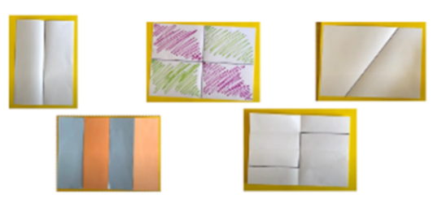
- Provide pairs of Stage 1 students with a few pieces of A4 paper and pencils to demonstrate different ways to halve a piece of paper. Students can fold or use pencils to indicate different halves. Challenge students to identify and record the different 2D shapes they create whilst halving the pieces of paper.
- Model to Early Stage 1 students how to find items around the classroom and use a pipe cleaner to partition the object into 2 equal parts to create halves.
- Early Stage 1 pairs collect objects from around the classroom and use pipe cleaners to create halves, see Figure 11.
Figure 11 – Half
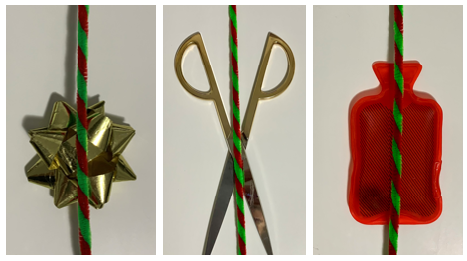

Discuss and connect the mathematics – 10 minutes
- Students display their work and go on a gallery walk. Students compare the ways their peers halved the paper or objects, with how they halved their own, taking note of which methods are the same and which are different.
Note: Look for examples of the way pieces of paper and objects have not been halved equally. Use these examples as a prompt for further thinking or alternatively, have an example prepared. View Paper halving – part 2 (from 5:32).
- Display an example where a piece of paper or object has not been halved equally. Ask students:
- What makes something a half?
- Has this piece of paper been halved?
- How can we prove that it has been halved?
Note: Stage 1 students should suggest strategies to prove a half by using direct comparison, further folding, using informal units like interlocking cubes, pattern shapes or sticky notes. If they do not, guide discussion to come up with a collection of ideas.

Proving halves – 30 minutes
- Provide pairs of Stage 1 students with a range of suggested materials. Students use informal units to cover the surface of each half to prove they have created equal halves.
- Stage 1 students sort their pieces of paper into equal halves and non-equal halves.
- Demonstrate to Early Stage 1 how an object can be about halfway, more than halfway or less than halfway. Move the pipe cleaner on the object showing each position.
- Early Stage 1 students work together to demonstrate about halfway, more than halfway or less than halfway on all the objects they collected.
- Early Stage 1 students choose one of the objects to draw and show about halfway, more than halfway or less than halfway.
- As a class, Stage 1 students demonstrate and share the way they proved their paper was divided into 2 equal halves. Early Stage 1 students model showing the position of their pipe cleaner and using the vocabulary, about halfway, more than halfway or less than halfway.
Note: Take photographs of how students have sorted their halves.
The table below details assessment opportunities and differentiation ideas.
Assessment opportunities | Too hard? | Too easy?
What to look for.  - Can students accurately halve a piece of paper? (MAO-WM-01, MAE-GM-03, MA1-2DS-01, MA1-GM-03)  - Can students show and describe the position as about halfway, more than halfway or less than halfway? (MAE-GM-03)  - Are students able to divide an object into 2 equal parts using a pipe cleaner to mark halfway? (MAE-GM-03)  - Are students able to identify different ways to halve a piece of paper? (MAO-WM-01, MA1-2DS-01, MA1-GM-03)  - Can students use materials to check they have created equal halves? (MAO-WM-01, MA1-2DS-02)  What to collect:  - photographs of student work (MAO-WM-01, MAE-GM-03, MA1-2DS-01, MA1-GM-03) | Students are not confident halving a piece of paper or using a pipe cleaner to mark halfway.  - Have students tell you anything they know about halves. Encourage links between their knowledge and halving a piece of paper. Model one way to halve the paper and ask them if they have another way to halve it.  - Provide students with a circular piece of paper as half always looks the same.  - Provide students with modelling clay and demonstrate how to physically break the item into 2 equal parts. | Students confidently halve A4 paper in a range of ways.  - Prompt students to think of other ways to halve an object using more than one-fold line, see Figure 10.  - Provide a piece of paper that has been halved in a complex way and ask the student to prove or disprove whether the paper has been halved.

Lesson 7: Transform shapes
Core concept: Objects can be transformed using movement.
The table below contains suggested learning intentions and success criteria. These are best co-constructed with students.
Learning intentions | Success criteria
All students are learning that shapes can be moved to create a variety of patterns.  Students working towards Early Stage 1 outcomes are learning that shapes can be turned to fit into a given space.  Students working towards Stage 1 outcomes are learning that shapes can be transformed using slides (translations) and reflections. | Students working towards Early Stage 1 outcomes can:  - continue and create repeating patterns  - turn shapes to make patterns and designs.  Students working towards Stage 1 outcomes can:  - identify slides (translations) and reflections in images and patterns  - make repeating patterns which involve slides (translations) and reflections.

Daily number sense: Shape sides – 10 minutes
- Build student understanding of number by investigating the number of sides a 2D shape has.
- Display or draw a pattern block and have students name the 2D shape and recall the number of sides.
- Early Stage 1 students record the number of sides the 2D shape has on their individual whiteboard. Then record the number before and after, Figure 13 – Shape sides.
- Double the pattern block for Stage 1 students so that 2 are displayed. Stage 1 students record the number doubled on their individual whiteboard, see Figure 12.
Figure 12 – Shape sides
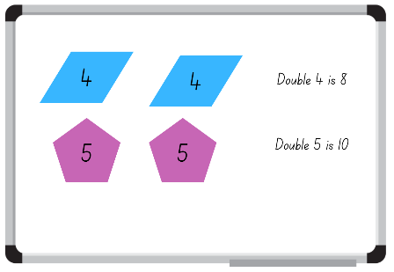
Images from Canva are licensed under Canva Content License Agreement.
- Choose students to share their responses and the strategy they used to get the total.

Translations and reflections – 25 minutes
This activity has been adapted from Making Patterns from NZ Maths.
- Display Resource 12: Patterns. Students turn and talk to discuss what they see in the image. Ask students:
- What 2D shapes are represented in the images?
- Are the 2D shapes the same each time?
- How are the 2D shapes the same? (shape, size, orientation, colour)
- Provide Early Stage 1 students with a collection of pattern and attribute blocks and challenge them to manipulate shapes to make a design inspired by Resource 12: Patterns, see Figure 13.
Figure 13 – Pattern block designs
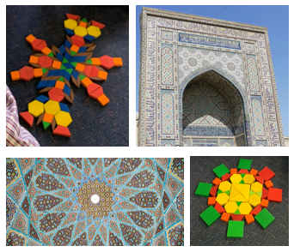
Images from Pixabay are licensed under the Pixabay Licence.
- Display Resource 13: Translation pattern for Stage 1 students and ask the same questions from step 6.
- Ask Stage 1 students to make a similar pattern using the pattern blocks. Whilst students are making their pattern, ask how they are transforming the shape. Guide students to see how the movement of the shape is a slide (translation).
- Allow time for students to use various shapes to practise sliding (translation) vertically, horizontally, and diagonally, see Figure 14.
Figure 14 – Slide (translation)
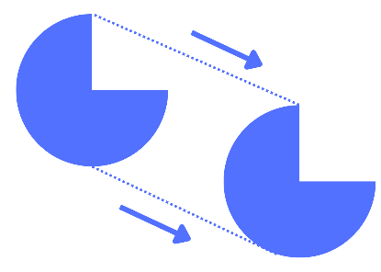
Images from Canva are licensed under Canva Content License Agreement.
Slide (translation): Sliding a shape without turning it.
- Display and print Resource 14: Reflection image. Stage 1 students turn and talk to discuss what they see in the image.
- Students share their ideas. Guide students to express that the image has been reflected and could be folded in half.
- Fold the image and use a mirror on the fold to show the reflection is the same as the other side.
- Provide Stage 1 students with a collection of pattern blocks and a mirror to look at how shapes reflect. Students model reflection with the pattern blocks. Draw attention to how some 2D shapes appear to look the same but have been reflected, see Figure 15.
Figure 15 – Reflection
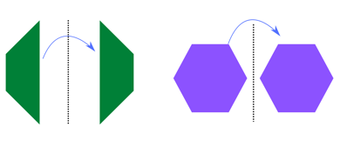
Images from Canva are licensed under Canva Content License Agreement.
- Early Stage 1 students display their designs for the class, highlighting the different 2D shapes they have used.
Reflection: Transformation of a shape formed by creating a mirror image on the other side of a given line.

Patterns – 15 minutes
- Create and display a repeating linear pattern with Pattern blocks that includes reflection and translation, see Figure 16. Ask students:
- Why is this a pattern?
- What would come next?
- Do any of the shapes show reflection? (Stage 1)
- Do any shapes slide (translation)? (Stage 1)
Figure 16 – Linear pattern
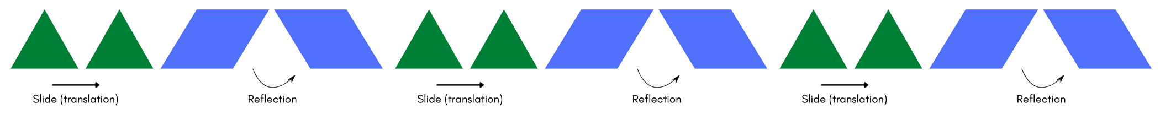
- Provide students with a collection of pattern blocks and challenge them to create a repeating linear pattern which includes:
- 2 or 3 different 2D shapes
- reflection (Stage 1)
- slide (Stage 1).
Note: Early Stage 1 students need to create and continue a pattern using 2D shapes, they may transform shapes, however it is not the expectation.
- Students create a variety of patterns with Stage 1 students including reflection and sliding in their patterns.
Linear pattern: A pattern created by the regular repetition of units with the same difference between terms.

Discuss and connect the mathematics – 10 minutes
- Students display their patterns and go on a gallery walk to determine the rule in their classmates' patterns. As they are observing patterns, ask students:
- Does this pattern have reflection and if so, where? (Stage 1)
- Does the shape slide (translation) and if so, where? (Stage 1)
- What would come next?
- As a class, reflect on whether students feel confident with their understanding of the success criteria.
The table below details assessment opportunities and differentiation ideas.
Assessment opportunities | Too hard? | Too easy?
What to look for.  - Can students identify slides (translations) in images and patterns? (MA1-2DS-01)  - Can students identify reflections in images and patterns? (MA1-2DS-01)  - Can students make repeating patterns which involve slides (translations) and reflections? (MAO-WM-01, MA1-2DS-01)  - Are students able to continue and create repeating patterns? (MAO-WM-01, MAE-FG-01, MAE-2DS-01)  - Are students able to turn shapes to make patterns and designs? (MAE-2DS-01)  What to collect:  - observational data. (MAO-WM-01, MAE-2DS-01, MAE-FG-01, MA1-2DS-01) | Students are not confident reflecting and sliding (translating) single shapes.  - Show students how to make the first slide (translation) or reflection of the shape, focusing on how it moves.  - Students model your movement and discuss what happened when sliding or reflecting the shape.  Students are not confident in creating a pattern with 2 or 3 different 2D shapes that slide (translation) and reflect or creating a simple pattern.  - Students create a pattern using one 2D shape (trapezium) with a focus on either sliding (translating) or reflecting.  - Create a simple pattern for students to copy and continue. | Students are confident with identifying and creating patterns that use slide (translation) and reflection.  - Students find natural materials like flowers or leaves and identify patterns within these objects. They look at the shapes within the patterns and determine if the shapes are reflecting or sliding.  - Students consider if there is a different transformation happening within the object.

Lesson 8: Symmetry and design
Core concept: 2D shapes are represented in pictures and designs. A symmetrical object is reflected with the same image.
The table below contains suggested learning intentions and success criteria. These are best co-constructed with students.
Learning intentions | Success criteria
Students working towards Early Stage 1 outcomes are learning that 2D shapes can be represented in pictures and designs.  Students working towards Stage 1 outcomes are learning that objects may have a line of symmetry. | All students can:  - turn shapes to fit and match a given design  - make pictures and designs using a selection of shapes  - identify familiar 2D shapes.  In addition, students working towards Stage 1 outcomes can:  - identify lines of symmetry in objects and pictures  - make patterns or designs which have a line of symmetry.

Daily number sense: Number bonds to 10 – 10 minutes
- Build student understanding of number bonds to 10 by providing a range of number representations to recall and record combinations.
- Display Resource 15: Representations of numbers. Students choose one number representation from inside the box and one or two number representations from outside the box and combine them to make 10.
- Students use their individual whiteboard to record their combinations, see Figure 17.
Figure 17 – Number bonds to 10
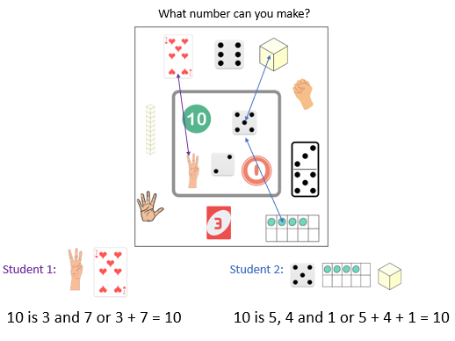
Images from Canva are licensed under Canva Content License Agreement.
- Choose different students to share how they used different representations to build 10.

Finding the line of symmetry and creating pictures – 30 minutes
This activity has been adapted from Pattern Matching from NZ Maths.
- Provide Early Stage 1 students with a collection of pattern and attribute blocks and Resource 16: 2D shape pictures. Students work independently to build the pictures in Resource 16: 2D shape pictures, see Figure 18. While working, ask students:
- What was the first 2D shape you used?
- How did you know to place it in that position?
- Which design was the most challenging?
- What 2D shapes have you used?
- Do you recognise any 2D shapes that have been created out of the smaller 2D shapes?
Figure 18 – Shape pictures
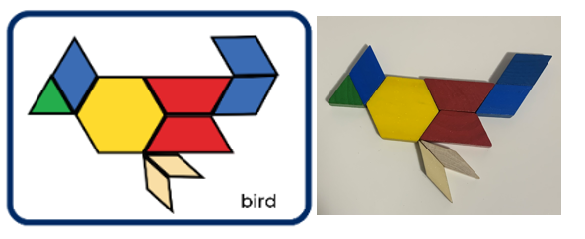
Note: Printing Resource 16: 2D shape pictures on cardboard will allow you to use them in future activities or rotations. Students are not building the pictures on the cards; the cards are to guide the build.
- In small groups, Stage 1 students cut out Resource 17: Shapes, talk about the shapes and share what they know about them.
- Ask Stage 1 students if they can fold their shapes in half so both halves are the same. Students work with their group to fold their shapes.
- As a class, Stage 1 groups share which shapes they could easily fold in half, and which ones were more difficult.
- Choose a shape with a line of symmetry and show how to draw a line on the fold. Use a mirror on the fold line to create (reflect) an image of the whole shape. Choose another shape which does not have a line of symmetry and draw a line on the fold. Use the mirror to show (reflect) that it does not create the whole shape.
- Explain that the fold line that creates the same halves side by side is called the line of symmetry.
Symmetry: A shape has line symmetry if matching parts are produced when it is folded along a line of symmetry. Each part represents the mirror image of the other.
- Provide Stage 1 students with a collection of objects and Resource 18: Images as well as mirrors and straws (used for a folding line). Students explore the various objects and use the mirrors and straws to sort the objects into 2 groups, objects with a line of symmetry and objects without a line of symmetry. As they are sorting objects, ask students:
- Why have you chosen this object?
- Did you use the mirror to see if the halves are the same?
- Can you put a straw down the line of symmetry?
- Why does this object not have a line of symmetry?
- How can you be sure?
Note: Some shapes and pictures have more than one line of symmetry. Allow students to discover this. Straws or similar items like pencils or wooden skewers are used to assist students in identifying and marking the line of symmetry.

Discuss and connect the mathematics – 20 minutes
- Provide Stage 1 students with a collection of pattern blocks, a mirror and a straw to create a symmetrical pattern/design, see Figure 19.
Figure 19 – Symmetrical designs
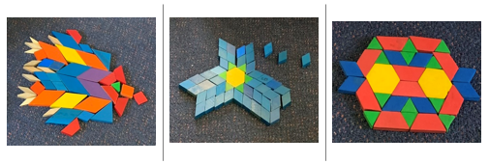
- Provide Early Stage 1 students with a collection of pattern and attribute blocks to develop their own 2D shape pictures. Students design a picture using the 2D shapes and trace around it. Students explain their picture and the known 2D shapes to an Early Stage 1 peer. Take photos of Early Stage 1 pictures.
Note: If Early Stage 1 students have access to technology, they can make shape pictures using digital technology and use audio to explain their picture and the known 2D shapes.
- As Stage 1 students are creating their pattern/design take photographs. Ask students:
- Where is the line of symmetry? Can you show me with a mirror and straw?
- How can you be sure?
- Does your pattern/design have more than one line of symmetry?
This table details assessment opportunities and differentiation ideas.
Assessment opportunities | Too hard? | Too easy?
What to look for.  - Are students able to turn shapes to fit and match a given design? (MAO-WM-01, MAE-2DS-01)  - Are students able to make pictures and designs using a selection of shapes? (MAO-WM-01, MAE-2DS-01)  - Are students able to identify familiar 2D shapes? (MAE-2DS-01)  - Can students identify lines of symmetry in objects and pictures? (MA1-2DS-01)  - Are students able to make patterns/designs which have a line of symmetry? (MAO-WM-01, MA1-2DS-01)  What to collect:  - photographs of student work. (MAO-WM-01, MAE-2DS-01, MA1-2DS-01) | Students are not confident finding the line of symmetry in objects and pictures.  - Students look at an image and tell you what is the same in the image.  - Circle the similarities and work together to fold the image so that the student can see that it is the same on both sides.  Students are not confident with creating a pattern/design with objects.  - Put one block down at a time and have the student mirror your action so that you are building a symmetrical pattern/design together. Have the student check by using a mirror.  - Continue to provide students with Resource 16: 2D shape pictures to use as a guide to build or inspire simple images. | Students can confidently identify lines of symmetry and build a symmetrical pattern/design.  - Students look for lines of symmetry in natural items like leaves, butterflies, and flowers.  - Students create half a symmetrical pattern for someone else to complete.  - Challenge students to create a pattern/design that has more than one line of symmetry.  Students can confidently build 2D shape pictures. Flash task cards from Resource 16: 2D shape pictures for 5 seconds and have students build the picture from memory.

Resource 1: Stage 1 table
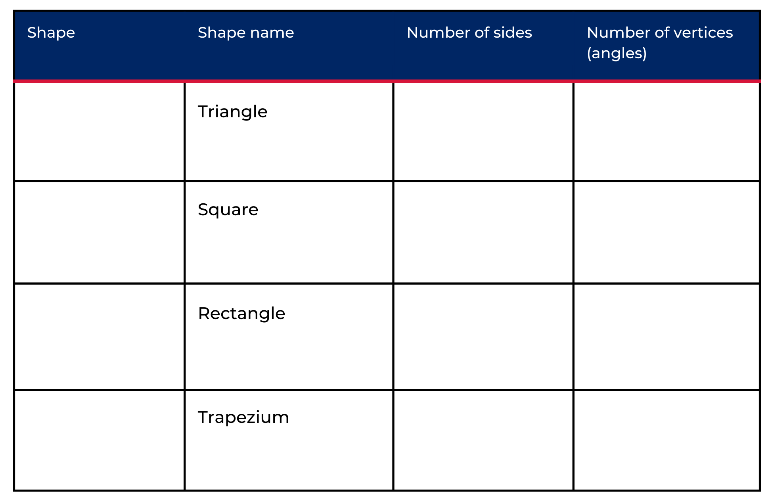
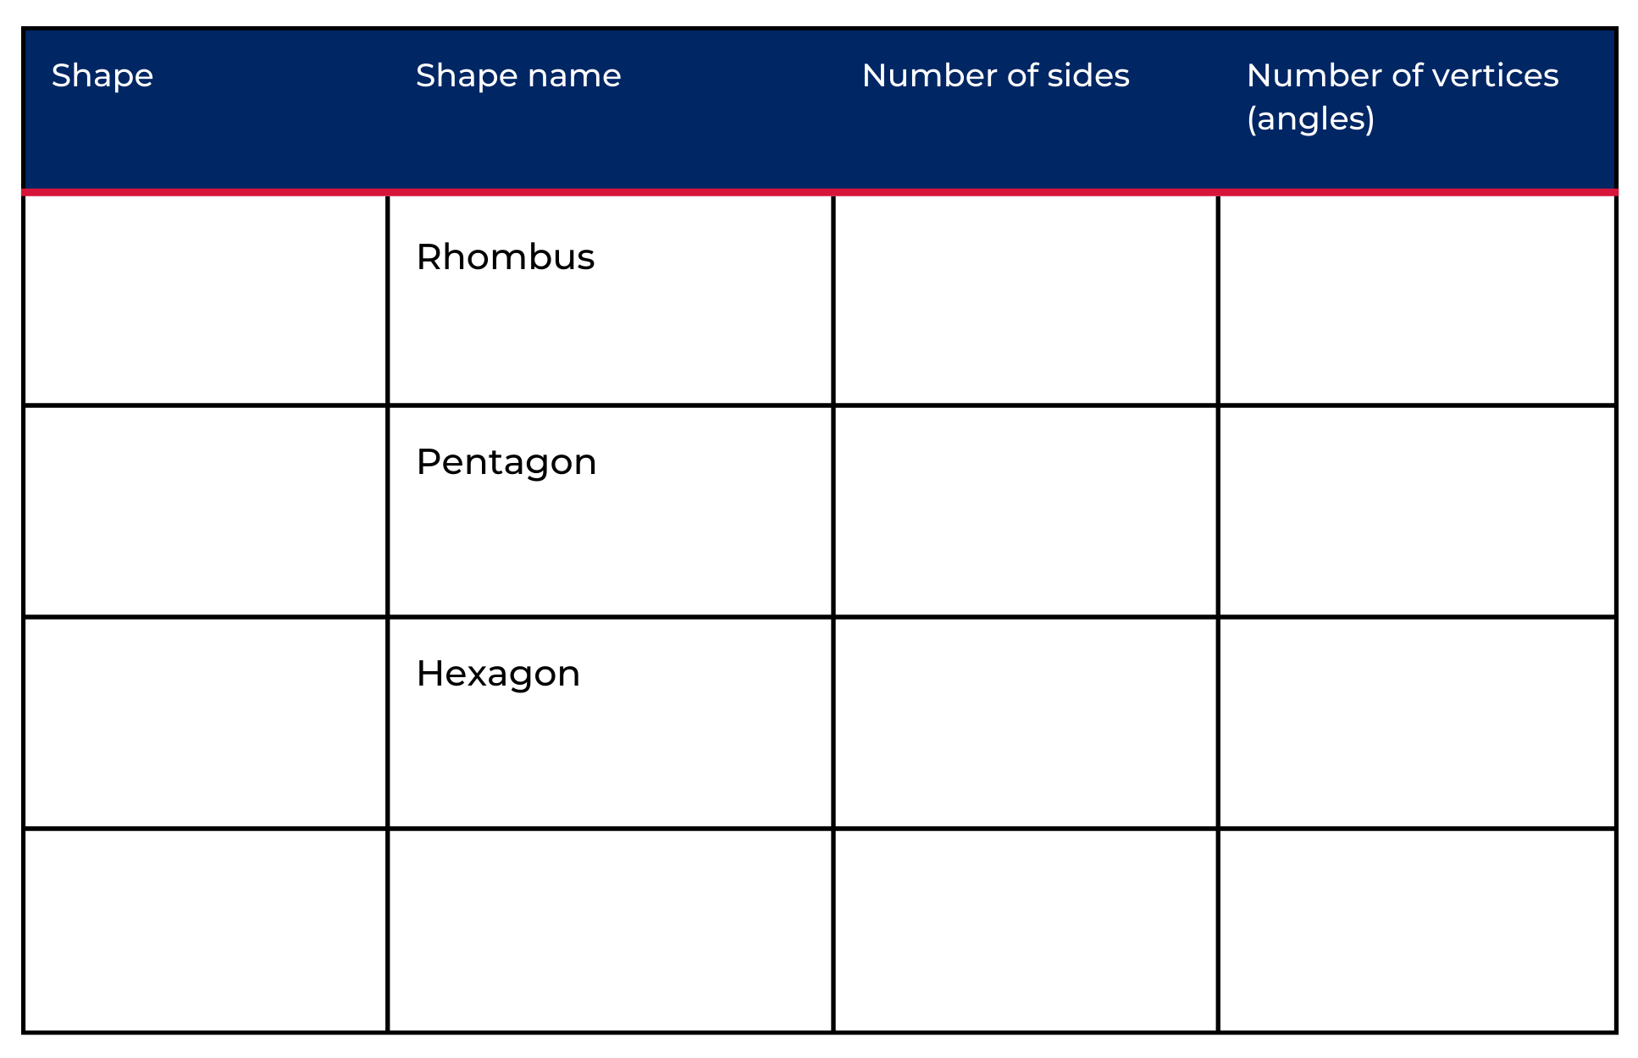

Resource 2: Dot talk
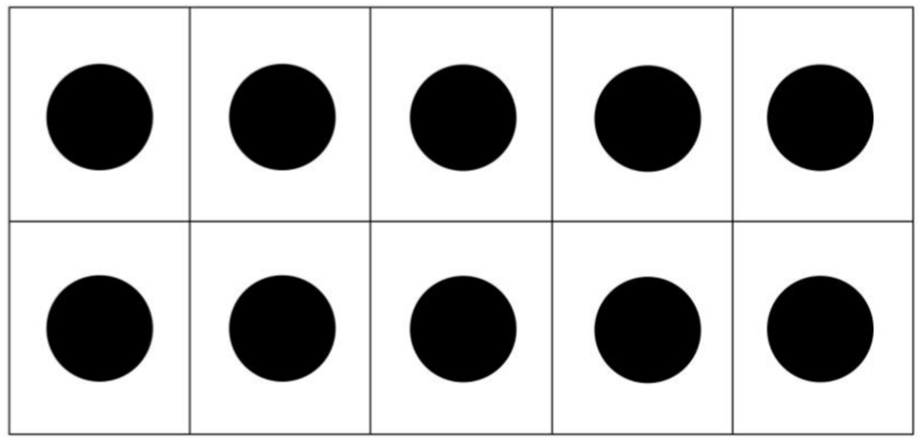

Resource 3: Folding rhombus
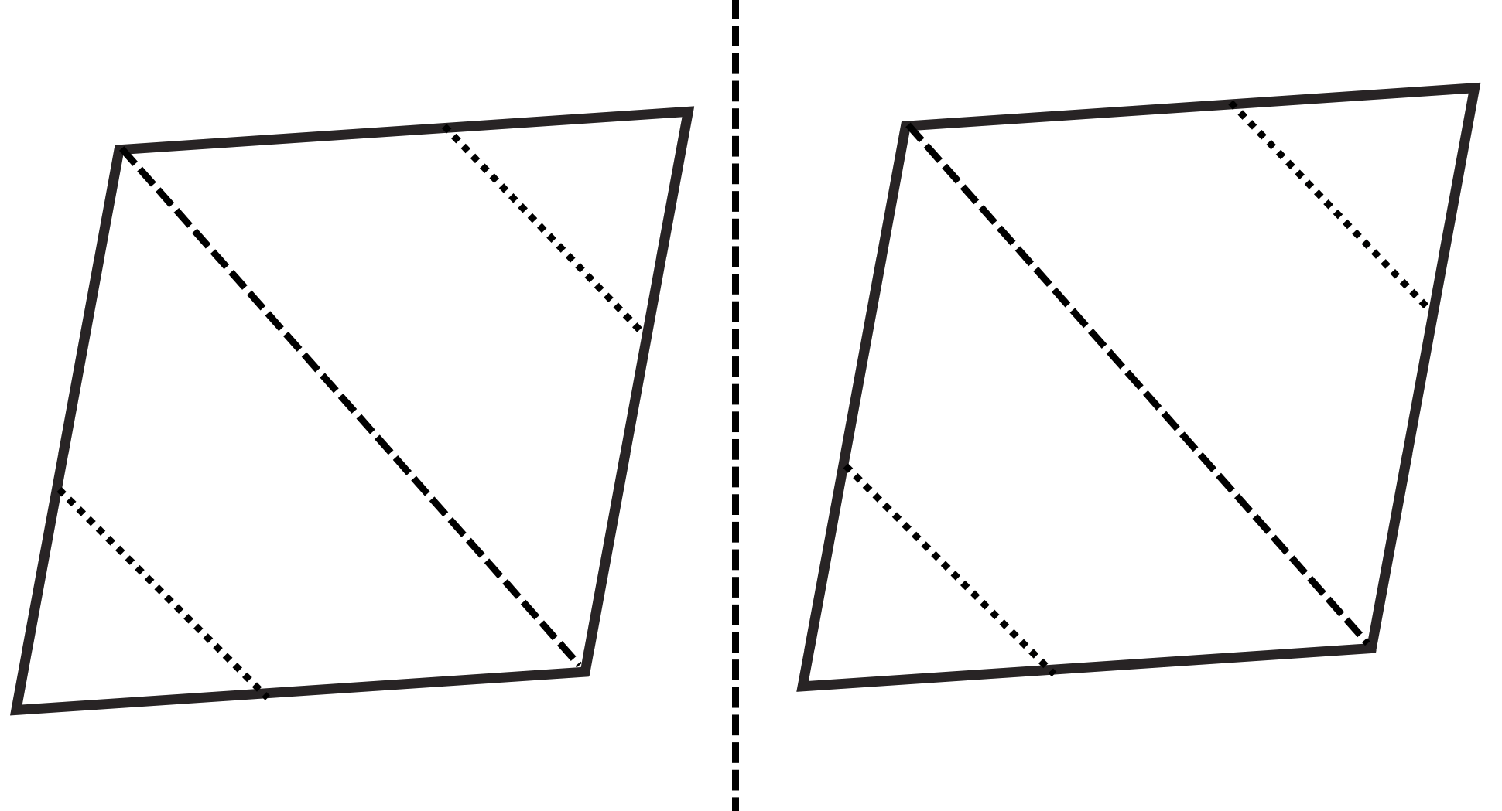

Resource 4: Instructions
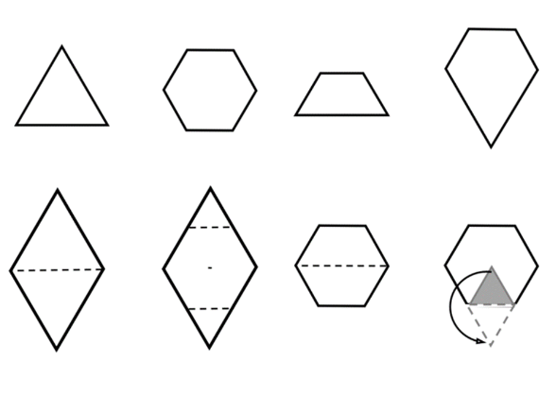

Resource 5: Triangles
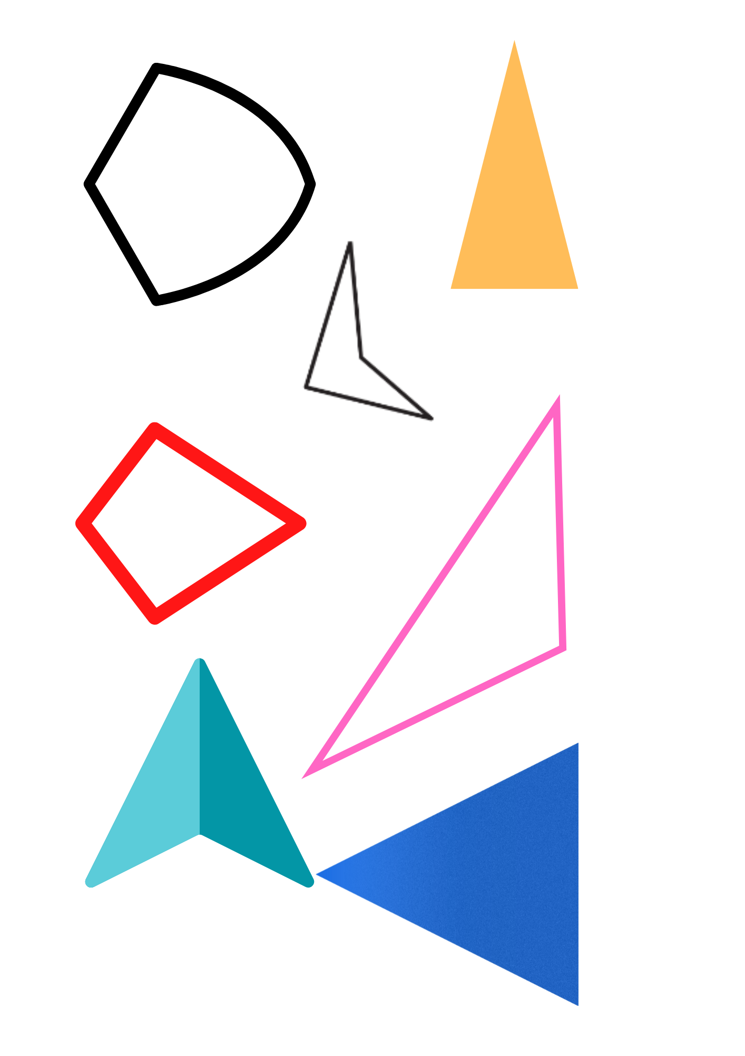
Images from Canva are licensed under Canva Content License Agreement.

Resource 6: Hexagon filler gameboard
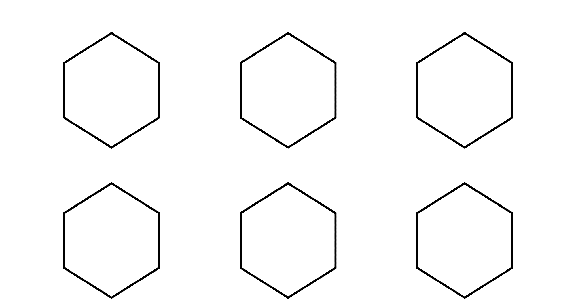
Image adapted from Moss et al (2016).

Resource 7: Hexagon filler game cards
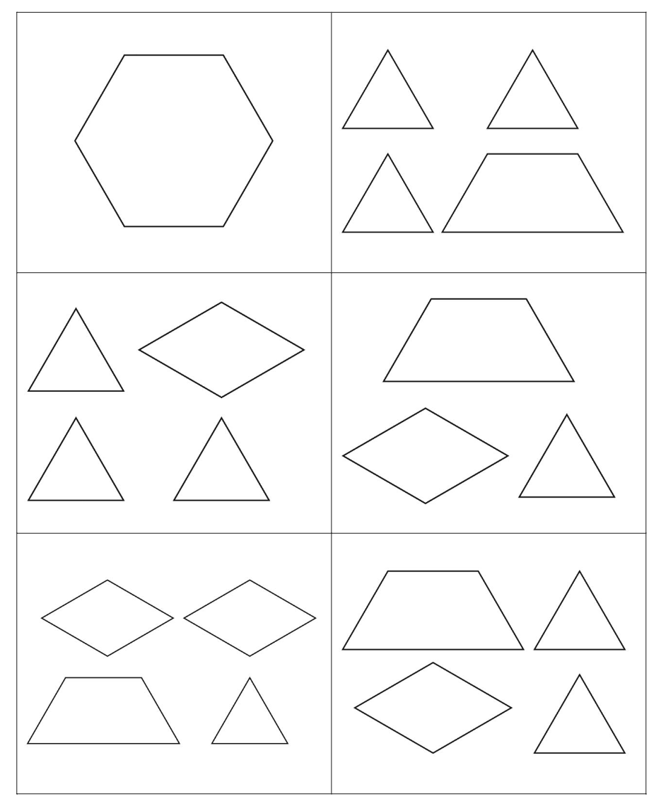
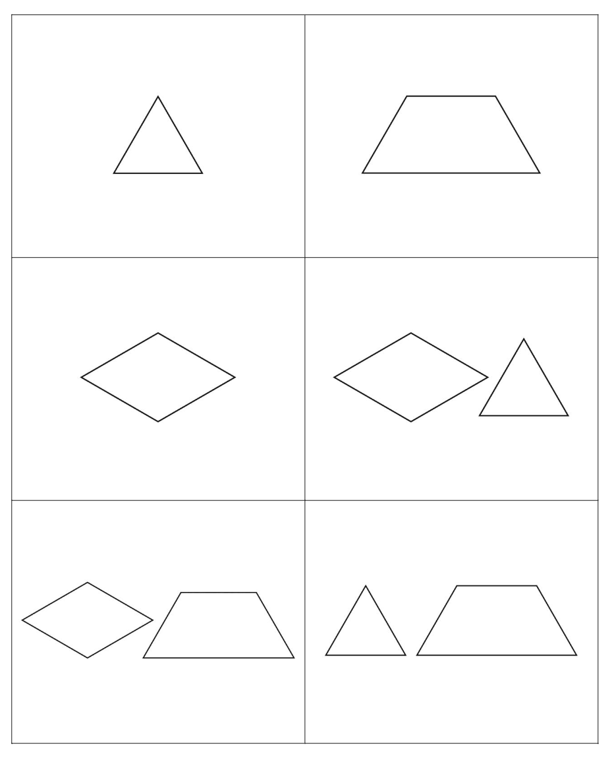
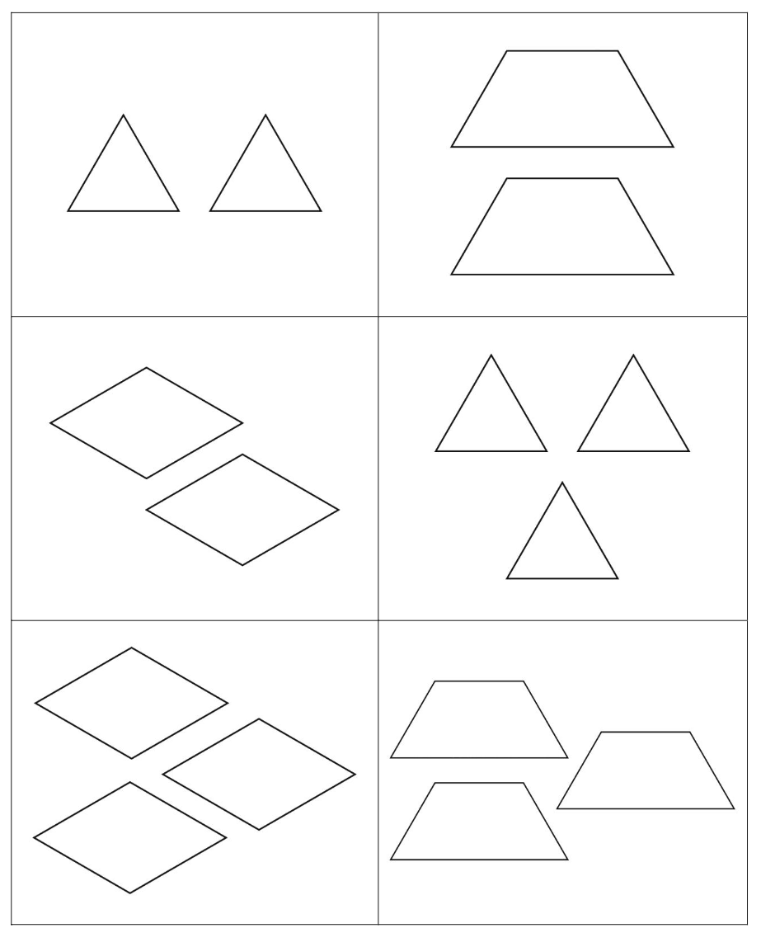
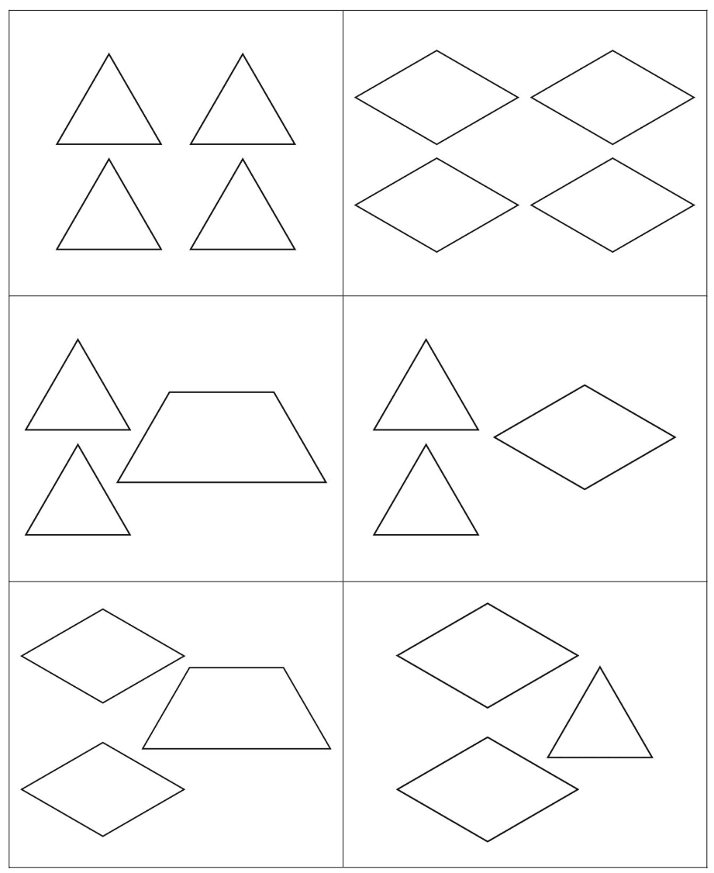
Image adapted from Moss et al (2016).

Resource 8: Assessing gameplay
Focus | Listen, watch, and think | Ask
Accuracy | Are they getting correct answers?  Are they able to name the 2D shapes? | What answer did you get?  What 2D shapes are you using?
Efficiency and strategy selection | Are they manipulating the 2D shape blocks to fix in the gameboard?  Do they seem to be labouring or a little stuck? | How did you solve it?  How did you work out how to fit the shapes into the hexagon?  Was there a more efficient strategy you could have used or was this strategy most efficient?
Flexibility and strategy selection | Are they using different strategies?  Can they apply them with the same confidence?  Are they thinking about which 2D shapes are needed to complete the hexagon? | Why did you pick that strategy?  Is there another strategy that you could use for that problem?  What shape/s are you hoping to turn over?  What shapes do you not want to turn over?
Adapted from Bay-Williams J and Kling G (2019).

Resource 9: Odd one out
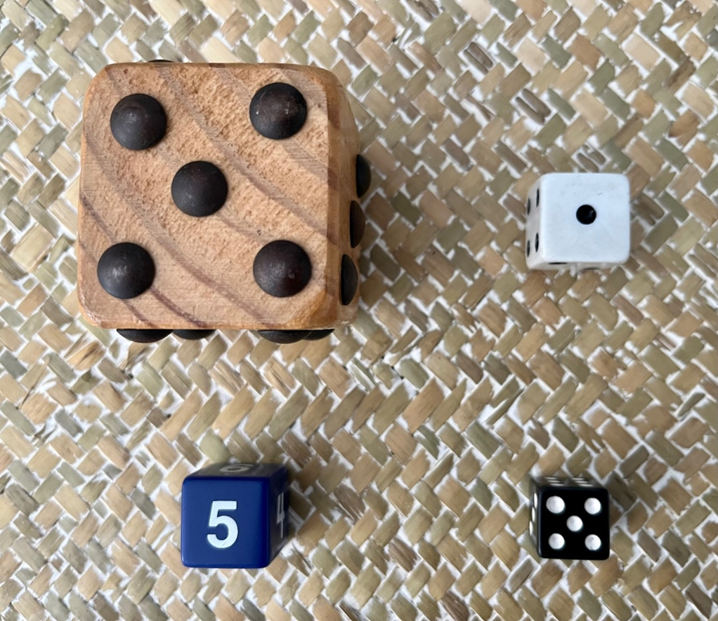

Resource 10: Shapes in a hexagon
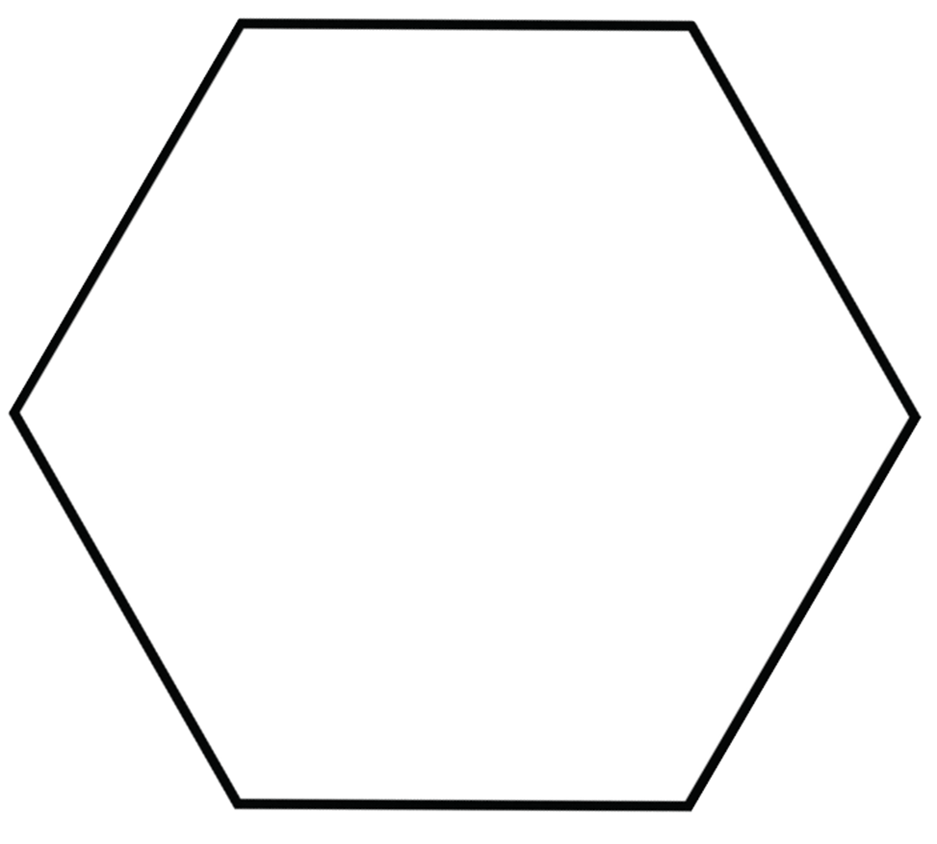

Resource 11: Examples of halves
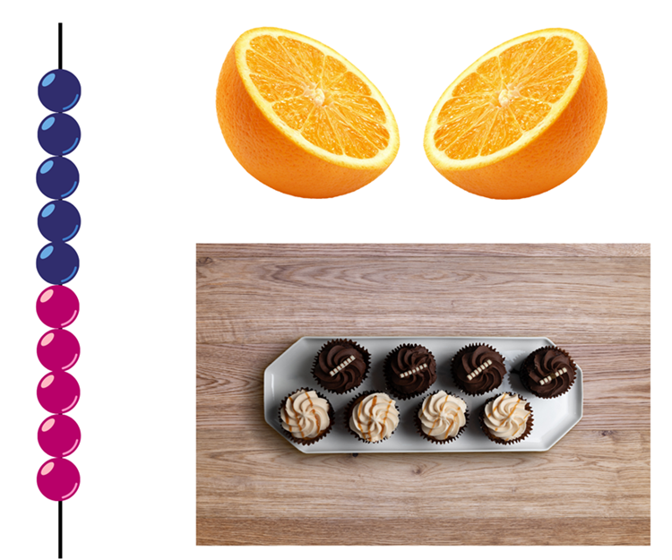
Images from Canva are licensed under Canva Content License Agreement.

Resource 12: Patterns
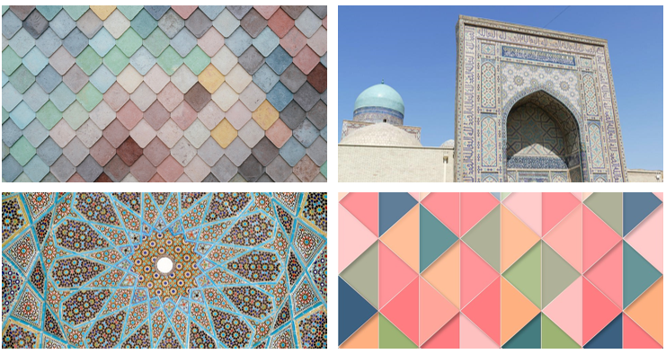
Images from Pixabay are licensed under the Pixabay Licence.

Resource 13: Translation pattern


Resource 14: Reflection image

"Church, Lake, Sunset, Panorama" by 12019 and used in accordance with the Pixabay Licence.

Resource 15: Representations of numbers
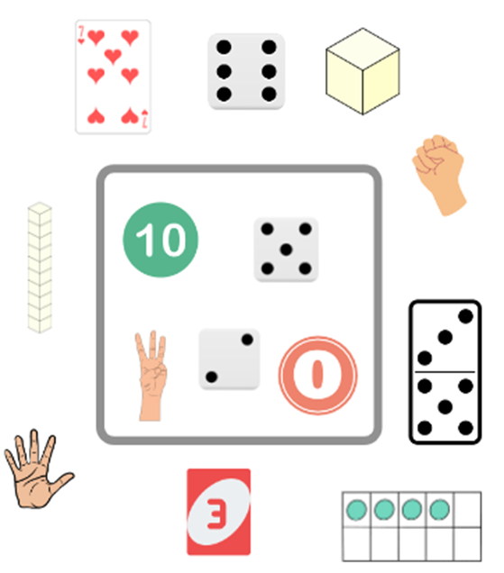
Images from Canva are licensed under Canva Content License Agreement.

Resource 16: 2D shape pictures
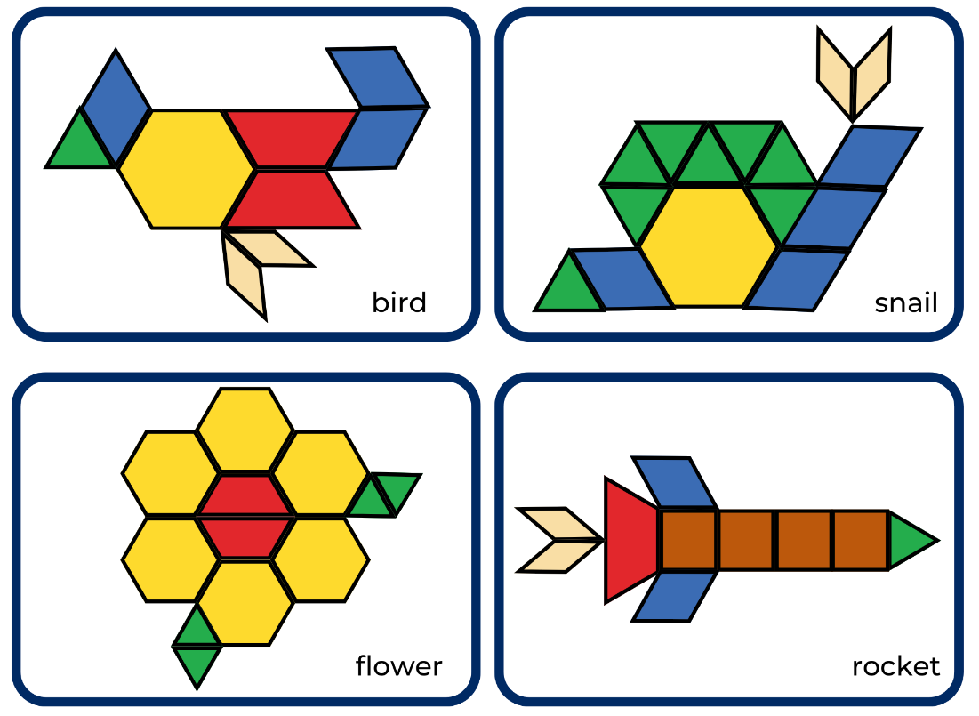
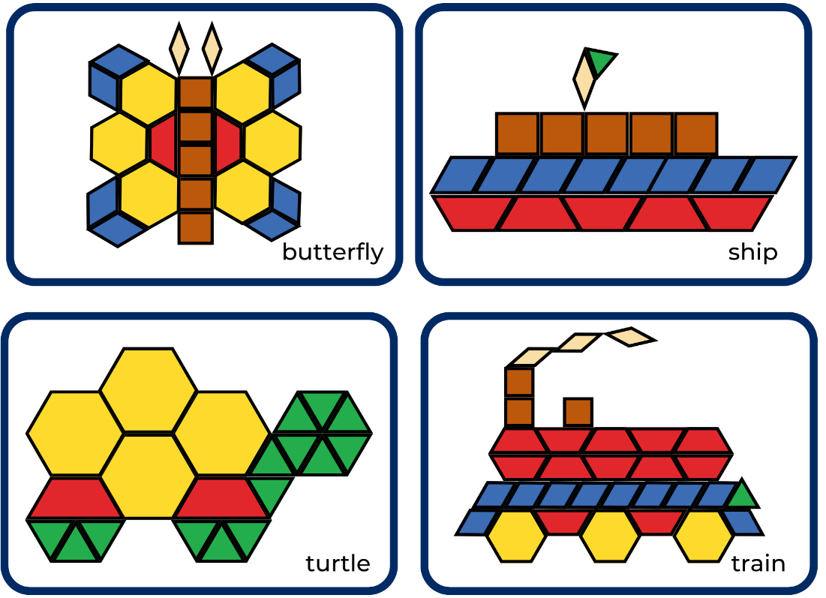

Resource 17: Shapes
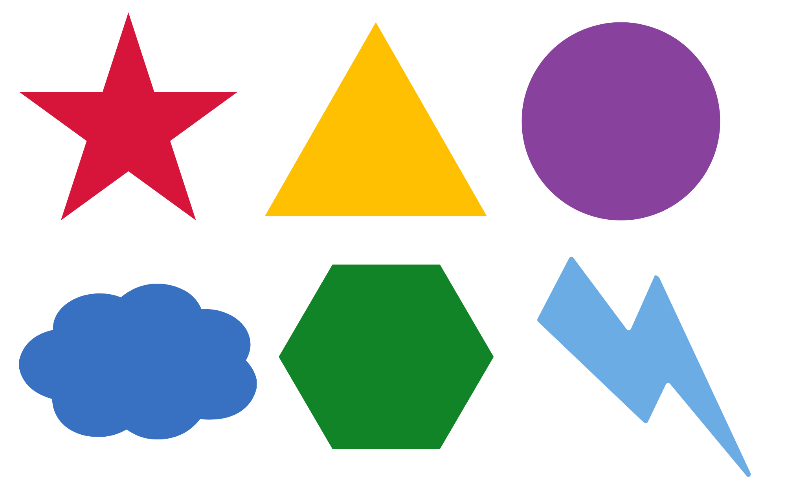
Adapted from Pattern Matching from NZ Maths (n.d).

Resource 18: Images

Images from Pixabay are licensed under the Pixabay Licence.

Images from Pixabay are licensed under the Pixabay Licence.

Syllabus outcomes and content
The table below outlines the syllabus outcomes and range of relevant syllabus content covered in this unit. Content is linked to National Numeracy Learning Progression version (3).
Focus area and outcomes | Content groups and content points | Lessons
Representing whole numbers  MAO-WM-01  MAE-RWN-01, MA1-RWN-01  MAE-RWN-02, MA1-RWN-02 | Early Stage 1  Instantly name the number of objects within small collections  - identify the number of items in different arrangements (CPr2) | 2 and 8
Representing whole numbers (cont) | Early Stage 1  Use the counting sequence of ones flexibly  - counts forwards to at least 30 and state the number after or before a given number, without needing to count from one (CPr4) | 1, 3, and 7
Representing whole numbers (cont) | Early Stage 1  Recognise number patterns  - recognise dice and domino dot patterns (NPA1, NPV2, CPr2) | 5
Representing whole numbers A | Stage 1  Use counting sequences of ones with two-digit number  - identify the number before and after a given two-digit number (CPr5)  - count forwards and backwards by ones from a given number to at least 120 (CPr6) | 1
Representing whole numbers A (cont) | Stage 1  Represent numbers on a line  - sequence numbers and arrange them on a line by considering the order and size of those numbers (CPr5) | 3
Combining and separating quantities  MAO-WM-01  MAE-CSQ-01, MA1-CSQ-01  MAE-CSQ-02 | Early Stage 1  Model additive relations and compare quantities  - combine two or more groups of objects to model addition, identifying the relationship between the parts and the whole (AdS1-AdS2) | 8
Combining and separating quantities (cont) | Early Stage 1  Identify part-whole relationships in numbers up to 10  - create, model and recognise combinations for numbers up to ten (AdS2) | 2 and 8
Combining and separating quantities  NOTE – there is only one combining and separating quantities outcome for Stage 1. | Stage 1  Recognise and recall number bonds up to ten  - recognise, recall and record combinations of two numbers that add up or bond to form 10 (AdS2, AdS6)  - describe combinations for numbers using words such as more than, less than and double (AdS6) | 2, 7, and 8
Forming groups  MAO-WM-01  MAE-FG-01, MAE-FG-02 | Early Stage 1  Copy, continue and create patterns  - copy, continue and create repeating patterns using shapes, objects, images or pictures (NPA1-NPA2) | 7
Geometric measure  MAO-WM-01  MAE-GM-01, MA1-GM-01  MAE-GM-02, MA1-GM-02  MAE-GM-03, MA1-GM-03 | Early Stage 1  Length: Use direct and indirect comparisons to decide which is longer  - compare lengths directly by placing objects side by side and aligning the ends (UuM2) | 2
Geometric measure (cont) | Early Stage 1  Length: Create half a length  - divide a length into two equal parts (InF1) | 6
Geometric measure A | Stage 1  Length: Measure the lengths of objects using informal units  - use uniform informal units to measure lengths and distances by placing the units end to end without gaps or overlaps (UuM2)  - select appropriate uniform informal units to measure lengths and distances (UuM3) | 2
Geometric measure A (cont) | Stage 1  Length: Subdivide lengths to find halves and quarters  - use concrete materials to model both half and quarters of a whole length, highlighting the length (InF2)  - identify two equal parts and the relationship of the parts to the whole length, linking words and images (InF2)  - recognise when lengths have or have not been divided into halves and quarters (InF2) | 6
Two-dimensional spatial structure  MAO-WM-01  MAE-2DS-01, MA1-2DS-01  MAE-2DS-02, MA1-2DS-02 | Early Stage 1  2D shapes: Sort, describe and name familiar shapes  - identify familiar shapes in a range of contexts  - sorts shapes according to features such as size and shape (UGP1-UGP2)  - recognise and explain how a group of shapes has been sorted  - describe shapes, including circles, squares, triangles and rectangles (UGP1-UGP2)  - distinguish examples of triangles from non-examples | 1–5, 7 and 8
Two-dimensional spatial structure (cont) | Early Stage 1  2D shapes: Represents shapes  - manipulates circles, squares, triangles and rectangles, and describe their features (UGP2-UGP3)  - turn shapes to fit into or match a given space  - make representations of shapes in a variety of ways, using paint, paper, movements or technology (UGP3)  - make pictures and designs using a selection of shapes  - identify and draw lines and curves | 1–5, 7 and 8
Two-dimensional spatial structure A | Stage 1  2D shapes: Recognise and classify shapes using obvious features  - explore, manipulate and describe features of polygons (UGP3)  - use the terms ‘side’, ‘vertex’ and ‘two-dimensional’ to describe plane (flat) shapes (UGP1-UGP2)  - create repeating linear patterns with shapes, including two-shape and three-shape patterns  - compare, sort and classify polygons according to the number of sides or vertices (UGP3-UGP4)  - recognise that shapes with the same name may have sides of equal or different lengths  - identify shapes presented in different orientations (UGP2) | 1–8
Two-dimensional spatial structure A (cont) | Stage 1  2D shapes: Transform shapes with slides and reflections  - recognise that sliding or reflecting a shape does not change its size or features (UGP2)  - identify and create a slide (translation) or reflection of a single shape and use the terms ‘slide’ (translation) and ‘reflection’ to describe the movement of the shape (UGP2)  - make designs with symmetry from reflection using paper-folding, mirrors, drawing or paintings (UGP3) | 7 and 8
Two-dimensional spatial structure A (cont) | Stage 1  Area: Measure areas using uniform informal units  - explore area using uniform informal units to cover the surface in rows or columns without gaps or overlaps (UuM5) | 6
Two-dimensional spatial structure B | Stage 1  2D shapes: Represent, combine and separate two-dimensional shapes  - make representations of two-dimensional shapes and combinations of shapes in different orientations  - combine and split single shapes and arrangements of shapes to form new shapes | 1–5

References
Links to third-party material and websites
Please note that the provided (reading/viewing material/list/links/texts) are a suggestion only and implies no endorsement, by the New South Wales Department of Education, of any author, publisher, or book title. School principals and teachers are best placed to assess the suitability of resources that would complement the curriculum and reflect the needs and interests of their students.
If you use the links provided in this document to access a third-party's website, you acknowledge that the terms of use, including licence terms set out on the third-party's website apply to the use which may be made of the materials on that third-party website or where permitted by the Copyright Act 1968 (Cth). The department accepts no responsibility for content on third-party websites.
Except as otherwise noted, all material is © State of New South Wales (Department of Education), 2021 and licensed under the Creative Commons Attribution 4.0 International License. All other material (third-party material) is used with permission or under licence. Where the copyright owner of third-party material has not licensed their material under a Creative Commons or similar licence, you should contact them directly for permission to reuse their material.
Mathematics K–10 Syllabus © 2022 NSW Education Standards Authority (NESA) for and on behalf of the Crown in right of the State of New South Wales.
© 2022 NSW Education Standards Authority. This document contains NSW Curriculum and syllabus content. The NSW Curriculum is developed by the NSW Education Standards Authority. This content is prepared by NESA for and on behalf of the Crown in right of the State of New South Wales. The material is protected by Crown copyright.
Please refer to the NESA Copyright Disclaimer for more information.
NESA holds the only official and up-to-date versions of the NSW Curriculum and syllabus documents. Please visit the NSW Education Standards Authority (NESA) website and the NSW Curriculum website.
National Numeracy Learning Progression © Australian Curriculum, Assessment and Reporting Authority (ACARA) 2010 to present, unless otherwise indicated. This material was downloaded from the Australian Curriculum website (National Numeracy Learning Progression) (accessed 13 September 2022) and was not modified. The material is licensed under CC BY 4.0. Version updates are tracked in the ‘Curriculum version history’ section on the 'About the Australian Curriculum' page of the Australian Curriculum website.
ACARA does not endorse any product that uses the Australian Curriculum or make any representations as to the quality of such products. Any product that uses material published on this website should not be taken to be affiliated with ACARA or have the sponsorship or approval of ACARA. It is up to each person to make their own assessment of the product, taking into account matters including, but not limited to, the version number and the degree to which the materials align with the content descriptions and achievement standards (where relevant). Where there is a claim of alignment, it is important to check that the materials align with the content descriptions and achievement standards (endorsed by all education Ministers), not the elaborations (examples provided by ACARA).
This resource contains images and content obtained from Canva, and their use outside of this resource is subject to Canva’s Content License Agreement. If you wish to use them separately from the resource, please go to Canva.
Askew M (2016) A Practical Guide to Transforming Primary Mathematics: Activities and tasks that really work, 1st edn, Routledge, New York.
Boaler J, Munson J and Williams C (2021) Mindset Mathematics: Visualising and Investigating Big Ideas, Grade 1, Jossey-Bass, New Jersey.
Bobis J, Mulligan J and Lowrie T (2013) Mathematics for Children: Challenging children to think mathematically, 4th edn, Pearson Education, Australia.
Browning S and Hatherley A (25 October 2020) Identifying 2D Shapes [television program], The Stickie Gang (Season 1, Episode 3), ABC iview, Australia, accessed 25 August 2022.
Burnett J, Irons CJ and Turton A (2007) Geo Paper Polygons: Exploring 2D Shapes Through Paper Folding, Origo Education, Narangba.
Burns M (2008) The Greedy Triangle (Silveria G, illus.), Scholastic, United States.
Clarke D and Roche A (2014) Engaging Maths: 25 favourite lessons, 2nd edn, The Mathematics Teaching and Learning Centre, Fitzroy.
Hattie J, Fisher D, Frey N, Gojak LM, Delano Moore S and Mellman W (2016) Visible Learning for Mathematics, Grades K-12: What Works Best to Optimize Student Learning, Corwin Press Inc, United States.
Hiebert J, Morris AK, Berk D and Jansen A (2007) ‘Preparing Teachers to Learn from Teaching’, Journal of Teacher Education, 58(1):47–61, doi:10.1177/0022487106295726.
Moss J, Bruce CD, Caswell B, Flynn T and Hawes Z (2016) Taking Shape: Activities to Develop Geometric and Spatial Thinking, Grades K-2, Pearson, Canada.
Murphy SJ (1996) Give Me Half! (Karas GB, illus.), HarperCollins, United States.
NCTM (National Council of Teachers of Mathematics) (2014) Principles to Actions: Ensuring Mathematical Success for All, National Council of Teachers of Mathematics, United States.
New Zealand Ministry of Education (n.d) ‘Making Patterns’, Resource Finder, NZ Maths website, accessed 24 August 2022.
New Zealand Ministry of Education (n.d) ‘Pattern Matching’, Resource Finder, NZ Maths website, accessed 24 August 2022.
Siemon D, Warren E, Beswick K, Faragher R, Miller J, Horne M, Jazby D and Breed M (2020) Teaching Mathematics: Foundations to Middle Years, 3rd edn, Oxford University Press Australia and New Zealand.
Toy Theatre (2022) ‘Number Chart Manipulatives’, Virtual Manipulatives, Toy Theatre website, accessed 13 September 2022.
Van de Walle JA, Karp KS, Bay-Williams JM (2019) Elementary and Middle School Mathematics: Teaching Developmentally, Global edn, Pearson Education, United States.

