Mathematics – Stage 1 – Unit 32
Contents
Unit description and duration 4
Student prior learning 4
Lesson overview and resources 5
Lesson 1: Repeating patterns are everywhere 10
Daily number sense: 10 less and 10 more – 15 minutes 10
Repeating patterns in our world – 40 minutes 13
Discussing and connecting the mathematics – 10 minutes 18
Lesson 2: We’re going on a repeating pattern hunt 19
Daily number sense: Number possibilities – 10 minutes 19
Repeating Pattern hunt – 45 minutes 21
Consolidation and meaningful practice – 10 minutes 25
Lesson 3: Reproducing patterns 26
Daily number sense: Estimating 100 – 15 minutes 26
Reproducing patterns: Part 1 – 5 minutes 31
Reproducing patterns: Part 2 – 40 minutes 32
Consolidation and meaningful practice: Gallery walk – 10 minutes 35
Lesson 4: Generating number patterns 36
Daily number sense: What other numbers belong? – 15 minutes 36
Generating number sequences: Part 1 – 20 minutes 38
Generating number sequences: Part 2 – 20 minutes 43
Consolidation and meaningful practice: What comes next? – 10 minutes 46
Lesson 5: Generating counting sequences 47
Daily number sense: Generating counting sequences – 15 minutes 48
How many legs? – 40 minutes 50
Consolidation and meaningful practice: Generating Patterns – 10 minutes 55
Lesson 6: Investigating counting sequences 56
Daily number sense: 10 minutes 56
30 square tiles – 35 minutes 57
Consolidation and meaningful practice: Investigating arrays – 20 minutes 61
Lesson 7: Problem-solving detectives 64
Daily number sense: Skip counting to 24 – 10 minutes 64
Array detectives – 45 minutes 65
Discussing the mathematics: What do our arrays tell us? – 5 minutes 68
Lesson 8: Arranging and displaying data 69
Daily number sense: An array of cupcakes – 15 minutes 69
Sort the street: Part 1 – 15 minutes 70
Sort the street: Part 2 – 35 minutes 72
Discussing the mathematics: What does the data tell us? – 5 minutes 75
Resource 1: Architectural repeating patterns 76
Resource 2: Modified architectural images 86
Resource 3: Number cards 89
Resource 4: How many legs? 90
Resource 5: Number patterns and their rules 91
Resource 6: 30 square tiles 92
Resource 7: Arrays in our world 93
Resource 8: Sort the street 95
Syllabus outcomes and content 96
References 101

Unit description and duration
This two-week unit develops student knowledge, skills and understanding about repeating patterns, arrays and different ways to present and communicate about data. Students are provided opportunities to:
- recognise, name, create and extend various patterns
- identify that repeating patterns have a core that repeats over and over and over again
- identify, describe, organise and compare a variety of arrays
- communicate their understanding and thinking as they create and explore various patterns and arrays
- select appropriate methods to display and interpret data
Mathematics K–10 Syllabus © 2022 NSW Education Standards Authority (NESA) for and on behalf of the Crown in right of the State of New South Wales.

Student prior learning
Before engaging in these teaching and learning activities, students would benefit from prior experience with:
- creating repeating patterns using various concrete materials
- identifying the core of a pattern and then using this to extend the pattern to repeat over and over and over again
- using letters, such as AB and AABB to label and describe the core of a pattern
- creating representations, such as an array and describing how many groups (rows and columns) and how many in each group
- arranging objects according to a characteristic to form a data display and using it to ask and answer questions.

Lesson overview and resources
The table below outlines the sequence and approximate timing of lessons; syllabus focus areas and content groups; and resources.
Lesson | Syllabus focus area and content groups | Resources
Lesson 1: Repeating patterns are everywhere  65 minutes  A repeating pattern must have a repeating core or a mathematical regularity. | Representing whole numbers A  - Continue and create number patterns  Representing whole numbers B  - Use counting sequences of ones and tens flexibly  - Form, regroup, and rename three-digit numbers | - Resource 1: Architectural repeating patterns  - Resource 2: Modified architectural images  - Digital device  - Sticky notes  - Various concrete materials  - Writing materials
Lesson 2: We’re going on a repeating pattern hunt  65 minutes  Repeating patterns have a core that repeats over and over and over again. | Representing whole numbers A  - Continue and create number patterns  Representing whole numbers B  - Form, regroup, and rename three-digit numbers | - Digital devices  - Writing materials
Lesson 3: Reproducing patterns  70 minutes  Identifying the repeating core helps to extend a pattern. | Representing whole numbers A  - Represent the structure of groups of ten in whole numbers  - Representing whole numbers B  - Form, regroup, and rename three-digit numbers  Forming groups A  - Use skip counting patterns | - Collection of various small concrete materials  - Digital devices  - Writing materials
Lesson 4: Generating number patterns  65 minutes  Number sequences can be arranged and repeated to create a variety of number patterns. | Representing whole numbers A  - Use counting sequences of ones with two-digit numbers and beyond  Forming groups A  - Use skip counting patterns  - Model and use equal groups of objects to represent multiplication  Forming groups B  - Represent and explain multiplication as the combining of equal groups | - Resource 3: Number cards  - Digital devices  - Paper squares or sticky notes  - Square tiles or similar concrete materials  - Writing materials
Lesson 5: Generating counting sequences  65 minutes  Problems can be solved using a number pattern or sequence. | Representing whole numbers A  - Use counting sequences of ones with two-digit numbers and beyond  Representing whole numbers B  - Form, regroup, and rename three-digit numbers  Forming groups A  - Use skip counting patterns  - Model and use equal groups of objects to represent multiplication  Forming groups B  - Represent and explain multiplication as the combining of equal groups  - Represent multiplication and division problems  Data A  - Ask questions and gather data  Data B  - Create displays of data and interpret them | - Resource 4: How many legs?  - Resource 5: Number patterns and their rules  - Craft sticks  - Ten-frames  - Sticky notes  - Writing materials
Lesson 6: Investigating counting sequences  65 minutes  An array can be positioned differently to reflect the same counting sequence and the whole quantity stays the same. | Representing whole numbers A  - Continue and create number patterns  Forming groups A  - Use skip counting patterns  Model and use equal groups of objects to represent multiplication  Forming groups B  - Represent and explain multiplication as the combining of equal groups  - Represent multiplication and division problem  Data B  - Create displays of data and interpret them | - Resource 6: 30 square tiles  - Digital devices  - Square tiles or similar concrete materials  - Writing materials
Lesson 7: Problem-solving detectives  60 minutes  Collecting and recording data is a useful strategy when problem solving. | Representing whole numbers A  - Continue and create number patterns  Representing whole numbers B  - Use counting sequences of ones and tens flexibly  Forming groups A  - Use skip counting patterns  Model and use equal groups of objects to represent multiplication  Forming groups B  - Represent and explain multiplication as the combining of equal groups  - Represent multiplication and division problem | - Resource 7: Arrays in our world  - Digital devices  - Number lines  - Ten-frames  - Writing materials
Lesson 8: Arranging and displaying data  70 minutes  Recorded data can be displayed in many ways and the results will provide meaningful information. | Representing whole numbers A  - Use counting sequences of ones with two-digit numbers and beyond  Data A  - Ask questions and gather data  Data B  - Create displays of data and interpret them | - Resource 8: Sort the street  - Counters  - Digital devices  - Writing materials

Lesson 1: Repeating patterns are everywhere
Core concept: A repeating pattern must have a repeating core or a mathematical regularity.
The table below contains suggested learning intentions and success criteria. These are best co-constructed with students.
Learning intentions | Success criteria
Students are learning that:  - repeating patterns can be identified, sorted, extended and represented in various ways  - a repeating pattern can have multiple repeating attributes such as colour, size, shape and texture  - there is a repeating pattern when skip counting by tens on and off the decade beyond 100. | Students can:  - identify and describe the repeating core of a pattern  - use letters such as AB, ABC and AABB to label and describe a repeating pattern core  - recognise and describe if a repeating pattern has a variety of other attributes which also repeat over and over and over again  - skip count by tens on and off the decade beyond 100.

Daily number sense: 10 less and 10 more – 15 minutes
- Build student understanding of skip counting by tens and identify the next multiple of 10 by exploring the game ‘10 less and 10 more’.
- Ask students to skip count by tens to 200 starting from zero. Record the numbers on the board and ask students what they notice about the number pattern.
- Ask students to skip count by tens to 200 starting ‘off the decade’, for example, starting from 7. Record the numbers on the board and ask students what they notice about the number pattern.
- Display a two-digit number on the board and place a sticky note on either side, as in Figure 1.
Figure 1 – 10 less and 10 more
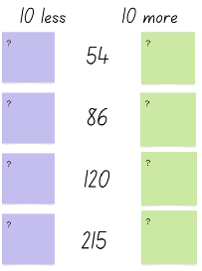
- Ask students if they can identify the number that is 10 less than and the number that is 10 more than the given numbers.
- Provide students with writing materials and display a variety of two and three-digit numbers for students to record the number 10 less than and 10 more than.
- Select students to share their results and record these for students to view.
The table below details assessment opportunities and differentiation ideas.
Assessment opportunities | Too hard? | Too easy?
What to look for:  - Are students able to name the number before and after a given 2 or 3-digit number? (MA1-RWN-01)  - Are students able to name the number 10 more and 10 less than a given 2 or 3-digit number? (MA1-RWN-01)  What to collect:  - records of discussions. (MAO-WM-01, MA1-RWN-01) | Students are unable to skip count by tens off the decade and they cannot name the number that is 10 more or 10 less than a given number.  - Provide students with counters, a number track and/or a hundred chart. Support students to use the counters to identify a skip count by tens pattern sequence.  - Provide students with a number track to 50 and model how to count backwards and forwards by 10. Ask students to identify a number on the line that is 10 less or 10 more. Repeat a number of times. | Students can create and continue various skip counting pattern sequences up to 999.  - Provide students with a 200 chart. Ask students to identify interesting skip counting sequences.  - Challenge students to create a backwards skip counting pattern from 999 that has missing numbers to share with a partner.

Repeating patterns in our world – 40 minutes
Note: The architectural images included will be used in multiple lessons. It is recommended to store copies in plastic sleeves to reduce wear and tear. Prior to the lesson view the architectural images and determine how they will be printed and distributed for the students to use. It is optional to provide 2 to 3 images per small group for this lesson. For subsequent lessons students can swap images with other groups so that they can explore all the architectural patterns.
- Display Resource 1: Architectural Repeating patterns. Discuss the designs, repeating shapes, colours, textures and sizes of objects. Ask students to identify and describe what they can see, and to name the repeating core pattern for the various designs.
- It is essential to draw students’ attention to how patterns can appear both vertically and horizontally, as well as how a pattern can have various elements that repeat over and over and over again, such as a shape, colour, texture and the size of a shape.
- Ask students to identify a pattern in an image and to describe the repeating core of the pattern. Ask:
- Is there more than one repeating core? Can you describe another repeating core?
- Are there other elements that are repeating over and over and over again? Such as colour or texture?
- Is the pattern a two-part, three-part of four-part pattern? Are there any five-part patterns?
- Can you label the repeating pattern using letters, such as A and B?
- Are the patterns repeating in one direction only or do some patterns repeat both vertically and horizontally?
- Select students to label the repeating core of the patterns identified in the displayed images using letters written on sticky notes, such as AB, ABB or ABC. Students may identify examples of repeating core patterns such as in Figure 2 and Figure 3.
Figure 2 – Multiple repeating core patterns
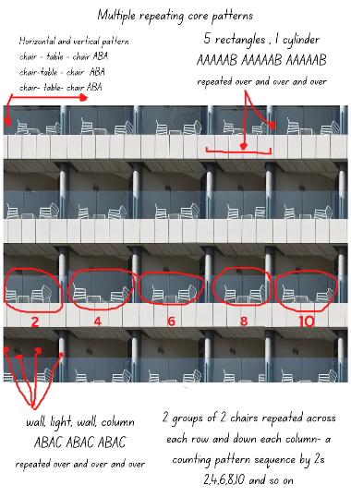
‘Modern Industry Steel Technology Expression City’ by moshehar has been adapted and used in accordance with the Pixabay License.
Figure 3 – Multiple repeating core patterns
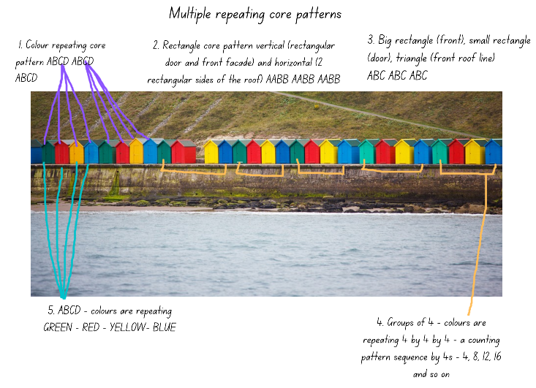
‘Architecture Beach Bright Cabin’ by PublicDomainPictures has been adapted and used in accordance with the Pixabay License.
- Provide each small group of students with a copy of images that have been selected and copied prior to the lesson at your discretion.
- Allow time for each small group to view their images and to discuss and label the repeating core patterns they identify. It is essential to draw students’ attention to various attributes that may be repeated in a pattern, such as texture, the quantity or number of objects, the size and the position of objects may also be repeated in a pattern, for example, a column on the left and a column on the right and so on.
- Provide each group with writing materials and concrete resources such as coloured shape tiles, blocks or coloured bricks.
- Explain that students will select one of the images and replicate the repeating core pattern using the concrete materials. Students need to record the core of the pattern identifying the elements that are repeating over and over and over again and clearly label the repeating core using letters.
- Students will use a digital device to photograph and annotate their design so that it can be displayed and shared with the class during a gallery walk.
The table below details assessment opportunities and differentiation ideas.
Assessment opportunities | Too hard? | Too easy?
What to look for:  - Are students able to find the core of a repeating pattern and describe it by stating the number of parts? ‘For example, ‘This is a three-part pattern’ (MAO-WM-01, MA1-RWN-01)  - Do students describe the pattern core using letters such as AB, ABC, ABB, AABBCC? (MAO-WM-01, MA1-RWN-01)  - Can students arrange concrete materials to create and model a repeating number pattern identified in an image? (MAO-WM-01, MA1-RWN-01)  What to collect:  - observations of students creating, labelling and representing patterns. (MAO-WM-01, MA1-RWN-01)  - photographs of students reproducing patterns from images. (MAO-WM-01, MA1-RWN-01) | Students are not able to identify the repeating core of a pattern displayed in the images.  - Provide students with Resource 2: Modified architectural images and support students to identify and reproduce the repeating core of the patterns within the images.  - Model how to identify and circle the repeating core of a pattern and support students to say out loud and describe the parts of the core that are repeating, for example window, door, window, door, window, door. | Students can identify and describe various repeating core patterns in the images, and they can create representations of these using concrete materials.  - In pairs, each student creates a representation of a core pattern from an image and their partner needs to guess which image the pattern represents and also continue the pattern labelling the core using letters AB and/or C.  - In pairs, each student creates a representation of a core pattern from an image and leaves a missing part of the pattern for their partner to guess and then continue the pattern including the missing part.

Discussing and connecting the mathematics – 10 minutes
- Select one of the pattern representations made by a student and cover one part of the repeating core with a piece of paper. Ask students:
- What is the missing part of the repeating core? How do you know?
- What parts of the pattern do you think are repeating over and over and over again?
- What would come next if this pattern was going to continue?
- How can you represent this pattern using body percussion, for example, using claps, clicks and hand rolls?

Lesson 2: We’re going on a repeating pattern hunt
Core concept: Repeating patterns have a core that repeats over and over and over again.
The table below contains suggested learning intentions and success criteria. These are best co-constructed with students.
Learning intentions | Success criteria
Students are learning that:  - in repeating patterns, the part that repeats is called the core  - a pattern core can be described as having a number of parts  - each digit in a two and three-digit number has a place value  - when sequencing numbers in order, all digits must be considered. | Students can:  - find the core of a repeating pattern in a variety of real-life patterns and label the core by the number of parts using letters such as, AB, ABC, ABB, AABBCC  - recognise, name and explain the place value of each digit in a two and three-digit number  - sequence jumbled two-digit numbers in the correct order from the smallest to the largest number.

Daily number sense: Number possibilities – 10 minutes
- Build student understanding of two-digit and three-digit numbers by investigating how to combine given numerals to make all possible numbers.
- Provide students with writing materials and ask them to view the displayed numerals on the board, 8, 4, 9, 1.
- Explain to students that they need to record all the possible numbers that can be made using only the displayed 4 numerals; all one digit, two-digit and three-digit numbers.
- Ask students to view the given numbers. Select students to share an example of a two and three-digit number, recording these.
- Provide each student with writing materials to problem-solve and record all the possible numbers they can. Ask:
- What is the largest number that can be made from these numbers? Can you explain how many hundreds, tens and ones there are in that number?
- What is an example of an odd number and an even number? Can you circle an example of each and share it with a partner.
- What is the largest, odd number you can make?
- What is an example of a number that has 9 tens?
- What is a number that has one hundred, 4 tens and 8 ones?
- Can you sequence three different two-digit numbers in order from the smallest two-digit number to the largest two-digit number?
- How do you know you have recorded all the possible combinations of numbers?
The table below details assessment opportunities and differentiation ideas.
Assessment opportunities | Too hard? | Too easy?
What to look for:  - Are students able to name the value of digits in a 3-digit number? (MA1-RWN-01)  - Can students identify odd and even numbers? (MA1-RWN-01)  - Are students able to sequence and arrange three 2-digit numbers in order from smallest to largest? (MA1-RWN-01)  - Can students identify place value and state if a number is in the hundreds, tens or ones place value? (MA1-RWN-01)  What to collect:  - recordings of students sharing their ideas and strategies (MAO-WM-01, MA1-RWN-01) | Students are not able to make or record two and three-digit numbers and they cannot name the place value for each digit.  - Display 2 different numbers such as, 4 and 5 and ask students to record all possible one and two-digit numbers. It is optional to then provide students with a third digit to explore three-digit numbers.  - Provide students with a place value chart and bundles of craft sticks. Model how to bundle groups of 10 craft sticks to represent the tens and the loose craft sticks to represent the ones. Explore various two-digit numbers. | Students can read, name and make three-digit numbers using given numerals.  - Ask students to order all the number combinations from the largest number made to the smallest number made.  - Ask students if there are more even or odd numbers made using the 4 numerals.

Repeating Pattern hunt – 45 minutes
- Provide small groups of students with a digital device to take photographs and writing materials to record pattern representations.
- Explain that students are going to explore the school playground to go on a ‘repeating pattern hunt’.
- Students work in a small group and each group needs to find 4 different repeating patterns to photograph.
- Ask students to suggest patterns that they may remember or have previously identified within the school context. See Figure 4.
Figure 4 – Examples of repeating patterns at school
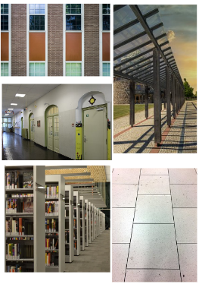
Images sourced from Pixabay and used in accordance with the Pixabay License.
- Explain to students that the repeating patterns need to have a core that repeats over and over and over again. Encourage students to identify patterns that may have more than one repeating core, such as shape and colour or tall and short or plastic or metal.
- Support and provide time for students as they explore the school context. Observe students as they select patterns to photograph and ask groups of students to identify the repeating core and label the pattern core using letters, such as ABB to ensure that they are correctly identifying and labelling the core of repeating patterns (see Figure 5).
Figure 5 – Example of an annotated repeating pattern
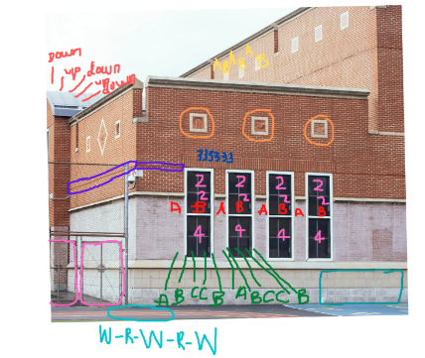
‘Empty sports ground near school’ by Mary Taylor is used in accordance with the Pexels license.
The table below details assessment opportunities and differentiation ideas.
Assessment opportunities | Too hard? | Too easy?
What to look for:  - Are students able to identify the repeating core of a pattern within a range of contexts? (MAO-WM-01, MA1-RWN-01)  - Can students name and describe the attributes of a repeating pattern within a range of contexts, such as shapes, quantity, colour, materials and size? (MAO-WM-01, MA1-RWN-01)  What to collect:  - observations and recordings of conversations and vocabulary used by students. (MAO-WM-01, MA1-RWN-01)  - photos and work samples of identified patterns. (MAO-WM-01, MA1-RWN-01) | Students are not able to find the repeating core of a pattern within a different context.  - Support students to identify a repeating core of such rectangles on a brick wall or repeated windows. Provide students with shape tiles or writing materials to create a representation of the pattern and to identify the repeating core.  - Support students to use chalk and label the repeating core of a simple AB pattern in the school context, such as a row of windows along a brick wall or steps on a staircase. | Students can identify and label a variety of more complex repeating patterns within a range of contexts.  Challenge students to identify a repeating core pattern that occurs horizontally and vertically in a pattern. For example, the glass and metal parts of a window and the rectangular shape.

Consolidation and meaningful practice – 10 minutes
- Select a variety of students to share their photographs and to describe their identified patterns. Ask:
- What would be the next part or elements of this pattern example if we continued to extend the pattern?
- Did you find any examples of a four or five-part pattern? Such as an ABCD pattern or ABBBC pattern?
- Did you find a pattern that included a different attribute, such as smooth and rough or how many corners or sides?
- Provide time and support for groups to share their photos and discuss patterns, focussing on both similar and different pattern cores and also the various identified pattern attributes.

Lesson 3: Reproducing patterns
Core concept: Identifying the repeating core helps to extend a pattern.
The table below contains suggested learning intentions and success criteria. These are best co-constructed with students.
Learning intentions | Success criteria
Students are learning that:  - identifying the repeating core helps to extend a pattern  - a variety of materials can be used to translate the core of a repeating pattern  - there are different strategies to solve problems  - mathematicians estimate by making informed judgements of a large quantity by viewing and comparing to what they already know. | Students can:  - describe a repeating pattern as having a two-part (AB) repeating core pattern, a three-part (for example ABC ABB) repeating core pattern, and so on  - create and extend a variety of representations of repeating core patterns by using what they know about a repeating pattern  - look, think and compare large quantities to make an accurate estimation.

Daily number sense: Estimating 100 – 15 minutes
- Build student understanding of the number 100 by estimating what 100 might look like when estimating quantities of a variety of concrete materials.
Students require a range of opportunities to develop the ability and skills to estimate accurately. Experiences with estimating meets both mathematical and practical needs. Students need to refer to their knowledge of numbers, make comparisons and draw on what is familiar to understand what is unfamiliar, and the ability to judge the reasonableness of their estimation.
Note: Prior to the lesson, collect a variety of familiar small concrete materials and display these in clear jars, containers or on paper plates. Label each container with the exact number of items but do not disclose this to students until the task is complete. Ensure that there are 2 containers with exactly 100 items, one container that has more than 100 items and one that has less than 100. Collected items might include, small pom poms, paper clips, small coloured bricks, counters, buttons, seashells, pasta and beads. Ask students to view one of the containers, for example a container with coloured bricks, and ask if they think there are 100, more than 100 or less than 100 in the container. Pass the container around so that students can heft, move and see the coloured bricks.
- Ask students to suggest strategies to determine what 100 coloured bricks would look like and select students to test their ideas. For example, students may suggest a pile made of 3 handfuls or pouring out half of the coloured bricks from the container would equal 100.
- Once the quantity of coloured bricks has been selected, observe strategies being used by students to count the large collection of coloured bricks. Ask students to share specific strategies to count a collection so that it will be more efficient and accurate, such as skip counting or making groups of 10.
- Once the count has been completed, discuss with students the accuracy of their estimates. In particular, focus on discussing strategies that were used to judge the reasonableness of their ideas and how they were able to determine what a quantity of 100 would look like as coloured bricks.
- Provide time for students to explore, discuss and record their estimates in workbooks for all containers. Ask students:
- Do you think 100 beads is 2 handfuls? How can we test that estimate?
- Is it harder or easier to estimate 100 with smaller or larger objects? Why?
- Which item is the most difficult to estimate and why?
- Does holding the container and moving the items help to make a more accurate estimate?
- Which item were you certain had 100 and which item were you certain did not have 100? Why? And were you correct with your estimate?
- Use a table to record students’ responses and then display the label stating how many items are in each container to show students which containers had 100 and which had more or less than 100 (see Figure 6).
Figure 6 – Examples of student responses and estimates
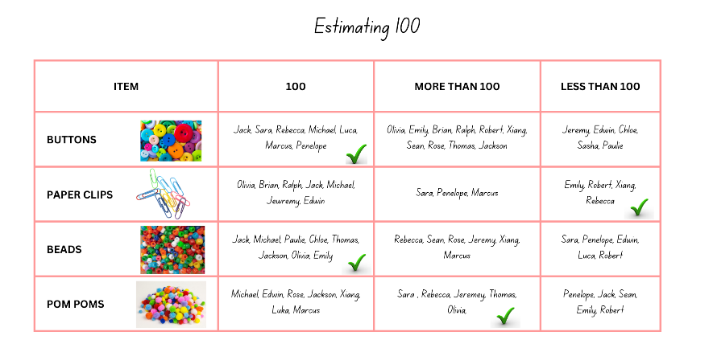
Images sourced from Canva and used in accordance with the Canva Content License Agreement.
- Discuss the accuracy and inaccuracy of students estimates and ensure that students have the opportunity to discuss how they arrived at their estimates. Once the correct amounts have been disclosed, discuss what may have gone right or wrong with estimating strategies.
- Use the collected data table to prompt a discussion by asking students:
- Which collection of items did most people estimate correctly? How many people?
- Which collection did most people find difficult to estimate correctly? How do you know this?
The table below details assessment opportunities and differentiation ideas.
Assessment opportunities | Too hard? | Too easy?
What to look for:  - Are students able to skip count forwards by twos, fives and tens accurately? (MA1-FG-01)  - Can students group objects into groups of ten when counting a large collection of objects? (MAO-WM-01, MA1-RWN-01)  - Are students recognising units of 100? (MA1-RWN-01)  - Are students able to combine smaller quantities of objects grouping these in tens to make the count more efficient? (MAO-WM-01, MA1-RWN-01)  What to collect:  - records of discussions and vocabulary being used when strategising and estimating. (MAO-WM-01, MA1-RWN-01) | Students are unable to estimate, arrange the collection into small groups or skip count.  - Collect a handful of coloured bricks. Ask students if they can tell how many coloured bricks there are without counting. Record estimates and ask students to count and check their estimate. Repeat a few times and then add an additional handful.  - Provide time for students to explore 2 handfuls of coloured bricks and to create a pattern which will enable counting. | Students can estimate to the nearest hundred.  - Ask students to estimate a mixed collection of concrete materials that have various sizes.  - Ask students to draw a representation of the strategy they used to estimate and how they arranged the materials to determine their estimate.

Reproducing patterns: Part 1 – 5 minutes
- Explain to students that for this part of the lesson they will be working in the same small group as they did in Lesson 2.
- Provide each pair of students within the small group with a digital device. Explain that each pair will select a different image of repeating patterns that they photographed with the digital device during the previous ‘repeating pattern hunt’ lesson.
- Explain that after each pair have selected a photograph, the group will identify, discuss, and label each part of the repeating core for each image. For example, students may annotate the shapes, the number of sides, colours, the number of objects, textures and/or the size of objects.
- Explain to students that they will use the annotated information that they identified as the core for their selected photograph to create a representation using Mathigon.
Note: If Mathigon is not available, use coloured paper shapes to create and photograph pattern representations.

Reproducing patterns: Part 2 – 40 minutes
- Display the Mathigon interactive board. Use the left menu to select the ‘Geometry’ option and then the ‘Polygons and Shapes’ option. Explain that the interactive board supports the understanding of and the creative exploration of repeating patterns.
Note: To cater for the diverse abilities and learning styles of students, consider small collaborative groups which include a range of learning abilities and pairs of students which may require more directed support, modelling and instructions. It is essential that students are referring to the photographs of the patterns they selected from the pattern hunt in the previous lesson.
- Model clicking or dragging shapes from the left menu onto the blank board. Show students how to rotate the individual shapes by clicking on the small black circle located above the shape and model how to change shape colours by using the colour wheel option which is located on the ‘options ribbon’ on the bottom centre of the board.
- Display a sample photograph or image of any school building and model how to create a repeating pattern which represents windows and a brick wall. It is essential to model for students how to change the colour of the shapes and manipulate the size and orientation (see Figure 7).
Figure 7 – Example of a representation of a repeating pattern found in a school building
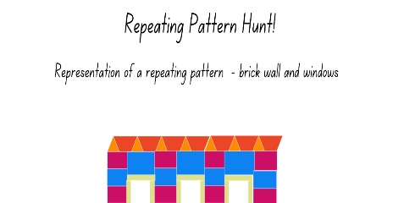
- In pairs, students use a digital device and the selected annotated image to create a representation of the repeating pattern using the shapes and polygons in Mathigon.
- Provide time and support for students to explore Mathigon. Bring students back to the floor and select several students to share how they have been manipulating and changing the shapes. Provide time for students to continue working with their partner to complete their pattern representations.
The table below details assessment opportunities and differentiation ideas.
Assessment opportunities | Too hard? | Too easy?
What to look for:  - What strategies are students using to arrange and group the various parts of the repeating core so that it accurately represents their selected photograph? (MAO-WM-01, MA1-RWN-01, MA1-FG-01)  - Is the repeating core of the pattern being represented accurately and does it repeat over and over and over again? (MAO-WM-01, MA1-RWN-01)  What to collect:  - observations and recordings of conversations and vocabulary used by students (MAO-WM-01, MA1-RWN-01, MA1-FG-01)  - photos and work samples of repeating patterns. (MAO-WM-01, MA1-RWN-01) | Students cannot manipulate shapes to create representations of repeated patterns.  - Model how to create a repeated pattern and support students to make simple repeating patterns, such as tiles or a fence.  - Provide students with coloured tiles and shape blocks to make the repeating pattern they identified in the photograph. | Students can create representations of the photographed repeating patterns.  - Students swap their representations with another small group. They need to identify the pattern core represented and then create the next part of the pattern.  - Ask students to use letters, such as A and B to label both of the repeating core patterns.

Consolidation and meaningful practice: Gallery walk – 10 minutes
- Students display their images and pattern representations on their digital device and go on a gallery walk. Allow time for students to view and discuss other students’ work. Ask:
- When you look at a repeating pattern representation can you identify where in the school context that pattern occurs?
- Is there a repeating pattern that has a very interesting repeating core? Can you describe the repeating core and what makes it interesting?
- Can you identify a repeating pattern that has a two-part (AB) repeating core pattern, a three-part (for example ABC ABB) repeating core pattern, and a four-part (for example ABCD or ABCC) repeating core pattern?

Lesson 4: Generating number patterns
Core concept: Number sequences can be arranged and repeated to create a variety of number patterns.
The table below contains suggested learning intentions and success criteria. These are best co-constructed with students.
Learning intentions | Success criteria
Students are learning that:  - growing patterns have something (an element) that gets bigger by the same amount each time  - shrinking patterns have something (an element) that gets smaller by the same amount each time  - mathematicians use arrays to represent a quantity of objects as groups in rows and columns  - arrays are useful when reasoning about the commutative property of multiplication. | Students can:  - identify other numbers that belong to a number pattern  - explain how a pattern grows or shrinks when something (an element) is added or removed  - arrange a quantity of objects into rows and columns creating an array  - explain, for example, 2 rows of 5 objects are the same as 5 rows of 2 objects, there are still 10 objects altogether.

Daily number sense: What other numbers belong? – 15 minutes
This lesson has been adapted from Talking about Patterns and Algebra (2010), NSW Department of Education.
- Build student understanding of identifying and describing number patterns by playing ‘What other numbers belong?’
- Display Resource 3: Number cards.
- Explain to students that the number sequence has been jumbled (see Figure 8).
Figure 8 – What other numbers belong?
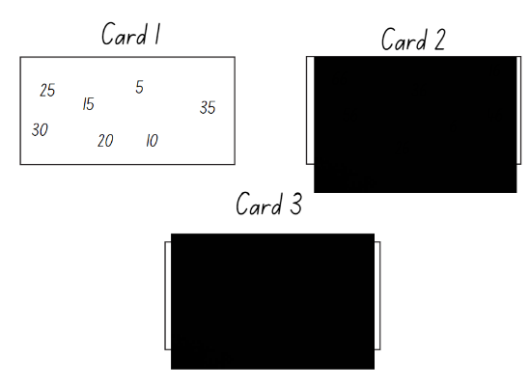
- Ask students:
- What other numbers could be added onto this card?
- How do you know?
- Record student responses and repeat the activity for Card 2 and Card 3.

Generating number sequences: Part 1 – 20 minutes
- Use virtual tiles, or other concrete materials to create an array that represents 12 by arranging 4 threes in both orientations (see Figure 9).
Figure 9 – 4 threes
- Using a piece of paper, cover part of the array and model for students how each column represents 4 ones, then 4 twos and lastly 4 threes (see Figure 10).
Figure 10 – Covering part of the array
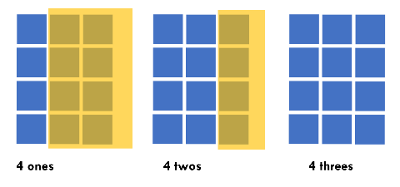
To support the development of multiplicative thinking and an understanding of multiplication and division, it is essential to explicitly teach students to distinguish between the number of groups (rows and columns) and the number in each group (row and column). For example, students need to know that there are 4 ones, 4 twos, 4 threes and so on, as this develops mental strategies for multiplication instead of relying on additive strategies. It is also necessary to explain that by physically changing the position or the presentation of an array, it does not change the overall quantity of objects. Understanding the commutative property of multiplication supports reasoning, the development of metalanguage and understanding of multiplication facts. For more information and research-based evidence see Stage 1 multiplication and division, Multiplication and division – cats on a mat, Multiplicative strategies, and Teaching Mathematics Foundations to middle years, 3rd edn (2021) by Siemon et al.
- Label each row of the array with a sticky note to show how each row of the counting pattern grows by 3 (see Figure 11).
Figure 11 – Labelling the array as a counting sequence
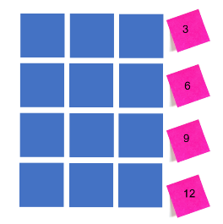
- Ask students:
- What number would come next in this number sequence? How do you know?
- How can you describe this number pattern?
- If the number sequence is getting bigger after each number, can you describe it as a growing pattern? Explain how?
- If you counted backwards, can you describe the number sequence as a shrinking pattern? Explain how?
- Provide students with writing materials and ask them to record an example of a growing and a shrinking pattern. Observe that students are recording the repeated constant difference in both the growing and shrinking sequences (see Figure 12).
Figure 12 – A number sequence that grows and shrinks
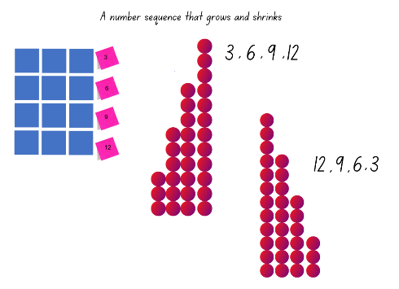
Note: Drawing student’s attention to the number pattern and the structure of the array provides students with opportunities to make generalisations, to view the structure of a given number as an array, to build knowledge and experience with other number sequences. It also provides the opportunity for students to observe how number patterns have an element that repeats over and over and over again, and this understanding of number patterns is one that students can trust.
- Provide time for students to use tiles or other concrete materials to explore building a variety of number sequences.
- Bring students together to share and discuss their findings. Ask students:
- Did all your number sequences have a common difference or a common quantity that the next number increased or decreased by?
- What is something interesting you noticed?
- What is something you are still wondering about?
The table below details assessment opportunities and differentiation ideas.
Assessment opportunities | Too hard? | Too easy?
What to look for:  - Can students identify the number before and after in a sequence? (MAO-WM-01, MA1-RWN-01)  - Are students able to identify the skip counting pattern for their number sequence? For example, can they describe that the sequence grows by twos or shrinks by twos? (MA1-FG-01)  - Can students distinguish how many rows, how many columns and how many objects in each row and how many objects in each column? (MAO-WM-01, MA1-FG-01)  - Are students able to communicate their understanding of the commutative property of multiplication when reasoning about their array? (MAO-WM-01, MA1-FG-01)  What to collect:  - Recordings and samples of work displaying students number sequences and their recorded findings. (MAO-WM-01, MA1-FG-01) | Students are unable to communicate their understanding of the commutative property.  - Support students by modelling that 5 can be represented as 2 counters and 3 more or 3 counters and 2 more. Repeat a few times with other numbers.  - Support students to create simple arrays; an array representing 6. Model how to identify what is a row and what is a column and then construct the same array, rearranging the rows and columns. | Students can record, describe and create various number sequences.  - Provide students with a hundred or 200 chart and challenge students to find a variety of interesting number sequences.  - Ask students to select one of their number sequences and create a representation.

Generating number sequences: Part 2 – 20 minutes
- Explain to students that you have been thinking about the different ways to represent 6. Using square tiles, display representations of 6 as number sequences and growing patterns, such as in Figure 13.
Figure 13 – This is 6
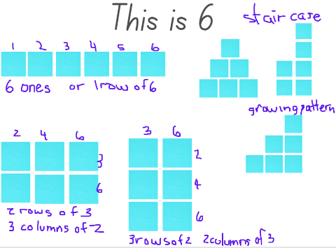
- Explain that the number 6 can be represented as arrays and as various growing staircase patterns. Ask if all numbers can be represented in such ways as 6.
- Provide pairs of students with square tiles or other suitable concrete materials, writing materials or a digital device to record findings.
- Explain that, in pairs, students will investigate 2 different ‘teen’ numbers of their choice. They need to label and record their findings.
- Once students have had time to explore some numbers ask:
- Is there anything you are wondering?
- Are there any ‘teen’ numbers that you cannot create in an array, a counting sequence or a growing pattern?
- For which ‘teen’ number were you able to create the most representations? Why do you think that was possible for that number?
- Bring students back together and select students to share their findings and explain their recordings.
The table below details assessment opportunities and differentiation ideas.
Assessment opportunities | Too hard? | Too easy?
What to look for:  - Are students able to identify and record a number pattern or sequence in a variety of ways? (MAO-WM-01, MA1-RWN-01)  - Can students distinguish how many rows and how many columns, how many objects in each row and how many objects in each column? (MAO-WM-01, MA1-FG-01)  - Are students able to describe counting sequences and growing patterns as having equal groups or equal rows and equal columns? (MA1-FG-01)  What to collect:  - Work samples that are labelled of students arrays and counting patterns or sequences. (MAO-WM-01, MA1-FG-01) | Students are unable to investigate the ‘teen’ numbers and create representations.  - Students explore numbers less than 10.  - Students work in small groups and collaboratively explore the number 10 and then the number 12. | Students can create various representations for all the ‘teen’ numbers.  - Students record number sentences to explain their findings for each ‘teen’ number.  - Challenge students to select one of the ‘teen’ numbers and record a shrinking pattern with missing elements for a partner to solve.

Consolidation and meaningful practice: What comes next? – 10 minutes
- Display an arrangement of tiles as in Figure 14.
Figure 14 – What comes next?
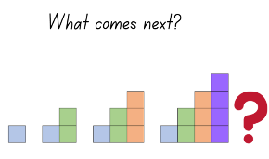
- Briefly discuss the arrangement of tiles, asking students to share what they notice.
- Ask students to view the growing pattern and each consecutive growing core and ask the following:
- Is this a number pattern?
- What is repeating over and over and over again?
- What number can we record for this pattern under each part of the sequence?
- Provide time for students to turn and talk with a partner and then select students to use the tiles and create the next part of the sequence. Discuss their reasoning.

Lesson 5: Generating counting sequences
Core concept: Problems can be solved using a number pattern or sequence.
The table below contains suggested learning intentions and success criteria. These are best co-constructed with students.
Learning intentions | Success criteria
Students are learning that:  - identifying and describing a number pattern is helpful when solving a problem  - to accurately group and count a large collection the number of objects needs to be the same in every group  - number patterns have a rule that repeats over and over and over again. | Students can:  - use a variety of skip counting patterns when solving a problem  - identify how many objects there are in each group and how many groups there are altogether  - describe the pattern rule when investigating a number sequence.

Daily number sense: Generating counting sequences – 15 minutes
This lesson has been adapted from Talking about Patterns and Algebra (2010), NSW Department of Education.
- Build student understanding of number pattern rules by investigating and generating visual and numerical counting sequences.
- Provide students with craft sticks and explain that they need to make a row of triangles. Ask students to make 4 triangles initially. Ask:
- What do you notice about this arrangement of triangles?
- Can you explain how this is a pattern? Is it just a triangle shape pattern or is it also a number pattern?
- If it is a number pattern, what could you count?
- Explain to students that this sequence of repeating the number of craft sticks is a number pattern or a counting sequence.
- Ask students to turn and talk with a partner and use sticky notes to label each triangle in the sequence, creating a counting sequence. For example, 3 craft sticks were used to make the first triangle, then 3 more to make the next, so that is 6 altogether. Then another 3, so now there are 9 craft sticks altogether, and so on (see Figure 15).
Figure 15 – A row of triangles representing a counting sequence
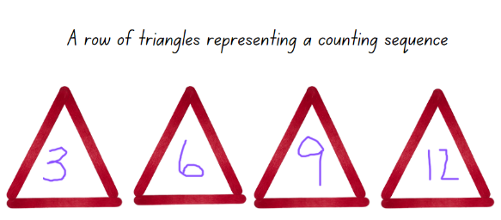
- Explicitly talk about the connection between the visual representation of the triangles and the numerical pattern. Explain that the pattern is a growing pattern because the rule or the core that repeats over and over and over again is an increase of 3 craft sticks to the previous 3 and so on.
- Explain that using manipulatives, diagrams and illustrations helps to figure out the rule for more complex number patterns and sequences.
- Provide time for students to continue the number pattern beyond 12.
- Discuss the counting sequence created and record the numbers, explicitly showing the rule for this pattern.
The table below details assessment opportunities and differentiation ideas.
Assessment opportunities | Too hard? | Too easy?
What to look for:  - Can students count forwards to at least 120? (MA1-RWN-01)  - Are students counting by threes as they count the triangles? (MA1-FG-01)  - Can students identify and describe the number pattern and suggest the next number in the sequence? (MA1-FG-01)  What to collect:  - photographs of students counting sequences and of the vocabulary used to describe the number pattern. (MAO-WM-01, MA1-FG-01) | Students are not able to identify the number pattern in the counting sequence using triangles.  - Provide students with interlocking cubes and support students to add 3 more interlocking cubes as each triangle is being made.  - Use 2 ten-frames and, as students are making each triangle, place 3 counters in the frame so that students can visualise how the groups of 3 are the repeating core and are added to the previous 3 counters. | Students can label and continue the triangle counting sequence.  - Ask students to create a number pattern using pentagons and/or squares.  - Provide students with writing materials and crafts sticks to create a counting sequence that has a missing element for a partner to solve.

How many legs? – 40 minutes
- Pose the following narrative: You were in a restaurant the other day and, while waiting for your meal to arrive, you wondered how many legs there were in the restaurant all together.
- Display Resource 4: How many legs? and explain that you observed 3 tables with 6 chairs and 6 people, 5 tables with 4 chairs and 4 people, and 7 tables with 2 chairs and 2 people. There were also 7 people serving the food and 3 chefs cooking in the kitchen. Ask how many legs there were altogether.
- Ask students:
- What is the problem asking you to do?
- What are some efficient strategies you could use to solve this problem?
- How will you count all the legs and keep track of the legs you have already counted?
- How will you count the legs you can see, as well as those that you can't see but know must be included?
- How will you record the solution?
- What type of diagram or drawings would be useful?
- Record suggestions on the board and discuss.
- Provide pairs of students with writing materials and explain that one strategy to problem-solve might be a diagram of the restaurant, but that might take a long time to draw all the tables, chairs and people.
- Explain that mathematicians solve problems like this all the time. When mathematicians count lots of things, they are collecting information about a quantity or data. The collected data will give them the solution to the problem. Mathematicians also like to use tally marks to help them track their counting.
Note: Explain to students that mathematicians use symbols such as tally marks to record counting, especially when counting a large collection while problem-solving. Tally marks are used to represent groups of 5 and this allows efficiency when counting a large collection as students can skip count by fives to find the total count. If students have not had the opportunity to work with tally marks before, model how to make a tally mark for one, 2, 3, 4 and how the diagonal line ends that group of tally marks as it represents the total number of 5. Provide time for students to explore tally marks for various two-digit numbers.
- Ask pairs of students to brainstorm ideas for how they can collect the data (count all the different legs) and represent the data (show the solution).
Note: Students may be able to collect the data but need support to organise and represent the data to show their solution to the problem. It is optional to share an example of a data table or a diagram as in Figure 16.
Figure 16 – How many leg’s - data table and a diagram
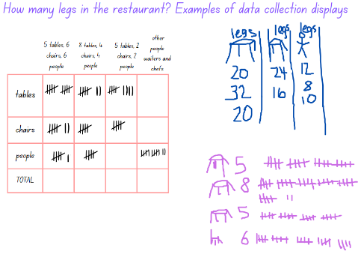
The table below details assessment opportunities and differentiation ideas.
Assessment opportunities | Too hard? | Too easy?
What to look for:  - Can students skip count by fives and track the count using tally marks? (MA1-FG-01, MA1-DATA-01)  - Can students count forwards and backwards to at last 120? (MA1-RWN-01)  - Can students group the legs into groups of 10 to assist with counting? (MA1-RWN-01)  - Can students distinguish how many legs are in each group of tables and chairs and then how many legs there are all together? (MA1-FG-01)  - Do students understand what the problem is asking them to do, and can they apply appropriate strategies to find the solution? (MAO-WM-01)  - Can students organise the collected data from counting the legs, into relevant categories and display the information accurately? (MAO-WM-01, MA1-DATA-01, MA1-DATA-02)  - Are students contributing to discussions by making comments or asking questions in response to the collected data as a solution to the problem? (MAO-WM-01, MA1-DATA-01)  What to collect:  - work samples of student's recordings and data table displaying the solution to the problem (MAO-WM-01, MA1-DATA-01  - recordings of students' conversations as they strategise and trial solutions to the problem. (MAO-WM-01) | Students are unable to count tally marks or problem solve with a multi–step problem.  - Provide students with counters and a visual display that shows the 5 times table to support skip counting by fives.  - Reduce the number of tables, chairs and people to include tables with only 2 chairs and 2 people.  - Provide students with concrete materials to illustrate the problem and find the solution. | Students have created a data table that clearly displays the results and is well organised.  - Ask students to identify patterns that they can see from the results in the data table. For example, counting by fours.  - Pose the scenario that there are 7 families with 6 members, 9 families with 5 members, 12 families with 4 members, and 8 families with 3 members.  - Ask students to decide the best seating arrangements for the people in the restaurant and then ask how many tables and chairs are needed.

Consolidation and meaningful practice: Generating Patterns – 10 minutes
- Provide students with writing materials and display Resource 5: Number patterns and their rules.
- Ask students to record what would be the next drawing, diagram or number for each of the displayed patterns. Ensure that students are identifying the pattern rule.
- Select students to share their solutions and discuss how do they know that they have identified the rule and have continued the patterns correctly.

Lesson 6: Investigating counting sequences
Core concept: An array can be positioned differently to reflect a different counting sequence but whole quantity stays the same.
The table below contains suggested learning intentions and success criteria. These are best co-constructed with students.
Learning intentions | Success criteria
Students are learning that:  - arrays are made of equal columns and equal rows  - an arrangement of a given number of counters, such as an array can be repositioned, but the quantity of counters stays the same  - investigating arrays are helpful when exploring counting sequences  - data tables are a useful way to explain number sequences. | Students can:  - identify how many objects in each row and how many objects in each column when investigating arrays  - describe an array by stating, for example, that there are 3 ones, then 6 ones, then 9 ones, then 12 ones, which is an array representing 12  - create a data table or diagram to represent a counting pattern or sequence.

Daily number sense: 10 minutes
- From a class need surfaced through formative assessment data, identify a short, focused activity that targets students’ knowledge, understanding and skills. Example activities may be drawn from the following resources:
- Thinking Mathematically Stage 1
- Universal Resources Hub.

30 square tiles – 35 minutes
Note: For this task it is optional to use small squares of paper for students to position and move, plastic or wooden square tiles or shapes, or students can use grid paper and colour in all the different options.
- Display Resource 6: 30 square tiles and ask students what they notice, and what do they wonder about the arrangement of tiles or the array.
The table below outlines stimulus prompts to generate conversation about the topic, along with anticipated responses from students.
Prompts | Anticipated student responses
- When all the square tiles are placed together in an array, does it remind you of a shape?  - How many square tiles have been used to create the rectangle?  - Can you label the rows and columns? How many square tiles are there in each row? How many square tiles are in each column?  - If it was flipped on its end, what would the shape be? How many rows and how many columns? How many tiles in each row and column?  - Can you describe this array of squares as a pattern?  - Can the 30 tiles be rearranged to create another rectangle that would look different to this one?  - How can you record your findings? Can you use a table to show how many tiles are needed for each row and each column? | - A rectangle because it has 2 long sides and 2 short sides.  - 30.  - If you flipped it, it would still be a rectangle and the long sides would be vertical and the short sides horizontal.  - Yes. 3, 6, 9, 12, 15, 18, 21, 24, 27, 30.  - 10, 20, 30.  - Yes. There are 6 lots (×) of 5 or 5 lots (×) of 6.  - We could list each quantity used in each row and column to show the different rectangles or we can draw a diagram and record how many there are.
- Provide pairs of students with concrete materials, a digital device or writing materials and explain that there may be other ways to arrange the 30 square tiles to make a different rectangle.
- Explain to students that they need to investigate all the possibilities and record their findings (see Figure 17).
Figure 17 – Labelled examples of rectangles
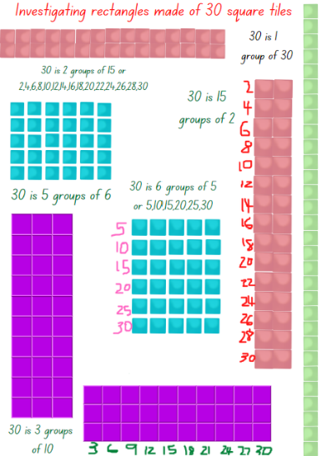
- Select students to share their representations. Ask students:
- How can you prove that these arrangements or arrays are really 30?
- Does it matter if the array is 5 rows of 6 square tiles or 6 rows of 5 square tiles? Is it still 30? How can you prove it?
The table below details assessment opportunities and differentiation ideas.
Assessment opportunities | Too hard? | Too easy?
What to look for:  - Can students arrange the tiles to show repeating equal groups? (MA1-FG-01)  - Can students skip count by twos, threes and fives? (MA1-RWN-01, MA1-FG-01)  - Are students creating an array of equal rows and equal columns to show 30? (MA1-FG-01)  - Do students understand the commutative property by displaying an array of 30 as 5 rows of 6 or 6 rows of 5? (MAO-WM-01, MA1-FG-01)  What to collect:  - recording of specific vocabulary being used by students (MAO-WM-01, MA1-FG-01)  - photographs or work samples displays student's arrays (MAO-WM-01, MA1-FG-01) | Students are unable to create multiple arrays using 30 tiles.  - Provide students with 10 square tiles initially and then 12. Model and support students to create arrays.  - Support students to explore other arrays using the 30 tiles by asking students to create equal groups of the total 30 tiles.  - Model and support students to use the groups to create arrays. | Students created a variety of arrays and label the number sequences for each array.  - Provide students with 36 or 42 square tiles to create rectangles and arrays.  - Challenge students to prove that arrays can be created for both odd and even numbers.

Consolidation and meaningful practice: Investigating arrays – 20 minutes
- Remind students that they created different rectangles using all the 30 square tiles.
- Explain that this time they will work in groups and each group will use a given number of square tiles up to 30. For example, first group 12 tiles, second group 15 tiles, third group 24 tiles, fourth group 25 tiles and fifth group 27 tiles. Each group needs to create all possible rectangles using their tiles and record the data in a table.
- Remind students that mathematicians collect information. This information is called data and there are different ways to represent data so that the information can be shared with others. One example is a data table.
- Model how to draw up a data table, such as in Figure 18.
Figure 18 – An example of a data table
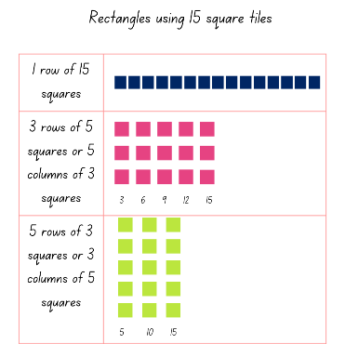
- Once students have completed their investigation, collate the data on a joint data table or an anchor chart. Discuss the findings and ask students what the data has made them wonder and if they can identify any interesting number patterns.
Assessment opportunities | Too hard? | Too easy?
What to look for:  - Can students create a data table to represent their findings? (MAO-WM-01, MA1-DATA-01)  - Are students able to interpret the data and justify how their representations are accurate arrays? (MAO-WM-01, MA1-FG-01, MA1-DATA-01)  What to collect:  - recording of specific vocabulary being used by students (MAO-WM-01, MA1-FG-01) | Students are unable to represent their data and explain their finding.  - Provide students with 10 tiles and support them to create representations. Use a digital device to record their findings and annotate the images.  - Display an array representing 6 and ask students to describe what they see and record statements on sticky notes to label the array. | Students can create a data table that displays a counting sequence and they justify the accuracy of their representation.  - Ask students to record 3 questions that they can ask about their data.  - Students discuss the answers to those questions.

Lesson 7: Problem-solving detectives
Core concept: Collecting and recording data is a useful strategy when problem-solving.
The table below contains suggested learning intentions and success criteria. These are best co-constructed with students.
Learning intentions | Success criteria
Students are learning that:  - data can be used to investigate, record and solve problems  - there are a variety of ways to solve a problem and find an accurate solution  - tally marks are a useful tool for recording a count  - mathematicians use arrays to represent a quantity of objects as groups in rows and columns. | Students can:  - use data to record solutions and solve everyday problems  - use tally marks to record quantities of a large collection and then count the total by skip counting by fives  - arrange a quantity of objects into rows and columns creating an array  - explain that 2 rows of 5 objects is the same as 5 rows of 2 objects.

Daily number sense: Skip counting to 24 – 10 minutes
- Build student understanding of number patterns and their rules by exploring skip counting sequences.
- Provide pairs of students with a number line to 24 and writing materials.
- Explain that students need to investigate how many different ways they can skip count to 24.
- Students can use the number line to sequence their counts and then record all the possible ways to share with the class.
- Ask students:
- Was there any skip counting sequence that did not work?
- Describe a skip counting sequence that was interesting from 1-24.
- What was the easiest skip counting sequence you found?

Array detectives – 45 minutes
This lesson has been adapted from Mindset Mathematics: Array Museum from Boaler et al. (2022).
Note: To successfully create a display of students’ work as an ‘array museum’ it is important to designate a space in the classroom prior to the lesson so that students’ creative samples can be displayed and further added to over the following weeks.
- Display Resource 7: Arrays in our world and ask students to share what they can see and in particular describe how the objects are arranged and organised systematically to create a display like an array.
Array: An array is a systematic arrangement of objects in rows and columns whereby each subsequent row has the same quantity, and each subsequent column has the same quantity. Arrays support multiplicative thinking and the early development of knowledge and understanding of multiplication and division.
- Ask students to share what they know about arrays and to provide examples, such as ten-frames, chess boards or dots on dominoes and dice. Display examples of arrays and ensure that students understand that an array has columns and rows which are systematically arranged to look like a grid, that every row has the same quantity of objects, and every column has the same quantity of objects (such as on a ten-frame).
- Provide time for students to turn and talk with a partner and to look around the classroom, identifying any examples of arrays. Examples may include a bookcase or windowpanes.
- Explain that mathematicians find arrays very useful to group, organise or ‘chunk’ a collection of items so that they can calculate or count how many items there are altogether, without needing to count by ones.
- Display 2 ten-frames in an arrangement that looks like an array. Ask students if they can suggest how to use the columns and rows to count how many squares there are altogether. Provide pairs of students with counters and ask them to make an array that models the 2 ten-frames. Select students to share their findings and results.
- Ask students to think about the ‘repeating pattern hunt’ lesson and to recall if they had photographed any repeating patterns that looked like an array. Ensure that students are identifying repeating patterns that have rows and columns like an array. Allow students to use digital devices to share photographs and to discuss how the repeating pattern is an array. Ask students:
- How can you prove that the repeating pattern is an array? How do you know?
- If you were going to count how many objects were in that repeating pattern or array, how might you do that?
- Explain that, in small groups, students will use a digital device to photograph and/or draw illustrations of arrays that they identify around the school context. Students can also use previously recorded photographs from the pattern hunt lesson.
- Explain that students will need to label their arrays, recording the total units or number of units in each column and each row.
The table below details assessment opportunities and differentiation ideas.
Assessment opportunities | Too hard? | Too easy?
What to look for:  - Are students identifying and creating arrays that have equal rows and equal columns? (MAO-WM-01, MA1-FG-01)  - Can students arrange large quantities of objects, grouping these to make counting larger quantities more efficient? (MA1-RWN-01)  - Do students explain and use the arrays to model how many items in each row/column and how many rows/columns altogether? (MAO-WM-01, MA1-RWN-01, MA1-FG-01)  What to collect:  - samples of work and labelled photographs or drawings of arrays. (MAO-WM-01, MA1-FG-01) | Students are unable to identify how many items in each row and column of an array.  - Provide students with counters and a ten-frame or an empty egg carton.  - Model and support students to identify a row and a column by using counters to represent numbers in rows and columns.  Students are unable to count with one-to-one correspondence.  - Use concrete materials to represent the group and support students to identify or move one, 2 or 3 items from the group.  - Model how to move the items into a simple array, such as 2 rows by 3 columns. | Students can calculate how many items in an array by using the columns and rows.  - Challenge students to calculate how many bricks there are in one section of a school wall and use this information to calculate how many bricks would be in the whole wall.  - Ask students to problem-solve and create an array that has columns and rows to represents the total quantity 150.

Discussing the mathematics: What do our arrays tell us? – 5 minutes
- Provide time for students to view the array museum and discuss their observations. Ask students:
- Are there any arrays that are similar or different?
- Are there any arrays that you can recognise and connect to a place in the school context?
- Can you see if there is one type of array that is more common at our school than any other? Why do you think this is so?
- Which array can you see, and know by looking at the rows and columns, has the largest number result? How can you describe this array to someone who can’t see it?

Lesson 8: Arranging and displaying data
Core concept: Recorded data can be displayed in many ways and the results provide meaningful information.
The table below contains suggested learning intentions and success criteria. These are best co-constructed with students.
Learning intentions | Success criteria
Students are learning that:  - exploring and sorting objects helps to notice things that are the same and different  - tally marks are a useful way of tracking a count  - data can be used to solve problems  - data can be recorded using symbols, pictures, words or numbers and the information can then be interpreted. | Students can:  - use tally marks to track a count and can then skip count by fives to find the total  - sort and organise collected data to find solutions to a problem  - ask questions and provide answers about data displayed in in a graph or table.

Daily number sense: An array of cupcakes – 15 minutes
- Build student understanding of arrays by exploring how to arrange a given quantity of objects into rows and columns.
- Explain that a baker made 36 cupcakes and wants to display these as an array in the shop window. The baker knows that there are different arrays to represent 36 but wants to know all the options.
- Provide pairs of students with counters and writing materials or a digital device to record their findings.
- Explain that students need to investigate how many different arrays, rows and columns can be made to arrange the 36 cupcakes.
- Provide time for students to share their different arrays and ask:
- How do you know you have found all possible arrays to represent 36?
- How do you know that each of your arrays has 36 cupcakes?
- Which array do you think is the most suitable for the baker to use? Why?

Sort the street: Part 1 – 15 minutes
This lesson has been adapted from NRICH, Sort the Street.
- Display and ask students to identify what is the same and what is different between all the houses.
- Provide each pair of students with a copy of Resource 8: Sort the street and a digital device.
- Explain that students will cut out each house and arrange them to represent 2 different ways that the houses can be sorted based on combinations of attributes or features. For example, one way is to sort houses with/without curtains and a verandah, houses with/without curtains and a chimney, or houses that are two storey or one storey (see Figure 19).
Figure 19 – Examples of sorting – sort 1 and sort 2
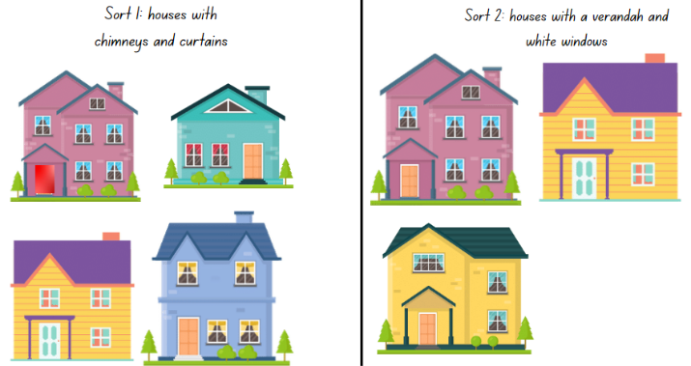
Images sourced from Canva and used in accordance with the Canva Content License Agreement.
- Explain that each sorting arrangement needs to be annotated and photographed using a digital device to explain the selected attributes and features used in the sort.
- Bring students back together and ask students to share one sort that they think is the most creative with another pair of students. Select students that have an interesting sort to share and display the photograph digitally for the class to view and discuss.

Sort the street: Part 2 – 35 minutes
- Explain that there were many different attributes and features identified and used to sort the houses. State that, during the class discussion, the shared examples showed that the houses in Resource 8: Sort the street had a lot of detail or information that was similar and also different.
- Explain that, when there is a lot of information that is the same or different, one way to collect and represent the data in order to share it, is to create a data display.
- Display Resource 8: Sort the street and explain that you are wondering how many different attributes or parts are shared between all the houses.
- Explain that they are going to work with a partner to create a data display to show how many different parts or attributes there are on all the houses in the street. For example, how many windows, doorknobs, shrubs, curtains and front doors.
- Discuss ways that the data could be collected, counted and then represented in a data display, like a graph, so that the information could be shared with others. Ask:
- What is one strategy to keep track of counting each of the parts? How will you track and record how many windows there are altogether? How will you know which houses you have already counted?
- How will you structure your graph so that the information can be shared? Will you have rows and columns? Will you use symbols, pictures or words to name each of the attributes/parts?
- How will you know if the information is accurate and easy to understand?
- What title will you give your graph? What data are you collecting and what information is your graph representing or sharing?
- Select students to share their ideas and record these on the board so that other students can refer to them if needed. Suggestions may include tally marks to track the count, a picture graph of the parts of the house with symbols to represent each individual part, or a data table with rows and columns to represent how many of each part there are (see Figure 20).
Figure 20 – Example of a data display for sort the street
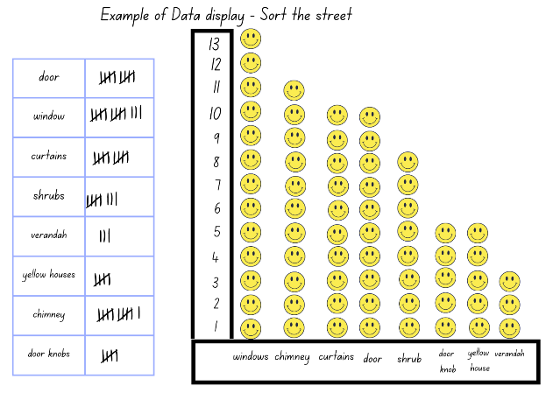
Images sourced from Canva and used in accordance with the Canva Content License Agreement.
The table below details assessment opportunities and differentiation ideas.
Assessment opportunities | Too hard? | Too easy?
What to look for:  - Are students sorting the data into appropriate categories and representing the information in a table, diagram or a graph? (MA1-DATA-01)  - Are students using tally marks and efficient counting strategies to keep track of the count? (MA1-DATA-01)  - Can students select appropriate symbols, pictures and/or words to represent a data value? (MA1-DATA-01)  What to collect:  - work samples and photographs of students work. (MAO-WM-01, MA1-DATA-01) | Students are unable to sort objects using more than 2 categories.  - Support students to list all the features of one image of a house and then ask students to compare with another house to identify what is the same and what is different. List the features and compare to one more house.  Students are unable to use tally marks to track the count or organise the collected data to create a display.  - Provide students with craft sticks to use as tally marks and ensure that a craft stick is placed diagonally to represent 5.  - In small groups, provide students with examples of picture graphs and a template of a simple table.  - Support students to collect data from 2 images of houses and to create a simple data display. | Students use tally marks accurately and are able to sort and design an informative data display.  - Ask students to record 3 questions that could be asked about their collected data.  - Ask students to identify which house was the most different to all the others and explain why.

Discussing the mathematics: What does the data tell us? – 5 minutes
- Provide time for each pair of students to Think-Pair-Share with another pair of students, sharing their data results and graphs. Ensure students are identifying individual attributes or features which have been used in their data collection. Ask:
- Which attribute or feature had the highest result on you graph? How do you know?
- Which attribute or feature had the least result on your graph? How do you know?
- Is there an attribute that you and your partner did not include in your graph, but the other pair of students did include in their graph?
- How do you know the information in your graph is accurate?

Resource 1: Architectural repeating patterns
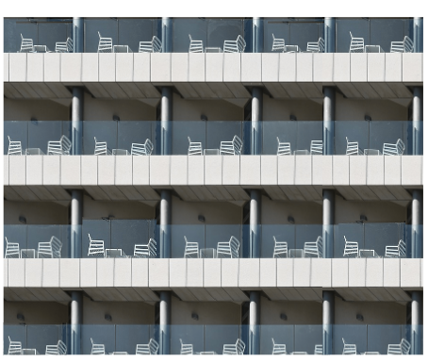
‘Modern Industry Steel Technology Expression City’ by moshehar is used in accordance with the Pixabay License.

‘Opera House Australia Sydney City Travel Break’ by HeungSoon is used in accordance with the Pixabay License.

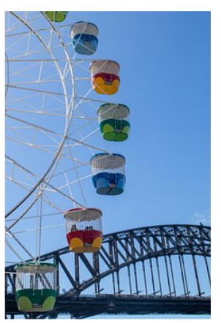
‘Ferris Wheel Sydney Attraction Wheel Bridge’ by Squirrel_photos is used in accordance with the Pixabay License.

‘Container Bridge Container Container Handling’ by bernswaelz is used in accordance with the Pixabay License.

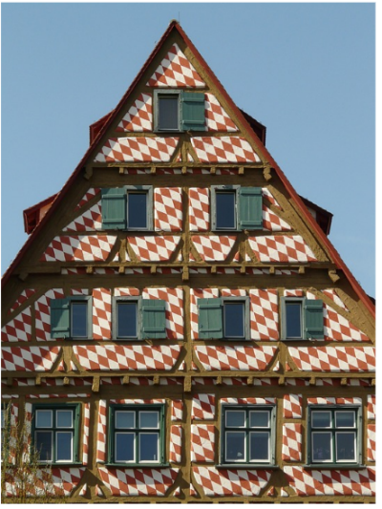
‘Truss Half-Timbered House Bar Entablature House’ by Hans is used in accordance with the Pixabay License.
‘Multicoloured Sea Beach Hut’ by dabu2604 is licensed under the Pixabay License.
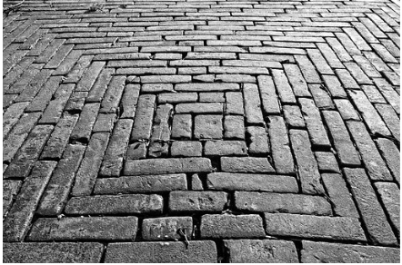
‘Brick Paving Sidewalk Street’ by Mabel Amber is licensed under the Pixabay License.
‘Hexagon Building Pattern Abstract’ by breivejulius is licensed under the Pixabay License.
‘Architecture Beach Bright Cabin’ by PublicDomainPictures is licensed under the Pixabay License.
‘Tower Architecture Building Sights’ by Ben Kerckx is licensed under the Pixabay License.

Resource 2: Modified architectural images
‘Bricks Wall Red Bricks Brick Wall’ by Pexels is licensed under the Pixabay License.
‘Building Architecture Modern’ by Kevin Schwarz is licensed under the Pixabay License.
‘Buildings Pedestrian Crossing City’ by Pexels is licensed under the Pixabay License.

Resource 3: Number cards
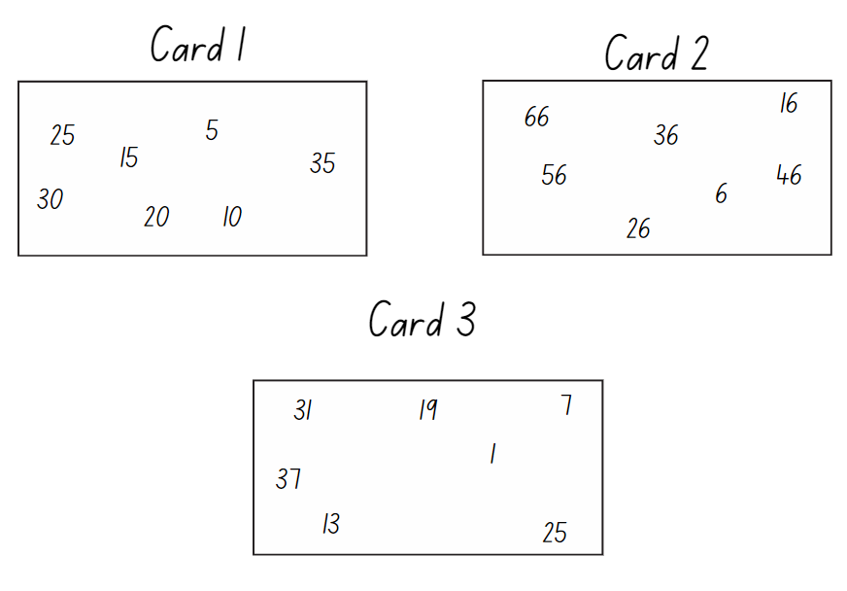

Resource 4: How many legs?
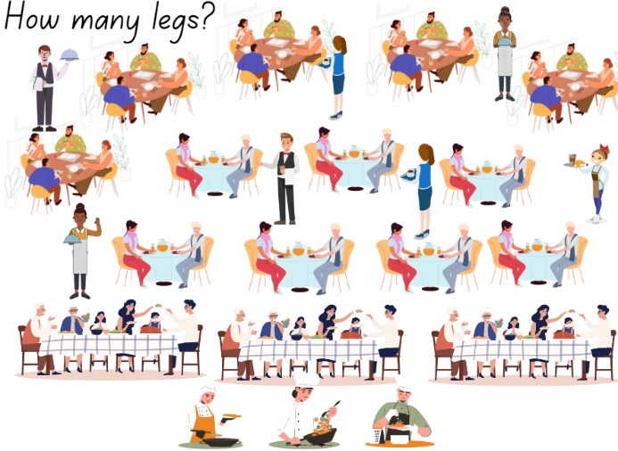
Images sourced from Canva and used in accordance with the Canva Content License Agreement.

Resource 5: Number patterns and their rules
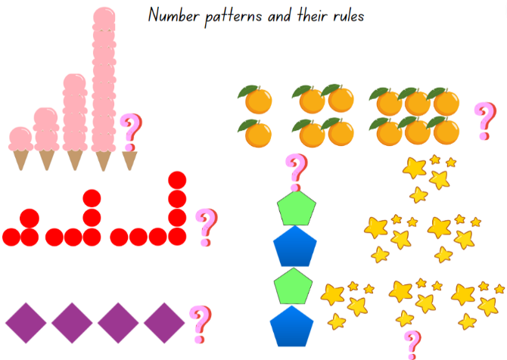
Images sourced from Canva and used in accordance with the Canva Content License Agreement.

Resource 6: 30 square tiles
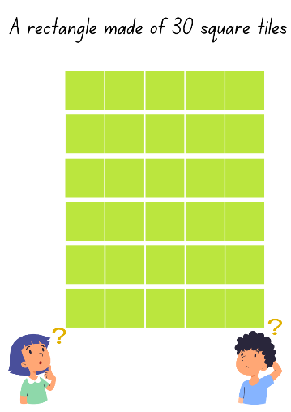
Images sourced from Canva and used in accordance with the Canva Content License Agreement.

Resource 7: Arrays in our world
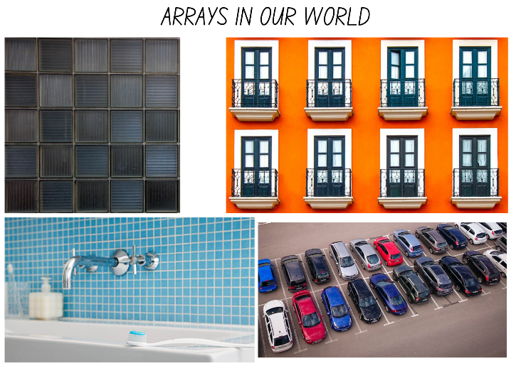
Images sourced from Pixabay and used in accordance with the Pixabay License.
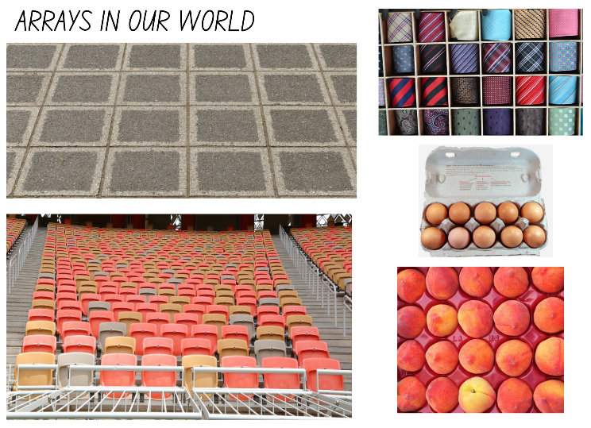
Images sourced from Pixabay and used in accordance with the Pixabay License.

Resource 8: Sort the street
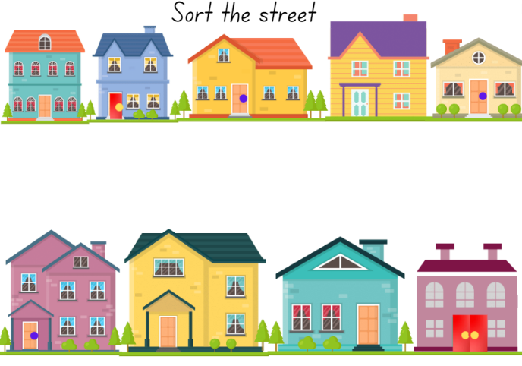
Images sourced from Canva and used in accordance with the Canva Content License Agreement.

Syllabus outcomes and content
The table below outlines the syllabus outcomes and range of relevant syllabus content covered in this unit. Content is linked to National Numeracy Learning Progression version (3).
Focus area and outcomes | Content groups and content points | Lessons
Representing whole numbers A  MAO-WM-01  MA1-RWN-01  MA1-RWN-02 | Use counting sequences of ones with two-digit numbers and beyond  - identify the number before and after a given two-digit number (CPr5)  Continue and create number patterns  - Model and describe 'odd' and 'even' numbers using items paired in two rows  - count forwards and backwards by twos from any starting point (CPr6-CPr7, MuS2)  Represent the structure of groups of ten in whole numbers  - recognise that ten ones is the same as one ten (NPV2, NPV4, (QuN7))  - use 10 as a reference in forming numbers from 11 to 20  - count large sets of objects by systematically grouping in tens (CPr7)  - estimate, to the nearest ten, the number of objects in a collection and check by counting in groups of ten (Reasons about quantity) (CPr7, NPV6) | 1–8
Representing whole numbers B  MAO-WM-01  MA1-RWN-01  MA1-RWN-02 | Use counting sequences of ones and tens flexibly  - identify the number before and after a given three-digit number (AdS8)  - count forwards and backwards by tens, on and off the decade, with two- and three-digit numbers (CPr7)  Form, regroup, and rename three-digit numbers  - count and represent large sets of objects by systematically grouping in tens and hundreds (CPr7, NPV5)  - recognise units of 100 (QuN8)  - estimate, to the nearest hundred, the number of objects in a collection and check by grouping and counting | 1–7
Forming groups A  MAO-WM-01  MA1-FG-01 | Count in multiples using rhythmic and skip counting  - count by twos, threes, fives and tens using rhythmic counting and skip counting  Use skip counting patterns  - identify and describe patterns when skip counting forwards or backwards by twos, fives and tens (MuS3, MuS4)  - determine a missing number in a number pattern with a constant difference  - describe how the missing number in a number pattern was determined (Reasons about relations)  Model and use equal groups of objects to represent multiplication  - model and describe collections of objects as groups of (MuS3)  - determine and distinguish between the number of groups and the number in each group when describing collections of objects (Reasons about relations) (MuS3, MuS4)  - find the total number of objects using skip counting of equal groups of a known size (MuS2, MuS3) | 3–7
Forming groups B  MAO-WM-01  MA1-FG-01 | Represent and explain multiplication as the combining of equal groups  - use objects, diagrams, images or actions to model multiplication as accumulating equal groups (MuS4)  - solve multiplication problems using repeated addition (MuS4)  - form arrays of equal rows and equal columns (MuS5)  - determine and distinguish between the number of rows/columns and the number in each row/column when describing collections of objects (MuS5)  - model the commutative property of multiplication, using an array (Reasons about relations) (MuS6) | 4–7
Data A  MAO-WM-01  MA1-DATA-01  MA1-DATA-02 | Ask questions and gather data  - gather data and track what has been counted by using concrete materials, tally marks, lists or symbols (IRD3)  Represent data with objects and drawings and describe the displays  - Use concrete materials or pictures of objects as symbols to create data displays where one object or picture represents one data value (IRD2)  - Describe information presented in one-to-one data displays (Reasons about relations) (IRD2)  - Use comparative language to describe information presented in a display, such as ‘more than' and ‘less than’  Interpret a data display and identify the biggest or smallest values (IRD2) | 5, 8
Data B  MAO-WM-01  MA1-DATA-02 | Create displays of data and interpret them  - organise collected data into lists and tables to display information (IRD2)  - represent data in a picture graph using a baseline, equal spacing and same-sized symbols (IRD2)  - interpret information presented in tables and picture graphs (Reasons about relations) (IRD2)  - record answers to questions using the information in tables and picture graphs (IRD2) | 5, 6, 8

References
Links to third-party material and websites
Please note that the provided (reading/viewing material/list/links/texts) are a suggestion only and implies no endorsement, by the New South Wales Department of Education, of any author, publisher, or book title. School principals and teachers are best placed to assess the suitability of resources that would complement the curriculum and reflect the needs and interests of their students.
If you use the links provided in this document to access a third-party's website, you acknowledge that the terms of use, including licence terms set out on the third-party's website apply to the use which may be made of the materials on that third-party website or where permitted by the Copyright Act 1968 (Cth). The department accepts no responsibility for content on third-party websites.
Except as otherwise noted, all material is © State of New South Wales (Department of Education), 2023 and licensed under the Creative Commons Attribution 4.0 International License. All other material (third-party material) is used with permission or under licence. Where the copyright owner of third-party material has not licensed their material under a Creative Commons or similar licence, you should contact them directly for permission to reuse their material.
Mathematics K–10 Syllabus © 2022 NSW Education Standards Authority (NESA) for and on behalf of the Crown in right of the State of New South Wales.
© 2022 NSW Education Standards Authority. This document contains NSW Curriculum and syllabus content. The NSW Curriculum is developed by the NSW Education Standards Authority. This content is prepared by NESA for and on behalf of the Crown in right of the State of New South Wales. The material is protected by Crown copyright.
Please refer to the NESA Copyright Disclaimer for more information.
NESA holds the only official and up-to-date versions of the NSW Curriculum and syllabus documents. Please visit the NSW Education Standards Authority (NESA) website and the NSW Curriculum website.
National Numeracy Learning Progression © Australian Curriculum, Assessment and Reporting Authority (ACARA) 2010 to present, unless otherwise indicated. This material was downloaded from the Australian Curriculum website (National Numeracy Learning Progression) (accessed 25 January 2023) and was not modified. The material is licensed under CC BY 4.0. Version updates are tracked in the ‘Curriculum version history’ section on the 'About the Australian Curriculum' page of the Australian Curriculum website.
ACARA does not endorse any product that uses the Australian Curriculum or make any representations as to the quality of such products. Any product that uses material published on this website should not be taken to be affiliated with ACARA or have the sponsorship or approval of ACARA. It is up to each person to make their own assessment of the product, taking into account matters including, but not limited to, the version number and the degree to which the materials align with the content descriptions and achievement standards (where relevant). Where there is a claim of alignment, it is important to check that the materials align with the content descriptions and achievement standards (endorsed by all education Ministers), not the elaborations (examples provided by ACARA).
This resource contains images and content obtained from Canva, and their use outside of this resource is subject to Canva’s Content License Agreement. If you wish to use them separately from the resource, please go to Canva.
Boaler J, Munson J and Williams C (2022) Mindset mathematics: Visualizing and Investigating Big Ideas: Grade 2, Jossey-Bass, United States.
Siemon D, Warren E, Beswick K, Faragher R, Miller J, Horne M, Jazby D, Breed M, Clark, J and Brady K (2020) Teaching Mathematics: Foundations to Middle Years, 3rd edn, Oxford University Press.
University of Cambridge (Faculty of Mathematics) (2022) Sort the street, NRICH website, accessed 25 January 2023.

