Mathematics – Stage 1 – Unit 30
Contents
Unit description and duration 4
Student prior learning 4
Lesson overview and resources 5
Lesson 1: Are we there yet? 17
Daily number sense: Garbage number lines! – 15 minutes 17
Part 1: Mirror mates – 10 minutes 18
Part 2: Hidden positions – 25 minutes 19
Consolidation and meaningful practice: Positional language – 10 minutes 20
Lesson 2: 'X’ marks the spot! 21
Daily number sense: More garbage! – 10 minutes 22
Treasure hunt: Part 1 – 20 minutes 22
Treasure hunt: Part 2 – 20 minutes 23
What is the mathematics? – 10 minutes 24
Lesson 3: Which is the way Mr Wolf? 25
Daily number sense: Number line dance – 10 minutes 25
Pig pathway: Part 1 – 20 minutes 26
Pig pathway: Part 2 – 20 minutes 27
Noticing and wondering – 10 minutes 29
Lesson 4: Songlines 30
Daily number sense: Counting in fives – 10 minutes 31
Songlines and symbols – 40 minutes 32
Noticing and wondering – 10 minutes 35
Lesson 5: Perplexing perspectives 36
Daily number sense: Teacher’s choice – 10 minutes 36
Building perspectives: Part 1 – 20 minutes 37
Building perspectives: Part 2 – 20 minutes 38
Consolidation and meaningful practice: Noticing and wondering – 10 minutes 39
Lesson 6: Welcome to our place 40
Daily number sense: Caterpillars – 15 minutes 41
Our place: Part 1 – 15 minutes 42
Our place: Part 2 – 30 minutes 43
Noticing and wondering – 10 minutes 44
Lesson 7: Tour guides 46
Daily number sense: Number line assessment – 15 minutes 46
Part 1: Paper run – 20 minutes 48
Part 2: Tour guides – 25 minutes 48
Noticing and wondering – 10 minutes 50
Lesson 8: We’re here! 51
Daily number sense: Assessment follow-up – 20 minutes 51
Part 1: At the Opera House – 10 minutes 52
Part 2: Tour feedback – 20 minutes 53
Part 3: Tour improvements – 10 minutes 54
Noticing and wondering – 10 minutes 55
Resource 1: Hidden positions gameboard 1 57
Resource 2: Hidden positions gameboard 2 58
Resource 3: Blank anchor chart 59
Resource 4: Pig pathways 1 60
Resource 5: Pig pathways 2 61
Resource 6: Pig pathways 3 62
Resource 7: Aboriginal animal symbols 63
Resource 8: Meeting place symbols 64
Resource 9: Natural environment symbols 65
Resource 10: Symbols template 66
Resource 11: Building perspectives 1 67
Resource 12: Building perspectives 2 68
Resource 13: Caterpillars 69
Resource 14: Caterpillar grids 1 70
Resource 15: Caterpillar grids 2 71
Resource 16: Number line assessment 72
Resource 17: Tour feedback 73
Syllabus outcomes and content 74
References 79
Further reading 81

Unit description and duration
This two-week unit develops student knowledge, understanding, and skills of position. Students are provided opportunities to:
- interpret simple maps by identifying objects in different locations
- make simple models from memory, photographs, drawings, or descriptions
- explore Aboriginal mapping of Country
- create a path from one location to another.
Mathematics K–10 Syllabus © 2022 NSW Education Standards Authority (NESA) for and on behalf of the Crown in right of the State of New South Wales.

Student prior learning
Before engaging in these teaching and learning activities, students would benefit from prior experience with:
- giving and following simple directions to position themselves or objects
- describing the position of an object in relation to another object, such as ‘in’, ‘on’, ‘under’, as well as the directions ‘up’ and ‘down’
- beginning to describe the positions of objects in relation to themselves using the terms ‘left’ and ‘right’.

Lesson overview and resources
The table below outlines the sequence and approximate timing of lessons; syllabus focus areas and content groups; and resources.
Lesson | Syllabus focus area and content groups | Resources
Lesson 1: Are we there yet?  60 minutes  Positional language is useful to describe locations of objects and how they move. | Representing whole numbers A  - Continue and create number patterns  - Represent numbers on a line  Representing whole numbers B  - Use counting sequences of ones and tens flexibly  Geometric measure A  - Position: Follow directions to familiar locations  Geometric measure B  - Position: Explore simple maps of familiar locations  Two-dimensional spatial structure A  - 2D shapes: Recognise and classify shapes using obvious features  - 2D shapes: Transform shapes with slides and reflections  Two-dimensional spatial structure B  - 2D shapes: Identify and describe the orientation of shapes using quarter turns | - Resource 1: Hidden positions gameboard 1 – class set  - Resource 2: Hidden positions gameboard 2  - Resource 3: Blank anchor chart  - Garbage! (4:44)  - Decks of playing cards  - Small objects such as pattern blocks, teddy counters, coloured counters  - Writing materials
Lesson 2: 'X’ marks the spot!  60 minutes  We can describe when people, shapes, or objects move, but we stay still. | Representing whole numbers A  - Use counting sequences of ones with two-digit numbers and beyond  - Continue and create number patterns  - Represent numbers on a line  Representing whole numbers B  - Use counting sequences of ones and tens flexibly  Geometric measure A  - Position: Follow directions to familiar locations  Geometric measure B  - Position: Explore simple maps of familiar locations  Two-dimensional spatial structure B  - 2D shapes: Identify and describe the orientation of shapes using quarter turns | - Garbage! (4:44)  - Anchor chart  - Decks of playing cards  - Small objects for students to hide
Lesson 3: Which is the way Mr Wolf?  60 minutes  We can describe the same location in different ways. | Representing whole numbers A  - Use counting sequences of ones with two-digit numbers and beyond  - Continue and create number patterns  - Represent numbers on a line  - Represent the structure of groups of ten in whole numbers  Representing whole numbers B  - Use counting sequences of ones and tens flexibly  Combining and separating quantities A  - Recognise and recall number bonds up to ten  - Use flexible strategies to solve addition and subtraction problems  Geometric measure A  - Position: Follow directions to familiar locations  Geometric measure B  - Position: Explore simple maps of familiar locations  Two-dimensional spatial structure A  - 2D shapes: Recognise and classify shapes using obvious features  - 2D shapes: Transform shapes with slides and reflections  Two-dimensional spatial structure B  - 2D shapes: Identify and describe the orientation of shapes using quarter turns | - Resource 4: Pig pathways 1 – class set  - Resource 5: Pig pathways 2 – class set  - Resource 6: Pig pathways 3 – class set  - Scieszka J (2004) The True Story of the Three Little Pigs (Smith L, illus.), Puffin, Great Britain (original work published 1989)  - Anchor chart  - Masking tape or chalk
Lesson 4: Songlines  60 minutes  Aboriginal cultures have used mathematics for thousands of years. | Representing whole numbers A  - Use counting sequences of ones with two-digit numbers and beyond  - Continue and create number patterns  - Represent numbers on a line  - Represent the structure of groups of ten in whole numbers  Representing whole numbers B  - Use counting sequences of ones and tens flexibly  - Form, regroup, and rename three-digit numbers  Combining and separating quantities A  - Recognise and recall number bonds up to ten  - Use flexible strategies to solve addition and subtraction problems  Geometric measure A  - Position: Follow directions to familiar locations  Geometric measure B  - Position: Explore simple maps of familiar locations  Two-dimensional spatial structure A  - 2D shapes: Recognise and classify shapes using obvious features  - 2D shapes: Transform shapes with slides and reflections  Two-dimensional spatial structure B  - 2D shapes: Identify and describe the orientation of shapes using quarter turns | - Resource 7: Aboriginal animal symbols – class set  - Resource 8: Meeting place symbols – class set  - Resource 9: Natural environment symbols – class set  - Resource 10: Symbols template – class set  - Anchor chart  - Lengths of string  - Writing materials
Lesson 5: Perplexing perspectives  60 minutes  Sometimes objects look different depending on where we are viewing them from. We call this perspective. | Representing whole numbers A  - Use counting sequences of ones with two-digit numbers and beyond  - Continue and create number patterns  - Represent numbers on a line  - Represent the structure of groups of ten in whole numbers  Representing whole numbers B  - Use counting sequences of ones and tens flexibly  - Form, regroup, and rename three-digit numbers  Two-dimensional spatial structure A  - 2D shapes: Recognise and classify shapes using obvious features  - 2D shapes: Transform shapes with slides and reflections  Two-dimensional spatial structure B  - 2D shapes: Identify and describe the orientation of shapes using quarter turns | - Resource 11: Building perspectives 1  - Resource 12: Building perspectives 2 – class set  - 3D shapes or objects  - Anchor chart  - Blocks or interlocking cubes  - Writing materials
Lesson 6: Welcome to our place  70 minutes  Places can be represented using maps and models. | Representing whole numbers A  - Use counting sequences of ones with two-digit numbers and beyond  - Continue and create number patterns  - Represent numbers on a line  - Represent the structure of groups of ten in whole numbers  Representing whole numbers B  - Use counting sequences of ones and tens flexibly  Geometric measure A  - Position: Follow directions to familiar locations  Geometric measure B  - Position: Explore simple maps of familiar locations  Two-dimensional spatial structure A  - 2D shapes: Recognise and classify shapes using obvious features  - 2D shapes: Transform shapes with slides and reflections  Two-dimensional spatial structure B  - 2D shapes: Identify and describe the orientation of shapes using quarter turns | - Resource 13: Caterpillars  - Resource 14: Caterpillar grids 1 – class set  - Resource 15: Caterpillar grids 2 – class set  - Digital map  - Anchor chart  - Interlocking cubes and blocks  - Writing materials
Lesson 7: Tour guides  70 minutes  Maps and models can be used to plan efficient pathways. | Representing whole numbers A  - Use counting sequences of ones with two-digit numbers and beyond  - Continue and create number patterns  - Represent numbers on a line  - Represent the structure of groups of ten in whole numbers  Representing whole numbers B  - Use counting sequences of ones and tens flexibly  - Form, regroup, and rename three-digit numbers  Combining and separating quantities A  - Recognise and recall number bonds up to ten  Geometric measure A  - Position: Follow directions to familiar locations  Geometric measure B  - Position: Explore simple maps of familiar locations  Two-dimensional spatial structure A  - 2D shapes: Recognise and classify shapes using obvious features  - 2D shapes: Transform shapes with slides and reflections  Two-dimensional spatial structure B  - 2D shapes: Identify and describe the orientation of shapes using quarter turns | - Resource 16: Number line assessment – class set  - Anchor chart  - lengths of ribbon or string  - Map and model of a local street from Lesson 6  - Writing materials
Lesson 8: We’re here!  70 minutes  Maps and models can be used to plan efficient pathways. | Representing whole numbers A  - Use counting sequences of ones with two-digit numbers and beyond  - Continue and create number patterns  - Represent numbers on a line  - Represent the structure of groups of ten in whole numbers  Representing whole numbers B  - Use counting sequences of ones and tens flexibly  - Form, regroup, and rename three-digit numbers  Combining and separating quantities A  - Recognise and recall number bonds up to ten  Geometric measure A  - Position: Follow directions to familiar locations  Geometric measure B  - Position: Explore simple maps of familiar locations  Two-dimensional spatial structure A  - 2D shapes: Recognise and classify shapes using obvious features  - 2D shapes: Transform shapes with slides and reflections  Two-dimensional spatial structure B  - 2D shapes: Identify and describe the orientation of shapes using quarter turns | - Resource 16: Number line assessment – students’ work samples  - Resource 17: Tour feedback – class set  - Garbage! (4:44)  - Anchor chart  - Decks of playing cards  - Digital map  - Students’ tour maps and models from Lesson 7  - Writing materials
Note: There are a range of ‘plugged’ and ‘unplugged’ digital resources that can be used to complement the students’ learning about positional concepts. Coding and robotics resources available to schools include the department’s STEM.T4L resource: How do I get there? and Code.org’s Computer Science Fundamentals for students aged 5-8: Course B (2022).

Lesson 1: Are we there yet?
Core concept: Positional language is useful to describe locations of objects and how they move.
The table below contains suggested learning intentions and success criteria. These are best co-constructed with students.
Learning intentions | Success criteria
Students are learning that:  - numbers can be sequenced and arranged on a line by thinking of the order and size of those numbers  - movements of people, shapes, and objects can be described, for example, ‘forwards’, ‘backwards’, ‘turn left’, and ‘turn right’  - clear instructions are helpful to find positions of objects. | Students can:  - explain why a numeral is positioned in a certain place using terms such as ‘before’, ‘after’, ‘more’, and ‘less’  - use forward and backward counting to work out which numbers they need to pick up next  - describe the movements of people, shapes, and objects, for example, ‘forwards’, ‘backwards’, ‘turn left’, and ‘turn right’  - give and follow clear instructions to find positions of objects.

Daily number sense: Garbage number lines! – 15 minutes
- Build student understanding of number lines by sequencing numbers in Garbage! (4:44)
- Model to students how to play the game:
- Shuffle the deck of playing cards and place the pile face down in the middle of both players. Each player draws 10 cards. Players organise their 10 cards in a row in front of them face down.
- Player 1 draws a card from the middle pile. They place this card in the matching position in their row of 10.
- Player 1 then picks up the card in its place. For example, if a 4 is drawn, Player 1 places the card in the fourth position and picks up the card in that position.
- Player 1 looks at the card and decides whether it can also be placed in their row. Their turn is over when they can no longer place a card in their row. This card is thrown away as 'garbage!'
- Player 2 draws a card to begin their turn and follows the same steps as Player 1.
- The first player to complete their entire row of cards is the winner!
- Students play the game with a partner.
- Discuss the game with students by asking:
- Can you explain why a numeral is positioned in a certain place using terms such as ‘before’, ‘after’, ‘more’, and ‘less’?
- What numbers are you hoping to turn over?
- What numbers don’t you want to turn over?

Part 1: Mirror mates – 10 minutes
This activity has been adapted from the task ‘Hidden positions’ by Van de Walle et al. (2019).
- Choose a student to place out of sight of the other students, just outside the classroom. They choose a position to hold, for example, placing their left hand on left hip or their right hand on their head.
- A second student stands where they can see the student outside but still see the rest of the class. They look at the position held by the student outside, then describe the position using words. The aim is for them to direct the class into the same position as the person outside.
- After several rounds, the students swap places with other members of the class. The positions can become more complex to increase level of challenge. Students can be supported to use language including ‘top’, ‘middle’, ‘left’, ‘above’, ‘below’, ‘next to’, and ‘beside’.

Part 2: Hidden positions – 25 minutes
- Model activity to the whole class first, being sure to use words such as ‘top row’, ‘middle row’, ‘left’, ‘right’, ‘above’, ‘below’, ‘next’, and ‘beside’.
- Students are given a copy of Resource 1: Hidden positions gameboard 1. A screen such as a book is placed between the grids so that students are not able to see each other’s gameboard.
- Each student has 4 different objects such as pattern blocks, teddy counters, different coloured counters, and so on.
- Player 1 places the objects onto 4 different sections of the grid.
- Player 1 then gives instructions on where Player 2 should place the objects on the grid to match.
- Player 1 should use words such as ‘top row’, ‘middle row’, ‘left’, ‘right’, ‘above’, ‘below’, ‘next’, and ‘beside’.
- Players then check to see if their boards match.
This table details assessment opportunities and differentiation ideas.
Assessment opportunities | Too hard? | Too easy?
What to look for:  - Can students describe movements of people and objects, for example, ‘forwards’, ‘backwards’, ‘left’ and ‘right’? (MAO-WM-01, MA1-GM-01)  - Do students give and follow clear instructions to find positions of objects? (MAO-WM-01, MA1-GM-01)  What to collect:  - observations of students describing locations, students’ gameboards. (MAO-WM-01, MA1-GM-01) | Students cannot describe movements or give and follow clear instructions to find positions of objects.  - Support students by using just one or 2 objects to begin.  - Model the use of words to describe the location of an object.  - Support students to describe the position of one of their objects, for example, ‘up’, ‘down’, ‘left’, and ‘right’. | Students can describe movements of people and objects, for example, ‘forwards’, ‘backwards’, ‘left’, and ‘right’.  - Provide students with more objects and a larger grid to use, for example, Resource 2: Hidden positions gameboard 2.  - Ask students to consider other ways to identify the locations of the objects. For example, they may name, label, or colour code the columns and rows. They may also develop their own grid coordinate system.

Consolidation and meaningful practice: Positional language – 10 minutes
- As a class, ask students:
- What did you notice while you were playing the game?
- Did you find any ways that were helpful to describe the locations of objects?
- What words did you use to describe the locations of the objects?
- Is there anything that you are still wondering?
- Use Resource 3: Blank anchor chart to summarise the positional language used. This can be used to add to it in future lessons and summarise the learning.

Lesson 2: 'X’ marks the spot!
Core concept: We can describe when people, shapes, or objects move, but we stay still.
The table below contains suggested learning intentions and success criteria. These are best co-constructed with students.
Learning intentions | Success criteria
Students are learning that:  - numbers can be sequenced and arranged on a line by thinking of the order and size of those numbers  - movements of people, shapes, and objects can be described using terms such as ‘forwards’, ‘backwards’, ‘turn left’, and ‘turn right’  - clear instructions are helpful to find positions of objects. | Students can:  - explain why a numeral is positioned in a certain place using terms such as ‘before’, ‘after’, ‘more’, and ‘less’  - use forward and backward counting to work out which numbers they need to pick up next  - describe the movements of people, shapes, and objects, for example, ‘forwards’, ‘backwards’, ‘turn left’, and ‘turn right’  - give and follow clear instructions to find positions of objects.

Daily number sense: More garbage! – 10 minutes
- Build student understanding of number lines by sequencing numbers in Garbage! (4:44)
- Revise how to play the game from Lesson 1.
- Students play the game with a partner.
- Other ways to play include:
- Use a picture card that a player can use to represent any number.
- If a player puts their unwanted card in the garbage and the other player needs it, it can be picked up to use.
- A king can be played to turn back over another player's card.
- Discuss the game with students by asking:
- Can you explain why a numeral is positioned in a certain place using terms such as ‘before’, ‘after’, ‘more’, and ‘less’?
- What numbers are you hoping to turn over?
- What numbers don’t you want to turn over?

Treasure hunt: Part 1 – 20 minutes
Note: Depending on the context, this lesson could be facilitated in an outdoor space.
- Hide an object somewhere in the learning space.
- Select a student to be the treasure hunter and make sure they do not know where the object representing the treasure is hidden.
- As the ‘navigator’, give the treasure hunter instructions to guide them to the object. For example, move forward 3 steps, turn right, move forward 2 steps, go back one step.
- Once the student finds the object, another student is selected to be the treasure hunter.
- The new treasure hunter closes their eyes while the object representing the treasure is hidden again. They open their eyes, then listen carefully to the instructions given by the navigator to guide them to the treasure.

Treasure hunt: Part 2 – 20 minutes
- Students work in pairs to play the treasure hunt themselves.
- Students take it in turns to be the treasure hunter and the navigator, making sure that they think carefully about the words used to guide the treasure hunters to the treasure.
This table details assessment opportunities and differentiation ideas.
Assessment opportunities | Too hard? | Too easy?
What to look for:  - Can students describe movements of people and objects, for example, ‘forwards’, ‘backwards’, ‘left’ and ‘right’? (MAO-WM-01, MA1-GM-01)  - Do students give and follow clear instructions to find positions of objects? (MAO-WM-01, MA1-GM-01)  What to collect:  - observations of students describing locations, students’ gameboards (MAO-WM-01, MA1-GM-01) | Students cannot give and follow clear instructions to find positions of objects.  - In a small group, model how to complete one direction at a time to arrive at a simple destination.  - Model the use of directions, including ‘forwards’, ‘backwards’, ‘left’, and ‘right’.  - Support a small group of students to complete one direction at a time to arrive at a destination. Students take it in turns to be the person giving the directions to their chosen destination. | Students give and follow clear instructions to find positions of objects.  - Students draw a representation of the area and provide written instructions using words and arrows.  - In pairs, students develop hand signals to give directions non-verbally.

What is the mathematics? – 10 minutes
- Regroup as a class and ask students:
- What problems did you and your partner face?
- How did you solve those problems?
- How important are the instructions you give to your partner?
- What words did you use to guide your partner to the treasure?
- Add new vocabulary to the anchor chart, for example, ‘forward’, ‘back’, ‘turn left’, and ‘turn right’. Summarise the lesson by explaining that those words are used to describe when people, shapes, or objects move, but the observer stays still.

Lesson 3: Which is the way Mr Wolf?
Core concept: We can describe the same location in different ways.
The table below contains suggested learning intentions and success criteria. These are best co-constructed with students.
Learning intentions | Success criteria
Students are learning that:  - giving and following directions can involve turning to the left and right  - the same location can be described in different ways  - paths can be created from one location to another. | Students can:  - give and follow directions, including directions involving turns to the left and right  - describe the same location in different ways  - create a path from one location to another.

Daily number sense: Number line dance – 10 minutes
This activity has been adapted from Sidewalk Line Dance (K-8) [video] (5:55) by youcubed.
- Build student understanding of representing numbers on a line by considering the order and size of those numbers.
- Draw a number line outside with even spacing up to 20. Select 4 students to choose a number to start on.
- Say ‘add 3’ and students all hop 3 numbers along the line. Ask students:
- What number are you on now?
- Has the distance between each of you changed or stayed the same?
- When students notice they are moving the same distance, ask them what distance this is.
Note: This can be challenging as students often count the dashes on the number line rather than the spaces between the numbers. If they are confused, have them walk the distance to see how many jumps they take to get from one number to the next.
- Provide other directions, for example, take away 2, add 5, subtract 6, or double your number. After each direction, ask students what number they are on and if the distance between students changed or stayed the same.
- After several directions, students swap with students who haven’t ‘danced the line’ yet. This activity can be modified in many ways to meet the needs of the students, including having the number line go by twos or fives.

Pig pathway: Part 1 – 20 minutes
Note: You may wish to read The True Story of the Three Little Pigs by Jon Scieszka (2004) to engage students before introducing them to the activity.
- Explain that the wolf is going to make a cake for his granny’s birthday, but he has run out of sugar. Students are going to help the wolf find a path to each of the pigs’ houses so he can ask for a cup of sugar.
- Use masking tape or chalk to create a grid of 5 by 5 squares on the classroom floor or outside. Other options include using an outdoor chess board, classroom sit spots, or an interactive whiteboard.
- Choose students to play the 3 pigs and the wolf or use markers to represent them. Identify which pig has either straw, sticks, or bricks as building materials. The wolf needs to visit the pigs in order of straw, sticks, and then bricks.
- The 3 pigs choose a spot anywhere on the grid.
- As a class, discuss one pathway for the wolf to visit each house. Record the pathway, including the directional language and record many steps were taken. For example, go forward 3 steps then turn right.
- Re-read the instructions and ask the students if the language used has been clear enough for the wolf.
- Ask students to think if there is another pathway to complete the wolf’s journey.

Pig pathway: Part 2 – 20 minutes
- Explain that students will work in pairs to find other pathways that the wolf could use.
- Students are given a copy of Resource 4: Pig pathways 1, Resource 5: Pig pathways 2 or Resource 6: Pig pathways 3 depending on their learning needs.
- One student guides the wolf through to the 3 houses in order using directional language. They record the pathway on the map using lines, arrows, and words.
- The second student then looks for a different pathway to guide the wolf through the map. They also use lines, arrows, and words to record the pathway on the map.
- The 2 students then compare the 2 pathways by counting how many steps each path took.
- Ask students to discuss in pairs:
- Which pathway do you think the wolf would take?
- Why might the wolf choose one pathway over another?
This table details assessment opportunities and differentiation ideas.
Assessment opportunities | Too hard? | Too easy?
What to look for:  - Can students create a path from one location to another, giving and following directions with left and right turns? (MAO-WM-01, MA1-GM-01)  - Can students describe the same location in different ways? (MAO-WM-01, MA1-GM-01)  What to collect:  - observations of students describing locations, students’ annotated work samples. (MAO-WM-01, MA1-GM-01) | Students cannot create a path from one location to another, giving and following directions with left and right turns.  - Support students by positioning the map in the direction they are moving.  - Provide a ‘left’ and ‘right’ scaffold to assist students.  Students cannot describe the same location in different ways.  - Model how to start a different pathway for the wolf. Support students to complete this different pathway.  - Show students that it is a different pathway by asking them to trace over both paths with their fingers.  - Ask students to identify what is different about the 2 pathways. | Students can create a path from one location to another, giving and following directions with left and right turns.  - Explain that the police are coming. Starting at a map corner, students give directions for the police to catch the wolf.  - Students write their directions to send as a text message to the police.  Students can describe the same location in different ways.  - Explain that the pigs have seen the wolf coming! They need to block the bridge with bricks. Students plot pathways for the pigs to get to the bridge first.  - Ask how many ways the wolf could sneak up on the pigs’ houses. Students work out sneaky alternatives.

Noticing and wondering – 10 minutes
- Regroup as a class and ask students:
- What did you notice during the activity?
- What words did you find were the most helpful for giving directions?
- Was there only one path the wolf could have chosen?
- Were there any pathways that you thought were better than the others? Why did you think they were better?
- Add new vocabulary to the anchor chart, summarising the learning that we can describe the same location in different ways.

Lesson 4: Songlines
Core concept: Aboriginal cultures have used maps to identify places of interest for thousands of years.
Note: Many of the symbols used by Aboriginal artists are a variation of lines or dots. While symbols differ extensively between language groups, family clans, and artists, there are a number of useful starting points that may help identify potential meaning (Pol 2020).
The symbols provided in this unit are common across many Aboriginal Nations, however templates are provided in the resource section to adapt for your local Country if required. Teachers are encouraged to work with their school’s Aboriginal Education team and local AECG (Aboriginal Education Consultative Group) to develop learning resources with local Aboriginal knowledge wherever possible. This lesson has been developed in consultation with the Aboriginal Outcomes and Partnerships Directorate.
The table below contains suggested learning intentions and success criteria. These are best co-constructed with students.
Learning intentions | Success criteria
Students are learning that:  - numbers can increase and decrease by fives from any starting point  - maps of Country are used by Aboriginal peoples for different purposes  - positional language is used to give directions to a location  - efficient pathways are well organised and well planned  - maps are used to locate areas of interest. | Students can:  - count forwards and backwards by fives  - recognise that a regular count by 5 pattern ends in a zero or a 5  - explore Aboriginal mapping of Country  - use positional language such as ‘forward’, ‘back’, ‘turn to the left’, or ‘turn to the right’  - identify an efficient pathway to a place of interest on a map.

Daily number sense: Counting in fives – 10 minutes
- Build student understanding of how maths is used in Aboriginal cultures by counting in fives.
- Explain that some Aboriginal cultures use a counting in 5 system for keeping track of their count. It’s sometimes known as 'body tallying'. This physical method of counting has been used for thousands and thousands of years.
- Students form a circle and take it in turns counting aloud by ones. Every time a student gets to a 5 or 10, the student high fives another student or the teacher.
- The count can start at zero, from a larger number, or go down from a given number depending on the class needs.
- Students then use whiteboards and write the numbers going up or down by fives. Students can work with a partner, as well as start on or off the decade.
- The activity can be concluded with the class choral counting by fives.

Songlines and symbols – 40 minutes
Songlines are known as navigational tracks, in that the elders or the trained Indigenous people will sing the landscape and therefore be able to move from location to location through it, and teach each other. At every location, each sacred site within that sung track, they perform rituals. Those rituals are repeated songs, and those songs encode the information. Research has shown that up to 70 per cent of Indigenous songs are knowledge about animals, plants and seasonality. They are singing the information in songs that tell stories because song, story, mythology, is so much more memorable than a list of facts. (Lynne Kelly on ABC Radio National, 2016).
- Explain that songlines are songs that have been used by Aboriginal peoples for thousands of years. The songs include information about plants, animals, the weather, and locations. Aboriginal cultures have used these like maps to identify places of interest.
- Explain that Aboriginal peoples did not have a written language. Instead, they used symbols as a means of storytelling. Many of the symbols used by Aboriginal artists are a variation of lines or dots. While symbols differ between language groups, family clans, and artists, there are a number of useful starting points that may help identify potential meaning.
- Display Resource 7: Aboriginal animal symbols and discuss how animals are usually represented by the tracks they leave in the dirt or sand. Kangaroos leave a set of mirror-image tick shapes from its hind paws and long tail. An emu leaves an arrow-shaped footprint. And goannas, possums, and other small marsupials leave E-shaped tracks due to their claws.
- Show Resource 8: Meeting place symbols, identifying that meeting places are usually marked as a circle or set of circles. These markings can represent a bonfire, campsite, or waterhole. Lines connecting circles usually show a journey of some kind, where travellers stop at a series of locations. Explain that this is an example of how Aboriginal peoples used maps to tell stories, identify locations, and give directions.
- Present Resource 9: Natural environment symbols, explaining that Aboriginal peoples have a strong connection to the land. They celebrate the sun, rain, and the stars by performing song and dance cycles during ceremonies.
Note: Resource 10: Symbols template can be used to incorporate traditional Aboriginal symbols from the school’s local Country.
- In pairs, students glue some of the animal, meeting place, and natural environment symbols on a sheet of paper.
- Explain that each pair of students will be given a length of string, for example, 30 cm, which represents a day’s journey on the map.
- Starting at one of the meeting places on their map, students will use the length of string to mark out a journey on their map. In their journey, they will be going hunting. They will need to visit at least one place with water and 2 places with animals.
- Students work in pairs to plan their journey using the length of string. They use words to describe the journey that they take. For example, they might say ‘walk from the meeting place to the river. At the river, turn left to go to the kangaroo trail’.
- The directions can be recorded by students using arrows or other symbols.
Note: The students’ maps could be used as a stimulus for creative writing about a traditional journey of Aboriginal peoples. This could provide an additional opportunity to use language that describes positions.
This table details assessment opportunities and differentiation ideas.
Assessment opportunities | Too hard? | Too easy?
What to look for:  - Do students use positional language such as ‘forward’, ‘back’, ‘turn to the left’ or ‘turn to the right’? (MAO-WM-01, MA1-GM-01)  - Can students identify an efficient pathway to a place of interest on a map? (MAO-WM-01, MA1-GM-01)  What to collect:  - observations and students’ maps. (MAO-WM-01, MA1-GM-01) | Students cannot use positional language such as ‘forward’, ‘back’, ‘turn to the left’, or ‘turn to the right’.  - Support students to turn their map so that they view the direction that the person would be travelling in.  - Use the map and demonstrate giving directions, for example, at the river, turn to the right.  Students are not able to identify an efficient pathway to a place of interest on a map.  - Show 2 pathways that lead to the same location. Make one less efficient, asking students which was the most efficient and why.  - Support students to choose a destination, then use the string to plan an efficient pathway. Students attempt to do it again independently. | Students can use positional language such as ‘forward’, ‘back’, ‘turn to the left’, or ‘turn to the right’.  - Students record the directions on their journey, using symbols to show directions and distances.  - Students create their own symbols to communicate directions and distances that another person could use to follow.  Students are able to identify an efficient pathway to a place of interest on a map.  - Students swap their map with another map and use their string to identify an efficient pathway.  - They check with the students who created the map to compare the pathways that were chosen. They decide which was the most efficient.
Note: This lesson also provides an opportunity to assess students’ learning of Aboriginal and Torres Strait Islander histories and cultures.

Noticing and wondering – 10 minutes
- Bring students together after they have explored their pathways. Ask:
- What are some things that you noticed about the pathway of your journey?
- Did you find a way to make your journey more efficient? What did you do?
- Is there anything that you are still wondering?
- Draw attention to examples that demonstrated the benefits of an efficient pathway.
- Update the class anchor chart. Summarise the learning that Aboriginal cultures have used maps to identify places of interest for thousands of years.

Lesson 5: Perplexing perspectives
Core concept: Sometimes objects look different depending on where we are viewing them from. We call this perspective.
The table below contains suggested learning intentions and success criteria. These are best co-constructed with students.
Learning intentions | Success criteria
Students are learning that:  - objects can be viewed and drawn from different perspectives  - an object’s size and appearance look different depending on the perspective. | Students can:  - view and draw objects from different perspectives  - identify that the appearance of an object looks different from different perspectives.

Daily number sense: Teacher’s choice – 10 minutes
- From a class need surfaced through formative assessment data, identify a short, focused activity that targets students’ knowledge, understanding, and skills. Example activities may be drawn from the following resources.
- Thinking Mathematically Stage 1
- Universal Resources Hub.

Building perspectives: Part 1 – 20 minutes
This activity has been adapted from the task ‘Building perspectives’ by Siemon et al. (2020).
- Explain that sometimes objects look different depending on where we are viewing them from. We call this perspective.
- Display Resource 11: Building perspectives 1, explaining that it is a view of 3D objects from above. Ask students to turn and talk with a partner about which 3D shapes or objects they think these might be.
- Provide some models of 3D objects, including the ones in the image.
- Choose some students to try and recreate the image displayed. They select, then position some of the 3D objects on a copy of Resource 12: Building perspectives 2 to test their thinking.
- After students have attempted to reconstruct the image, ask:
- Do you think that this model represents the shapes in the image?
- How do you know? What clues can you use to be sure?
- How can different perspectives help us to confirm our thinking?
- When the class have agreed on the correct arrangement, students view the shapes from different perspectives. Use language to describe these perspectives, including ‘top’, ‘back’, ‘front’, and ‘side’.
- Ask students to identify what they can see on the sides of the 3D shapes from the different perspectives. Demonstrate how to record the shapes seen from the different perspectives on the whiteboard.
Note: This is an opportunity to remind students that the faces of the 3D shapes are 2D shapes. This connection can help support their learning about the perspectives of 3D shapes.

Building perspectives: Part 2 – 20 minutes
- In pairs, students are each given 5-10 blocks or interlocking cubes and their own copy of Resource 12: Building perspectives 2.
- Out of their partner’s view, one student uses the blocks to create a 3D model, for example, several towers of 2-3 blocks each. They position these on Resource 12: Building perspectives 2.
- These students then draw their own creation from 3 different perspectives: the top, front, and side.
- Students give their 3 perspectives drawing to their partner who tries to recreate their 3D construction on. They are to use their own copy of Resource 12: Building perspectives 2 to build it.
- Once the second student has built their model, they compare it to the original model. Both students compare the models to see how accurate the recreation was.
- The students swap roles and repeat the activity.
This table details assessment opportunities and differentiation ideas.
Assessment opportunities | Too hard? | Too easy?
What to look for:  - Can students identify that the appearance of an object looks different from different perspectives. (MAO-WM-01, MA1-GM-01)  - Are students able to view and draw objects from different perspectives? (MAO-WM-01, MA1-GM-01)  What to collect:  - observations and student work samples. (MAO-WM-01, MA1-GM-01) | Students cannot identify that the appearance of an object looks different from different perspectives.  - Revise the activity in Building perspectives: Part 1.  - Support students to describe the shapes they can see on each 3D object from different perspectives.  Students are not able to view and draw objects from different perspectives.  - As a small group, support students to participate in the Building perspectives: Part 2 activity.  - Support students to draw the arrangement of towers they can see from each perspective. | Students can identify that the appearance of an object looks different from different perspectives.  - Students use a combination of 3D shapes and interlocking cubes to include more detail in their models.  - Ask students to use words to accurately describe what they see. For example, ‘I can see that the tower has 3 square blocks on the bottom, with a triangle on the top’.  Students are able to view and draw objects from different perspectives.  - Students draw models made of 3D shapes and interlocking cubes.  - The number of blocks used in the models can be increased.

Consolidation and meaningful practice: Noticing and wondering – 10 minutes
- Bring the class together and ask:
- What did you notice during the activity?
- What words did you find helpful for describing the different perspectives?
- What did you learn about seeing objects from different perspectives?
- Was there something that you and your partner found challenging? What did you do?
- Is there anything that you are still wondering?
- Add any new vocabulary identified to the anchor chart. Summarise the learning that sometimes objects look different depending on the perspective we are viewing them from.

Lesson 6: Welcome to our place
Core concept: Places can be represented using maps and models.
The table below contains suggested learning intentions and success criteria. These are best co-constructed with students.
Learning intentions | Success criteria
Students are learning that:  - number lines can follow different pathways  - places can be represented using maps and models  - giving directions can include turning to the left and right  - maps can be interpreted by identifying objects in different locations. | Students can:  - create various number lines  - compare and explain their pathways  - make simple models of a familiar place  - give directions including turn to the left or turn to the right  - interpret simple maps by identifying objects in different locations.

Daily number sense: Caterpillars – 15 minutes
This activity has been adapted from Caterpillars by NRICH.
- Build student understanding of sequencing numbers on a number line by playing Caterpillars.
- Display Resource 13: Caterpillars and say that a caterpillar’s body is made up of segments. Explain that these caterpillars have one number on each little part, up to 16 in total. The coloured example caterpillars have a pale blue head with green and blue body segments. Their body bends at right angles so that each part is lying in a square.
- Tell students that if they look carefully at the shapes of the caterpillars, their bodies can turn in different ways. The black lines at the top right of Resource 13: Caterpillars show how some of these number lines can look.
- Show Resource 14: Caterpillar grids 1 and explain that each square in the grid is a piece of the caterpillar’s body. Each part of the body has one number in that box, connecting all of the boxes together by the numbers 1-16.
- Students work with a partner to create some caterpillar bodies, connecting all of the boxes together by the numbers 1-16. If needed, they can start by creating a caterpillar using the grid of 9 squares, with the numbers 1-9. There is also the option to create caterpillars with numbers up to 25, using the grids on Resource 15: Caterpillar grids 2.
- When students have discovered some different caterpillar body patterns, get them to compare. Ask:
- Do you notice anything that is the same about your caterpillar number lines? Can you explain why this happens?
- Do you notice anything different about your caterpillar number lines? Can you explain why this happens?

Our place: Part 1 – 15 minutes
Note: Although the text’s language is generally for older students, you may wish view some pages from My place by Nadia Wheatley to introduce the concept of describing a familiar location.
- Use a digital map to show students a map of a familiar location, for example, their school. Demonstrate how the ‘layers’ function can be used to show specific information, such as an aerial photograph, traffic conditions, or public transport.
- Explain how the street view (the small yellow person) on digital maps can be used to show images of a position within the map.
- Drag and drop the yellow person onto a street near the school and ask students if they recognise the location. Ask students to direct you to the front gate of the school, using language including ‘go forwards’, ‘turn around’, ‘turn to the left’, or ‘turn to the right’.
- Ask the students to help you make a model of a local street. For example, interlocking cubes can be used to represent buildings and pencils can mark the outline of the road.
- Students consider if the features are positioned in a way that is an accurate representation of the location. The model’s features can be checked on digital maps for accuracy.
- Discuss how your position around the model changes the features that you can see. Students view the model from several different perspectives, discussing how the features they see changes depending on their position.
- Once the students are satisfied with the model, record this on paper as a map. Mark the features included in the model, explaining that this is showing an overhead point of view, or perspective.

Our place: Part 2 – 30 minutes
- Explain that students will be working in pairs to design a model of a familiar place, for example, their classroom, school, or another familiar place. Show them the materials and answer any questions they might have.
- Students work in pairs to decide on a familiar place to feature in their model. They create the model using materials, for example, interlocking cubes, blocks, and pencils.
- When students are satisfied with their model, they test it for accuracy by viewing it from different perspectives.
- Students use the model to create a map of their design on paper. They may require support to view their model from an overhead perspective, similar to digital maps.
- After completing their map, students test it with their partner. They use it to try and navigate through their chosen space, thinking about features they identified accurately. Students can adjust their map based on their findings when testing it.
This table details assessment opportunities and differentiation ideas.
Assessment opportunities | Too hard? | Too easy?
What to look for:  - Can students make simple models of a familiar place? (MAO-WM-01, MA1-GM-01)  - Do students give directions including ‘turn to the left’ or ‘turn to the right’? (MAO-WM-01, MA1-GM-01)  - Are students able to interpret simple maps by identifying objects in different locations? (MAO-WM-01, MA1-GM-01)  What to collect:  - observations and the students’ maps. (MAO-WM-01, MA1-GM-01) | Students cannot make a simple model of a familiar place.  - Support students to find a specific space to focus on. Identify 3-4 main features in this space and model how to represent these using interlocking cubes and blocks.  - Show how to view the model from several perspectives, including from directly above.  Students cannot interpret simple maps or give directions.  - Support students to record their model’s features on paper as a map.  - Use the map and the model to demonstrate giving directions, for example, ‘at the end of the building, turn right’. | Students are able to make a simple model of a familiar place.  - Encourage students to look for additional features that could be included in their model.  - Students reflect on the accuracy of the size and spacing of the features in their model.  Students are able to interpret simple maps or give directions.  - Ask students to consider using colours or a key to support another person to easily identify the features on the map.  - Students use a block to represent a person and guide them through the model. One student gives directions from the map to guide the other student, who ‘walks’ the person through the model by following the instructions.

Noticing and wondering – 10 minutes
- Students display their map next to their model, then go on a gallery walk to observe other students’ models and maps. Prompt students to be thinking about what they notice on their gallery walk and if there is anything there is still wondering.
- Ask students:
- What did you notice on the gallery walk?
- What did you and your partner find challenging about these activities?
- What did you and your partner do to work through these challenges?
- Is there anything that you are still wondering?
- Draw attention to one or 2 examples where students’ map of a familiar place reflected their model accurately. Identify the features that made this an accurate representation. Add these to the anchor chart.
- Summarise the learning that places can be represented using maps and models. Collect the students’ maps for use in future lessons.

Lesson 7: Tour guides
Core concept: Maps and models can be used to plan efficient pathways.
The table below contains suggested learning intentions and success criteria. These are best co-constructed with students.
Learning intentions | Success criteria
Students are learning that:  - numbers can be sequenced and arranged on a line by thinking of the order and size of those numbers  - places can be represented using maps and models  - maps can be interpreted by identifying objects in different locations  - pathways take us from one location to another. | Students can:  - use forward and backward count to identify missing numbers in a sequence  - interpret simple maps by identifying objects in different locations  - plan an efficient path from one location to another.

Daily number sense: Number line assessment – 15 minutes
- Build student understanding of sequencing numbers on a number line by completing a number line assessment.
- Provide students with a copy of Resource 16: Number line assessment and read the tasks aloud to them.
- Ask students to find as many of the missing numbers as they can. Explain that they can take their time and ask you for help if they are unsure what to do.
- This can be used to determine if students are working below, at, or beyond the Stage expectations. The Daily number sense: Assessment follow-up activity in the next lesson provides an opportunity for the teacher to provide additional support for students working below Stage expectations.
This table details assessment opportunities and differentiation ideas.
Assessment opportunities | Too hard? | Too easy?
What to look for:  - Can students sequence and arrange numbers on a line by thinking of the order and size of those numbers? (MAO-WM-01, MA1-RWN-01, MA1-RWN-02)  What to collect:  - students’ copies of Resource 16: Number line assessment and observations. (MAO-WM-01, MA1-RWN-01, MA1-RWN-02) | Students cannot sequence and arrange numbers on a line by thinking of the order and size of those numbers.  - Support students by drawing a blank number line with marks for the numbers 0-10. Provide several numbers as clues, then work with students to count aloud to 10, completing the line.  - Use counters to represent the value of each number on the line, arranged in a line for each corresponding number. | Students can sequence and arrange numbers on a line by thinking of the order and size of those numbers.  - Students create their own number line on the reverse of their Resource 16: Number line assessment.  - Ask students to create a number line between a specific number range. For example, to create a number line increasing by fives between 120 and 150.

Part 1: Paper run – 20 minutes
- Revisit the map and the model of a local street from the previous lesson. Ask students to pretend that they have been asked to deliver newspapers to all the buildings on the street.
- Say that maps and models can be used to plan efficient pathways. Explain that they don’t want to spend all day delivering the newspapers, so they need to find the most efficient pathway.
- Students turn and talk with a partner to share their thinking about the most efficient pathway to deliver the newspapers.
- Ask several pairs of students to share their thinking, then as a class, evaluate the different pathways.
- Using a length of ribbon or string, test each of their pathways to see which were the most efficient. Provide a non-example of an inefficient pathway, showing how it covers a longer distance and takes more time to complete.

Part 2: Tour guides – 25 minutes
- Ask students to imagine that the school’s open day is coming up. They have been asked to design a tour of the familiar place that they mapped in the previous lesson.
- Explain that there will be lot of visitors, so there needs to be an efficient pathway for people to move through the location without making them walk too far or taking too much time.
- In their pairs, students use their map to decide on an efficient pathway for the visitors to move through their location. They mark this on their map in pencil so it can be changed or added to.
- Students ‘walk their map’ by following the pathway around their location. They can make changes if they identify improvements that could be made to it.
This table details assessment opportunities and differentiation ideas.
Assessment opportunities | Too hard? | Too easy?
What to look for:  - Are students able to interpret simple maps by identifying objects in different locations? (MAO-WM-01, MA1-GM-01)  - Can students plan an efficient path from one location to another? (MAO-WM-01, MA1-GM-01)  What to collect:  - observations and the students’ maps. (MAO-WM-01, MA1-GM-01) | Students are unable to interpret simple maps by identifying objects in different locations.  - Support students to orientate themselves at the starting point of their identified pathway.  - Ask students to identify the next point of their map, then prompt them to identify this in the actual location. Students walk to this location, then repeat the process to follow the pathway on their map.  Students are unable to plan an efficient path from one location to another.  - Ask students to identify a starting point, as well as the other places they want visitors to go to.  - Support students to plot a pathway that visits these locations efficiently. | Students are able to interpret simple maps by identifying objects in different locations.  - Students look for additional features that could be included in their model.  - Students consider using colours or a key to support another person to identify the features on the map.  Students are able to plan an efficient path from one location to another.  - Ask students to consider variations they could make to the tour. For example, how could they make it shorter for elderly people who get tired? What if people only had a short amount of time and could only do a tour of the most important locations?  - Students consider the accessibility of their pathway. For example, would their pathway be accessible for people in wheelchairs? Would it need to change if there was heavy rain?

Noticing and wondering – 10 minutes
- Bring students together after they have had an opportunity to test their open day tour pathway. Ask:
- What are some things that you noticed while you were testing your tour pathway?
- Did you find a way to make your pathway more efficient?
- Was there anything that you and your partner changed on your map? Why?
- Is there anything that you are still wondering about your pathway?
- Draw attention to examples that demonstrated the benefits of an efficient pathway.
- Summarise the learning that maps and models can be used to plan efficient pathways. Update the anchor chart and collect the students’ maps for use in future lessons.

Lesson 8: We’re here!
Core concept: Maps and models can be used to evaluate efficient pathways.
The table below contains suggested learning intentions and success criteria. These are best co-constructed with students.
Learning intentions | Success criteria
Students are learning that:  - numbers can be sequenced and arranged on a line by thinking of the order and size of those numbers  - maps can be interpreted by following specific pathways  - pathways can be evaluated on their efficiency. | Students can:  - explain why a numeral is positioned in a certain place  - use forward and backward count to identify missing numbers in a sequence  - interpret simple maps by following a specific pathway  - evaluate the efficiency of a pathway from one location to another.

Daily number sense: Assessment follow-up – 20 minutes
- Build student understanding of number lines with students who are requiring assessment follow-up support by sequencing numbers on a number line.
- For students not requiring assessment follow-up support, they consolidate their understanding of number lines by sequencing numbers in the game Garbage! (4:44) from Lesson 2. Revise how to play the game, then these students play the game with a partner.
Note: After analysing the Resource 16: Number line assessment students’ work samples from the previous lesson, identify the students who could benefit from additional support with sequencing numbers on a number line.
- For students requiring assessment follow-up support, start by drawing a blank number line with marks for the numbers 0-10. Provide several numbers as clues, then work with students to complete the number line. This could be done by counting aloud to 10 or using the provided numbers as clues to identify the missing numbers before and after.
- Use counters to represent the value of each number on the line, arranged in a line for each corresponding number. These can be arranged to show a staircase pattern.
- Using whiteboards, students draw a number line for a partner and provide 2 number clues. Students swap whiteboards with their partner and try to identify the missing numbers.

Part 1: At the Opera House – 10 minutes
- Introduce the story that Jordan and Sahara are visiting Sydney with their mum. They are going to the Opera House and are wondering if they will also be able to see the Harbour Bridge.
- Use a digital map to help Jordan and Sahara plan their trip. Show students the Sydney Opera House. Demonstrate how the ‘layers’ function can be used to show specific information, such as an aerial photograph, traffic conditions, or public transport.
- Show how the street view (the small yellow person) on Google Maps can be used to show images of a position within the map.
- Drag and drop the yellow person next to the Sydney Opera House and compare this perspective from the overhead view. Ask students to direct you to view the Harbour Bridge, for example, go forwards, turn to the left or turn to the right.
- Discuss what students see when viewing the Sydney Opera House from different perspectives and draw these on the whiteboard.

Part 2: Tour feedback – 20 minutes
- Explain that that maps and models can be used to evaluate if a pathway is efficient. Tell students that they will test another groups’ open day tour. They will follow the pathway on one of the open day maps and give feedback.
Note: Explain to students that ‘evaluate’ means to think about the features of something and if they are helpful or not. ‘Feedback’ means to tell someone what has worked well and what could be improved. Evaluations and feedback are best when they are honest but respectful. This helps a person feel confident about what is working and what they could refine.
- Display Resource 17: Tour feedback and provide students with a copy. They will also need something to lean on and something to write with. Discuss the criteria that students will be considering as they follow the tour pathway on a map:
- Did you know where to start?
- Could you follow the pathway or did you get lost?
- Did it take you to the finish?
- Was it efficient? How do you know?
- What did you like about the map?
- What could have made it even better?
- In pairs, students use another group’s map and start the tour. They use Resource 17: Tour feedback to record their thinking about the other students’ map.

Part 3: Tour improvements – 10 minutes
- After using another group’s map to follow the tour pathway, students re-join the class.
- Students return the other students’ map. They share their feedback using Resource 17: Tour feedback.
- Prompt students to consider any changes they may need to make to the pathway on their map. From the feedback, students may think of ways to make it more efficient or improve the tour for visitors.
This table details assessment opportunities and differentiation ideas.
Assessment opportunities | Too hard? | Too easy?
What to look for:  - Can students interpret simple maps by following a specific pathway?  - Do students evaluate the efficiency of a pathway from one location to another? (MAO-WM-01, MA1-GM-01)  What to collect:  - observations, students’ maps and Resource 17: Tour feedback. (MAO-WM-01, MA1-GM-01) | Students are unable to interpret simple maps by following a specific pathway.  - Support students to orientate themselves at the starting point of their identified pathway.  - Ask students to identify the next point of their map, then prompt them to identify this in the actual location. Students walk to this location, then repeat the process.  Students are unable to evaluate an efficient path from one location to another.  - Support students to go through each of the questions on Resource 17: Tour feedback comparing this to their experience.  - Provide support for students to record their feedback clearly. | Students are able to interpret simple maps by following a specific pathway.  - Students consider additional features that could be included on the tour to enhance visitors’ experience.  - Prompt students to reflect on the similarities and differences between this tour and their own.  Students are able to evaluate an efficient path from one location to another.  - Ask students to evaluate variations they could suggest for the tour. For example, what if people only had a short amount of time and could only do a tour of the most important locations?  - Students evaluate the accessibility of the tour pathway. For example, would their pathway be accessible for people in wheelchairs? Would it need to change if there was heavy rain?

Noticing and wondering – 10 minutes
- Bring students together after they have had an opportunity to give and receive feedback on the tour pathways. Ask:
- What are some things that you noticed while you were testing the tour pathways?
- Did you find a way to make a pathway more efficient? How?
- Was there anything that you and your partner changed about your tour? Why?
- Is there anything that you are still wondering about your pathway?
- Draw attention to examples that demonstrated the benefits of an efficient pathway. Display the anchor chart and students’ tour maps and models to celebrate the students’ learning across the unit.

Resource 1: Hidden positions gameboard 1

Resource 2: Hidden positions gameboard 2

Resource 3: Blank anchor chart
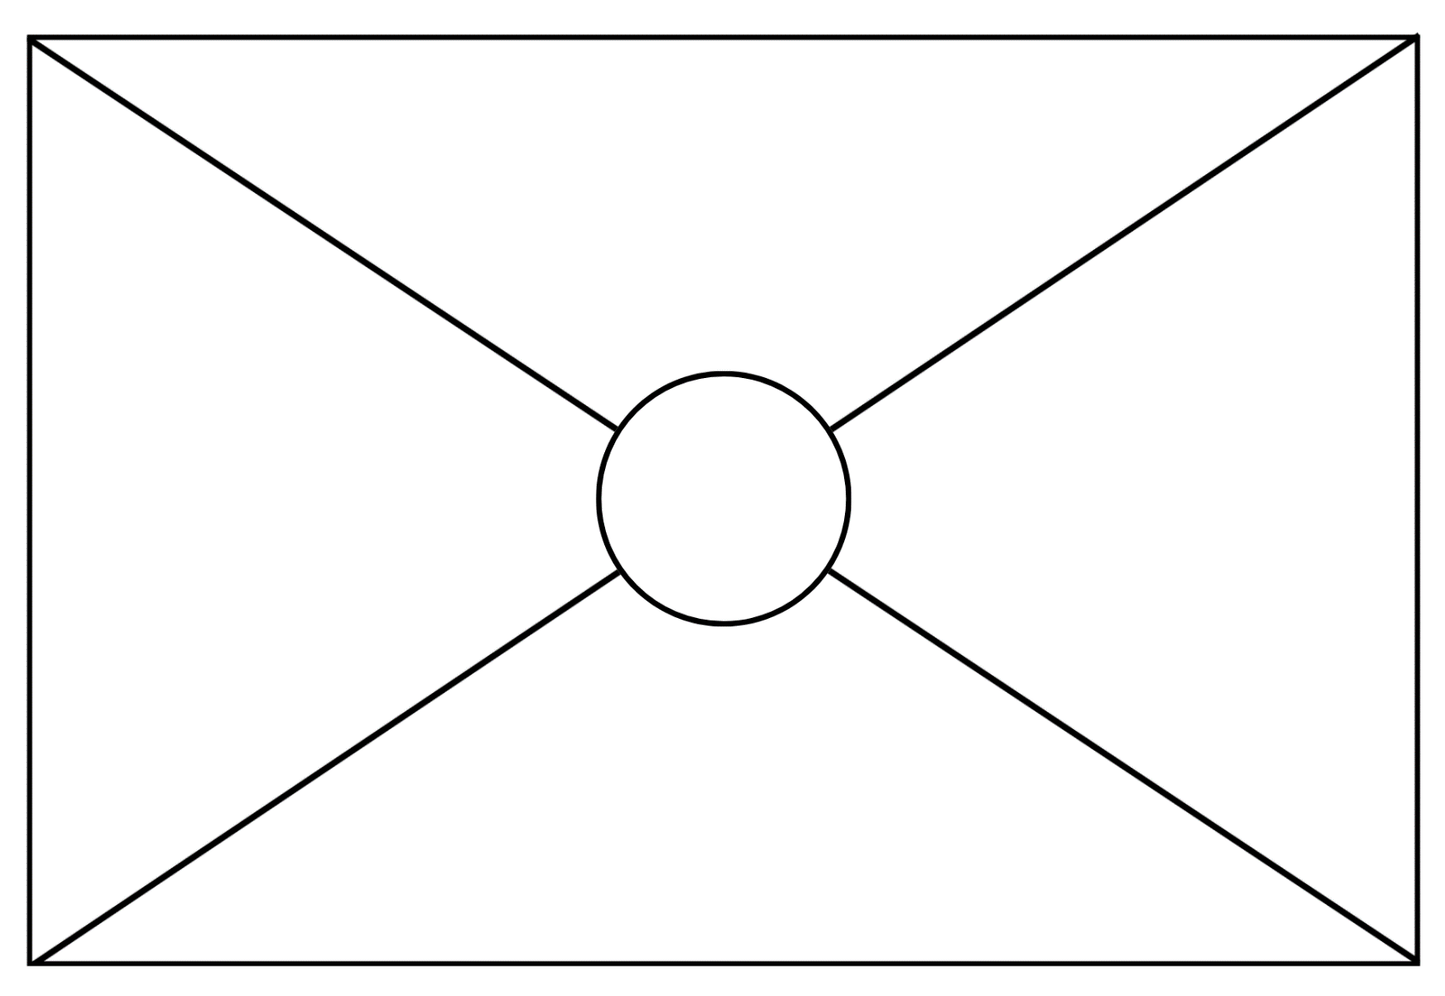

Resource 4: Pig pathways 1
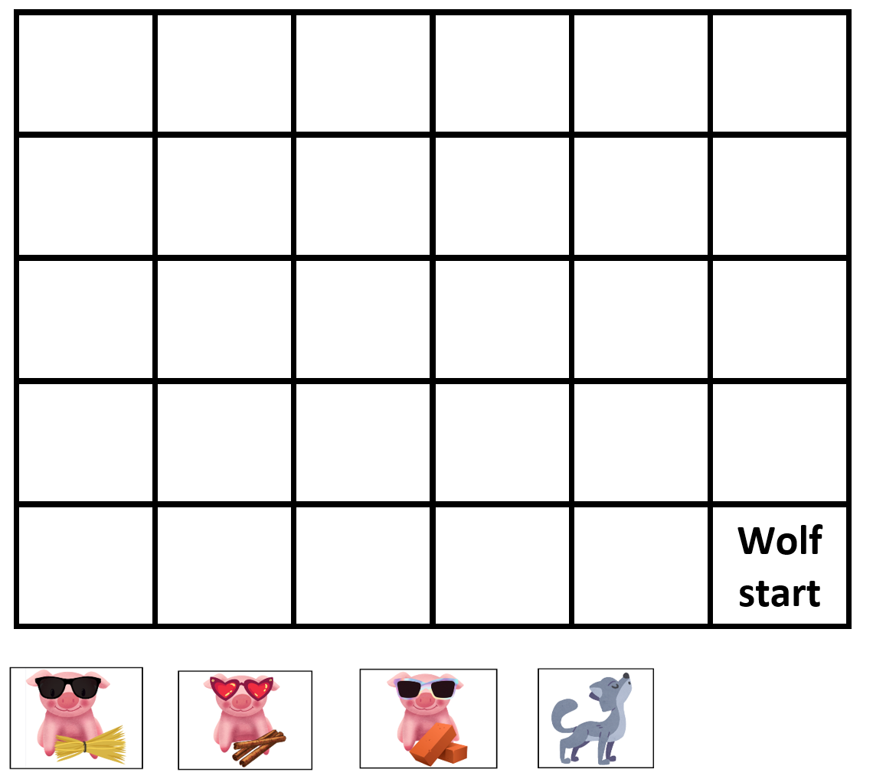
Images sourced from Canva and used in accordance with the Canva Content License Agreement.

Resource 5: Pig pathways 2
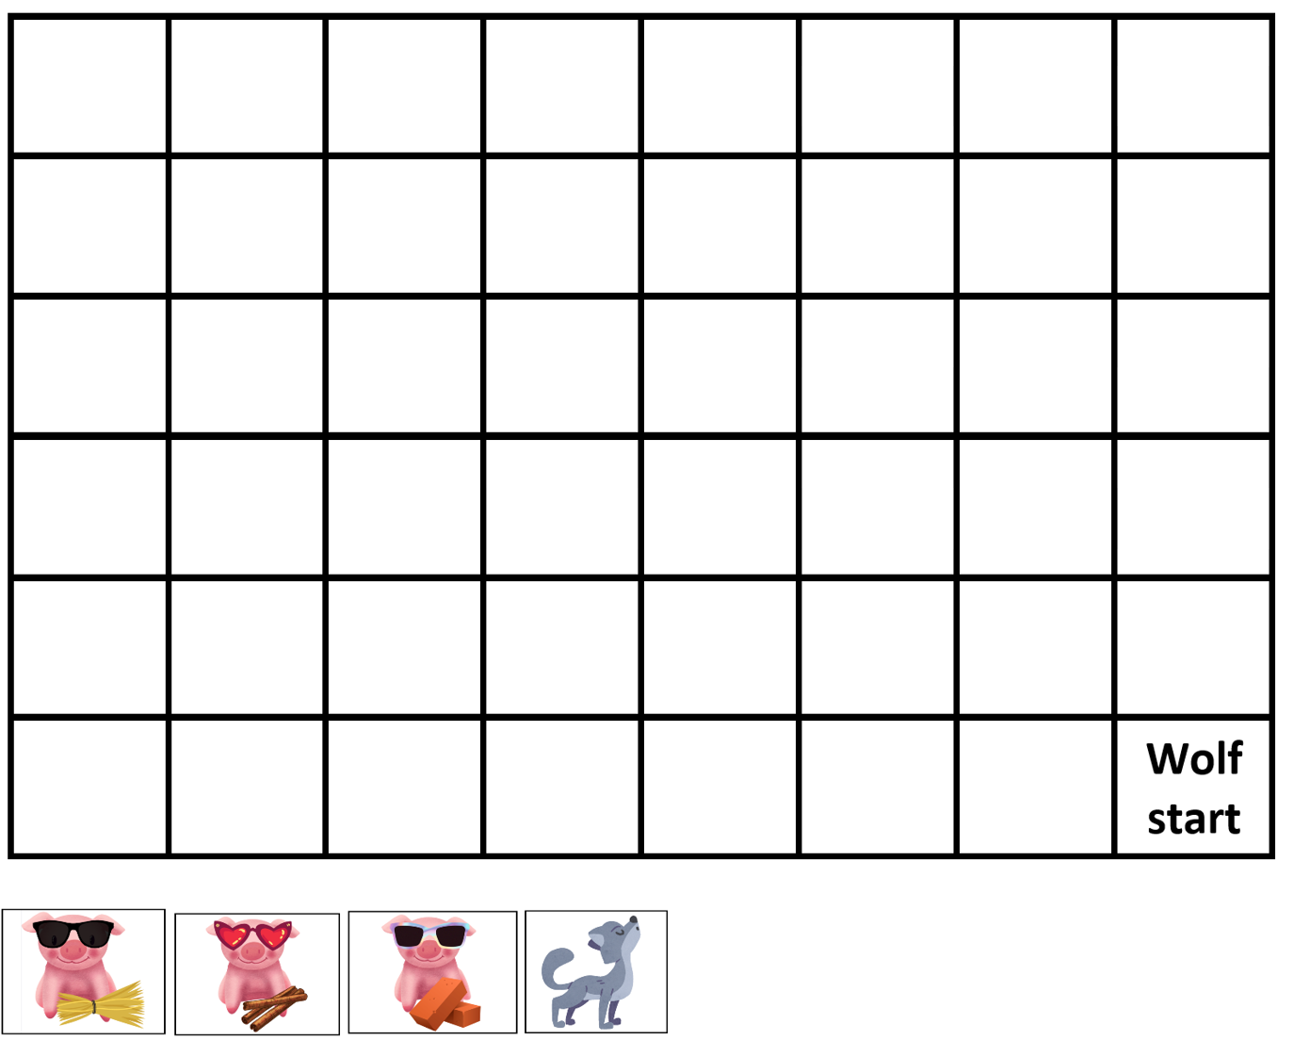
Images sourced from Canva and used in accordance with the Canva Content License Agreement.

Resource 6: Pig pathways 3
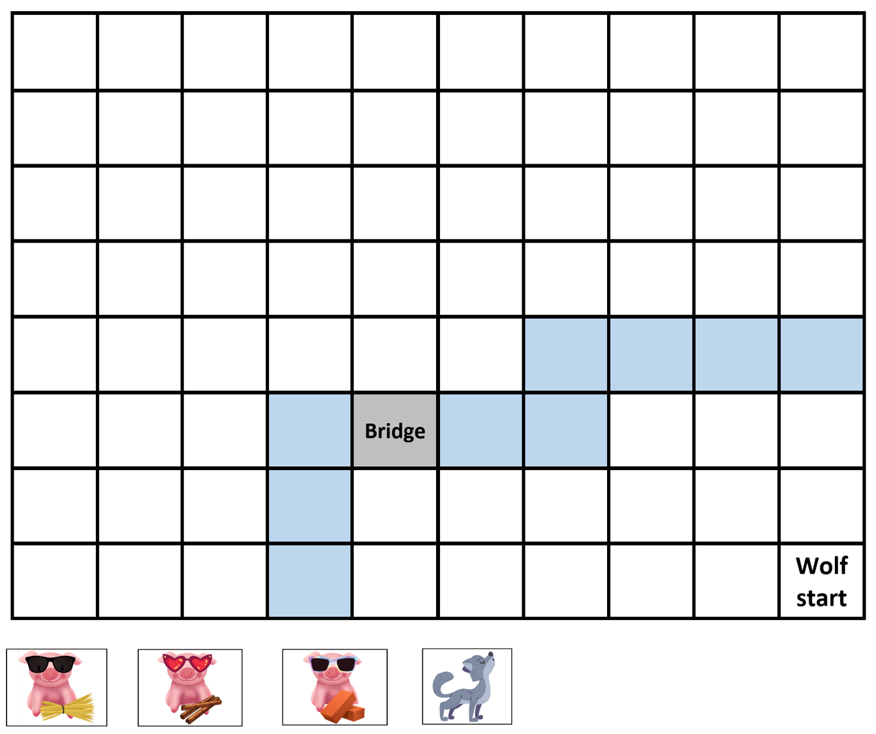
Images sourced from Canva and used in accordance with the Canva Content License Agreement.

Resource 7: Aboriginal animal symbols
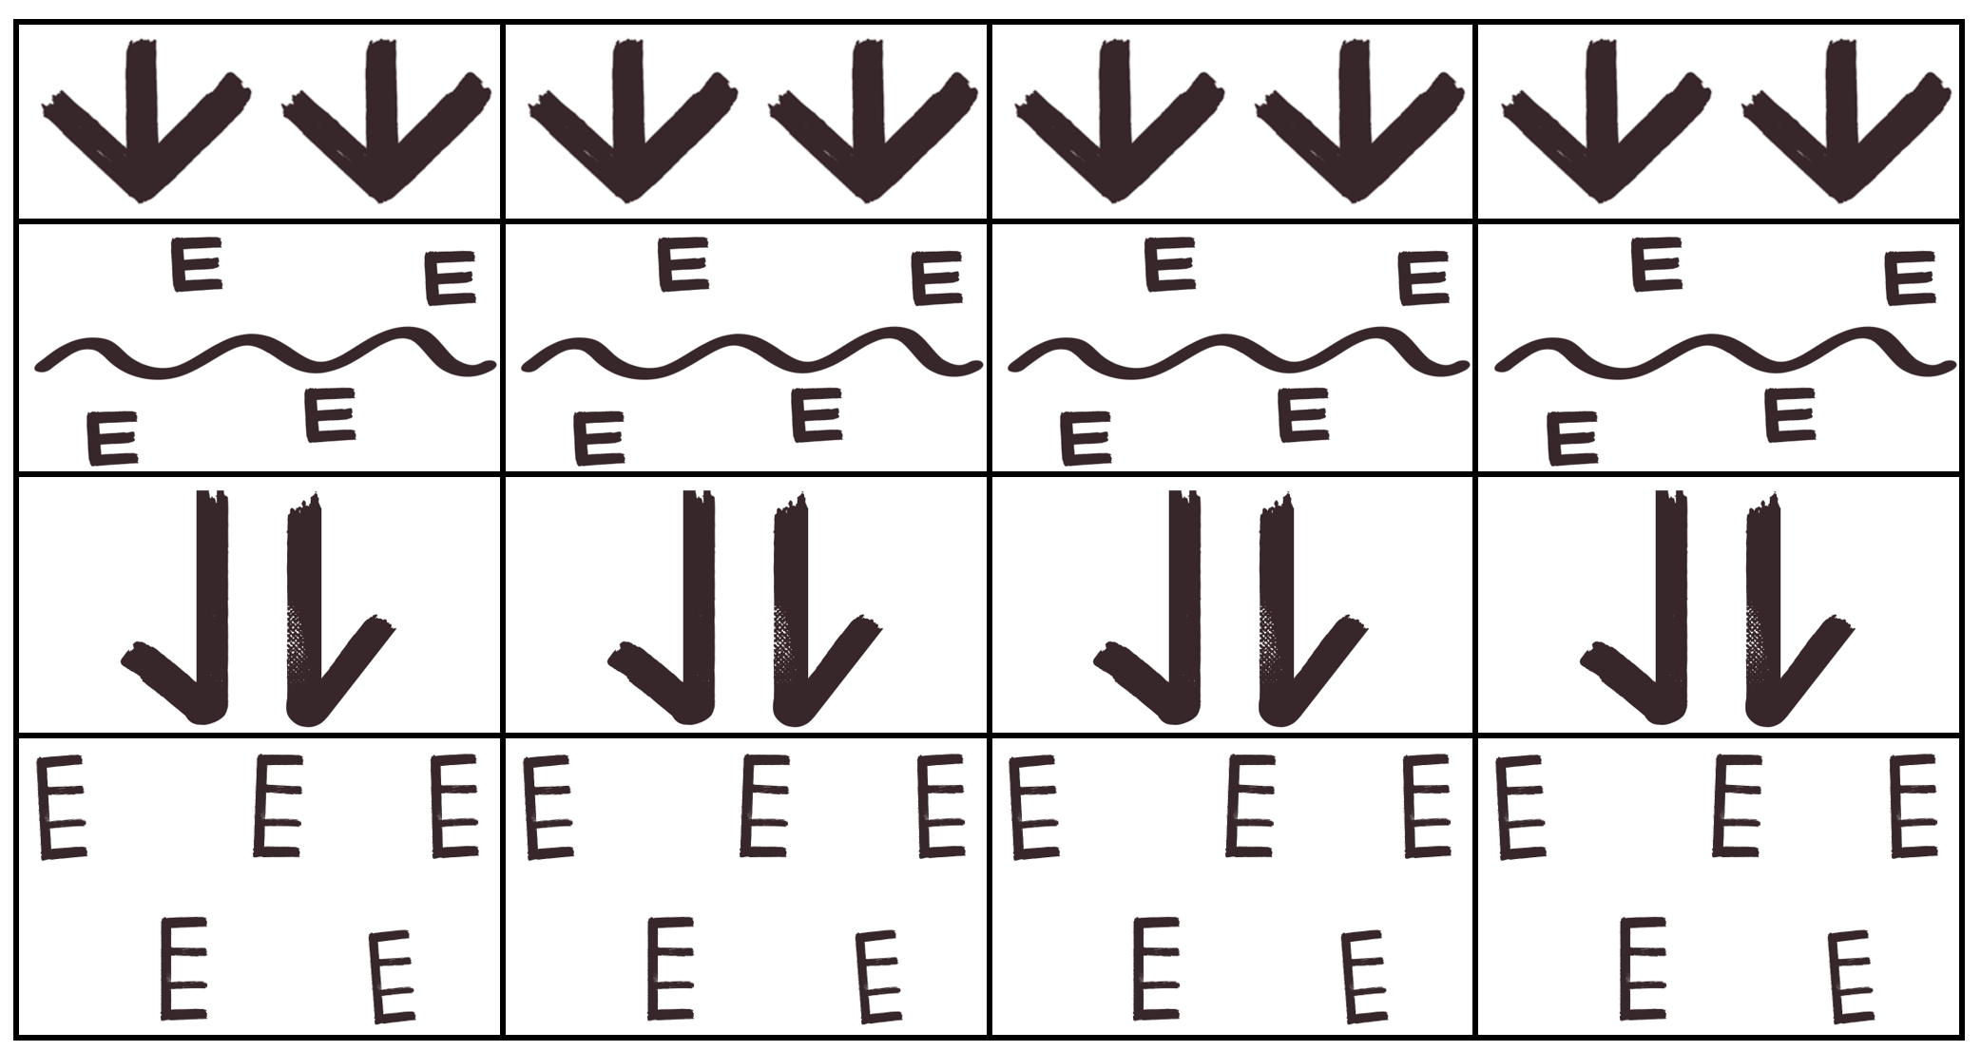
Images sourced from Canva and used in accordance with the Canva Content License Agreement.

Resource 8: Meeting place symbols
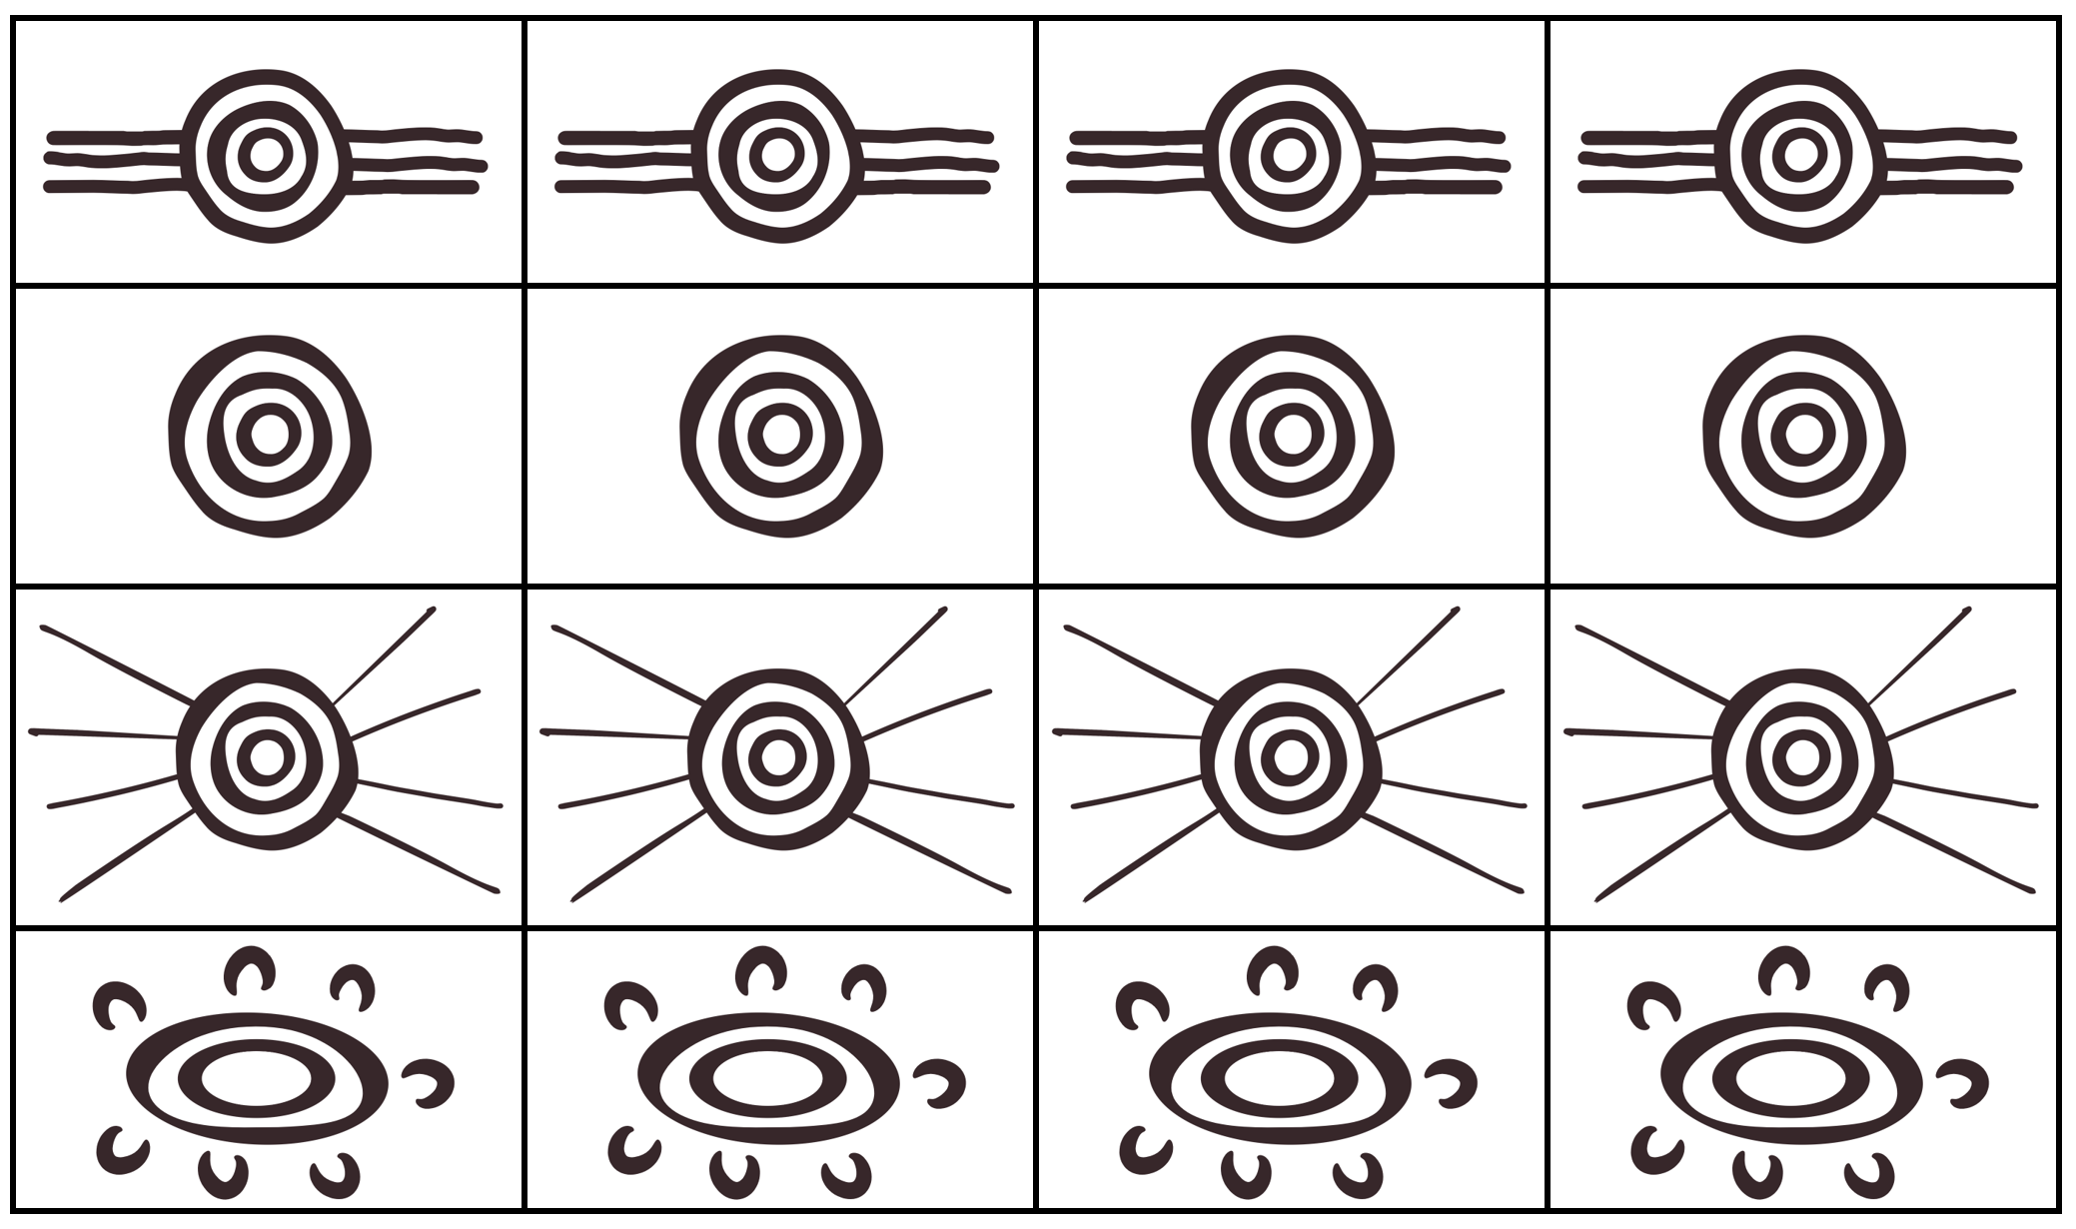
Images sourced from Canva and used in accordance with the Canva Content License Agreement.

Resource 9: Natural environment symbols
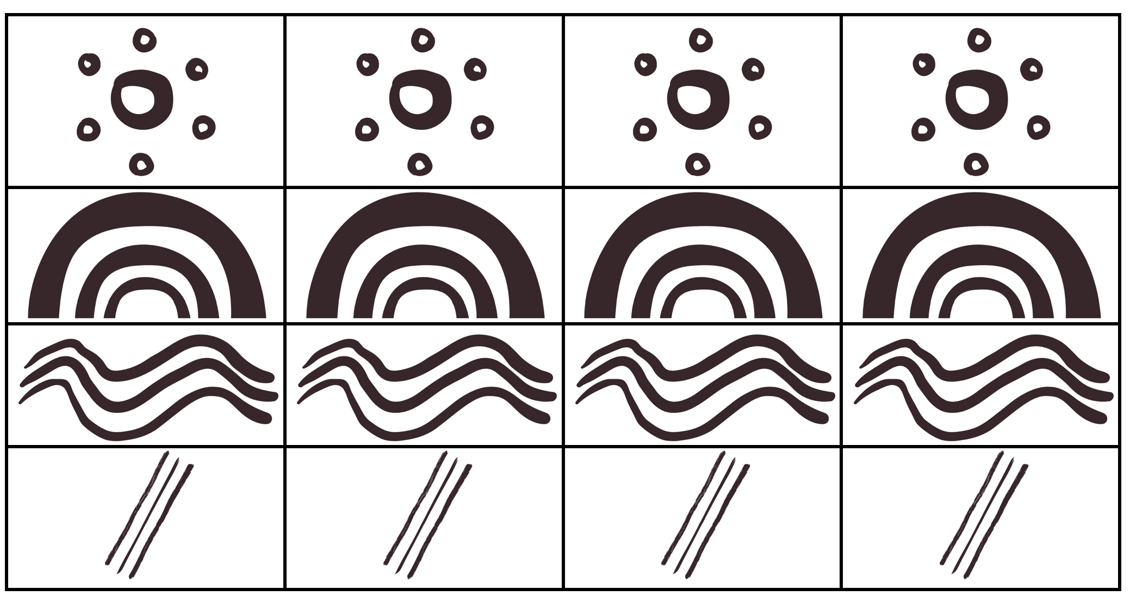
Images sourced from Canva and used in accordance with the Canva Content License Agreement.

Resource 10: Symbols template

Resource 11: Building perspectives 1
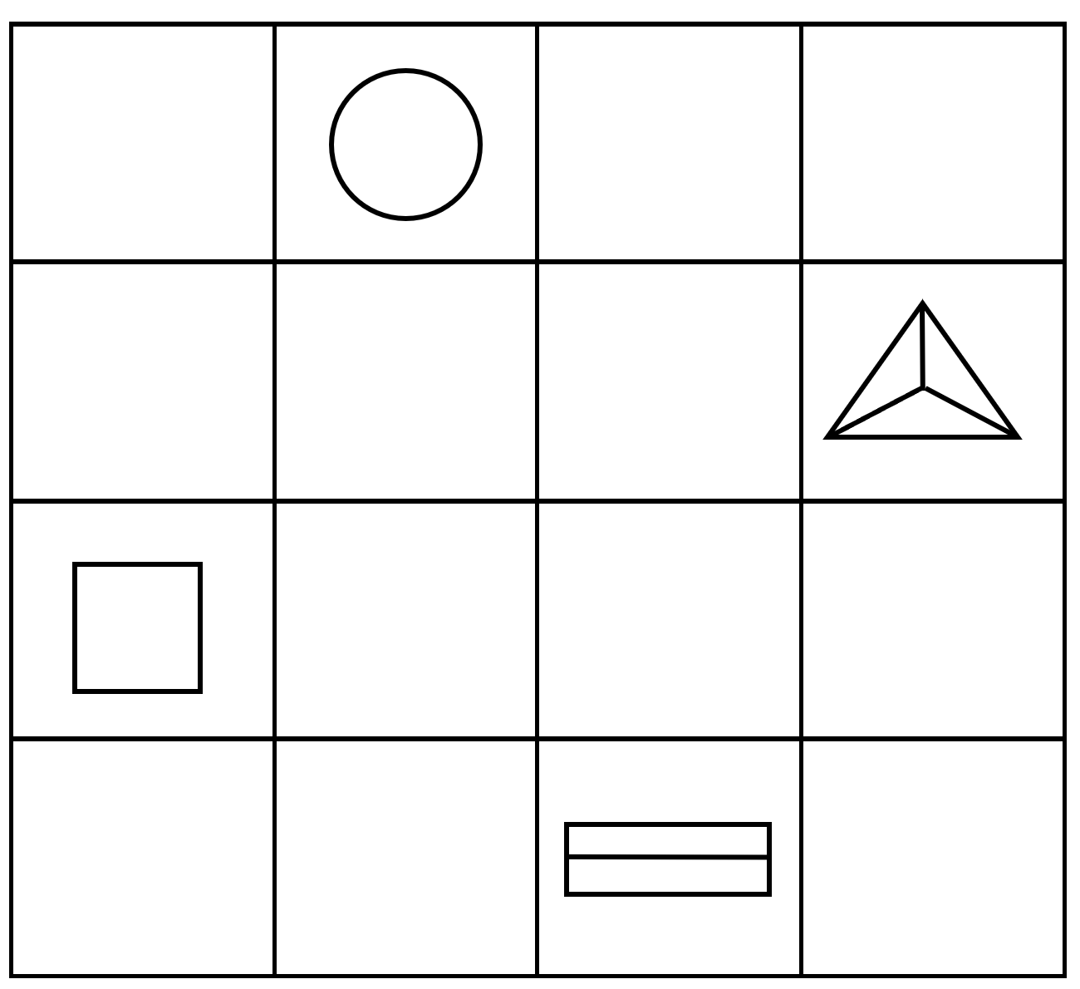

Resource 12: Building perspectives 2

Resource 13: Caterpillars
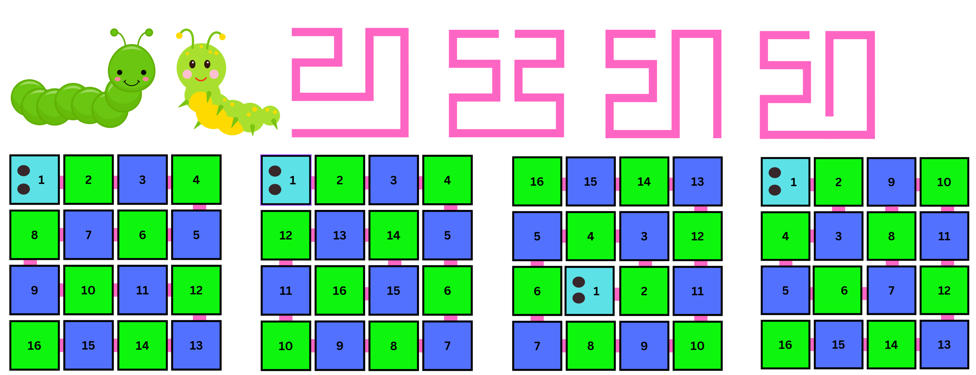
Images sourced from Canva and used in accordance with the Canva Content License Agreement.

Resource 14: Caterpillar grids 1
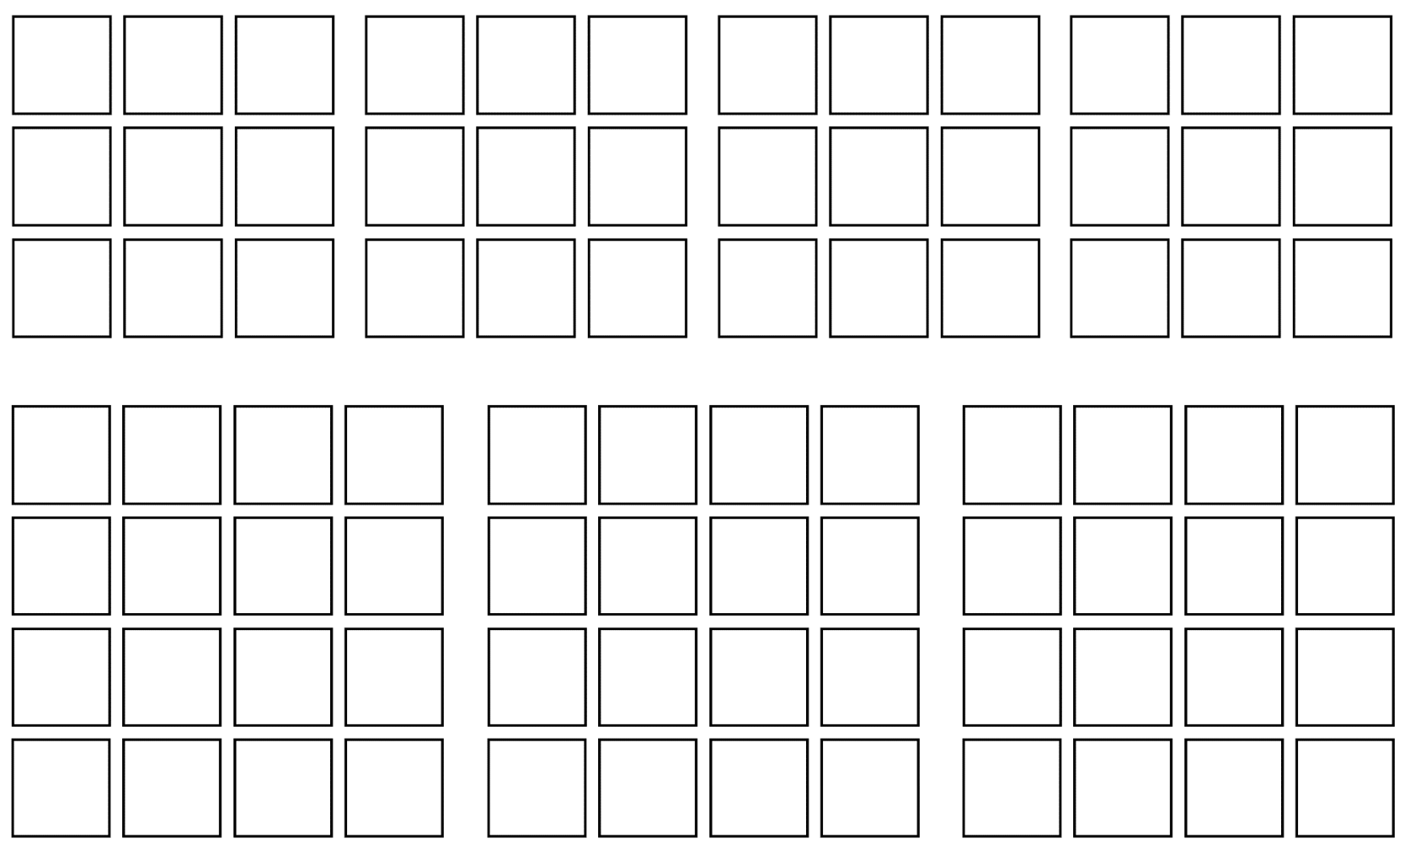

Resource 15: Caterpillar grids 2
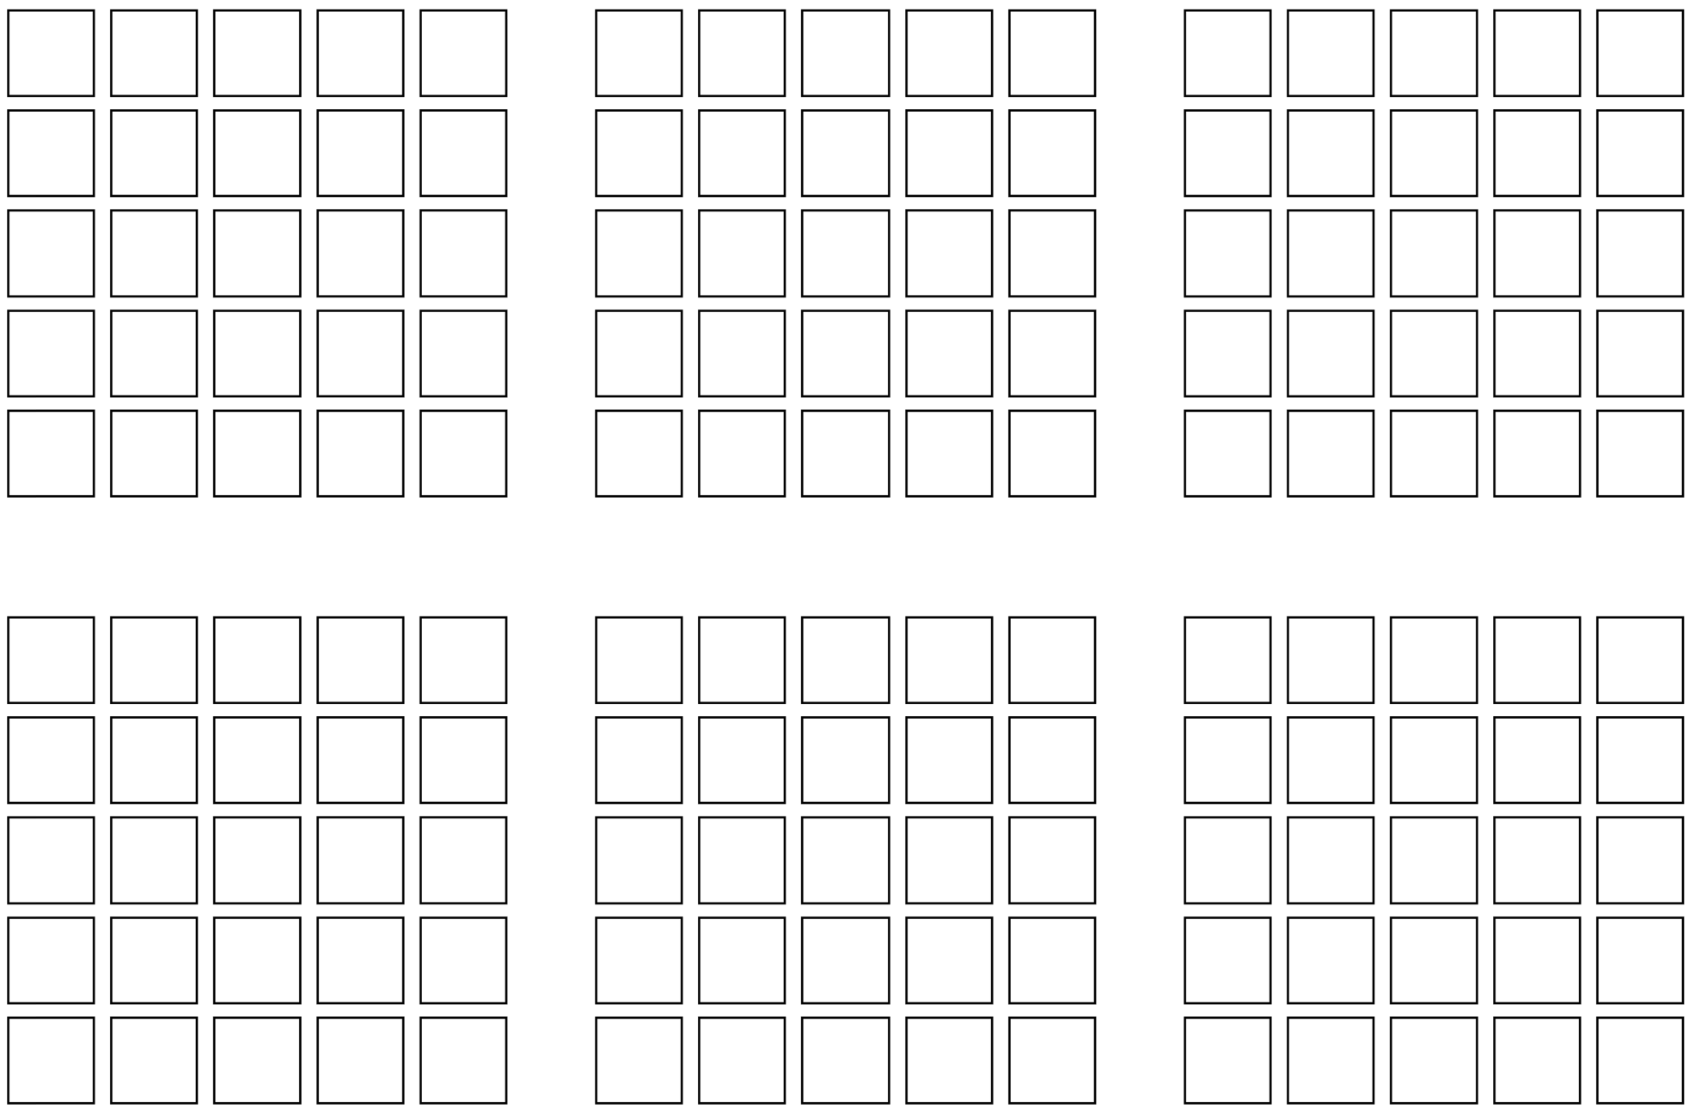

Resource 16: Number line assessment
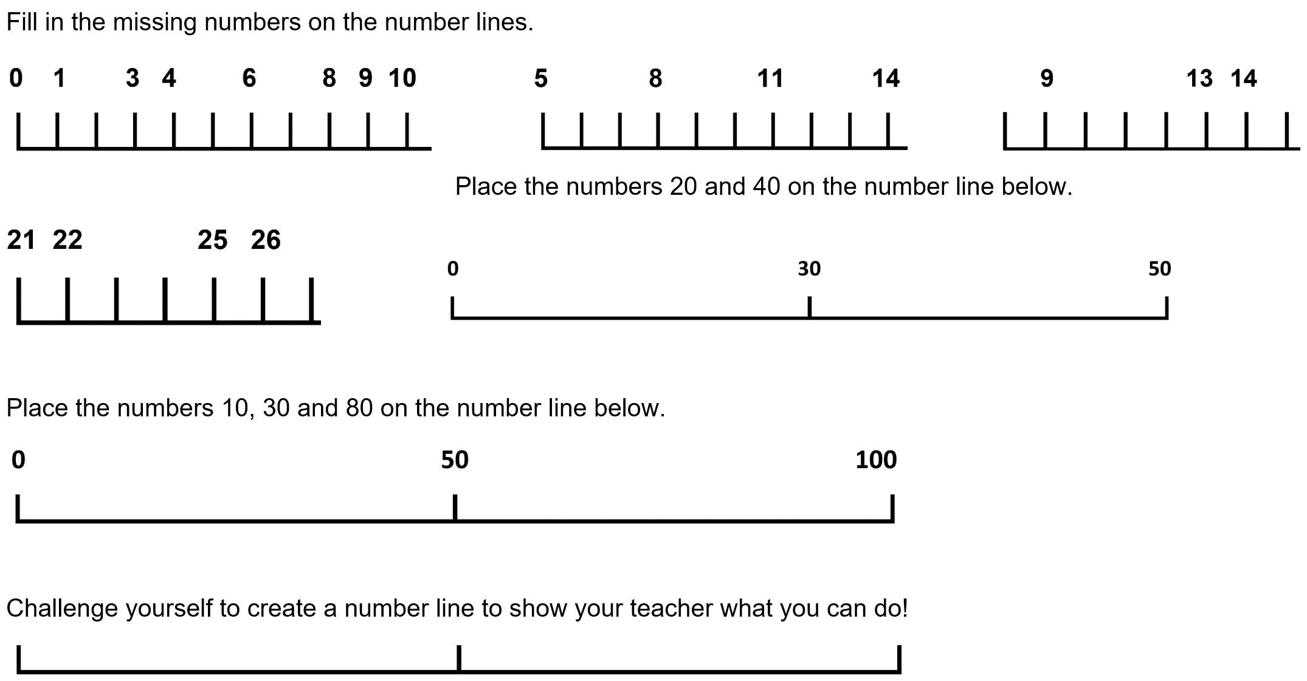

Resource 17: Tour feedback
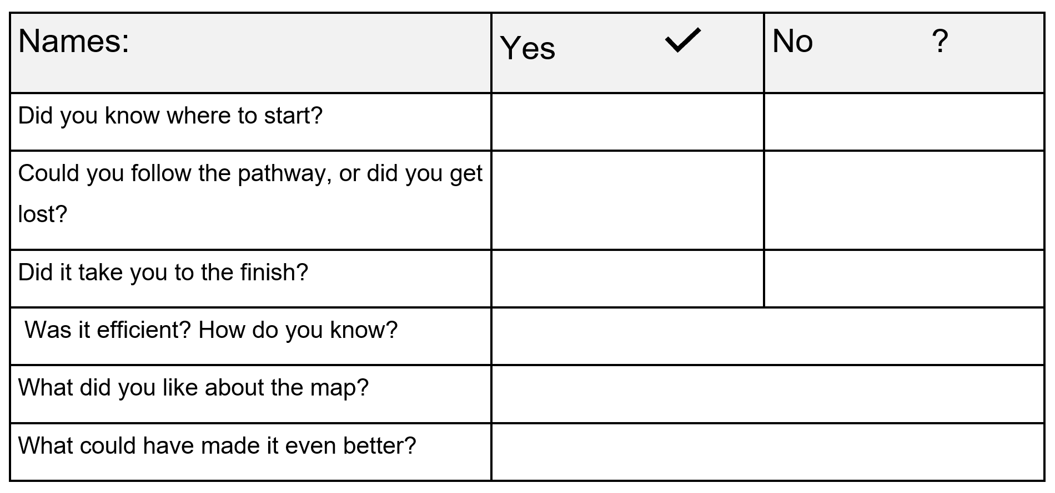

Syllabus outcomes and content
The table below outlines the syllabus outcomes and range of relevant syllabus content covered in this unit. Content is linked to National Numeracy Learning Progression version (3).
Focus area and outcomes | Content groups and content points | Lessons
Representing whole numbers A  MAO-WM-01  MA1-RWN-01  MA1-RWN-02 | Use counting sequences of ones with two-digit numbers and beyond  - identify the number before and after a given two-digit number (CPr5)  - count forwards and backwards by ones from a given number to at least 120 (CPr6)  Continue and create number patterns  - count forwards and backwards by twos from any starting point (CPr6-CPr7, MuS2)  Represent numbers on a line  - sequence numbers and arrange them on a line by considering the order and size of those numbers (CPr5)  - locate the approximate position of multiples of 10 on a model of a number line from 0 to 100 (CPr5)  Represent the structure of groups of ten in whole numbers  - recognise that ten ones is the same as one ten (NPV2, NPV4)  - use 10 as a reference in forming numbers from 11 to 20 (CPr7)  - count large sets of objects by systematically grouping in tens (CPr7)  - use number lines and number charts to assist with locating the nearest ten to a number | 1–8
Representing whole numbers B  MAO-WM-01  MA1-RWN-01  MA1-RWN-02 | Use counting sequences of ones and tens flexibly  - count forwards and backwards by tens, on and off the decade, with two- and three-digit numbers (CPr7)  Form, regroup, and rename three-digit numbers  - state the quantity value of digits in numbers of up to three digits (NPV5)  - identify the nearest hundred to a number  - recognise units of 100 (UnM5, NPV5) | 1–8
Combining and separating quantities A  MAO-WM-01  MA1-CSQ-01 | Recognise and recall number bonds up to ten  - recognise, recall and record combinations of two numbers that add up or bond to form 10 (AdS2, AdS6)  - create, recall and recognise combinations of two numbers that add up to numbers less than 10 (AdS2, AdS6)  - describe combinations for numbers using words such as more than, less than and double (AdS6)  Use flexible strategies to solve addition and subtraction problems  - use non-count-by-one strategies such as using doubles for near doubles and combining numbers that add to ten (AdS6)  - represent addition and subtraction using structured materials such as a bead string or similar model (AdS6-AdS7) | 3–4, 7–8
Geometric measure A  MAO-WM-01  MA1-GM-01 | Position: Follow directions to familiar  - give and follow directions, including directions involving turns to the left and right, to move between familiar locations (PoL2)  - give and follow instructions to position objects in models and drawings (PoL2)  - describe the path from one location to another on drawings and diagrams | 1–8
Geometric measure B  MAO-WM-01  MA1-GM-01 | Position: Explore simple maps of familiar locations  - make simple models from memory, photographs, drawings or descriptions  - interpret simple maps by identifying objects in different locations (PoL3)  - create a path from one location to another (PoL3) | 3–8
Two-dimensional spatial structure A  MAO-WM-01  MA1-2DS-01 | 2D shapes: Recognise and classify shapes using obvious features  - explore, manipulate and describe features of polygons (UGP3)  - select and name a shape from a description of its features, identifying triangles, quadrilaterals, pentagons, hexagons and octagons  - identify shapes presented in different orientations (UGP2)  2D shapes: Transform shapes with slides and reflections  - recognise that sliding or reflecting a shape does not change its size or features (UGP2)  - identify and create a slide (translation) or reflection of a single shape and use the terms ‘slide’ (translation) and ‘reflection’ to describe the movement of the shape (UGP2)  - make designs with symmetry from reflection using paper-folding, mirrors, drawings or paintings (UGP3) | 1–8
Two-dimensional spatial structure B  MAO-WM-01  MA1-2DS-01 | 2D shapes: Identify and describe the orientation of shapes using quarter turns  - identify full, half and quarter turns of a single shape and describe the movement of the shape (UuM4)  - identify and describe directions of turns as ‘left turn’, ‘right turn’, ‘clockwise’ or ‘anti-clockwise’ (UuM4) | 1–8

References
Links to third-party material and websites
Please note that the provided (reading/viewing material/list/links/texts) are a suggestion only and implies no endorsement, by the New South Wales Department of Education, of any author, publisher, or book title. School principals and teachers are best placed to assess the suitability of resources that would complement the curriculum and reflect the needs and interests of their students.
If you use the links provided in this document to access a third-party's website, you acknowledge that the terms of use, including licence terms set out on the third-party's website apply to the use which may be made of the materials on that third-party website or where permitted by the Copyright Act 1968 (Cth). The department accepts no responsibility for content on third-party websites.
Except as otherwise noted, all material is © State of New South Wales (Department of Education), 2021 and licensed under the Creative Commons Attribution 4.0 International License. All other material (third-party material) is used with permission or under licence. Where the copyright owner of third-party material has not licensed their material under a Creative Commons or similar licence, you should contact them directly for permission to reuse their material.
Mathematics K–10 Syllabus © 2022 NSW Education Standards Authority (NESA) for and on behalf of the Crown in right of the State of New South Wales.
© 2022 NSW Education Standards Authority. This document contains NSW Curriculum and syllabus content. The NSW Curriculum is developed by the NSW Education Standards Authority. This content is prepared by NESA for and on behalf of the Crown in right of the State of New South Wales. The material is protected by Crown copyright.
Please refer to the NESA Copyright Disclaimer for more information.
NESA holds the only official and up-to-date versions of the NSW Curriculum and syllabus documents. Please visit the NSW Education Standards Authority (NESA) website and the NSW Curriculum website.
National Numeracy Learning Progression © Australian Curriculum, Assessment and Reporting Authority (ACARA) 2010 to present, unless otherwise indicated. This material was downloaded from the Australian Curriculum website (National Numeracy Learning Progression) (accessed 6 December 2022) and was not modified. The material is licensed under CC BY 4.0. Version updates are tracked in the ‘Curriculum version history’ section on the 'About the Australian Curriculum' page of the Australian Curriculum website.
ACARA does not endorse any product that uses the Australian Curriculum or make any representations as to the quality of such products. Any product that uses material published on this website should not be taken to be affiliated with ACARA or have the sponsorship or approval of ACARA. It is up to each person to make their own assessment of the product, taking into account matters including, but not limited to, the version number and the degree to which the materials align with the content descriptions and achievement standards (where relevant). Where there is a claim of alignment, it is important to check that the materials align with the content descriptions and achievement standards (endorsed by all education Ministers), not the elaborations (examples provided by ACARA).
This resource contains images and content obtained from Canva, and their use outside of this resource is subject to Canva’s Content License Agreement. If you wish to use them separately from the resource, please go to Canva.
Code.org (2022) Code.org, accessed 6 December 2022.
Code.org (2022) ‘Course B (2022)’, Courses by Code.org, Grades K-5: Computer Science Fundamentals for Elementary Schools, accessed 6 December 2022.
Google Maps (2022) Sydney Opera House [Google Map], accessed 6 December 2022.
Malcolm L and Willis O (8 July 2016) ‘Songlines: the Indigenous memory code’, ABC Radio National, accessed 6 December 2022.
NSW AECG (NSW Aboriginal Education Consultative Group Incorporated) (2022) NSW AECG [website], accessed 6 December 2022.
Pol G (20 July 2020) ‘First Nations Symbols’, Common Ground First Nations: Articles, accessed 6 December 2022.
Scieszka J (2004) The True Story of the Three Little Pigs (Smith L, illus.), Puffin, Great Britain (original work published 1989).
Siemon D, Warren E, Beswick K, Faragher R, Miller J, Horne M, Jazby D, Breed M, Clark J and Brady K (2020) Teaching Mathematics: Foundations to Middle Years, 3rd edn, Oxford University Press Australia and New Zealand.
Stanford University (n.d.) ‘Sidewalk line dance’, Resources, youcubed website, accessed 6 December 2022.
Stanford University (n.d.) youcubed [website], accessed 6 December 2022.
University of Cambridge (Faculty of Mathematics) (2022) Caterpillars, NRICH website, accessed 6 December 2022.
University of Cambridge (Faculty of Mathematics) (2022) NRICH [website], accessed 6 December 2022.
Van de Walle J, Karp K, Bay-Williams JM, Brass A, Bentley B, Ferguson S, Goff W, Livy S, Marshman M, Martin D, Pearn C, Prodromou T, Symons D and Wilkie K (2019) Primary and Middle Years Mathematics: Teaching Developmentally, 1st Australian edn, Pearson Australia.
Wheatley N (2008) My place (Rawlins D, illus.), 20th anniversary edn, Walker Books Australia (original work published 1987).

Further reading
Glynn-McDonald R (20 August 2019) ‘Songlines’, Common Ground First Nations: Articles, accessed 6 December 2022.

