Whales and chihuahuas
Students explore the concept of proportion by exploring relationships between their own height and objects they can't easily see or measure.

Visible learning
In this lesson, the learning intentions and success criteria are introduced within the launch rather than at the beginning of the lesson.

Learning intention
- To visualise lengths by comparing familiar objects.

Success criteria
- I can make approximate comparisons between familiar lengths and unseen long and short objects.
- I can estimate the length of objects larger and smaller than me.
- I can visualise proportion to check if my answers are logical.

Syllabus outcomes
A student:
- develops understanding and fluency in mathematics through exploring and connecting mathematical concepts, choosing and applying mathematical techniques to solve problems, and communicating their thinking and reasoning coherently and clearly MAO-WM-01
- identifies and applies the properties of similar figures and scale drawings to solve problems MA5-GEO-C-01
Mathematics K–10 Syllabus © NSW Education Standards Authority (NESA) for and on behalf of the Crown in right of the State of New South Wales, 2022.
Please use the associated PowerPoint Whales and Chihuahuas to display images in this lesson.

Activity structure

Launch
- Display Figure 1.
Figure 1 – Blue whale
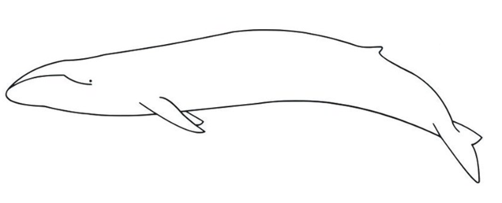
“Blue whale size” by Flickker photos is licensed under CC BY-NC-ND 2.0.
- Have students independently create a Notice and Wonder list (bit.ly/noticewonderstrategy) for Figure 1.
- Ask them to share their list with a partner, then create a class list on the board.
- Use student responses to ask further questions such as:
- How long is a blue whale?
- Would a blue whale fit in this room?
- How much longer is a whale than you?
For this activity, students are considering a whale’s length to be head to tail.
- Display Appendix A and have students indicate via a finger vote which image shows a blue whale compared to an average human. (A is correct).
Student questions and answers will provide an indication of whether they are thinking and comparing additively (How much longer is a whale than you?) or multiplicatively (How many times longer than you is a whale?).
- Share with students the learning intention and success criteria for the lesson.
- As a class, mark out the length of a blue whale (27 m) outside.
- Ask students to predict how many students could lie within the whale. Have students lie down in a line from end-to-end within the whale, to see how many students fit in the whale.

Explore

How many chihuahuas in the Big Banana?
- Display Figure 2.
Figure 2 – 30 cm long chihuahua
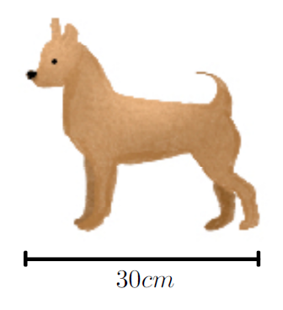
- Tell students they will be guessing how many chihuahuas long that things are (measuring from head to tail). As an example, if we say the average student is 150 cm tall, that would be 5 chihuahuas long, as shown in Figure 3.
Figure 3 – silhouette next to 5 chihuahuas
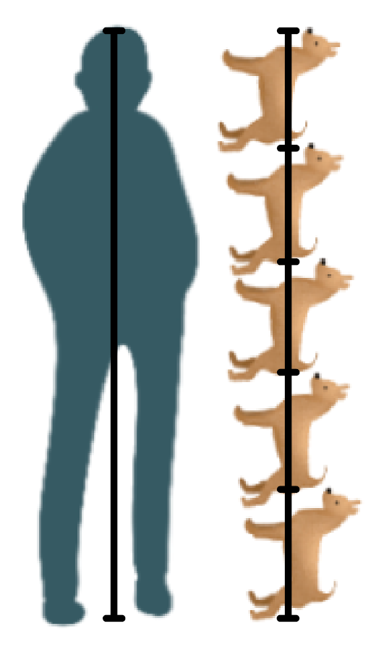
- Ask students to answer using the following sentence structure scaffold as a pair/share:
The student is made up of __ chihuahuas. So, the student is __ times longer than a chihuahua.
The intention of these questions is to assist in explicitly moving students from an additive mindset (How much longer…) to a multiplicative mindset (How many times longer/ What part of…).
- Organise students into random groups of 3 and provide each group with a mini whiteboard and one whiteboard marker.
- Read each item aloud. Allow students time to discuss then write down how many chihuahuas long that object might be. Don’t read out the measurements in parentheses until students have made their predictions.
- Big Banana (13 m which is 43 chihuahuas)
- Whale (27 m which is 90 chihuahuas)
- Bus (12.5 m which is 42 chihuahuas)
- Cricket pitch (20 m which is 67 chihuahuas)
- Crocodile (3 m which is 10 chihuahuas)
- Volleyball court (15 m which is 50 chihuahuas)

Summarise
- Print and distribute or display Appendix B.
- Students work in pairs to engage with this activity.

Equipment
- I’m as tall as a… (Appendix B)
- Laptop per pair of students
- Tape measure

Whole group reflection
- Ask reflection questions from the activity such as:
- Was anything larger/smaller than you expected?
- Is anyone proud of their error?
- What were the more difficult objects to estimate and why?
- What strategies did you use?
- Make explicit to students that this unit will develop their skills to work with scale and proportion. Emphasise the importance of using this activity to check if their answer is logical when working with scale.

Apply
Have students predict and calculate measurements around the classroom or the outside world. For example:
- How many chihuahuas would fit along your desk?
- How many chihuahuas would fit along the whiteboard?
- How many whales would fit along the oval?
- How many whales would fit along the Sydney Harbour bridge?
- How many whales would fit between Earth and the moon?
- How many chihuahuas would fit between Earth and the moon?

Assessment and Differentiation

Suggested opportunities for differentiation
Explore
- Make use of manipulatives such as a 30 cm ruler to assist students with the How many chihuahuas is the Big Banana? activity. Have students predict and measure tangible objects around the room using the ruler.
- Challenge students to consider how many students would fit inside a blue whale (capacity).
- Challenge students to consider what part of a larger measurement, smaller measurements are. For example, what part of the student is a chihuahua (one-fifth as long)?
Apply
- Make use of manipulatives such as counters and have students predict the length of objects in counters.
- Prompt students to think more deeply about units, such as:
- Would you rather measure the distance from Sydney to Melbourne in whales or chihuahuas? How about centimetres or kilometres?
- Why do you think we use different units instead of measuring everything in millimetres?
- Students access bit.ly/solarsystemscroll to see the universe to scale. Students can change the units to blue whales.

Suggested opportunities for assessment
- Monitor students’ predictions throughout the lesson to assess their understanding of units and estimation.
- Create an exit ticket question such as: How many chihuahuas tall are you?

Appendix A

Whale
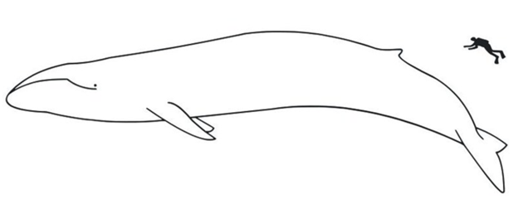
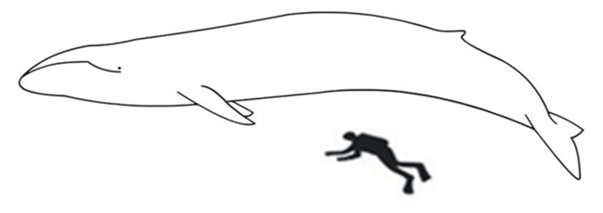
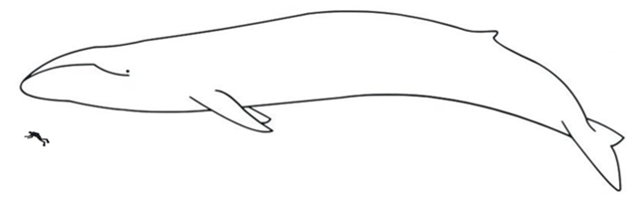

Appendix B

I’m as tall as a…
In pairs:
- Measure and record each person's height.
- Choose an object that corresponds to each of the sizes: Very large, Large and so on. Be creative!
- Estimate how tall the object is in reference to your height.
- Swap sheets with your partner and get them to find the actual heights of your objects using the internet.
- Find the difference between the estimate and actual measurements to complete the error column for your partner’s sheet. You will need all measurements in centimetres so you can add it up to find the total error.
Size | Object | Estimate | Actual | Error
Example | Train | 4 × my height = 600 cm | 4.5 m | 150 cm
Very large
Large
Your height
Small
Very small
 |  |  | Total Error: | cm

© State of New South Wales (Department of Education), 2023
The copyright material published in this resource is subject to the Copyright Act 1968 (Cth) and is owned by the NSW Department of Education or, where indicated, by a party other than the NSW Department of Education (third-party material).
Copyright material available in this resource and owned by the NSW Department of Education is licensed under a Creative Commons Attribution 4.0 International (CC BY 4.0) licence.
This licence allows you to share and adapt the material for any purpose, even commercially.
Attribution should be given to © State of New South Wales (Department of Education), 2023.
Material in this resource not available under a Creative Commons licence:
- the NSW Department of Education logo, other logos and trademark-protected material
- material owned by a third party that has been reproduced with permission. You will need to obtain permission from the third party to reuse its material.
Links to third-party material and websites
Please note that the provided (reading/viewing material/list/links/texts) are a suggestion only and implies no endorsement, by the New South Wales Department of Education, of any author, publisher, or book title. School principals and teachers are best placed to assess the suitability of resources that would complement the curriculum and reflect the needs and interests of their students.
If you use the links provided in this document to access a third-party's website, you acknowledge that the terms of use, including licence terms set out on the third-party's website apply to the use which may be made of the materials on that third-party website or where permitted by the Copyright Act 1968 (Cth). The department accepts no responsibility for content on third-party websites.

