Similar figures in art
This lesson provides students with opportunities to explore similar figures and scale in art.

Visible learning

Learning intentions
- To explore the use of similar figures and scale.
- To explore the meaning behind symbols used in Aboriginal artwork.

Success criteria
- I can use a grid to draw similar figures.
- I can use a vanishing point to draw similar figures.
- I can recognise symbols in Aboriginal artwork and appreciate their meaning.

Syllabus outcomes
A student:
- develops understanding and fluency in mathematics through exploring and connecting mathematical concepts, choosing and applying mathematical techniques to solve problems, and communicating their thinking and reasoning coherently and clearly MAO-WM-01
- identifies and applies the properties of similar figures and scale drawings to solve problems MA5-GEO-C-01
Mathematics K–10 Syllabus © NSW Education Standards Authority (NESA) for and on behalf of the Crown in right of the State of New South Wales, 2022.
Please use the associated PowerPoint Similar figures in art to display images in this lesson.

Activity structure

Warm up
- Display the Which one doesn’t belong activity retrieved from https://wodb.ca/images/shape34.png. For more information about this strategy, refer to bit.ly/wodbstrategy.
- Have students justify which one doesn’t belong in a Think-Pair-Share (bit.ly/thinkpairsharestrategy).
There is no wrong answer. Have students explain their choice.

Launch
This activity provides students the opportunity to discover and practice artistic techniques used to produce similar figures.
- Students are to draw the apple below in their books. The apple should take up half a page.
Figure 1 – red apple
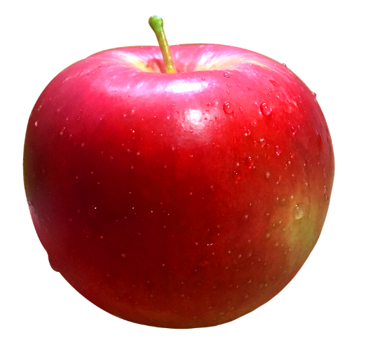
"Red Apple" by Abhijit Tembhekar is licensed under CC BY-NC-ND 2.0

- Reflection questions to be considered by students:
- Was that an easy activity?
- Did you make the apple larger or smaller?
- What made the activity difficult?
- Is your apple the correct shape and size?
- Did you have difficulty making your apple half a page?
- The background information below should be shared with students, then ask students to do the Enlargement activity (Appendix A).

Background information
Artists use similarity in artworks to serve a variety of purposes. With the absence of technology, artists have been using grids to change the size of objects whilst maintaining the object’s true shape for centuries. One of the most famous grid techniques is that of artist Albrecht Dürer. Dürer used a transparent grid that was positioned between himself and the object of the artwork. For this technique to work, the artist has to position their eye in exactly the same spot each time they look at the subject and re-create what they see onto a smaller grid on their paper. Below is an artwork by Albrecht Dürer depicting this process.
Figure 2 – artwork by Albrecht Dürer
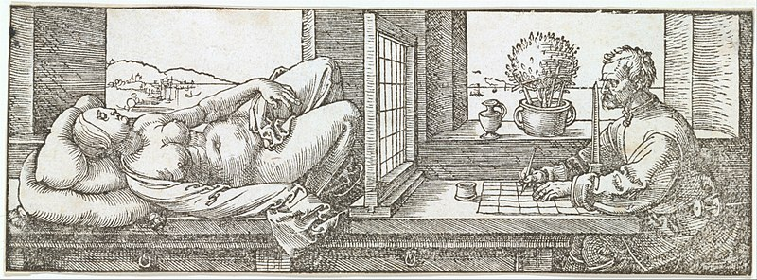
"Draughtsman Making a Perspective Drawing of a Reclining Woman" by Draughtsman Making a Perspective Drawing of a Reclining Woman" by Metropolitan Museum of Art is licensed under CC BY-SA 3.0

Artists also use grids to enlarge images and create murals. The famous silo art trail in Victoria is a series of large-scale paintings created on silos. These can also be seen in rural NSW.
Figure 3 – silo art
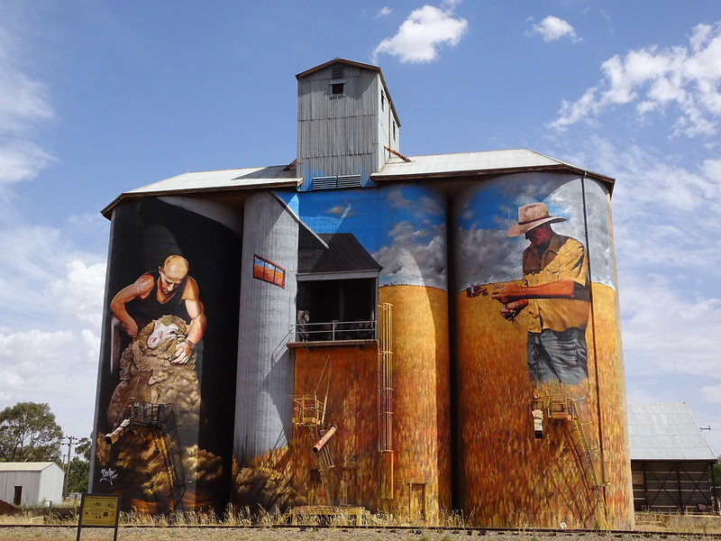
‘Weethalle. NSW. Colourful silo art on the local silos’ by NoDerivs is licensed under CC BY-ND 2.0.

Explore
- Explain to students, using a grid is not the only way that you can enlarge or dilate two-dimensional objects. In this activity students will explore creating similar figures using vanishing points and investigate properties of similar figures using this method.
- Print and distribute Appendix B.
- Students engage with the activity in pairs or independently.
- Prompt early finishers with a question such as: ‘The text MATHEMATICS in the smaller logo was created using a font size of 20. What do you think the font size of the larger logo is? Explain your reasoning.’

Summarise
- Students compare the 2 drawing techniques: enlargement using a grid and vanishing points.
- Discuss where each technique might have a purpose beyond creating artworks.

Apply
- Remind students of the learning intentions of the lesson.
- So far students have explored artistic strategies that involve similar figures and scale. Now they will be exploring why some artists choose to use repeated imagery and the meaning behind those symbols.
- Please try to have a local Aboriginal artist visit your school as a guest speaker to talk about symbolism and figures commonly seen in Aboriginal art. Encourage students to ask questions such as:
- How have Aboriginal artists created similar figures throughout their history?
- Do the symbols mean the same thing between Aboriginal communities?
- Do they (the artist) use repeated figures in their art and if so, what does it mean to them?
If a guest speaker is not able to attend your school, you might like to use the symbols and common definitions from Aboriginal Art Symbols (https://artark.com.au/pages/aboriginal-art-symbols).
At the bottom of the link are some artworks demonstrating symbols in use.
- Print and cut out the symbols and definitions separately, so that students can work in groups to match the symbols with their meanings. Encourage discussions of why symbols would be repeated many times within an artwork and how artists may have created these symbols throughout history.
- Following from this activity, students should be exposed to local Aboriginal artwork whether at a local exhibition or works shared online. Have students suggest the meaning behind the symbols used and the story the artist might have been trying to tell.

Assessment and Differentiation

Suggested opportunities for differentiation
Launch
- If students are unable to draw by hand, you could have them finger paint inside a larger grid.
Explore
- Students could be challenged by providing them with a more detailed item to enlarge.
- If students have difficulty measuring with a ruler, they could be encouraged to measure to the nearest whole or half centimetre rather than measuring in millimetres.

Suggested opportunities for assessment
- Listen for students using correct vocabulary and reasoning in their discussions.

Appendix A

Enlargement activity
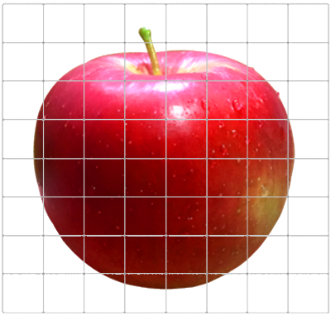
- Use the grid provided to enlarge the image of the apple.
- Look at each square individually and re-create it into the corresponding square on the bigger grid. It might be a good strategy to re-create the outline of the apple first before adding details and shading.
- What is similar between the original apple and your enlarged image?

Appendix B

Using vanishing points
The following image shows similar figures A B C D E F G H and A’ B’ C’ D’ E’ F’ G’ H’.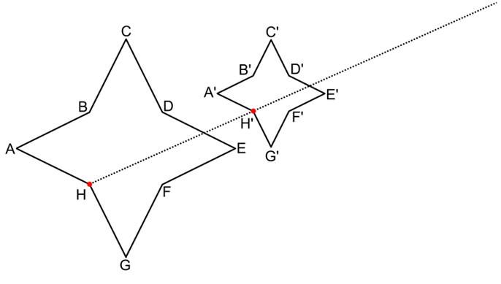
You do:
- Draw a long line joining A to A’, B to B’, C to C’ and so on.
- Label the point where all the lines intercept O. This is called the vanishing point in perspective drawing.
- Use a ruler to complete the measurements in the table below.
 | Measurement |  | Measurement
OA |  | OA’
OB |  | OB’
OC |  | OC’
OD |  | OD’
OE |  | OE’
OF |  | OF’
OG |  | OG’
- What do you notice about the measurements?
- Complete the enlarged logo shown below by first locating and then using the vanishing point.
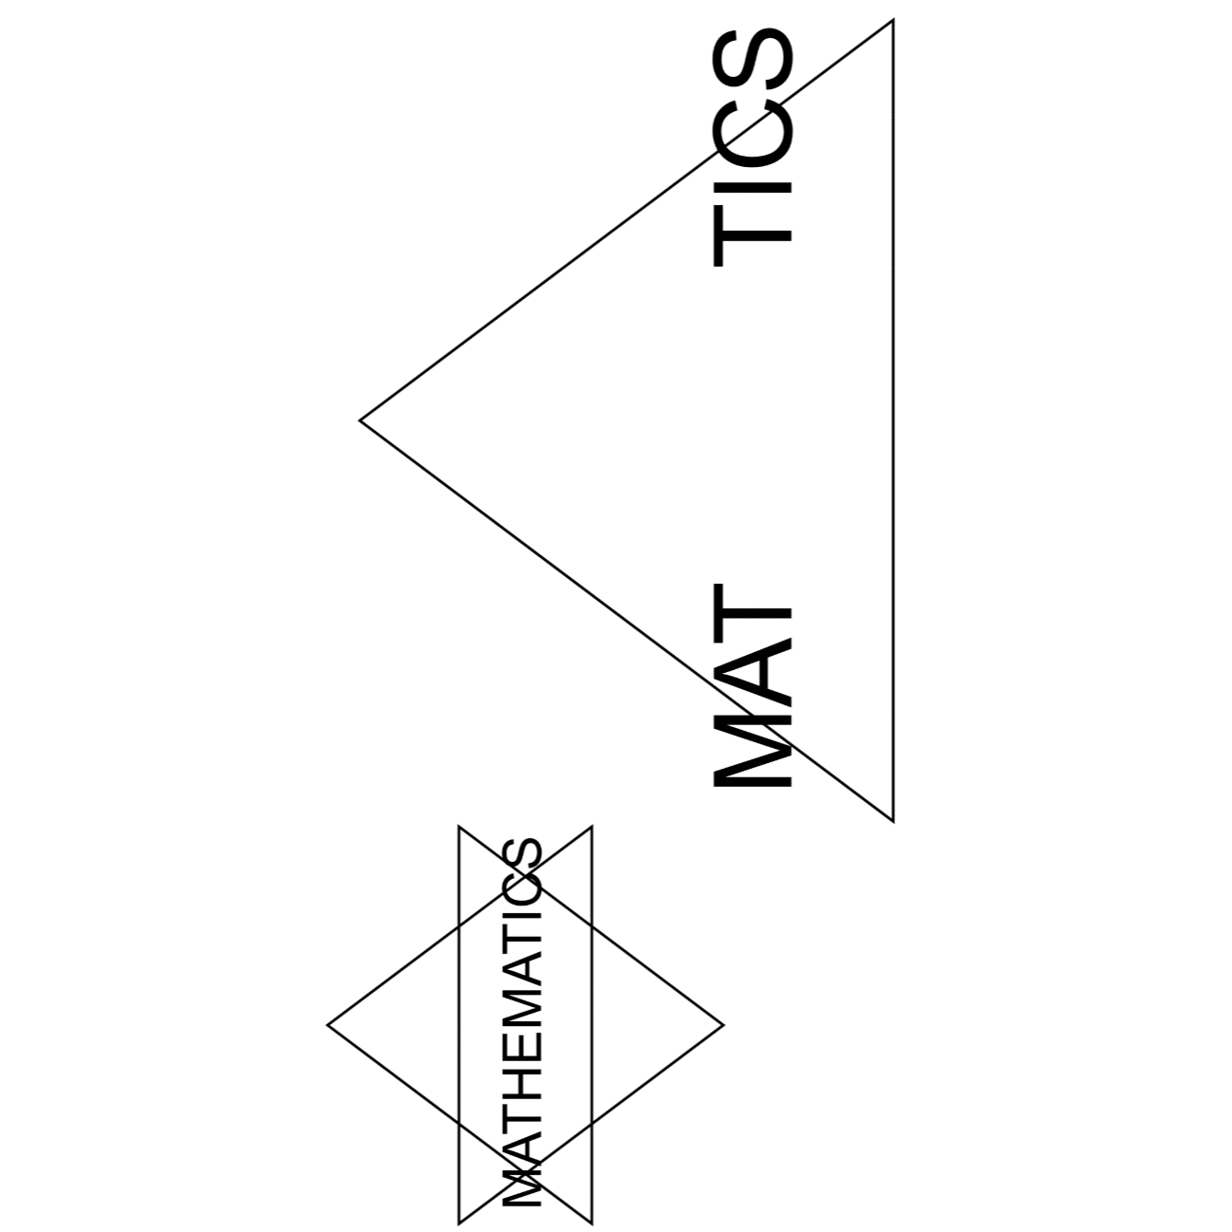

Sample solutions
 | Measurement |  | Measurement
OA | 140mm | OA’ | 70mm
OB | 110mm | OB’ | 55mm
OC | 96mm | OC’ | 48mm
OD | 88mm | OD’ | 44mm
OE | 70mm | OE’ | 35mm
OF | 100mm | OF’ | 50mm
OG | 120mm | OG’ | 60mm
What do you notice about the measurements?
The distance from the large star to the vanishing point is double that of the small star to the vanishing point.

© State of New South Wales (Department of Education), 2023
The copyright material published in this resource is subject to the Copyright Act 1968 (Cth) and is owned by the NSW Department of Education or, where indicated, by a party other than the NSW Department of Education (third-party material).
Copyright material available in this resource and owned by the NSW Department of Education is licensed under a Creative Commons Attribution 4.0 International (CC BY 4.0) licence.
This licence allows you to share and adapt the material for any purpose, even commercially.
Attribution should be given to © State of New South Wales (Department of Education), 2023.
Material in this resource not available under a Creative Commons licence:
- the NSW Department of Education logo, other logos and trademark-protected material
- material owned by a third party that has been reproduced with permission. You will need to obtain permission from the third party to reuse its material.
Links to third-party material and websites
Please note that the provided (reading/viewing material/list/links/texts) are a suggestion only and implies no endorsement, by the New South Wales Department of Education, of any author, publisher, or book title. School principals and teachers are best placed to assess the suitability of resources that would complement the curriculum and reflect the needs and interests of their students.
If you use the links provided in this document to access a third-party's website, you acknowledge that the terms of use, including licence terms set out on the third-party's website apply to the use which may be made of the materials on that third-party website or where permitted by the Copyright Act 1968 (Cth). The department accepts no responsibility for content on third-party websites.

