Scale factor
This lesson comes after students have been introduced to naming and writing similarity statements for corresponding sides in similar figures.
This lesson has an explicit teaching focus. Students are first introduced to the definition of scale factor, then utilise their prior knowledge of corresponding sides to apply the scale factor and find the scale factor between 2 similar figures.

Visible learning

Learning intentions
- To understand and be able to determine the scale factor between 2 similar figures.
- To be able to use scale factors to find missing sides in similar figures.

Success criteria
- I can identify and name corresponding sides of similar figures.
- I can use a scale factor to find missing sides in similar figures.
- I can use given information to determine the scale factor between 2 similar figures.

Syllabus outcomes
A student:
- develops understanding and fluency in mathematics through exploring and connecting mathematical concepts, choosing and applying mathematical techniques to solve problems, and communicating their thinking and reasoning coherently and clearly MAO-WM-01
- identifies and applies the properties of similar figures and scale drawings to solve problems MA5-GEO-C-01
Mathematics K–10 Syllabus © NSW Education Standards Authority (NESA) for and on behalf of the Crown in right of the State of New South Wales, 2022.
Please use the associated PowerPoint Scale factor to display images in this lesson.

Activity structure

Warm up
- Display the following ratios and ask students to write each ratio in its simplest form:
$$4:6$$
$$1:2$$
$$10:16$$
$$20:30$$
$$0.2:0.3$$

Launch
- Display Figure 1.
Figure 1 – two trees
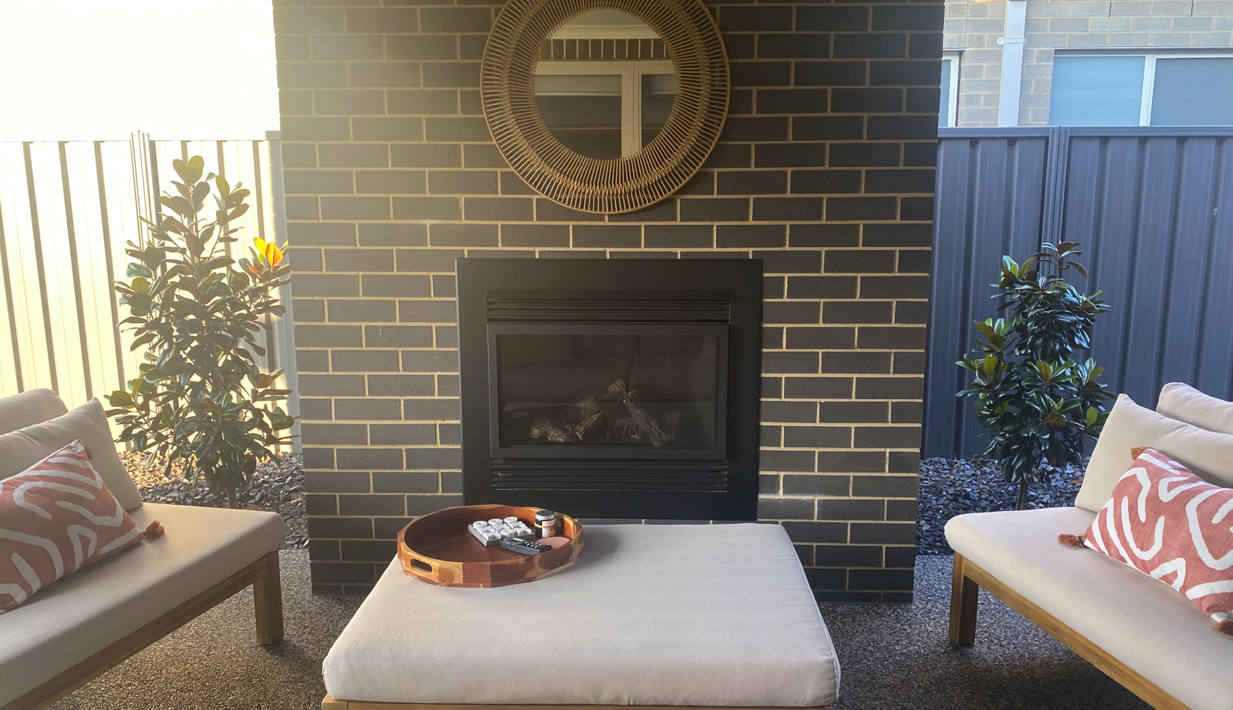
- Tell students this photo was taken in the afternoon.
- When planted, the trees had identical heights of 0.7 metres.
- At the time of the photo being taken, the left tree (Tree A) was 1.7 metres tall, and the right tree (Tree B) was 1.25 metres tall.
- Ask students 2 questions:
- How much taller is Tree A than Tree B?
- How many times taller is the tree on the left than the tree on the right?
- Using the example of the trees, introduce scale factor as how many times larger one object is than another. You could say Tree A is 1.3 times larger than Tree B or the scale factor from Tree B to Tree A is 1.3.
The purpose of this launch is to help students define scale factor. We want to understand scale factor so that we can express proportion in conversation. For example, ‘one tree is 45 cm taller than the other’ might not be as impactful as ‘Tree A is 1 $\frac{1}{3}$ times taller’ or ‘Tree B is about $\frac{5}{7}$ the height of Tree A’.
This is especially useful when we get to very small and large measurements.

Explore
This activity is intended to illustrate scale factor on a linear model, which should assist students that are thinking additively.

What is scale factor?
- Set up this Desmos activity (bit.ly/desmosclassroomstrategy) and share the student code with the class: Scale factor mini golf.
The task is called Dilation mini golf. It’s important to define dilate, as prompts will often use dilate to describe the scale factor being applied. For this task you can define dilate as ‘multiply by’.
Note: on slide 6, a length of 10 ft is used. This could cause confusion for students if not addressed.
- Model the first slide to the class. Have students press Try it and perform a Think-Pair-Share to discuss what Scale Factor: 4 means.
- Have students complete the following sentence scaffold with a partner:
The total distance is made up of __ segments. So, the total distance is ___ segments long.
- Have students complete the activity.
You can limit students to certain slides in Desmos using the Pacing feature in the teacher dashboard. You might like to only use one or 2 slides for the whole class instead of the entire activity.

Summarise

Faded examples worksheets
- Print and distribute Appendix A.
- Explain the first example to students and model how to interact with faded examples (bit.ly/fadedexamplesstrategy).
- When students are finished, have them write notes to their future selves on ‘how to find missing lengths when you know the scale factor’.

Apply
- Print and distribute Appendix B.
- Explain the first example to students and model how to interact with faded examples (bit.ly/fadedexamplesstrategy).
- When students are finished have them write notes to their future selves on: ‘how to find the scale factor’ (bit.ly/notesstrategy).

Assessment and Differentiation

Suggested opportunities for differentiation
Warm up
- If students have had limited exposure to ratios, they might benefit from expressing each of the ratios given using a colour mixing game (https://trycolors.com/games/guess-mix.)
- Challenge students to write as many of their own ratios as they can that are also equivalent to 2:3.
Launch
- Have students create 2 towers using centicubes and compare these using the same additive and multiplicative strategies.
Apply
- Have students measure 2 similar objects in the classroom, eg, pencils, and determine the scale factor from one to the other. This will likely produce a decimal scale factor.
- When students have finished Appendices A and B. have them find the scale factor of the original figure that was on the right. Students should identify this is the reciprocal scale factor, rather than repeating the process.

Suggested opportunities for assessment
- Assess students’ additive and multiplicative thinking in Launch discussions.
- Review students’ notes to future self.
- With a teacher account you can view students’ progress in Desmos in real time or after the activity. You could start the next lesson by reviewing a slide students struggled with.

Appendix A

Scale factor faded examples – triangles
Determine the missing lengths in the following sets of similar figures by using the scale factors provided. In each set, the original figure is on the left.
Note: the diagrams below are not drawn to scale.
- Scale factor = 2
$$△ABC \sim △DEF$$
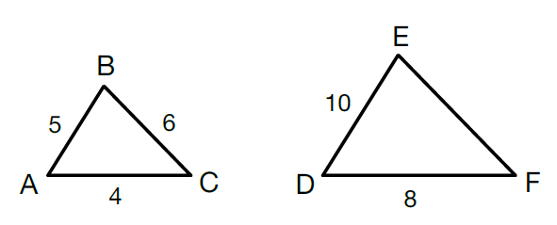
$$EF corresponds to BC$$
$$and BC=6$$
$$so EF=2×6$$
$$EF=12$$

- Scale factor = 4
$$△ABC \sim △DEF$$
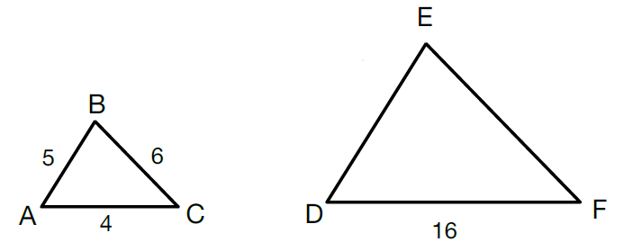
$$DE corresponds to AB$$  $$and AB=5$$  $$so DE=4 ×5$$  $$DE=20$$ | $$EF corresponds to BC$$

- Scale factor = 9
$$△ABC \sim △DEF$$
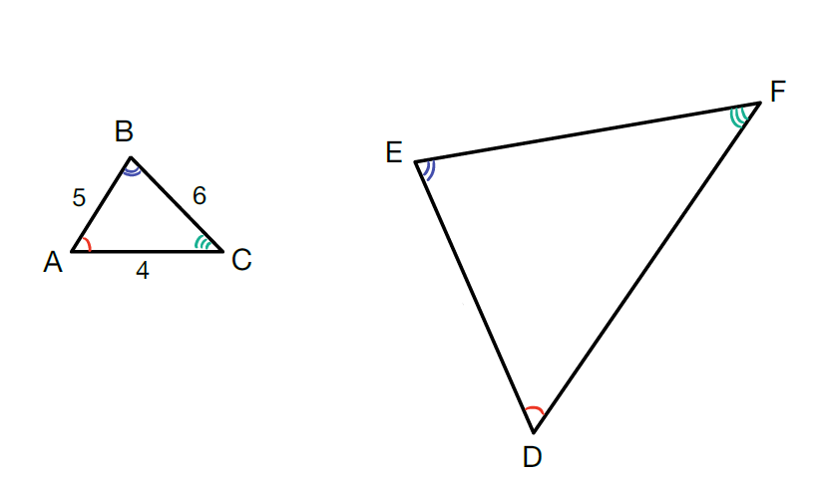
$$DE corresponds to AB$$

- Scale factor = $\frac{1}{10}$
$$△ABC \sim △DEF$$
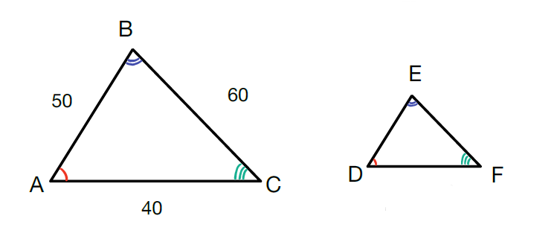

- Scale factor = 6
Why do we not write similarity statements for circles?
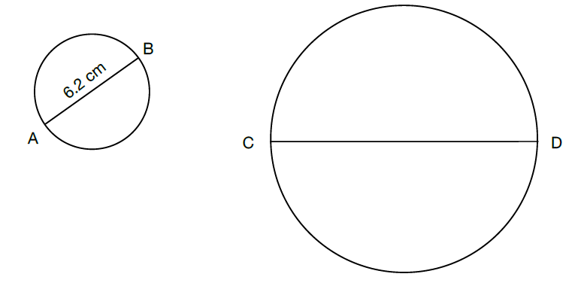

- Scale factor = 1.5
$$TUVQRS\sim ABCDEF$$
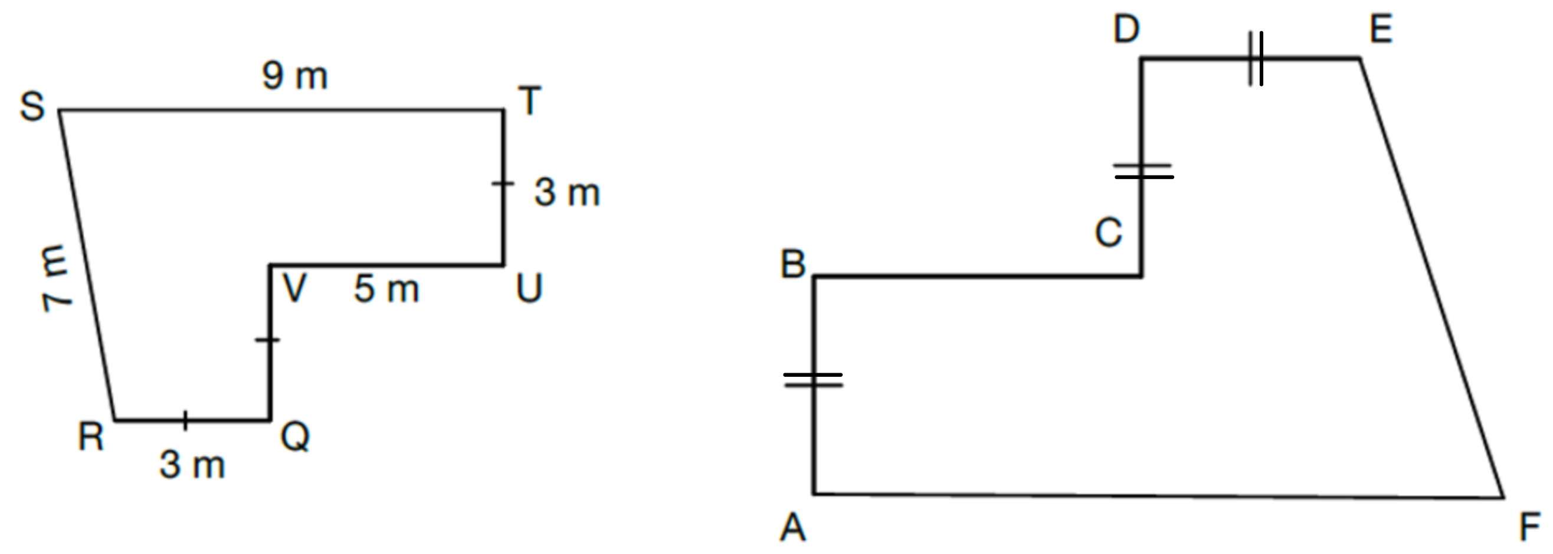

- Scale factor = $\frac{1}{1000}$
$$△DEF \sim △ABC$$
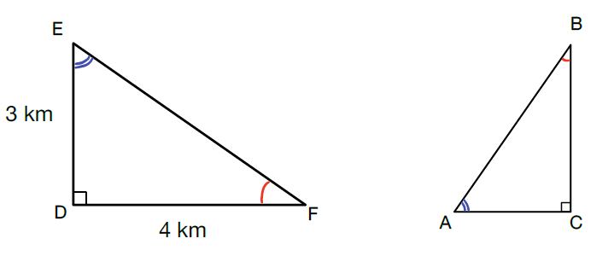

Appendix B

Find scale factor faded examples
Determine the scale factor and find any missing lengths in the following sets of similar figures.
Note: the diagrams below are not drawn to scale
- $∆ABC\sim ∆DEF$
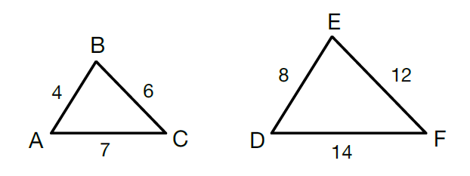
Method 1  $$DE corresponds to AB$$  $$so Scale factor=\frac{DE}{AB}$$  $$Scale factor=\frac{8}{4}$$  $$Scale factor=2$$ | Method 2  $$DE corresponds to AB$$  So, we can write the equation$:$$$4x=8$$  Where $x$ is the scale factor  Solving the equation gives:  $$x=\frac{8}{4}$$  $$x=2$$  Scale factor $=2$

- $∆ABC\sim ∆DEF$
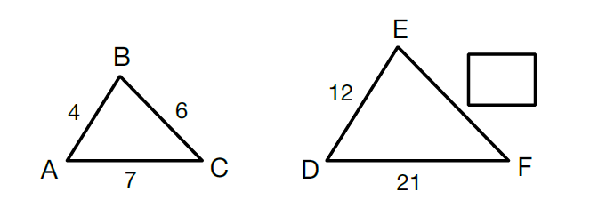
- $ABCD\sim EHGF$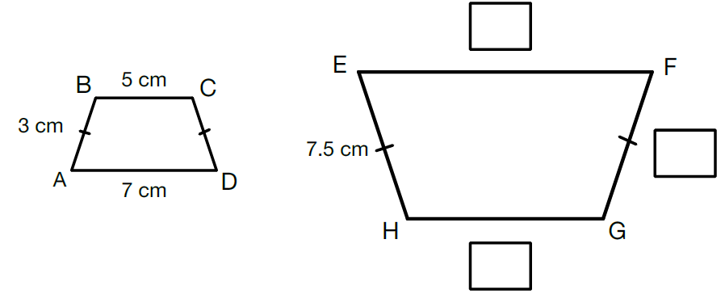

- ABCD~QTSR
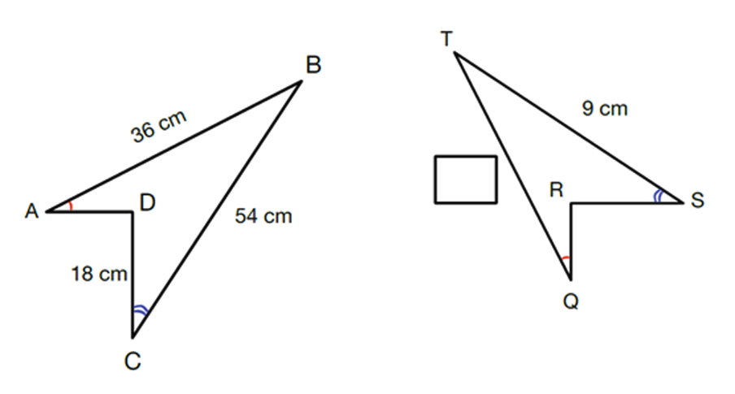

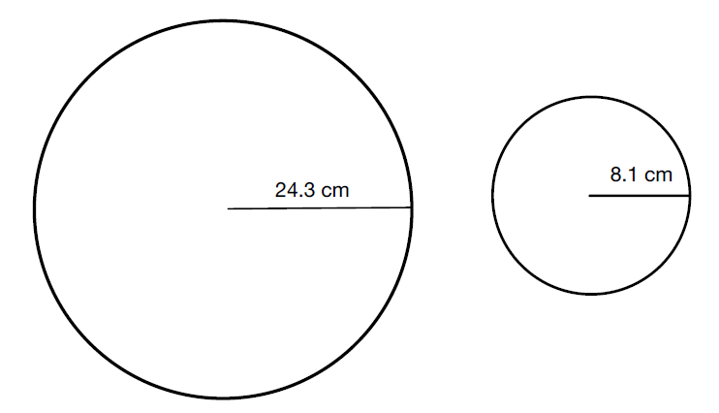

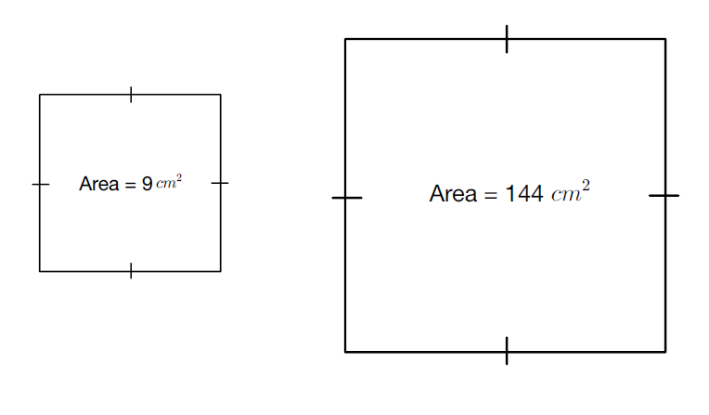

Sample solutions

Launch
How much taller is the tree on the left than the tree on the right? 0.45 metres
How many times taller is the tree on the left than the tree on the right? This is the opportunity to introduce the idea of scale factor. $\frac{1.7}{1.25}=1.36$ so the left tree is 1.36 times taller, or approximately $1\frac{1}{3}$ times taller.

Appendix A
- Full example is given
- $EF corresponds to BC$$$EF=4×6 \\ EF=24$$
- $DE corresponds to AB$$$DE=9×5 \\ DE=45 \\ EF corresponds to BC \\ EF=9×6 \\ EF=54 \\ DF corresponds to AC \\ DF=9×4 \\ DF=36$$
- $DE corresponds to AB$$$DE=\frac{1}{10}×50 \\ DE=5 \\ EF corresponds to BC \\ EF=\frac{1}{10}×60 \\ EF=6 \\ DF corresponds to AC \\ DF=\frac{1}{10}×40 \\ DF=4$$
- $AB corresponds to CD$$$AB=6×6.2 \\ AB=36.6 cm$$
- $AB,CD,DE correspond to TU,VQ,RQ$$$AB,CD,DE=1.5×3 \\ AB,CD,DE=4.5 m \\ AF corresponds to ST \\ AF=1.5×9 \\ AF=13.5 m \\ VU corresponds to BC \\ VU=1.5×5 \\ VU=7.5 m \\ EF corresponds to RS \\ EF=1.5×7 \\ EF=10.5 m$$
- $AC corresponds to ED$$$AC=\frac{1}{1000}×3 km \\ AC=3 m \\ CB corresponds to DF \\ CB=\frac{1}{1000}×4 km \\ CB=4 m \\ Pythagorean Theorem ∴AB=5 m$$

Appendix B
- Full example is given.
- $DE corresponds to AB$$$Scale factor=\frac{12}{4} \\ Scale factor=3 \\ EF\sim BC \\ EF=3×6 \\ EF=18$$
- $FG=EH$$$FG=7.5 cm \\ Scale factor=\frac{7.5}{3} \\ Scale factor=2.5 \\ EF corresponds to AD \\ EF=2.5×7.5 \\ EF=18.75 cm \\ HG corresponds to BC \\ HG=2.5×5 \\ HG-12.5 cm$$
- $ST corresponds to CB$$$ST=\frac{9}{54} \\ Scale factor=\frac{1}{6} \\ QT=\frac{1}{6}×36 \\ QT=6 cm$$
- $Students need to introduce their own labels to name sides$$$Scale factor=\frac{8.1}{24.3} \\ Scale factor=\frac{1}{3} \\ Students could be extended to find the circumference and diameter$$
- $Look for\frac{144}{9} as a common misconcpetion$$$Side length of smaller square=3 \\ Side length of larger square=12 \\ Scale factor=\frac{12}{3} \\ Scale factor=4$$

© State of New South Wales (Department of Education), 2023
The copyright material published in this resource is subject to the Copyright Act 1968 (Cth) and is owned by the NSW Department of Education or, where indicated, by a party other than the NSW Department of Education (third-party material).
Copyright material available in this resource and owned by the NSW Department of Education is licensed under a Creative Commons Attribution 4.0 International (CC BY 4.0) licence.
This licence allows you to share and adapt the material for any purpose, even commercially.
Attribution should be given to © State of New South Wales (Department of Education), 2023.
Material in this resource not available under a Creative Commons licence:
- the NSW Department of Education logo, other logos and trademark-protected material
- material owned by a third party that has been reproduced with permission. You will need to obtain permission from the third party to reuse its material.
Links to third-party material and websites
Please note that the provided (reading/viewing material/list/links/texts) are a suggestion only and implies no endorsement, by the New South Wales Department of Education, of any author, publisher, or book title. School principals and teachers are best placed to assess the suitability of resources that would complement the curriculum and reflect the needs and interests of their students.
If you use the links provided in this document to access a third-party's website, you acknowledge that the terms of use, including licence terms set out on the third-party's website apply to the use which may be made of the materials on that third-party website or where permitted by the Copyright Act 1968 (Cth). The department accepts no responsibility for content on third-party websites.

