Mapping the classroom
In this activity, students use a Cartesian plane over maps of their classroom and school and construct right-angled triangles to find distances and midpoints in the real world.
This activity is designed to support students who have experience with Pythagoras' theorem as a first introduction to distances and midpoints in the Cartesian plane.

Visible learning

Learning intentions
- To be able to use Pythagoras' theorem to find the distance between 2 points in a Cartesian plane.
- To know that a midpoint is equidistant from 2 endpoints.

Success criteria
- I can interpret a map of a known place.
- I can construct a right-angled triangle using horizontal and vertical lines and a desired diagonal line.
- I can apply Pythagoras' theorem to find an unknown distance in a Cartesian plane.
- I can locate a midpoint between 2 points on a Cartesian plane.

Syllabus outcomes
A student:
- develops understanding and fluency in mathematics through exploring and connecting mathematical concepts, choosing and applying mathematical techniques to solve problems, and communicating their thinking and reasoning coherently and clearly MAO-WM-01
- determines the midpoint, gradient and length of an interval and graphs linear relationships, with and without digital tools MA5-LIN-C-01
Mathematics K–10 Syllabus © NSW Education Standards Authority (NESA) for and on behalf of the Crown in right of the State of New South Wales, 2022.

Activity structure

Launch
- Give each student a copy of Appendix A.
- Students engage in a Think-Pair-Share (bit.ly/thinkpairsharestrategy) to discuss what methods they would use to measure the given lengths and distances.
- Challenge students to make an estimate, and to develop a method to test that estimate, completing the first 2 columns of the table in Appendix A.
The final measurement in this list is the most important. The purpose of this discussion is to identify measurements that are particularly difficult to find accurately. Teachers are encouraged to modify Appendix A to suit locations at their school and use it to support this launch task.
- Get students to use measuring tools to measure the distances and lengths described in step 1 and compare results with their estimates. Students can go to Google Maps (google.com/maps) to measure longer distances. Appendix B demonstrates how to obtain measurements between distances in Google Maps.
- Ask students to consider how Google Maps calculates these distances. Share that we will be investigating one approach.

Explore
Students will construct a map of the classroom, overlay a Cartesian plane, and use Pythagoras' theorem to find the distance between points and averages to find midpoints.

Constructing a map
As an alternative to the steps below, this activity can be simulated using the Desmos activity, Mapping the Classroom (bit.ly/desmosmappingtheclassroom).

Equipment
- Tape measures (one per student)
- Rulers (one per student)
- A4 paper or grid paper (one per student).

Method
Steps in this process could be demonstrated by the teacher using the following Desmos graph, Distances in the classroom (bit.ly/Desmosmapoftheclassroom). Students could also use the Desmos graph to construct their map of the classroom.
To operate the Desmos graph, follow the instructions on the left of screen, and turn on the folders by selecting the circle beside the name of the folder.
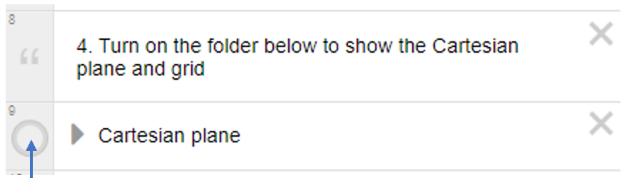

- Students are to measure and record the dimensions of the classroom.
- Decide upon an appropriate scale factor and draw a rectangle representing the classroom on an A4 sheet of paper or grid paper. For example:
Figure 1 – a rectangle representing the size of a classroom
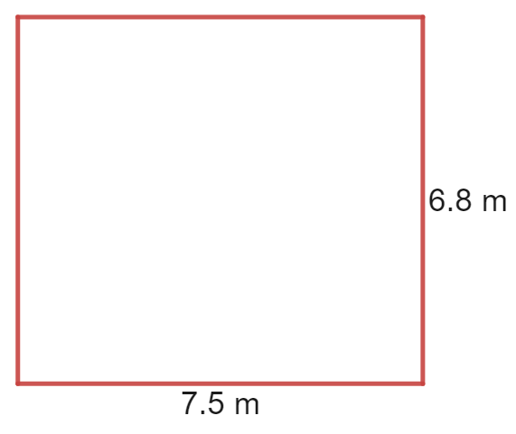
Using grid paper will require students to determine an appropriate number of squares to represent 1 metre.
- Students to measure and record the dimensions of a desk in the classroom.
- Students to determine the length and width required to draw desks in proportion with the sketch of the room.
The above tasks can easily be modified to be completed by individual students, in groups or as a class.

- Students are to use a ruler to draw desks to scale in the rectangle diagram representing their classroom.
Figure 2 – desks drawn to scale in a rectangle diagram
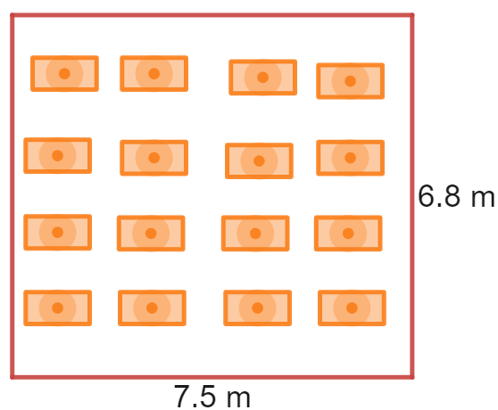
- Have students draw a grid over the top of their diagram. It is important here to make clear that units need to be evenly spaced out, and that a room measurement on the diagram should match this number of squares on the grid, for example, 6.8 m should be represented as 6.8 squares on the grid, as show below.
Figure 3 – desks drawn to scale with grid
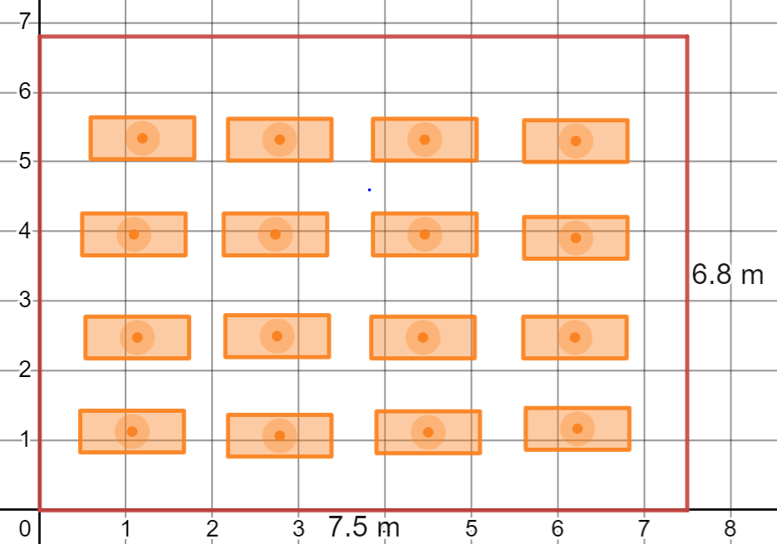
If using grid paper, students will draw a set of axes, as in step 6, marking out individual metres.

Finding distances
The steps below can be demonstrated by the teacher in the Desmos graph, Distances in the classroom – classroom already set (bit.ly/desmosdistancesintheclassroom2), where a classroom is already laid out.
- Have students mark a horizontal distance on the map and use the grid to determine its length. For example, the distance indicated in the image below goes from 1 to 5 and is a distance of $5-1=4$ metres.
Figure 4 – map with horizontal distance marked
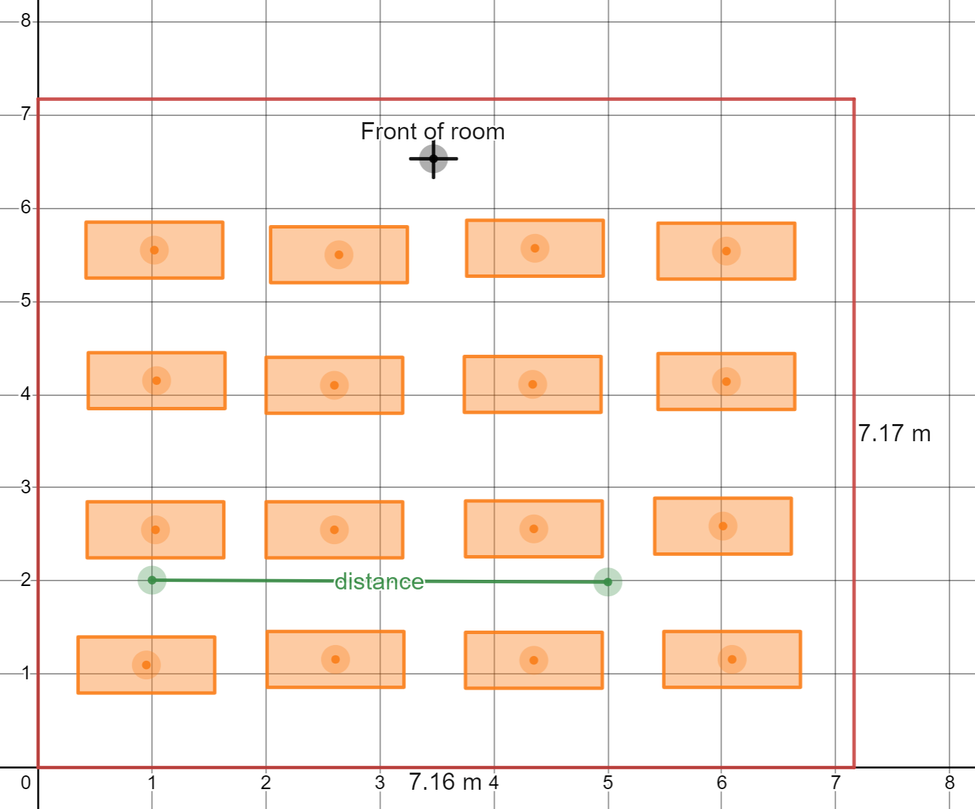
Image created using Desmos and is licensed under the Desmos Terms of Service.

- Repeat step 1 with a vertical distance.
Figure 5 – map with vertical distance marked
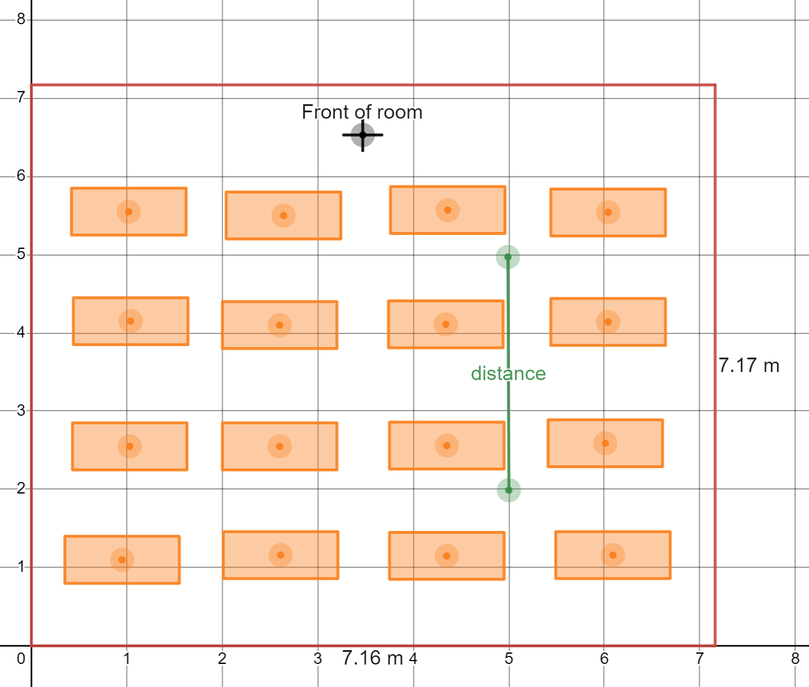
Image created using Desmos and is licensed under the Desmos Terms of Service.
- Have each individual student indicate any diagonal distance on their map. In groups, students are to discuss possible answers to the following questions.
- Where is the diagonal distance on each person's map located in the real room?
- How could we calculate this distance on the map?
Teachers could choose to reveal that the method of solution will include the horizontal and vertical distances from a right-angled triangle to aid the discussion in step 3.
Figure 6 – map with diagonal distance marked
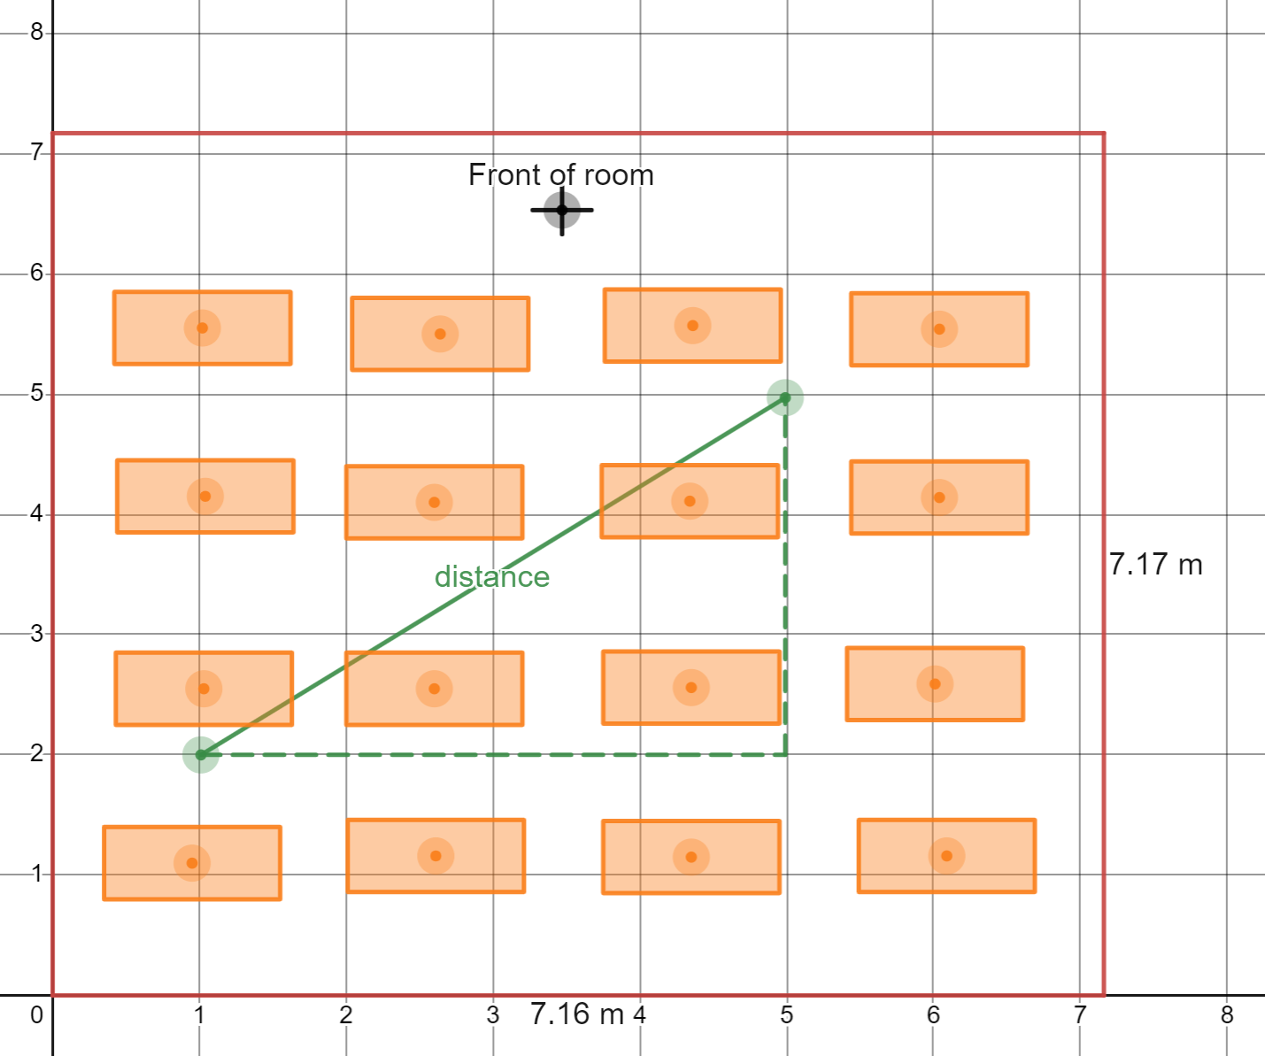
Image created using Desmos and is licensed under the Desmos Terms of Service.
- Display Appendix C on the screen. Instruct students to review this worked example, giving a thumbs up to the teacher when they have finished reading.
- Have students share in pairs what they believe the reasoning is behind each step of the worked solution. Summarise findings as a class.
- Instruct students to draw 2 further diagonal lines on their map, noting where their distances travel from and to in the real classroom. Students then use Pythagoras' theorem and the method displayed in Appendix C to calculate the 3 distances.
- Students should then use tape measures to compare their calculations with the real-life measurements.

Finding a midpoint
- Display the Desmos graph, Midpoints (bit.ly/desmosmidpoints) on the screen.
- Drag the endpoints of the interval in the Desmos graph to display a horizontal interval. Ask students to discuss in pairs how they know the green dot is the midpoint.
Figure 7 – midpoint of a horizontal line
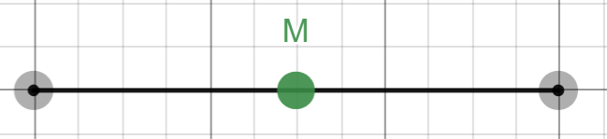
Image created using Desmos and is licensed under the Desmos Terms of Service.
- Repeat step 2 with a vertical interval.
- Show a diagonal interval and turn on the X midpoint folder.
Figure 8 – the X midpoint selection tool from Desmos
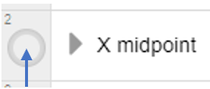
- Have students complete a Notice and Wonder (bit.ly/noticewonderstrategy) list about what they believe is happening with the location of a midpoint of a diagonal interval.
Figure 9 – midpoint of a diagonal line
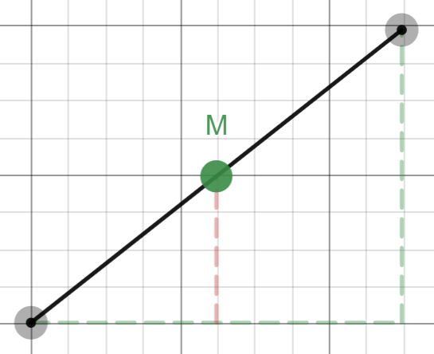
Image created using Desmos and is licensed under the Desmos Terms of Service.
- Have students locate the midpoint of their 3 diagonal intervals from their distance calculations.
- Students should test their results in groups, finding the midpoints from their map in the real classroom, and using a tape measure to find the distances to the endpoints of the interval to see if they are equal.

Summarise
- Students have created their own Google Map of the classroom, and this should allow them to calculate distances and midpoints from their classroom without even being there. Have students engage in a Think-Pair-Share (bit.ly/thinkpairsharestrategy), considering the following questions.
- Is my Google Map accurate?
- What features of the grid make it useful to calculate midpoints and distances?
When summarising, highlight the perpendicular lines in the grid that allows us to form useful right-angled triangles.
- Students should complete the exit ticket in Appendix D to demonstrate their ability to find distances and midpoints.

Apply
There are many ceremonies that are a part of Aboriginal culture. Before colonisation, there were general gatherings between neighbouring Mobs, where they would trade, discuss marriages and more.
Students are to find a suitable gathering place that is halfway between 2 neighbouring Mobs close to their school.
- Students upload a Map of Australia showing Aboriginal Country http://nationalunitygovernment.org/pdf/aboriginal-australia-map.pdf.
- Adjust the size of the image to suit the grid or develop and use a scale factor. This is demonstrated in Appendix E.
- Find the distance and midpoint between the lands of 2 neighbouring Mobs.

Alternative activity
- Students use a map of their school, suburb or another familiar local venue to find distances and midpoints between key locations on the map using the methods from this lesson.
A PDF of the map of your school and buildings within your school can be obtained by school staff through the application AMS on the Web via your Department of Education Portal. Go to this application, type in the name of your school and click on the tab PDF Sites and Building Plans. The whole school map may already display a grid reference that can be used for this activity.

Assessment and Differentiation

Suggested opportunities for differentiation
Launch
- Appendix A should be personalised to suit the knowledge and experiences of students in your class.
Explore
- To remove measuring skills as a barrier to participation, students can work in groups to construct the map of the classroom.
- Students could be challenged to find an endpoint if they are given one endpoint and the midpoint.
- Challenge students to select the most appropriate number of significant figures to round their calculations to, given that they will be comparing them with real world measurements.
Apply
- Students are challenged in this part of the lesson by a Cartesian plane that places the origin at the centre of the map, giving opportunity to calculations with negative values.
- Alternatively, teachers can give instructions on moving the centre to place the origin at the bottom left of the map to support learners who find operating with negative numbers particularly difficult.

Suggested opportunities for assessment
Explore
- Students could submit their maps to demonstrate their ability to construct and interpret a scale map.
Summarise
- Collect the exit ticket and review to determine to what extent students have understood how to calculate distance and midpoint of an interval.

Appendix A

Measuring lengths and distances
For each length or distance, make an estimate, and then record what measuring tool or device you would use to check your answer.
Length or distance | Estimate | How would you measure it? | Actual measurement
Length of a book
Height of a door
Length of a room
Length of your desk
Height of a student
Distance from a student sitting at the back of the room to a student at the front
Distance to the local shops
Distance from one block to another block in the school
Distance from Sydney to Canberra

Appendix B

Measuring distances in Google Maps
The instructions below outline how to obtain measurements using Google Maps.
- Go to Google maps (google.com/maps).
- Use the search function to find a location of interest, such as a street or suburb.
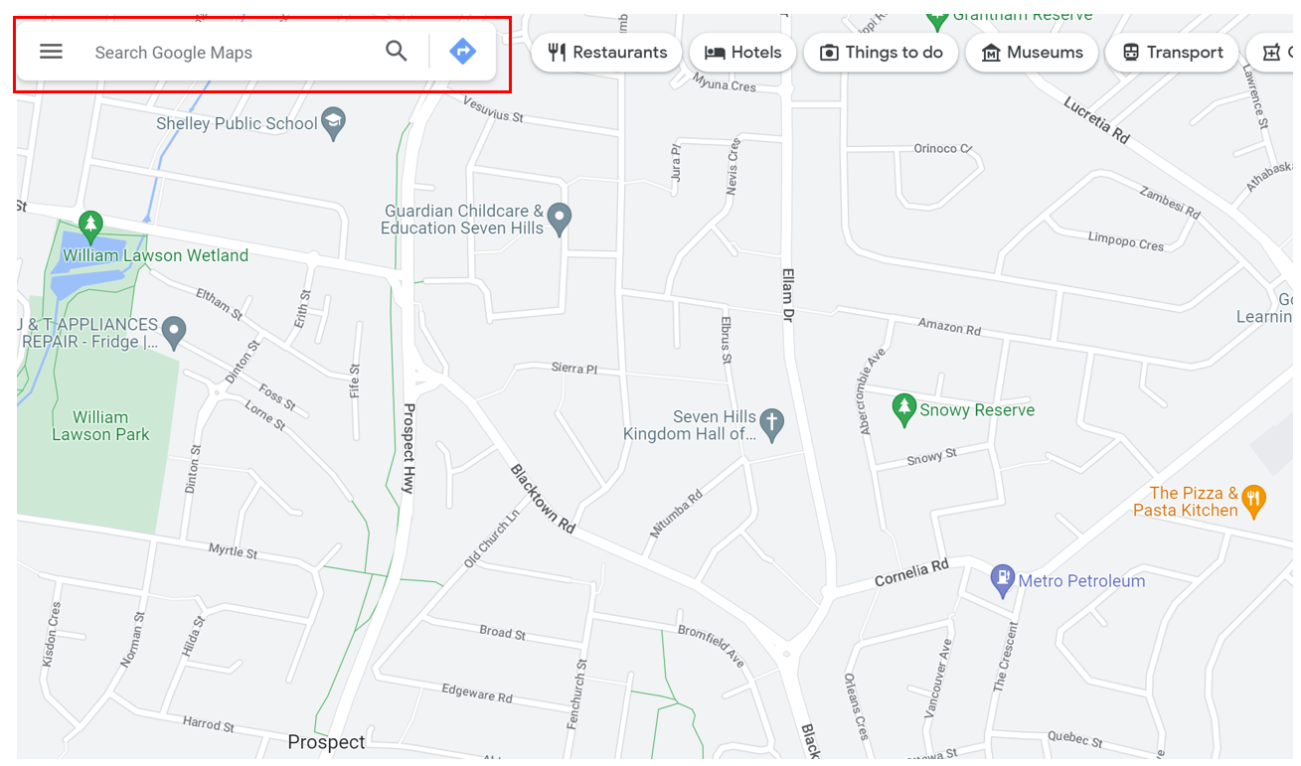
Map data © 2023 Google

- Right click where you would like to measure from on the map and select Measure distance.
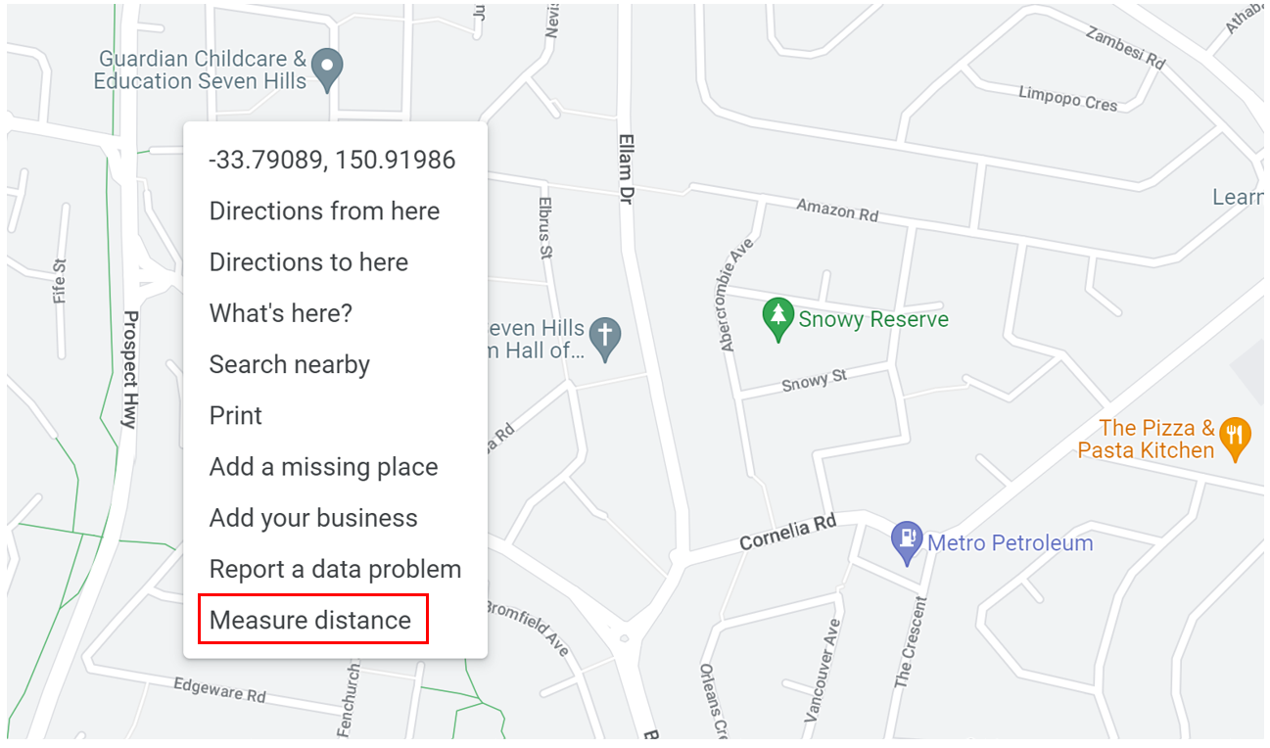
Map data © 2023 Google
- Click on the endpoint of your destination and a measurement will appear.
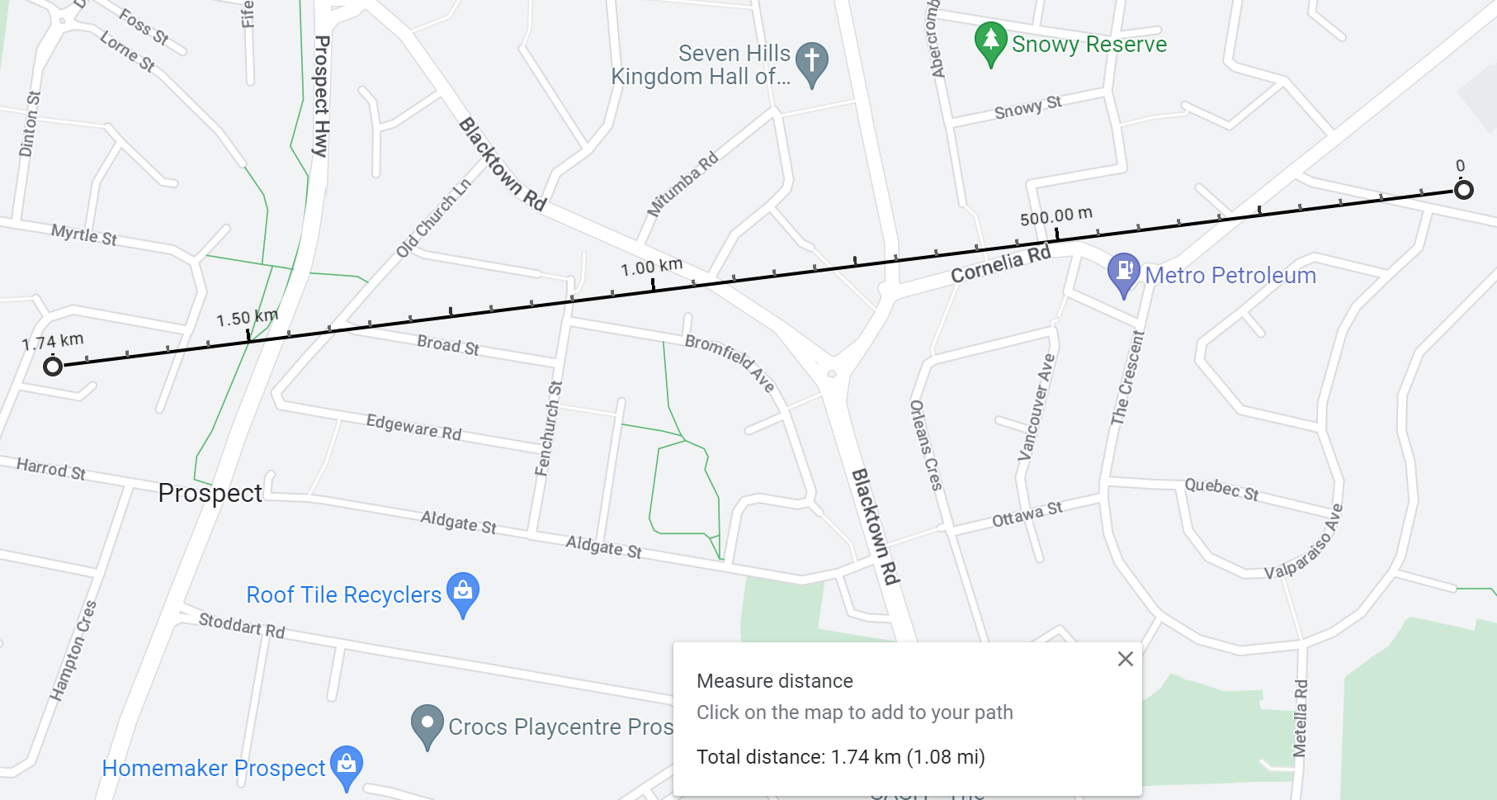
Map data © 2023 Google

Appendix C

Worked example
Image created using Desmos and is licensed under the Desmos Terms of Service.

Vertical distance
V = 5 - 2 = 3 metres

Horizontal distance
H = 5 - 1 = 4 metres

Diagonal distance
$$d^{2}=H^{2}+V^{2} \\ d^{2}=4^{2}+3^{2} \\ d^{2}=16+9 \\ d^{2}=25$$
$$d=\sqrt{25}$$$d=5$ metres

Appendix D

Exit ticket
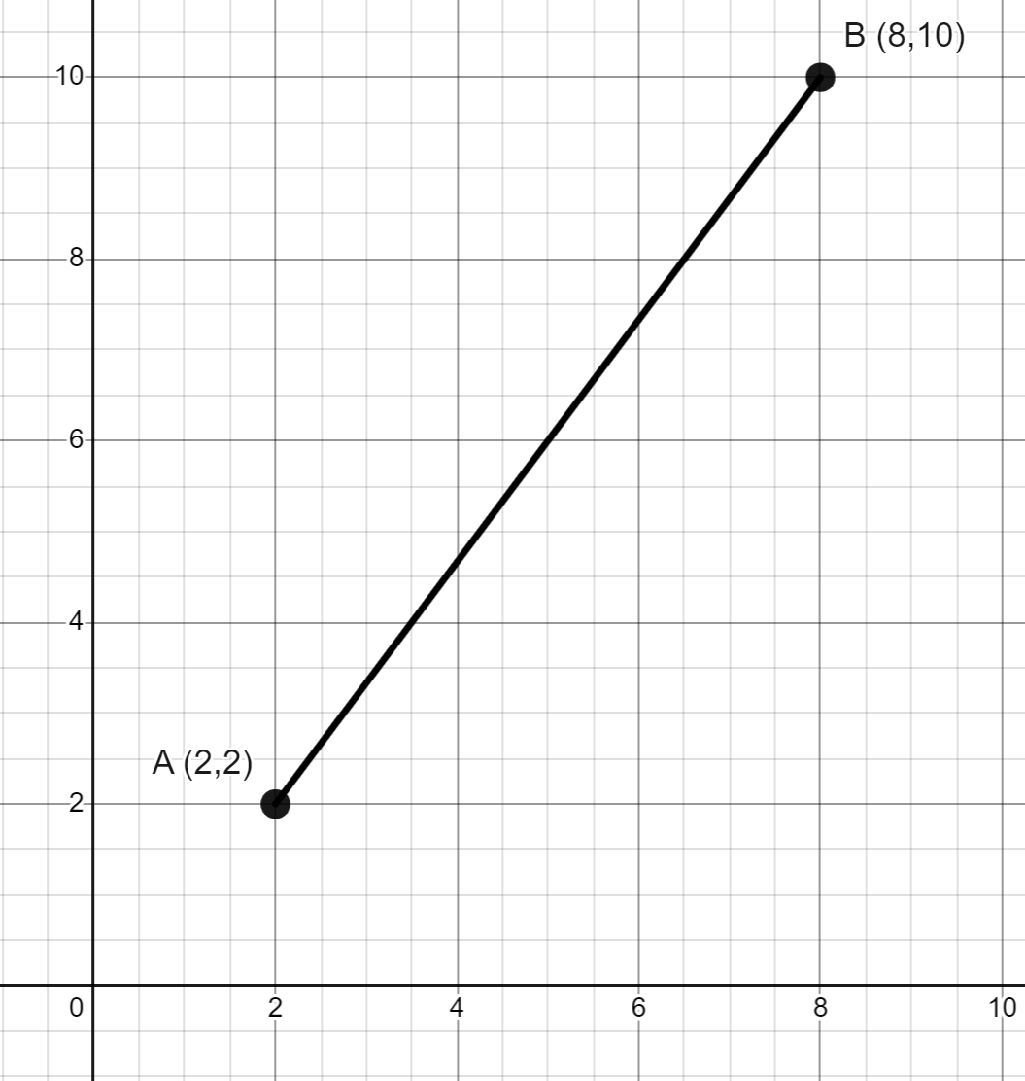
- Find the distance of the interval AB.
- Find the midpoint of the interval AB.

Appendix E

Laying a Cartesian plane over a map with Desmos
- Go to Desmos Calculator (desmos.com/calculator).
- Click on the '+' button at the top left of the Desmos graph. Select image and find the file of the map you wish to upload.
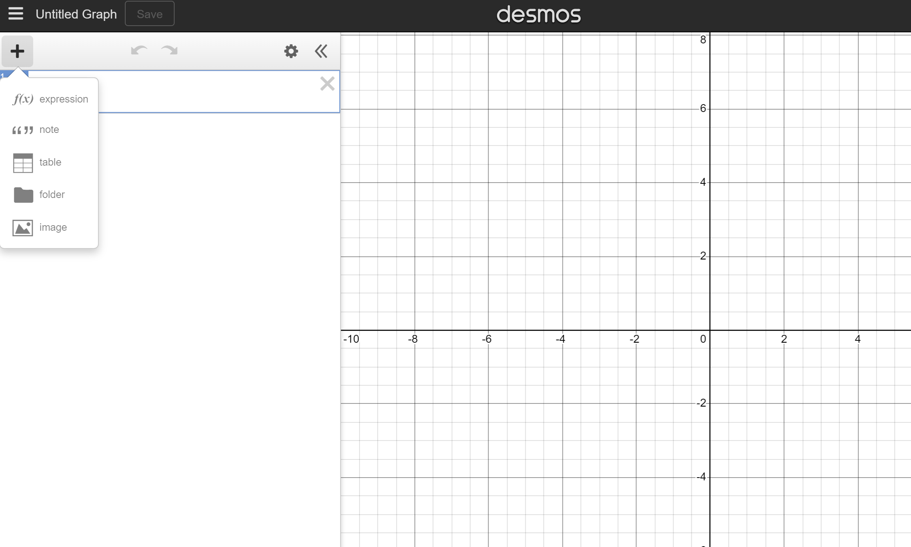
Image created using Desmos and is licensed under the Desmos Terms of Service.

- The map will now appear with the Cartesian plane over the top.
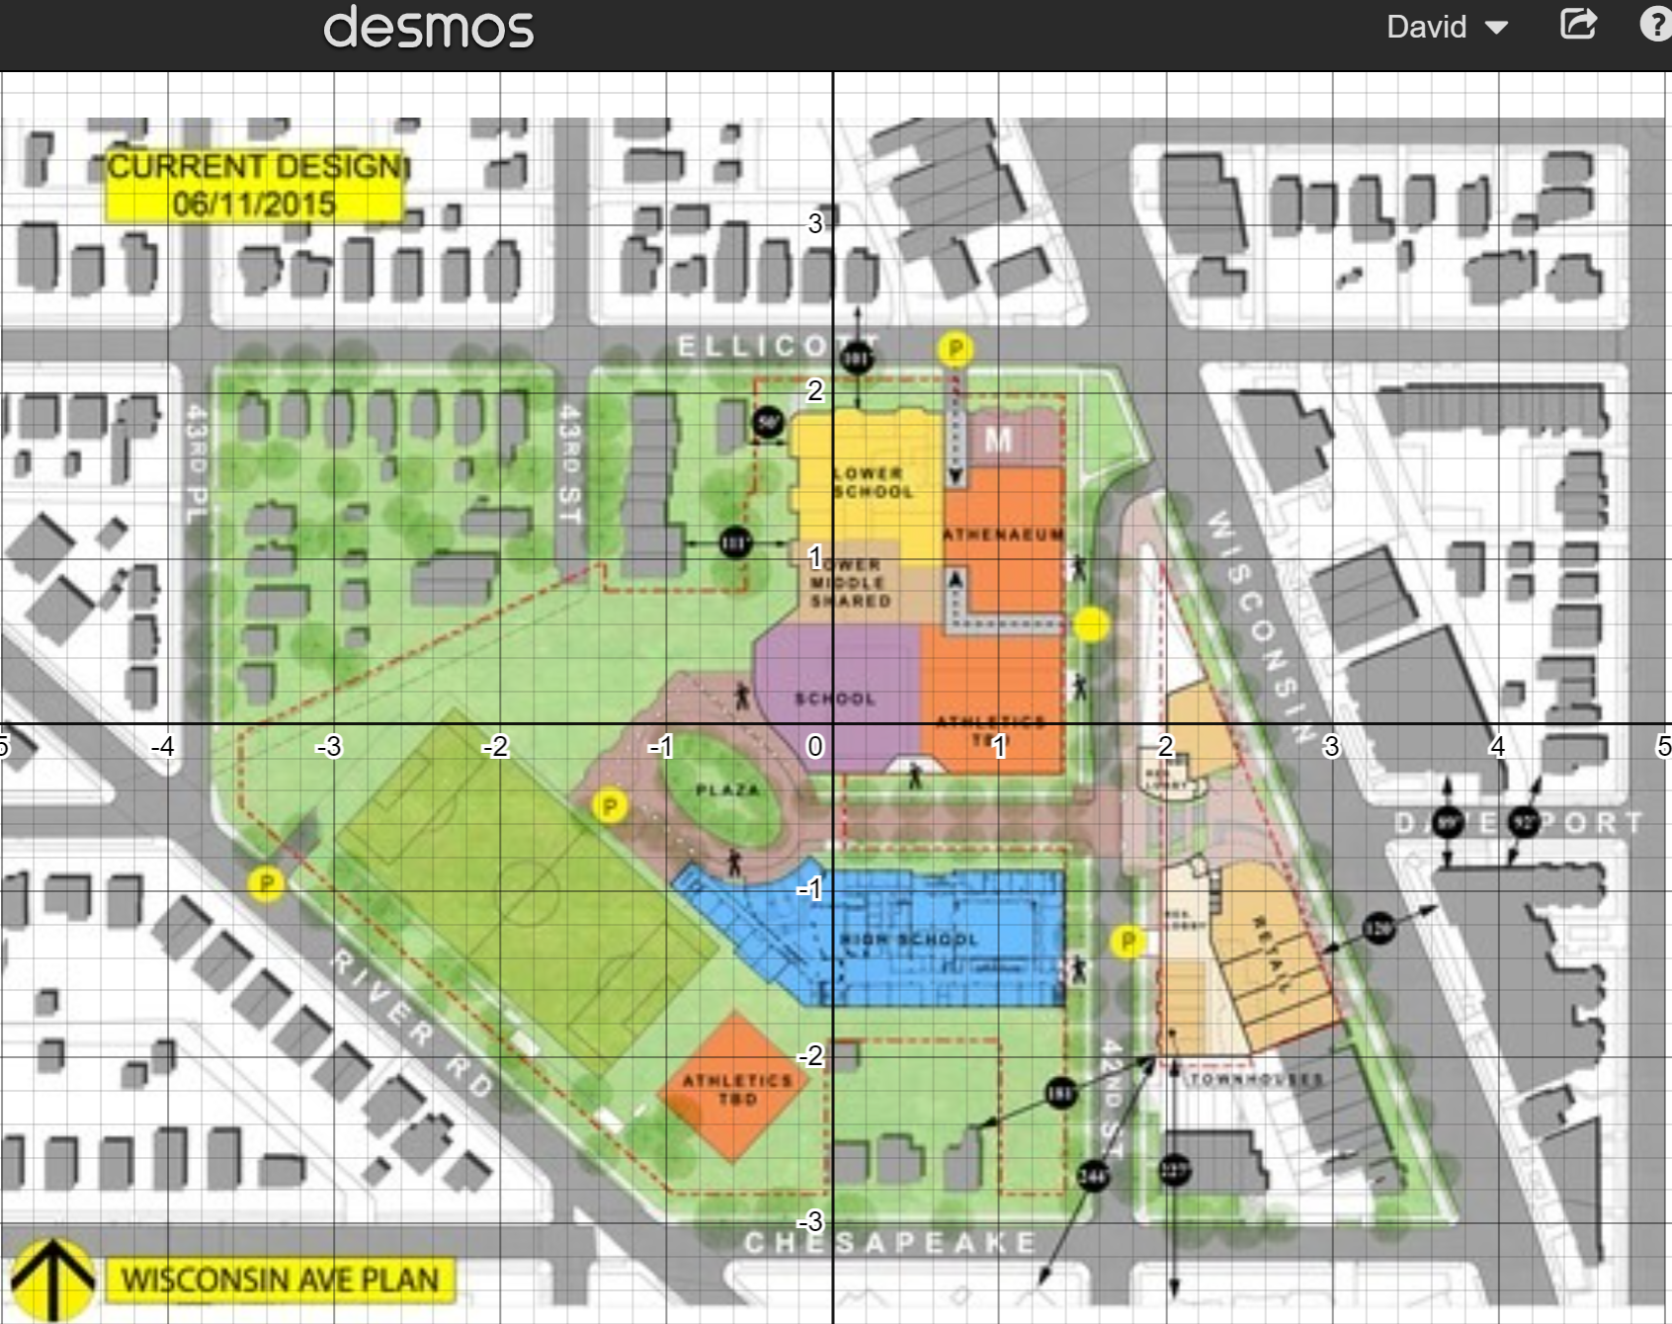
Image created using Desmos and is licensed under the Desmos Terms of Service.
Unfortunately, the dimensions are not in the ratio 1:1 as has been the case throughout the lesson.

- Find a distance that is either horizontal or vertical in the map. The example below is easily measured in the map, starting at approximately 0.4 and finishing at approximately 1.4, making it a distance of 1 unit.
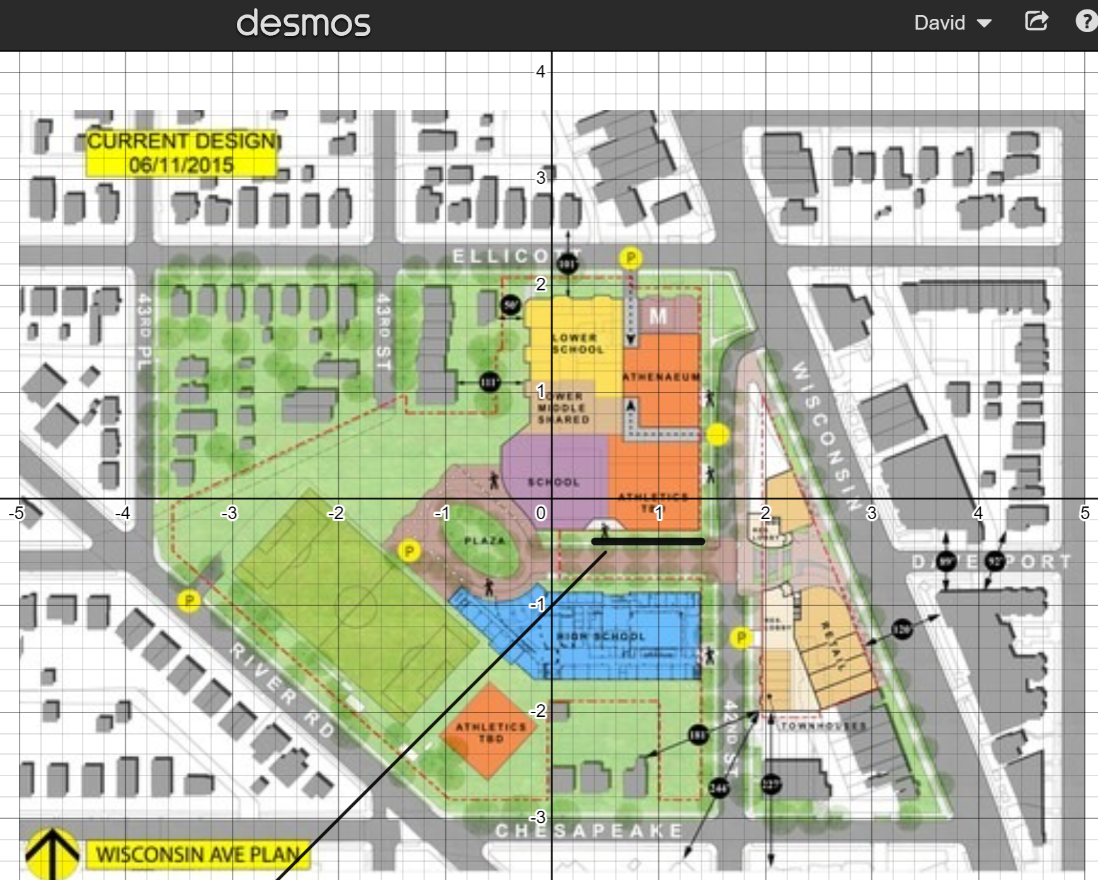
Image created using Desmos and is licensed under the Desmos Terms of Service.
- Measure this same distance in real life. For the sake of this example, let's assume it is 12 metres.
- Form a ratio and simplify. For example, 1:12, meaning 1 unit in the map is equal to 12 metres in real life.
- Alternatively, adjust the picture so that the 12 metres we measured is represented by 12 units in the diagram. To do this, go to the settings on the left of screen, and adjust both the width and the height to be 12 times as large as they currently are.
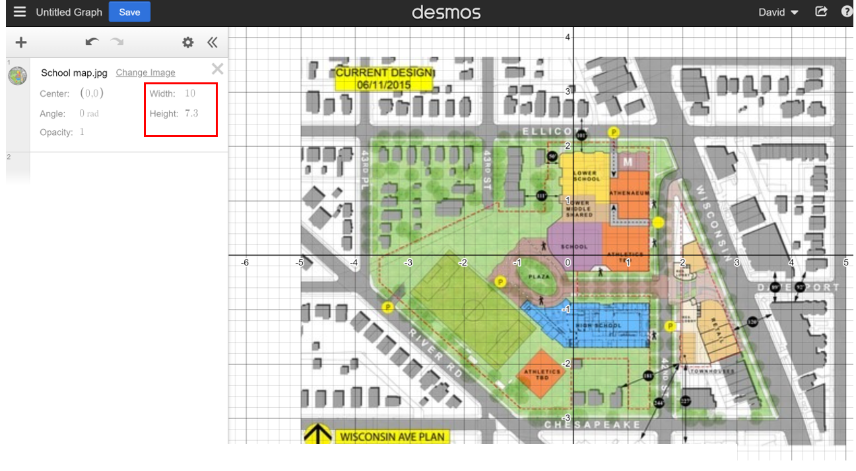
Image created using Desmos and is licensed under the Desmos Terms of Service.

© State of New South Wales (Department of Education), 2023
The copyright material published in this resource is subject to the Copyright Act 1968 (Cth) and is owned by the NSW Department of Education or, where indicated, by a party other than the NSW Department of Education (third-party material).
Copyright material available in this resource and owned by the NSW Department of Education is licensed under a Creative Commons Attribution 4.0 International (CC BY 4.0) licence.
This licence allows you to share and adapt the material for any purpose, even commercially.
Attribution should be given to © State of New South Wales (Department of Education), 2023.
Material in this resource not available under a Creative Commons licence:
- the NSW Department of Education logo, other logos and trademark-protected material
- material owned by a third party that has been reproduced with permission. You will need to obtain permission from the third party to reuse its material.
Links to third-party material and websites
Please note that the provided (reading/viewing material/list/links/texts) are a suggestion only and implies no endorsement, by the New South Wales Department of Education, of any author, publisher, or book title. School principals and teachers are best placed to assess the suitability of resources that would complement the curriculum and reflect the needs and interests of their students.
If you use the links provided in this document to access a third-party's website, you acknowledge that the terms of use, including licence terms set out on the third-party's website apply to the use which may be made of the materials on that third-party website or where permitted by the Copyright Act 1968 (Cth). The department accepts no responsibility for content on third-party websites.

