Gradients in the Cartesian plane
In this activity, students engage with Desmos graphs to develop definitions for gradients between 2 points on the Cartesian plane, applying practical methods and generalising to develop a formula.
This activity is designed to support students who have some experience working with coordinates on the Cartesian plane and simple horizontal and vertical distances.
This lesson incorporates Path content.

Visible learning

Learning intentions
- To be able to find gradients between 2 points on the Cartesian plane.

Success criteria
- I can describe gradients of intervals as positive or negative.
- I can explain what a gradient of 0 will look like.
- I can find a rise and run in the Cartesian plane and use this to find the gradient of an interval.
- I can apply a formula to find gradients.

Syllabus outcomes
A student:
- develops understanding and fluency in mathematics through exploring and connecting mathematical concepts, choosing and applying mathematical techniques to solve problems, and communicating their thinking and reasoning coherently and clearly MAO-WM-01
- determines the midpoint, gradient and length of an interval and graphs linear relationships, with and without digital tools MA5-LIN-C-01
- describes and applies transformations, the midpoint, gradient/slope and distance formulas and equations of lines to solve problems MA5-LIN-P-01

Activity structure

Warm up
- If devices per students are available, have students complete the Desmos activity Gradients in the Cartesian plane (bit.ly/DesmosGradientsMarbleslides).
- Give all students a copy of Appendix A and instruct them to order the displayed gradients in from largest gradient to smallest, or most positive to most negative.
Students can use the Desmos graph Gradients Launch (bit.ly/Desmoslaunchgradients) to make images resembling each gradient assist their ordering decisions.

Launch
- Display Figure 1.
Figure 1 – Cartesian plane
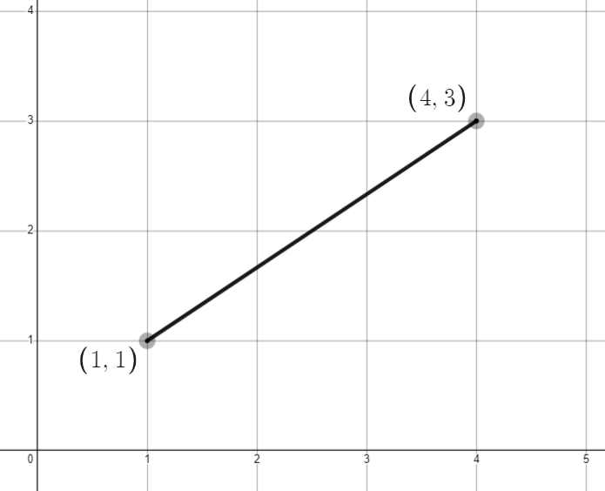
- Remind students that to find the gradient, we find $\frac{rise}{run}$. Ask students to individually write down what they believe to be the gradient of the interval.
- Have students engage in a Think-Pair-Share (bit.ly/thinkpairsharestrategy) focused on this question, emphasising the need to communicate reasons for their answer when sharing and the process they took to find their answer.
- Monitor student responses to determine if the concept requires review.
- Display Figure 2.
Figure 2 – Cartesian plane with a diagonal interval
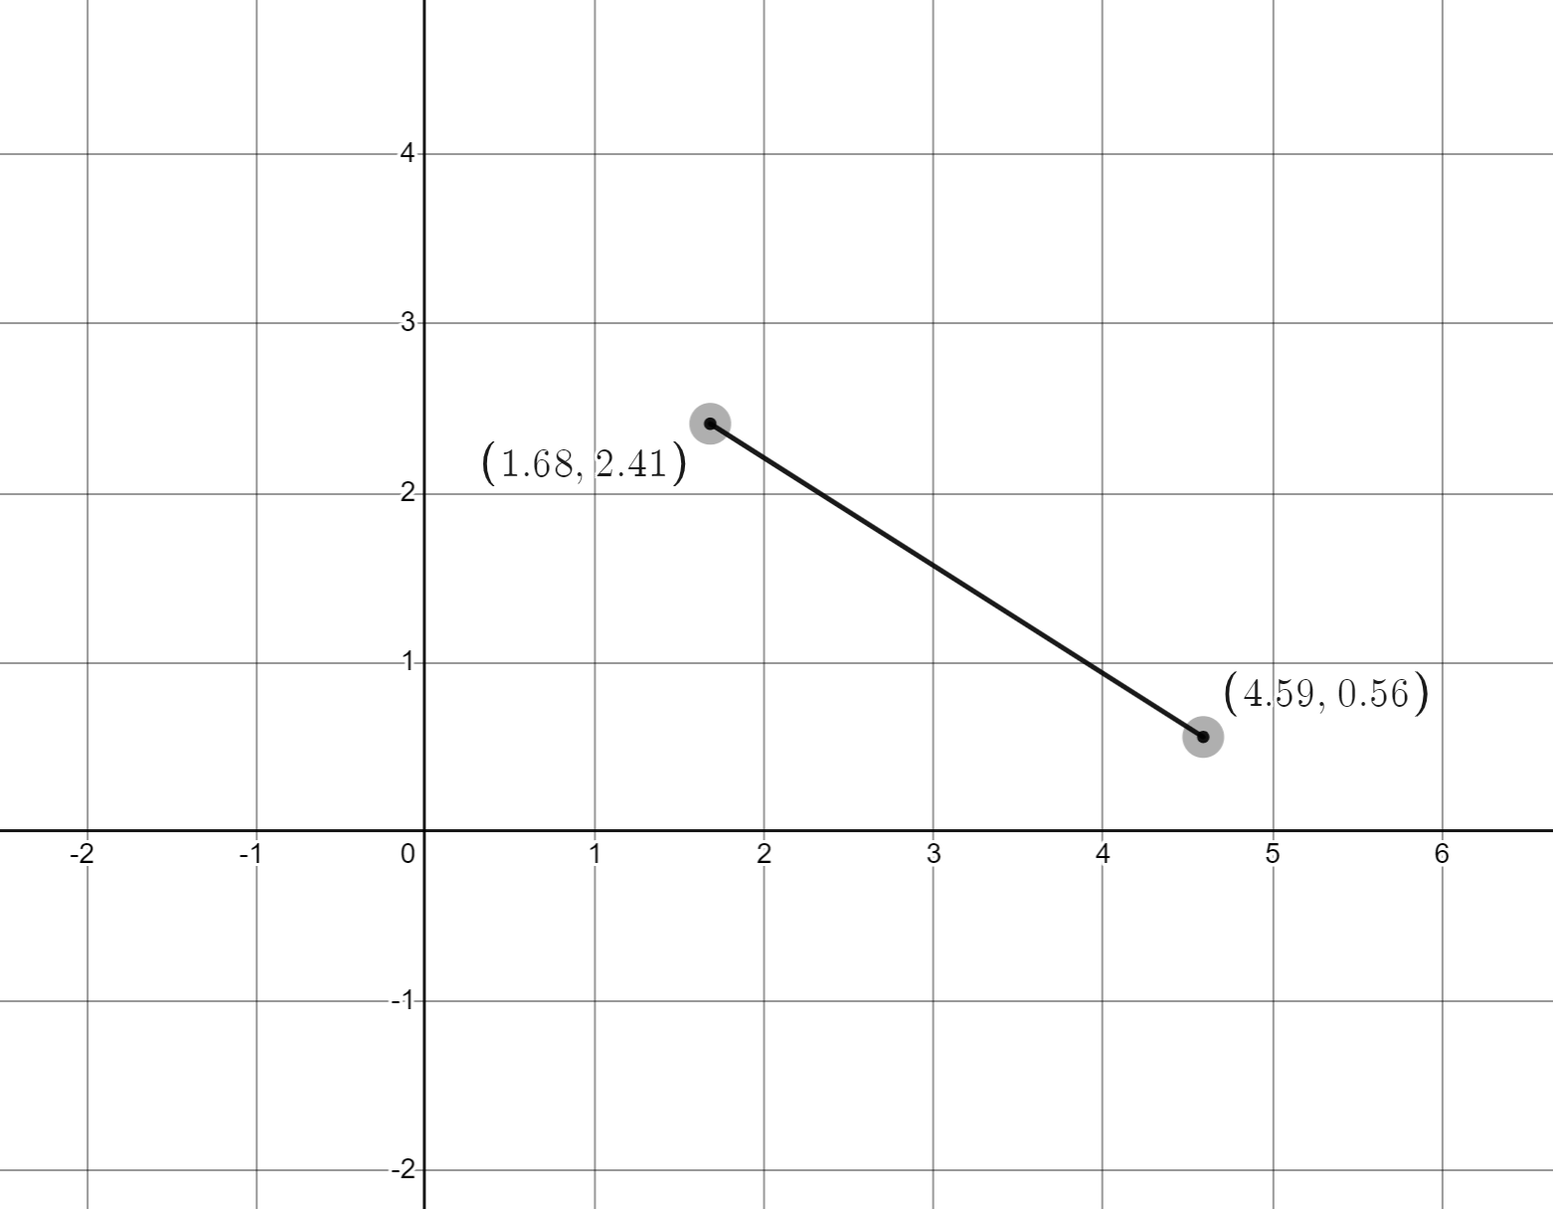
- Ask students to individually consider gradient between the 2 points. Have students engage in a Think-Pair-Share (bit.ly/thinkpairsharestrategy) about this problem, encouraging them to focus on their reasons for estimates.
- Select non-volunteers using the pause, pounce, bounce strategy, (bit.ly/pausepouncebounce) for students to share their estimates and reasoning.
- The teacher can display this Desmos graph, Gradients Launch (bit.ly/Desmoslaunchgradients), which contains this interval. Turning on the ‘Calculation’ folder in Desmos, by clicking the dot next to Calculation on the far left will reveal the approximate solutions.
Figure 3 – ‘Calculation’ folder from Desmos
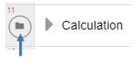
- Conclude that to accurately find gradients for any situation, we need to establish a clear approach that can be used in any situation.

Explore
The instructions below describe technology used on the teacher's screen. Appendix B has been provided if there is no access to technology. If a device with internet access is available per student or between pairs, consider providing students access to each of the graphs to aid their investigation. The advantage here would be allowing them to adjust and investigate what is going on in each case.
- Display the Desmos graph, Gradients (bit.ly/Desmosgrad), and move the endpoints to an appropriate interval for your students, for instance positive integer values in the coordinates.
- Turn on the ‘Gradient triangle’ folder on the left of screen, and have students engage in a Think-Pair-Share (bit.ly/thinkpairsharestrategy) about the calculations and distances on the screen. Ask:
- What are the calculations on the screen doing?
- Where do the numbers in the calculations come from?
- How do you use these calculations to find the gradient of an interval, m?
- Turn on the ‘Gradient calculations’ folder and give students time to read individually. Instruct students to give a thumbs up when they are ready to have a discussion with a peer.
- Have students engage in a Think-Pair-Share (bit.ly/thinkpairsharestrategy) to discuss what is happening at each step. Ask each pair of students to write down any parts of the working that they would like to clarify.
- Review the solution with students, selecting non-volunteers using the pause, pounce, bounce strategy, (bit.ly/pausepouncebounce) to explain what they know and what they'd like to ask about the solution.
- Leave the worked solution on the board.
- Give students the link to the Desmos graph and have them adjust the endpoints to create different intervals.
- Students are to record the endpoints and calculate the gradient, showing all working. Instruct students that they can turn on the ‘Gradient triangle’ folder if required and turn on the ‘Gradient calculations’ folder to check their solutions.

Summarise

Generalising
- Open the Desmos graph, Gradient generalising (bit.ly/Desmosgradgen), and raise with students that we want to develop rules to follow to find the gradient of an interval between any 2 points.
- Challenge students in groups to find an expression for the gradient between the 2 general points, justifying their solution.
- Review the solution with students, asking volunteers and non-volunteers to explain what they know and what they'd like to ask about the solution.

Developing a formula
This part of the lesson is based around content from a Path focus area. It is unnecessary for students to complete both the ‘Generalising’ and the ‘Developing a formula’ sections.
- Open the Desmos graph (bit.ly/Desmosgradformula) and raise with students that we want to develop rules to follow to find the gradient of the interval between any 2 points.
- Challenge students in groups to find an expression for the gradient of the interval between the 2 general points, justifying their solution.
- Review the solution with students, asking volunteers and non-volunteers to explain what they know and what they'd like to ask about the solution.

Apply
- Give students access to the Desmos graph (bit.ly/DesmosgradFWE).
- Have students move the endpoints to create a new problem, finding the gradient of the interval between 2 points. Students should copy and complete a problem on level 1.
- Students then move the endpoints, move the switch to level 2, and copy and complete.
- Continue this process until you have completed a problem on every level, including level 5 where the working is empty.

Assessment and Differentiation

Suggested opportunities for differentiation
- The Desmos graphs throughout the activity allow an exploration for students that does not depend on their skills plotting points.
- Consideration should be taken when choosing intervals for your students, for instance, weaker students may require positive whole numbers only and to challenge students you may consider using decimals.
Launch
- The Desmos activity allows an exploration for students where mistakes can easily be examined and corrected with no consequence.
- Students may benefit from writing their strategy down on a VNPS (bit.ly/VNPSstrategy) and conducting a gallery walk (bit.ly/DLSgallerywalk) with the class before selecting students to share their answers.
Explore
- Prior to turning on the ‘Distance calculations’ folder, challenge students to share their own calculations with the class.
Summarise
- Both generalising how to find the distance between 2 points and developing the formula for the distance have been included in this activity, depending on your students select one and/or the other.

Suggested opportunities for assessment
Launch
- The Desmos activity allows the teacher to record, review, and give feedback on student responses. There are multiple opportunities for students to express their thinking.
Apply
- Review the answers found by students in the faded worked examples to assess their skills and understanding of finding the distance.

Appendix A

Ordering gradients
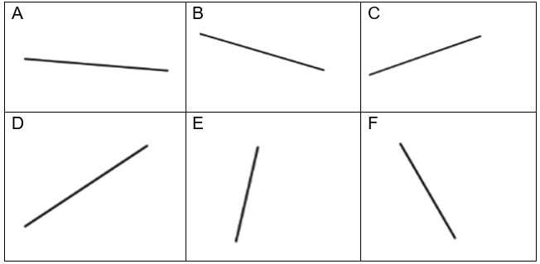

Sample solutions

Appendix A – ordering gradients
E, D, C, A, B, F

Appendix B

Gradients
- Consider the interval below.
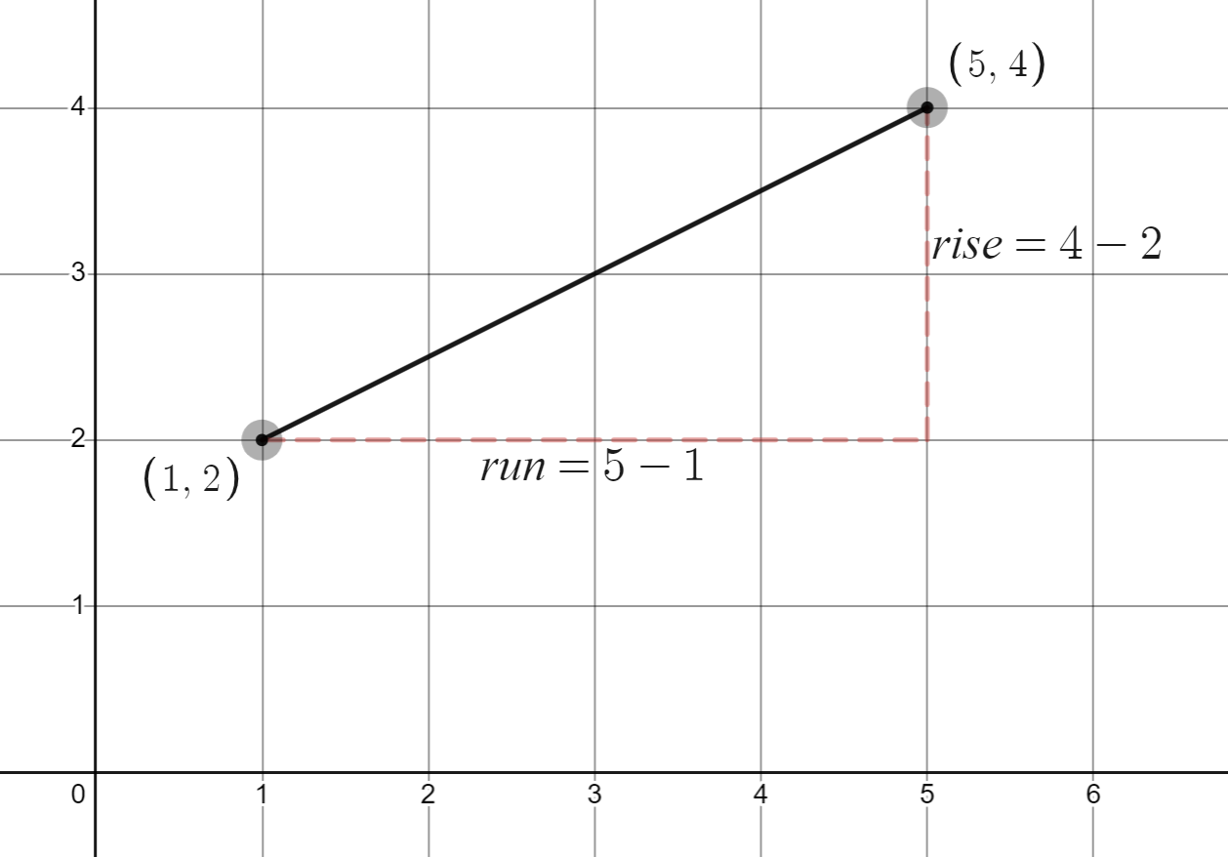
- What are the calculations labelled rise and run doing?
- Where do the numbers in the calculations come from?
- How do you use these calculations to find the gradient of the interval?
- Your teacher will now demonstrate how to find the gradient from these calculations. Once you have reviewed this and understand the solution consider the following:
- What would happen if one $x$ coordinate was negative?
- What would happen if both $x$ coordinates were negative?
- What would happen if one $y$ coordinate was negative?
- What would happen if both $y$ coordinates were negative?
- What would happen if the slope was going in the opposite direction, like the interval below?
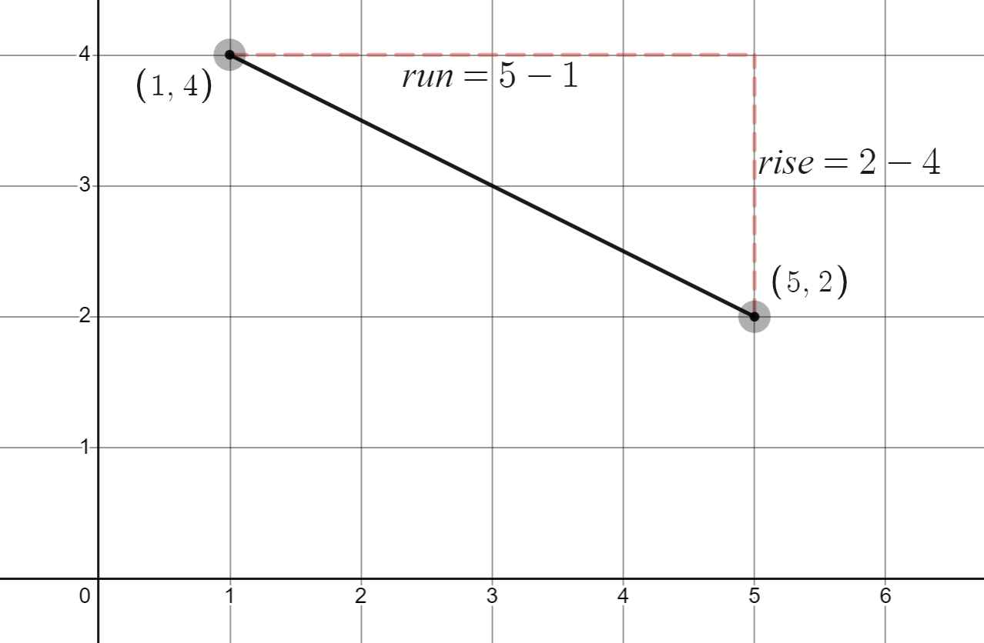
© State of New South Wales (Department of Education), 2023
The copyright material published in this resource is subject to the Copyright Act 1968 (Cth) and is owned by the NSW Department of Education or, where indicated, by a party other than the NSW Department of Education (third-party material).
Copyright material available in this resource and owned by the NSW Department of Education is licensed under a Creative Commons Attribution 4.0 International (CC BY 4.0) licence.
This licence allows you to share and adapt the material for any purpose, even commercially.
Attribution should be given to © State of New South Wales (Department of Education), 2023.
Material in this resource not available under a Creative Commons licence:
- the NSW Department of Education logo, other logos and trademark-protected material
- material owned by a third party that has been reproduced with permission. You will need to obtain permission from the third party to reuse its material.
Links to third-party material and websites
Please note that the provided (reading/viewing material/list/links/texts) are a suggestion only and implies no endorsement, by the New South Wales Department of Education, of any author, publisher, or book title. School principals and teachers are best placed to assess the suitability of resources that would complement the curriculum and reflect the needs and interests of their students.
If you use the links provided in this document to access a third-party's website, you acknowledge that the terms of use, including licence terms set out on the third-party's website apply to the use which may be made of the materials on that third-party website or where permitted by the Copyright Act 1968 (Cth). The department accepts no responsibility for content on third-party websites.

