# Working collaboratively with the Evaluation and Planning Tool (EP Tool)

**Important notes**

As Department of Education employees, you have free access to Microsoft SharePoint and Adobe Acrobat.

You **cannot work on the EP Tool simultaneously**, but it is live and writable through Adobe Acrobat and Microsoft SharePoint, eliminating the need to download it or experience issues with version control.

## Instructions

1. Save a copy of the EP tool in a designated shared folder. There are 2 ways to do this, via Teams or SharePoint:

In **Teams**, on the top banner click on the ‘Files’ section to the right of ‘Posts’. Then select ‘Upload’ and from the drop down, click ‘Files’.

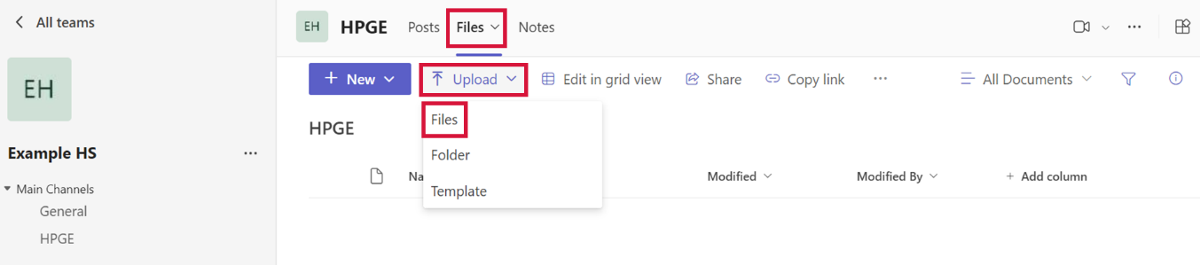

In **SharePoint**, in ‘Documents’ on the menu select ‘Upload’, then from the drop down, click ‘Files’.

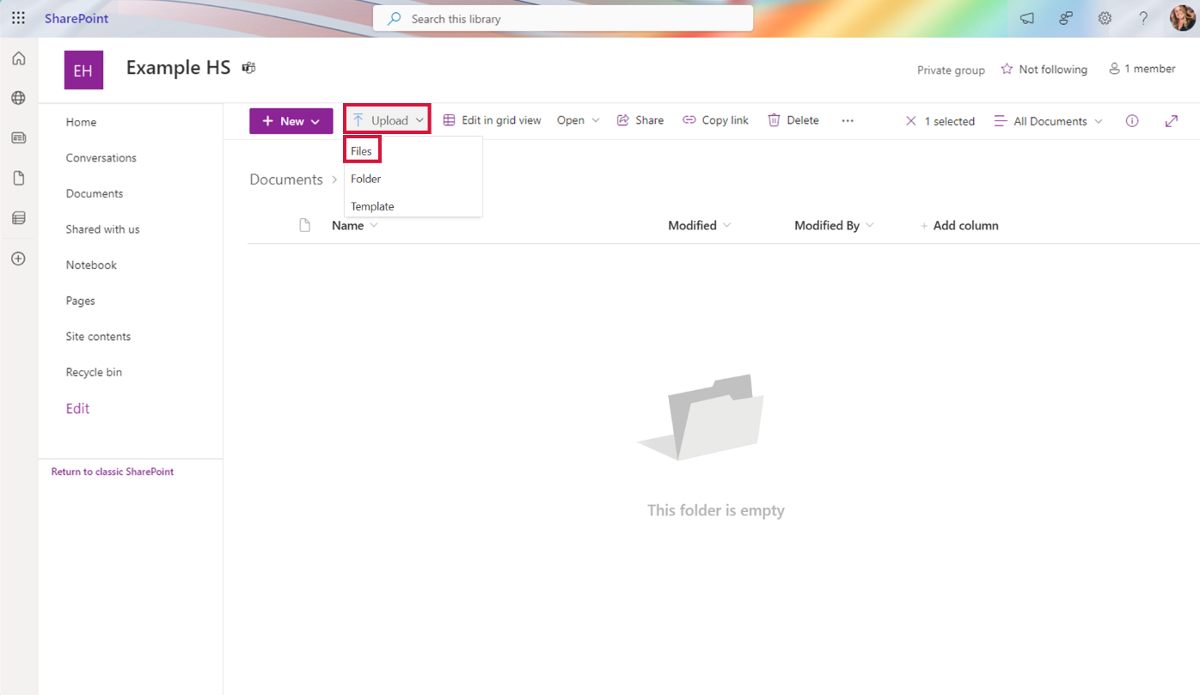

1. Ensure your document and/or selected channel is shared with everyone you would like to contribute to the document.

Click the ellipsis (…) to the right of the document title and select ‘Manage access’.

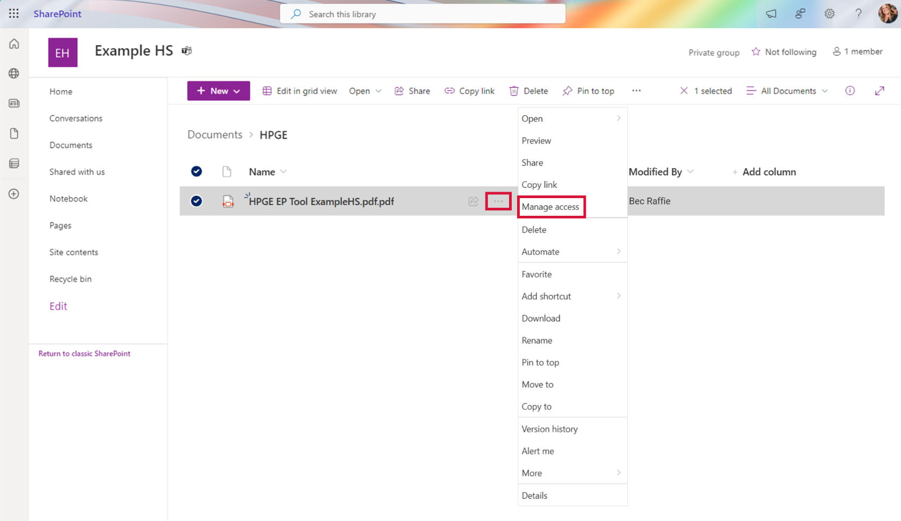

Leaders can manage who will have view only or edit access.

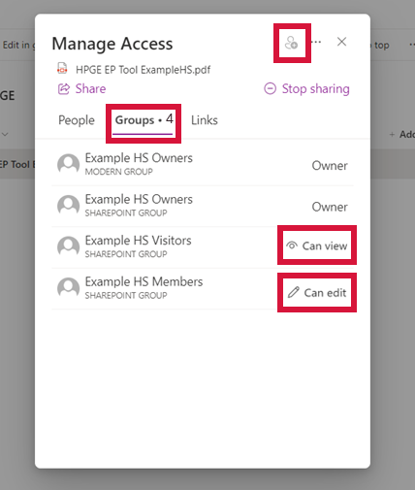

1. Before working on the document and making edits, you must ‘check out’ the document **from SharePoint.** This ensures multiple people do not have the document open at the same time and save their edits over the top of each other.

Click the ellipsis (…) to the right of the document title and hover over ‘more’. Then click ‘Check out’.

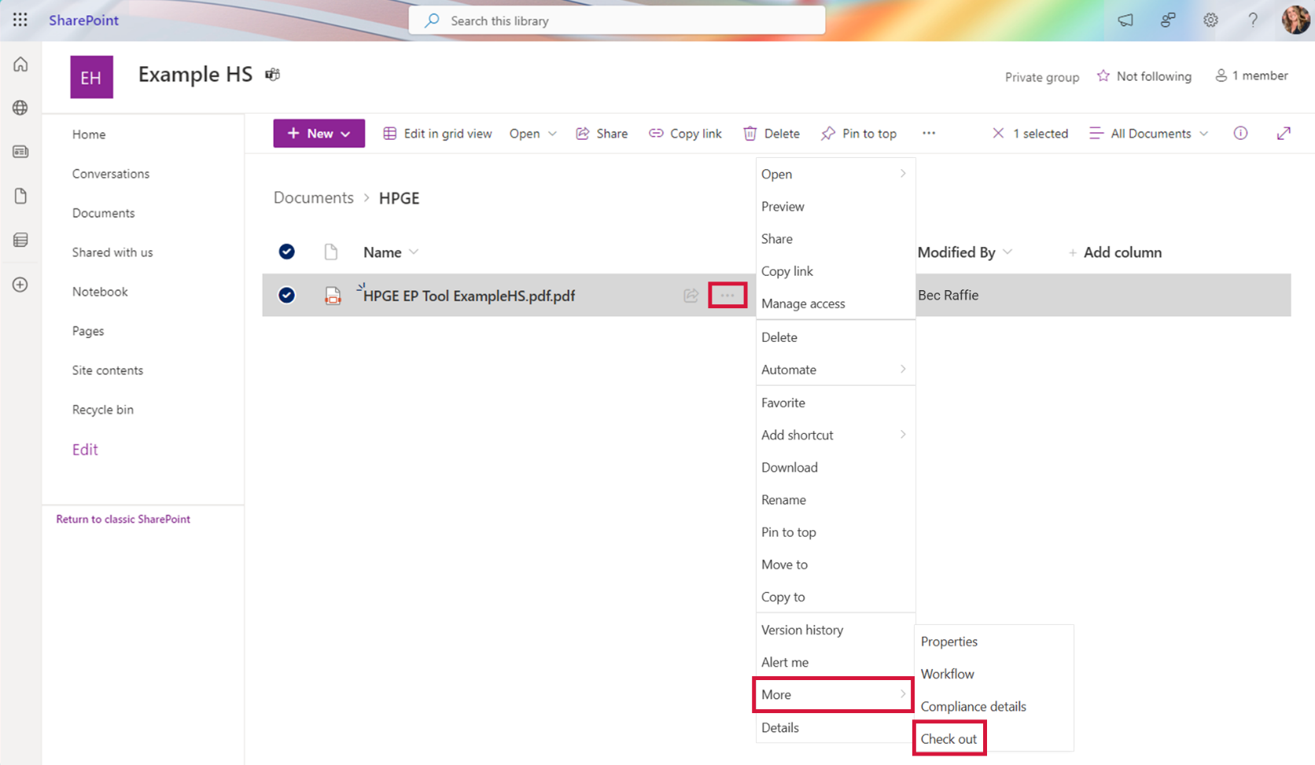

1. When you have the document ‘checked out’, you will see an arrow in a red circle next to the file name. If you hover over the red circle, you can see that others cannot edit it.

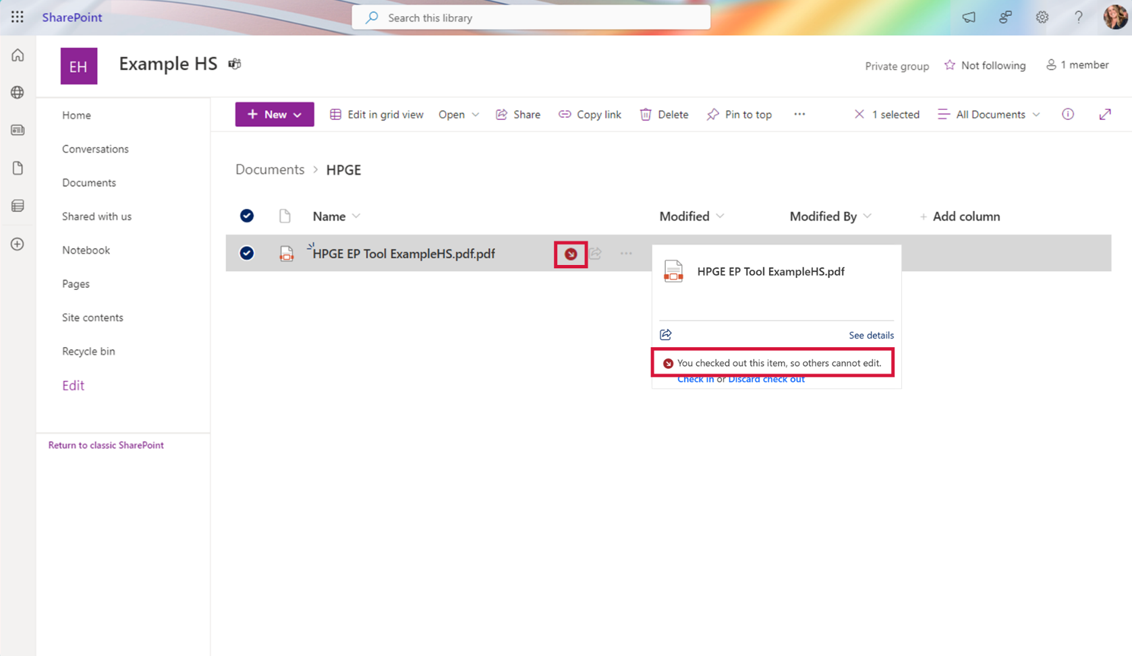

Others will see an arrow in an unfilled circle. When they hover over it, it will tell them who has the document currently ‘checked out’.

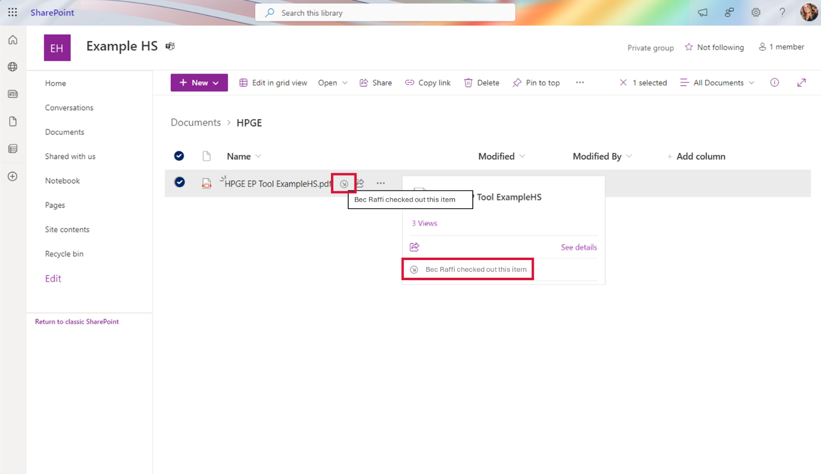

1. **Always open the document in Adobe Acrobat app.**

Click the ellipsis (…) to the right of the document title. Select ‘Open’ and then ‘Open in app’.

Note: If you open in the browser, you will not have the full functionality of the EP tool including the auto-populating fields throughout.

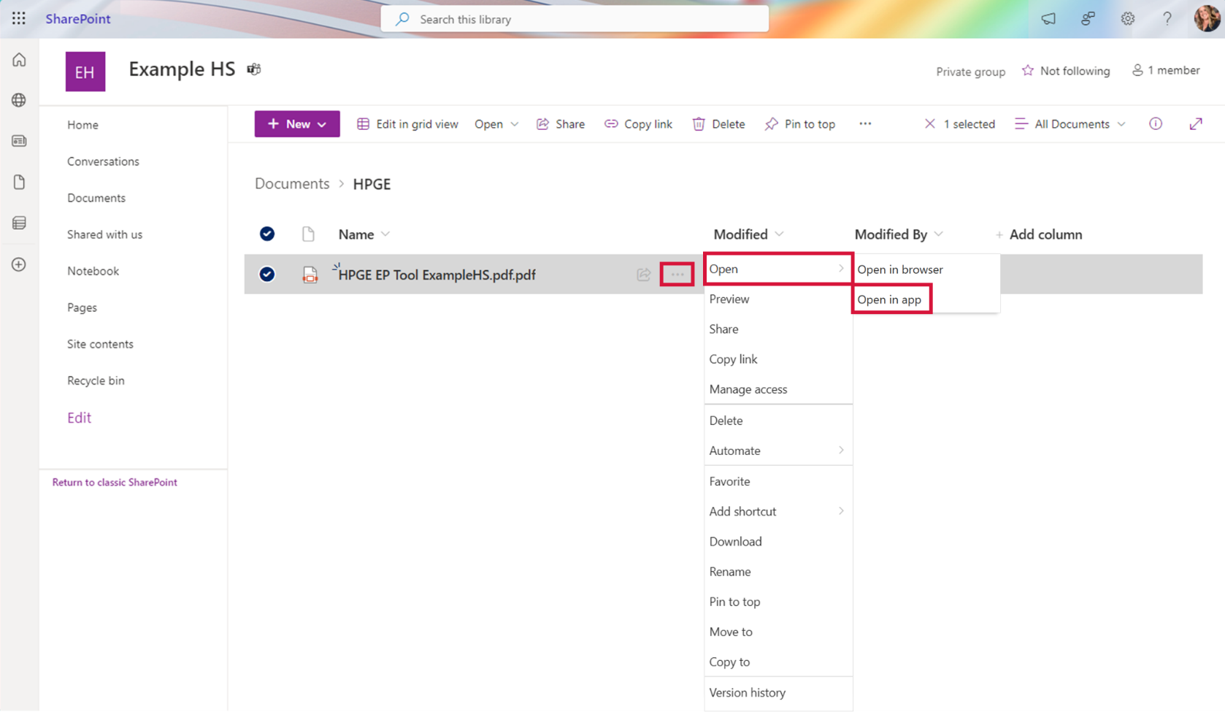

You can now work on the document as normal.

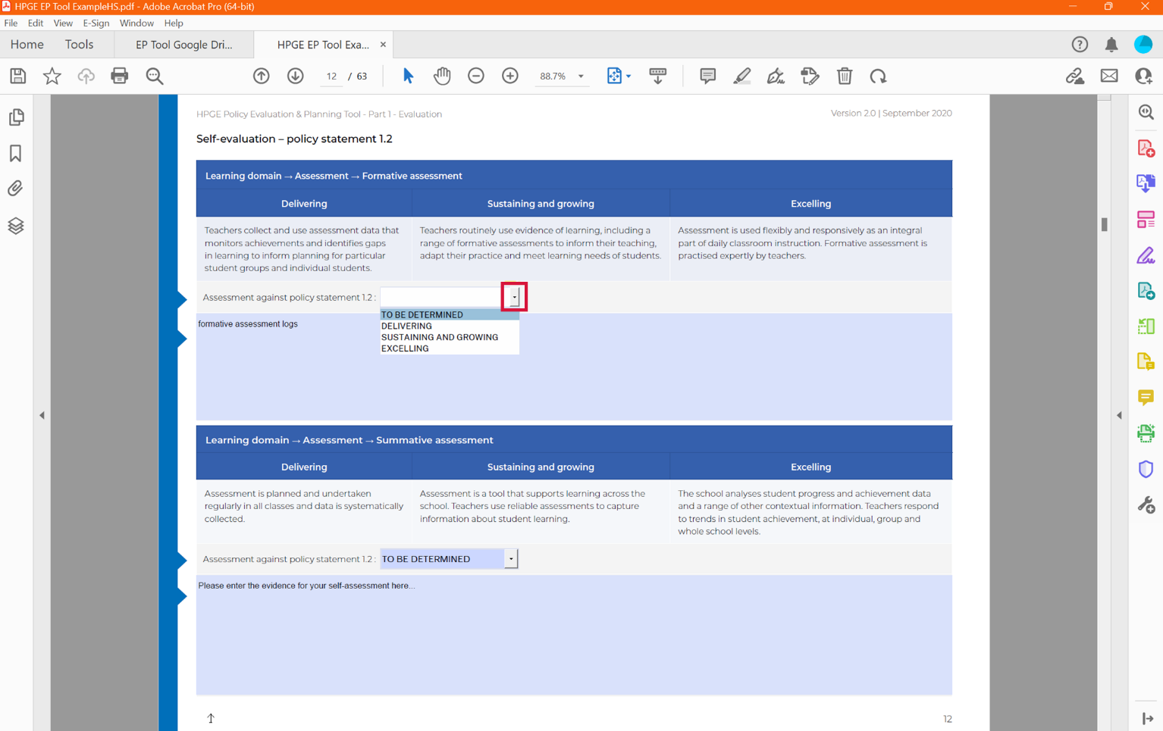

1. When you are finished working on the document, click the save icon before closing the document.

Important: The EP Tool will not autosave while you are working.

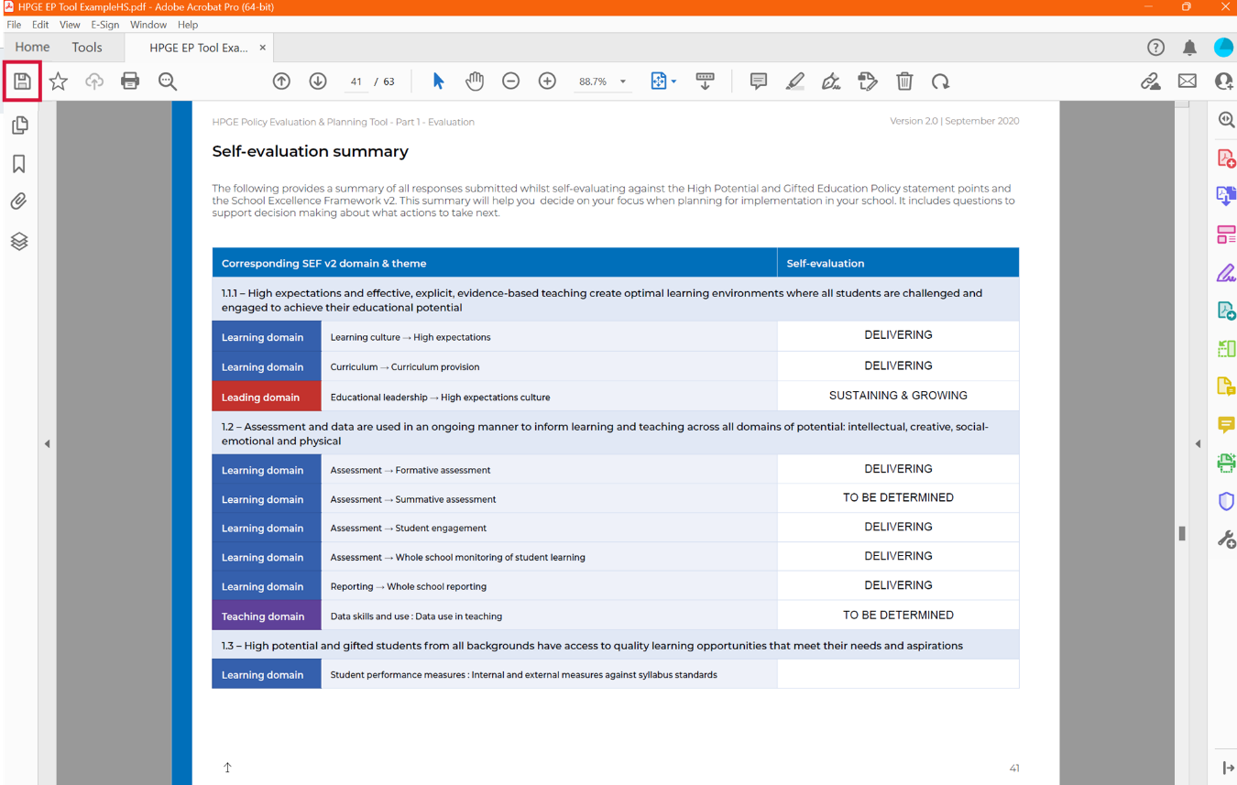

In SharePoint, you will see that it was last modified ‘A few seconds ago’.

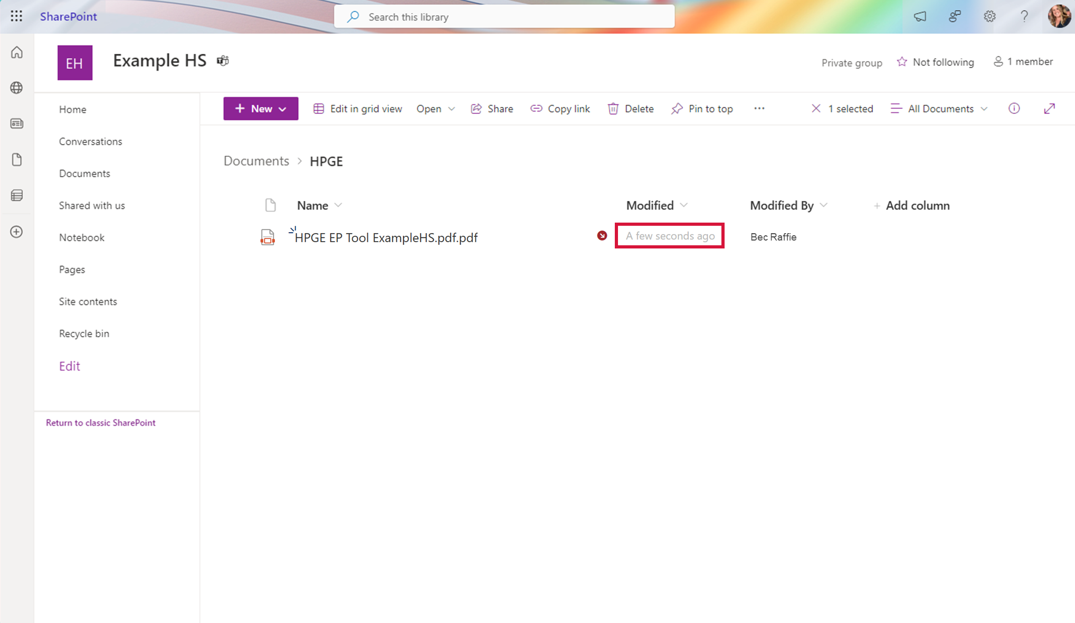

1. ‘Check in’ the document after editing and saving. There are 2 ways to do this:

Option 1 – hover over the red circle with the arrow and click ‘Check in’ in the box that appears.

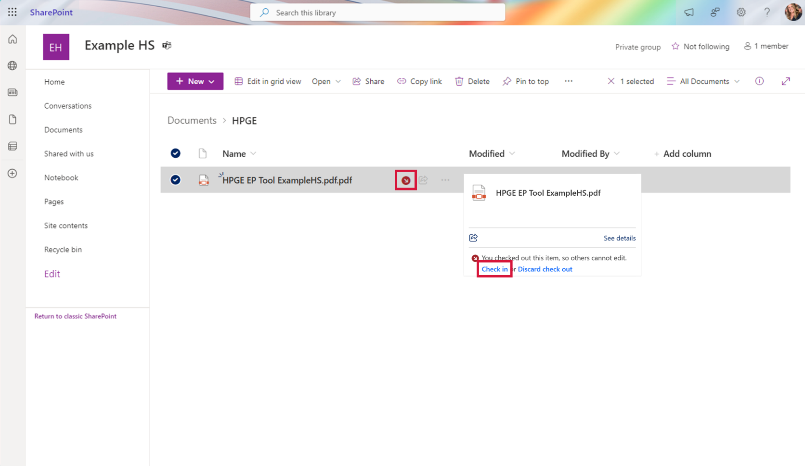

Option 2 – click the ellipsis (…) to the right of the document title and hover over ‘more’. Then click ‘Check in’.

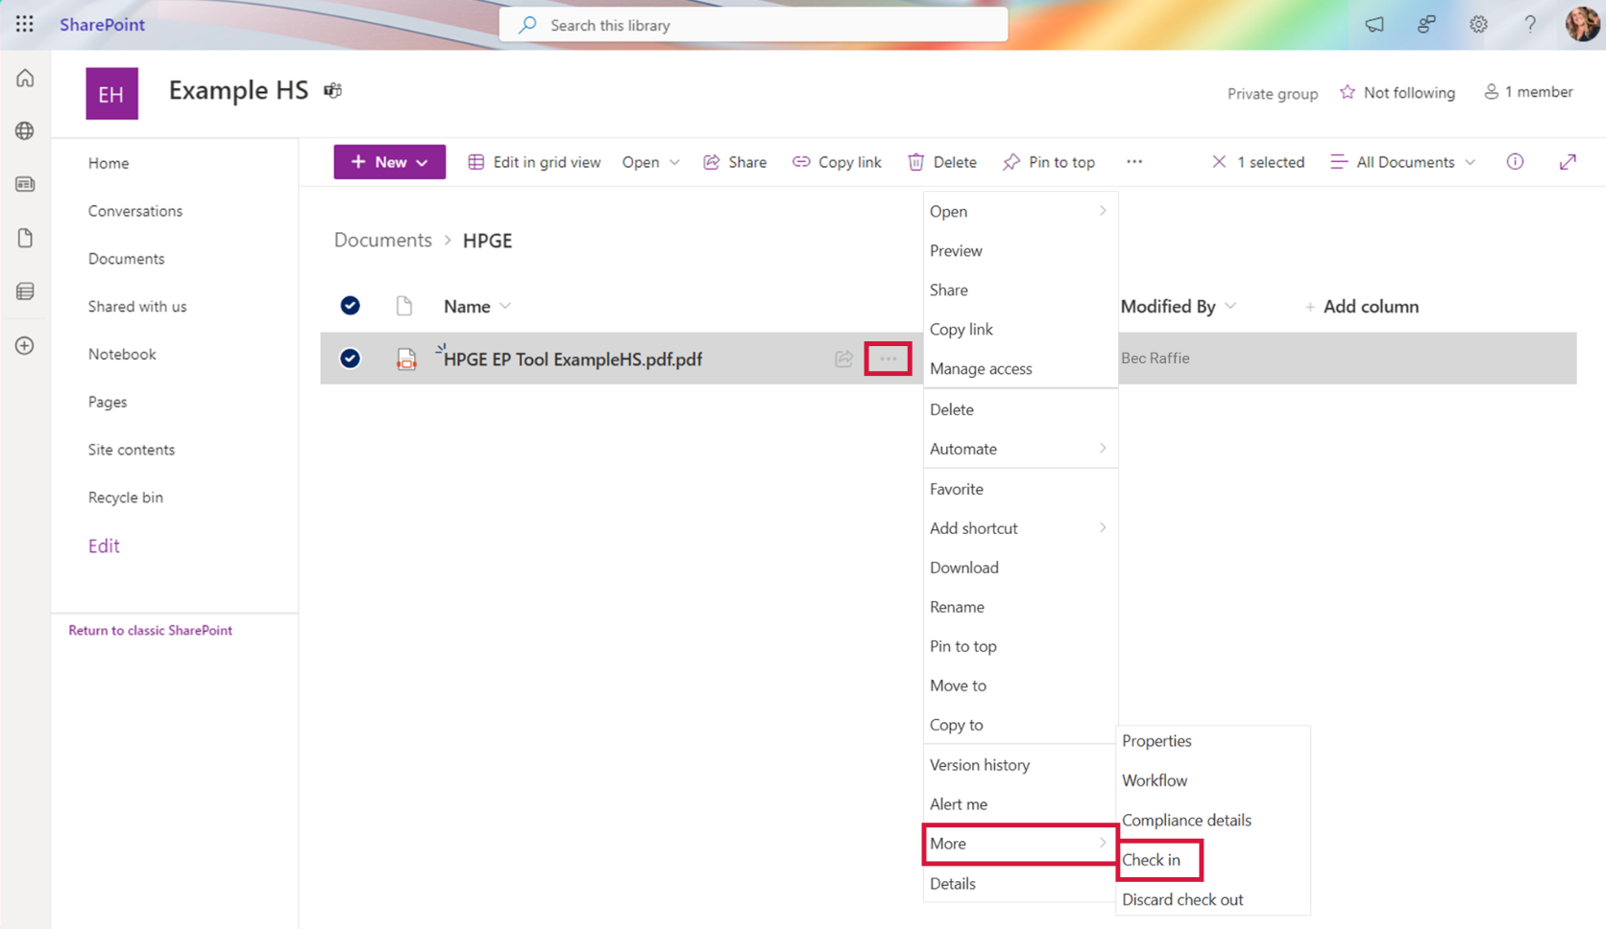

You can type a comment to briefly explain what changes you have made.

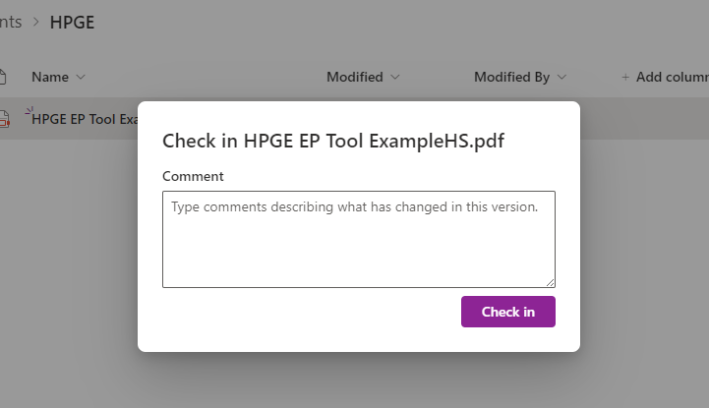

1. You can see the version history of the document.

To see the version history, you need to access it from SharePoint (not Teams).

If you are in Teams, on the top banner click the ellipsis (…), and select ‘Open in SharePoint’.

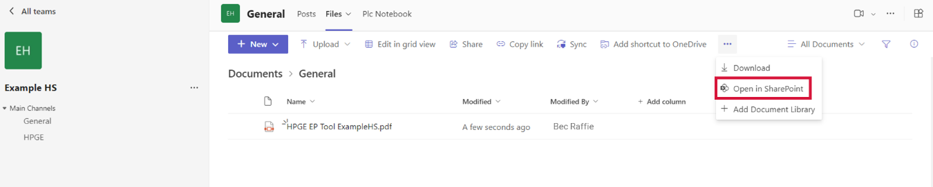

In SharePoint click the ellipsis (…) next to the file name and click ‘Version history’.

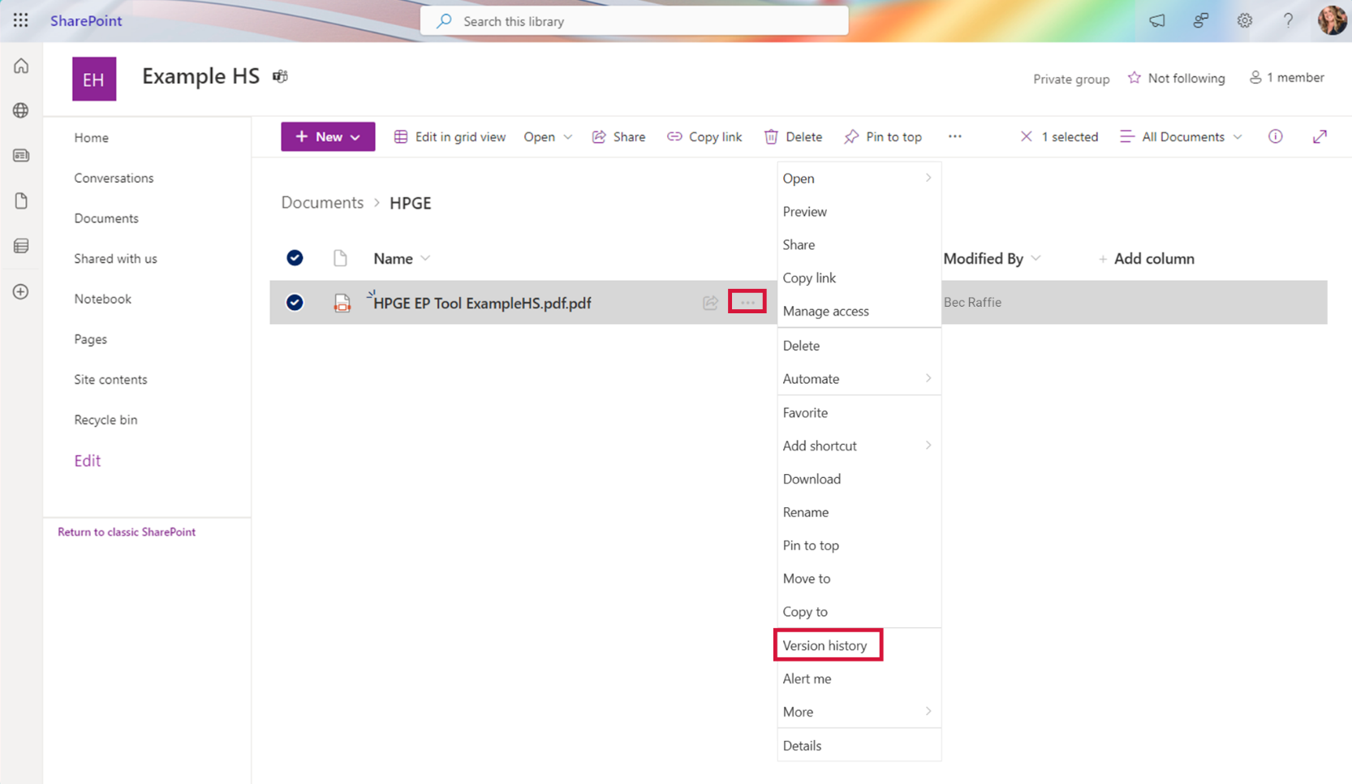

This will show you each time the document was edited, who modified it, and any comments left at ‘check in’.

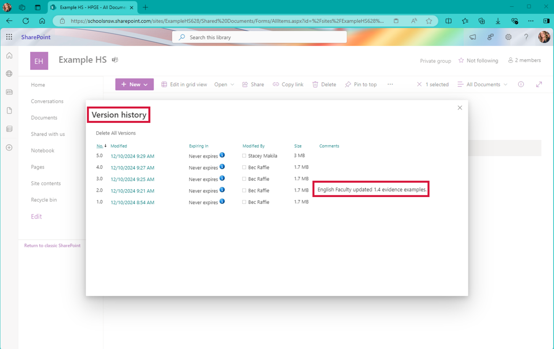

In version history, click on the drop down arrow beside the date modified to:

* view previous versions of the document,
* restore to a previous version, or
* delete previous versions.

