# This booklet belongs to:

# Week B – Tuesday

## Day at a glance:

|  |  |  |  |  |  |
| --- | --- | --- | --- | --- | --- |
| Tuesday | Streching and warming up | Taking photos | Catching | Guess my number | Maps |
| Estimated time | 5-10 mins | 10-20 mins | 15 mins | 10 – 20 mins | 15 – 20 mins |
| Resources required | None | A camera if you have one | A ball or something to throw and catch | None | Playing cards, Lego or blocks |

## Stretching and warm up

Learning goal: Children understand that stretching and moving is part of being healthy.

You can watch the video via this QR code. If you can’t watch the video, go to step 3.

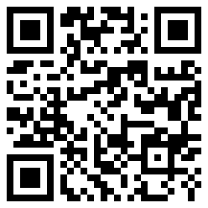

1. Watch the video.
2. Copy the superhero stretches.
3. Who are your favourite superheroes? Pretend to run, fly or jump like them.
4. Try the stretch in the photo below.



"Stretch and Bend Exercise" by moonjazz is licensed under CC BY-NC 2.0

* 1. Reach high towards the sky as tall as you can.
  2. Bend to one side, stretch, then bend to the other.
  3. Back to the middle and stretch high to the sun.
  4. Drop your arms and shake them out, squeeze your fingers.

## Taking photos

Learning goal: Children use information and communication technologies to make sense of their world.

You can watch the story via this QR code. If you can’t watch the story, you can start at step 2.



Harrison, Pamela.  2019, *Emily Green’s Garden / Penny Harrison*, New Frontier Sydney

1. Listen to the story, ‘Emily Green’s Garden’ read by Costa Georgiadis.
2. After listening to the story, think about the plants in the area you live. You might be able to see some out the window, in your backyard or you might have some growing inside your house.
3. Ask someone to help you take a photo of each of the plants you can see.
4. How many photos did you take? Did you take any photos of trees? Do any of the plants have flowers on them?
5. If you can’t take a photo, here are some to look at below. Which one is a tree and which is a flower?

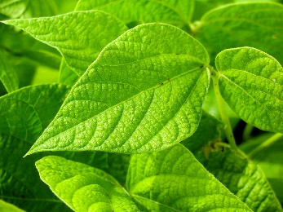

"Green Plant Leaves" by Image Catalog is marked with CC0 1.0

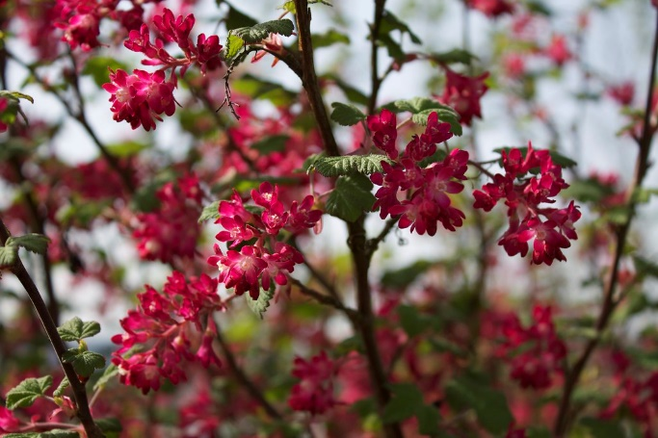

"Flowers" by Nouhailler is licensed under CC BY-SA 2.0

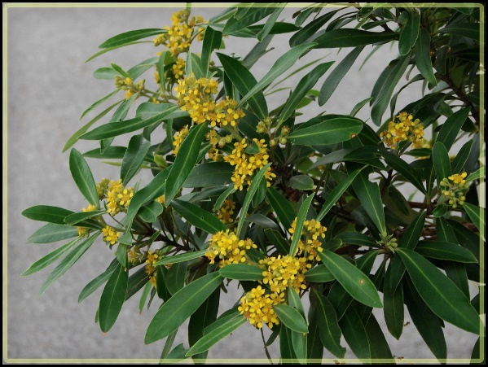

"Tristaniopsis laurina - 'Water Gum'" by Tatters ✾ is licensed under CC BY 2.0

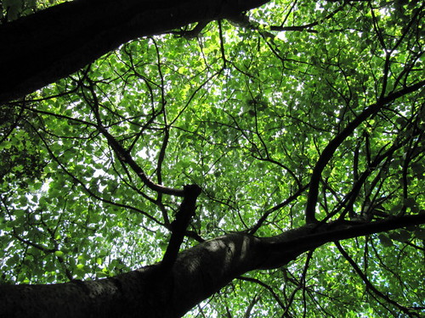

"Populus alba (White Poplar)" by wallygrom is licensed under CC BY-SA 2.0

## Catching

Learning goal: Children catch using two hands.

You can watch the video via this QR code. If you can’t watch the video, you can start at step 2.

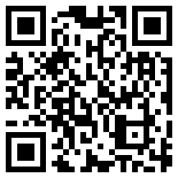

1. Watch the video to see how the children catch a ball.
2. Find a ball and ask someone to play with you.
3. Stand close together and throw and catch with each other.
4. How many times can you catch the ball without dropping it?
5. If you are going well, take a step backwards each time you catch the ball.

## Guess my number

Learning goal: Children recognise numbers.

You can watch the video via the QR code:

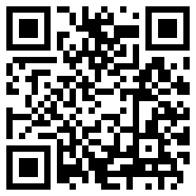

What to do:

* Watch the video to learn how to play, ‘Guess my number’.
* Arrange playing cards from the smallest number to the largest number, like in the video. If you don’t have playing cards, make your own.
* Point to each card and say the number.
* Make groups of LEGO or blocks, and match them with the number card, like in the video.
* Play the game with someone in your family.

## Maps

Learning goal: Children make connections between symbols and directions using a map.

You can watch the video via this QR code. If you can’t watch the video, you can try step 3.



1. Watch the video and join in the activity.
2. On the map in the video, did you find:
   1. the hospital?
   2. the fire station?
   3. the dentist?
3. After watching the video, draw a map of your bedroom, backyard or favourite park.

## Extra learning activities

Learn to count through the song, 'Five little monkeys’ and the story, 'Let’s count goats' with these literacy and numeracy activities.

You can access the activities via this QR code:



**Five little monkeys**

* Use fingers to count through the song.

*Five little monkeys jumping on the bed*

*One fell off and bumped his head*

*Mama called the doctor and the doctor said*

*"No more monkeys jumping on the bed!"*

*Four little monkeys jumping on the bed*

*One fell off and bumped his head*

*Mama called the doctor and the doctor said*

*"No more monkeys jumping on the bed!"*

*Three little monkeys jumping on the bed*

*One fell off and bumped his head*

*Mama called the doctor and the doctor said*

*"No more monkeys jumping on the bed!"*

*Two little monkeys jumping on the bed*

*One fell off and bumped his head*

*Mama called the doctor and the doctor said*

*"No more monkeys jumping on the bed!"*

*One little monkey jumping on the bed*

*He fell off and bumped his head*

*Mama called the doctor and the doctor said*

*"Put those monkeys right to bed!"*

**© State of New South Wales (Department of Education), 2021**

The copyright material published in this document is subject to the Copyright Act 1968 (Cth) and is owned by the NSW Department of Education or, where indicated, by a party other than the NSW Department of Education.

Copyright material available in this document is licensed under a Creative Commons Attribution 4.0 International (CC BY 4.0) licence.

See <https://education.nsw.gov.au/about-us/copyright>for further details.

